**WIPOTEC driver documentation.**

The Teklynx WIPOTEC driver has been developed to design labels in CODESOFT and export it into TQS system. The exported XML file is formatted according to the WIPOTEC document: "CLF TQS_EN.docx"

 

The predesigned CODESOFT label can be saved into file with “. CLF” extension and should be copied to the local folder of the computer with running TQS software. In the CODESOFT driver setup dialog a user can setup default path for saving CLF files. In the picture below there are options of the driver setup dialog, where a user can assign a default path for saved labels.

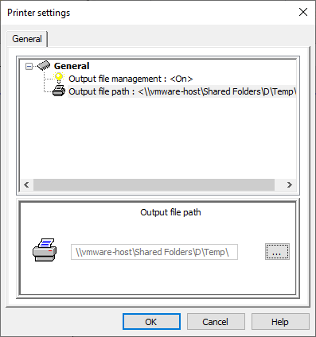

The user can activate option “Output file management” and select path to the storage for CLF files. When option “Output file management” is activated, the driver saves CLF output to activated path.

For importing template CLF files, which are generated by CODESOFT driver, a user needs to activate edit mode in the TQS system. In the Line Manager application of the TQS system a user can activate “Article” tab, select article for editing, and press “ConfigureFast” button.

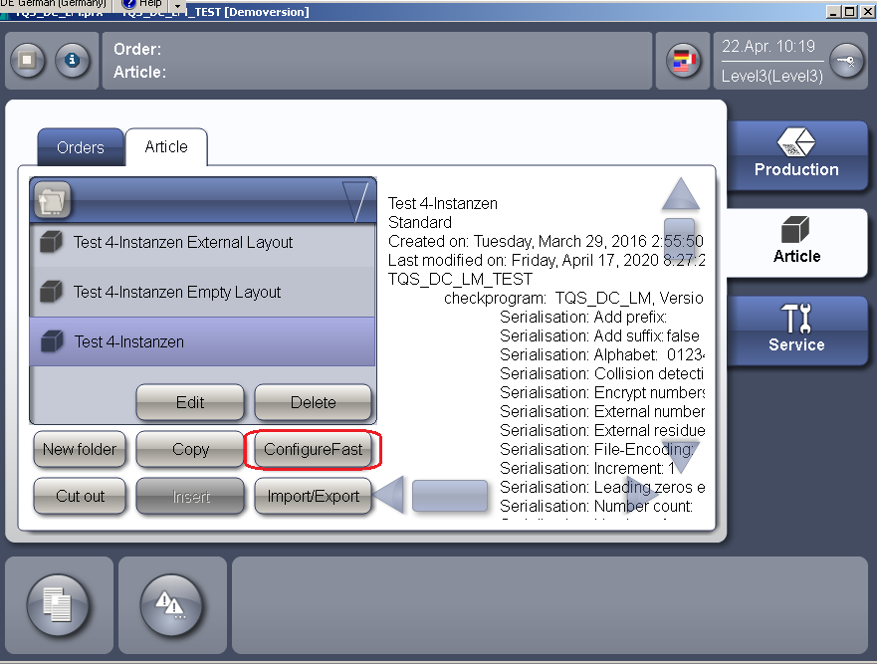

The TQS system switches to the “Edit” mode and highlights all active applications with orange color. The generated CLF files must be copied to the local folder of the computer with running line application. For importing CLF template files into TQS Line application a user needs authorizing in the Line application. The user’s login and password should be input in the dialog, which appears after pressing “Key” button in the left upper corner.

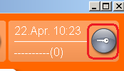

**Pic. Key button**

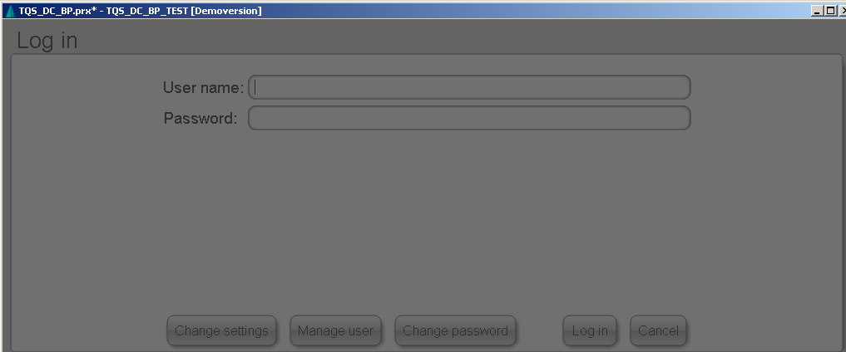

**Pic. Login dialog**

User can activate vertical “Article” tab and select “Layout” horizontal tab for display Layout edit window, like on screenshot below:

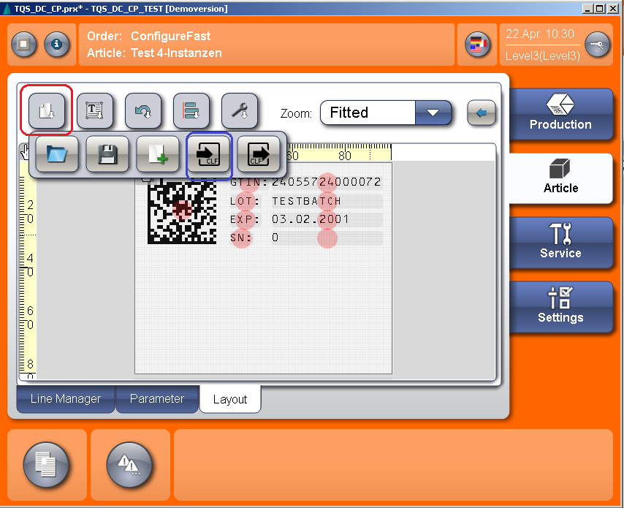

**Pic. TQS system in edit mode with imported CLF file**

After pressing the button framed with red colour, buttons submenu is opened. User should press the button framed with the blue color for opening file open dialog. In the File open dialog User can open local folder, which contains imported CLF file and load it into TQS application for further usage in the production process.

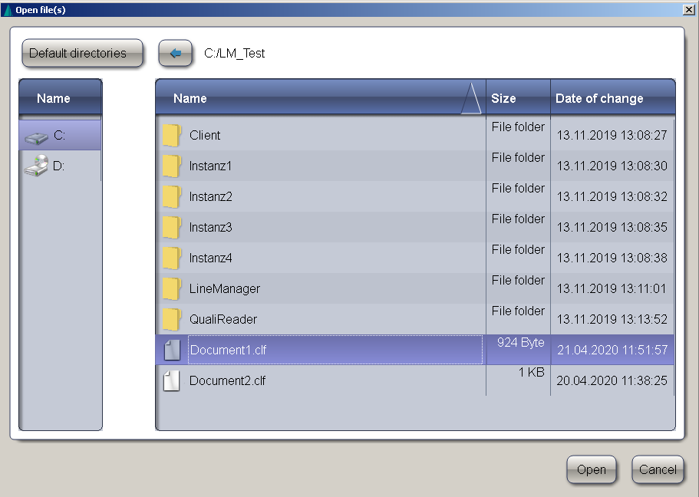

**Pic. The CLF file open dialog window**.

**The label object types, supported by PWPT driver.**

The PWPT driver can generate TQS native code for the following list of CODESOFT label objects:

* Static text field
* Variable text field
* Date field
* Static barcode field (static barcodes does not support composite data)
  + CODE 39
  + UPC-E
  + UPC-A
  + CODE 128 (AUTO, A, B, C)
  + CODE 2of5
  + DataMatrix
  + QR Code
* Variable barcode field (can contain only one GS1AIData function or GS1/ IFA code)
  + CODE 39 + HR (Human readable)
  + UPC-E + HR
  + UPC-A + HR
  + EAN 13 + HR
  + CODE 128 (AUTO, A, B, C) + HR
  + DataMatrix
  + QR Code
  + GS1_Code 128 + HR
  + GS1 DataMatrix
  + GS1_DataBar
* Formula barcode field (can contain any GS1AIData functions or GS1/ IFA codes)
  + CODE 39 + HR
  + UPC-E
  + UPC-A
  + CODE 128 + HR (AUTO, A, B, C)
  + DataMatrix
  + QR Code
  + GS1_Code 128 + HR (support composite data)
  + GS1 DataMatrix (support composite data)
  + GS1_DataBar (support composite data)
* Graphic objects

Any other types of the CODESOFT label object can be used in label design and exported to the CLF file as graphic.

**Static text field**

The static text field can contain any data without size limitation. The CODESOFT PWPT driver supports six predefined printer fonts: Arial (Bold/Italic), Arial Unicode MS (Bold/Italic), Courier New (Bold/Italic), OCR-A, OCR-B and OCR-B 75W. All other registered Windows font are also available for usage with text fields.

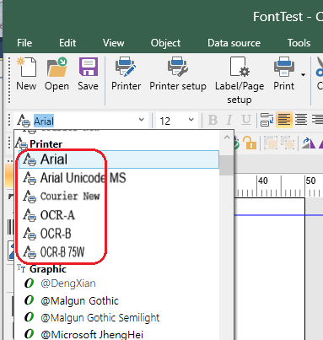

**Pic. The list of the predefined fonts.**

The example how to use text fields with different fonts can be found on the screenshot and example files below.

|  |  |
| --- | --- |
|  | D:\Temp\AttachFileHandler.png |

**Pic. Static text fields with different fonts.**



The CODESOFT LAB file and CLF output file.

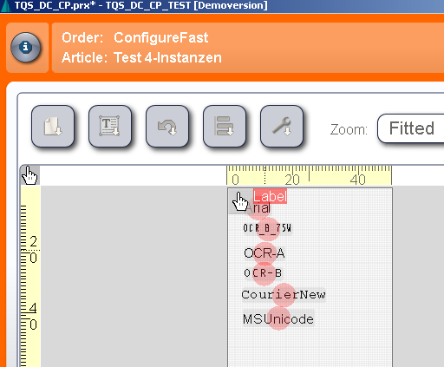

**Pic. Imported CLF file into TQS system**.

**Variable text field**

The CODESOFT variables are basement for creation variable text fields. According to the CLF XSD scheme the variable text field can contain only digit values with max size 4 digits. So, in case User defines not digit data for value, the TQS system will generate errors during the import of CLF file process.

In the example below the variable Var1 contains the wrong type of data (string “text Data” as variable data).

Such a type of data is not supported by the TQS system for variable text field objects. The next error is generated during importing the CLF file into the TQS system.

|  |  |
| --- | --- |
|  | TQS system error message. |

For example, when variable Var1 contains GS1 code 17, then TQS system imports CLF file without error message.

|  |  |
| --- | --- |
|  |  |

The default width of the text fields is calculated by CODESOFT automatically, according to the text length and font properties. However, the width of the text field can be resized by switching on checkbox “Wordwrap” in the text field “Properties”-> “Paragraph” dialog.

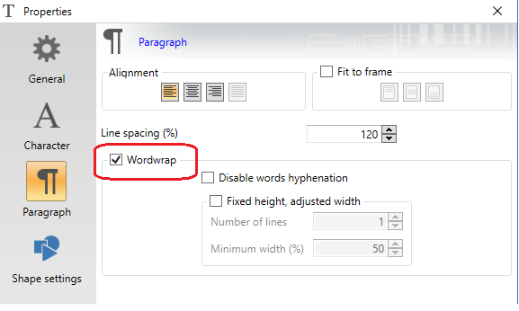

**Pic. Wordwrap option in the text properties dialog.**

|  |  |
| --- | --- |
|  |  |

**Pic. Variable text fields with correct value and different width.**



The CODESOFT label file and CLF output file .

The CODESOFT formulas can be used for creation variable text field with the same rules as for simple variable fields. But in the formula text field User can use a special GS1AIData function for defining GS1 or IFA content or many other functions for manipulating the formula content.

In case a variable contains more than one GS1AIData function, the driver displays a warning message and generates a static text field with formula content instead of a variable text field.

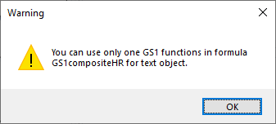

**Pic. Warning message.**

|  |  |
| --- | --- |
| **Formula with simple data.** | **Formula with function.** |



Example files: and CLF output file:

In case when a User will defined GS1AIData function with GS1 code, then driver print “clf:gs1” attribute for “text- variable” field. For example the driver will generate “clf:gs1” content for formula with expression: GS1AIData("01", "0000012345", 1, 0).

In case when a User will defined GS1AIData function with some IFA code, then driver print “clf:ifa” attribute for “text- variable” field.

For example the driver will generate “clf:ifa” content for formula with expression: GS1AIData("9N", "0000012345", 1, 0).

In all other cases, when a User will defined symbols value without “”, the driver will generate ”clf:custom” content for “text- variable” field.

For example the driver will generate “clf: custom” content for formula or variable with expressions: 118, 301, 302, etc.



Example files: and CLF output file: .

**Date field**

The CODESOFT date fields are represented in the TQS system like a text field with additional XML attributes where User can define date format. The format for the date field can be selected by User from the list of predefined formats or it can be customized, as it is shown on the screenshot below:

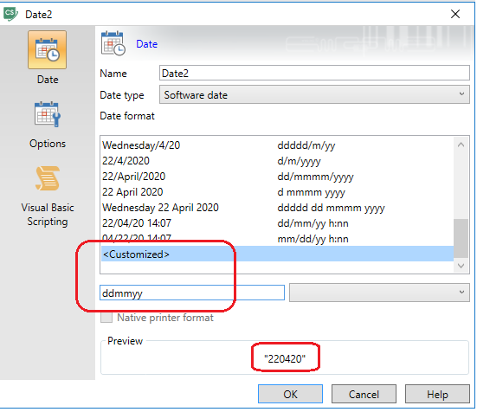

|  |  |
| --- | --- |
| **Date field with different formats.** | **Date field with different formats, exported to TQS system.** |



Example files: and CLF output file:

**Static barcode field**

The data value of the static barcode field can contain any symbols without any length restriction . The length and type of barcode data symbols depend on the type of barcode. For example, CODE 39, CODE 93 and CODE 128 barcodes support digits and letters in the barcode data, but CODE 2OF5 supports only digit data.

|  |  |
| --- | --- |
|  |  |

**Pic. Result of importing static barcodes from CODESOFT to the TQS system**.



Example files: and CLF output file:

The driver will generate “clf:code-128” attribute for Code-128 with type AUTO and “clf:code-128a”, “clf:code-128b”, “clf:code-128c” for types “A”, “B” and “C” respectively.

By default, all barcodes are created with the option to generate Human Readable text on the printer side. But User can change this option in the barcode properties dialog in the special window, which appears after pressing the “Human Readable” button.

When option “Generated by the printer” is checked off, then the driver generates additional text element into the CLF file with human readable text.

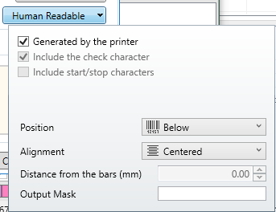

**Pic. Human Readable dialog.**

For select another HR font for barcode a User just need to deactivate the option "Generated by the printer" in the “Human Readable” dialog:

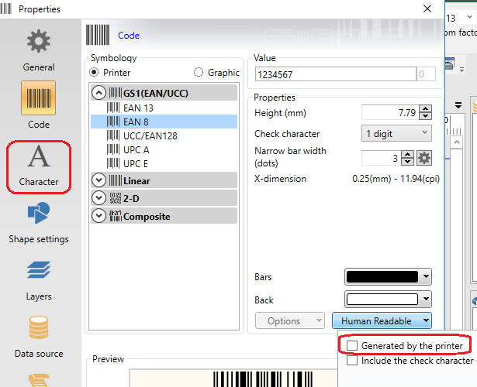

Then “Character” option will have activated.

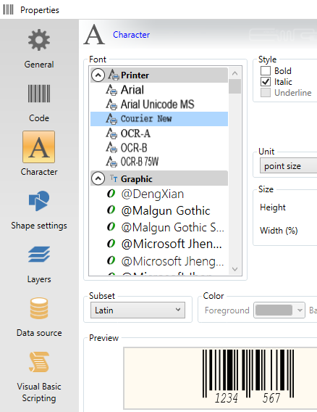

In the “Character” dialog a User can redefine HR font and size.

The DATAMATRIX barcode has additional options which can be setup with “Specific option” dialog. This dialog is displayed when User opens barcode properties and selects the “Specific option” menu.

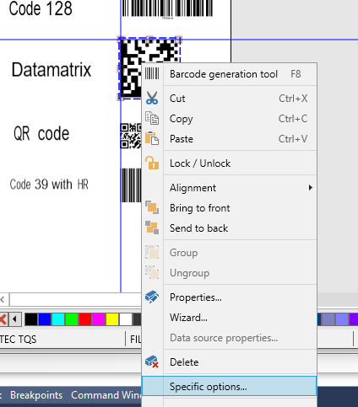

In the dialog window User can change horizontal and vertical reduction values and option “Fixed module size XML tag”, which allows the driver to generate additional attribute “module-size”.

|  |  |
| --- | --- |
|  |  |

**Pic. Specific option dialog for DATAMATRIX barcode.**

**Variable barcode field**

The CODESOFT variables can be used for creating the TQS variable barcodes.

The CODESOFT variables values for barcodes or text fields are restricted by the data length (max four symbols) and can contain only one GS1 or IFA code as value, according to types description in the CLF XSD scheme.

The driver will generate “clf:data-matrix-variable” barcode type for variable and “clf:gs1-data-matrix-variable” barcode type for formulas.

The next CODESOFT barcode types are not supported by the IFA coding system: UCC/EAN 128, DATAMATRIX and QR Code.

|  |  |
| --- | --- |
|  |  |

**Pic. Examples of the barcodes for variable fields.**



Example files: and CLF output file: .

Managing HR text for barcodes.

The driver recalculating the HR text size automatically, during a User changed barcodes height or width. In cases when a User need to implement special style for barcode HR text, then he can make next steps:

1. Switch OFF the “Generated by the printer” check box in the barcode HR sub-dialog in the CODESOFT and select option “None” in the “Position” list box.

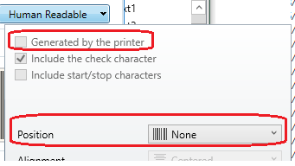

1. Place static or variable HR text field on the label (for example: below barcode) and setup font style for this field.
2. Print the label and generate XML template.

|  |  |
| --- | --- |
|  |  |

**Pic. The screenshots with examples.**



Example files: and CLF output file:.

**Formula barcode field**

The CODESOFT formulas can be used for creation text or barcode elements with complex data.

The formula data can contain simple GS1 or IFA codes, or it can contain complex expressions for generating complex GS1 or IFA data. Also it can contain composite data for creating composite barcodes.

The CODESOFT driver automatically determines formula data type and generates GS1 or IFA data attributes.

Special function GS1AIData is used for coding formula data. This function is available in the formula editor and has 4 parameters:

1. GS1 or IFA code
2. Temporary data which is ignored during creation of the driver output
3. The option which determines that this element is the last in the expression
4. The option which determines whether to calculate or not to calculate the check sum.

The formulas can contain more than one GS1AIData function. These functions can be concatenated with special “&” symbol.

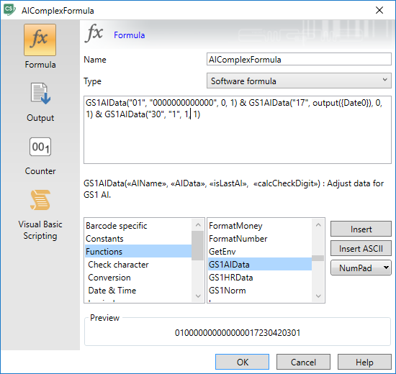

**Pic. Formula editor.**

The formulas data can be defined in the special GS1 wizard or manually in the formula editor.

Using the GS1 Wizard is more helpful because this wizard checks consistency of the GS1 data.

For running GS1 Wizard User should select “GS1 Wizard” menu item as it is shown in the picture below.

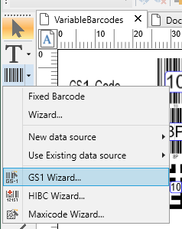

**Pic. Menu item “GS1 Wizard”.**

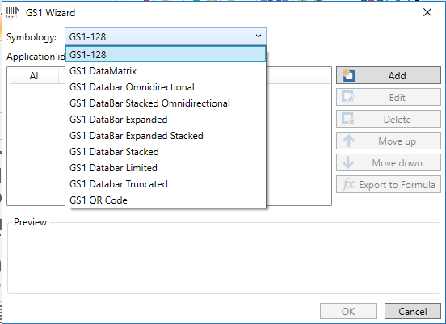

**Pic. GS1 Wizard.**

In the wizard User can select different types of barcodes.

Note: GS1 QR Code is not supported by the TQS system.

The dialog “GS1 data input” opens after User presses the “Add” button. In this dialog User can define complex data for new barcode by selecting available GS1 codes from the list.

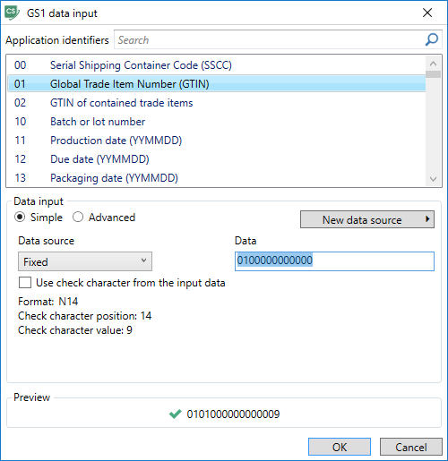

The data source can be fixed value or it can use some predefined variables as data source. It can be useful when User needs to set formatting for GS1 Date codes for the text field. It is shown in the pictures below:

|  |  |
| --- | --- |
| **User defined CODESOFT Date variable and set customer Date format.** | **In the GS1 data input wizard user can select variable type of the Data source and select Variable name from the variable list.** |

In this case the driver generates a formatting attribute for the formula text field with GS1 Date code.

|  |
| --- |
|  |

**Pic. Formatting attributes for formula text field with GS1 Date code in the output CLF file.**

As CODESOFT does not support IFA coding system, User can create IFA formula in the formula editor. For these purposes, User can use GS1AIData function but instead GS1 codes it is necessary to use codes of the IFA system. Driver automatically determines the system which is used and generates appropriate barcode type.

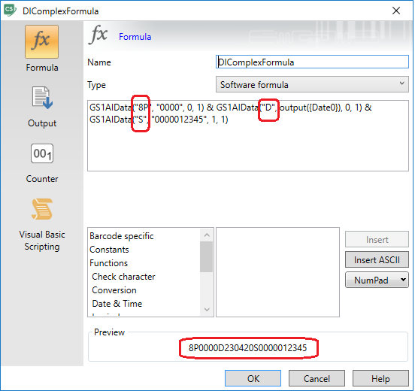

**Pic. Example for formula with IFA codes.**

In case DATAMATRIX barcode contains IFA formula then driver will generate “ppn-data-matrtix” barcode in the output CLF file.

|  |  |
| --- | --- |
|  |  |

**Pic. Example for export CODESOFT label with single/complex formula to the TQS system. Also this example contains DATAMATRIX barcode which convert to the ppn-data-matrix barcode in the TQS system.**



Example files: and CLF output file:.

The composite barcodes have two parts of data - linear component and 2D composite component. To separate these two parts User should use special separation symbol “|” in the formula editor.

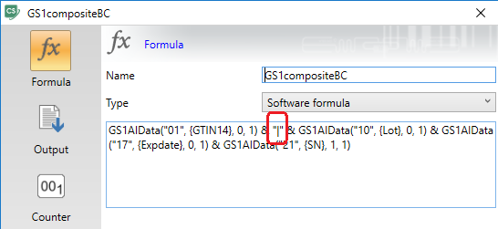

**Pic. Formula separation symbol for composite barcodes.**

Left part of formula before “|” symbol is a linear component, all GS1AIData functions in the right part of formula represent the composite component.

|  |  |
| --- | --- |
|  |  |

**Pic. Label with composite barcodes.**



Example files: and CLF output file:.

User can input GS1 simplifier expression (for example: “01|10,17,21”) into CODESOFT formula for composite barcode. In this case driver will generating XML output for composite barcode with linear and composite part separated by the ”|” symbol.

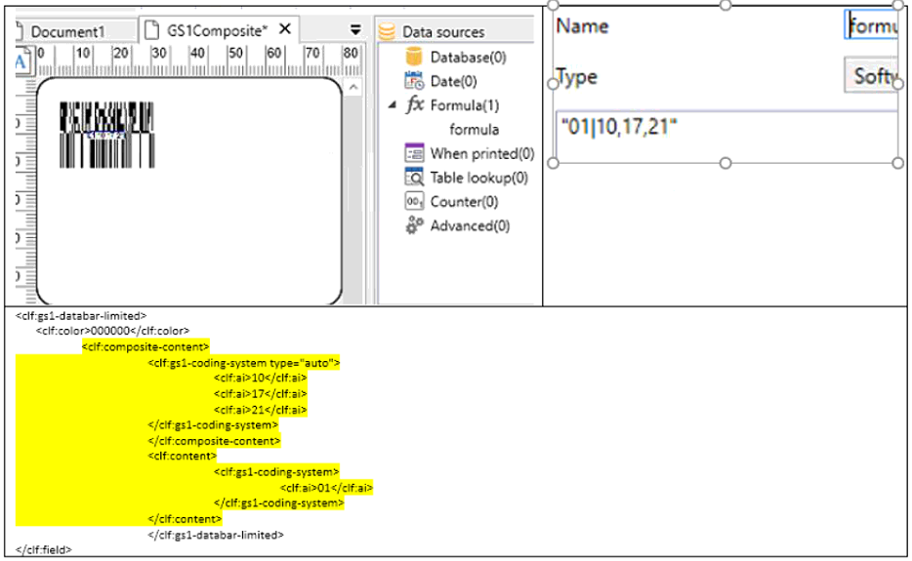

All types of the barcodes, which are not supported by the TQS system, can be generated in the CODESOFT as graphical objects. To display all the possible types of barcodes in the CODESOFT application User can select the “Graphic” radio button in the barcode properties dialog.

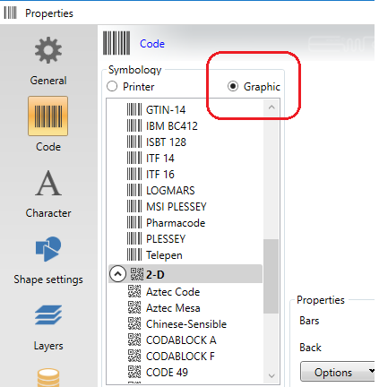

**Graphic objects**

Any label objects in the CODESOFT can be represented as graphic objects. To switch to this mode User can open label object properties dialog and switch on “Send as graphic” option.

On the screenshot below all the objects in the example label are imported into the TQS system like graphic objects.

|  |  |
| --- | --- |
|  |  |

**Pic. Example with graphic objects.**