

**METRO RAIL TRANSPORTATION SYSTEM**

**-*Moving People, Saving Time & Energy***



**NORTH SOUTH UNIVERSITY**

**COURSE:**CSE 115

**SECTION:**04

**PROJECT TITLE:**Metro Rail Transportation System

**SUBMITTED TO:**Rashed Selim Topu (RSL)

**DATE OF SUBMISSION:**22/04/2017

**SUBMITTED BY:**   Group IV

1. Taslima Mozumder                   ID : 1711403042
2. Nadin Tasmia                              ID : 1712836642
3. Salekur Rahaman                       ID : 1713018642

**METRO RAIL TRANSPORTATION SYSTEM**

Dhaka, the capital of Bangladesh is one of the most highly populated and traffic congested cities in the world with an ever increasing population of over 14 million.

Under the Road Transportation and Highways Division of the Ministry of Road Transport and Bridge, the Metro Rail Transportation System (MRTS) was taken up by the Government. MRTS will run on elevated Rail tracks around the Dhaka City.

**DOCUMENTATION**

**Purpose:** The main objective of this project is to illustrate the process of buying and booking ticket by a passenger. There are two panels, as follows:

* Admin
* Passenger

**FUNCTION REQUIREMENTS**

**Main Menu:**

There are three options in the Main Menu where the user can get to choose whether to select Admin or Passenger or go back to exit the program.

* The NID number and password is needed to Login as an Admin.
* The phone number and the password is needed to Login as a passenger.

**Admin Profile Menu:**

After Login, an Admin gets to enter his/her own profile menu. Then the available options are:

* Update Notice
* Update Cost
* List of number of Passenger/Passengers
* Details of Passenger/Passengers

**Passenger Profile Menu:**

After Login as a specific user, the user gets to enter his/her profile. The available options are:

* Create account
* Login
* Buy online Ticket
* Book online Ticket
* See the payment method
* Play Brain Game

**Ticket Process:**

For the ticket processing, there are five locations given and the price is based on per kilometer travelled from one destination to another. The locations are:

* Tongi
* Uttara
* Airport
* Bashundhara
* Mirpur

**FLOWCHART OF AN ADMIN:**

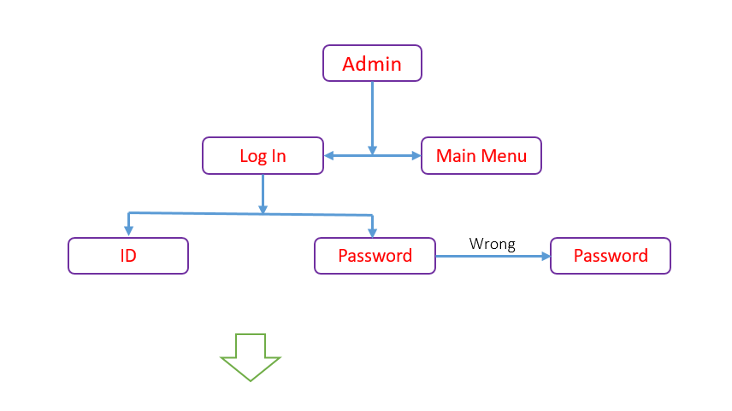

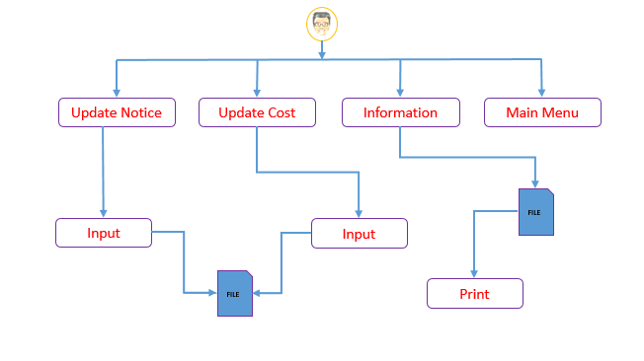

**FLOWCHART OF A PASSENGER**:

