DIGITAL EGYPT PIONEERS INITIATIVE (DEPI) — DATA ANALYSIS TRACK
System Analysis & Design: DFD & Technology Stack
Project Idea 5 (Outstanding): Metropolitan Transportation Authority (MTA) Daily Ridership Analytics & Forecasting

Phase & Milestone  Phase 2: System Analysis & Design | Submission Deadline  November 6 (DEPI Schedule) | Dataset Coverage  March 1, 2020 – October 31, 2024 (1,706 Days) | Data Dimensions  15 Columns (7 NYC Transit Modes)
Primary BI Platform  Microsoft Power BI (Power Query & DAX) | Forecasting & ETL  Python (Pandas), Power BI | Version Control  Git & GitHub Repository | Prepared By  Mohamed Hossam Attya Awad
1. Project Architecture & Dataset Overview
This System Analysis and Design document defines the Technology Stack (Tech Stack) and Data Flow Diagrams (DFD Level 0 & Level 1) for the Metropolitan Transportation Authority (MTA) Daily Ridership project. The dataset tracks systemwide daily estimated ridership and traffic across seven New York transportation agencies—Subways, Buses, Long Island Rail Road (LIRR), Metro-North Railroad (MNR), Access-A-Ride (AAR), Bridges and Tunnels (B&T), and Staten Island Railway (SIR)—alongside each mode's percentage comparison against a comparable 2019 pre-pandemic baseline day.
2. Technology Stack (Tech Stack) Specification
The following technology stack aligns directly with the 4-week project execution roadmap (Data Cleaning, Analysis & Next-Month Forecasting, Interactive Dashboarding, and Final Presentation) and satisfies all DEPI GitHub documentation standards:
Architecture Layer | Selected Tool / Technology | Project Phase | Technical Justification & Specific Deliverable Role
1. Data Source & Schema Layer | Raw CSV Files  (MTA_Daily_Ridership.csv &  MTA_data_dictionary.csv) | Week 1  (Input Data) | Stores 1,706 daily observations across 15 columns (Date + 7 pairs of Total Estimated Ridership and % of Comparable Pre-Pandemic Day) alongside official field metadata.
2. Data Cleaning & Preprocessing (ETL) | Power BI (Power Query / M)  & Python (Pandas, NumPy in Jupyter Notebook) | Week 1  (Cleaning Phase) | Parses ISO dates, validates zero/missing agency records (early LIRR/MNR dates), unpivots the 14 wide transit columns into a normalized Star Schema, and produces the required Week 1 'Data Preprocessing Notebook'.
3. Exploratory Data Analysis & KPIs | Microsoft Power BI  (DAX Measures & Analytical Model) | Week 2  (Analysis Phase) | Answers stakeholder decision-making questions: post-pandemic recovery ratios vs. 2019 baselines, weekday commute vs. weekend leisure patterns, and modal split across NYCT, LIRR, MNR, AAR, B&T, and SIR.
4. Predictive Modeling (Forecasting) | Microsoft Power BI (Analytics Pane & DAX Baseline Forecasting)  (Optional/Secondary: Python Prophet / SARIMA) | Week 2  (Forecasting Task) | Fulfills the core Week 2 requirement ('Predict amount of ridership for the next month') by training time-series models on daily ridership trends and exporting 30-day predictions with 95% confidence intervals.
5. Data Visualization & BI Dashboard | Microsoft Power BI Desktop  (.pbix Interactive Report) | Week 3  (Dashboard Phase) | Builds executive KPI cards, multi-agency recovery trend lines, day-of-week heatmaps, dynamic date/agency slicers, and dedicated next-month forecast views for MTA decision makers.
6. System Design & Wireframing | Draw.io (diagrams.net),  Mermaid.js & Figma / Canva | Phase 2 & Week 4  (Design & Delivery) | Used to design standard Use Case, ERD, and DFD (Level 0 & Level 1) architectural diagrams, dashboard UI wireframes, and the final project summary infographic.
7. Version Control & Collaboration | Git & GitHub Repository  (Markdown Documentation) | Weeks 1–4  (Continuous) | Centralized team repository hosting commented notebooks, DAX scripts, clean datasets, test reports, and README.md setup instructions with clear weekly member commit logs.
8. Reporting & Presentation | Microsoft Word (.docx) &  PowerPoint (.pptx) | Week 4  (Final Delivery) | Produces the formal Software Requirements Specification (SRS), System Design Documentation, User Guide, and Final Executive Presentation deck.

3. Data Flow Diagrams (DFD Architecture)
A Data Flow Diagram (DFD) maps how data moves from external sources through internal transformation processes and data stores to final business stakeholders. Below are both the Context-Level Diagram (Level 0) and the Detailed Process Architecture (Level 1).
3.1 DFD Level 0 — Context Diagram
DFD Level 0 represents the entire MTA Daily Ridership Analytics & Forecasting pipeline as a single high-level process (Process 0.0) interacting with three external entities: the MTA Open Data Portal (raw data provider), the DEPI Data Analysis Team (system designers & analysts), and MTA Decision Makers (executive consumers of the dashboard and monthly forecasts).
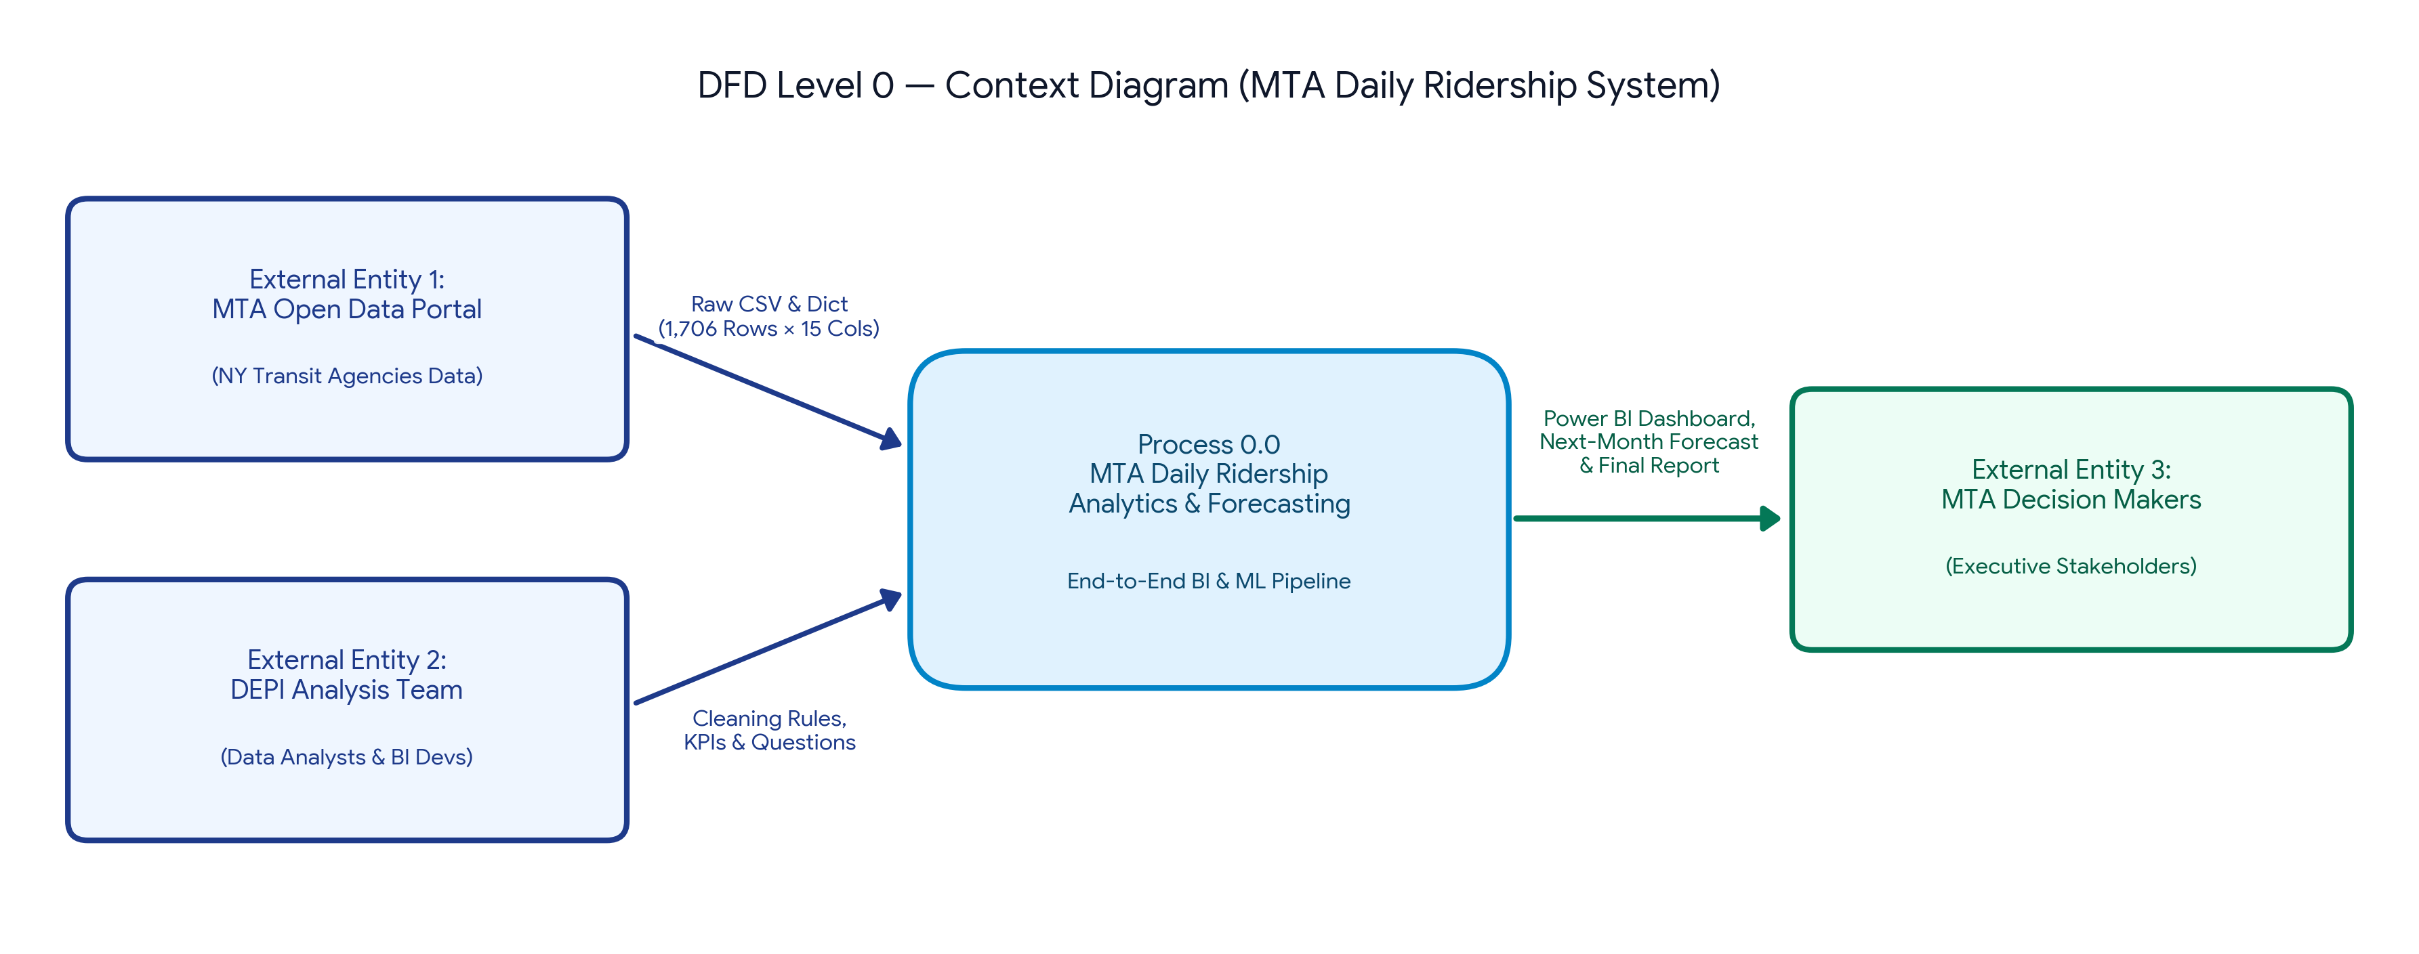
3.2 DFD Level 1 — Detailed System Process Breakdown (Weeks 1 to 4)
DFD Level 1 decomposes Process 0.0 into four sequential operational processes and two structured data stores aligned with the 4-week project plan:
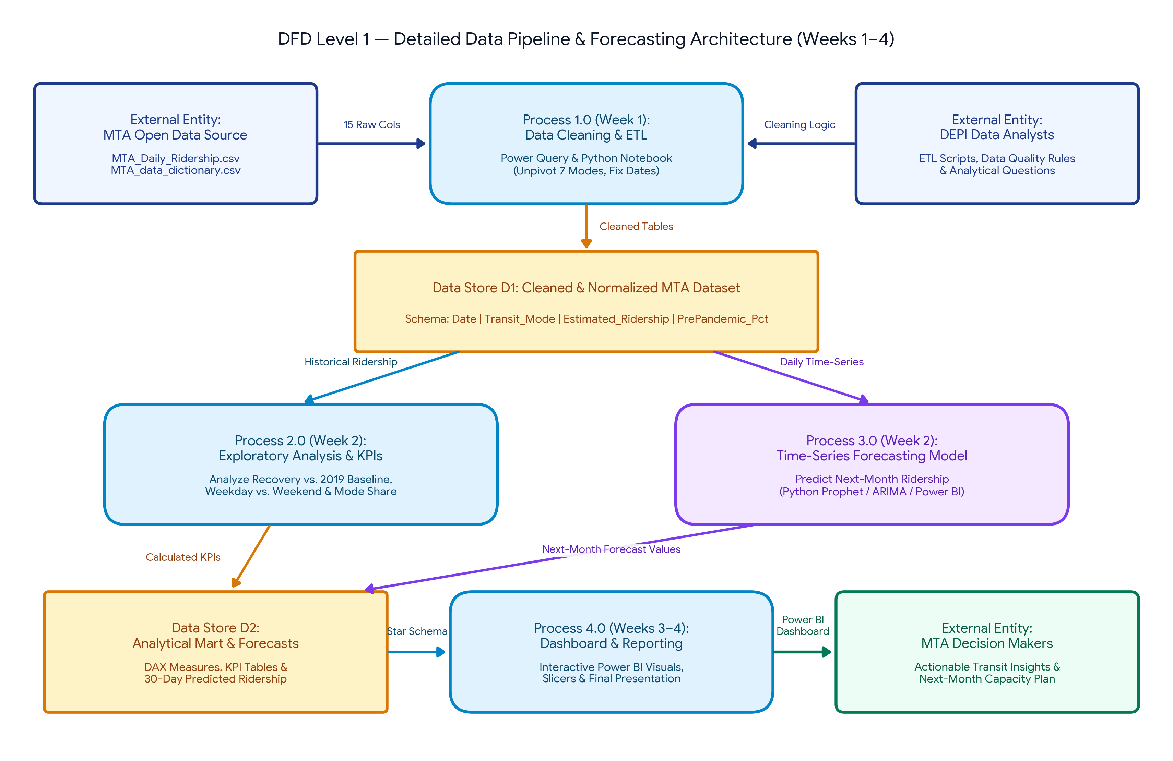
3.3 DFD Level 1 Component Specification Table
DFD Component ID & Name | Component Type | Input Data Flows | Processing Logic / Storage Structure | Output Data Flows
Process 1.0:  Data Cleaning & Preprocessing  (Week 1) | Process | • Raw CSV (1,706 rows × 15 cols)  • Data Dictionary CSV  • Team ETL & Validation Rules | • Convert 'Date' to ISO YYYY-MM-DD  • Handle missing/zero early pandemic values  • Unpivot 7 transit modes into normalized rows  • Export Python Preprocessing Notebook | • Validated & Normalized Records into Data Store D1
Data Store D1:  Cleaned & Normalized MTA Dataset | Data Store | • Validated Records from Process 1.0 | • Fact_Daily_Ridership (Date, Mode_ID, Estimated_Ridership, PrePandemic_Pct)  • Dim_Calendar & Dim_Transit_Mode | • Historical Series to Process 2.0  • Daily Time-Series to Process 3.0
Process 2.0:  Exploratory Data Analysis & KPIs  (Week 2) | Process | • Historical Ridership from D1  • Stakeholder Analysis Questions | • Compute recovery index vs. 2019 baseline  • Compare weekday commute vs. weekend volume  • Rank agency share (Subways, Buses, LIRR, MNR, B&T, AAR, SIR) | • Calculated KPI Metrics & Aggregated Views into Data Store D2
Process 3.0:  Time-Series Forecasting Model  (Week 2) | Process | • Daily Time-Series (2020–2024) from D1  • Model Hyperparameters | • Train Microsoft Power BI (Analytics Pane & DAX Baseline Forecasting)  • (Optional/Secondary: Python Prophet / SARIMA)  • Capture weekly & seasonal transit cycles  • Predict daily ridership for the next 30 days | • Next-Month Ridership Predictions & Confidence Intervals into D2
Data Store D2:  Analytical Mart & Forecast Store | Data Store | • KPI Metrics from Process 2.0  • 30-Day Predictions from Process 3.0 | • Power BI Star Schema Data Model  • DAX Measures Library & Forecast Output Table | • Complete Analytical Model to Process 4.0
Process 4.0:  Power BI Dashboard & Final Report  (Weeks 3 & 4) | Process | • Star Schema & Forecast Model from D2 | • Render interactive Power BI visuals & slicers  • Compile final analytical report & presentation deck | • Interactive Dashboard, Forecast Insights & Final Report to MTA Decision Makers

GitHub Repository Integration Note (DEPI Compliance): To obtain full credit during weekly instructor evaluations, upload this Word document alongside the companion high-resolution DFD diagrams inside your repository's /docs or /design folder with a clear commit message (e.g., docs(phase-2): add system DFD level 0/1 diagrams and tech stack specification).

