DATABASES

“php artisan make:model Post -mfs”

**Migrations**

**Migrate**

* “ php artisan migrate”

**Factory Model**

**Create:** “php artisan make:factory PostFactory –model=Post” (if wo didn’t create it with model)

Used to create dummy rows for the table

* Add “use Illuminate\Support\Str;” to the top
* Change “Post::class;” to “\App\Models\Post::class;”

**QUERY BUILDER**

Add “use Illuminate\Support\Facades\DB;”

Using the builder

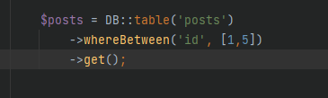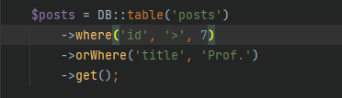

Inserting:



**Queries**

Model::all(): returns all rows.

Model::sum(‘column’): sums the values in this column.

->get(): returns the rows.

->count(): returns the count of the rows.

**Eloquent**

1. First go to the model and mention the table name and the primary key. Graphical user interface, text, application

   Description automatically generated
2. Add ‘use App\Models\ModelName’ to the controller. Text

   Description automatically generated with medium confidence



Selecting all rows :

Using where: