
المملكة العربية السعودية ARABIA SAUDI OF KINGDOM
MINISTRY OF EDUCATION – JAZAN UNIVERSITY جـــــازان جــامـعــة - التعليم وزارة
COLLEGE OF ENGINEERING & COMPUTER SCIENCE الحاسب وعلوم الهندسة كلية
 |  |  |  | MINI-PR BACHELOR IN INFORM  Academic Year: 2025 – 2026 |  |  |  |  | OJECT  ATION TECHNOLOGY  Term: (□First / ☑Second)
Student Name: (1) |  |  | Misaa Alnjjar |  |  |  |  |  |  |  |  | Student ID: (1) |  |  | 202413629
Student Name: (2) |  |  | Rawan Sheani |  |  |  |  |  |  |  |  | Student ID: (2) |  |  | 202413554
Student Name: (3) |  |  | Meaad Yahya |  |  |  |  |  |  |  |  | Student ID: (3) |  |  | 202413633
Student Name: (4) |  |  | Ramah Ibrahim |  |  |  |  |  |  |  |  | Student ID: (4) |  |  | 202413669
Section Number: |  |  |  |  |  |  | Group ID: |  |  |  |  | Start Date: |  |  | 5/2/2026
Course Name: |  |  | Mobile Application Development |  |  |  |  |  |  |  |  | End Date: |  |  | 5/4/2026
Course Code: |  |  | ITEC-343 |  |  |  | Course Level: |  |  | 6 |  | Maximum Marks: |  |  | 15
Marks Summary (15)
Question # |  | Performance Indicator |  |  | Total Marks |  | Obtained Marks
 |  |  |  |  |  |  | Student 1 |  |  |  | Student 2 |  | Student 3 |  |  | Student 4
Q1 |  | PI – (2.1) |  |  | 5
Q2 |  | PI – (3.2) |  |  | 5
Q3 |  | PI – (3.3) |  |  | 5
Teacher’s  Signature |  | Shazia Ali |  |  | 15
 | CLO-PI-SO Mapping
 | CLO IDs |  |  | SO-1 |  | SO-2 |  | SO-3 |  |  |  | SO-4 |  | SO-5 |  | SO-6
 | CLO#01
 | CLO#02
 | CLO#03 |  |  |  |  | PI 2.1
 | CLO#04
 | CLO#05 |  |  |  |  |  |  | PI 3.2, PI 3.3
 | CLO#06
Instructions:
- Include a title page with assignment number, Jazan University logo, student name, student Jazan University ID, teacher name, course name, course code, program name, department and college name.
- Use the required naming convention, typically including your name, course code, and assignment number (e.g., Ali_ITEC-251_Assignment#01.docx).
- Use font Times New Roman, and font size 14 for title page text and make it bold.
- Use font Times New Roman, and font size 12 for rest of the pages. Make headings bold.
- Use 1.5 spacing with 1-inch margins on all sides.
- Include page numbers on each page except the title page.
- Do not leave blank spaces between paragraphs. Avoid very long (1 page) and very short (1-2 sentences) paragraphs. Indent each paragraph.
- Correct all common spelling, and typographical errors (use spell-check).
- Submit the assignment (in this format only) to correct section number on Blackboard in .doc, .docx, or
.pdf format.
ITEC-343/Mobile Application Development/2025-2026/Second Semester Page 1 of 2

SmartShop Mobile Application

Introduction
In recent years, mobile applications have become an essential part of daily life. People use mobile apps for communication, education, entertainment, and shopping. Among these, shopping applications are very popular because they provide convenience and allow users to browse and purchase products easily without visiting physical stores.
This project presents the development of a mobile application called SmartShop using Flutter. The application simulates a simple shopping platform where users can view products, check their details, watch related videos, and access additional information. The project focuses on applying the concepts learned in the Mobile Application Development course in a practical way.

Problem Statement
Traditional shopping methods require time and effort, as users need to visit stores physically. In addition, customers may not have enough information about products before making a purchase decision.
The SmartShop application aims to solve these issues by providing a digital platform where users can:
- Browse products easily
- View detailed information
- Watch videos related to products
- Navigate between sections smoothly

Project Objectives
The main objectives of this project are as follows:
- To develop a mobile application using Flutter
- To design multiple interactive screens
- To display products in an organized and clear format
- To provide detailed information about each product
- To integrate video playback functionality
- To include a web or external content feature
- To create a contact page that includes student and course information
- To apply theoretical knowledge in a practical project

System Overview
The SmartShop application is divided into several main parts. Each part is implemented as a separate screen:
- Home Screen
- Products Screen
- Product Details Screen
- Video Screen
- WebView Screen
- Contact Us Screen
All screens are connected through navigation, allowing the user to move easily between them.

Application Design and Structure
The application is designed using a simple and modular structure. Each screen is written in a separate Dart file to make the code more organized and easier to manage.
Flutter widgets are used to build the user interface. The design focuses on clarity and ease of use, so the user can interact with the application without confusion.
Navigation between screens is implemented using the Navigator class and MaterialPageRoute.

Screenshots of app interface

Home Screen
The Home Screen is the first screen that appears when the application starts. It contains a welcome message and buttons that allow the user to navigate to other screens such as products, videos, website, and contact page.
This screen serves as the main entry point of the application.
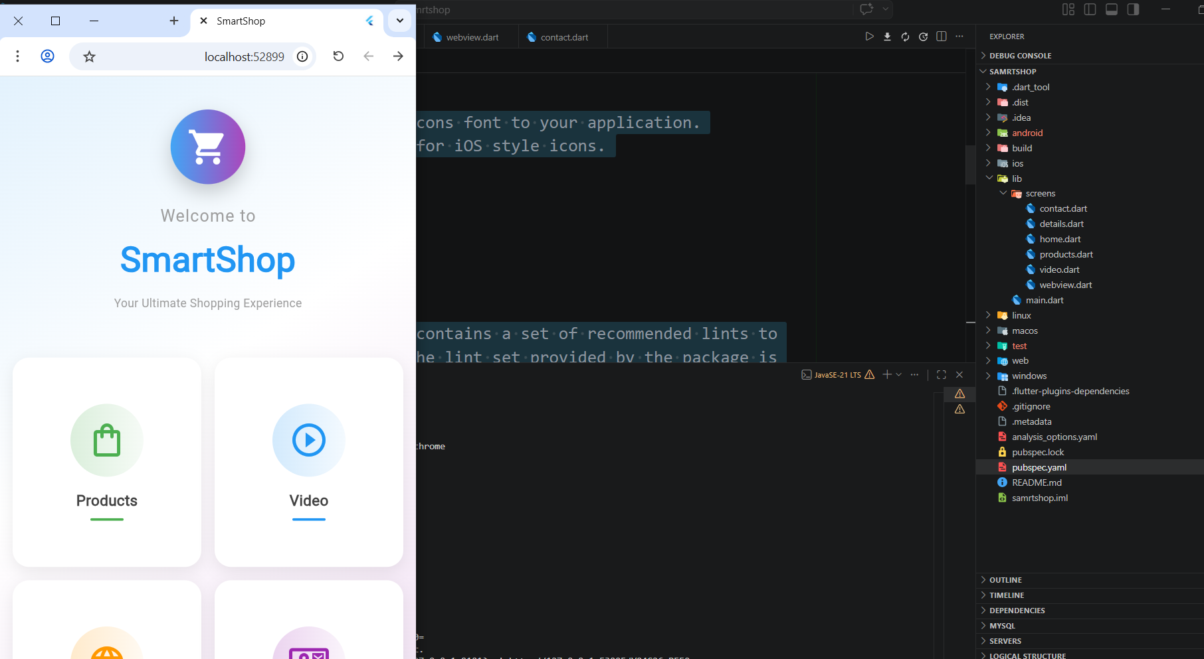

Products Screen
The Products Screen displays a list of products in a grid layout. Each product is shown with an image, name, and price.
This screen allows the user to browse different products easily. When the user selects a product, they are taken to the details screen.
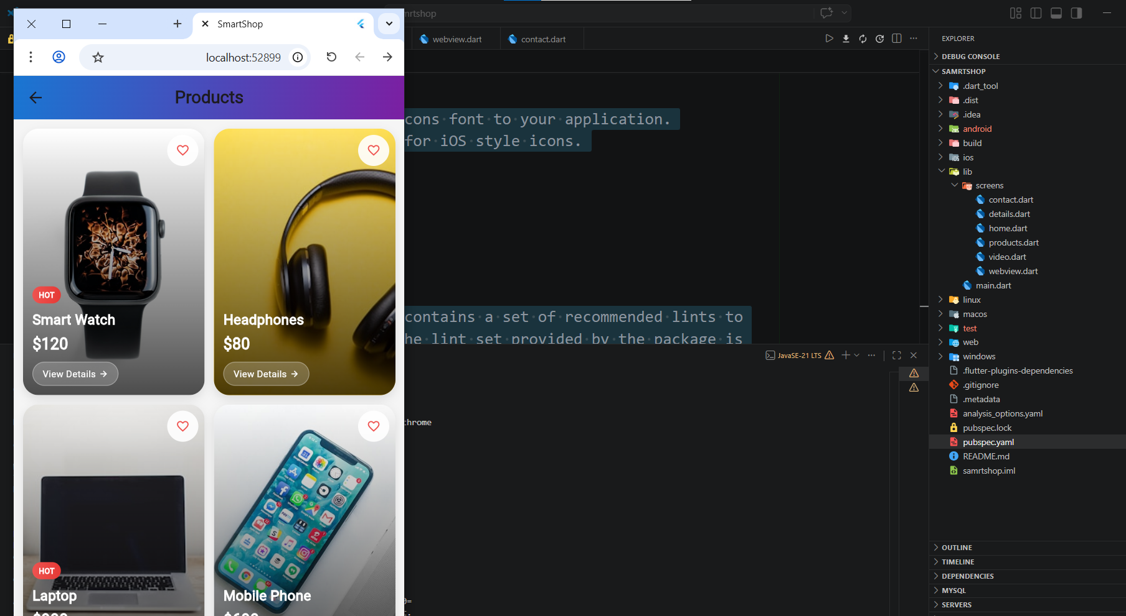

Product Details Screen
The Product Details Screen shows more information about the selected product. It includes a larger image, product name, price, and a short description.
There is also a button labeled "Buy Now" which simulates a purchase action.
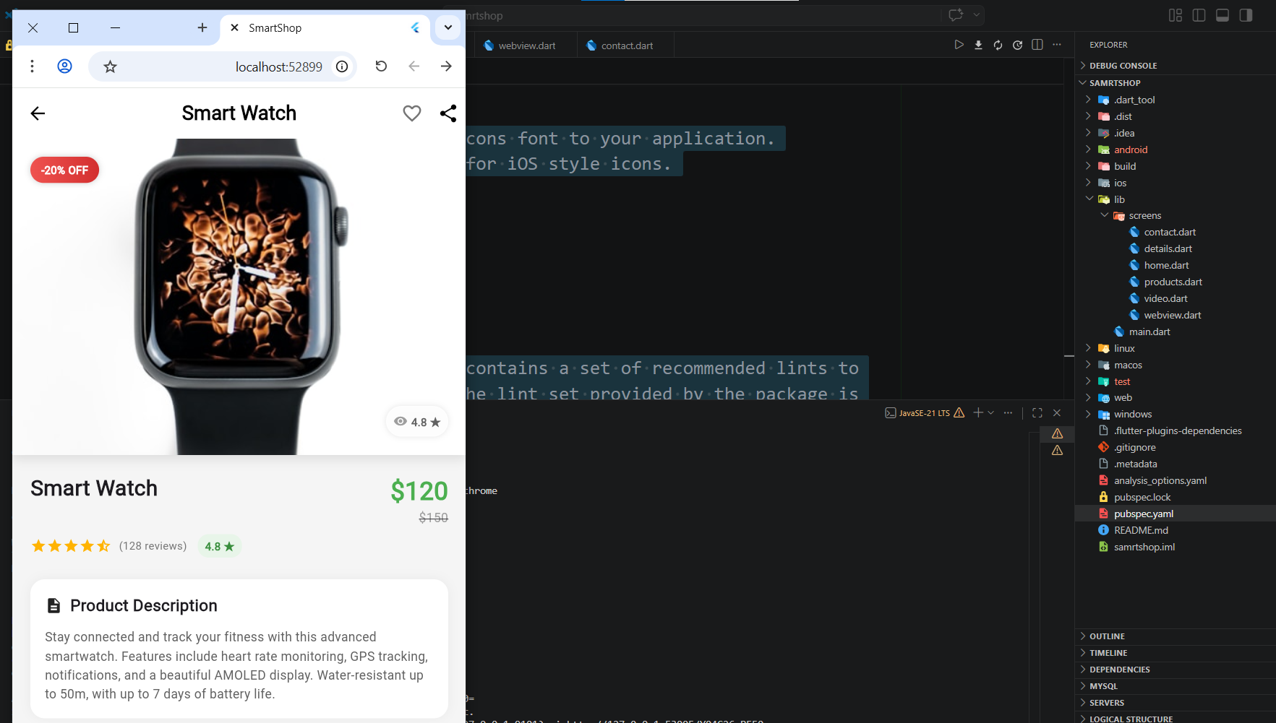

Video Screen
The Video Screen allows the user to watch videos related to the products. The videos are displayed using a video player.
The screen includes:
- A video player
- A loading indicator while the video is loading
- Play and pause controls
- A list of videos that the user can select
This feature improves user understanding of the products.

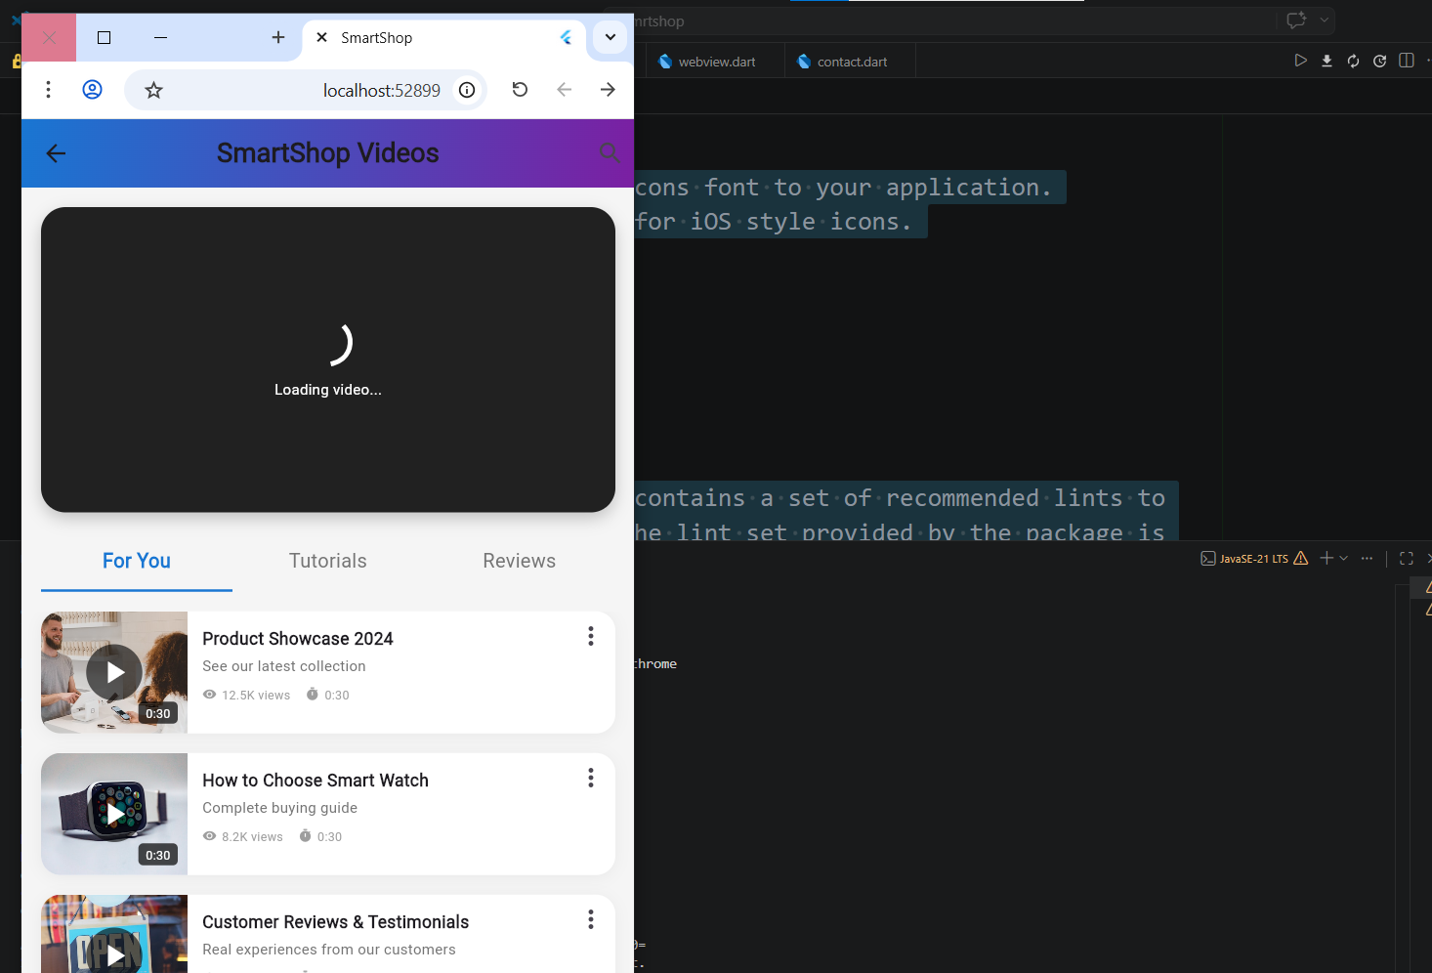

WebView Screen
The WebView Screen is used to display external web content. In some cases, due to environment limitations, a simplified version is used.
This screen demonstrates how mobile applications can integrate web-based information.
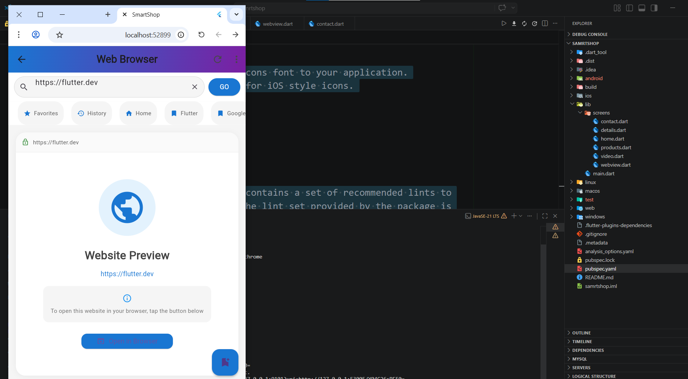

Contact Us Screen
The Contact Us Screen displays information about the students and the course. It includes names, student IDs, course name, and course code.
This screen is required as part of the project instructions.

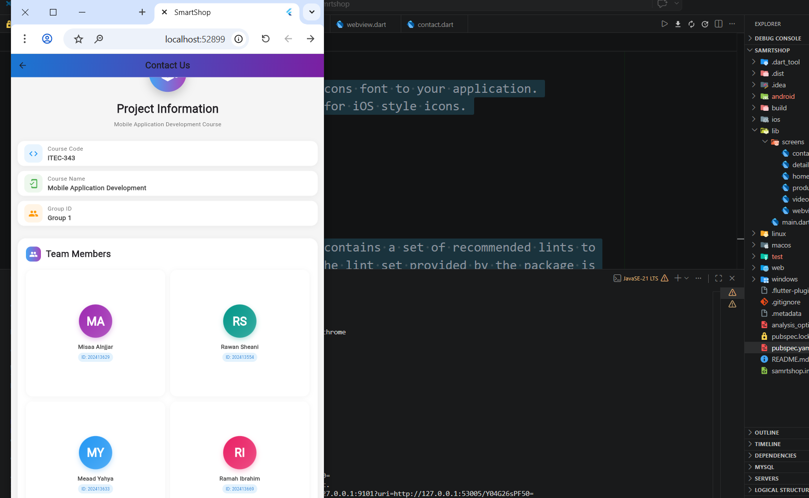

Technologies Used
The application was developed using the following technologies:
- Flutter framework for building the user interface
- Dart programming language
- Material Design components
- video_player package for video playback

Code Snippets

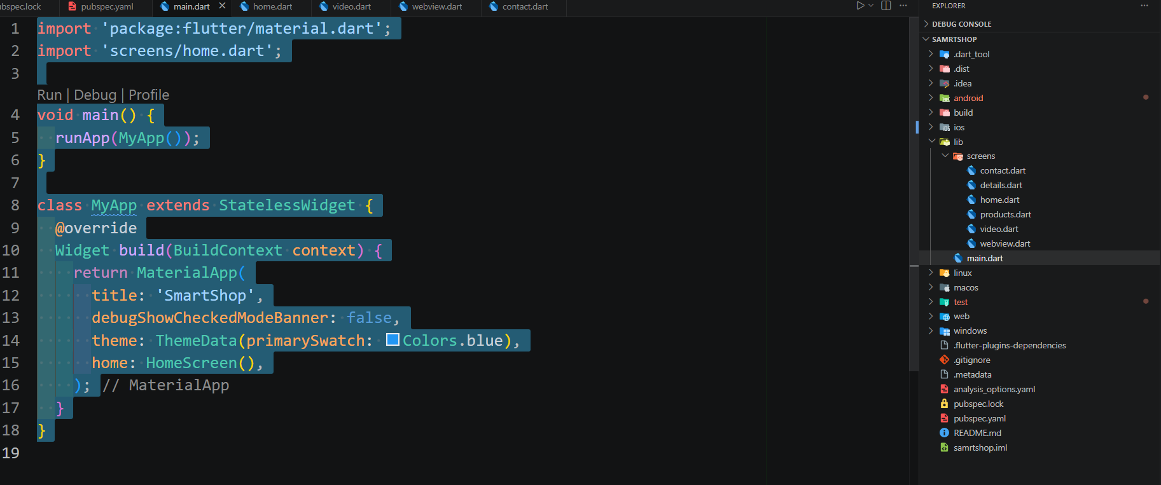

Home Page

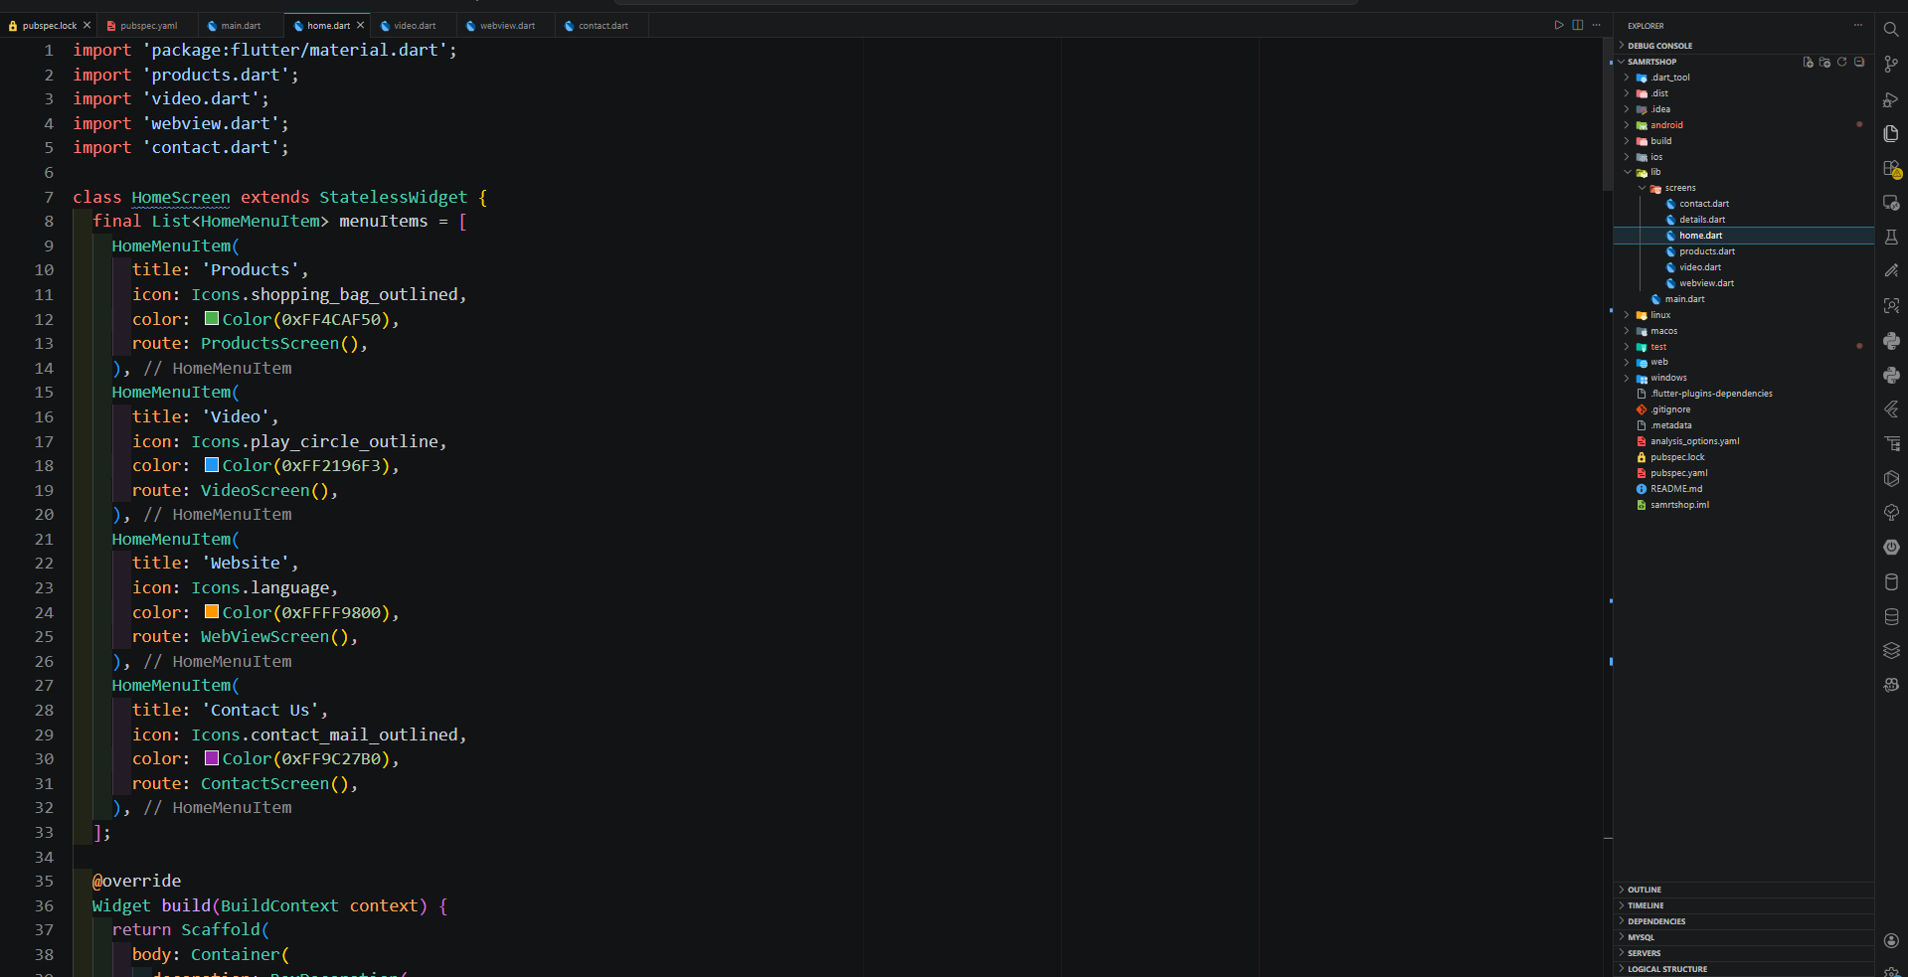

Products Page

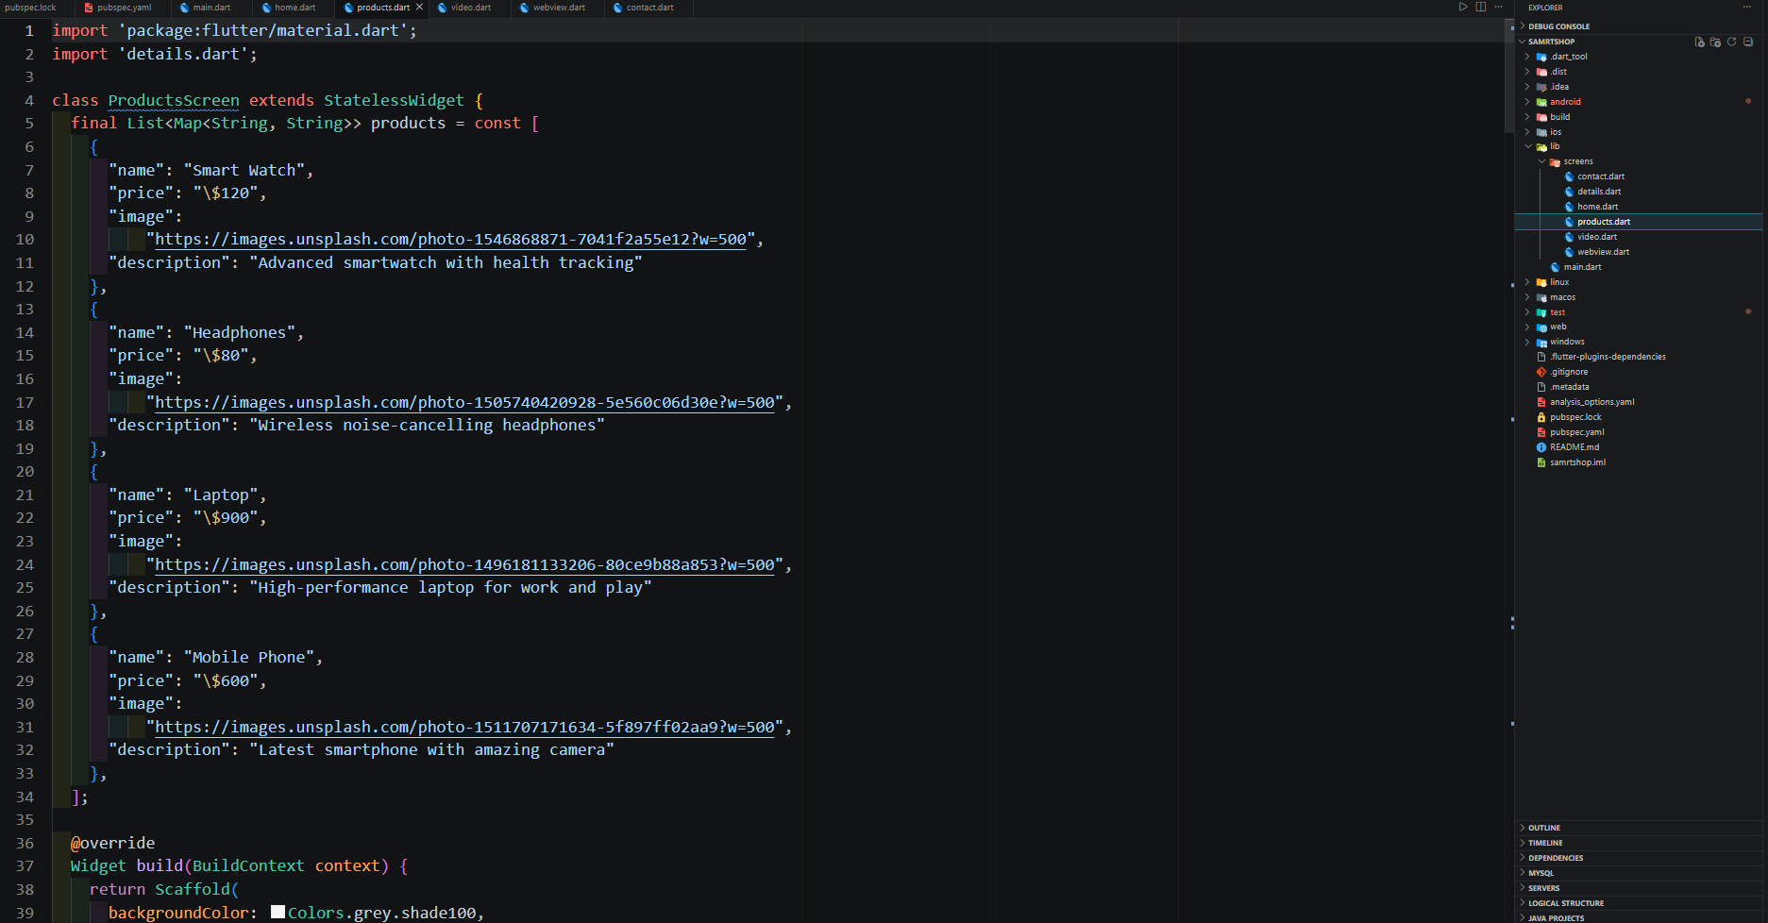

Products Details Page

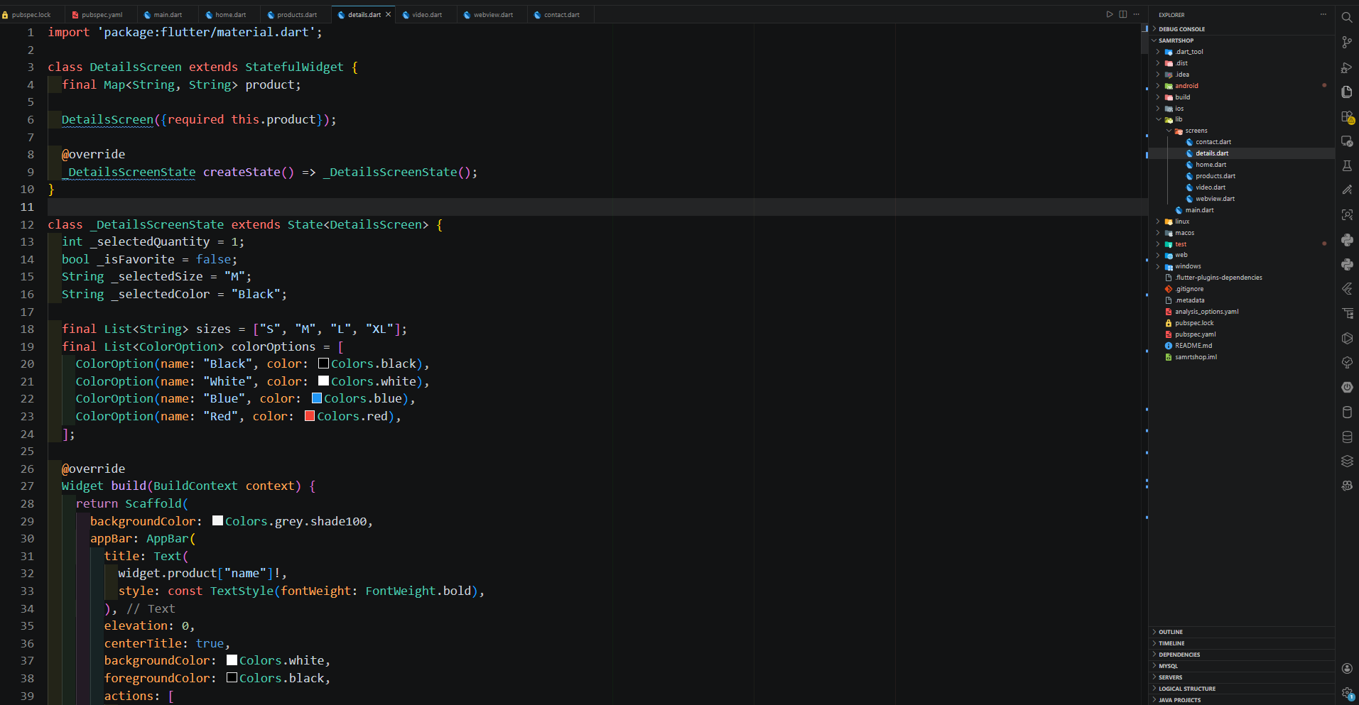

Video Page

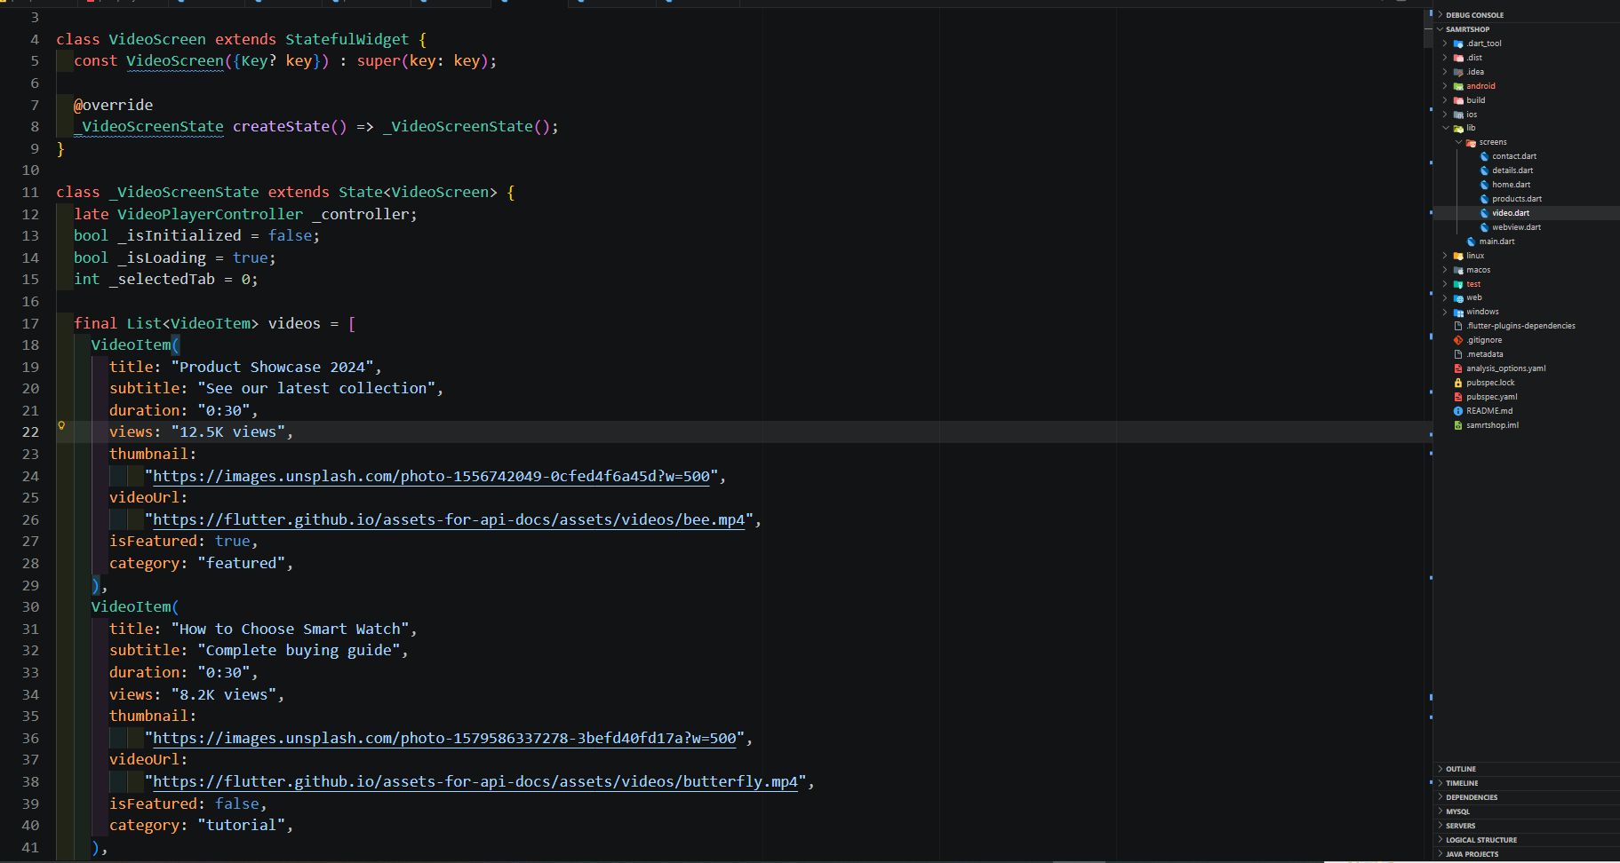

Webview Page

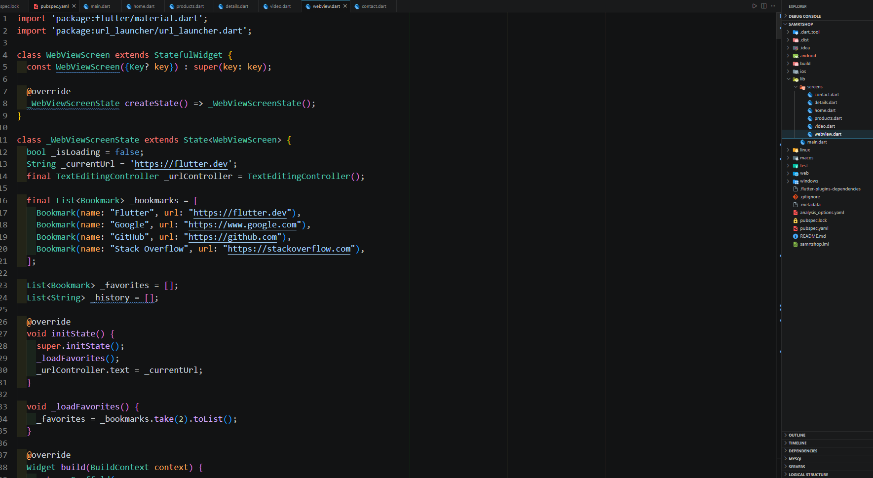

Contact us Page

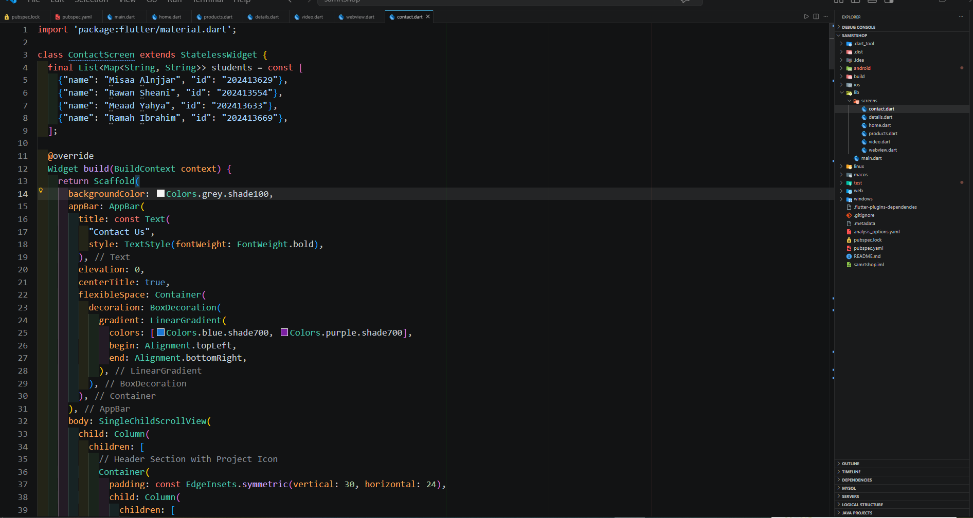

Conclusion
In conclusion, the SmartShop application is a successful implementation of a simple mobile application using Flutter. The project helped in understanding how to design user interfaces, manage navigation, and integrate multimedia features.
It also provided practical experience in building a real application and solving development challenges.

