KINGDOM OF SAUDI ARABIA| JAZAN UNIVERSITY

COLLEGE OF ENGINEERING AND COMPUTER SCIENCE

LAB ASSIGNMENT

Academic Year | 2025-26 | Semester | Second
Course with code | Computer Security and Privacy / COMP–323 | Section | 2221
Type of Assignment | Practical (Home Assignment) | Marks | 10
Date of Announcement | 29-03-2026 | Deadline | 29-04- 2026
Shujoon Ali ‏Almangri 202413327

LAB ASSIGNMENT PROBLEM STATEMENT [CLO 2.4]
- Scan any three IP addresses from your friends group Using the Netdiscover tool. [3 Marks]
sudo netdiscover -r 192.168.1.0/24
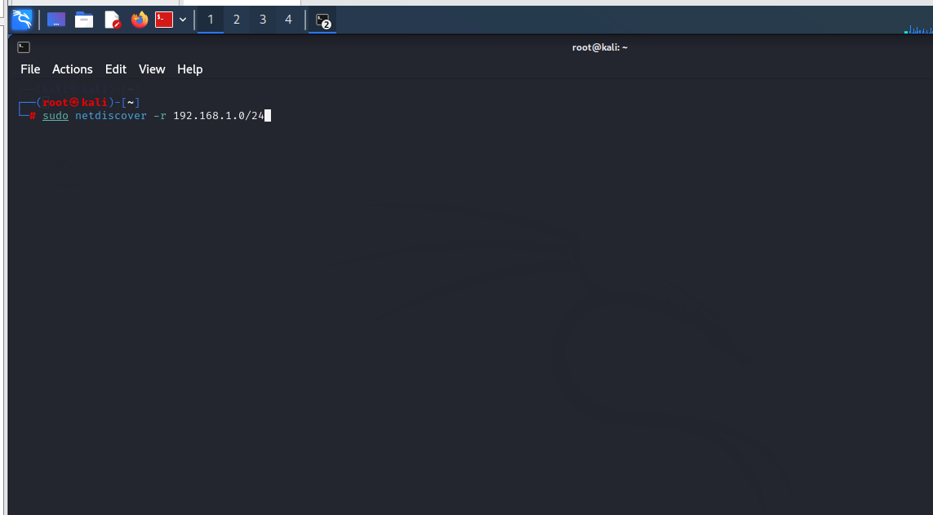
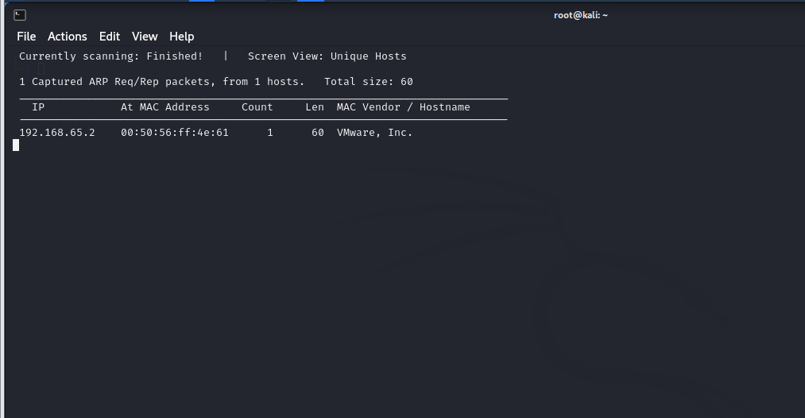

- Use your personal details, such as name and email ID, to generate a full key with a 4096-bit key size and a 1-month validity using the RSA algorithm in the GPG tool.
[3 Marks]
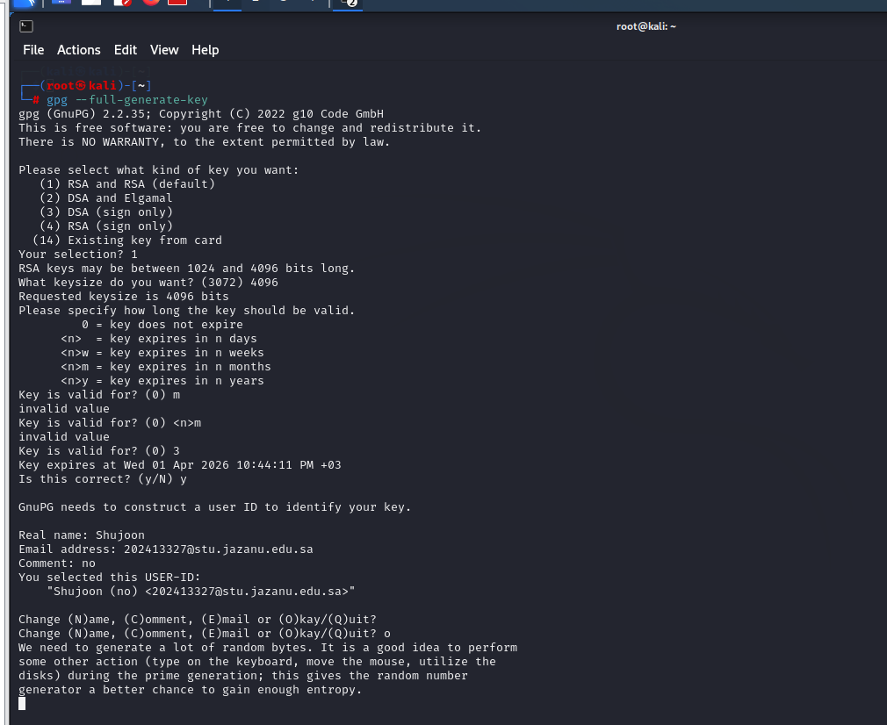
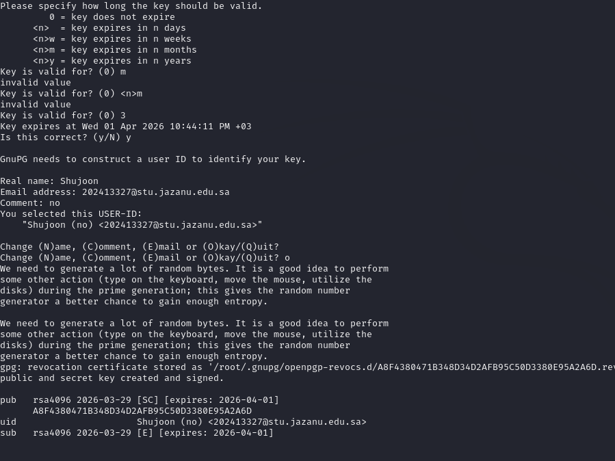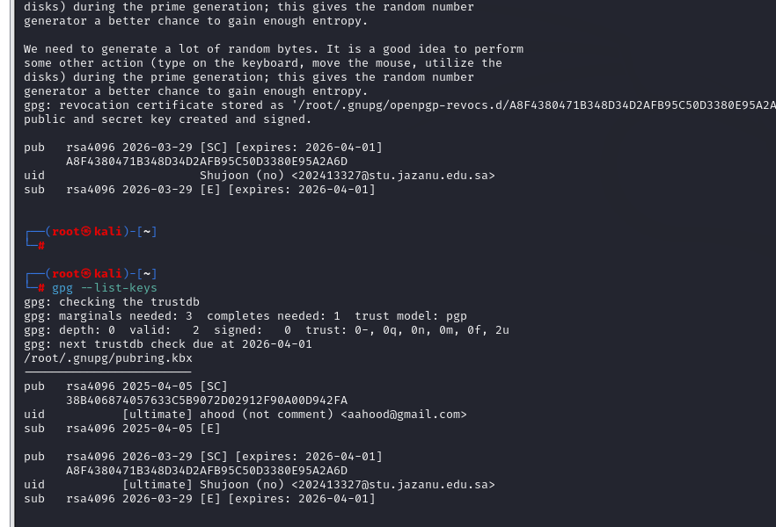

- Create a user account with the name “usr1” and assign the password “123456”. Crack the user account password using the John the Ripper tool in Kali Linux. [2 Marks]
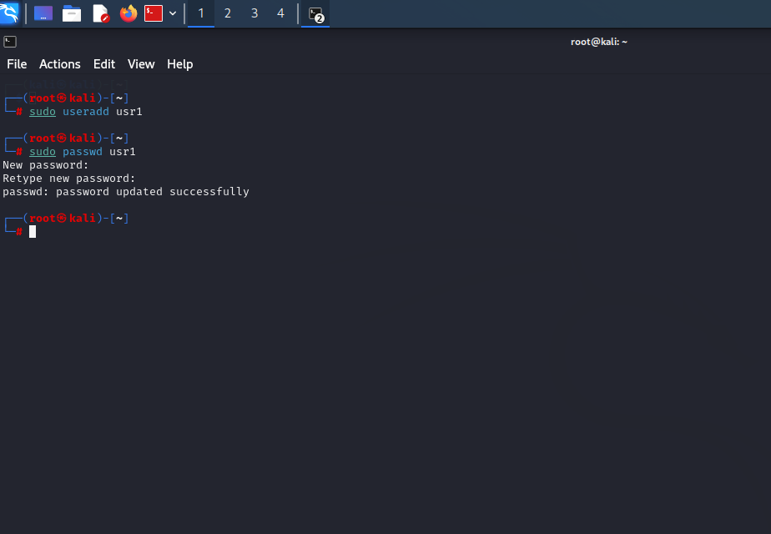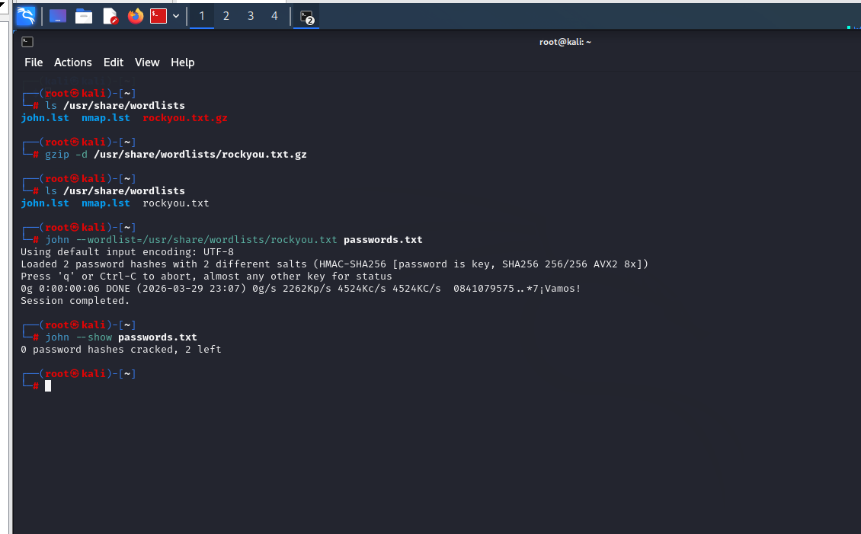

Result:
The password was not cracked successfully using John the Ripper, even with the rockyou wordlist.

Reason:
The system uses a strong hashing algorithm (SHA256/yescrypt), which makes password cracking difficult even for weak passwords like “123456”.

- Create TWO directory with name MIDTERM AND FINAL. Create two files MIDTERM.TXT AND FINAL.TXT inside the directory FINAL.
Copy MIDEXAM.TXT to directory MIDTERM. [2 Marks]

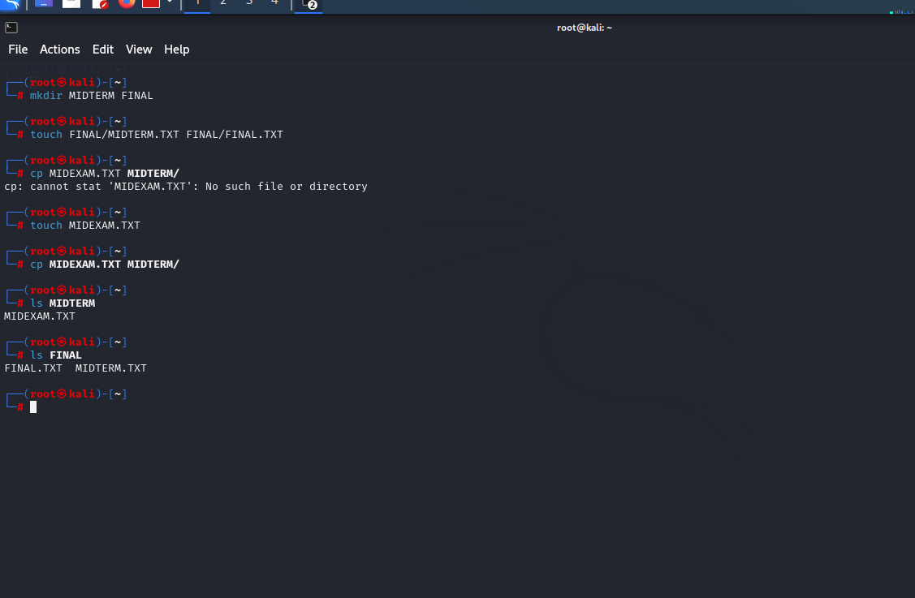

Name of the Course teacher | MS. ANJALI GUPTA | Signature

Note:

            - While providing answers, students have to give the step by step commands and screenshots of each step to show their answers.
            - Submit the assignment on or before the deadline on the Blackboard portal. Late assignment submissions will not be allowed.
            - Students should not copy and paste assignments directly from other students. Assignments will also be evaluated based on plagiarism/cheating, and marks will be deducted if plagiarism/cheating is found.

