1. Script to Find World-Writable Files

Answer:
A world-writable file means others (everyone) have write permission (w).
In Linux, this is dangerous because anyone can modify the file.

Bash Script:
#!/bin/bash
echo "Searching for world-writable files..."
# Search from root directory
find / -type f -perm -002 2>/dev/null
echo "Search completed."

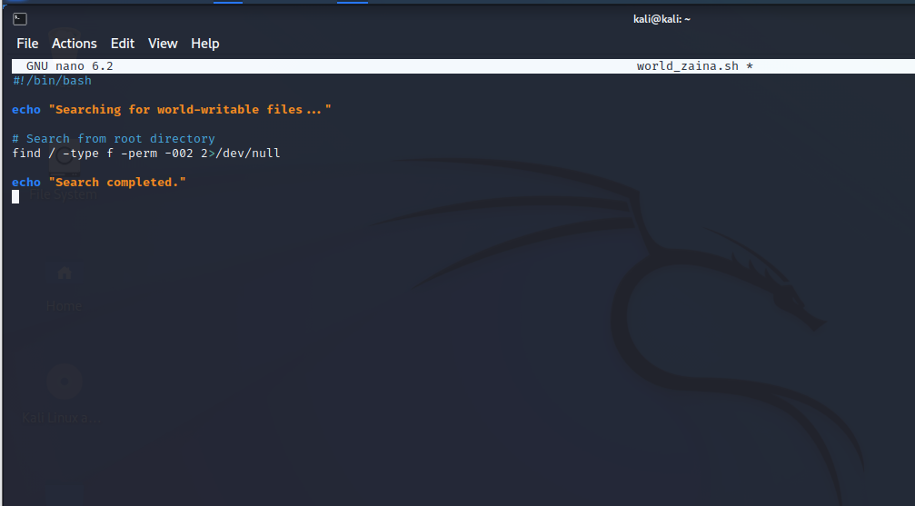
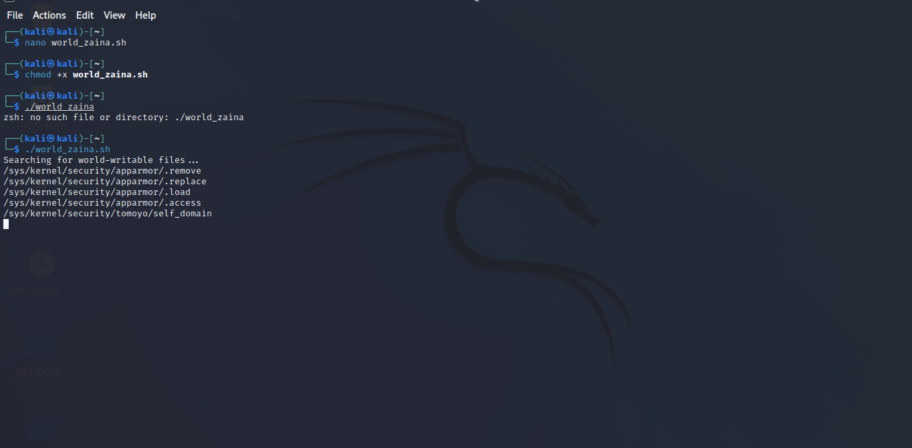
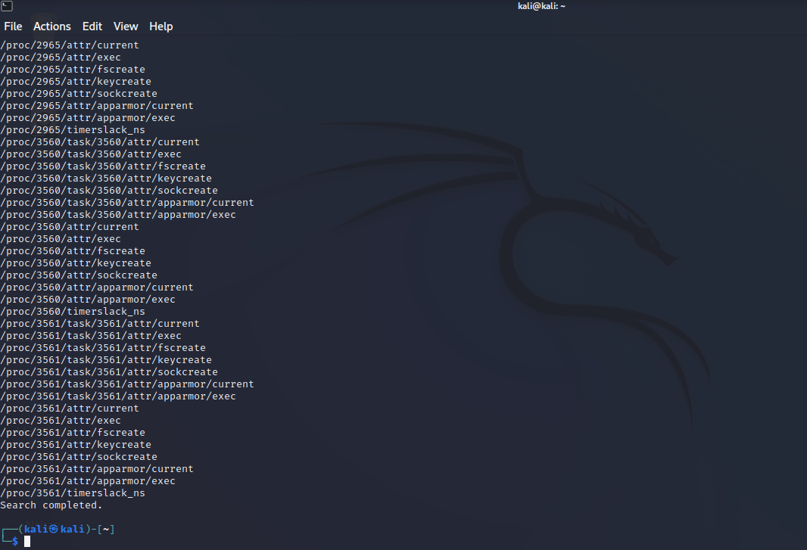

Explanation
- find / → starts searching from the root directory
- -type f → looks for files only
- -perm -002 → finds files where others have write permission
- 2>/dev/null → hides permission denied errors

2. How Windows NTFS Implements DAC

Answer:
Windows NTFS uses Discretionary Access Control (DAC) through something called Access Control Lists (ACLs).

Explanation:
- Every file or folder in NTFS has a security descriptor
- This descriptor contains an Access Control List (ACL)
- The ACL includes multiple Access Control Entries (ACEs)

How it works:
- Each ACE defines:
  - A user or group
  - Their permissions (read, write, execute, full control)
Example:
- User A → Read only
- User B → Full control

Key Idea:
Just like Linux DAC:
- The owner of the file decides who can access it
- Permissions can be granted or removed anytime

Features of NTFS DAC:
- Supports users and groups
- Fine-grained permissions (more detailed than Linux)
- Permissions inheritance from parent folders

Limitation:
- If permissions are set incorrectly → security risk
- Similar to Linux chmod 777 problem

