Flipkart E-Commerce Product
& Pricing Analytics
Project Report
Category: Data Analytics
Field | Detail
Project Title | Flipkart E-Commerce Product & Pricing Analytics
Project Type | Data Analytics (with a bonus text-classification model)
Dataset | Flipkart E-Commerce Sample Dataset (Kaggle)
Dataset Size | ~20,000 product listings, 15 original columns
Tools Used | Python, Pandas, NumPy, Matplotlib, Seaborn, Scikit-learn

1. Introduction
Online marketplaces such as Flipkart host tens of thousands of products across dozens of categories, each with its own pricing and discounting behaviour. Understanding how a catalog is structured, which categories and brands dominate it, and how discounting is applied helps a business team make better assortment, pricing, and promotion decisions. This project performs an end-to-end data analytics study on a real Flipkart product listing dataset to surface these patterns and translate them into actionable business insights.

2. Problem Statement
Given a raw export of Flipkart product listings, the goal is to clean and structure the data, explore pricing and discount behaviour across categories and brands, identify gaps such as missing ratings, and summarise the findings as clear business insights. As a bonus extension, a lightweight machine learning model is built to predict a product's category directly from its product name, demonstrating how text data in the catalog can be used for automated tagging.

3. Dataset Description
The dataset used is the publicly available Flipkart E-Commerce Sample Dataset from Kaggle (PromptCloudHQ/flipkart-products), containing approximately 20,000 product listings crawled from Flipkart. It includes fields such as product name, a nested category tree, retail price, discounted price, brand, product and overall rating, an 'FK Advantage' flag, product description, and product specifications. This dataset is independent of and different from the dataset used in the course masterclass session.
Key columns used in this analysis:
- product_name — the product title, used for keyword analysis and category prediction
- product_category_tree — nested category path, parsed into main and sub category
- retail_price / discounted_price — used to compute discount amount and discount percentage
- brand — used to analyse brand concentration in the catalog
- product_rating / overall_rating — used to analyse rating coverage and distribution
- is_FK_Advantage_product — flag comparing FK Advantage vs regular listings
- description — used to compute description length as a text-richness feature

4. Methodology

4.1 Data Cleaning
- Removed duplicate listings based on the unique product ID
- Parsed the nested product_category_tree field into clean main_category and sub_category fields
- Converted retail_price and discounted_price to numeric, and removed rows with invalid or missing prices
- Removed inconsistent rows where discounted price exceeded retail price
- Converted 'No rating available' text values into proper missing values and added a has_rating flag
- Filled missing brand values with 'Unknown' and normalised the is_FK_Advantage_product flag to boolean
- Engineered discount_amount, discount_percent, description_length and product_name_length features

4.2 Exploratory Data Analysis
After cleaning, 19,922 valid product listings remained. The sections below walk through each analysis performed, along with the corresponding visualization.

5. Analysis & Results

5.1 Category Distribution
Clothing and Jewellery are by far the two largest categories in the catalog, together accounting for nearly half of all listings. This shows the catalog is heavily concentrated in a small number of categories rather than spread evenly.
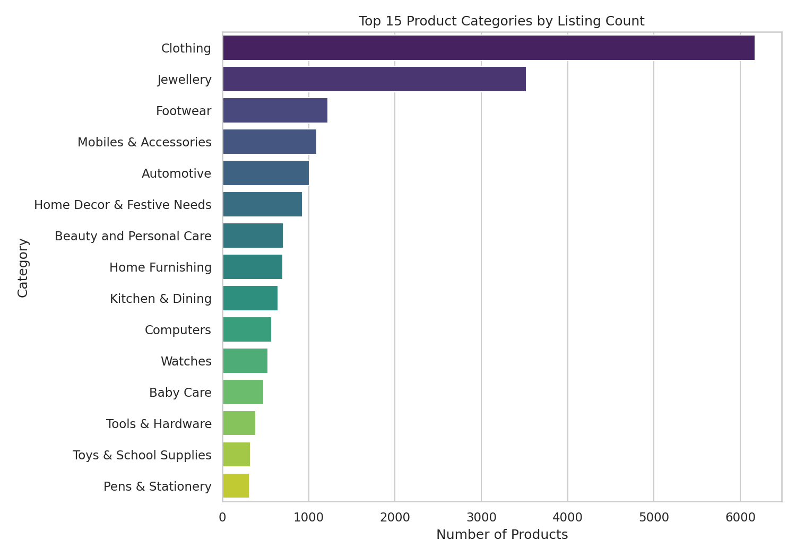
Figure 1: Top 15 product categories by listing count

5.2 Price Distribution
Both retail and discounted prices are right-skewed, with most products priced at the lower end and a long tail of higher-priced items. The discounted price distribution sits consistently to the left of the retail price distribution, confirming that discounting is applied broadly across the catalog.
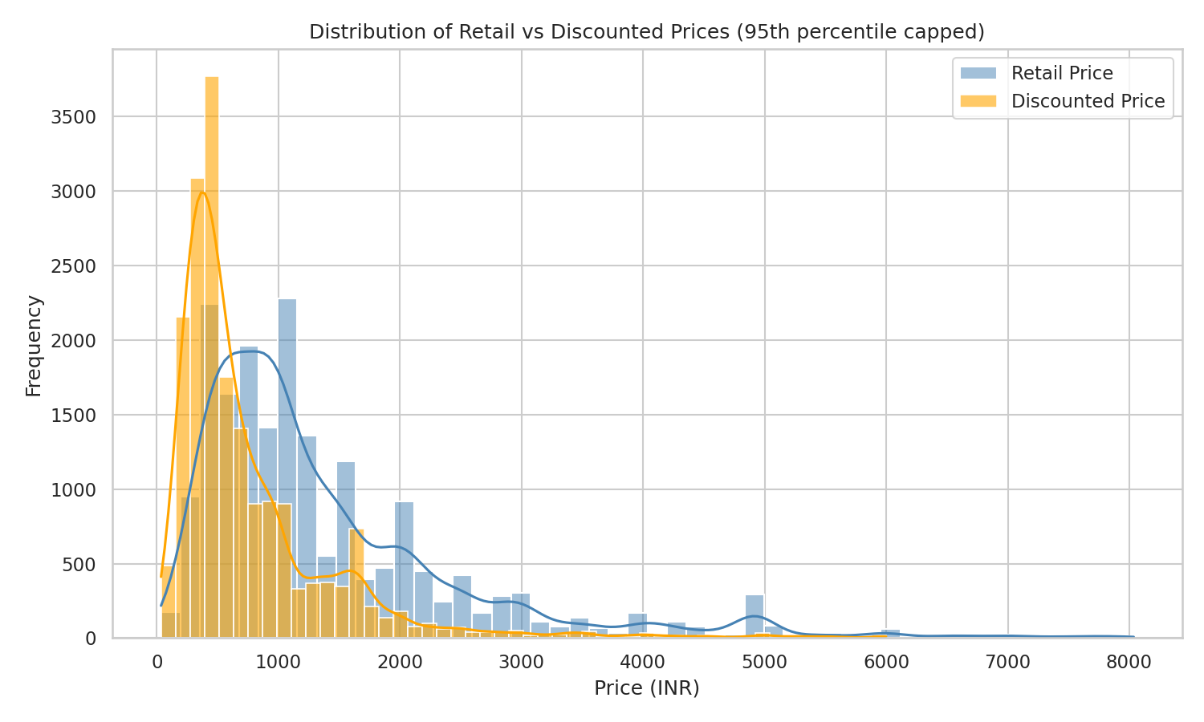
Figure 2: Distribution of retail vs discounted prices (95th percentile capped)

5.3 Discount Percentage by Category
Average discount percentage varies significantly across the top categories. Automotive and Mobiles & Accessories carry the highest average discounts, while other categories are discounted more conservatively. This suggests category-specific promotional strategies rather than a single blanket discount policy.
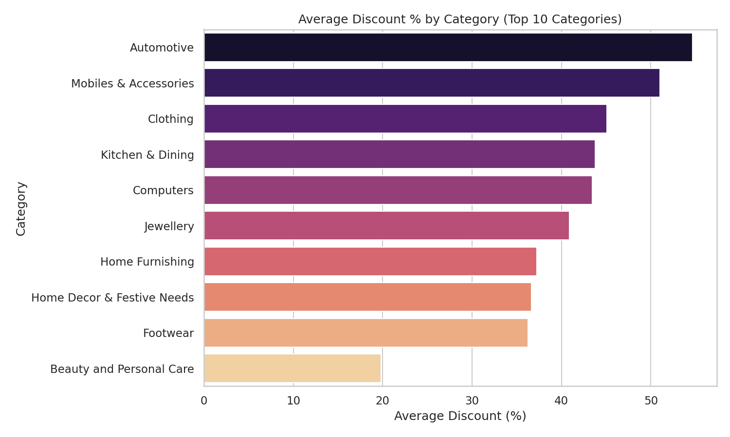
Figure 3: Average discount % by category (top 10 categories)

5.4 Brand Concentration
A relatively small set of brands account for a large share of listings within their categories, with Allure Auto, Voylla, and TheLostPuppy among the most frequently listed brands. This indicates certain brands have built a large catalog footprint on the platform.
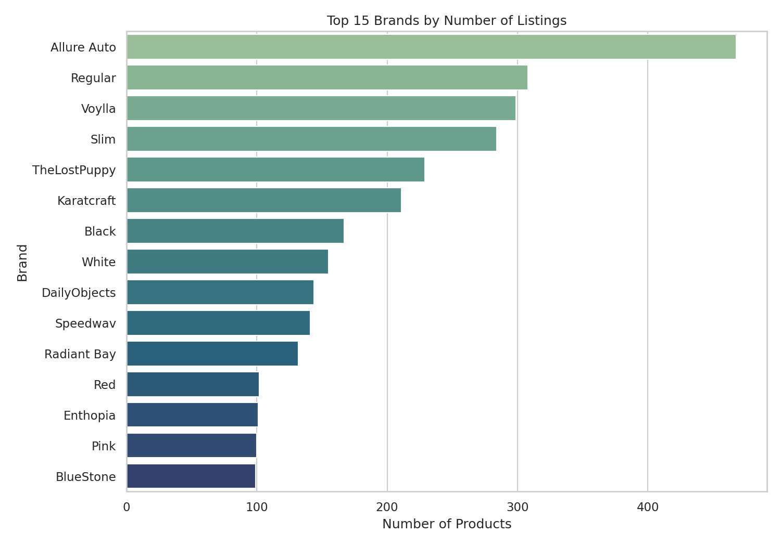
Figure 4: Top 15 brands by number of listings

5.5 Correlation Between Numeric Features
Retail price and discounted price are, as expected, strongly positively correlated. Discount percentage shows a weaker relationship with price, while description and product name length show little correlation with pricing, suggesting listing detail is not directly used to justify pricing decisions.
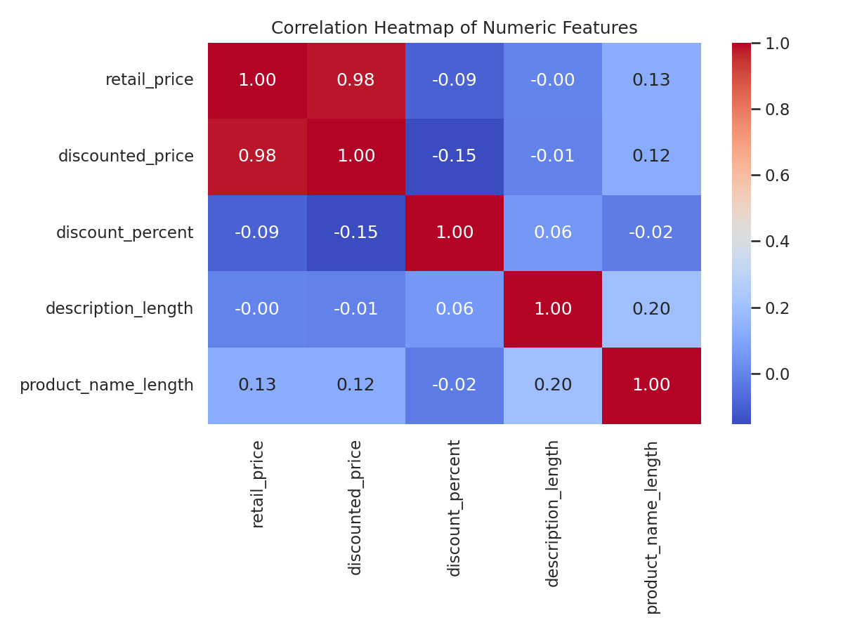
Figure 5: Correlation heatmap of numeric features

5.6 Rating Coverage
Only a small fraction of products in the catalog have received a rating at all, and among rated products, 5-star ratings are the most common. This points to a significant gap in review collection across the catalog.
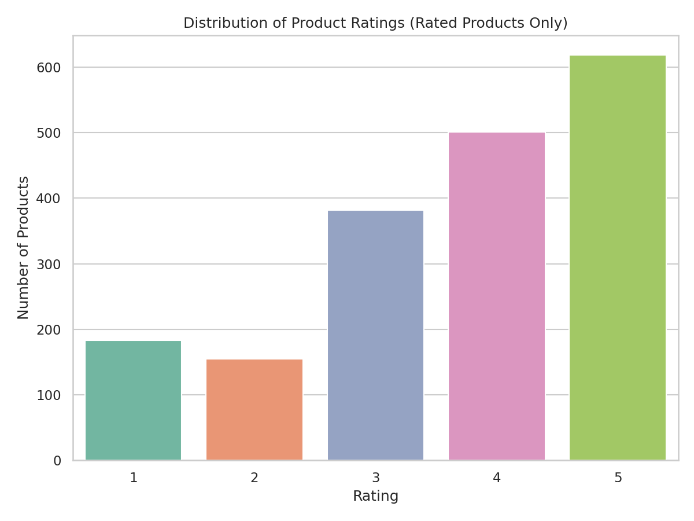
Figure 6: Distribution of product ratings (rated products only)

5.7 FK Advantage vs Regular Products
Regular listings carry a noticeably higher average discount than FK Advantage products. This difference is useful context when evaluating how the FK Advantage program is priced relative to the rest of the catalog.
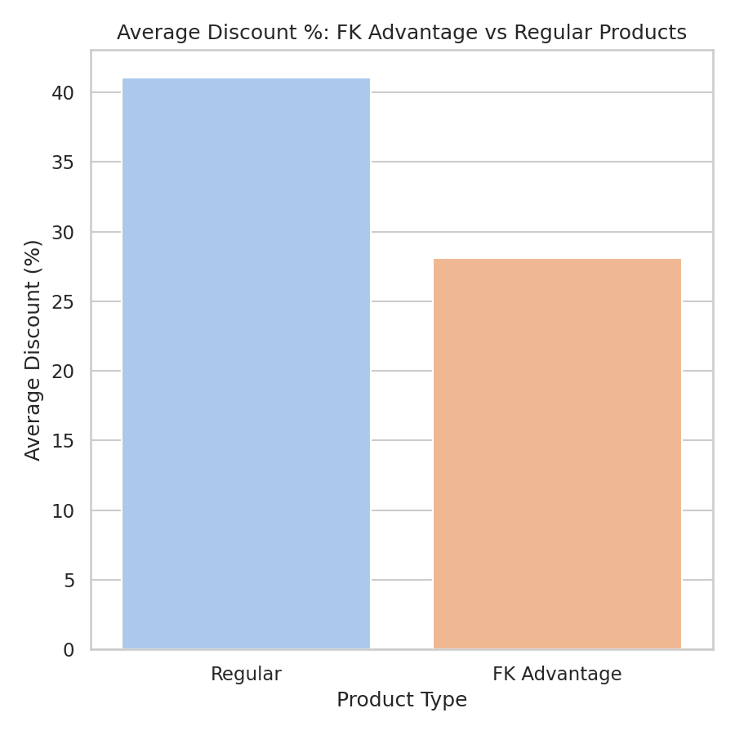
Figure 7: Average discount % — FK Advantage vs regular products

5.8 Common Keywords in Product Names
Analysing word frequency across product names highlights the vocabulary that dominates the catalog, such as 'shirt', 'necklace', 'solid', and 'casual', reflecting the strong presence of clothing and jewellery listings identified earlier.
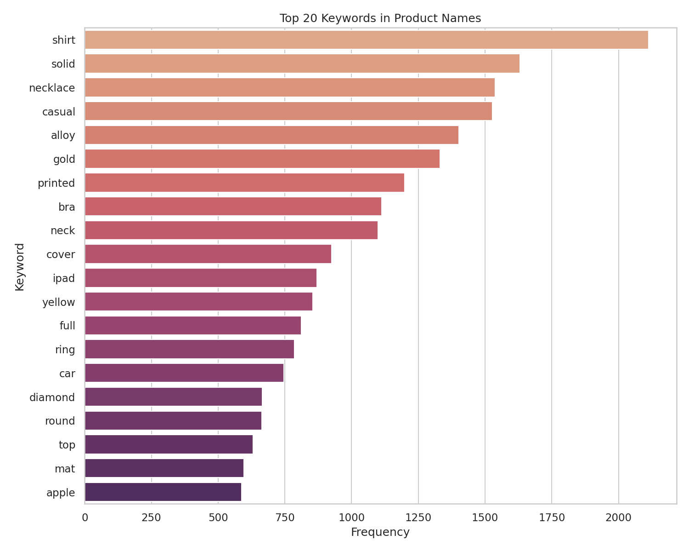
Figure 8: Top 20 keywords in product names

5.9 Price Spread Across Categories
A boxplot of discounted prices across the top categories shows that categories like Computers and Mobiles & Accessories have a wider price spread and higher median prices compared to categories like Jewellery, which is more tightly clustered at lower price points.
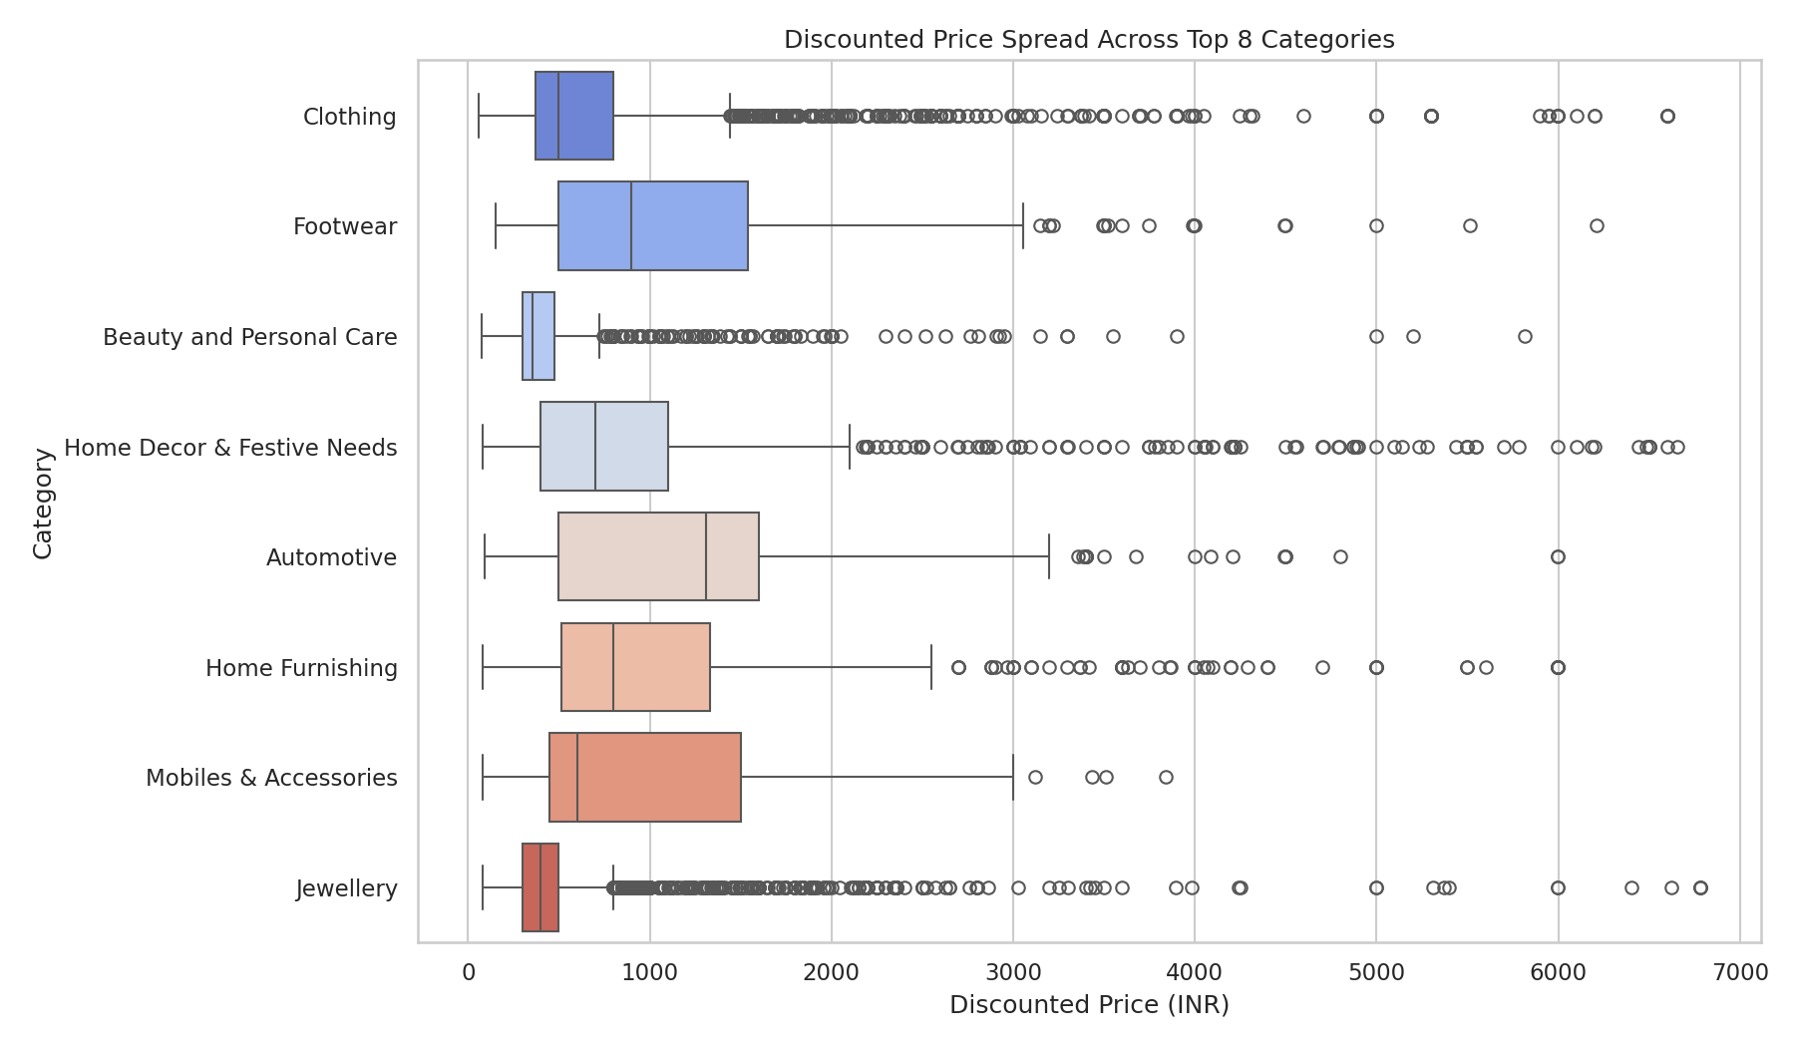
Figure 9: Discounted price spread across top 8 categories

6. Bonus: Category Prediction Model
As an extension beyond pure analytics, a TF-IDF vectorizer combined with a Logistic Regression classifier was trained to predict a product's main category directly from its product name text, using the eight most common categories. This demonstrates how the catalog's text data can support automated tagging and quality checks.
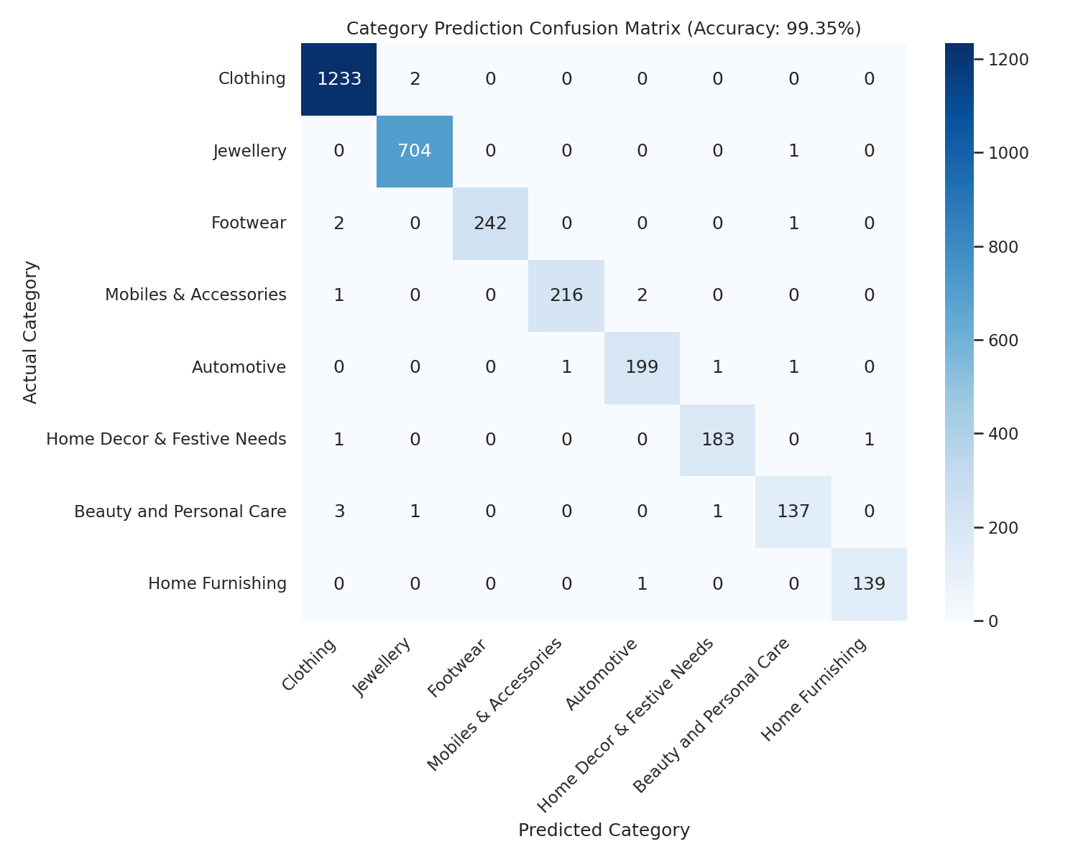
Figure 10: Confusion matrix for category prediction from product name
The model achieved a high test-set accuracy, showing that product names alone carry a strong, learnable signal about a product's category.

7. Business Insights
- Clothing and Jewellery dominate the catalog, together making up a large share of all listings — indicating category concentration and a potential opportunity to diversify inventory.
- Discounting strategy is category-specific: Automotive and Mobiles & Accessories are discounted far more aggressively than the catalog average.
- A handful of brands (Allure Auto, Voylla, TheLostPuppy, and others) account for a disproportionately large number of listings, showing high brand concentration in certain categories.
- FK Advantage products are discounted less aggressively than regular listings, which may reflect a different (potentially premium or curated) positioning for that program.
- The large majority of products carry no customer rating at all, representing a significant gap in review collection that limits customers' ability to make informed purchase decisions.
- Product names alone are strongly predictive of category, meaning simple text models could automate catalog tagging, flag miscategorised listings, or support search relevance improvements.

8. Conclusion
This project cleaned and analysed a real-world Flipkart product catalog to uncover patterns in category concentration, pricing, discounting, brand distribution, and rating coverage. The resulting insights are directly actionable for a marketplace or seller team — from rebalancing category mix and tailoring discount strategy, to closing the review-collection gap and using text-based models to support catalog quality. The bonus category-prediction model further shows that even simple machine learning techniques can extract strong business value from unstructured text already present in the catalog.

