
A
Project presentation on
SalesIQ
M.C.A. Semester-III
KARAN PATEL
(25034211116)
HARSH DARJI
(25034211094)
Guided by
Prof. Narendra Patel
Submitted to
Acharya Motibhai Patel Institute of Computer Studies,
Ganpat University
July - Dec 2026

1. INTRODUCTION
1.1 Project Profile
Project Title | SalesIQ
Project Category | Web Application
Objective | To develop an AI-powered Sales and Inventory Forecasting Dashboard that helps admins and sales staff track sales, manage stock, view real-time analytics, and get smart business suggestions.
Front End | HTML5, Tailwind CSS, JavaScript
Back End | Firebase, Firestore
Tool | Visual Studio Code, Firebase Console, Gemini API
Server | Firebase Cloud Server
Documentation Tool | Microsoft Word, Microsoft PowerPoint
Internal Guide | Prof. Narendra Patel
Developed By | Karan Patel (25034211116)  Harsh Darji (25034211094)
Group No | 21

2. SYSTEM STUDY AND ANALYSIS
2.1 Problem Statement
- Small and medium retail/general stores commonly manage sales, billing and inventory using manual registers, disconnected spreadsheets or basic standalone billing software.
- Admins and owners have no real-time visibility into revenue, stock levels or staff performance unless reports are compiled by hand.
- Low-stock and out-of-stock situations are usually noticed only after a sale is missed, with no way to anticipate demand or plan reorders in advance.
- There is no single connected platform where an Admin and multiple Sales Staff can work together with instantly synchronized sales and stock data.
- SalesIQ aims to design and build a web-based dashboard that centralizes sales, inventory and staff activity, and augments it with AI-based forecasting and business suggestions.
2.2 Existing System
- In the traditional system, sales and stock records are usually maintained manually in notebooks, Excel sheets or separate standalone billing tools.
- Each staff member records sales independently; there is no shared, real-time view of stock or revenue across the business.
- Reports on low-stock products, daily revenue, product performance and staff-wise sales must be compiled by hand.
- There is no automatic forecasting or AI-based suggestion system to support day-to-day decision making.
2.2.1 Drawbacks
- Manual records are error-prone, hard to search, and easily lost or duplicated.
- No real-time synchronization between what staff sell and what the Admin sees on the dashboard.
- Stock updates lag behind actual sales, causing overselling or missed reorders.
- Report generation is slow and depends on manual compilation at the end of the day or week.
- Staff accountability is difficult to track without a centralized, timestamped sales log.

2.2 Proposed System
- SalesIQ provides a single web-based platform where Admin and Sales Staff work from one connected system.
- Sales created by staff or admin are stored in Cloud Firestore and reflected instantly on the dashboard through real-time listeners.
- Product stock is reduced automatically after billing, and low-stock or out-of-stock products are highlighted automatically.
- Stock-finish and reorder forecasts are calculated automatically from sales history (FEFO-aware, per batch), and a Gemini-powered AI insights assistant answers natural-language questions about revenue trends, fast-moving products and expiry risk.
2.2.1 Advantages / Comparison Study
Aspect | Existing System | Proposed System (SalesIQ)
Record keeping | Manual notebooks / Excel sheets | Centralized Firestore database
Data visibility | Delayed, compiled manually | Real-time dashboard for Admin & Staff
Stock updates | Manual, often outdated | Automatic on every sale
Low-stock alerts | Noticed only after stock-out | Automatic, real-time alerts
Reporting | Manual, time-consuming | Instant charts & reports
Forecasting | None | Formula-based stock forecasting + Gemini-powered AI insights chat
Staff accountability | Hard to track | Staff-wise sales history logged automatically

2.2.2 Modules (with short description)
Admin Module
- Register/login; the app is multi-admin — each Admin's products, staff and sales are scoped independently.
- Manage products, inventory, batches, suppliers, purchases, customers, notifications and settings.
- Claim staff who self-register: assign to self, assign by username, bulk-assign, reassign to another Admin, or deactivate/remove.
- View dashboard KPIs, live charts, batch expiry alerts, and ask the AI insights assistant business questions.
Batch & Expiry Module
- Track each purchased batch (supplier, MFG/expiry date, purchased vs. remaining quantity, cost) with an automatic status ladder from Active through Near/Critical Expiry to Expired.
- Print batch labels and export batch reports to CSV.
Disposals Module
- Dispose stock from a batch (Expired, Damaged, Recalled, Lost, Returned, Other); reduces batch and product stock together and logs a disposal record.
Sales Staff Module
- Self-register with a username, then wait for an Admin to assign them before they can sell.
- Create a new sale by selecting a product, entering quantity and payment mode; stock reduces automatically on completion.
- View available stock, check own sales history and create customer billing entries.

3. DEVELOPMENT ENVIRONMENT
3.1 Hardware Requirement
Server Side
RAM | 8 GB (Minimum), 16 GB (Recommended)
Processor | Intel i3 or higher
Internal Storage | 1 TB (Minimum)

Client Side
RAM | 4 GB (Minimum)
Processor | Dual core or higher
Internal Storage | 100 MB (Minimum)

3.2 Software Requirement
Server Side
Operating System | Windows 10/11
Web server | Visual Studio Code, Firebase Console
Front end | Html, tailwind css, javascript vanilla
database | firestore

Client Side
Browser | Chrome, Brave, Safari, Edge
Operating System | Windows 10/11 or any compatible

3.3 Programming Environment
Server Side
Firebase Cloud Server hosts the application and the Firestore database.
Client Side
Any modern browser (Chrome, Brave, Safari, Edge) running on desktop or mobile.
Development is done in Visual Studio Code with the Firebase CLI and Firebase Console for configuration, rules and monitoring.
3.3.1 About Front-End
- HTML5 is used for the page structure and semantic markup of the dashboard.
- Tailwind CSS provides a responsive, utility-first design system used consistently across all dashboard views.
- JavaScript (vanilla) drives interactivity, real-time chart updates and Firestore listener handling.
- A charting library (e.g. Chart.js) renders animated, real-time revenue and sales visualizations on the dashboard.
3.3.2 About Back-End
- Firebase Authentication handles Admin and Sales Staff login and role-based access.
- Cloud Firestore acts as the real-time NoSQL database for Admin, Staff, Product, Batch and Sales records.
- Firebase Hosting deploys and serves the web application from Firebase's cloud server.
- The Gemini API (Llama 3.1/3.3 and Gemma2 models) powers an AI insights chat that answers business questions from the stored sales, batch and disposal data. Stock-finish and reorder forecasts are computed separately with a deterministic average-daily-sales / FEFO formula.

4. SYSTEM DESIGN AND DEVELOPMENT
4.1 USER MODELING LANGUAGE DIAGRAMS
4.1.1 Flowchart
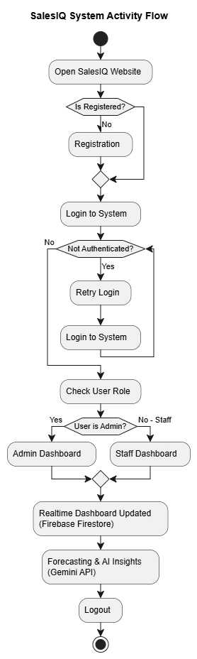

4.1.2 Use-Case Diagram

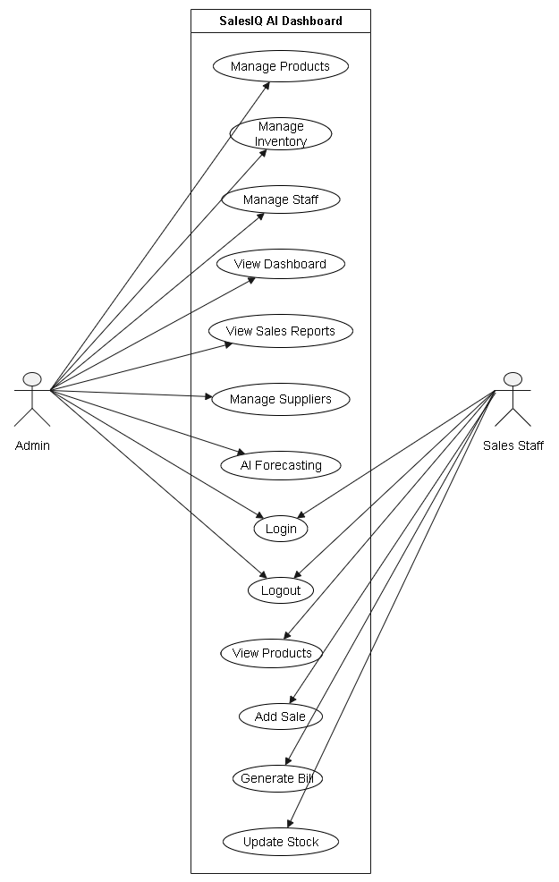
4.1.3 Activity Diagram – Admin
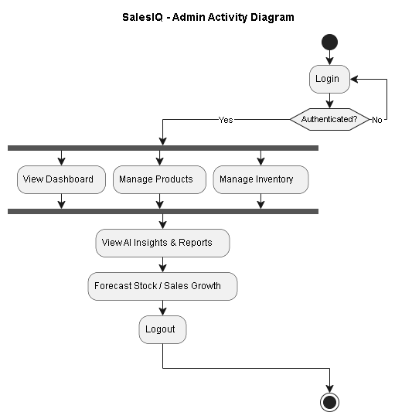

4.1.3 Activity Diagram – Sales Staff
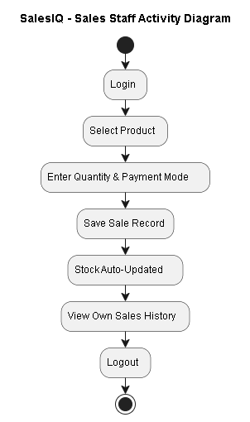

4.1.4 Sequence Diagram – Admin
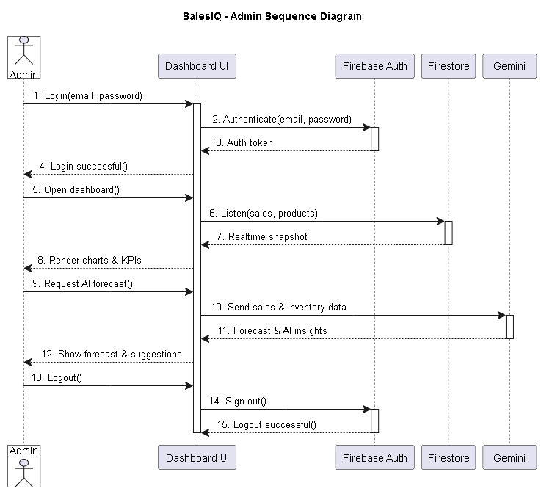
4.1.4 Sequence Diagram – Sales Staff
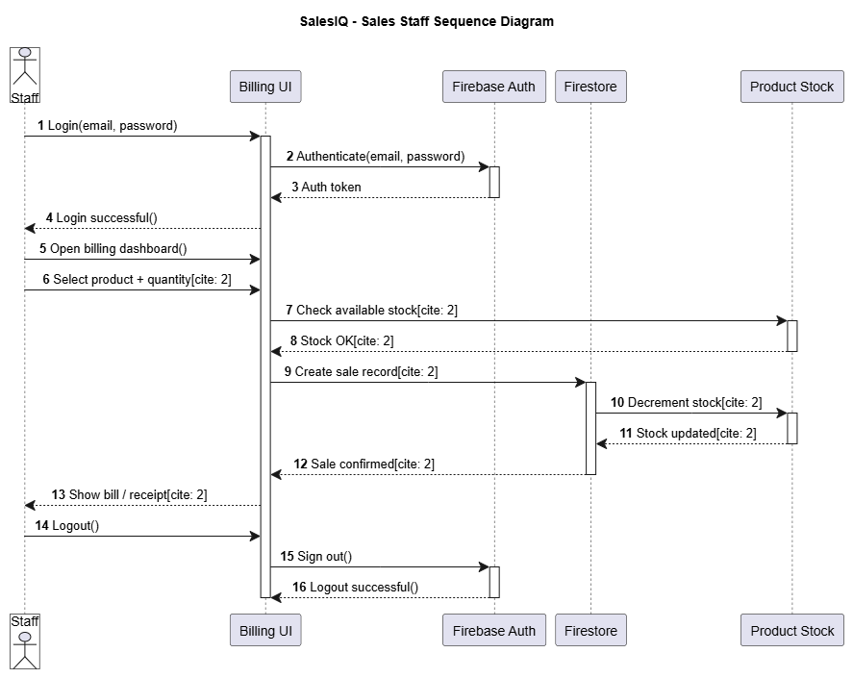
4.1.5 Deployment Diagram
Note: dashed association lines represent deployment/communication paths between nodes.
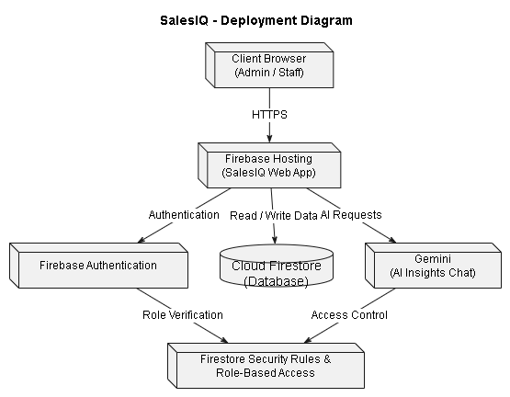

4.1.6 Class Diagram
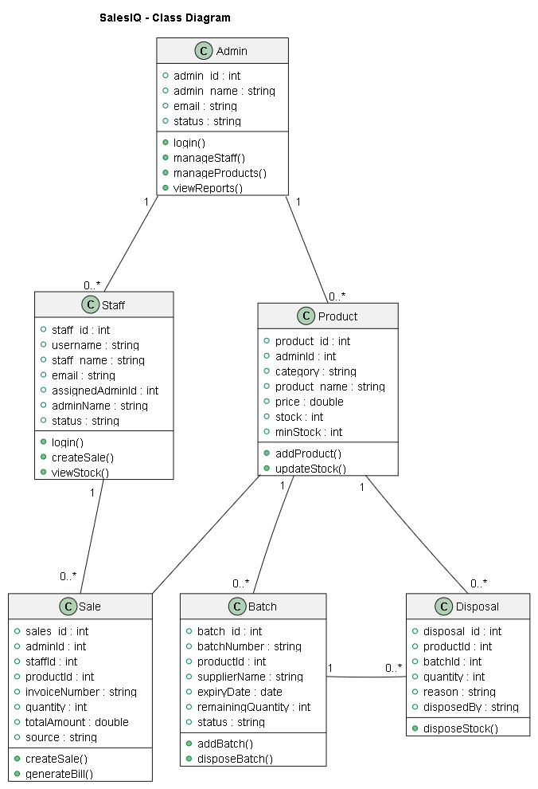

4.2 DATA DICTIONARY
1. Admins
Primary Key :- admin_id
Table Description :- Represents Admin details.
Sr.No | Field Name | Data Type | Constraint | Description
1 | admin_id | String | Primary Key | Unique identifier.
2 | Admin_name | String | Not Null | Stores admin name.
3 | E-mail | String | Not Null | Stores admin e-mail.
4 | Status | Boolean | Not Null | Status of the admin: Active or Not-Active.

2. Staff
Primary Key :- staff_id
Foreign Key :- assignedAdminId
Table Description :- Represents Sales Staff details. Staff self-register and stay pending until an Admin assigns them.
Sr.No | Field Name | Data Type | Constraint | Description
1 | staff_id | ObjectId | Primary Key | Unique identifier.
2 | username | String | Not Null, Unique | Login username, used by Admin to assign staff.
3 | staff_name | String | Not Null | Stores staff name.
4 | E-mail | String | Not Null | Stores staff e-mail.
5 | assignedAdminId | Object | Foreign Key (nullable) | Admin this staff is assigned to; empty while pending.
6 | adminName | String | Nullable | Denormalized name of the assigned admin.
7 | status | String | Not Null | pending_assignment, active, or inactive.
8 | assignedAt | Timestamp | Nullable | When the staff was assigned to an admin.

3. Products
Primary Key :- product_id
Foreign Key :- adminId
Table Description :- Represents product details, scoped per Admin.
Sr.No | Field Name | Data Type | Constraint | Description
1 | product_id | ObjectId | Primary Key | Unique identifier.
2 | adminId | Object | Foreign Key | Owning admin — products are scoped per admin.
3 | category | String | Not Null | Stores the category of the product.
4 | product_name | String | Not Null | Stores product name.
5 | price | Double | Not Null | Selling price.
6 | stock | Int | Not Null | Total stock across all batches.
7 | minStock | Int | Not Null | Threshold used to flag “Low Stock”.

4. Product Batches
Primary Key :- batch_id
Foreign Key :- adminId, productId
Table Description :- Represents a purchased batch of a product, with expiry / FEFO tracking.
Sr.No | Field Name | Data Type | Constraint | Description
1 | batch_id | ObjectId | Primary Key | Unique identifier.
2 | batchNumber | String | Not Null | Human-readable batch number, printed on labels.
3 | productId | Object | Foreign Key | Stores id of product.
4 | supplierName | String | Nullable | Supplier this batch was purchased from.
5 | manufactureDate / expiryDate | Date | Not Null | Used to compute batch status (Active → Upcoming → Near → Critical → Expired).
6 | purchasedQuantity | Int | Not Null | Quantity originally received.
7 | remainingQuantity | Int | Not Null | Quantity left to sell; reduced by sales/disposals.
8 | purchasePrice | Double | Not Null | Cost price, used for batch stock value.
9 | status | String | Not Null | Active, Disposed, or Empty (expiry-based statuses are computed, not stored).

5. Sales
Primary Key :- sales_id
Foreign Key :- adminId, staffId, productId
Table Description :- Represents a sale / billing record.
Sr.No | Field Name | Data Type | Constraint | Description
1 | sales_id | ObjectId | Primary Key | Unique identifier.
2 | adminId | Object | Foreign Key | Owning admin — sales are scoped per admin.
3 | staffId | Object | Foreign Key (nullable) | Staff who made the sale; null for admin billing.
4 | productId | ObjectId | Foreign Key | Reference to product sold.
5 | invoiceNumber | String | Not Null | Printed on the customer bill.
6 | quantity | Int | Not Null | Units sold.
7 | totalAmount | Double | Not Null | Sale value.
8 | source | String | Not Null | staff, admin, or dummy (demo data generator).

6. Disposals
Primary Key :- disposal_id
Foreign Key :- productId, batchId
Table Description :- Represents stock written off from a batch — expired, damaged, recalled, lost or returned.
Sr.No | Field Name | Data Type | Constraint | Description
1 | disposal_id | ObjectId | Primary Key | Unique identifier.
2 | productId | Object | Foreign Key | Reference to product.
3 | batchId / batchNumber | Object / String | Foreign Key | Reference to the batch disposed from.
4 | quantity | Int | Not Null | Units disposed.
5 | reason | String | Not Null | Expired, Damaged, Recalled, Lost, Returned or Other.
6 | remarks | String | Nullable | Free-text note.
7 | disposedAt / disposedBy | Timestamp / Object | Not Null | When and by which admin the disposal was recorded.

4.3 Input Design
Signup page:- New user creation page
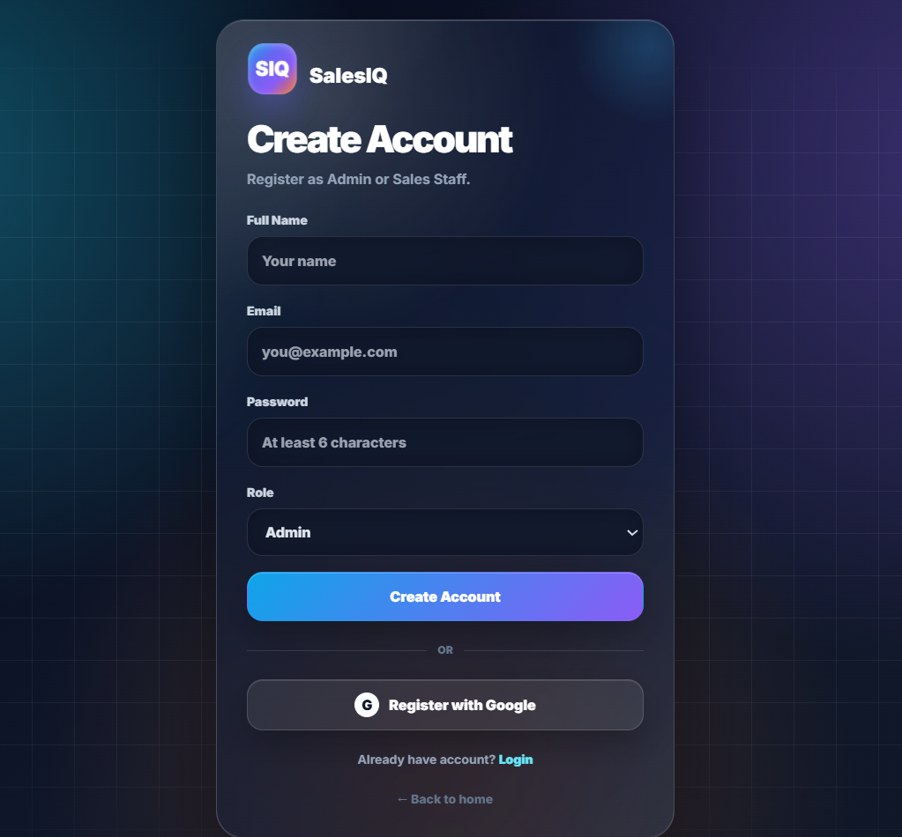

Add product form:- To add new products
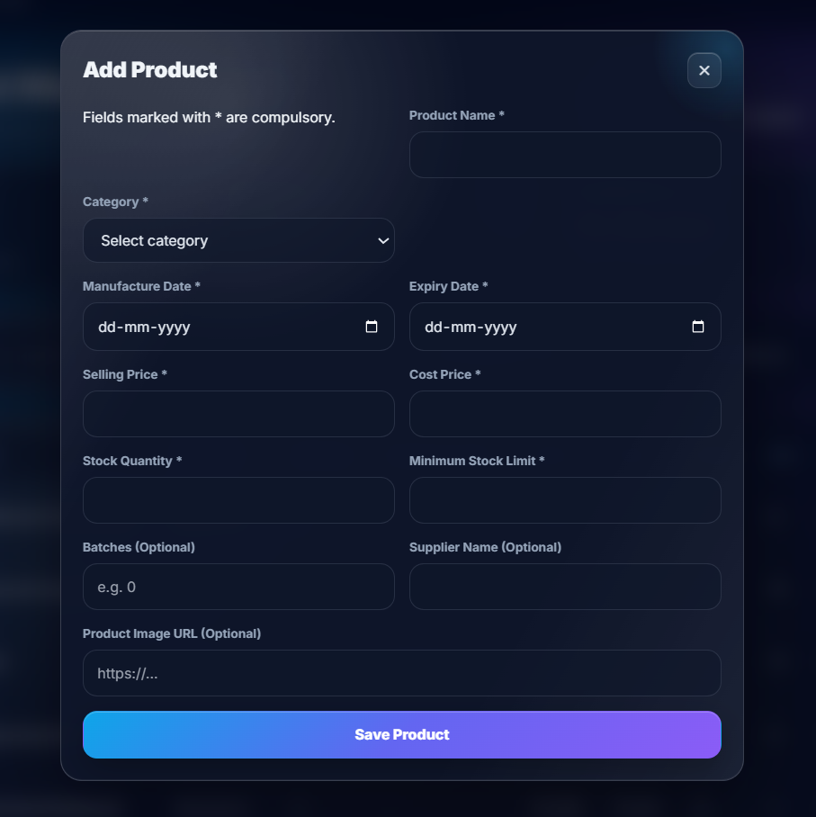
Add sales:- To add sell of a product
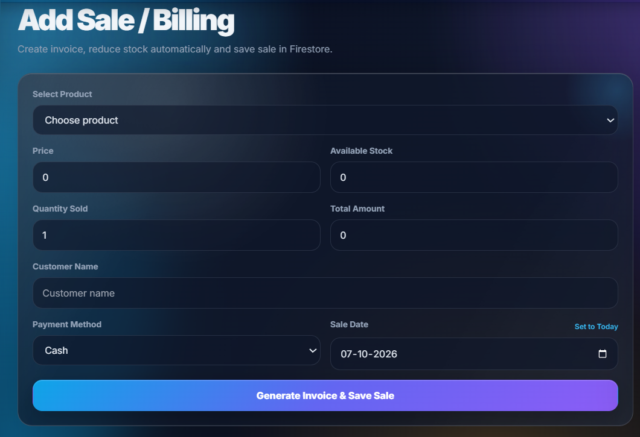
4.4 Output Design
Dashboard:- shows sales analytics
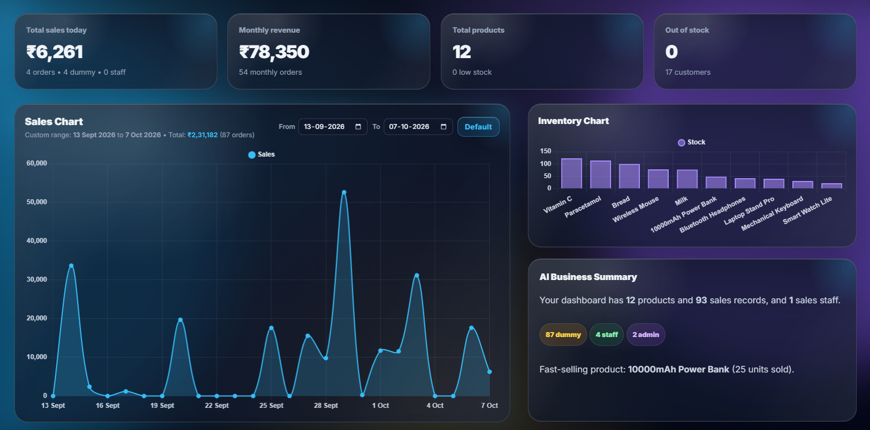
Products & Inventory:- shows inventory and products information
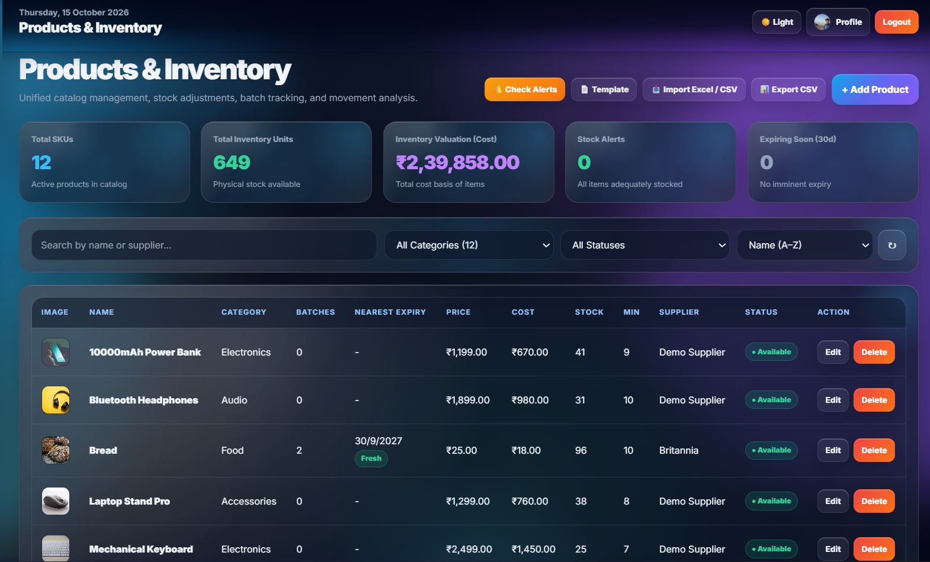
Forecasting page:- shows sales forecast of selected products
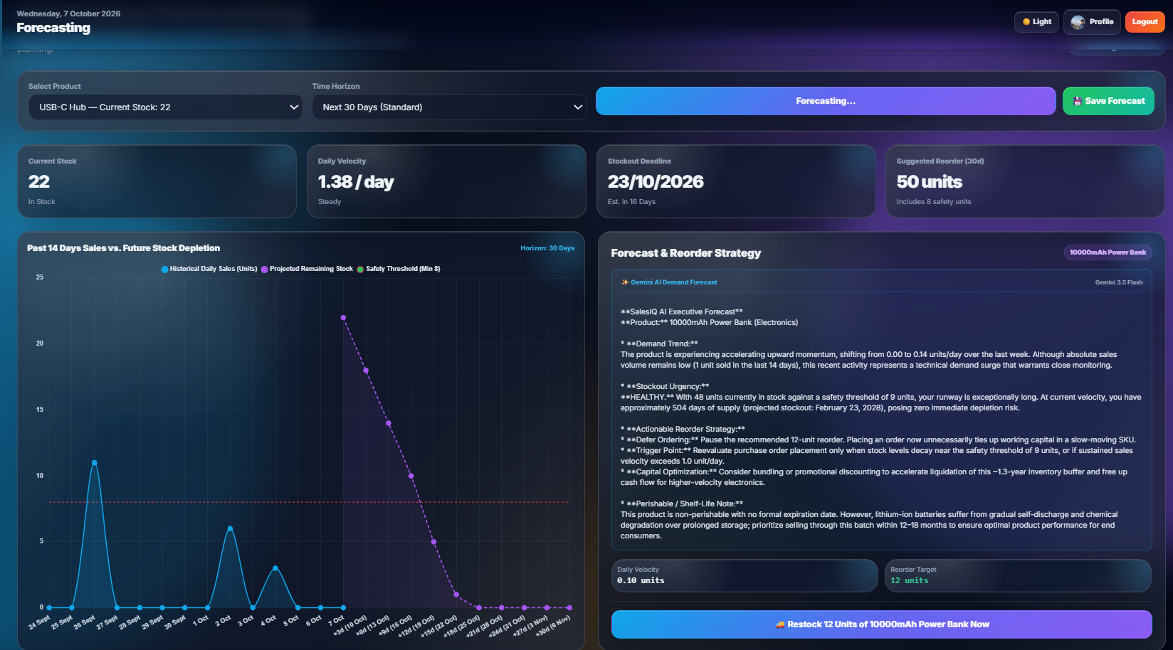
Forecasting page:- AI business insights and strategic analytics dashboard
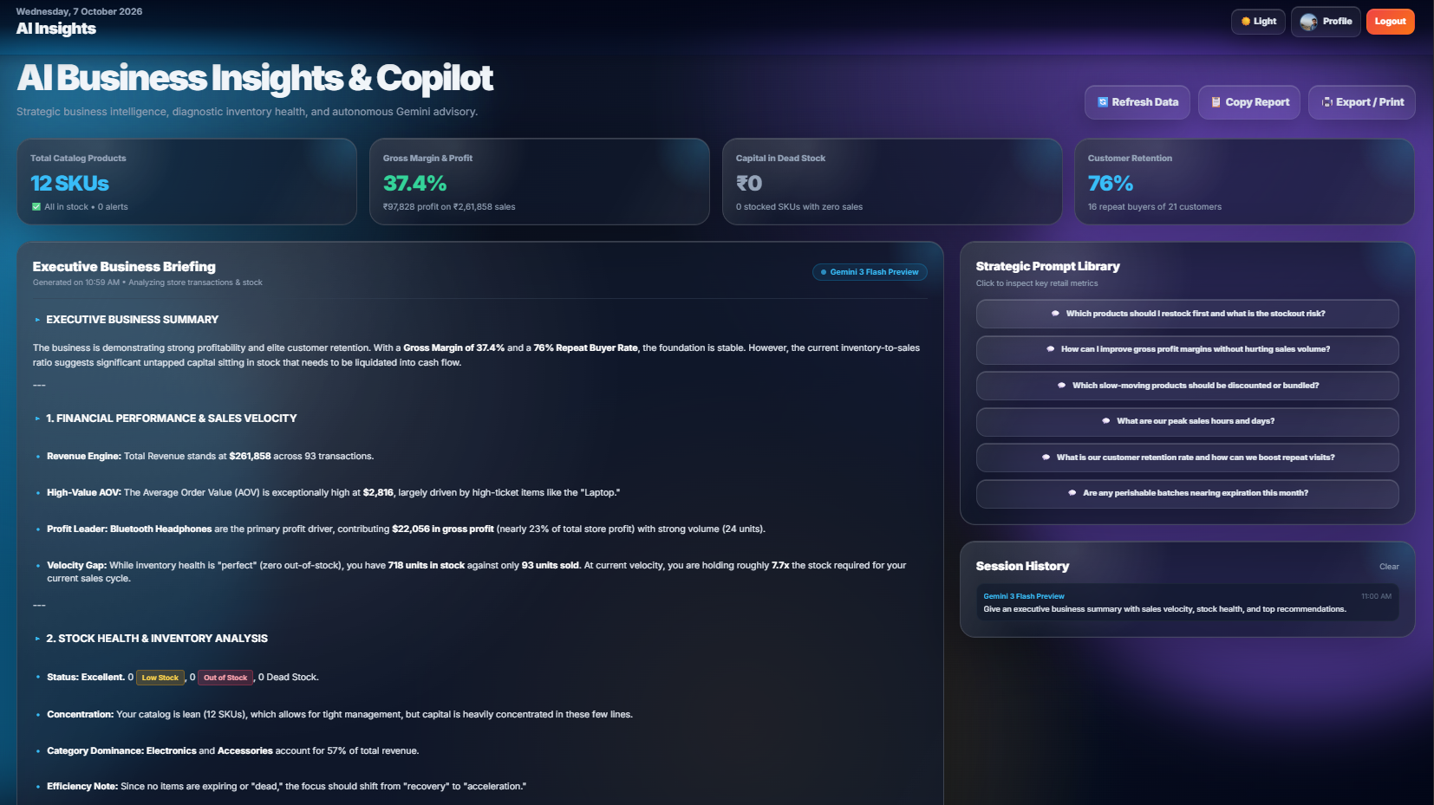

5. SYSTEM TESTING
5.1 System Testing
- Each module (Admin, Sales Staff) was tested individually and then as an integrated system before deployment.
- Testing focused on two categories: Output Testing — correctness of dashboard values, reports and charts; and Validation Testing — input field checks and error handling.
- Testing was carried out on Chrome, Edge and Safari, across both desktop and mobile viewport sizes.
- Real-time behaviour was verified by performing a sale on one device/staff account and confirming the Admin dashboard updated instantly on another.

5.1.1 Output Testing
Test Case | Input / Action | Expected Output | Actual Output | Result
TC-01 | Staff completes a sale of 3 units | Stock reduces by 3; sale appears instantly on Admin dashboard | Stock reduces by 3; sale appears instantly on Admin dashboard | Pass
TC-02 | Product stock falls below reorder threshold | Product flagged as “Low Stock” on dashboard | Product flagged as “Low Stock” on dashboard | Pass
TC-03 | Admin opens dashboard after multiple sales | Total revenue & order count match sum of Firestore sales records | Total revenue & order count match sum of Firestore sales records | Pass
TC-04 | Admin asks the AI insights assistant a business question | Total revenue & order count match sum of Firestore sales records | Total revenue & order count match sum of Firestore sales records | Pass

5.1.2 Validation Testing
Test Case | Input | Expected Output | Actual Output | Result
TC-05 | Sale quantity left blank or 0 | Form blocks submission; shows “Enter a valid quantity” | Form blocks submission; shows “Enter a valid quantity” | Pass
TC-06 | Sale quantity greater than available stock | Form blocks submission; shows “Insufficient stock” | Form blocks submission; shows “Insufficient stock” | Pass
TC-07 | Staff e-mail left blank on registration | Form blocks submission; shows “E-mail is required” | Form blocks submission; shows “E-mail is required” | Pass
TC-08 | Invalid e-mail format entered | Form blocks submission; shows “Enter a valid e-mail” | Form blocks submission; shows “Enter a valid e-mail” | Pass
TC-09 | Unauthenticated user opens a dashboard URL directly | User is redirected to the login page | User is redirected to the login page | Pass

6. CONCLUSION AND FUTURE ENHANCEMENT
6.1 Conclusion
- SalesIQ successfully brings Admin and Sales Staff onto one connected, real-time platform for sales and inventory management.
- Firestore's real-time listeners ensure that every sale and stock update is reflected instantly across dashboards.
- The AI insights layer, powered by Gemini, moves the system from a purely record-keeping tool to one that gives forward-looking, decision-support insights.
- The project meets its core objective of replacing manual, disconnected record-keeping with a centralized, intelligent dashboard.

6.2 Future Enhancements
- Automated purchase-order generation when AI forecasting flags a reorder need.
- A customer-facing module for order history and loyalty tracking.
- Multi-branch / multi-store support with consolidated analytics.
- Push/e-mail notifications for critical alerts (out-of-stock, unusual sales patterns).
- Additional role-based access levels beyond Admin/Staff (e.g. Manager, Auditor).
- A companion mobile app using the same Firebase backend.

7. BIBLIOGRAPHY & REFERENCES
7.1 Books References
- Sommerville, I., “Software Engineering”, Pearson Education.
- Pressman, R.S., “Software Engineering: A Practitioner’s Approach”, McGraw-Hill.
- Booch, G., Rumbaugh, J., Jacobson, I., “The Unified Modeling Language User Guide”, Addison-Wesley.
- Elmasri, R., Navathe, S.B., “Fundamentals of Database Systems”, Pearson Education.

7.2 Web References
- Firebase Documentation — firebase.google.com/docs
- Cloud Firestore Documentation — firebase.google.com/docs/firestore
- Tailwind CSS Documentation — tailwindcss.com/docs
- Gemini API Documentation — console.Gemini.com/docs
- MDN Web Docs (HTML / JavaScript) — developer.mozilla.org

