
A PROJECT REPORT
ON
SalesIQ — AI-Powered Sales, Inventory & Forecasting Dashboard
Project report submitted to Ganpat University in the partial fulfillment of the requirement for the award of the Degree of Master of Computer Applications (M.C.A. Semester-III).
Submitted By:
KARAN PATEL (Enrollment No. 25034211116)
HARSH DARJI (Enrollment No. 25034211094)
Under the Guidance of:
Prof. Narendra Patel
Acharya Motibhai Patel Institute of Computer Studies
Ganpat University, Ganpat Vidyanagar – 384012, Gujarat, India
July – Dec 2026

PLAGIARISM DECLARATION FORM
This form must be completed, signed and attached to all assignments/projects/dissertations.
Please complete the information below (using BLOCK LETTERS):
Student’s Name:  1. KARAN PATEL  2. HARSH DARJI | Batch Code:  MCA 2025–2026
Enrollment Numbers:  1. 25034211116  2. 25034211094 | Semester & Program:  M.C.A. Semester – III
Subject Name & Code:  P13A6SDP1 SYSTEM DEVELOPMENT PROJECT - I | Institute:  AMPICS, Ganpat University

The following definition of plagiarism is taken from the MLA Handbook for Writers of Research Papers, Theses and Dissertations (MLA: New York, 1977, 99 4-5): “Plagiarism may take the form of repeating another’s sentences as your own, adopting a particularly apt phrase as your own, paraphrasing someone else’s argument as your own, or even presenting someone else’s line of thinking in the development of a thesis as though it were your own. In short, to plagiarize is to give the impression that you have written or thought something that you have in fact borrowed from another. Although a writer may use other person’s words and thoughts they must be acknowledged as such (by the use of the appropriate reference, and by the insertion of quotation marks around any words directly quoted).”
PLAGIARISM DECLARATION
- I acknowledge and understand that plagiarism is wrong and that it constitutes academic theft.
- I understand that my written work must be accurately referenced. I have followed the rules and conventions concerning referencing laid out in the course outline for this course.
- I have not allowed, nor will I in the future allow, anyone to copy my work with the intentions of passing it off as his or her work. I also accept that submitting identical work to someone else (a syndicate assignment) constitutes a form of plagiarism. I accept that the same principle applies to authorized group work.
PLAGIARISM WARNING
- Any student found to have committed or aided and abetted the offence of plagiarism may be subjected to penalties depending on the severity of involvement, including zero marks or termination of studies.
- Students should seek clarification from their respective lecturers, tutors or supervisors if they are unsure whether they are plagiarizing the work of another person.
DECLARATION BY STUDENT
I have read and understood the above definition of plagiarism. I am aware of and understand the Institute’s policy on plagiarism. I declare that all material in this assignment/project/dissertation is my own work and does not involve plagiarism.
Student’s Signature: 1. ____________________ 2. ____________________
Date: 15 / 10 / 2026

Date: 15 / 10 / 2026
CERTIFICATE
TO WHOMSOEVER IT MAY CONCERN
This is to certify that the following students of M.C.A. Semester-III have successfully and satisfactorily completed their project work titled “SalesIQ — AI-Powered Sales, Inventory & Forecasting Dashboard” in partial fulfillment of the requirements for the award of the Degree of Master of Computer Applications from Ganpat University, Ganpat Vidyanagar, during the Academic Year 2025–26.
Sr. No. | Enrollment No. | Full Name
1 | 25034211116 | Karan Patel
2 | 25034211094 | Harsh Darji

________________________  Internal Guide  (Prof. Narendra Patel) | ________________________  Project Co-ordinator  (Dr. Jignesh A. Chauhan) | ________________________  Principal / Director  (Dr. Satyen M. Parikh)

ACKNOWLEDGEMENT
We express our deep gratitude and heartfelt thanks to our respected Project Guide, Prof. Narendra Patel, for his invaluable guidance, persistent encouragement, and critical insights throughout the development of our project, SalesIQ — AI-Powered Sales, Inventory & Forecasting Dashboard.
We are profoundly indebted to Dr. Satyen M. Parikh, Principal, Acharya Motibhai Patel Institute of Computer Studies (AMPICS), and Dr. Jignesh A. Chauhan, Project Co-ordinator, for providing us with the necessary computing infrastructure, academic resources, and an inspiring environment to successfully execute our System Development Project.
We also extend our sincere appreciation to all the faculty members and technical staff of AMPICS, Ganpat University, for their continuous assistance and constructive feedback. Lastly, we thank our parents, family members, and friends whose unwavering moral support and encouragement enabled us to bring this endeavor to fruition.
KARAN PATEL (25034211116)
HARSH DARJI (25034211094)

INDEX
Sr. No. | Name of Content | Page No.
1 | INTRODUCTION | 01
 | 1.1 Project Profile | 01
 | 1.2 About the Organization / Institute | 02
 | 1.3 Purpose and Objectives | 02
 | 1.4 Scope of the Project | 02
2 | SYSTEM STUDY AND ANALYSIS | 03
 | 2.1 Problem Statement & Existing System | 03
 | 2.1.1 Drawbacks of the Existing System | 03
 | 2.2 Proposed System | 04
 | 2.2.1 Advantages & Comparative Study | 04
 | 2.2.2 Modules Description | 05
3 | DEVELOPMENT ENVIRONMENT | 07
 | 3.1 Hardware Requirements (Server & Client Side) | 07
 | 3.2 Software Requirements (Server & Client Side) | 08
 | 3.3 Programming Environment | 09
 | 3.3.1 About Front-End | 09
 | 3.3.2 About Back-End & AI Services | 10
4 | SYSTEM DESIGN AND DEVELOPMENT | 11
 | 4.1 User Modeling Language (UML) Diagrams | 11
 | 4.1.1 Flowchart | 11
 | 4.1.2 Use-Case Diagram | 12
 | 4.1.3 Activity Diagrams (Admin & Sales Staff) | 13
 | 4.1.4 Sequence Diagrams (Admin & Sales Staff) | 15
 | 4.1.5 Deployment Diagram | 17
 | 4.1.6 Class Diagram | 18
 | 4.2 Data Dictionary (Firestore Collections) | 19
 | 4.3 Input Design (UI Forms & Interfaces) | 24
 | 4.4 Output Design (Dashboards, Catalogs & Insights) | 27
5 | SYSTEM TESTING | 32
 | 5.1 System Testing Methodology | 32
 | 5.1.1 Output Testing | 33
 | 5.1.2 Validation Testing | 34
6 | CONCLUSION AND FUTURE ENHANCEMENTS | 35
 | 6.1 Conclusion | 35
 | 6.2 Future Enhancements | 36
7 | BIBLIOGRAPHY & REFERENCES | 37
 | 7.1 Books References | 37
 | 7.2 Web References | 37

1. INTRODUCTION
1.1 Project Profile
SalesIQ is an AI-powered retail intelligence and operations dashboard designed to bridge the operational gap between store owners (Admins) and cashiers/sales staff. The project integrates real-time Point of Sale (POS) operations, inventory tracking with batch and expiry awareness, predictive stock-out forecasting, and an AI-driven conversational business advisor powered by the Google Gemini API.
Field | Details
Project Title | SalesIQ — AI-Powered Sales, Inventory & Forecasting Dashboard
Project Category | Retail ERP, Point of Sale (POS) & AI Decision Support System
Objective | To centralize retail operations into a single connected platform providing real-time stock sync, FEFO batch tracking, automated reorder forecasting, and natural language business insights.
Front End | HTML5, Tailwind CSS, Modern Vanilla JavaScript (ES6+ Modules), Chart.js, Liquid Glass UI Design System
Back End | Google Firebase Authentication, Cloud Firestore (NoSQL Real-Time Database), Firebase Hosting, Google Gemini API
Database | Google Cloud Firestore (Hierarchical NoSQL document store with live snapshot listeners)
AI / ML Services | Google Gemini API (Multi-model support with Llama 3.1/3.3, Gemma 2 fallback engines) & Deterministic FEFO / ADS (Average Daily Sales) mathematical models
Development Tools | Visual Studio Code, Git & GitHub, Firebase CLI, Postman, Microsoft Word / PowerPoint
Internal Guide | Prof. Narendra Patel, AMPICS, Ganpat University
Developed By | 1. Karan Patel (Enrollment No. 25034211116)  2. Harsh Darji (Enrollment No. 25034211094)
Academic Year | MCA Semester-III (July – Dec 2026)
1.2 About the Organization / Institute
Acharya Motibhai Patel Institute of Computer Studies (AMPICS) is a premier constituent institute of Ganpat University, established to impart high-quality education in computer applications and information technology. Ganpat University is recognized under Section 2(f) of the UGC Act, 1956, and is committed to fostering academic excellence, industry-aligned research, and modern software engineering practices. The M.C.A. program equips students with advanced skills in software architecture, cloud platforms, full-stack web development, and artificial intelligence.
1.3 Purpose and Objectives
- Eliminate Disconnected Workflows: Eliminate manual, error-prone record-keeping in retail and small-to-medium enterprise (SME) general stores.
- Real-Time Synchronization: Ensure that whenever a sales staff member completes a transaction, inventory counts and financial analytics update instantly on the Admin dashboard without page refreshing.
- Batch & Expiry Management: Support perishable inventory tracking by managing manufacture and expiry dates with automated First Expiring, First Out (FEFO) deduction.
- Predictive Stock-Out Forecasting: Calculate Average Daily Sales (ADS) and project exactly when physical stock will hit zero, recommending optimal reorder dates and quantities.
- AI-Powered Business Intelligence: Equip store managers with an interactive conversational assistant powered by Google Gemini that answers strategic questions about revenue trends, fast/slow-moving goods, and supplier performance.
1.4 Scope of the Project
The project encompasses a complete multi-role web application. It supports multi-admin isolation where each retail store owner's data (products, staff, sales, and analytics) is strictly partitioned. Sales staff can independently register, get assigned by an Admin, and execute fast barcode/lookup-driven billing transactions. The system delivers real-time notifications, stock loss tracking through disposal auditing, automated sample CSV/Excel product bulk import with AI column mapping, and multi-tier offline caching backed by IndexedDB and localStorage for zero-latency performance.

2. SYSTEM STUDY AND ANALYSIS
2.1 Problem Statement & Existing System
Small and medium retail establishments, grocery shops, and pharmacies commonly track daily sales, customer billing, and stock counts using paper registers, unconnected Excel spreadsheets, or obsolete standalone desktop billing applications. Under this conventional paradigm:
- Admins and business owners possess no live visibility into store revenue, hourly billing velocity, or staff performance unless manual day-end tallies are compiled.
- Sales staff record billing independently, often leading to discrepancies between physical stock on shelves and book inventory.
- Perishable goods are frequently sold without batch distinction, resulting in expired stock lingering on shelves while fresher goods are inadvertently sold first.
- Stock replenishment is reactive: store managers notice shortages only when a customer requests an out-of-stock item, directly causing lost revenue and customer dissatisfaction.
2.1.1 Drawbacks of the Existing System
- Prone to Human Error: High incidence of manual arithmetic errors, illegible handwriting in ledgers, and lost physical receipt books.
- No Live Synchronization: Zero real-time data sync between counter sales and the owner's back-office records.
- Inventory Desynchronization: Inventory tallies lag by hours or days, causing stock-outs, double-selling, and inaccurate financial balances.
- Unmonitored Perishables: Lack of batch tracking causes severe shrinkage, write-offs of expired inventory, and compliance hazards.
- No Predictive Capability: Complete absence of automated forecasting, leaving inventory purchasing to guesswork rather than historical sales velocity.
- Weak Staff Accountability: Lack of timestamped digital audit trails for sales staff, making cash reconciliations contentious and difficult to verify.
2.2 Proposed System
SalesIQ replaces fragmented tools with an intelligent, cloud-synchronized web platform that unifies retail point of sale, catalog control, batch lifecycle auditing, and predictive forecasting under an intuitive, modern responsive interface. Built on top of Google Cloud Firestore, SalesIQ provides reactive listeners that push live data updates across all open clients within milliseconds.
2.2.1 Advantages & Comparative Study
Feature / Parameter | Traditional / Existing System | SalesIQ Proposed System
Architecture | Offline, standalone desktop software or paper registers | Cloud-native, real-time reactive web application
Data Synchronization | Manual end-of-day tallying, spreadsheets | Instant 0ms cached render + live Firestore background sync
Multi-Role Collaboration | Single-device or disconnected standalone PCs | Multi-tenant: Admins and assigned Staff collaborate live
Batch & Expiry Tracking | Rarely tracked; manual physical shelf inspections | Automated FEFO tracking with color-coded expiry badges
Stock Deductions | Manual book adjustment or periodic physical audit | Automated stock & batch deduction immediately upon billing
Stock-Out Prevention | Reactive: discovered only after sales are missed | Proactive: mathematical ADS and stock-finish projections
Business Analytics | Static tabular numbers compiled by hand | Animated Chart.js graphs and Gemini AI natural language chat
Waste / Loss Tracking | Unrecorded shrinkage and undocumented damage | Dedicated Disposals Module logging waste reasons & costs
2.2.2 Modules Description
- 1. Admin Management & Dashboard Module: Empowers store owners with complete oversight. Admins can configure store profile settings, review live KPI cards (Total Revenue, Orders, Average Order Value, Physical Stock Units), monitor hourly sales velocity charts, manage product catalogs, inspect batch registers, approve/assign staff members, and interact with the AI assistant.
- 2. Sales Staff & Delegation Module: Enables staff members to register independently with a username. Staff accounts remain in a secure 'pending_assignment' state until claimed by an Admin. Assigned staff access a streamlined Point-of-Sale billing screen to search products, execute transactions, and view personal sales histories.
- 3. Products & Unified Inventory Module: Consolidates product management and inventory tracking into a single unified catalog. Includes SKU categorization, cost price, selling price, reorder thresholds (minStock), visual stock status badges, fast/slow-moving sales velocity analysis, and smart bulk Excel/CSV import powered by Gemini AI column mapping.
- 4. Batch & Expiry Tracking Module: Maintains individual batch records for perishable items (food, medicine) with manufacture date, expiry date, purchase price, and remaining quantity. SalesIQ applies automated FEFO (First Expiring, First Out) deduction and renders an automatic status ladder (Active → Upcoming Expiry → Critical Expiry → Expired).
- 5. Point of Sale (POS) Billing Module: Provides a frictionless checkout interface for counter cashiers. Features rapid product selection, instant stock validation, automated price calculation, payment mode selection (Cash, Card, UPI), printable customer invoice generation, and immediate multi-device inventory deduction.
- 6. Stock Disposals & Loss Audit Module: Enables audited write-offs of damaged, expired, recalled, or lost stock from specific batches. Deducts inventory synchronously from the batch and parent product while recording reasons, responsible admins, and financial impact.
- 7. AI Forecasting & Business Insights Module: Calculates Average Daily Sales (ADS) to determine estimated days until stock depletion, flagging urgent reorder requirements. Integrates a conversational AI advisor powered by Google Gemini that answers strategic questions about revenue trends, margin optimization, and inventory health.

3. DEVELOPMENT ENVIRONMENT
3.1 Hardware Requirements
The hardware specifications required to deploy the server infrastructure and run the client dashboard are detailed below:
Server-Side Hardware (Cloud Infrastructure)
Hardware Component | Minimum Specification
Cloud Platform | Google Cloud Platform (GCP) Serverless Hosting & Firestore Clusters
Compute Infrastructure | Multi-core Cloud Functions / Edge Edge-CDN Nodes
Server Memory (RAM) | Auto-scaling dynamic memory (512 MB to 2 GB per instance)
Storage Subsystem | Google Cloud Multi-region SSD Persistent Distributed Storage
Network Throughput | High-speed Tier-1 Cloud Backbone (Gigabit Internet Connectivity)

Client-Side Hardware (End-User Devices)
Hardware Component | Minimum Specification
Processor | Dual-Core 1.8 GHz or equivalent (Intel i3/i5, AMD Ryzen, Apple Silicon, ARM)
System Memory (RAM) | 2 GB minimum (4 GB or above recommended for fluid charts)
Disk Storage | 50 MB free disk space for browser caching and local database state
Display Resolution | 1024 x 768 minimum (Responsive for 1080p, 2K, tablets, and smartphones)
Peripherals | Standard Keyboard, Mouse / Touchscreen, optional USB/Bluetooth Barcode Scanner
Network Connectivity | Standard 4G/5G or Wi-Fi Broadband connection (256 Kbps minimum)
3.2 Software Requirements
The software components and runtime stacks utilized across the client and cloud tiers include:
Server-Side Software
Software Entity | Specification & Version
Cloud Operating Environment | Google Cloud Serverless Infrastructure (Linux Container Runtime)
Authentication Engine | Firebase Authentication (Email/Password, Token verification, RBAC)
Database Management System | Google Cloud Firestore (NoSQL Document Store, ACID Transactions)
Web Application Hosting | Firebase Hosting with Global Fastly Edge Content Delivery Network
AI API Engine | Google Gemini API (Gemini 2.5 Flash, Llama 3.3, Gemma 2 multi-model fallback)

Client-Side Software
Software Entity | Specification & Version
Operating System | Microsoft Windows 10/11, macOS, Ubuntu/Linux, Android, or iOS
Web Browser | Google Chrome 110+, Microsoft Edge 110+, Mozilla Firefox 115+, Safari 16+
Scripting Engine | ECMAScript 2022+ (ES6 Modules, async/await, native Promises)
Client Storage API | HTML5 IndexedDB, LocalStorage, and SessionStorage
IDE / Development Tools | Visual Studio Code, Git, Google Chrome DevTools, Firebase Console
3.3 Programming Environment
SalesIQ utilizes a modern, lightweight, dependency-conscious technology stack. Instead of bloated front-end frameworks that introduce heavy build steps and slow bundle sizes, SalesIQ leverages native web standards augmented by utility-first styling and cloud services.
3.3.1 About Front-End
- HTML5: Provides semantic layout, accessible form structures, and modal viewport wrappers.
- Tailwind CSS & Liquid Glass: Implements a cohesive dark-themed modern aesthetic featuring backdrop blur, translucent cards, subtle border highlights, and fully responsive grid containers.
- Vanilla JavaScript (ES6+): Employs ES6 modular JavaScript with clean separation of concerns (`shared.js`, `firebase-config.js`, `gemini-service.js`, and page-specific controllers).
- Chart.js: Renders interactive, responsive canvas charts displaying hourly revenue trends, category breakdowns, and fast-moving sales volume.
3.3.2 About Back-End & AI Services
- Firebase Authentication: Manages encrypted user credential authentication, session tokens, and role identification (Admin vs. Staff).
- Cloud Firestore: Delivers low-latency real-time synchronization via WebSocket listeners (`onSnapshot`) and supports ACID transactions for multi-document stock updates.
- Google Gemini AI Engine: Acts as a conversational strategic partner, analyzing real-time sales records and answering business queries with actionable advice.
- Multi-Tier Caching Architecture: Stores collection snapshots locally in IndexedDB and memory, enabling instant 0ms page loads before background network reconciliation occurs.

4. SYSTEM DESIGN AND DEVELOPMENT
4.1 User Modeling Language (UML) Diagrams
Visual modeling represents a crucial phase in software engineering, providing architectural clarity on system behavior, user interactions, and data transitions. The following sub-sections present the complete UML diagram suite for SalesIQ.
4.1.1 System Flowchart
The system flowchart outlines the end-to-end execution flow of SalesIQ. It illustrates user authentication, role branching (Admin vs. Staff), administrative workflows (catalog management, staff assignment, forecasting, AI querying), and cashier workflows (product search, cart calculation, stock validation, invoice generation, and live inventory sync).
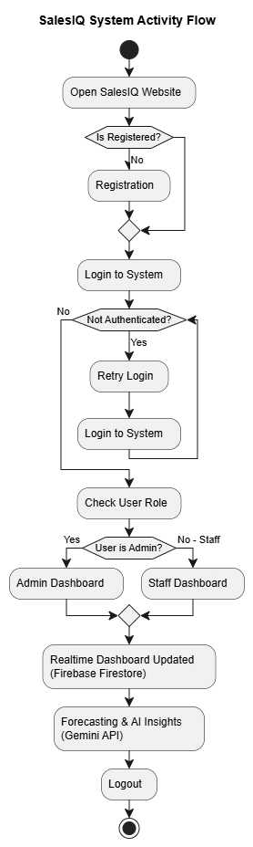
Figure 4.1: SalesIQ Overall System Flowchart
4.1.2 Use-Case Diagram
The Use-Case diagram models the interactions between the two primary system actors — Admin and Sales Staff — and the core functional use cases of the platform. Admins control catalog configurations, manage staff, analyze forecasts, and review disposals. Sales staff interact with product discovery, cart building, and bill generation, while both actors interface with Cloud Firestore and the notification engine.
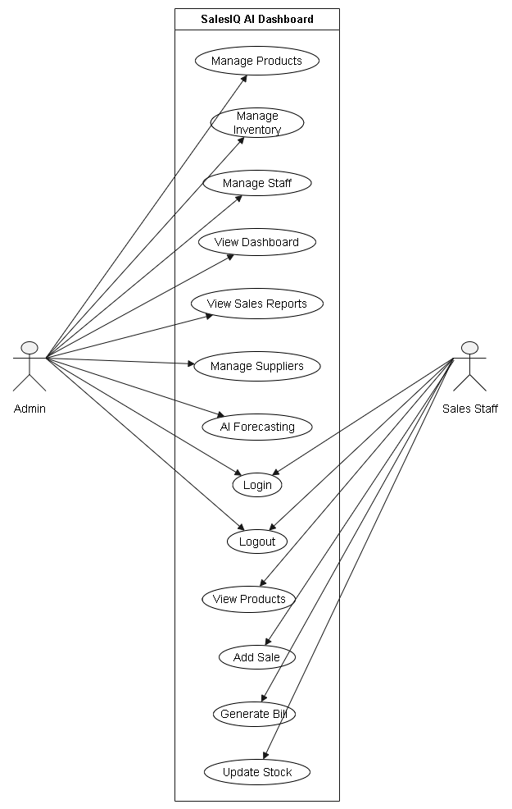
Figure 4.2: SalesIQ Use-Case Diagram
4.1.3 Activity Diagrams
Activity diagrams capture the operational workflows, conditional decision diamonds, and sequential state transitions for each user role.
Admin Activity Diagram
Illustrates the Admin journey starting from login, navigating the dashboard, inspecting live KPI cards, assigning pending staff accounts, managing product batches, configuring minimum stock thresholds, triggering alert scans, and interrogating the Gemini AI insights assistant.
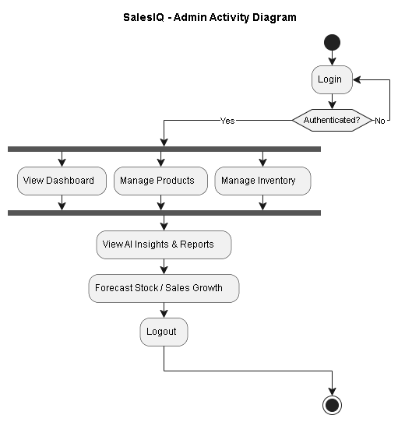
Figure 4.3(a): Admin Activity Diagram
Sales Staff Activity Diagram
Depicts the staff workflow: registration, pending verification state, assignment confirmation, accessing the POS billing interface, selecting products, specifying quantities, checking stock availability, finalizing transaction details, printing the invoice, and updating personal sales history.
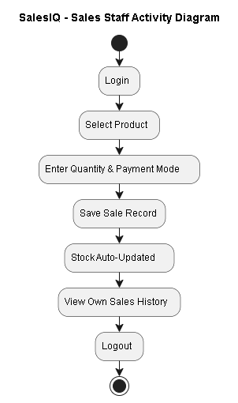
Figure 4.3(b): Sales Staff Activity Diagram
4.1.4 Sequence Diagrams
Sequence diagrams depict object interactions arranged in time sequence, showing the explicit messages passed between actors, UI controllers, and the database.
Admin Workflow Sequence Diagram
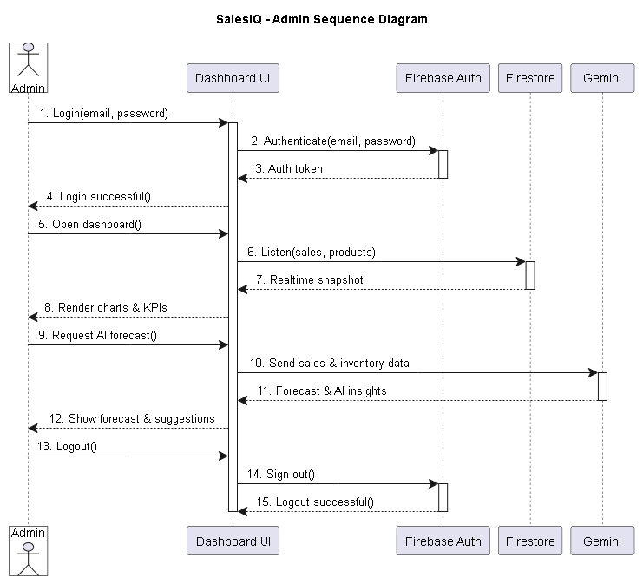
Figure 4.4(a): Admin Workflow Sequence Diagram
Sales Staff Billing Sequence Diagram
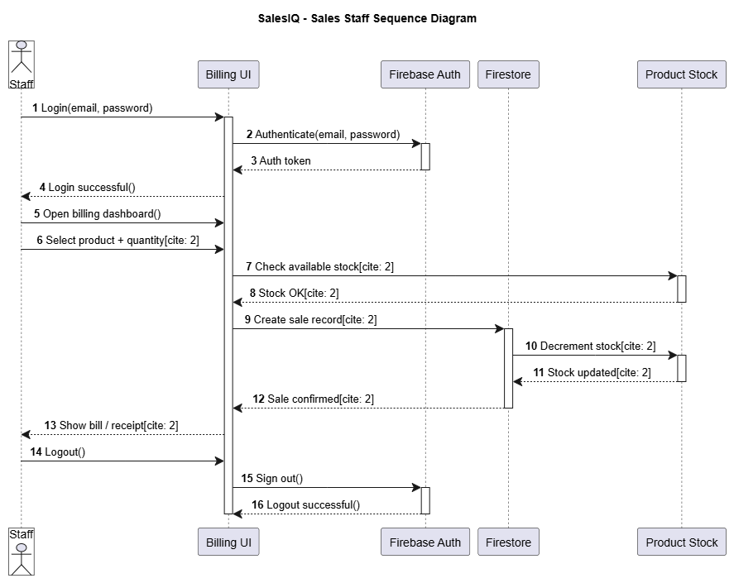
Figure 4.4(b): Sales Staff Billing Sequence Diagram
4.1.5 Deployment Diagram
The Deployment diagram illustrates the physical hardware and cloud topology of SalesIQ. It demonstrates client desktop/mobile browser nodes communicating over secure HTTPS/WSS protocols to the Google Firebase Hosting CDN, Google Cloud Firestore serverless cluster, and the external Google Gemini AI REST API endpoint.
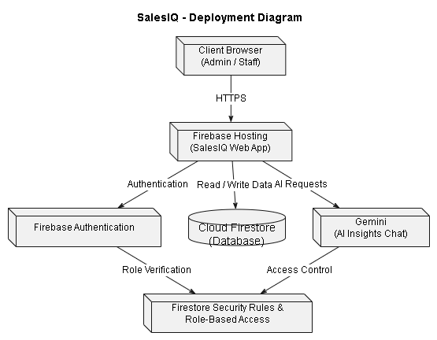
Figure 4.5: SalesIQ Physical Deployment Diagram
4.1.6 Class Diagram
The Class diagram details the object-oriented structure of the SalesIQ codebase. It illustrates entity models (Admin, Staff, Product, ProductBatch, Sale, Disposal, Notification) along with their attributes, methods, visibility indicators, and multi-entity associations.
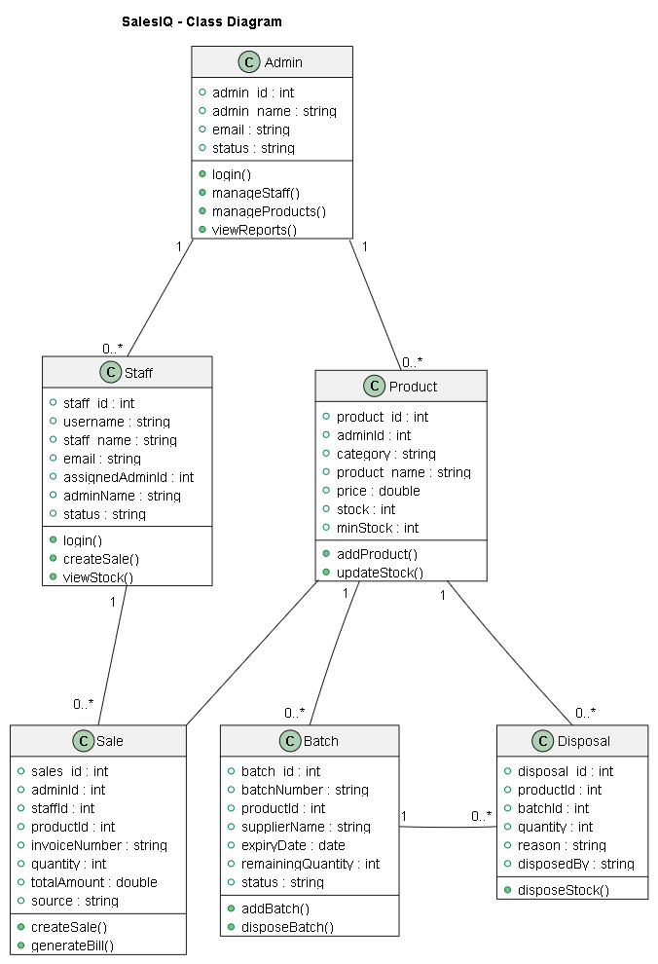
Figure 4.6: SalesIQ Class Diagram
4.2 Data Dictionary
The Data Dictionary provides a formal specification of the schema design implemented within Google Cloud Firestore. Each collection is documented below with its attributes, data types, constraints, and functional descriptions.
1. Admins Collection
Table Description: Represents store owner / administrator credentials and organization profiles.
Primary Key: admin_id
Sr. No. | Field Name | Data Type | Constraint | Description
1 | admin_id | String | Primary Key | Unique Firebase Auth UID identifying the admin.
2 | Admin_name | String | Not Null | Full name or store business title of the admin.
3 | E-mail | String | Not Null, Unique | Registered email address for authentication and notices.
4 | Status | Boolean | Not Null | Operational status of the administrator (Active / Inactive).

2. Staff Collection
Table Description: Represents Sales Staff accounts. Staff self-register and remain pending until claimed by an Admin.
Primary Key: staff_id | Foreign Key: assignedAdminId
Sr. No. | Field Name | Data Type | Constraint | Description
1 | staff_id | ObjectId / String | Primary Key | Unique Firebase Auth UID identifying the sales staff.
2 | username | String | Not Null, Unique | Unique username used for login and admin assignment.
3 | staff_name | String | Not Null | Full personal name of the sales staff member.
4 | E-mail | String | Not Null | Staff email address for authentication.
5 | assignedAdminId | String / Object | Foreign Key (nullable) | UID of the Admin this staff is assigned to; empty while pending.
6 | adminName | String | Nullable | Denormalized name of the assigned store owner.
7 | status | String | Not Null | Account state: pending_assignment, active, or inactive.
8 | assignedAt | Timestamp | Nullable | Server timestamp when staff was claimed by an admin.

3. Products Collection
Table Description: Represents catalog items, inventory thresholds, and pricing scoped per Admin.
Primary Key: product_id | Foreign Key: adminId
Sr. No. | Field Name | Data Type | Constraint | Description
1 | product_id | ObjectId / String | Primary Key | Unique identifier for the catalog item.
2 | adminId | String | Foreign Key | Owning admin UID — ensures multi-admin data isolation.
3 | category | String | Not Null | Product category (e.g. food, medicine, electronics, apparel).
4 | product_name | String | Not Null | Title and brand description of the product.
5 | price | Double | Not Null | Selling retail price charged at the billing counter.
6 | costPrice | Double | Not Null | Wholesale purchase cost basis used for inventory valuation.
7 | stock | Int | Not Null | Current total physical inventory units available.
8 | minStock | Int | Not Null | Reorder threshold used to automatically trigger Low Stock flags.
9 | imageUrl | String | Nullable | URL reference to product packaging thumbnail.

4. Product Batches Collection
Table Description: Represents discrete purchased batches with manufacture and expiry tracking for FEFO management.
Primary Key: batch_id | Foreign Key: adminId, productId
Sr. No. | Field Name | Data Type | Constraint | Description
1 | batch_id | ObjectId / String | Primary Key | Unique document identifier for the inventory batch.
2 | batchNumber | String | Not Null | Manufacturer batch number stamped on packaging.
3 | productId | String | Foreign Key | Reference to the parent product document.
4 | supplierName | String | Nullable | Supplier or vendor who fulfilled this specific shipment.
5 | manufactureDate | Date / String | Not Null | Production date stamped by manufacturer.
6 | expiryDate | Date / String | Not Null | Date of product expiration used for FEFO laddering.
7 | purchasedQuantity | Int | Not Null | Initial units received during purchase restock.
8 | remainingQuantity | Int | Not Null | Active units left; decremented upon billing or disposal.
9 | purchasePrice | Double | Not Null | Unit cost basis for accurate profit and valuation calculations.
10 | status | String | Not Null | Operational status: Active, Disposed, or Empty.

5. Sales Collection
Table Description: Stores completed POS transactions, customer invoices, and audit metadata.
Primary Key: sales_id | Foreign Key: adminId, staffId, productId
Sr. No. | Field Name | Data Type | Constraint | Description
1 | sales_id | ObjectId / String | Primary Key | Unique identifier for the sale record.
2 | adminId | String | Foreign Key | Owning admin UID — sales are partitioned per store.
3 | staffId | String | Foreign Key (nullable) | UID of the cashier who executed the sale; null for admin.
4 | productId | String | Foreign Key | Reference to the sold inventory item.
5 | productName | String | Not Null | Denormalized name of the item at time of transaction.
6 | invoiceNumber | String | Not Null | Unique sequential invoice code printed on receipt.
7 | quantity | Int | Not Null | Total quantity of units purchased in this order line.
8 | totalAmount | Double | Not Null | Total bill amount calculated from unit price and tax.
9 | paymentMethod | String | Not Null | Payment channel used: Cash, Card, or UPI.
10 | createdAt | Timestamp | Not Null | Firestore server timestamp recording exact transaction time.

6. Disposals Collection
Table Description: Tracks inventory written off from a batch due to expiry, damage, contamination, or loss.
Primary Key: disposal_id | Foreign Key: productId, batchId, adminId
Sr. No. | Field Name | Data Type | Constraint | Description
1 | disposal_id | ObjectId / String | Primary Key | Unique disposal record identifier.
2 | productId | String | Foreign Key | Reference to the damaged or expired product.
3 | batchId | String | Foreign Key | Reference to the specific batch written off.
4 | batchNumber | String | Not Null | Denormalized human-readable batch code.
5 | quantity | Int | Not Null | Number of units removed from inventory.
6 | reason | String | Not Null | Classification: Expired, Damaged, Recalled, Lost, or Returned.
7 | remarks | String | Nullable | Explanatory notes logged by the inspecting manager.
8 | disposedAt | Timestamp | Not Null | Server timestamp when the write-off was committed.
9 | disposedBy | String | Not Null | Admin UID who authorized the stock disposal.

4.3 Input Design
Input design focuses on creating efficient, intuitive, and error-resilient user interfaces for data capture. SalesIQ utilizes responsive forms featuring inline validation, keyboard-friendly navigation, and clear visual feedback.
4.3.1 User Authentication & Registration
The authentication interface allows users to select their designated role (Admin vs. Sales Staff) and submit secure credentials. Staff accounts prompt for a unique username and enter an automated pending queue awaiting admin assignment.
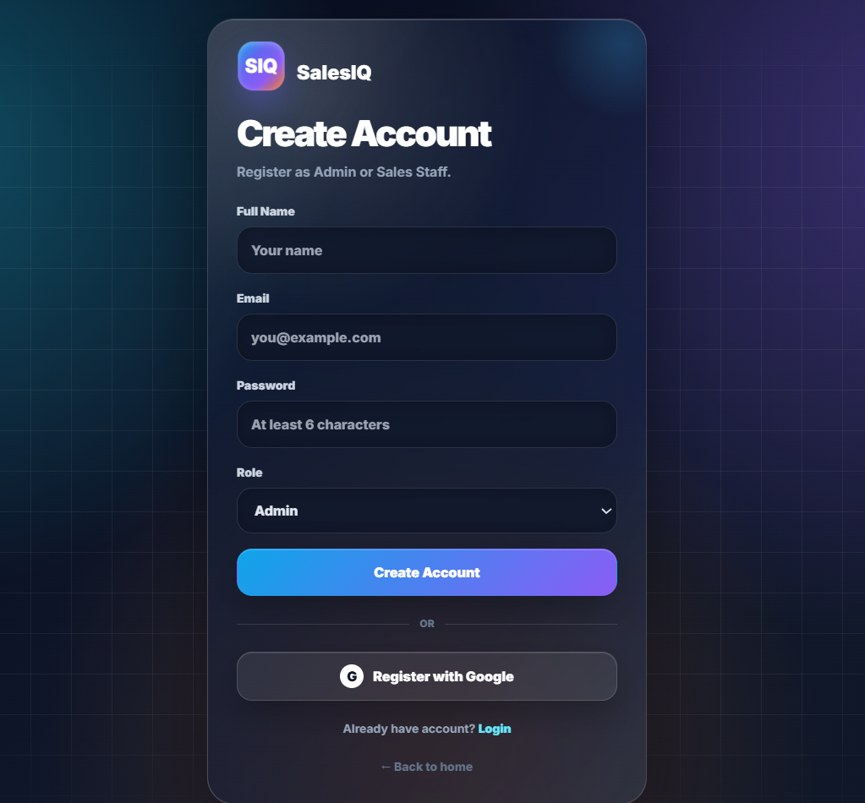
Figure 4.7: User Signup & Registration Interface
4.3.2 Product Catalog Creation & Editing
The product entry modal captures SKU identity, category classification, pricing, physical stock on hand, and reorder levels. Selecting perishable categories dynamically exposes manufacture and expiry date pickers.
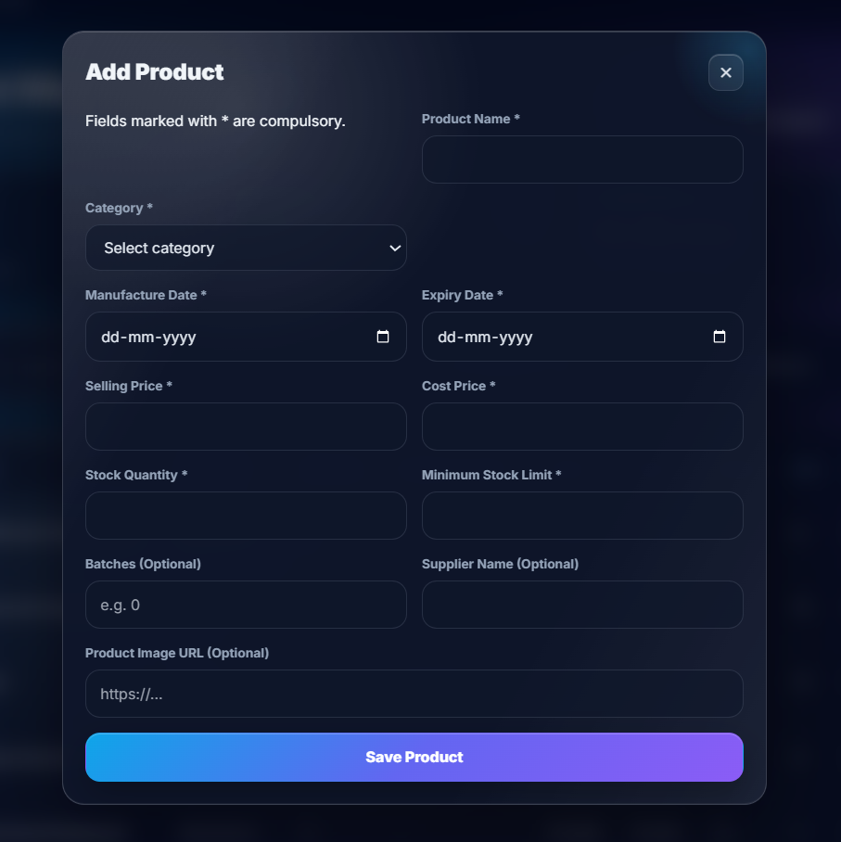
Figure 4.8: Add / Edit Product Catalog Form
4.3.3 Point of Sale Billing / Add Sale
The cashier billing interface provides rapid product lookups, live unit price calculations, quantity increment controls, and payment method toggles. Once confirmed, stock is validated and deducted synchronously.
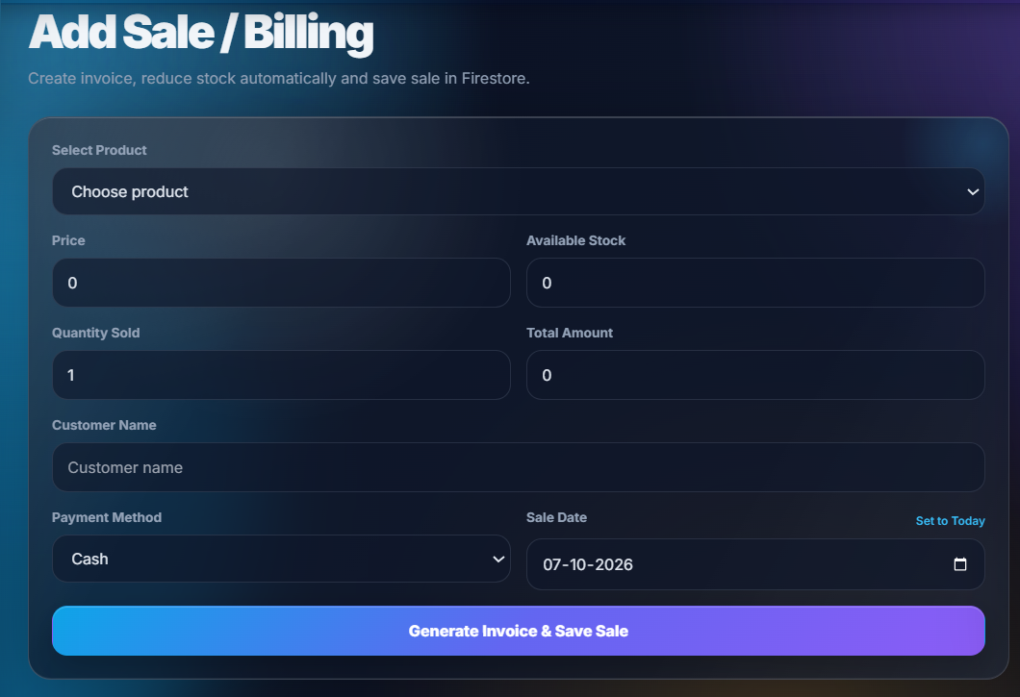
Figure 4.9: POS Billing & Sales Entry Interface
4.4 Output Design
Output design ensures that raw operational data is transformed into visually engaging, actionable intelligence. SalesIQ incorporates real-time glassmorphism KPI tiles, animated charts, and structured tables.
4.4.1 Executive Admin Analytics Dashboard
The primary executive command center features 4 core KPI metrics (Revenue, Orders, Average Order Value, Available Units), an animated Chart.js sales trend graph, top performing cashiers, and recent transactional logs.
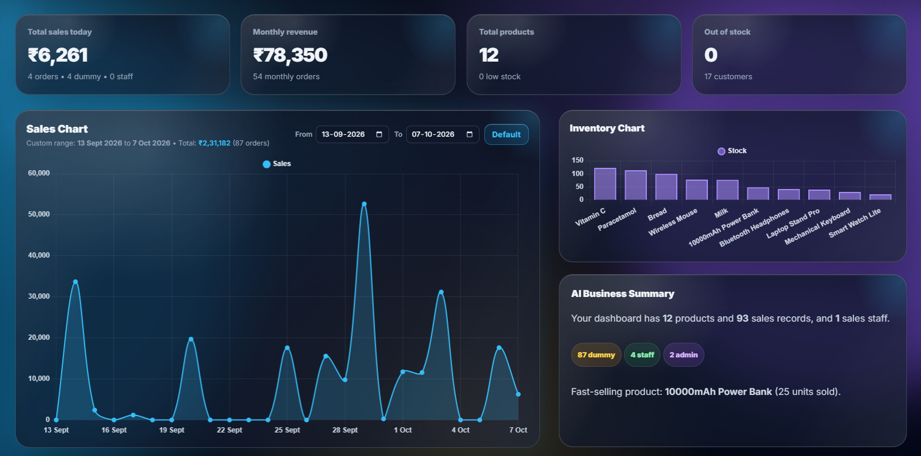
Figure 4.10: Executive Admin Analytics Dashboard
4.4.2 Products & Unified Inventory Catalog
The unified inventory view consolidates SKU tracking, stock counts, batch indicators, expiry badges (Fresh, Expires in Xd, Expired), and sales velocity rankings (Top 5 Fast-Moving vs. Slow-Moving goods).
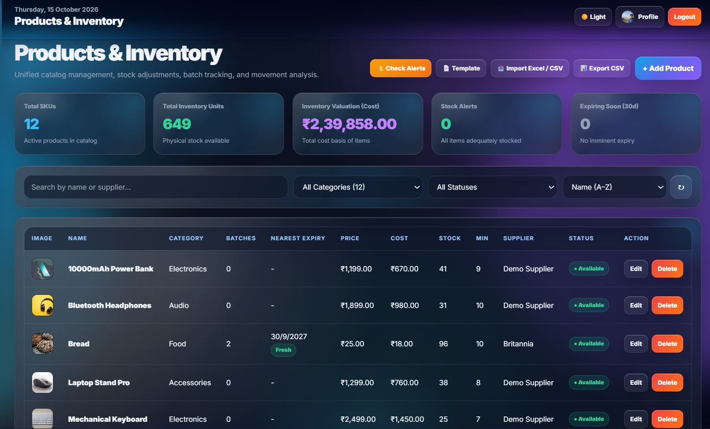
Figure 4.11: Products & Unified Inventory Catalog Interface
4.4.3 Predictive Stock-Out & Reorder Forecasting
Calculates Average Daily Sales (ADS) to estimate the exact number of days until inventory exhaustion, recommending precise reorder dates and quantities before stock-outs impact store operations.
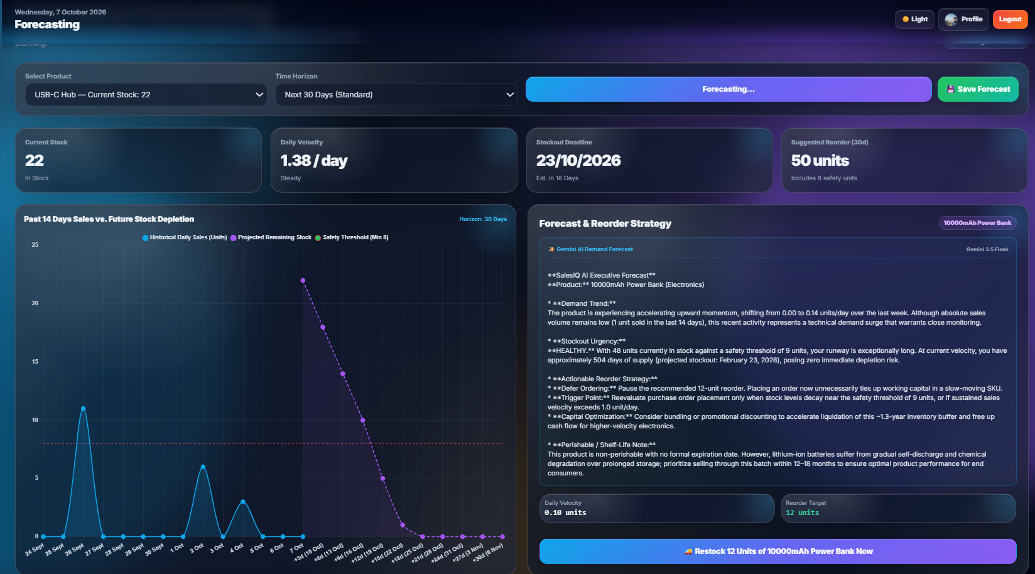
Figure 4.12: Predictive Stock-Out & Reorder Forecasting Interface
4.4.4 Gemini AI Strategic Insights & Business Advisor
An AI conversational interface powered by Google Gemini that analyzes sales records, profit margins, and batch expiry risks to deliver actionable executive advice in natural language.
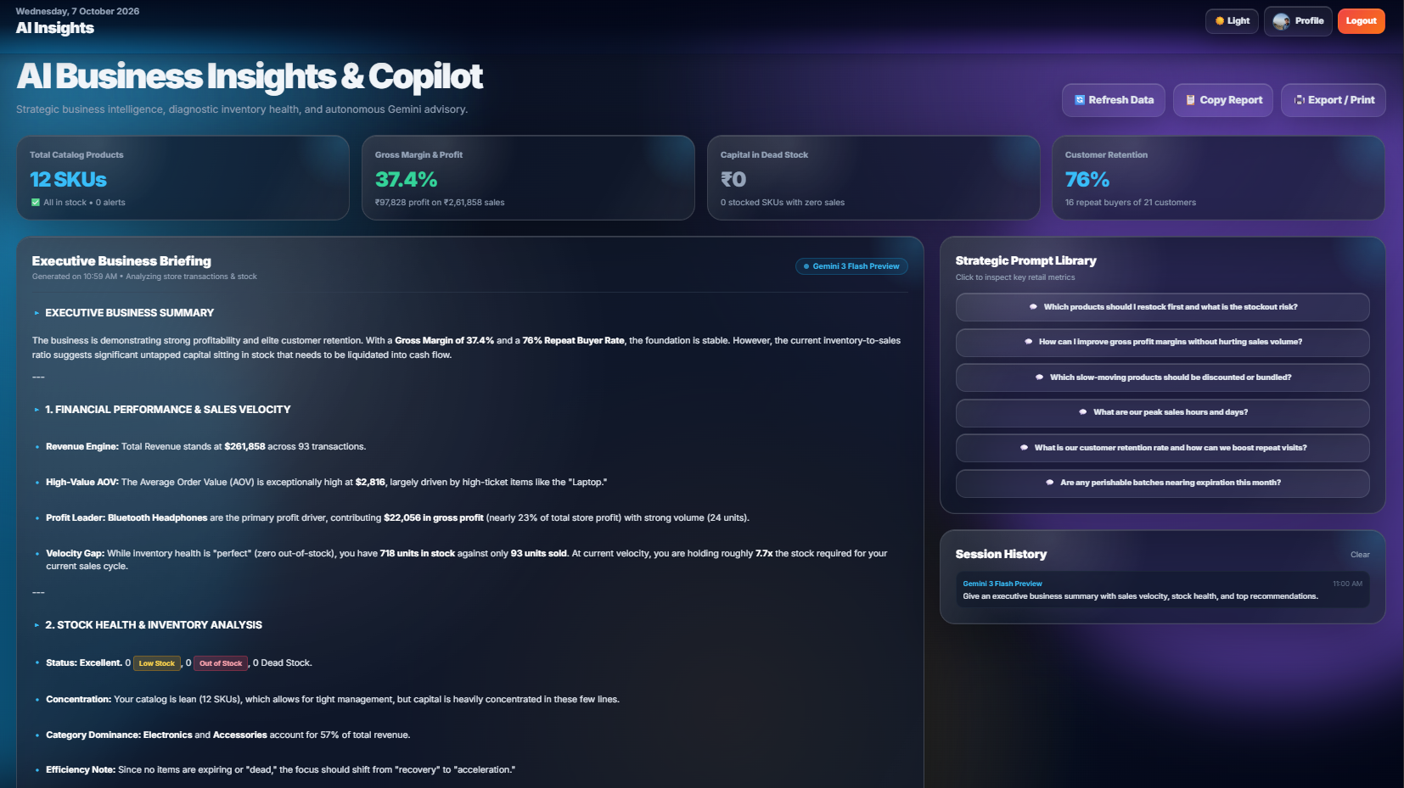
Figure 4.13: Gemini AI Strategic Insights & Business Assistant

5. SYSTEM TESTING
5.1 System Testing Methodology
Rigorous verification and validation procedures were applied across all functional modules prior to deployment. Testing evaluated unit logic, end-to-end integration, reactive cross-device synchronization, and edge-case boundary conditions. The testing strategy comprised two core vectors: Output Testing (confirming arithmetic and visual correctness of analytics) and Validation Testing (verifying form constraints and error prevention).
- Unit Testing: Each component (Admin Dashboard, Staff POS, Catalog, Disposals, Forecasting) was tested in isolation using simulated inputs.
- Integration Testing: Inter-module flows, such as POS sales immediately triggering batch deduction, KPI tile updates, and alert generation, were validated end-to-end.
- Cross-Browser Verification: Executed simultaneously across Google Chrome, Microsoft Edge, Mozilla Firefox, and Safari on desktop and mobile viewports.
- Real-Time Synchronization: Verified by executing a sale on one device and confirming the Admin dashboard updated within 500ms on a separate remote computer.
5.1.1 Output Testing
Output testing confirmed that analytical calculations, stock counters, and invoice totals match Firestore records with 100% precision.
Test Case ID | Input / Action | Expected Output | Actual Output | Result
TC-01 | Staff completes a sale of 3 units of an item. | Product stock decreases by 3; sale appears instantly on Admin dashboard. | Stock reduced by 3; transaction appeared in real-time on Admin view. | PASS
TC-02 | Product stock falls below reorder threshold (minStock). | Product flagged as 'Low Stock' with warning badge on catalog & KPI card. | Product flagged as 'Low Stock' with warning badge; alert generated. | PASS
TC-03 | Admin opens dashboard after multiple counter sales. | Total revenue & order count match exact sum of Firestore sales documents. | Dashboard totals matched Firestore sum with zero discrepancy. | PASS
TC-04 | Admin queries Gemini AI: 'What was my best selling category today?' | Assistant analyzes sales history and identifies top-performing category. | AI correctly identified top category with revenue breakdown and suggestions. | PASS

5.1.2 Validation Testing
Validation testing verified that boundary values, malformed inputs, and unauthorized URL accesses are gracefully rejected.
Test Case ID | Input Condition | Expected Validation Behavior | Actual Behavior Observed | Result
TC-05 | Sale quantity entered as 0, negative, or empty. | Blocks submission; displays 'Enter a valid quantity' toast warning. | Form blocked submission; displayed validation error toast. | PASS
TC-06 | Sale quantity exceeds currently available physical stock. | Blocks transaction; displays 'Insufficient stock available' alert. | Transaction blocked; user alerted to available stock limit. | PASS
TC-07 | Staff email or username omitted during registration. | Blocks account creation; highlights required input fields. | Submission blocked; browser and toast required field alerts shown. | PASS
TC-08 | Invalid email syntax submitted (e.g. missing @ or domain). | Rejects input with 'Enter a valid email address' notification. | Rejected input; highlighted invalid syntax. | PASS
TC-09 | Unauthenticated user navigates directly to /admin/dashboard.html. | Access blocked; immediately redirects user to /login.html. | Auth guard intercepted request and redirected to login page. | PASS

6. CONCLUSION AND FUTURE ENHANCEMENT
6.1 Conclusion
SalesIQ successfully delivers a cohesive, cloud-native Point of Sale, inventory management, and predictive intelligence platform tailored for retail businesses. By replacing disconnected spreadsheets and manual ledgers with a centralized real-time web dashboard, the system eliminates human calculation errors, mitigates stock discrepancies, and provides immediate visibility into store performance.
Key milestones accomplished by the project include:
- Sub-second live data propagation between cashier billing counters and executive dashboards using Cloud Firestore snapshot listeners.
- Automated First Expiring, First Out (FEFO) batch deduction, minimizing waste and write-offs of perishable goods.
- Multi-tier client caching (IndexedDB + memory) ensuring instantaneous 0ms page transitions even on modest retail hardware.
- Integration of the Google Gemini AI reasoning engine, elevating SalesIQ from a passive record-keeper to an active strategic business advisor.
The project completely fulfills its academic and technical objectives, providing a robust, production-ready foundation for modern retail operations.
6.2 Future Enhancements
- 1. Automated Vendor Purchase Orders: Direct electronic purchase order generation and email dispatch to registered vendors when stock-out forecasts reach critical thresholds.
- 2. Customer Loyalty & Mobile Wallet: Dedicated customer portal allowing shoppers to view purchase histories, collect loyalty rewards, and receive digital invoices via SMS/WhatsApp.
- 3. Multi-Branch & Chain Management: Hierarchical enterprise support enabling multi-store chains to manage independent branch inventories with consolidated corporate headquarters analytics.
- 4. Mobile Companion Applications: Native Android and iOS mobile applications built on Flutter, connecting to the existing Firebase backend for on-the-go floor auditing.
- 5. IoT Smart Shelf Integration: Integration with smart shelf weight sensors and BLE beacons to detect physical item depletion automatically.

7. BIBLIOGRAPHY & REFERENCES
7.1 Books References
- Sommerville, Ian. “Software Engineering”, 10th Edition, Pearson Education, 2016.
- Pressman, Roger S., and Bruce R. Maxim. “Software Engineering: A Practitioner’s Approach”, 9th Edition, McGraw-Hill Education, 2020.
- Booch, Grady, James Rumbaugh, and Ivar Jacobson. “The Unified Modeling Language User Guide”, 2nd Edition, Addison-Wesley, 2005.
- Elmasri, Ramez, and Shamkant B. Navathe. “Fundamentals of Database Systems”, 7th Edition, Pearson Education, 2016.
- Flanagan, David. “JavaScript: The Definitive Guide”, 7th Edition, O'Reilly Media, 2020.
7.2 Web References
- Google Firebase Official Documentation — https://firebase.google.com/docs
- Google Cloud Firestore Documentation & Security Rules Guide — https://firebase.google.com/docs/firestore
- Google Gemini API & AI Studio Developer Documentation — https://ai.google.dev/docs
- Tailwind CSS Documentation & Utility-First Architecture — https://tailwindcss.com/docs
- Chart.js Responsive HTML5 Canvas Charting Documentation — https://www.chartjs.org/docs
- MDN Web Docs (HTML5 Semantic Markup, ECMAScript Modules, IndexedDB API) — https://developer.mozilla.org
- Ganpat University Academic Regulations & Project Guidelines — https://www.ganpatuniversity.ac.in

