Experiment Summary Charts
APMCM 2026 B experiment figure pack (as of July 19, 2026)
This document summarizes 12 formal experiments. Smoke tests are excluded. The current best run is v3.4 v3.0 + CBAM, with test accuracy 86.35% and Macro F1 0.8646.
Key takeaway: pretraining, label smoothing, and CBAM are the strongest improvements so far.
Formal run folders follow the vX.Y_change naming rule so each version also records its key modification.
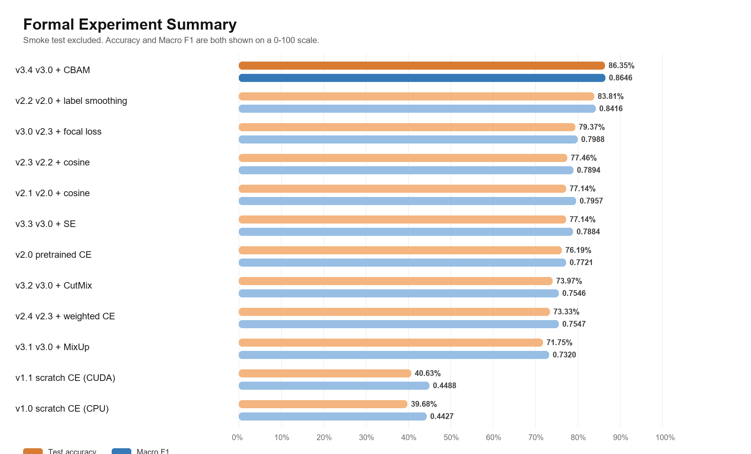
Figure 1. Test accuracy and Macro F1 across the 12 formal experiments.
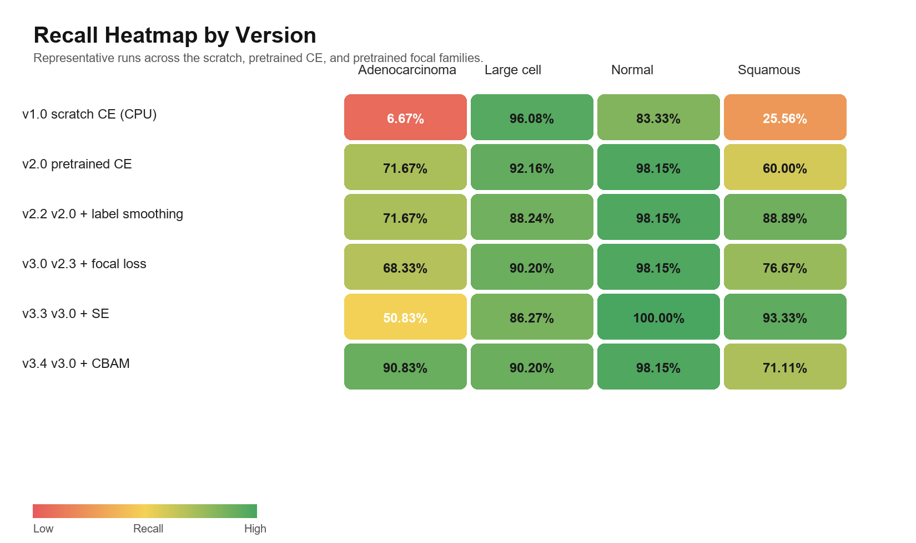
Figure 2. Per-class recall heatmap for representative experiment versions.
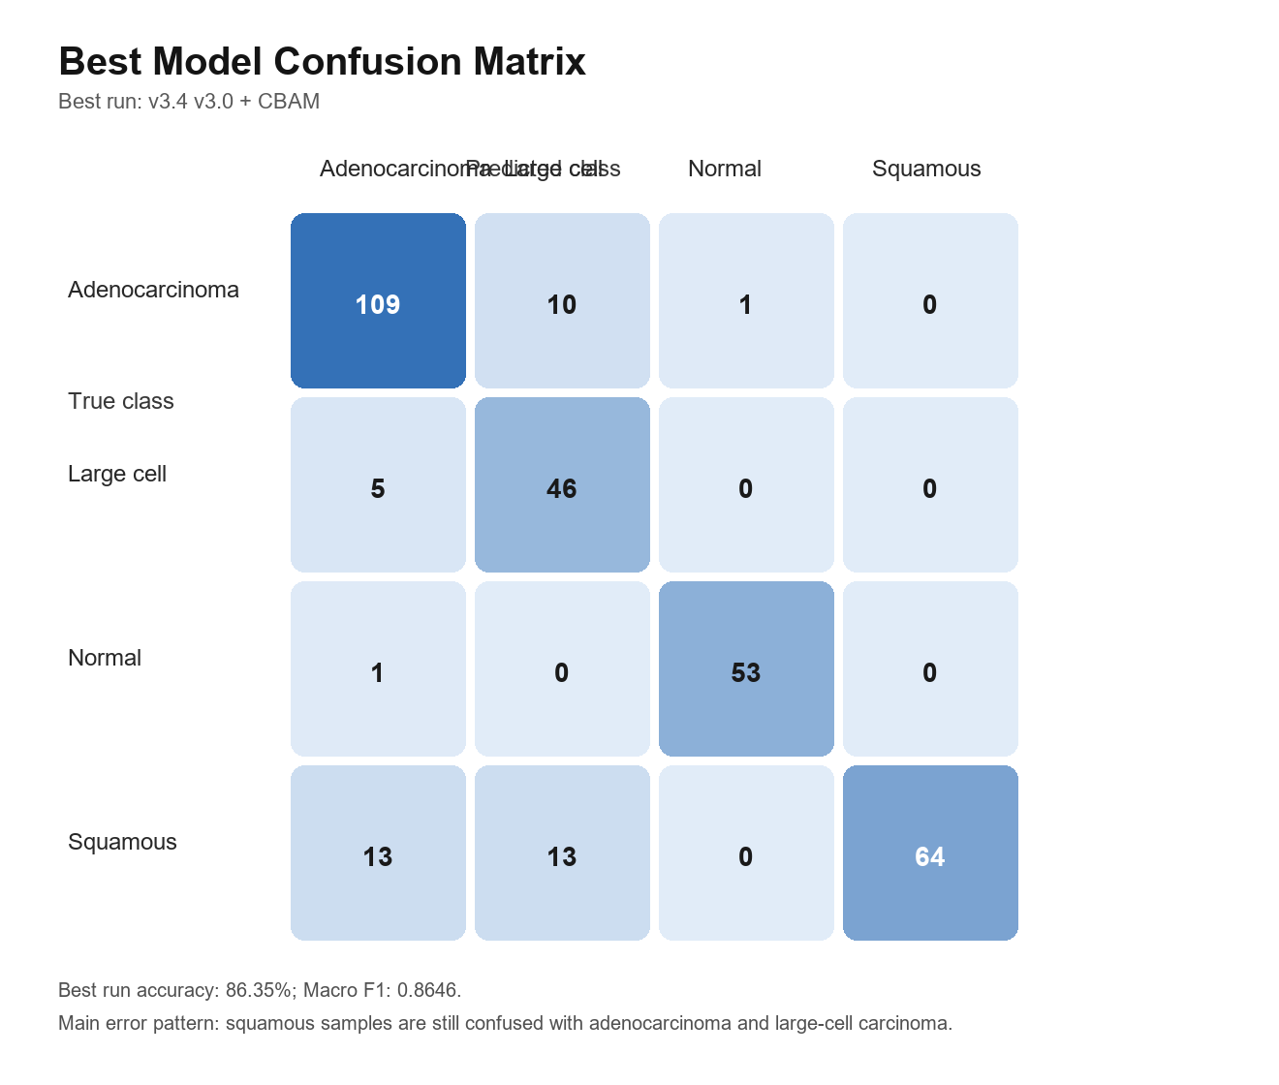
Figure 3. Test confusion matrix of the current best model v3.4_pretrained_focal_ls_cosine_cbam.
Short oral summary
1. The 12 formal experiments are complete, and the project has moved into the optimization stage.
2. The strongest current line is v3.x: pretrained + focal + label smoothing + cosine.
3. The best current result is v3.4_pretrained_focal_ls_cosine_cbam with 86.35% test accuracy and Macro F1 0.8646.
4. The next focus remains squamous recall and error analysis.

