Rich Field Report

1. Test Campaign
The measurement team ran three cells for 1200 cycles at 25 degrees.
The chart below summarises the retained capacity per cell.
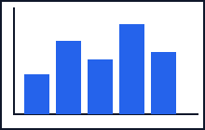
Figure 1: capacity retained after the campaign. Cell A-103 sits at the review threshold.
Cell | Cycles | Capacity
A-101 | 500 | 92 percent
A-102 | 800 | 88 percent
A-103 | 1200 | 71 percent
Conclusion: two cells passed, one is flagged for review.

