# Project Report

**Course: Mobile App Development**

**Institution: Karakoram International University, Gilgit**

**Instructor: Mr. Mujahid Hussain**

**Reporter: Saliha Nishad Farid**

**Project Title: My Profile App**

**GitHub Project Link:**  **https://github.com/Saliha-Nishat/flutter_app-Screen**

## 1. Objective

The objective of this project was to develop a simple and interactive Flutter application that demonstrates the use of basic widgets, layouts, navigation, and Material Design principles. The project aimed to help students gain practical experience in building user interfaces and managing multiple screens in a Flutter environment.

## 2. Learning Outcomes

i) Use core Flutter widgets like Text, Image, Column, Row, and Container  
ii) Apply layout widgets such as Padding, Align, and Card  
iii) Implement navigation between multiple screens  
iv) Use custom widgets for code reusability  
v) Understand and apply Material Design principles in a real Flutter app

## 3. Project Description

The project is a personal profile app named 'My Profile App' consisting of three screens:

1. Welcome Screen  
 Features a light blue background and centered text: 'Welcome to My Profile'.  
 Includes a white 'View Profile' button to navigate to the Profile Screen.  
  
2. Profile Screen  
 i) Displays a circular profile image, name, profession, and a short bio.  
 ii) Contact info (email, phone, location) shown in a Card layout.  
iii) Social media icons added using IconButton widgets.  
iv) Floating Action Button (FAB) navigates to the About Me screen.  
  
3. About Me Screen  
i) Contains sections for Education, Skills, and Hobbies.  
ii) Uses ListView and Chip widgets for layout.  
ii) Includes a Back button to return to Profile Screen.

## 4. UI Design & Implementation

Used MaterialApp and Scaffold for structure, with custom colors and typography. Cards, Containers, and Padding were used for layout organization. The app is responsive and works across different screen sizes.

**5. Design Choices & Description**

## Overall Design Theme

The app follows a simple, modern, and elegant design inspired by Material Design principles. I chose teal and light blue as the primary color palette because they give a calm, professional, and visually clean look that matches a personal or portfolio-style app. The layout is designed to be centered, symmetrical, and responsive, ensuring the UI looks good on all screen sizes.

## Welcome Screen (Home Page)

Background: A soft light blue background was used to create a friendly and welcoming atmosphere.  
Typography: The title “Welcome to My Profile” is displayed using a large, bold white font with a subtle shadow.  
Button: The “View My Profile” button is styled with teal color and rounded corners.  
Navigation: On tap, the button navigates to the Profile Screen, providing smooth flow between screens.

## Profile Screen

AppBar: Simple teal AppBar with the title 'My Profile'.  
Profile Picture: Circular avatar with teal border for visual focus.  
Name & Profession: 'Saliha Nishad' in bold, 'Flutter Developer' in italic teal font.  
Short Bio: A 2–3 line description to give a personal touch, center-aligned.  
Contact Info: Cards with icons for Email, Phone, and Location, neatly arranged.  
Social Media: Three teal icons (LinkedIn, GitHub, Twitter) in a row.  
FAB: Floating Action Button labeled 'About Me' for navigation to next screen.

## About Me Screen

AppBar: Retains teal color for consistency.  
Layout: Single-column ListView with padding for readability.  
Text: Introductory paragraph describing personality and passion.  
Navigation: Back button to return to Profile Screen.

## UI Components and Widgets Used

Scaffold – for screen structure.  
MaterialApp – for theming and routes.  
Column & Row – for layout organization.  
Card, Padding, Container – for spacing and layout.  
ListTile – for contact details.  
CircleAvatar – for profile image.  
ElevatedButton & FAB – for navigation.

## User Experience (UX) Goals

Simplicity – minimal and clutter-free.  
Consistency – unified colors and typography.  
Responsiveness – adapts to screen sizes.  
Intuitive Navigation – easy movement between screens.

## Future Improvements (Optional Ideas)

Add dark mode toggle.  
Include BottomNavigationBar instead of FAB.  
Store user data in JSON or local database for dynamic updates.

## 6. Technologies & Tools Used

Framework: Flutter  
Language: Dart  
IDE: Visual Studio Code  
Platform: Flutter Web / Android Emulator  
Widgets: Text, Column, Row, Image, Card, IconButton, FloatingActionButton, ListView, Chip

## 7. Testing & Output

The app successfully displayed all three screens with proper navigation. The Welcome Screen showed the correct background color and button. The design followed Material Design standards and was functional on Chrome.

## 8. Conclusion

The 'My Profile App' project provided valuable experience in using Flutter's widget-based architecture. It improved understanding of UI design, navigation, and app structure. Overall, it enhanced confidence in using Flutter for real-world applications.

**9.**

## 10. Screenshots

Screenshots of each screen are inserted here.

**Code of App Screen**

import 'package:flutter/material.dart';

void main() {

  runApp(MyProfileApp());

}

class MyProfileApp extends StatelessWidget {

  @override

  Widget build(BuildContext context) {

    return MaterialApp(

      title: 'My Profile App',

      debugShowCheckedModeBanner: false,

      theme: ThemeData(

        primarySwatch: Colors.teal,

        fontFamily: 'Roboto',

      ),

      home: WelcomeScreen(),

      routes: {

        '/profile': (context) => ProfileScreen(),

        '/about': (context) => AboutScreen(),

      },

    );

  }

}

// -------------------------------------------------------------

// 🌸 Screen 1: Welcome Screen

// -------------------------------------------------------------

class WelcomeScreen extends StatelessWidget {

  @override

  Widget build(BuildContext context) {

    return Scaffold(

      body: Container(

        decoration: BoxDecoration(

          gradient: LinearGradient(

            colors: [Colors.teal.shade200, Colors.teal.shade800],

            begin: Alignment.topLeft,

            end: Alignment.bottomRight,

          ),

        ),

        child: Center(

          child: Column(

            mainAxisAlignment: MainAxisAlignment.center,

            children: [

              Text(

                'Welcome to My Profile',

                style: TextStyle(

                  fontSize: 28,

                  fontWeight: FontWeight.bold,

                  color: Colors.white,

                ),

              ),

              const SizedBox(height: 40),

              ElevatedButton(

                onPressed: () {

                  Navigator.pushNamed(context, '/profile');

                },

                child: const Text('View Profile'),

                style: ElevatedButton.styleFrom(

                  backgroundColor: Colors.white,

                  foregroundColor: Colors.teal,

                  padding: EdgeInsets.symmetric(horizontal: 30, vertical: 15),

                  shape: RoundedRectangleBorder(

                    borderRadius: BorderRadius.circular(30),

                  ),

                ),

              ),

            ],

          ),

        ),

      ),

    );

  }

}

// -------------------------------------------------------------

// 👤 Screen 2: Profile Screen

// -------------------------------------------------------------

class ProfileScreen extends StatelessWidget {

  final String profileImage = 'assets/profile.jpg'; // Add this image in assets

  @override

  Widget build(BuildContext context) {

    return Scaffold(

      appBar: AppBar(title: Text('My Profile')),

      floatingActionButton: FloatingActionButton(

        onPressed: () {

          Navigator.pushNamed(context, '/about');

        },

        child: Icon(Icons.info_outline),

      ),

      body: SingleChildScrollView(

        padding: EdgeInsets.all(16),

        child: Column(

          children: [

            CircleAvatar(

              radius: 70,

              backgroundImage: AssetImage(profileImage),

            ),

            SizedBox(height: 16),

            Text(

              'Saliha Nishad',

              style: TextStyle(fontSize: 24, fontWeight: FontWeight.bold),

            ),

            Text(

              'Flutter Developer',

              style: TextStyle(fontSize: 18, color: Colors.teal),

            ),

            SizedBox(height: 10),

            Text(

              'A passionate Flutter learner who loves building beautiful and functional apps.',

              textAlign: TextAlign.center,

            ),

            SizedBox(height: 20),

            Card(

              margin: EdgeInsets.symmetric(vertical: 10),

              elevation: 3,

              child: Padding(

                padding: const EdgeInsets.all(12.0),

                child: Column(

                  children: const [

                    InfoCard(icon: Icons.email, text: 'saliha@example.com'),

                    InfoCard(icon: Icons.phone, text: '+92 300 1234567'),

                    InfoCard(icon: Icons.location_on, text: 'Gilgit, Pakistan'),

                  ],

                ),

              ),

            ),

            SizedBox(height: 10),

            Row(

              mainAxisAlignment: MainAxisAlignment.center,

              children: const [

                IconButton(onPressed: null, icon: Icon(Icons.link)),

                IconButton(onPressed: null, icon: Icon(Icons.code)),

                IconButton(onPressed: null, icon: Icon(Icons.alternate_email)),

              ],

            ),

          ],

        ),

      ),

    );

  }

}

// -------------------------------------------------------------

// 📇 InfoCard Widget (Reusable)

// -------------------------------------------------------------

class InfoCard extends StatelessWidget {

  final IconData icon;

  final String text;

  const InfoCard({required this.icon, required this.text});

  @override

  Widget build(BuildContext context) {

    return Padding(

      padding: const EdgeInsets.symmetric(vertical: 8.0),

      child: Row(

        children: [

          Icon(icon, color: Colors.teal),

          SizedBox(width: 10),

          Text(text, style: TextStyle(fontSize: 16)),

        ],

      ),

    );

  }

}

// -------------------------------------------------------------

// 📘 Screen 3: About Me Page

// -------------------------------------------------------------

class AboutScreen extends StatelessWidget {

  const AboutScreen({super.key});

  @override

  Widget build(BuildContext context) {

    return Scaffold(

      appBar: AppBar(

        title: Text('About Me'),

        leading: IconButton(

          icon: Icon(Icons.arrow_back),

          onPressed: () => Navigator.pop(context),

        ),

      ),

      body: ListView(

        padding: EdgeInsets.all(16),

        children: [

          Text('Education',

              style: TextStyle(fontSize: 20, fontWeight: FontWeight.bold)),

          Text('BS Computer Science, Karakoram International University'),

          SizedBox(height: 20),

          Text('Skills',

              style: TextStyle(fontSize: 20, fontWeight: FontWeight.bold)),

          Wrap(

            spacing: 8,

            children: const [

              Chip(label: Text('Flutter')),

              Chip(label: Text('Dart')),

              Chip(label: Text('UI Design')),

              Chip(label: Text('GitHub')),

            ],

          ),

          SizedBox(height: 20),

          Text('Hobbies',

              style: TextStyle(fontSize: 20, fontWeight: FontWeight.bold)),

          Text(

              'Reading, Learning new technologies, Exploring nature, and Designing.'),

        ],

      ),

    );

  }

}

**Output of the code**

1. 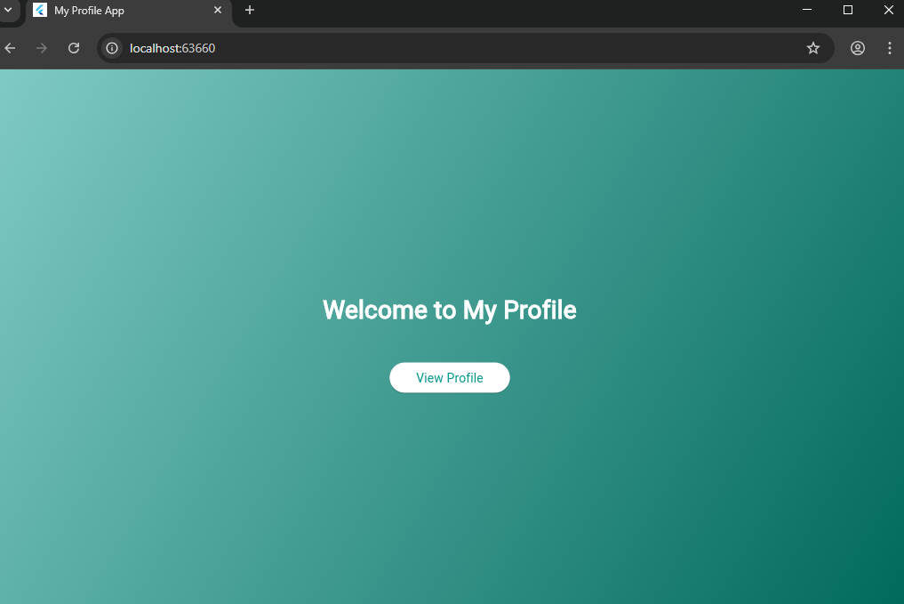**Screen 1**

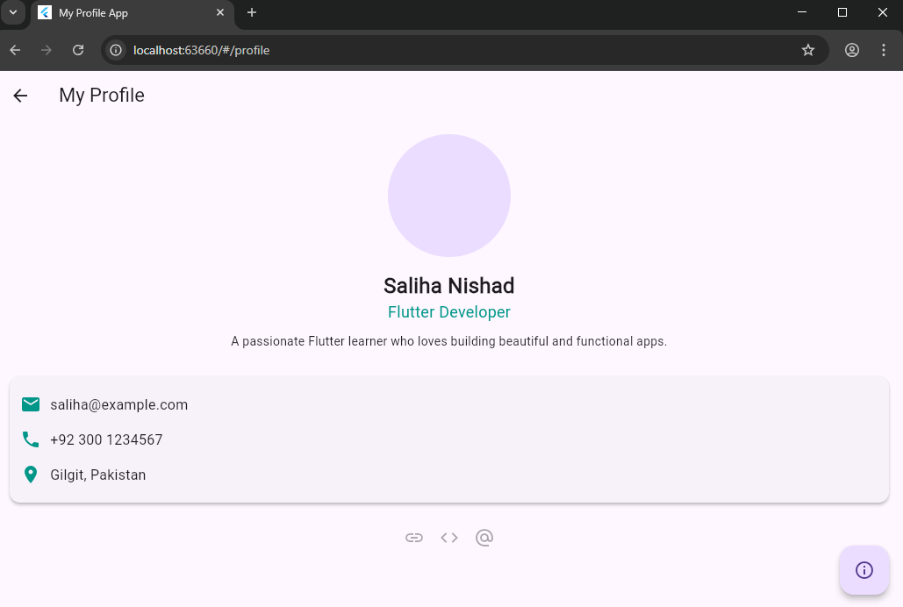

1. 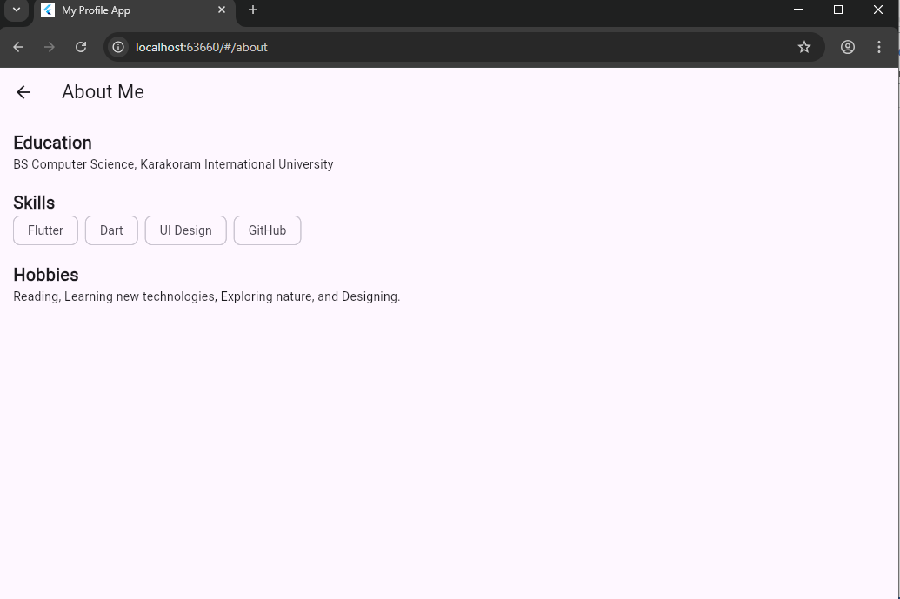**Screen 3**