**Saliha Aziz**

**Sp20-bse-017**

**Mobile Application Development**

**Lab Assignment # 2**

**Output file**

**Original:**

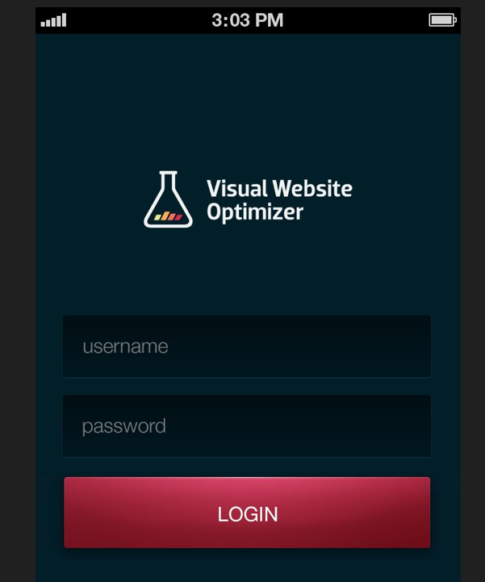

**Design:**

