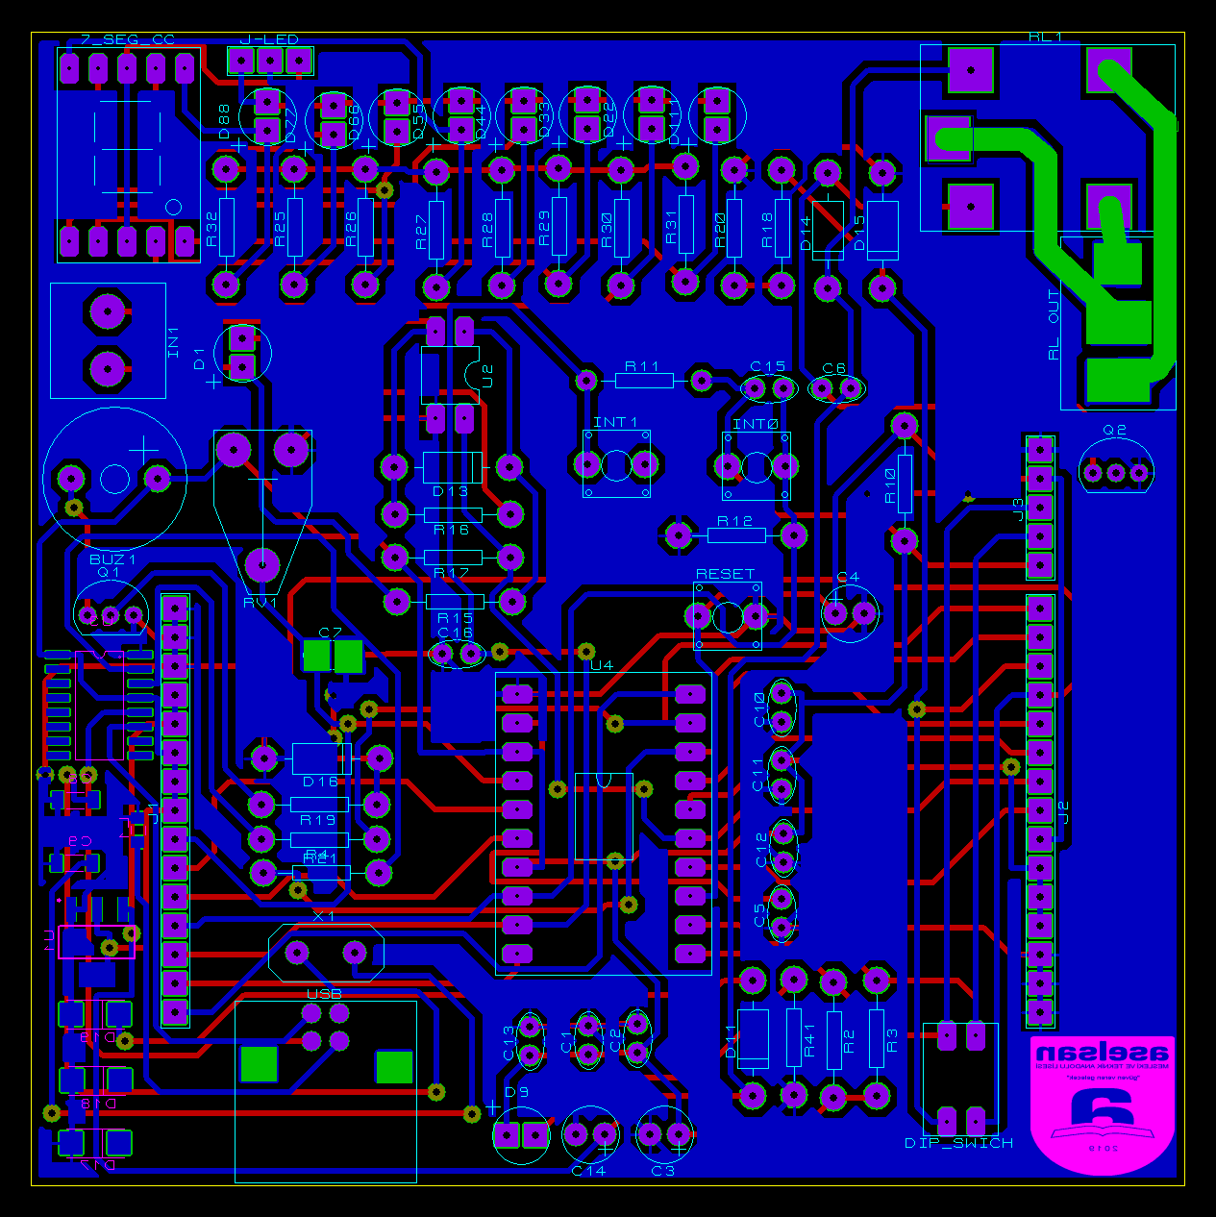

**GENEL BASKI DEVRE GÖRÜNÜŞÜ**

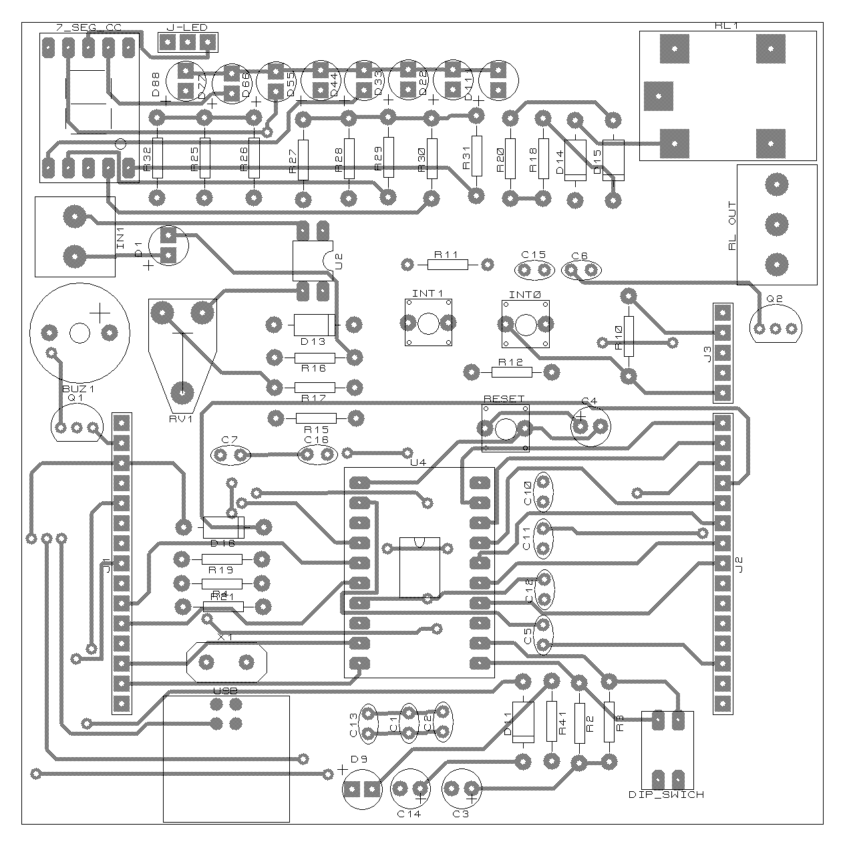

**ÜST KATMAN YERLEŞİM PLANI**

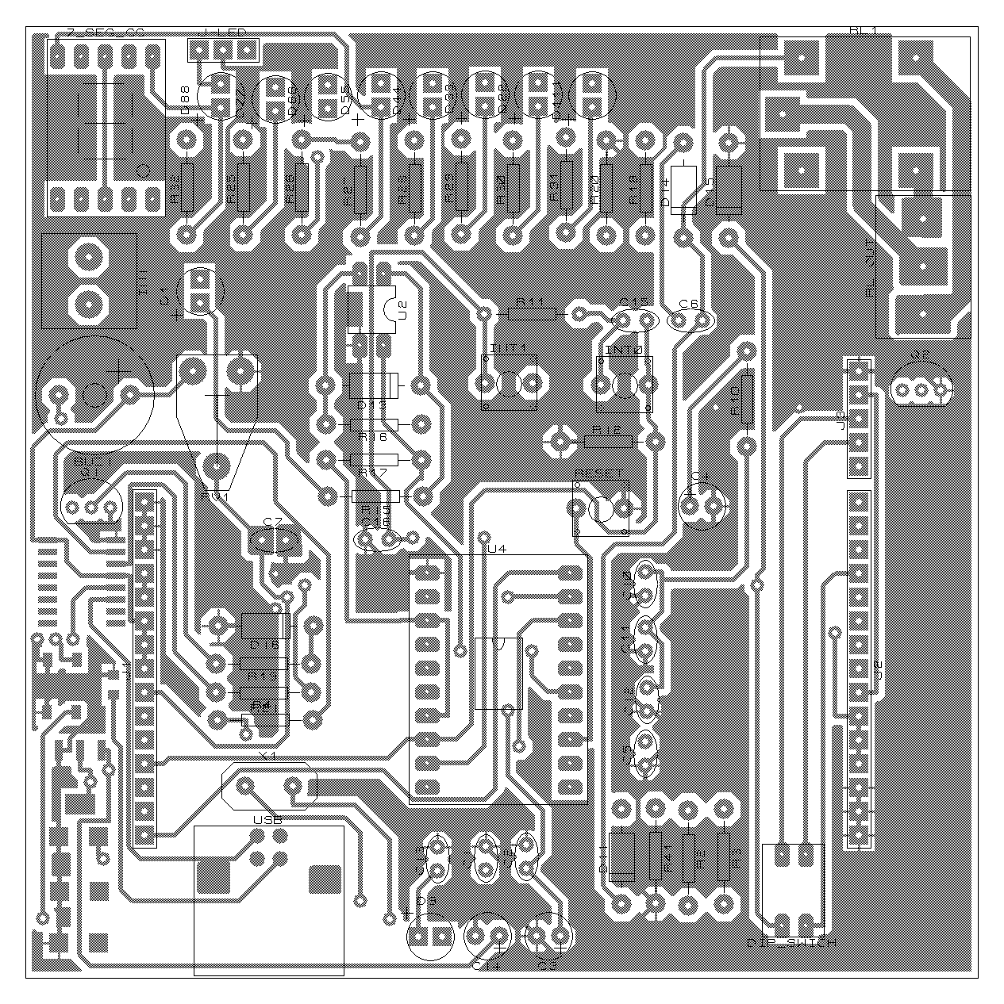

**ALT KATMAN YERLEŞİM PLANI**

|  |  |  |  |  |  |
| --- | --- | --- | --- | --- | --- |
| **Bill Of Materials for 41** | |  |  |  |  |
|  |  |  |  |  |  |
| **Design Title** | | | 41 | |  |
| **Author** | | |  | |  |
| **Document Number** | | |  | |  |
| **Revision** | | |  | |  |
| **Design Created** | | | 21 Şubat 2023 Salı | |  |
| **Design Last Modified** | | | 26 Nisan 2023 Çarşamba | |  |
| **Total Parts In Design** | | | 79 | |  |
|  |  |  |  |  |  |
| **Category** | **Quantity** | **References** | **Value** | **PCB Package** |  |
| Capacitors | 1 | C1 | 220nF | CAP10 |  |
| Capacitors | 5 | C2,C7,C11,C13,C16 | 100nF | CAP10 |  |
| Capacitors | 2 | C3-C4 | 10uF | ELEC-RAD10 |  |
| Capacitors | 3 | C5-C6,C10 | 1uF | CAP10 |  |
| Capacitors | 2 | C8-C9 | 22pF | 1206 |  |
| Capacitors | 1 | C12 | 10nF | CAP10 |  |
| Capacitors | 1 | C14 | 1uF | ELEC-RAD10 |  |
| Capacitors | 1 | C15 | 100uF | CAP10 |  |
| Resistors | 8 | R2-R3,R10-R12,R18-R20 | 10k | RES40 |  |
| Resistors | 2 | R4,R21 | 1k | RES40 |  |
| Resistors | 2 | R15,R17 | 4k7 | RES40 |  |
| Resistors | 1 | R16 | 1.2k | RES40 |  |
| Resistors | 8 | R25-R32 | 220 | RES40 |  |
| Resistors | 1 | R41 | 470 | RES40 |  |
| Integrated Circuits | 1 | U1 | LM1117MP-3,3 | SOT230P700X180-4 |  |
| Integrated Circuits | 1 | U2 | PC817 | DIL04 |  |
| Integrated Circuits | 1 | U3 |  | SOP16 |  |
| Integrated Circuits | 1 | U4 |  | M031FB0AE |  |
| Transistors | 2 | Q1-Q2 | BC337 | TO92 |  |
| Diodes | 10 | D1,D9,D22,D33,D44,D55,D66,D77,D88,D111 | LED | LED |  |
| Diodes | 5 | D11,D13-D16 | 1N4001 | DO41 |  |
| Diodes | 3 | D17-D19 | SMAJ7 | DO214 |  |
| Miscellaneous | 1 | 7_SEG_CC |  | 7SEG |  |
| Miscellaneous | 1 | BUZ1 | BUZZER | BUZZERRR |  |
| Miscellaneous | 1 | DIP_SWICH |  | DIP_SWTCH |  |
| Miscellaneous | 1 | IN1 | TBLOCK-I2 | TBLOCK-I2 |  |
| Miscellaneous | 3 | INT0-INT1,RESET |  | BUTTON |  |
| Miscellaneous | 2 | J1-J2 | CONN-H15 | CONN-SIL15 |  |
| Miscellaneous | 1 | J3 | TBLOCK-I5 | CONN-SIL5 |  |
| Miscellaneous | 1 | J-LED | TBLOCK-I3 | CONN-SIL3 |  |
| Miscellaneous | 1 | L1 | MMZ1608R300A | 0805 |  |
| Miscellaneous | 1 | RL1 | G5CLE-1-DC5 | RLY-OMRON-C4 |  |
| Miscellaneous | 1 | RL OUT | TBLOCK-I3 | TBLOCK-I3 |  |
| Miscellaneous | 1 | RV1 | 10k | PRE-HMIN |  |
| Miscellaneous | 1 | USB | TBLOCK-I4 | USB-B |  |
| Miscellaneous | 1 | X1 | CRYSTAL | XTAL18 |  |

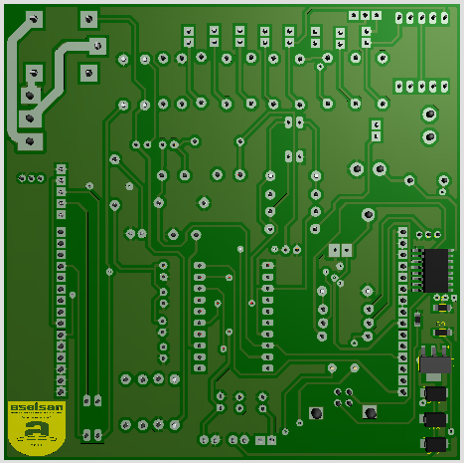

**ALT KATMAN 3D GÖRÜNTÜ**

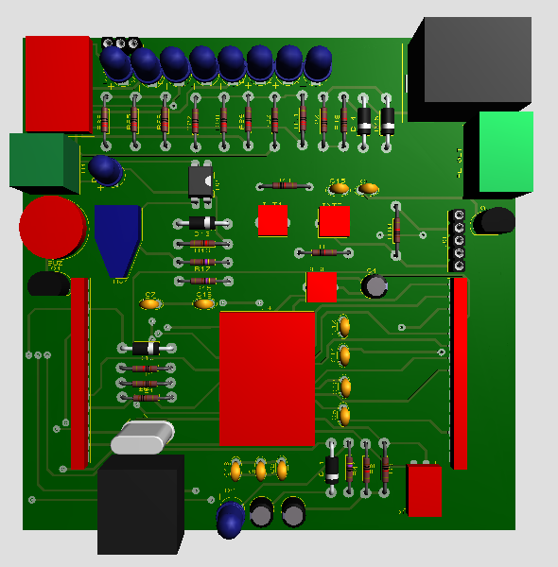

**ÜST KATMAN 3D GÖRÜNTÜ**