Proposal Revision Package — v2
AI Chatbot with Mood Detection — FER Reinstated per Stakeholder Requirement
Pregnancy Support System (MaternaLink) — Project ID R26-IT-146
Livera S.D — IT22638168
How to use this document
This is v2 of the revision package, superseding the previous text-only version. It reinstates facial emotion recognition (FER) as a third mood-detection signal, per confirmed stakeholder requirement, while carrying forward the risk mitigations identified during the earlier simplification review (head-pose sensitivity, on-device privacy, consent flow). Merge into the original proposal report at the same section numbers as before: 1.2–1.3, 2, 3, 4, 8–9.

Summary of Changes from the Text-Only Revision
Facial emotion recognition returns as a third mood signal alongside bilingual text sentiment and typing/response-delay behaviour. The known technical risk identified earlier — 2D FER accuracy degrading sharply at the downward head angle typical of phone use — is not solved by reinstating the model; it is carried forward as a stated, mitigated limitation rather than an unaddressed one.
Area | Text-only revision | v2 — FER reinstated
Mood signals | Bilingual sentiment + typing/delay (2 signals) | Facial expression + bilingual sentiment + typing/delay (3 signals)
Facial signal design | N/A | On-device TFLite inference; confidence-threshold filtering discards low-confidence (likely off-angle) frames; Exponential Moving Average (EMA) smooths per-frame noise before fusion
Fusion weights | Text 70% / Behaviour 30% | Facial 45% / Text 40% / Behaviour 15% — initial values, empirically tuned in testing as before
Datasets | None required (no training) | FER-2013 + AffectNet reinstated for MobileNetV2 transfer learning
Tools | Node.js-only stack | Adds TensorFlow Lite, Python + Keras (training only, not runtime), Expo Camera API, Google Colab Pro
Privacy/consent | N/A | Bilingual consent notice before first camera use; one-tap opt-out (falls back to text + behaviour signals only); raw frames discarded immediately after inference, never stored or transmitted
Risk register | R1, R6, R9 removed | R1 (FER accuracy), R6 (camera privacy), R9 (skin-tone bias) reinstated, each with a stated mitigation rather than left open
WBS | 10 tasks | 12 tasks — FER dataset prep and model training restored as T3–T4
Budget | ~LKR 36,500 (Colab Pro removed) | ~LKR 44,000 (Colab Pro reinstated for training compute)

Note on the earlier head-pose concern
This is a real, literature-confirmed accuracy risk for 2D FER systems at non-frontal angles, not a hypothetical. Reinstating FER does not remove that risk — it means the proposal now needs to name it explicitly and show a mitigation, which Sections 3.2.2 and Appendix D (risk R1) below do. An examiner is more likely to accept a known limitation that is measured and mitigated than one that is quietly omitted.

2. Objective (v2)

2.1 Main Objective
To design and build an AI-powered chatbot module within the MaternaLink pregnancy support application that tracks the emotional wellbeing of pregnant women in Sri Lanka in real time through on-device facial expression recognition, bilingual (Sinhala/English) text sentiment analysis, and passive typing-behaviour signals, responds in Sinhala and English with conversation that adjusts to how she is feeling, and provides culturally appropriate therapeutic music recommendations, with all chat history and content stored locally for full offline access.

2.2 Specific Objectives

Objective 1 — Bilingual Chatbot Interface
Unchanged: a chatbot screen in Sinhala Unicode and English, warm and culturally appropriate in tone, reviewed by a Sinhala language consultant.

Objective 2 — Mood Detection Module
Implement three passive mood signals: (a) on-device facial expression recognition via a MobileNetV2 transfer-learning model fine-tuned on FER-2013 and AffectNet, exported to TFLite, with confidence-threshold filtering and Exponential Moving Average smoothing applied before the signal enters fusion; (b) bilingual text sentiment — a self-hosted DistilBERT transformer for English, a lexicon-based classifier for Sinhala; (c) typing-speed and response-delay signals from message timestamps. No signal requires deliberate input from the user.

Objective 3 — Mood Fusion and Adaptive Response Engine
Combine all three signals into a single mood score (facial 45% / text 40% / behaviour 15%, tuned empirically during testing). Inject this into the chatbot's system prompt so tone adjusts automatically, and trigger the music recommendation when a distress threshold is crossed.

Objective 4 — Offline Data Management
Unchanged: local chat history and music via AsyncStorage, plus a standalone JSON mood-history export for the doctor-facing MaternaLink component.

3. Methodology (v2)

3.1 Research Approach
Design Science Research, unchanged. Reinstating FER returns the component to three independently-risky subsystems; the WBS (Section 8) reallocates time accordingly, and the evaluation plan (Section 3.5) measures the facial signal's real-world accuracy explicitly rather than assuming it.

3.2 Technical Approach

3.2.1 The Bilingual Chatbot Interface
Unchanged from the previous revision: React Native (Expo) chat screen with Sinhala Unicode and English input.

3.2.2 Facial Emotion Recognition (Reinstated)
Every 30–40 seconds during an active chat session, the Expo Camera API captures a single front-camera frame, resized to 48×48 pixels, converted to greyscale, and normalised entirely on-device. The frame is passed through a MobileNetV2 model, pretrained on ImageNet and fine-tuned on FER-2013 and AffectNet, exported to TensorFlow Lite with a 3-class output (calm / mildly distressed / significantly distressed).
Two mitigations are applied to the known head-pose accuracy risk (a downward-angled phone-holding pose degrades 2D FER accuracy — this is a documented limitation of 2D facial expression systems, not specific to this implementation):
- Confidence-threshold filtering: frames where the model's top-class confidence falls below a set threshold are discarded rather than passed to fusion, on the basis that low confidence is often a symptom of a poor viewing angle rather than genuine ambiguity of expression.
- Temporal smoothing via Exponential Moving Average (EMA): smoothed_score = α × current_frame_score + (1 − α) × previous_smoothed_score (α ≈ 0.3–0.4). This prevents a single noisy or misclassified frame from causing a visible jump in the chatbot's tone, and is the 'soft average' behaviour specified in the original stakeholder requirement.
The raw camera frame is discarded immediately after inference; it is never stored on-device or transmitted. This is stated explicitly in the bilingual consent notice shown before first use, alongside a one-tap toggle to disable camera access, in which case the system continues operating on text and behavioural signals only (Objective 2's other two components are unaffected by this toggle).

3.2.3 Mood Detection — English
Unchanged from the previous revision: Xenova/distilbert-base-uncased-finetuned-sst-2-english via Transformers.js, self-hosted in the Node.js backend (Apache-2.0 licence, quantized to ~67MB). See the previous revision package for the full comparison against a lexicon-based scorer, a larger tweet-trained transformer, and single-call LLM classification, all of which still hold.

3.2.4 Mood Detection — Sinhala
Unchanged: lexicon-based, via the sentiment npm package's registerLanguage() extension (MIT licence) with an original ~150–250 word pregnancy-domain vocabulary, informed by Chathuranga, Lorensuhewa & Kalyani (2019).

3.2.5 Behavioural Signals
Unchanged: typing speed and response delay from existing message timestamps.

3.2.6 Mood Fusion Engine
With three signals reinstated, the fusion layer combines facial expression (45%), text sentiment (40%), and behavioural signals (15%) into a single 0–100 mood score. The facial weight is set below the original proposal's 50% specifically because the head-pose literature gives reason to trust it somewhat less than a frontal-assumption design would; all three weights are initial values, tuned empirically against self-report agreement during testing (Section 3.5).

3.2.7 Therapeutic Content and Offline Storage
Unchanged from the previous revision: a fixed set of ~10 bundled royalty-free tracks, mood-mapped by lookup table, with chat history and saved tracks stored in AsyncStorage for full offline access.

3.3 Tools and Platforms (v2)
Tool | Purpose | Licence
React Native (Expo) | Bilingual chatbot UI + front camera capture | MIT
Expo Camera API | Silent periodic frame capture during active chat | MIT
TensorFlow Lite | On-device FER inference; no image ever leaves the device | Apache-2.0
Python + Keras | FER model training and TFLite export (offline, not runtime) | Apache-2.0 / MIT
Google Colab Pro | GPU access for MobileNetV2 fine-tuning | N/A (paid service)
FER-2013 + AffectNet | Training data for the facial expression model | Open research licences
Node.js + Express | Backend: chat, text/behaviour mood detection, LLM integration | MIT
Transformers.js + DistilBERT SST-2 | English sentiment (quantized, self-hosted, ~67MB) | Apache-2.0
sentiment (npm) | Sinhala lexicon-based sentiment scoring | MIT
AsyncStorage (React Native) | Local offline chat history and music storage | MIT
LLM API | Chatbot response generation, mood-conditioned prompts | Per provider terms

3.4 Datasets and Resources (v2)
Resource | Type | Role
FER-2013 (~35,000 labelled images, 7 classes remapped to 3) | Training data | Base dataset for MobileNetV2 fine-tuning
AffectNet | Training data | Adds real-world condition diversity (lighting, partial occlusion) beyond FER-2013's more controlled images
~200-phrase labelled Sinhala pregnancy-context test set | Self-created (evaluation only) | Validates Sinhala lexicon accuracy
~100-phrase labelled English pregnancy-context test set | Self-created (evaluation only) | Validates DistilBERT accuracy outside its native movie-review domain
Held-out FER-2013/AffectNet test split | Evaluation only | FER model accuracy/precision/recall, measured at a range of head-pose angles where labels permit
Sinhala PASS-S (Priyadarshanie et al., 2020, BMC Psychiatry) | Validated clinical instrument | Ground truth for the self-report agreement evaluation

3.5 Evaluation Plan (v2)
What is measured | Target | How
FER model accuracy (3-class) | ≥ 65% on held-out test split | Precision/recall/F1 on FER-2013 + AffectNet held-out data; accuracy also reported separately for frontal vs. off-angle subsets where labels allow, to characterise the head-pose effect rather than assume it away
On-device FER inference time | < 3 seconds per frame | Timing logs on a mid-range Android test device
English sentiment accuracy | ≥ 80% on pregnancy-context test set | DistilBERT output vs. hand-labelled ~100-phrase set
Sinhala sentiment accuracy | ≥ 70% on pregnancy-context test set | Lexicon output vs. hand-labelled ~200-phrase set
Mood detection agreement with self-report | ≥ 70% agreement | Fused 3-signal mood score vs. Sinhala PASS-S self-report
Backend inference latency and RAM footprint (text/behaviour signals) | Documented and reported | Logged on the actual deployment platform
User satisfaction with chatbot tone | 4 out of 5 or above | Post-session questionnaire
Offline functionality | 100% accessible without internet | Airplane-mode test

4. High-Level System Architecture (v2)

4.1 Overview
The four-module structure is unchanged; Module 2 (Mood Detection) now produces three signal streams instead of two, and Module 3's fusion logic combines all three.
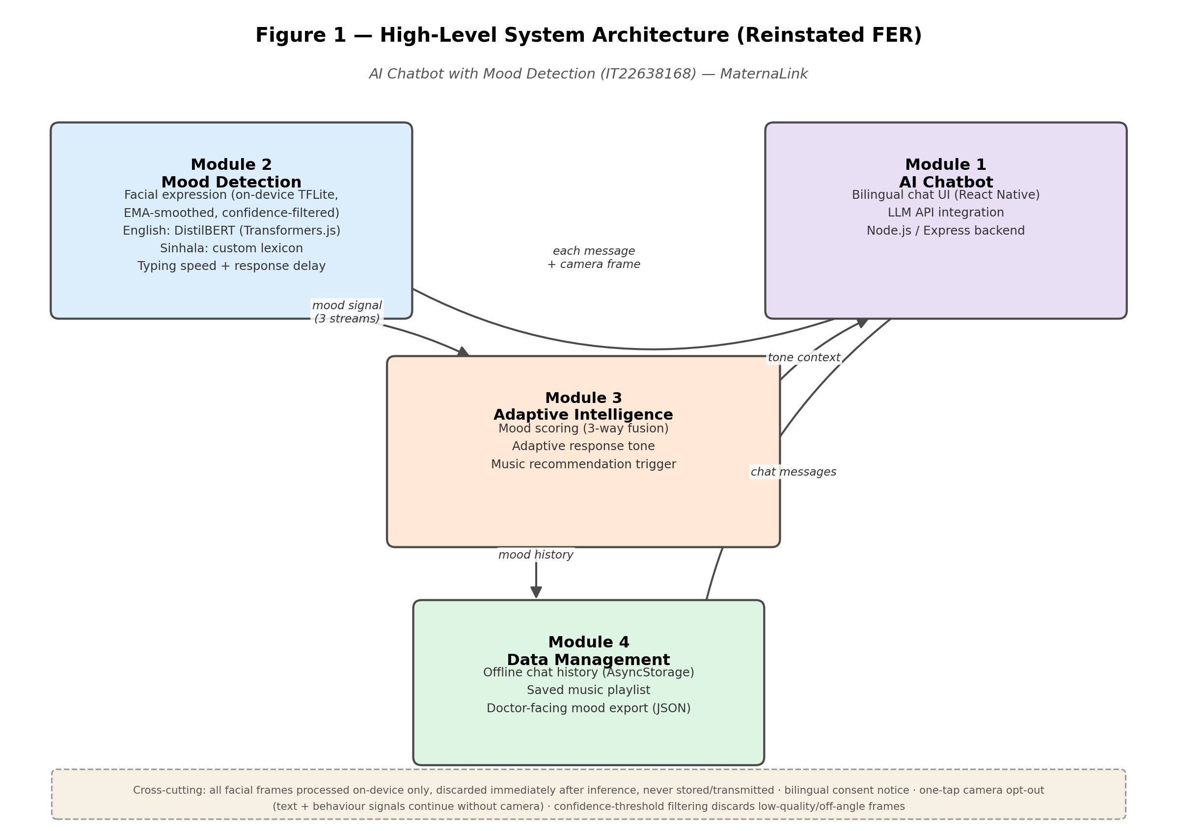
Figure 1 — High-level system architecture with facial expression recognition reinstated as a third signal.

4.2 Layer-by-Layer Description

Module 1 — AI Chatbot
Unchanged: bilingual chat interface, Node.js/Express backend, LLM API integration.

Module 2 — Mood Detection
Runs on every user message and every camera timer tick: facial expression via on-device TFLite (EMA-smoothed, confidence-filtered), English text via DistilBERT, Sinhala text via the custom lexicon, and typing/delay signals from timestamps.

Module 3 — Adaptive Intelligence
Combines all three Module 2 outputs into a single mood score (45% facial / 40% text / 15% behaviour), updates the chatbot's system prompt context, and triggers the music recommendation banner at the distress threshold.

Module 4 — Data Management
Unchanged: AsyncStorage for chat history and music, standalone JSON mood export for the doctor-facing component.

4.3 Data Flow — Step by Step
- User sends a message in Sinhala or English; it is saved to local storage immediately.
- The message is classified by Module 2's text pipeline (DistilBERT or lexicon) alongside typing speed and response delay.
- In parallel, the background camera timer (every 30–40s) captures a frame, runs it through the on-device FER model, applies confidence filtering, and updates the EMA-smoothed facial mood signal.
- Module 3 fuses all three signals into a mood score and updates the chatbot's system prompt context.
- The backend calls the LLM API with the mood-conditioned prompt; the response is tone-adjusted accordingly.
- If the mood score crosses the distress threshold, the music recommendation banner is triggered.
- The response is displayed and saved locally; the updated mood score is available for the next exchange.

8. Work Breakdown Structure (v2)
Reinstating FER dataset preparation and model training returns the WBS to twelve tasks. Testing (T11) remains expanded relative to the original proposal to include deployment benchmarking, and now also covers FER accuracy measurement across head-pose conditions.
ID | Task | Deliverable | Timeline
T1 | Literature review & gap analysis (verified sources) | Sections 1.2–1.3 with real, verified citations | Weeks 1–2
T2 | UI wireframes + AsyncStorage schema design | Figma wireframes and storage schema diagram | Week 3
T3 | FER dataset prep: FER-2013 + AffectNet, 3-class remap | Preprocessed dataset and augmentation pipeline ready | Weeks 3–4
T4 | FER model training (MobileNetV2 transfer learning) + TFLite export | Trained .tflite model with evaluation accuracy report | Weeks 4–6
T5 | Bilingual chatbot UI + camera capture integration | Working chat screen with background camera capture | Weeks 4–7
T6 | Text/behaviour mood detection (English DistilBERT + Sinhala lexicon) | Working module producing text/behaviour mood signals | Weeks 6–8
T7 | Mood fusion engine (3-way) + adaptive response logic | Fusion layer outputting a mood score; tone adjusting correctly | Weeks 8–9
T8 | Node.js backend + LLM integration (bilingual, mood-aware prompts) | Functional chatbot backend responding per mood | Weeks 9–10
T9 | Therapeutic music feature + offline playlist | Working player with bundled tracks | Week 10–11
T10 | Doctor-facing mood export (standalone JSON module) | Mood history export, independent of doctor-side readiness | Weeks 11–12
T11 | Integration testing, evaluation & deployment benchmarking | Test report covering Section 3.5 metrics, incl. FER accuracy by head-pose condition | Weeks 12–13.5
T12 | Demo preparation & dissertation writing | Working live demo and completed written submission | Weeks 13.5–14

9. Gantt Chart (v2)
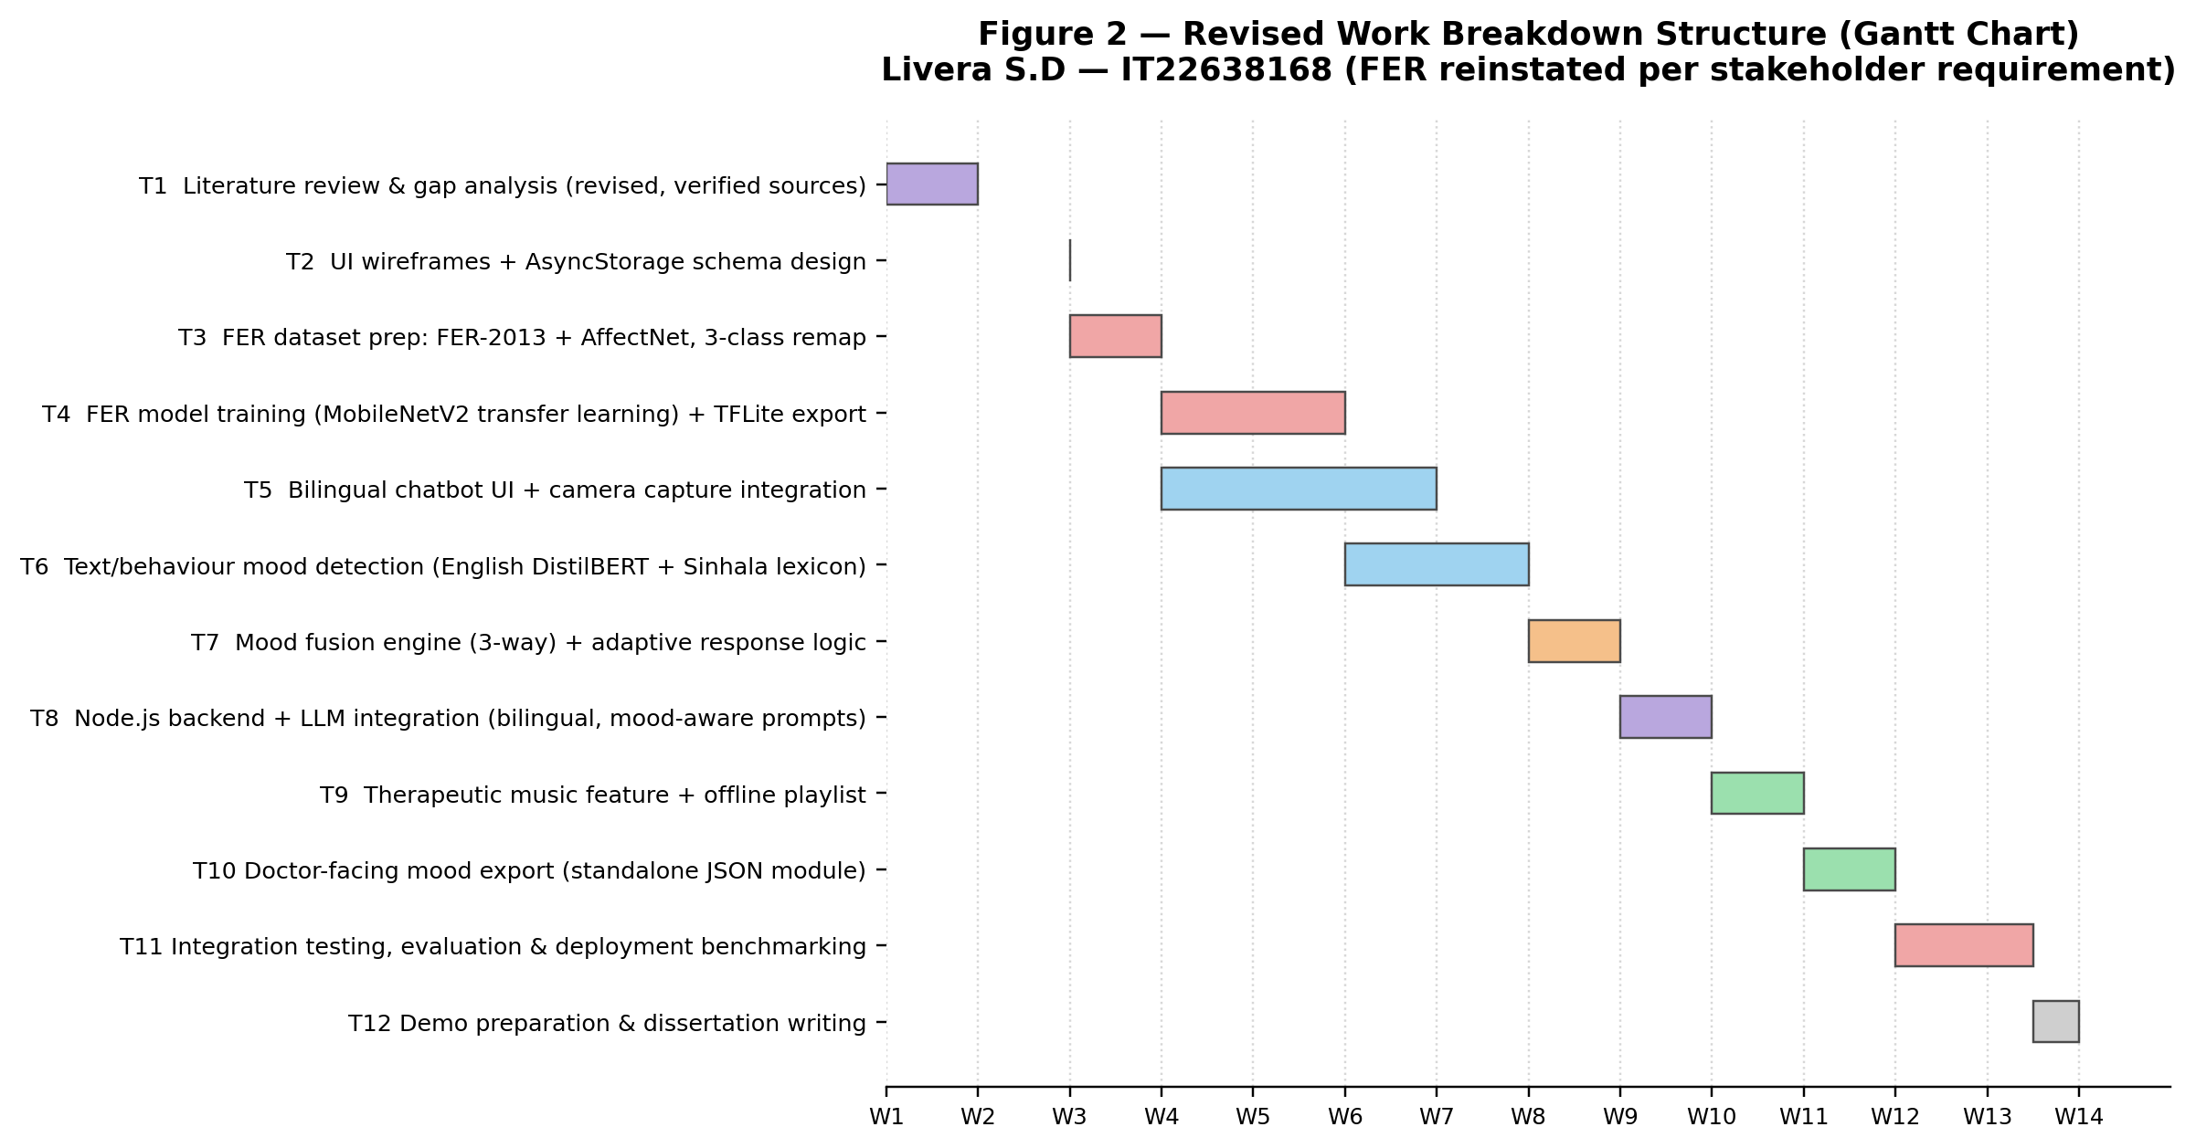
Figure 2 — Revised 14-week timeline, 12 tasks, FER training compressed into Weeks 4–6.
A note on timeline pressure
T4 (FER training) and T5 (UI/camera integration) now run concurrently to fit fourteen weeks, which is tight for a single author. If FER training overruns — a real possibility, since transfer learning convergence time is not fully predictable in advance — the most defensible fallback is to demo with a documented accuracy figure below the 65% target rather than delay other modules, and to state the shortfall honestly in the evaluation section rather than not reporting it. Flagging this now, before it happens, is worth doing openly with your supervisor.

Appendix D — Risk Analysis (v2, FER items reinstated)
# | Risk | Likelihood | Impact | Mitigation
R1 | FER accuracy stays below 65% on 3-class output, particularly at off-angle head poses | Medium–High | High | Confidence-threshold filtering and EMA smoothing (Section 3.2.2); report accuracy separately for frontal vs. off-angle subsets rather than a single blended figure; heavier augmentation and EfficientNet-Lite as a fallback architecture if MobileNetV2 underperforms
R6 | Users uncomfortable with camera access given Sri Lankan privacy norms | High | High | Clear bilingual consent screen before first use; visible indicator when camera is active; one-tap disable toggle that falls back to text + behaviour signals only, not a full feature loss
R9 | FER model biased toward lighter skin tones in training data | Medium | High | Deliberately test with participants of diverse Sri Lankan ethnicities during usability testing; apply skin-tone-aware augmentation during fine-tuning

Budget Adjustment
Reinstating FER training restores the Google Colab Pro line item removed in the text-only revision. Revised total: approximately LKR 44,000 (matching the original proposal's budget, since the training pipeline is now the same as originally planned).

Outstanding Items
- Verification of the Sunitha & Nalini (2022) music-therapy citation and the Chathuranga, Lorensuhewa & Kalyani (2019) Sinhala lexicon citation — referenced but not yet independently re-confirmed in this specific revision.
- The FER accuracy target (≥65%) is carried over from the original proposal; it has not been empirically validated against phone-holding head-pose conditions specifically, and Section 3.5's split-by-pose measurement is designed to surface the real number rather than assume it.
- Appendix E (Ethical Documents) — the privacy notice must explicitly cover camera access again (bilingual, before first use), reversing the simplification made in the text-only revision.

