# DECLARATION

We, NDAYISABYE Salim, NZAYISINGIZA Daniel, and IRANZI Benjamin hereby to declare that this research proposal submitted to the department of electrical and electronic engineering at IPRC KIGALI is our original work under the supervision of Mr. MIGAMBI OLIVIER. We declare that to the best of our knowledge; that this work has never been submitted here or elsewhere in previous application for award of an academic qualification.

Names Signature

**NDAYISABYE Salim ……………………………………..**

**NZAYISINGIZA Daniel ………………………………………**

**IRANZI Benjamin ………………………………………….**

# APPROVAL

This is to certify that the project work entitled “ AUTOMTED DISPENSER MACHINE (ADM) ” carried out by NDAYISABYE Salim, NZAYISINGIZA Daniel, and IRANZI Benjamin has been checked and approved for meeting part of requirements and regulations governing the award of the advanced diploma in department of electrical and electronics engineering (EEE) at IPRC KIGALI during academic year 2021-2022.

**Supervisor Head of department of EEE engineering**

**Mr. MIGAMBI Olivier Mr. Munyaneza ADOLPHE**

**Signature…………… Signature………………**

# DEDICATION

To our parents

To our brothers and sisters

To all our lecturers

To all our best friends whom helped us in one way or another.

# ACKNOWLEDGMENT

We would like to express deeply and sincerely thanks to government of Rwanda for having supported us in each and daily life to achieve advanced diploma courses.

We would like also to express our deep and sincere gratitude to our supervisor Eng. MIGAMBI Olivier, for his wide and unlimited support and knowledge and constructive ideas have been with us along this project. We are very thankful to our parents and all technicians for their guidance, advice and motivation our sincere appreciation.

# ABSTRACT

This project delves into how Automated Dispenser Machine (ADM) acts as substitutes to the common pharmacies routine of giving relevant medicines. ADM is a machine that delivers pills to patients and it works as a replacement for the pharmacist. Briefly, this ADM has the capacity of detecting the requested pills and liquid medicine by the patients easily. And from here the patient is served. Once the patient have taken all prescriptions from his/her doctor, he/she will receive a couple of numbers which is a token encoding all the information written by the doctor.

and after the payment, that very token is what the patient inputs in the Automated Dispenser Machine

the machine is responsible to send that token to the cloud server for token verification and checking whether the user has paid for the meds she/he wants if not the process ends and if the all are valid the machine starts the delivering or medicines feeding mechanism and the medicine lists in Pharmacist’s dashboard gets updated.

#### Table of Contents

DECLARATION I

APPROVAL II

DEDICATION III

ACKNOWLEDGMENT IV

ABSTRACT V

List of figures IX

List of abbreviations X

CHAPTER 1. GENERAL INTRODUCTION 1

1.1: Background information 1

1.2: Problem statement 2

1.3: Objectives 2

1.3.1: Main objectives 2

1.5: Scope of project 3

1.6: Justification 3

1.7: Research Hypothesis 3

1.8: Limitation of the study 3

1.9: Organization of study 4

CHAPTER 2: LITERATURE REVIEW 5

2.1: Introduction 5

2.2: Concepts, Opinions and ideas from author/experts 5

2.3: Theoretical perspectives 5

2.4: Servo motor 6

2.4.1: Servo Motor Working 7

2.5: Raspberry pi4 (model B) 8

2.5.1: Features of Raspberry Pi 9

2. HDMI port 9

3. Graphic Processing Unit (GPU) 10

4. Memory (RAM) 10

5. Ethernet port 10

6. SD card slot 10

7. General Purpose Input and Output (GPIO) pins 10

8. LEDs 11

9. USB ports 11

10. Power source 11

2.5.2: Models of Raspberry Pi 12

1. Raspberry Pi Zero 12

2. Raspberry Pi 1 12

3. Raspberry Pi 2 B 13

4. Raspberry Pi 3 13

5. Raspberry Pi 4B 13

6. Raspberry Pi 400 13

2.5.3: Uses of Raspberry Pi 13

1. Constructing a desktop PC 13

2. Enabling media usage 14

3. Controlling IoT robots 14

4. Acting as a printer server 14

5. Replacing web servers 14

6. Converting into retro gaming machines 14

7. Attaching to surveillance cameras 15

8. Supporting digital signage 15

9. Conducting network penetration tests 15

10. Providing data to business intelligence dashboards 15

2.7. Computer monitor (Flat Panel Monitors) 16

CHAPTER 3: RESEARCH METHODOLOGY 19

3.1: Introduction 19

3.2: Research design 19

3.3: Research instrument 19

3.4: Documentation 19

3.5: Data analysis and interpretation 19

3.6: Ethical consideration 20

3.7: Tools and software 20

3.7.1: Tools 20

3.7.2: Components 20

3.7.3: Software 20

CHAPTER 4: DESIGN AND IMPLEMENTATION 21

4.1: Introduction 21

4.2: General block diagram 21

4.2.1: Hardware (ADM) 22

4.2.2: Program flowchart 23

4.4: Working principle 24

CHAPTER 5: CONCLUSION AND RECOMMENDATION 25

5.1: Introduction 25

5.2: Conclusion 25

5.3: Recommendation 25

5.3.1: Recommendation to Rwanda polytechnic-IPRC KIGALI 25

5.3.2: Recommendation to the country 25

References 26

# List of figures

Figure 1.servo motor. 6

Figure 2.Raspberry pi4 (model B). 10

Figure 3.Numeric keypads. 15

Figure 4.Computer monitor 16

Figure 5.General block diagram 19

Figure 6.Hardware (ADM) 20

Figure 7.Program flowchart 21

Figure 8. Automated Dispenser Machine circuit diagram 22

# List of Abbreviations

# DC: Direct Current

# AC: Alternating Current

# PWM: Pulse Width Modulation

# HDMI: High Definition Multimedia Interface

# CPU: Central Processing Unit

# RAM: Random Access Memory

# GPIO: General Purpose Input and Output

# LED: Light Emitting Diode

# USB: Universal Service Bus

# MB: Mega Bytes

# CUPS: Common Unix Printing System

# VDT: Video Display Terminal

# VDU: Video Display Unit

# CRT: Cathode Ray Tube

**PDA:** Personal Digital Assistant

**HTML:** Hyper Text Markup Language

**LCD:** Liquid Crystal Display

**ADM:** Automated Dispenser Machine

**PHL:** Philadelphia International Airport

**HTTPS:** Hypertext Transfer Protocol Secure

**PC:** Personal Computer

**IOT:** Internet Of things

**SD:** Secure Digital

**IDEs:** Integrated Development Environments

# CHAPTER 1. GENERAL INTRODUCTION

## 1.1: Background information

## It is in nature that people fall sick and there is no way we can run out of it .For that reason mankind has worked hardly to find a solution to at least buy few more time on earth by finding medicine, and this has indeed played a significant role in improving life condition. Starting Worldwide with Rwanda ,where life expectance has raised from 69.38 years in 2021 to 69.69 years now (2022) ,which is 0.45% according to [1] This really shows a great change and an impact the medicine revolution has brought to the modern world, that is why scientists are working day and night to figure out how generations can live a bit longer by creating possible way people can visit medical facilities that includes pharmacies easily. In regards to what stated above ,and getting more interested on how we could at least put a mile stone of what others have contributed .we did various research on different kinds of automated dispenser machine such as Outpatient Pharmacy Automation System from china and smart pharmacy launched by Dubai health authority but they all focused on one thing benefiting and simplifying the work done by pharmacists neglecting possible way to help the patient to get service easily Whereby the patient meets the doctor and after the meeting he/she receives prescription. The latter is electronically transferred to the pharmacy.The pharmacist checks the prescription for any clinical or hospital information if everything is okay.With one click of button the pharmacists instructs the robot to dispence medicines and it can dispense 12 prescriptions in less than one minute.Then the medicines reach the pharmacist and check them again and gives them to the patient.Then the patient pays the money to the accountant of pharmacy.Back in Rwanda, when patients are looking for medicine in pharmacies, sometimes they can't get that service because some pharmacies especially in rural areas are not open 24 hours a day or you find that they are far from the patients, so they can't get the medicine they want at the right time. Due to that we thought of designing and implementing this automated machine to solve patient’s challenges and problem which were not met in other designed automated machine.

# And the problem faced by the patients, our project came to solve them.

## 1.2: Problem statement

From the above-mentioned statements, we have noticed some problems, but the most important ones are listed below:

1. Rural areas do not work 24 hours and you find out that the patients end up not acquiring the medicine in another way round. Pharmacists are also people who can get fatigued.
2. Opening a new branch of a pharmacy requires much capital (either by renting or building pharmacy house) hence the shortage of enough pharmacies in comparison to the population.
3. Sometimes it takes long time for the patient to receive medication when the pharmacists are not working professionally.
4. Administering medication that is not intended for the patients.

## 1.3: Objectives

## 1.3.1: Main objectives

The main objective is to design and implement, double-check, test, and validate an ADM machine.

**1.3.2 Specific objectives**

* Designing and developing an internet-based platform that which is meant to be used by patients to visit and get the invoice for simple common generic medicine.
* Designing and developing an internet platform that professional specialized medical doctors will use to approve one medicine in case it is not a simple common generic medicine like stated above.
* Design ADM machine ( hardware)
* Develop a firmware (embedded program) that will be controlling the ADM machine system i.e. Motors, selection of the medicine from the chamber, and detection and coding of the token number.

**1.4**: Research **questions**

* What is the essential programming language to use?
* Where will the project be implemented?
* How will the patient be getting the medicine?
* How to interface the machine with internet?

Since patients are given medicine regarding the age and weight how will that be sorted out**?**

## 1.5: Scope of project

This project is created for each individual to benefit but still there are those that are not able to use it such as :

* People with no smart phones.
* With no internet access.
* Areas with no electricity.
* Not able to handle liquid medicine.
* Not possible without access to Momo pay.

## 1.6: Justification

To help customers get medicine is not  only the easiest way by saving time and transport money at any given time but also to help the pharmacist distribute medicine  around at low cost since ADM is so cheaper compared to constructing a pharmacy or rending one including paying the pharmacist better functioning.

## 1.7: Research Hypothesis

At the end of this research, the designed project was implemented and is meant to be able to act as mobile pharmacies around the country.

## 1.8: Limitation of the study

When we were working with the project we faced some challenges that limited us to perform at maximum and some of them are as following;

* We really hard little time relating to what we had to cover in the whole project
* Luck of resources to which we believed the school could help but at the end we had to do everything by our own.
* Lack of some knowledge; as technicians since the project touches different corners of medical agencies and organization to which we did not have enough information.

## 1.9: Organization of study

This project is organized into five chapters as follow:

Chapter 1: General introduction

Chapter 2: Literature review

Chapter 3: Research methodology

Chapter 4: Design and implementation

Chapter5: Conclusion and recommendation

# CHAPTER 2: LITERATURE REVIEW

## 2.1: Introduction

This chapter has mainly focused on other author/expert’s works, their opinions and ideas that present some similarities with the one mentioned in this book, it explains basic concept ,related study and information that had been used during development of this project and contains the basic components used and their functions.

## 2.2: Concepts, Opinions and ideas from author/experts

## Muhamad Farhan Mohd Mazlan,,Siti Zuliana Salleh and Mohd Sayuti Ab Karim say that Automatic dispensing machines (ADM) or (automated drug cabinets) are a computerized drug storage and dispensing device used in the health care settings like hospitals and nursing homes, and are located at the point of care (the ward, ICU, ED) rather than in the central pharmacy. Much like a bank ATM, an ADM functions as a decentralized distribution point in the hospital pharmacy system and is interfaced with the main medication information systems. The ADM provides proper storage, inventory control and security for pharmaceuticals at the point of care, and can only be used by authorized users who are authenticated by passwords and often biometric measures such as fingerprint readers. After being validated, the clinician must select the correct patient and medication before the cabinet will open and dispense the requested medication(s). ADM have several major advantages over traditional pharmacy delivery systems. First, the most commonly needed pharmaceuticals are already present at the point of care and do not need to be sent or transported from main pharmacy stores, a time and labor intensive process. This can save considerable time in the daily workflow of nurses. Second, controlled substances remain in a secure lockbox until needed and access to the vault is secured by multi-factor authentication and audit trails to prevent waste and drug diversion. Third, patient charges and inventory control tasks are simplified in an automated dispensing system and "lost charges" are much reduced. Finally, the ADM can provide clinical decision support to improve patient safety---providing drug-allergy alerts, drug-drug interactions, advise on high risk medication (heparin, insulin) and avoid confusion with "sound alike" medications. The ADM does not prevent all drug dispensing and administration errors, and is not a panacea for ending all adverse drug administration errors. Precise adherence to standard protocols for administering medication must be followed by clinical personnel and are the final fail safe for preventing errors. Pharmacy can still stock the wrong medication in a given drug cabinet, and a clinician can still pick a "look-alike" medication from an adjacent drug drawer. In addition, the ADM should ideally be used as part of an eMAR system using barcodes on both the medication and the actual patient bracelet to insure the right patient is getting the right medication. In addition, the ADM is an electronic device, takes some time to access and dispense medication, and could malfunction at a critical time in a patient's care; for this reason, a separate supply of most resuscitation/critical care drugs ( e.g. epinephrine, atropine) are kept in traditional resuscitation kits (code carts) for immediate use during an emergency. Automatic dispensing devices, in simplified format, are already being used in the home environment to assist in the correct administration of complicated medical regimens to elderly patients and those with memory impairments. This may improve compliance and safety in this population at high risk for medication errors. As clinical decision support improves, ADM will become more sophisticated and provide more useful assistance to patients and clinicians alike.

## 2.3: Theoretical perspectives

## Here we will talk about the components to be used in this project and their functions.

## 2.4: Servo motor

A **servo motor** is a type of motor that can rotate with great precision(is a [rotary actuator](https://en.wikipedia.org/wiki/Rotary_actuator) or [linear actuator](https://en.wikipedia.org/wiki/Linear_actuator) that allows for precise control of angular or linear position, velocity and acceleration).Normally this type of motor consists of a control circuit that provides feedback on the current position of the motor shaft, this feedback allows the servo motors to rotate with great precision. If you want to rotate an object at some specific angles or distance, then you use a servo motor. It is just made up of a simple motor which runs through a **servo mechanism**. If motor is powered by a DC power supply then it is called DC servo motor, and if it is AC-powered motor then it is called AC servo motor. Apart from these major classifications, there are many other types of servo motors based on the type of gear arrangement and operating characteristics. A servo motor usually comes with a gear arrangement that allows us to get a very high torque servo motor in small and lightweight packages. Due to these features, they are being used in many applications like toy car, RC helicopters and planes, Robotics, etc.

Servo motors are rated in kg/cm (kilogram per centimeter) most hobby servo motors are rated at 3kg/cm or 6kg/cm or 12kg/cm. This kg/cm tells you how much weight your servo motor can lift at a particular distance. For example: A 6kg/cm Servo motor should be able to lift 6kg if the load is suspended 1cm away from the motors shaft, the greater the distance the lesser the weight carrying capacity.  The position of a servo motor is decided by electrical pulse and its circuitry is placed beside the motor. The function of the servo motor is to convert the control signal of the controller into the rotational angular displacement or angular velocity of the motor output shaft. Servo motor is used to drive the joints.

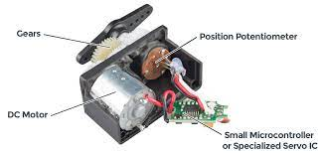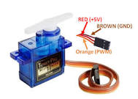

Figure 1.servo motor.

### 2.4.1: Servo Motor Working

A servo consists of a Motor (DC or AC), a potentiometer, gear assembly, and a controlling circuit. First of all, we use gear assembly to reduce RPM and to increase torque of the motor. Say at initial position of servo motor shaft, the position of the potentiometer knob is such that there is no electrical signal generated at the output port of the potentiometer. Now an electrical signal is given to another input terminal of the error detector amplifier. Now the difference between these two signals, one comes from the potentiometer and another comes from other sources, will be processed in a feedback mechanism and output will be provided in terms of error signal. This error signal acts as the input for motor and motor starts rotating. Now motor shaft is connected with the potentiometer and as the motor rotates so the potentiometer and it will generate a signal. So as the potentiometer’s angular position changes, its output feedback signal changes. After sometime the position of potentiometer reaches at a position that the output of potentiometer is same as external signal provided. At this condition, there will be no output signal from the amplifier to the motor input as there is no difference between external applied signal and the signal generated at potentiometer, and in this situation motor stops rotating.

All motors have three wires coming out of them. Out of which two will be used for Supply (positive and negative) and one will be used for the signal that is to be sent from the MCU.

Servo motor is controlled by PWM (Pulse with Modulation) which is provided by the control wires. There is a minimum pulse, a maximum pulse and a repetition rate. Servo motor can turn 90 degree from either direction form its neutral position. The servo motor expects to see a pulse every 20 milliseconds (ms) and the length of the pulse will determine how far the motor turns. For example, a 1.5ms pulse will make the motor turn to the 90° position, such as if pulse is shorter than 1.5ms shaft moves to 0° and if it is longer than 1.5ms than it will turn the servo to 180°.

Servo motor works on **PWM (Pulse width modulation)** principle means its angle of rotation is controlled by the duration of applied pulse to its Control PIN. Basically servo motor is made up of **DC motor which is controlled by a variable resistor (potentiometer) and some gears**. High speed force of DC motor is converted into torque by Gears. We know that WORK= FORCE X DISTANCE, in DC motor Force is less and distance (speed) is high and in Servo, force is High and distance is less. The potentiometer is connected to the output shaft of the Servo, to calculate the angle and stop the DC motor on the required angle.

## 2.5: Raspberry pi4 (model B)

Raspberry Pi is a programmable device. It comes with all the critical features of the motherboard in an average computer but without peripherals or internal storage. To set up the Raspberry computer, you will need an SD card inserted into the provided space. The SD card should have the operating system installed and is required for the computer to boot. Raspberry computers are compatible with Linux OS. This reduces the amount of memory needed and creates an environment for diversity. After setting up the OS, one can connect Raspberry Pi to output devices like computer monitors or a High-Definition Multimedia Interface (HDMI) television. Input units like mice or keyboards should also be connected. This minicomputer’s exact use and applications depend on the buyer and can cover many functions.

Raspberry Pi is defined as a minicomputer the size of a credit card that is interoperable with any input and output hardware device like a monitor, a television, a mouse, or a keyboard – effectively converting the set-up into a full-fledged PC at a low cost.

The first generation of computers came as massive processing systems built with vacuum tube technology. Over the years, more compact and less expensive versions of what a computer would come to look like sprung up. Today, we have minicomputer gadgets such as smartphones in our pockets. Even though computers have become so commonplace, they are still not widely accessible in developing countries. This imbalance in access to computers and programming technology led to the development and creation of the Raspberry Pi computer.

Raspberry Pi is a small, low-cost, single-board computer the size of a credit card that allows people from different backgrounds and levels of expertise to experience and learn to compute. It is an enhanced motherboard developed in the United Kingdom by the Raspberry Pi foundation, now widely accepted as a part of evolving computer technology. The minicomputer can connect with other peripheral hardware devices such as a keyboard, mouse, and monitor. One can use Raspberry Pi for various purposes, including learning programming languages and orchestrating [network management.](https://www.spiceworks.com/tech/networking/articles/what-is-network-management/) It is multifunctional and gained even more popularity in the past few years than initially projected.

### 2.5.1: Features of Raspberry Pi

For a non-savvy computer user, first contact with Raspberry Pi designs can be a little confusing. Several features are embedded on the board, each with its specific uses. Overall, the different features control the general criteria of a standard 21st-century computer: processor speed and quality, Bluetooth, connection and peripheral ports, and software compatibility. The features of Raspberry Pi computers that make all these possible include:

**1. Central Processing Unit (CPU)**

Every computer has a Central Processing Unit, and so does the Raspberry Pi. It is the computer’s brain and carries out instructions using logical and mathematical operations. Raspberry Pi makes use of the ARM11 series processor on its boards.

### 2. HDMI port

Raspberry Pi board has an HDMI or High Definition Multimedia Interface port that allows the device to have video options of the output from the computer displayed. An HDMI cable connects the Raspberry Pi to an HDTV. The supported versions include 1.3 and 1.3. It also comes with an RCA port for other display options.

### 3. Graphic Processing Unit (GPU)

This unit, GPU or Graphic Processing Unit, is another part of the Raspberry pi board. Its primary purpose is to hasten the speed of image calculations.

### 4. Memory (RAM)

Random Access Memory is a core part of a computer’s processing system. It is where real-time information is stored for easy access. The initial Raspberry Pi had 256MB RAM. Over the years, developers gradually and significantly improved the size. Different Raspberry Pi models come with varying capacities. The model with the maximum capacity presently is the Raspberry Pi 4 with 8GB RAM space.

### 5. Ethernet port

The Ethernet port is a connectivity hardware feature available on B models of Raspberry Pi. The Ethernet port enables wired internet access to the minicomputer. Without it, software updates, web surfing, etc., would not be possible using the Raspberry Pi. The Ethernet port found on Raspberry computers uses the RJ45 Ethernet jack. With this component, Raspberry Pi can connect to routers and other devices.

### 6. SD card slot

Like most other regular computers, Raspberry Pi must have some sort of storage device. However, unlike conventional PCs, it does not come with a hard drive, nor does it come with a memory card. The Raspberry Pi board has a Secure Digital card or SD card slot where users must insert SD cards for the computer to function. The SD card functions like a hard drive as it contains the operating system necessary for turning the system on. It also serves to store data.

### 7. General Purpose Input and Output (GPIO) pins

These are upward projecting pins in a cluster on one side of the board. The oldest models of the Raspberry Pi had 26 pins, but most have 40 GPIO pins. These pins are pretty sensitive and should be handled carefully. They are essential parts of the Raspberry Pi device as they add to its diverse applications. GPIO pins are used to interact with other electronic circuits. They can read and control the electric signals from other boards or devices based on how the user programs them.

### 8. LEDs

These are a group of five light-emitting diodes. They signal the user on the present status of the Raspberry Pi unit. Their function covers:

* **PWR (Red):**This functions solely to indicate power status. When the unit is on, it emits a red light and only goes off when the unit is switched off, or disconnected from the power source.
* **ACT (Green):**This flashes to indicate any form of SD card activity.
* **LNK (Orange):**LNK LED gives off an orange light to signify that active Ethernet connectivity has been established.
* **100 (Orange):**This light comes on during Ethernet connection when the data speed reaches 100Mbps.
* **FDX (Orange):**FDX light also comes during Ethernet connection. It shows that the connection is a full-duplex.

### 9. USB ports

Universal service bus (USB) ports are a principal part of Raspberry Pi. They allow the computer to connect to a keyboard, mouse, hard drives, etc. The first model of Raspberry Pi had only two USB 2.0 ports. Subsequent models increased this number to four. Raspberry Pi 4 and Pi 400, much newer models, come with a mix of USB 2.0 and USB 3.0 ports.

### 10. Power source

Raspberry Pi has a power source connector that typically uses a 5V micro USB power cable. The amount of electricity any Raspberry Pi consumes depends on what it’s used for and the number of peripheral hardware devices connected.

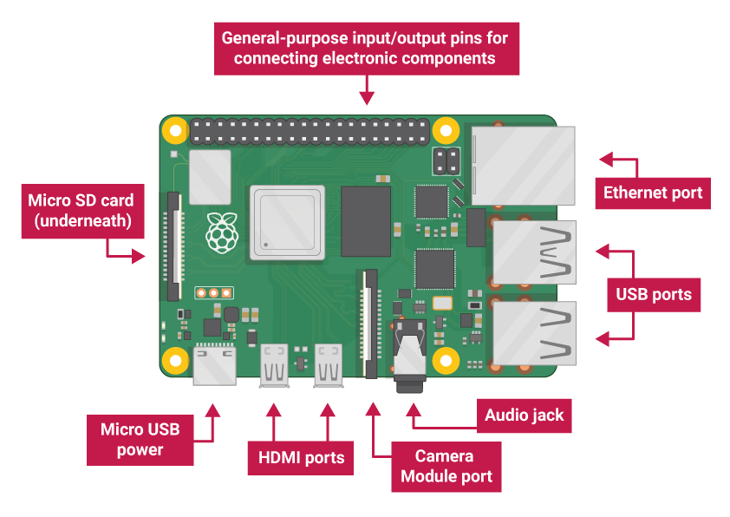

Figure 2.Raspberry pi4 (model B).

### 2.5.2: Models of Raspberry Pi

### 1. Raspberry Pi Zero

This is the cheapest Raspberry model produced by the company. One can get it for as low as $5, which is quite impressive considering the extent of its functionality. Although not the first model to be released, it boasts a smaller, more compact size than the Raspberry Pi 1. Raspberry Pi Zero has the same processor and RAM (512 MB) as the Pi 1 Model B+. The Raspberry Pi Zero does not come with Wi-Fi or [Bluetooth,](https://www.spiceworks.com/tech/iot/articles/what-is-bluetooth-le/)but it can be made internet accessible via USB.

Its slightly more expensive version, Raspberry Pi Zero W, comes with Bluetooth 4.0 and a built-in 802.11n Wi-Fi connectivity. For projects that require GPIO pins, other versions of Raspberry Pi may be more suitable.

### 2. Raspberry Pi 1

Raspberry Pi 1 Model B was released in 2012. It served as a baseline in size for future releases. Initially, it had 26 GPIO pins, 256MB RAM capacity, and a single CPU core. You couldn’t use it for heavy tasks with high processing needs. In 2014, the Raspberry Pi B+ was released with a starting RAM capacity of 512MB and 40 GPIO pins, becoming standard across all other models. Raspberry Pi Model B+ is sold at $25 and comes with four USB ports and an Ethernet connection. Pi 1 Model A+ ($20) can be considered for faster CPU processing speed, but it comes without an Ethernet connection.

### 3. Raspberry Pi 2 B

In February 2015, Raspberry released the 2B model. Compared to the prior releases, Raspberry Pi 2 B significantly improved, specifically in memory and speed. The RAM capacity was increased to 1GB. Pi 2B comes in the standard size, with 4 USB ports. It is currently priced at about $35, which is pretty affordable.

### 4. Raspberry Pi 3

Raspberry Pi 3 B was released in 2016. The B+ version, which came out in 2018, can boast a faster processing unit, Ethernet (802.11ac), and Wi-Fi than the earlier version. Generally, Raspberry PI 3 offers the user a wide range of use. It comes with the standard HDMI and USB ports, 1GB RAM, and Wi-Fi and Bluetooth connections in addition to the already functional Ethernet. One remarkable thing about this model is that it doesn’t generate much heat or consume too much power. This makes it suitable for projects that require passive cooling and can be acquired at $35.

### 5. Raspberry Pi 4B

Released in 2019, Raspberry 4B is a vast improvement from its predecessors, with a varying memory capacity from 2GB RAM to 8GB RAM. It also has a faster 1.5GHz processor and a good mix of 2.0 and 3.0 USB ports. Pi 4B is an ideal Raspberry model as it is suitable for virtually every use case with higher RAM capacity to satisfy even the most dedicated programmers. Depending on memory, the price ranges from $35 to $75, but each comes with all connectivity options.

### 6. Raspberry Pi 400

This model is unique as it comes in the form of a keyboard. It was launched in 2020 and operated with 4GB RAM. It comes with standard USB ports and needs just a monitor and mouse to make it a home computer set. Pi 400 costs $70 and can be used effectively in classrooms.

### 2.5.3: Uses of Raspberry Pi

Raspberry Pi has reached an unprecedented level of popularity. Originally created for educational purposes, it has become a go-to solution for tech enthusiasts looking for something to tinker with. This has led to the emergence of several relevant use cases. They are:

### 1. Constructing a desktop PC

One can use Raspberry Pi to construct a typical desktop personal computer. The hardware includes Raspberry Pi, a micro SD card with an operating system installed, a constant power source, and an output display device like an old monitor or television. It is also essential to have a USB mouse and keyboard. With all these, the user can work with fully functional devices for a very cheap cost.

### 2. Enabling media usage

Among the many uses of the Raspberry Pi, it has found profound popularity as a Kodi media player. Kodi software is a free, open-source media player that can be installed from official sites. One must install other add-ons. However, the user must be careful when using Raspberry Pi as a Kodi media center, as it can predispose the unit to security problems. This is easily prevented using a [virtual private network (VPN)](https://www.spiceworks.com/collaboration/remote-support/articles/what-is-a-virtual-private-network/) for data encryption.

### 3. Controlling IoT robots

Robotics is a vital part of today’s technology that promises to strongly influence the future, particularly the [Internet of Things (IoT).](https://www.spiceworks.com/tech/iot/articles/what-is-internet-of-things/) Raspberry Pi, therefore, is playing a crucial role in the technology of the future. Currently, there are several robot controller Raspberry Pi projects. Anyone can order fully packaged robot parts with DIY instructions and programs from many Pi communities. You can also choose to build your robot from scratch.

Raspberry Pi provides the best core a robot can have. Its miniature, lightweight nature, combined with the unit’s low price, makes it simply perfect. The Pi Zero is very popular for robotics because it boasts an even slimmer and more compact size than other Pi models.

### 4. Acting as a printer server

Raspberry Pi can also be used as a printer server. This is especially important for older printers. Setting this printing server up requires installing CUPS (Common Unix Printing System) file-sharing software. CUPS gives the user access to multiple printer drivers, which should be installed depending on the type of printer.

### 5. Replacing web servers

One other practical application of the Raspberry Pi computer is its use as a web server. This simply means configuring the computer to be able to host HTTP websites. It can function as a web server on the internet directly or in a local network such as a home or office. To do this, one must install specific software – the complete LAMP stack comprising Linux, Apache, MySQL, and PHP. After this, one can use the www directory to save HTML files, and the Raspberry Pi can function as a fully functional web server.

### 6. Converting into retro gaming machines

Users can also make Raspberry Pi into a gaming console. Without any additional modification, Minecraft comes with the default Pi operating system, Raspbian. Beyond Minecraft, other multiplayer games can also be set up on Raspberry Pi. One can achieve the best gaming experience by using multiple Raspberry Pis with one dedicated as a server.

### 7. Attaching to surveillance cameras

Businesses, offices, and even homes need surveillance cameras to prevent and apprehend security threats. For some, this can be very expensive, especially for small businesses. However, Raspberry Pi comes in as an excellent alternative. Combining it with a camera module allows anyone to set up their personal surveillance system.

### 8. Supporting digital signage

Most businesses now use digital signage to achieve a great deal of marketing. Information like the latest product, restaurant menus, adverts, appropriate behavior, maps, etc., can be displayed on large screens or specialized platforms. Raspberry Pi is not left out in this application – the minicomputer is perfect for displaying text and images. It can also display animations but will require more power and data consumption. Overall, using Raspberry Pi for digital signage is a cost-effective process.

### 9. Conducting network penetration tests

Computer and [network security i](https://www.spiceworks.com/it-security/network-security/articles/what-is-network-security/)s a big deal for everyone in today’s hyperconnected society. Personal and financial information stored on various sites may get into the wrong hands. This has created a massive market for [cybersecurity software](https://www.spiceworks.com/it-security/vulnerability-management/articles/top-cybersecurity-companies/). But the only way to ensure that you have adequate security is to test it. With Raspberry Pi, you can create an offensive security hacking tool to ‘attack’ your network. Any breach found is immediately repaired and closed down.

### 10. Providing data to business intelligence dashboards

Business intelligence dashboards, in one form or the other, are a vital part of any successful organization. It is a data visualization and analysis tool that displays the status of business metrics and key performance indicators of an organization or team. With Raspberry Pi, any business can display real-time data on a dashboard. The computer helps collect data from multiple sources using business intelligence apps like Power BI.

**2.6: Numeric keypads**

Numeric keypads (also called number pad, numpad, or keyboard number keypads) are separate small keyboards used to input numbers for specific purpose. A numeric keypad may also be a separate device, not built into a keyboard. Numeric keypads usually connect to a computer with a [USB](https://www.computerhope.com/jargon/u/usb.htm) cable, but older keypads may use a serial connector instead of USB. Some separate numeric keypads have a single-line LCD screen, like a calculator and the [Kensington](https://www.computerhope.com/comp/kensingt.htm) keypad to the right.

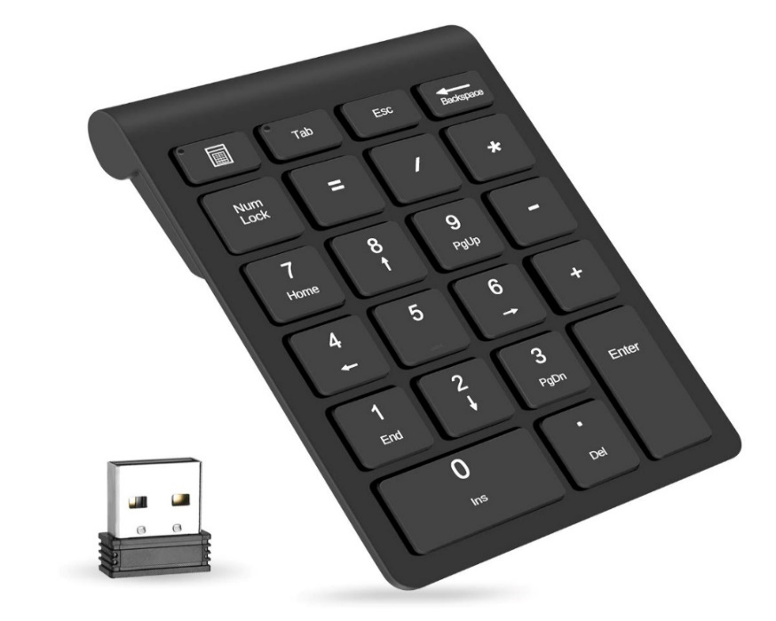

Figure 3.Numeric keypads.

### 2.7. Computer monitor (Flat Panel Monitors)

A computer monitor is an [output device](https://en.wikipedia.org/wiki/Output_device) that displays information in pictorial or textual form. A discrete monitor comprises a [visual display](https://en.wikipedia.org/wiki/Electronic_visual_display), support electronics, [power supply](https://en.wikipedia.org/wiki/Power_supply), [housing](https://en.wikipedia.org/wiki/Housing_(engineering)), [electrical connectors](https://en.wikipedia.org/wiki/Electrical_connector), and external user controls.

Or

A monitor is an electronic output device that is also known as a **video display terminal** (VDT) or a **video display unit** (VDU). It is used to display images, text, video, and graphics information generated by a connected computer via a computer's video card. Although it is almost like a TV, its resolution is much higher than a TV. The first computer monitor was introduced on **1 March 1973**, which was part of the Xerox Alto computer system.

Older monitors were built by using a fluorescent screen and Cathode Ray Tube (CRT), which made them heavy and large in size and thus causing them to cover more space on the desk. Nowadays, all monitors are made up by using flat-panel display technology, commonly backlit with LEDs. These modern monitors take less space on the desk as compared to older CRT displays.

These types of monitors are lightweight and take less space. They consume less power as compared to CRT monitors. These monitors are more effective as they do not provide harmful radiation. These monitors are more expensive than CRTs. The flat-panel monitors are used in PDA, notebook computers, and cellular phones. These monitors are available in various sizes like 15", 17", 18" & 19" and more. The display of a flat-panel monitor is made with the help of two plates of glass. These plates contain a substance, which is activated in many ways.

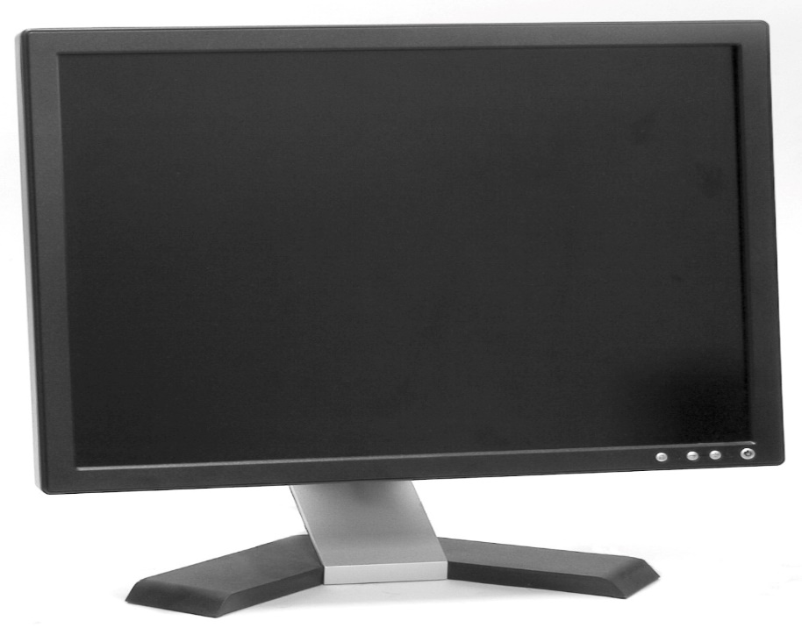

Figure 4.Computer monitor

### 2.8 Software used

Software is a set of instructions, data or programs used to operate computers and execute specific tasks. It is the opposite of hardware, which describes the physical aspects of a computer. Software is a generic term used to refer to applications, scripts and programs that run on a device. A mobile application or app is a computer program or software application designed to run on a mobile device such as a phone, tablet, or watch.

### 2.8.1 Flutter SDK

This is the main software required to build a Flutter app. It includes the Flutter framework, the Dart programming language, and various tools for developing Flutter apps. You can download the Flutter SDK from the Flutter website (<https://flutter.dev/>).

### 2.8.2 Raspberry pi software

Raspbian is the official operating system for the Raspberry Pi. It is based on Debian and comes with a variety of tools and libraries for building Raspberry Pi apps. You can download Raspbian from the Raspberry Pi website (<https://www.raspberrypi.org/downloads/>).

### 2.8.3 Android Studio or Visual Studio Code

These are IDEs (Integrated Development Environments) that you can use to write and debug your Flutter code. Both IDEs come with a built-in Flutter plugin, which makes it easy to develop Flutter apps.

### 2.8.4 Git

Git is a version control system that you can use to track changes to your Flutter code. It is not required, but it is a useful tool to have if you want to collaborate with other developers or track changes to your code over time.

### 2.8.5 BACKEND

Node.js: This is the main run time environment that is required to run an Express.js app. It includes the Node.js runtime and the npm package manager, which you can use to install dependencies and packages for your app. You can download Node.js from the official website (https://nodejs.org/).

### 2.8.6 A text editor

A text editor is used to write and edit your code. There are many options available, such as Sublime Text, Atom, Visual Studio Code, and more. Choose one that you are comfortable with and that has good support for JavaScript and Node.js development.

### 2.8.7A terminal emulator

A terminal emulator is used to run commands and interact with your Raspberry Pi. On the Raspberry Pi, you can use the built-in Terminal application.

# 

# CHAPTER 3: RESEARCH METHODOLOGY

## 3.1: Introduction

This chapter describes and shows the research design, research instruments, ethical consideration and the limitation of the project in data collection and analysis process.

## 3.2: Research design

In the research design , the necessary understanding and useful information needed in this project comes from various resources. For getting good result, choice of methods and technics was required to be used while making research and data collection. Here sources like books, websites on the internet, as well as reports done by other researchers have been conducted.

## 3.3: Research instrument

The research instrument we have used to collect data is questionnaire method, with this approach, a set of questions are administered by the researcher I questionnaire form to respondents in order to provide him or her information relevant to the topic of study.

## 3.4: Documentation

At this point, the necessary getting and useful information needed in our research project came from various resources. Some of the resources are books, class notes, websites and other work done by different researchers, also in this section, different people have been consulted for their ideas and we made the discussion looking for how this research project could be done successfully.

## 3.5: Data analysis and interpretation

In collection data, we have used rating as one of the type of question where the respondent is asked to select one point on rating scale .after getting information from questionnaires, interview guide and observation we have seen that our project will help to reduce deaths, the journey people take to reach pharmacies and also better management.

## 3.6: Ethical consideration

For getting good result, it requires good choice of methods and techniques used for making research and data collection. Cause to achieve this we have to combine knowledge starting from that we acquire from class, different books, internet and data from different fields.

## 3.7: Tools and software

### 3.7.1: Tools

* Digital Multimeter
* Plier
* Soldering iron
* Screw driver

### 3.7.2: Components

* Raspberry pi
* Servo motor
* Numeric keypads
* Computer monitor

### 3.7.3: Software

* Raspberry pi software
* Text editor
* Android Studio or Visual Studio Code
* Android Emulator or iOS Simulator
* A terminal emulator

# 

# 4: DESIGN AND IMPLEMENTATION

## 4.1: Introduction

In order for Automated Pharmacy machine to work properly it needed three main systems to work together, the first one is the software application running on cloud which is responsible of processing all the requests made by the user either on their app or on the machine itself , secondly is the firmware on the machine installed in the chip(Micro-controller) which is responsible of running the electro-mechanical parts of the machine, lastly is the physical part of the machine which includes the housing, motors, monitor , keyboard etc.

All of these parts will have to connect and communicate for the final smooth performance.

## 4.2: General block diagram

**C**loud

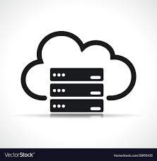

USER(s)

HARDWARE (ADM)

PHARMACIST(s)

Figure . General block diagram

* **Pharmacist:** Update existing medications so that the patient can receive the desired medication if it is available.
* **User:** The patient's role here is to prescribe medication.
* **Hardware (ADM):** This machine dispenses medication to the patient based on the patient's request.
* **Cloud:** "The cloud" refers to servers that are accessed over the Internet and the software and databases that run on those servers. Cloud servers are located in [data centers](https://www.cloudflare.com/learning/cdn/glossary/data-center/) all over the world. By using cloud computing, users and companies do not have to manage physical servers themselves or run software applications on their own machines. The cloud enables users to access the same files and applications from almost any device, because the computing and storage takes place on servers in a data center, instead of locally on the user device. This is why a user can log in to their Instagram account on a new phone after their old phone breaks and still find their old account in place, with all their photos, videos, and conversation history. It works the same way with cloud [email](https://www.cloudflare.com/learning/email-security/what-is-email/) providers like Gmail or Microsoft Office 365, and with [cloud storage](https://www.cloudflare.com/learning/cloud/what-is-cloud-storage/) providers like Dropbox or Google Drive.

## 4.2.1: Hardware (ADM)

RASPBERRY PI

DRIVER

ACTUATOR

(SERVO MOTOR)

Storage

Figure 6.Hardware (ADM)

* A servo drive is an automatic device that converts pulse signals from the controller into motor motion to achieve precise positioning. It takes a command signal and compares it with the feedback from a servomechanism in order to provide the required voltage to a servo motor to correct any deviation from the commanded status.
* The function of the servo motor is to convert the control signal of the controller into the rotational angular displacement or angular velocity of the motor output shaft. Servo motor is used to drive the joints
* The Raspberry Pi commands and control electronic components to perform tasks (to deliver medicines).Directly control many servos at once via software. Each numbered GPIO pin can manage a servo. It is, however, not recommended to power the servos with the Raspberry Pi. Note that the Raspberry Pi should not supply the voltage to the servo. Instead, employ an external power supply to drive the servomotor because the Raspberry Pi’s GPIO pins might be unable to supply enough power to make the motor turn at an acceptable rate.

### 4.2.2: Program flowchart

INITIALIZTION

Update database

Read (check) if there is any request

IFYES

Figure .Program flowchart

Is there any paid request?

Activate actuator to deliver medicine

IFNO

**4.3: Circuit diagram and Working principle**

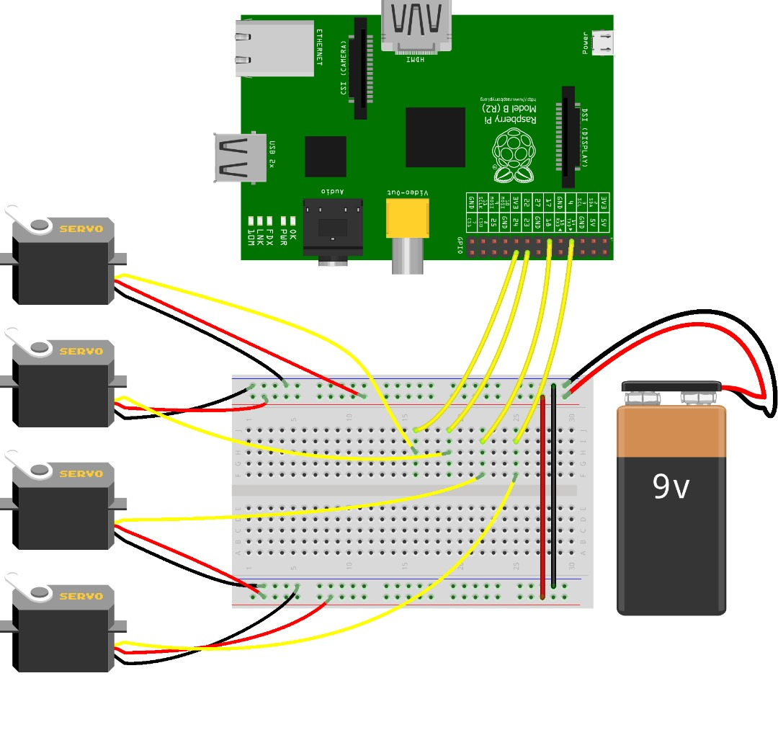

Figure 8. Automated Dispenser Machine circuit diagram

## 4.4: Working principle

Once the user have taken all prescriptions from his/her doctor he/she will receive a couple of numbers which is a token encoding all the information written by the doctor,

and after the payment, that very token is what the user inputs in the Automated Pharmacy Machine

the machine is responsible to send that token to the cloud server for token verification and checking whether the user has paid for the meds she/he wants if not the process ends and if the all are valid the machine starts the delivering or medicines feeding mechanism

and the medicine lists in Pharmacist’s dashboard updates.

# CHAPTER 5: CONCLUSION AND RECOMMENDATION

## 5.1: Introduction

This chapter shows how we conclude after the implementation of our project and the recommended challenges we had during the implementation of this project.

## 5.2: Conclusion

Based on what our project ADM (Automated Dispenser Machine) will do, we found that it works as well as we hoped it would.

## 5.3: Recommendation

Referring to the challenges faced during the implementation of this project, we would like to address the following recommendations.

### 5.3.1: Recommendation to Rwanda polytechnic-IPRC KIGALI

* We recommend IPRC KIGALI to improve the documents and books in library so that students doing their research will not struggle due to unavailability of books.
* We also recommend IPRC KIGALI to increase and make sure that the students get enough school trips because it helps students think out of the box and increase their self-confidence.

### 5.3.2: Recommendation to the country

* We also recommend the government of Rwanda to help schools and students to get access to the internet at all school compound in order to facilitate them in their research
* Availability of electronic components is a big challenge and they are very expensive .The government of Rwanda and private sector in general might put into consideration finding a way those components reach to the market at affordable price.

# References

* [1] (https://www.macrotrends.net.RW).
* <https://www.google.com/search?q=servo+motor+role&rlz=1C1BNSD_enRW997RW997&oq=servo+motor+role&aqs=chrome..69i57j0i22i30l5j0i390l4.8832j0j15&sourceid=chrome&ie=UTF-8>
* https://www.spiceworks.com/tech/networking/articles/what-is-raspberry-pi/
* https://www.youtube.com/watch?v=j-bNu1yICMw
* <https://www.youtube.com/watch?v=-6iUTGZTkm8>
* <https://tutorials-raspberrypi.com/raspberry-pi-servo-motor-control/>
* https://www.digikey.com/en/maker/blogs/2021/how-to-control-servo-motors-with-a-raspberry-pi#:~:text=A%20servo%20rotates%20towards%20its,servos%20with%20the%20Raspberry%20Pi.