LAB Logbook

Lab 1

1-**DataFrame**: A smart spreadsheet/table that is easy to work with everything from customer information to complex bank transfer activities.

2-**Series**: A single column of labelled data that helps to track more specific individual measurements like stock prices over time.

3-**DataFrameGroupBy**: The tool that makes organisation easier into meaningful blocks, for example sales by region or marketing results by campaign.

4-**read_csv**: The handy import tool that pulls data from files into Python, automatically handles messy data.

5-**loc/iloc**: A data selection helper that allows grabbing exactly the needed information.

Lab 2

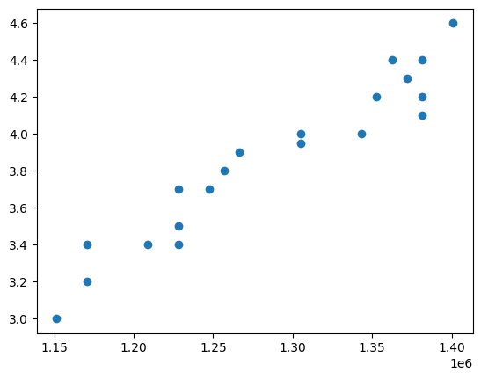

SID=1919019*0.75 =1439264.25

cost_guess = 4.3

Lab 3

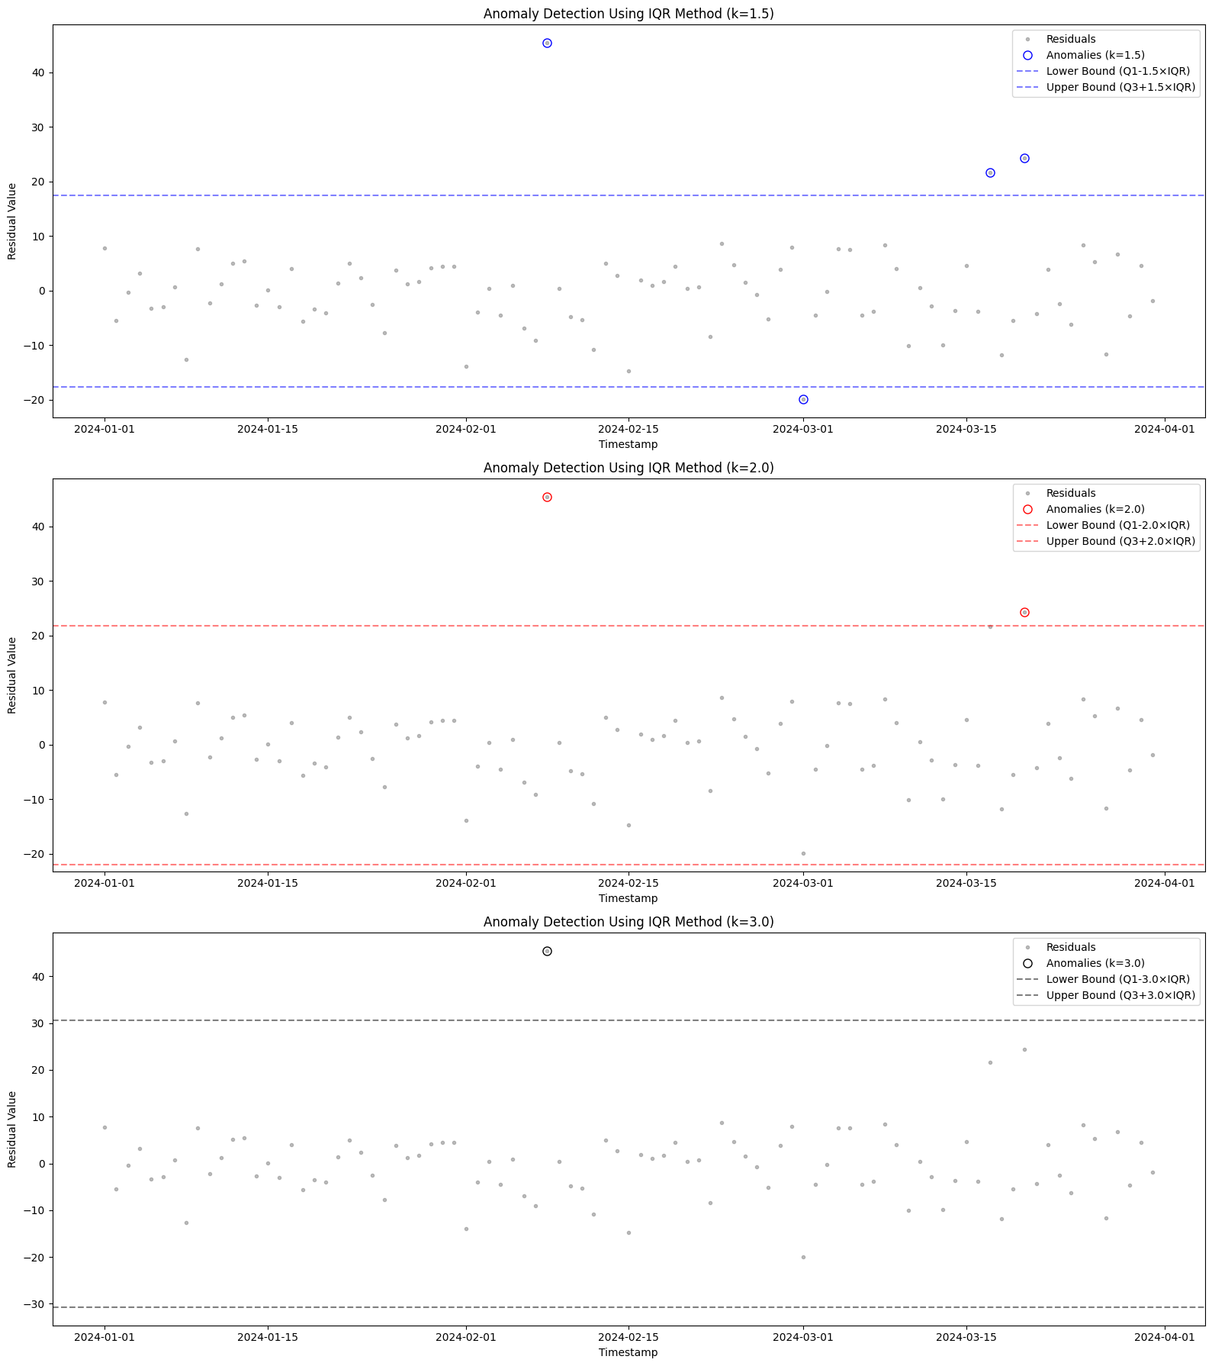

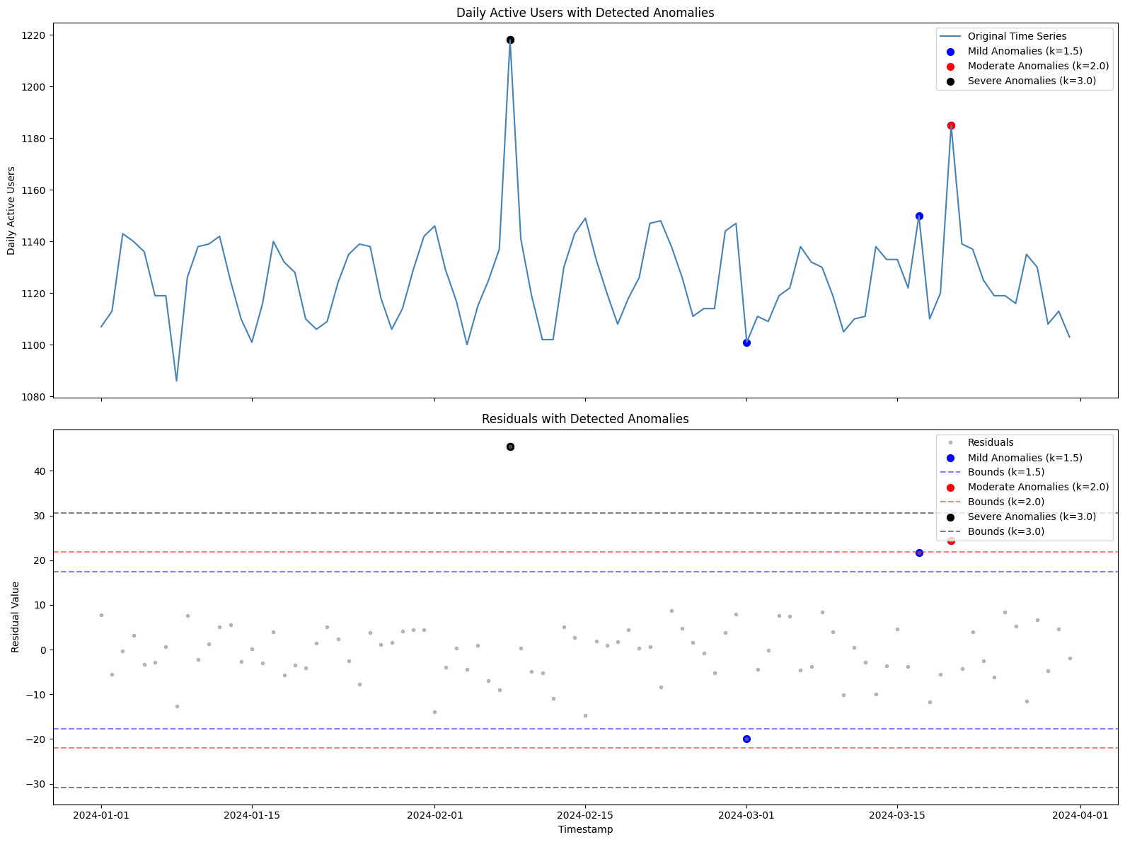

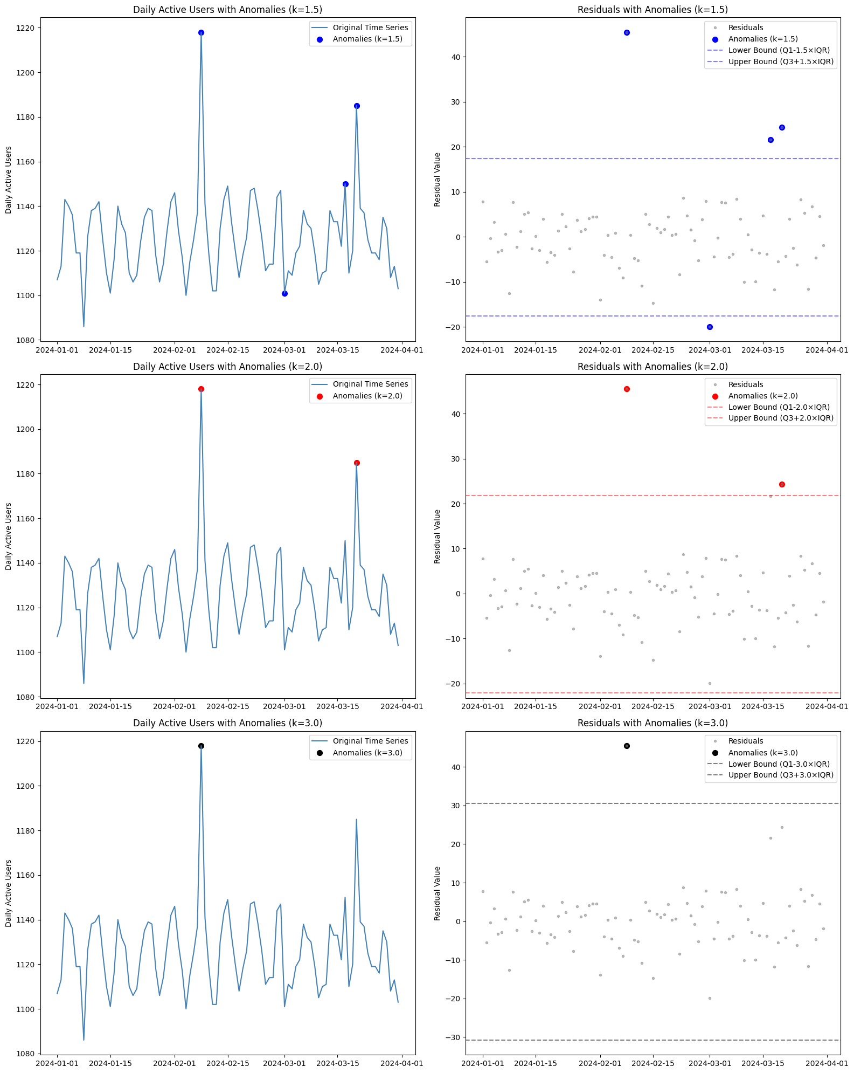

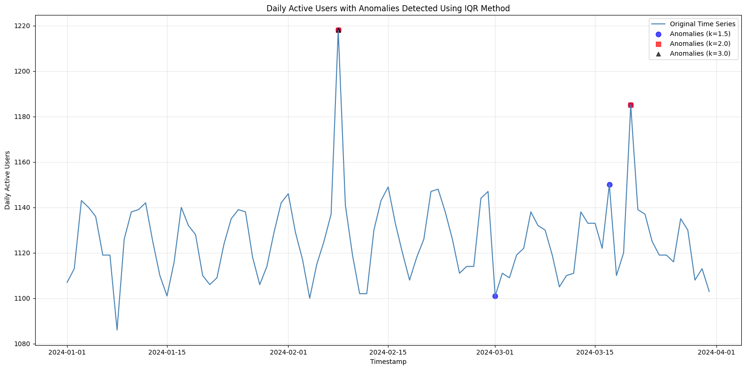

Lab 4

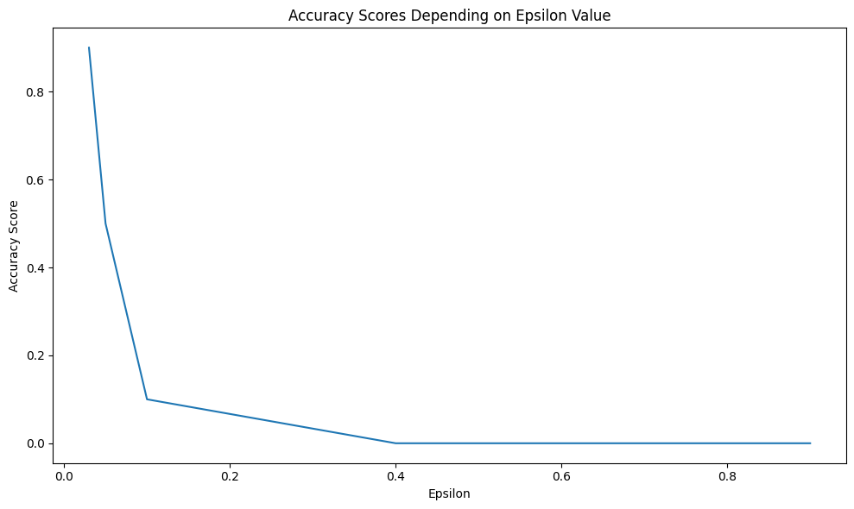

Accuracy before poisoning: 0.9772

Accuracy after poisoning: 0.0974

Lab 5

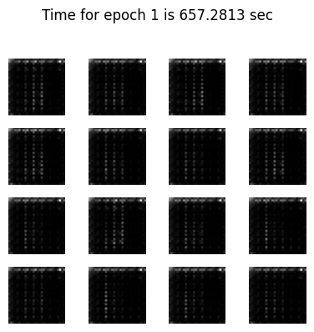

Time for epoch 1 is 657.2813 sec

Lab 6

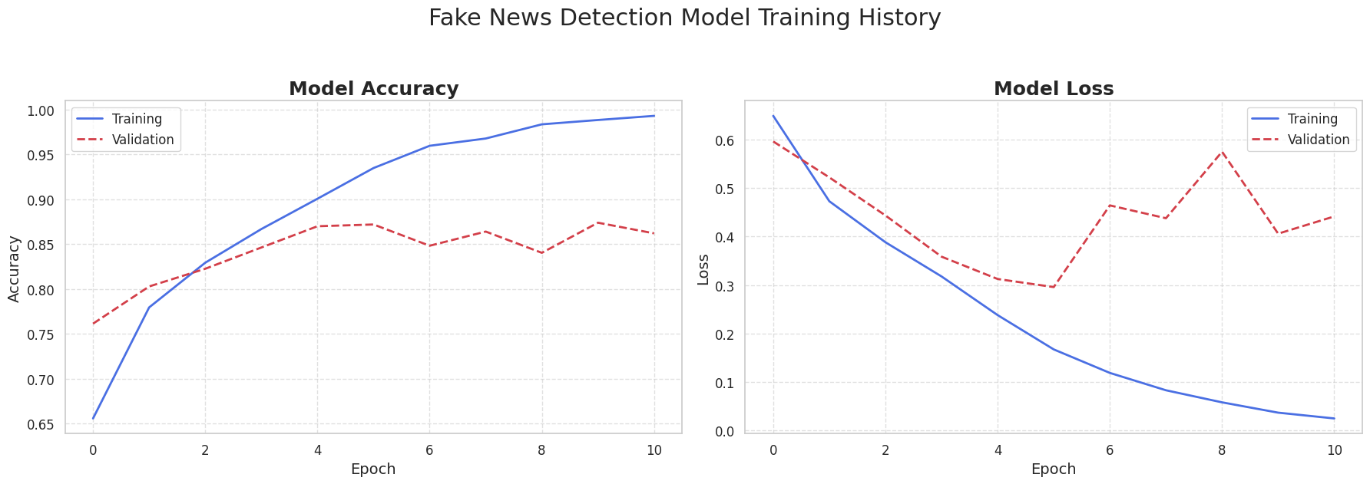

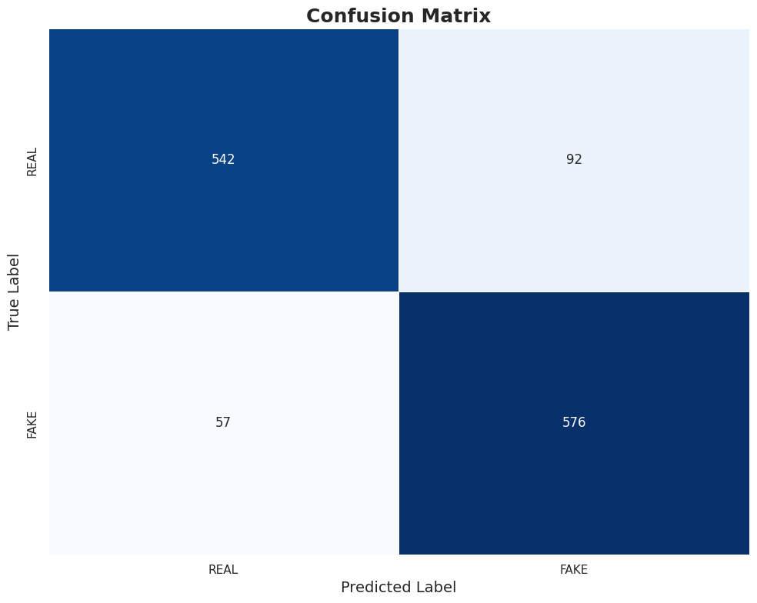

Lab 7

Modified input: hello

Encrypted text: WlRY7eYgnfQ=

Decrypted text: hello

user input cryptography

<class 'str'>

AES Encrypted: xd2DlKZ/1N0rOmHa6cijLA==

AES Decrypted: cryptography

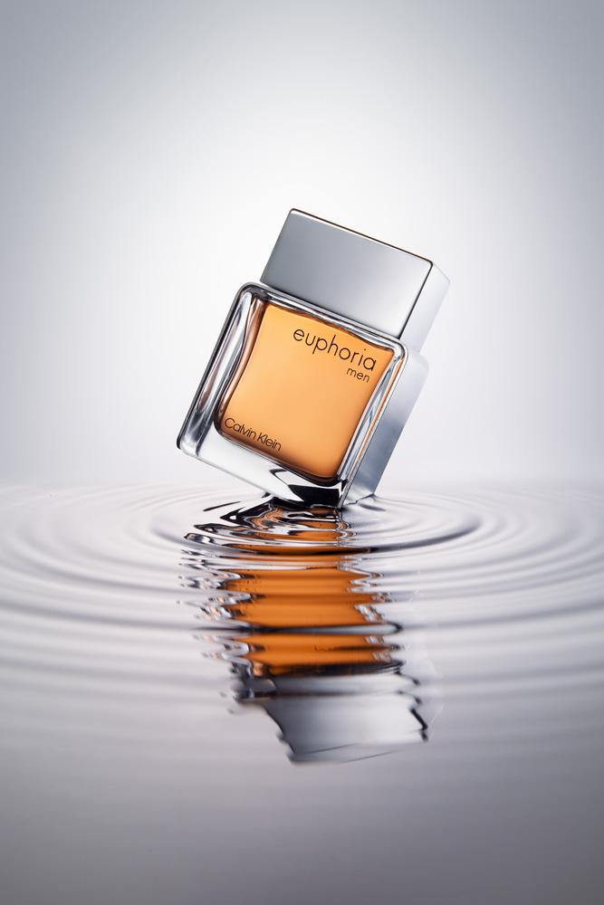

NO

Lab 8

1- Charles Buckley

2- p = 23, g = 5, s =  2, private key = 6

Lab 9

1- 23andMe data breach (2022)

2-https://www.risk-strategies.com/blog/understanding-the-23andme-data-breach-and-ensuring-cybersecurity

Lab 10

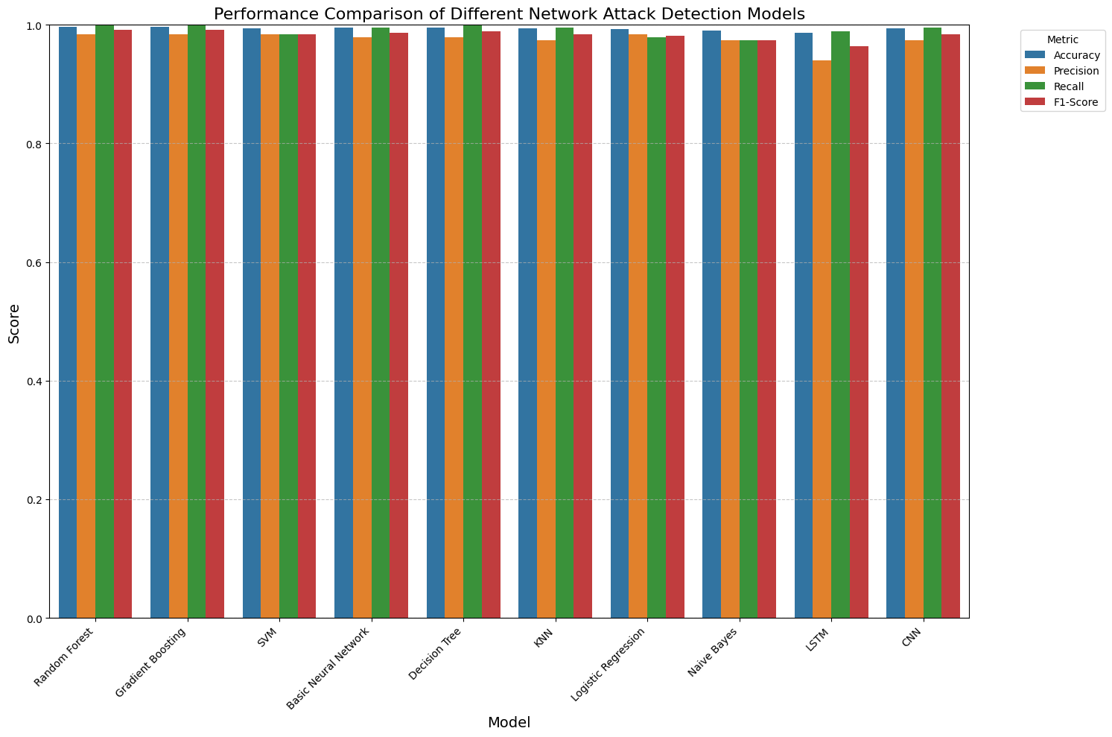

Lab 11

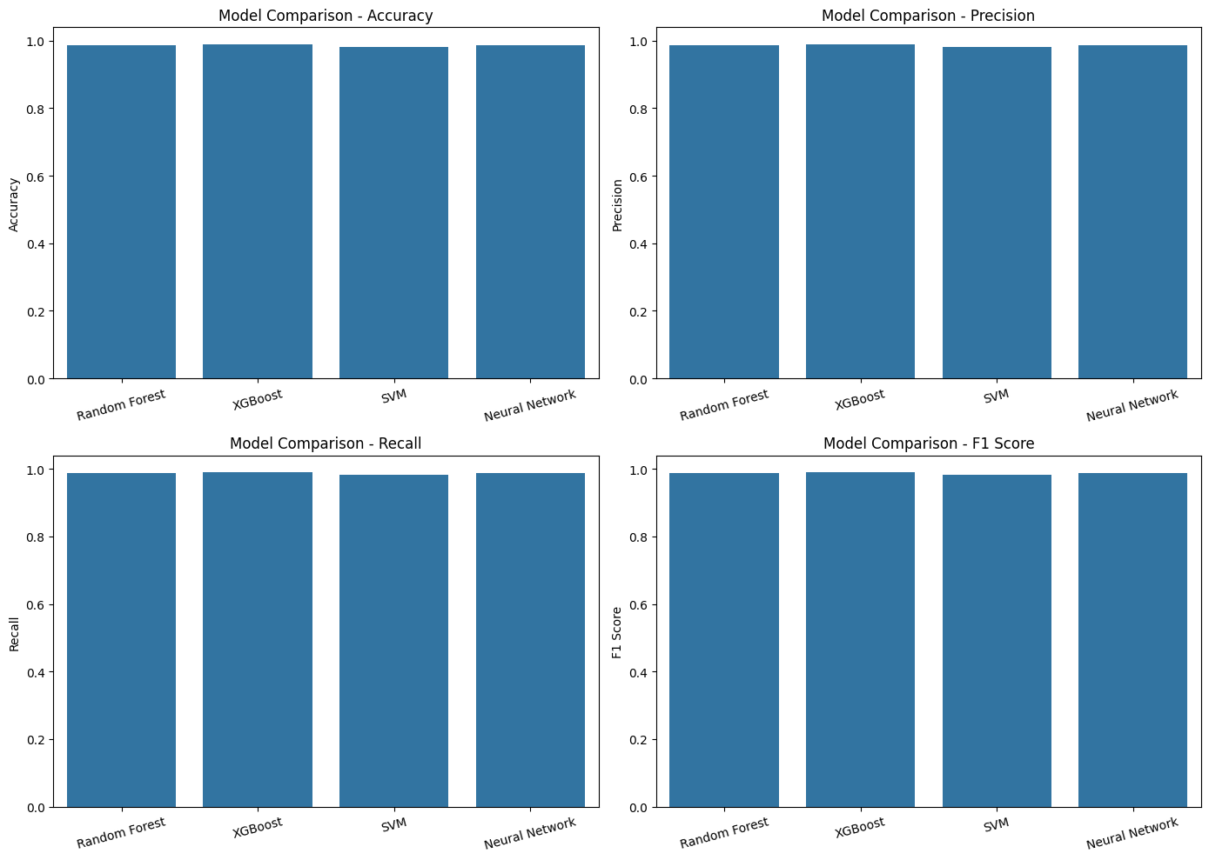

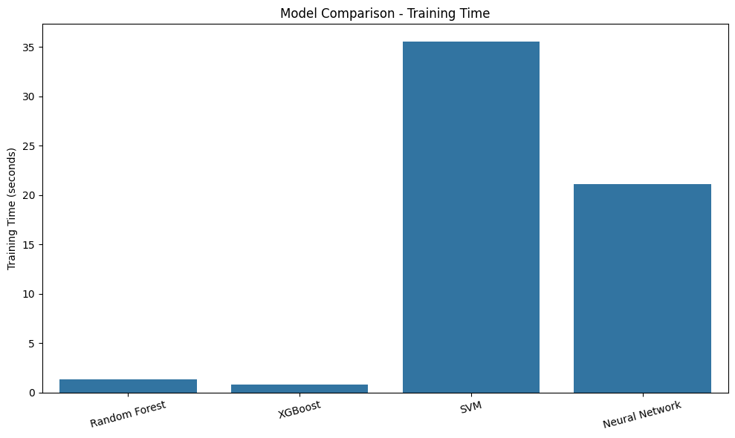

Lab 12

GitHub link - https://github.com/Salimboevm/Cyber-Security.git