Company Scenario — NorthStar Lending, Inc.
Portfolio note: NorthStar Lending is a fictional company created for this lab project. All systems, data, and findings are invented to demonstrate a realistic GRC risk-assessment workflow. No real company or data is involved.

1. Business overview
Attribute | Detail
Company | NorthStar Lending, Inc.
Sector | Financial services / fintech
Business model | Online small-business lending and ACH payment processing
Headquarters | Dallas, TX (remote-first workforce)
Size | ~50 employees; ~8,000 active small-business borrowers
Hosting | Cloud-native (AWS); SaaS-heavy (Google Workspace, Salesforce, Slack)
Public/private | Privately held, venture-backed
NorthStar lets small businesses apply for working-capital loans through a web and mobile portal, pulls bank and credit data to underwrite, and disburses/collects funds via ACH. It is scaling quickly and signing larger customers who now demand evidence of a security program (SOC 2, security questionnaires).

2. Why this company has real compliance drivers
Because NorthStar handles consumers’ and businesses’ financial data, several obligations apply. These are the “why” behind every risk in the register:
- GLBA Safeguards Rule (FTC, 16 CFR 314): As a non-bank financial institution, NorthStar must maintain a written information security program, designate a qualified individual, perform periodic risk assessments, and implement specific safeguards (access controls, encryption, MFA, logging, incident response).
- PCI DSS: A portion of repayments are made by debit/credit card, bringing the cardholder-data environment into scope.
- SOC 2 (Trust Services Criteria): Enterprise customers require a SOC 2 Type II report before signing; this drives most of the control expectations.
- FFIEC / state lending regulation: As a lender and money-movement business, NorthStar is subject to examination expectations and state licensing conditions.
- State privacy & breach-notification laws (e.g., Texas, plus every state where borrowers reside).
Framework choice: This assessment uses the NIST Cybersecurity Framework (CSF) 2.0 as the organizing backbone, because it is control-neutral, maps cleanly to GLBA/FFIEC expectations, and crosswalks to the controls a SOC 2 or ISO 27001 effort would require (see Project 2 — Controls Crosswalk).

3. Scope of the assessment
In scope: the systems that store, process, or transmit customer financial data and the controls that protect them.
# | Asset / System | Description | Data sensitivity
A1 | Borrower loan portal (web/mobile) | Customer-facing application and APIs | High — PII, financial, credentials
A2 | Underwriting platform | Pulls bank/credit data, scores applicants | High — PII, SSN, bank data
A3 | ACH / payments service | Initiates disbursements and collections | High — bank account numbers
A4 | Customer database (AWS RDS) | System of record for borrowers and loans | High — PII, financial
A5 | Cloud storage (AWS S3) | Documents, statements, exports | High — PII, financial
A6 | Corporate SaaS (Workspace, Salesforce, Slack) | Email, CRM, collaboration | Medium — PII, internal
A7 | Employee endpoints | Laptops used by remote staff | Medium — access to all above
A8 | Identity provider (SSO) | Authentication to all systems | High — keys to the kingdom
Out of scope for this iteration: physical security of the (minimal) office, and the HR/benefits systems that do not touch customer financial data.

4. Data types handled
- Customer PII: names, addresses, dates of birth, Social Security Numbers, Employer Identification Numbers.
- Financial data: bank account and routing numbers, card data, credit reports, loan balances and history.
- Credentials & secrets: customer portal logins, employee SSO, API keys.

5. How this scenario feeds the rest of the project
The business context above determines, for each risk: - how likely a threat is to materialize (threat environment for a fintech), and - how large the impact would be (regulatory, financial, and reputational, given the data types and obligations listed).
Those two judgments are what the risk register (data/risk-register.csv) and the scoring model (scripts/risk_scoring.py) turn into prioritized, defensible numbers in the risk assessment report (docs/03-risk-assessment-report.md).

Risk Assessment Methodology
This assessment uses a semi-quantitative model for all risks, plus a quantitative (annualized loss) layer for the highest-priority risks. The approach aligns with NIST SP 800-30 (Guide for Conducting Risk Assessments) and the risk-assessment expectation of the GLBA Safeguards Rule.

1. Risk model
For each risk we assess inherent risk (before considering controls) and residual risk (after existing controls), so the register shows both the raw exposure and what current controls actually buy down.
Risk Score = Likelihood × Impact
Both factors use a 1–5 scale. Scores range from 1 to 25 and are banded into qualitative levels for reporting and prioritization.

1.1 Likelihood scale
Value | Rating | Meaning (annualized)
1 | Rare | Not expected in a multi-year horizon (< ~5%/yr)
2 | Unlikely | Could occur but not expected (~5–20%/yr)
3 | Possible | Might occur at some point (~20–50%/yr)
4 | Likely | Expected to occur (~50–80%/yr)
5 | Almost certain | Expected to occur repeatedly (> ~80%/yr)

1.2 Impact scale
Impact is rated on the worst plausible outcome across three dimensions — financial, regulatory/legal, and reputational — reflecting NorthStar’s data and obligations.
Value | Rating | Example impact for NorthStar
1 | Insignificant | Minor internal disruption; no data or regulatory effect
2 | Minor | Limited disruption; easily remediated; no reportable data loss
3 | Moderate | Localized data exposure; customer notification; recoverable cost
4 | Major | Breach of regulated financial data; regulatory scrutiny; material cost
5 | Severe | Large-scale breach of SSN/bank data; GLBA enforcement; existential cost

1.3 Risk level bands
Score (L × I) | Level | Action expectation
1–4 | Low | Accept / monitor
5–9 | Moderate | Plan remediation
10–14 | High | Remediate on a defined timeline
15–25 | Critical | Remediate urgently; escalate to leadership

2. Control effectiveness → residual risk
Existing controls reduce likelihood, impact, or both. Each risk records the current controls and a control-effectiveness rating that justifies the residual scores:
Rating | Meaning
None | No meaningful control in place
Low | Partial/ad-hoc control; easily bypassed
Moderate | Control exists but has gaps or isn’t consistently enforced
Strong | Well-designed, consistently operating control
Residual likelihood and impact are re-rated on the same 1–5 scales given those controls. Residual risk is what drives the treatment decision.

3. Risk treatment
Each risk is assigned one of the four standard treatments (per ISO 31000 / NIST 800-30):
- Mitigate — add or strengthen controls to reduce the risk.
- Transfer — shift risk via insurance or contractual terms.
- Avoid — stop the activity that creates the risk.
- Accept — formally accept the residual risk (documented, owner sign-off).

4. Quantitative layer (top risks) — the finance view
For the highest-residual risks, a qualitative score isn’t enough to justify spend. We add a single-loss / annualized-loss estimate so leadership can compare the cost of a control to the risk it reduces — the same expected-value logic used in financial analysis.
SLE (Single Loss Expectancy) = Asset Value × Exposure Factor
ALE (Annualized Loss Expectancy) = SLE × ARO (Annualized Rate of Occurrence)
Risk-reduction value of a control = ALE(before) − ALE(after)
Where: - Exposure Factor (EF): the fraction of the asset’s value lost if the event occurs. - ARO: how many times per year the event is expected (derived from the likelihood rating, e.g., “Possible” ≈ 0.35/yr).
Worked example (Risk R03 — insecure API exposing customer data): Estimated loss per breach event (notification, regulatory, remediation, churn) SLE = $1,200,000; estimated frequency ARO = 0.4/yr → ALE ≈ $480,000/yr. Implementing API authentication, rate-limiting, and a WAF is estimated to cut ARO to ~0.1/yr → ALE ≈ $120,000/yr, a modeled risk reduction of ~$360,000/yr against a control cost well under that. The investment is justified on expected-value grounds.
These figures are illustrative estimates for a fictional company — the point is the method of translating a security risk into a financial decision, which is how GRC earns a seat at the budget table.

5. Limitations
- Likelihood and impact ratings are expert-judgment estimates, not actuarial data.
- The quantitative layer uses modeled loss figures; a real program would refine these with industry breach-cost data (e.g., IBM Cost of a Data Breach) and internal financials.
- This is a point-in-time assessment; risk should be re-assessed at least annually and on major change (a GLBA expectation).

Information Security Risk Assessment Report

NorthStar Lending, Inc. — NIST CSF 2.0
Portfolio note: NorthStar Lending is a fictional company. This report is a lab exercise demonstrating a GRC risk-assessment deliverable; all data is invented.
Prepared by: Salim Mbaye Framework: NIST Cybersecurity Framework (CSF) 2.0 Method: Semi-quantitative (NIST SP 800-30), with an annualized-loss layer for top risks Date: October 20th, 2026

1. Executive summary
NorthStar Lending, a fintech handling customer financial data (PII, SSNs, bank and card data), was assessed against the NIST CSF 2.0. Fourteen risks were identified and scored for inherent and residual exposure.
Headline results (residual, after existing controls):
Residual level | Count
Critical | 4
High | 6
Moderate | 4
Low | 0
The organization carries meaningful unmitigated risk concentrated in identity and access (no enforced MFA), application/API security, cloud configuration, and incident readiness. None of these require large capital — they require a formalized security program, which is also a direct GLBA Safeguards Rule obligation. The four Critical risks should be remediated within 30–60 days.
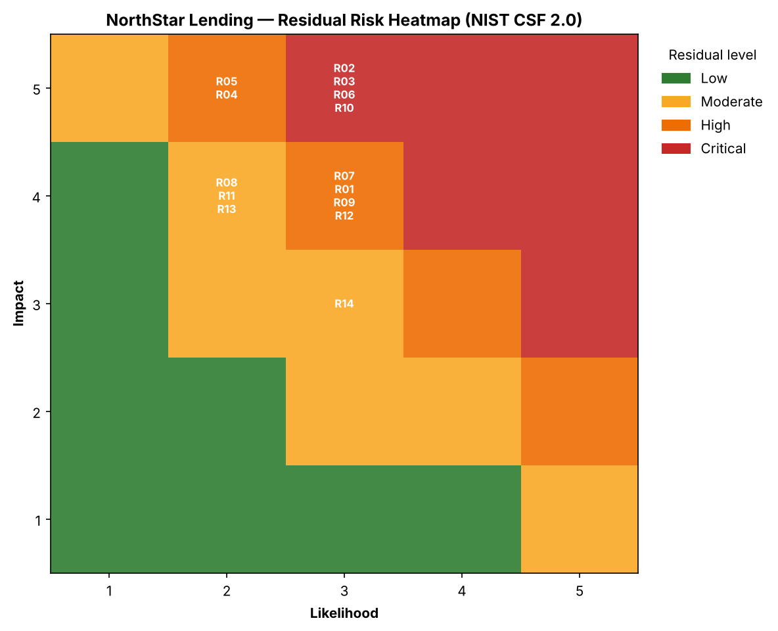
Residual Risk Heatmap

2. Top risks and recommended treatment
The four Critical residual risks (score 15) are the priority:
ID | Risk | Residual | Why it matters | Recommended action
R02 | No enforced MFA on admin/SSO | Critical | A single phished admin credential compromises every system; #1 breach cause | Enforce phishing-resistant MFA on all admin and SSO accounts
R03 | Insecure customer API | Critical | APIs expose regulated financial data directly to the internet | OAuth2 + authorization checks, rate limiting, WAF, API gateway
R06 | Public/misconfigured cloud storage | Critical | A single misconfigured bucket can leak the full customer dataset | Block Public Access, deploy CSPM, scan IaC pre-deploy
R10 | No incident response plan | Critical | A breach without a plan multiplies cost, downtime, and regulatory exposure | Documented IR plan, roles/runbooks, annual tabletop
The six High risks (R01, R07, R09, R12 at score 12; plus others) follow on a 60–90 day timeline and are listed in outputs/risk-register-scored.csv.

3. The quantitative view (why this gets funded)
For R03 (insecure API), a qualitative “Critical” rating is translated into money so leadership can weigh control cost against risk reduction:
Metric | Before controls | After controls
Single Loss Expectancy (SLE) | $1,200,000 | $1,200,000
Annualized Rate of Occurrence (ARO) | 0.4 / yr | 0.1 / yr
Annualized Loss Expectancy (ALE) | $480,000 / yr | $120,000 / yr
Modeled risk reduction ≈ $360,000/yr against a control cost (API gateway, WAF, engineering time) well below that — the investment is justified on expected-value grounds. (Figures illustrative; see methodology §4.)

4. Findings mapped to NIST CSF 2.0 functions
Function | Theme of gaps | Representative risks
GV Govern | No written security program; no vendor risk mgmt; no risk-assessment cadence (GLBA gap) | R07, R11, R14
ID Identify | Incomplete asset inventory; no vulnerability management | R12, R14
PR Protect | No enforced MFA; weak API security; inconsistent encryption; cloud misconfig | R01–R06, R08
DE Detect | No centralized logging/SIEM; limited monitoring | R09
RS Respond | No incident response plan or testing | R10
RC Recover | Untested backups; no DR/BCP | R04, R13
The spread across all six functions is itself the finding: NorthStar has point tools but no program. The remediation roadmap therefore leads with governance.

5. Remediation roadmap
Phase 1 — 0–60 days (Critical): Enforce MFA (R02); secure APIs (R03); lock down cloud storage with Block Public Access + CSPM (R06); write and socialize an incident response plan (R10). In parallel, stand up the written information security program and designate a Qualified Individual (R11) — the GLBA foundation everything else hangs on.
Phase 2 — 60–120 days (High): Centralized logging/SIEM (R09); vulnerability management with patch SLAs (R12); vendor risk program (R07); phishing-resistant MFA rollout to all staff + simulations (R01).
Phase 3 — 120–180 days (Moderate + maturity): Least privilege and access reviews (R08); org-wide encryption enforcement (R05); DR/BCP with tested restores (R13); SaaS discovery and asset inventory (R14). Re-run this assessment to measure residual risk reduction.

6. How to reproduce
pip install -r scripts/requirements.txt
python3 scripts/risk_scoring.py
# regenerates outputs/: scored register, heatmap, and summary

7. Sources & standards referenced
- NIST Cybersecurity Framework (CSF) 2.0
- NIST SP 800-30 Rev. 1 — Guide for Conducting Risk Assessments
- FTC Safeguards Rule, 16 CFR Part 314 (GLBA)
- NIST SP 800-53 Rev. 5 and CIS Controls v8 (control references; see Project 2 crosswalk)

