SOX IT General Controls (ITGC) — Overview
Portfolio note: This is a lab project using the same fictional fintech, NorthStar Lending, Inc., introduced in the risk assessment project. NorthStar is preparing for an eventual IPO, which is when a private company must get its controls SOX-ready. All data is invented.

1. What SOX is and why IT cares
The Sarbanes-Oxley Act of 2002 (SOX) was passed after the Enron and WorldCom accounting scandals to restore trust in public-company financial reporting. The part that matters here is Section 404: company management must assess and report on the effectiveness of its Internal Control over Financial Reporting (ICFR), and (for larger filers) the external auditor must attest to it.
Here’s the link to IT: modern financial statements are produced by IT systems — general ledgers, billing, loan and payment platforms, databases. If those systems aren’t controlled, the numbers they produce can’t be trusted. IT General Controls (ITGC) are the controls over the IT environment that give assurance the financial applications and data are reliable. If ITGCs fail, the auditor can’t rely on any of the automated controls or system-generated reports that sit on top of them — so ITGC failures have outsized consequences.
The one-sentence version for an interview: “ITGCs are the foundation that lets auditors trust the systems producing the financial statements — if they’re broken, nothing built on those systems can be relied upon.”

2. The four ITGC domains
Essentially every SOX ITGC program organizes around these four domains:
Domain | What it assures | Example controls
Access to Programs & Data | Only authorized, appropriate users can access financial systems and data | User provisioning approval, access reviews, timely termination, privileged-access restriction, MFA, segregation of duties
Program Changes | Changes to financial systems are authorized, tested, and approved before production | Change approval, testing before deployment, developer ≠ deployer separation, emergency-change review
Program Development | New financial systems are built and implemented with proper controls | SDLC approvals, data-migration validation, user acceptance testing (UAT) sign-off
Computer Operations | Systems run reliably and problems are resolved | Job scheduling and monitoring, backup execution and restore testing, incident/problem management

3. Two concepts that make this a finance-crossover skill
Segregation of Duties (SoD). No single person should control all parts of a transaction — e.g., the same person shouldn’t be able to both write code and deploy it to production unreviewed, or both create a vendor and approve a payment to it. SoD failures are a classic path to fraud and a frequent source of SOX findings. (NorthStar’s finding CM-03 is an SoD gap.)
Deficiency severity. Not every failed control is equal. SOX classifies them by the likelihood and magnitude of a resulting financial misstatement:
Classification | Meaning
Control Deficiency | A control doesn’t operate effectively, but the impact is limited.
Significant Deficiency | Important enough to merit attention by those charged with governance (audit committee).
Material Weakness | A reasonable possibility that a material misstatement of the financial statements would not be prevented or detected in time. The most severe — must be disclosed.
This severity language (straight from PCAOB Auditing Standard 2201) is what separates an IT auditor who understands why a control matters from one who just checks boxes.

4. How this project is structured
- Control matrix (data/itgc-controls.csv) — 16 ITGC controls across the four domains, each with a control objective, activity, owner, test procedure, test result, and deficiency severity.
- Assessment script (scripts/itgc_assessment.py) — summarizes test results, counts deficiencies by severity, computes a control-effectiveness rate, and renders a status chart.
- Findings report (docs/03-findings-report.md) — the deficiencies, their severity, root cause, and remediation, written as an audit deliverable.

SOX ITGC Assessment — Findings Report

NorthStar Lending, Inc. — IPO Readiness
Portfolio note: Fictional company and data; a lab exercise demonstrating a SOX ITGC assessment deliverable.
Prepared by: Salim Mbaye Scope: IT General Controls supporting financial reporting (4 domains, 16 controls) Standard: PCAOB AS 2201; SOX Section 404 (ICFR) Date: October 2026

1. Executive summary
NorthStar Lending’s IT General Controls were assessed across the four ITGC domains as part of IPO readiness. Of 16 controls tested, 11 (69%) operated effectively. Five deficiencies were identified, including one material weakness.
Overall conclusion | MATERIAL WEAKNESS
Because a material weakness exists, ITGC cannot currently be concluded effective, and the automated controls and system-generated reports that depend on these IT controls cannot yet be fully relied upon for financial-reporting purposes. The material weakness is concentrated in change management (developer access to production), with additional significant deficiencies in access management.
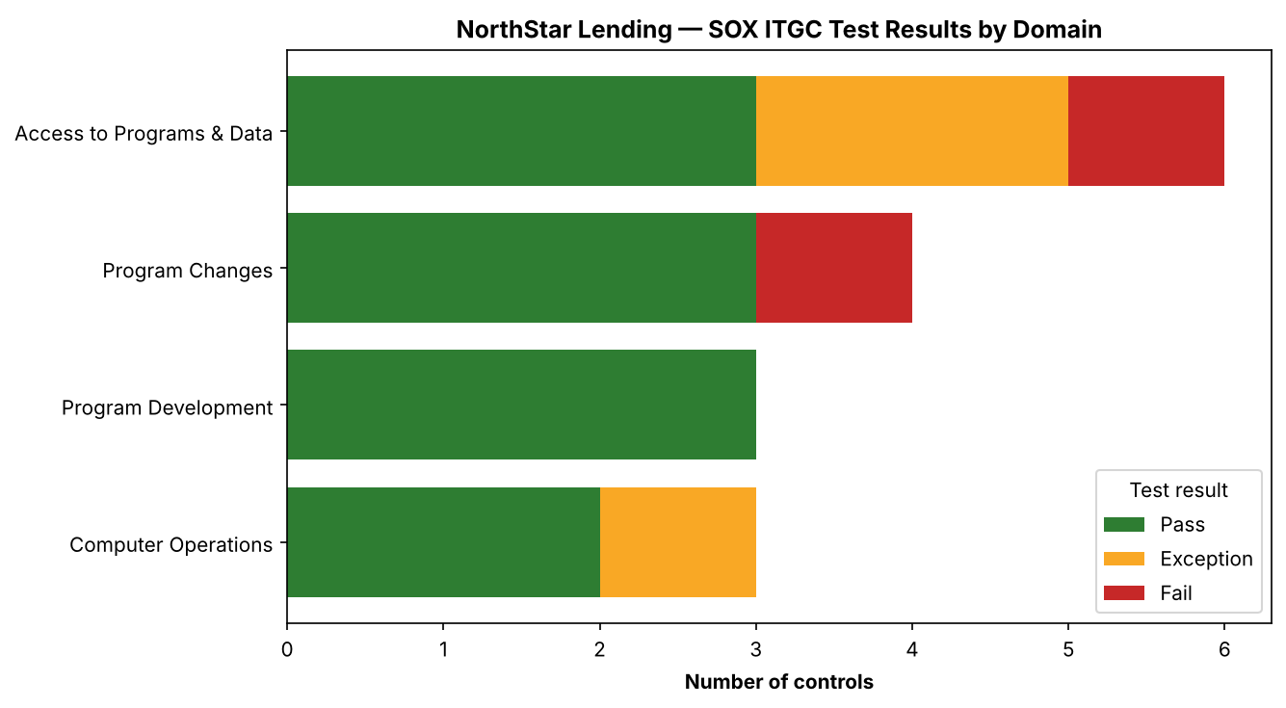
ITGC test results by domain

2. Deficiencies

CM-03 — Developers have standing production access — Material Weakness
- Condition: Developers hold standing access to deploy directly to the production financial systems, with no enforced separation between who writes code and who releases it.
- Why it’s a material weakness: This is a segregation-of-duties failure over the systems that produce financial data. An unreviewed or unauthorized change could alter financial transactions or reporting with no compensating control to catch it — a reasonable possibility of a material misstatement that would not be prevented or detected.
- Root cause: Rapid startup growth; deployment speed prioritized over control.
- Remediation: Remove developer standing production access; route all deployments through a controlled CI/CD pipeline with independent approval and an audit trail.

AC-03 — Terminated access not revoked timely — Significant Deficiency
- Condition: In a sample of 15 terminations, access was not revoked within the 24-hour SLA for several separated users.
- Impact: Former employees may retain access to financial systems — an access and fraud risk.
- Remediation: Automate deprovisioning via an HR-triggered workflow; monitor SLA.

AC-02 — Quarterly access recertification not consistently performed — Significant Deficiency
- Condition: Recertification evidence was missing for part of the year.
- Impact: Access creep — users may accumulate inappropriate access undetected.
- Remediation: Formalize and enforce quarterly recertification with tracked completion.

AC-06 — Segregation-of-duties conflicts unresolved — Control Deficiency
- Condition: The SoD conflict report shows unresolved conflicting access grants.
- Remediation: Implement an SoD ruleset and remediate the conflicting grants.

CO-02 — Backups not restore-tested — Control Deficiency
- Condition: Backups run, but restoration has not been periodically tested.
- Remediation: Establish documented periodic restore testing with retained evidence.

3. Remediation priority
Priority | Control | Severity | Action
1 | CM-03 | Material Weakness | Remove dev prod access; controlled CI/CD with approval
2 | AC-03 | Significant Deficiency | Automate timely deprovisioning
3 | AC-02 | Significant Deficiency | Enforce quarterly access recertification
4 | AC-06 | Control Deficiency | Deploy SoD ruleset; clear conflicts
5 | CO-02 | Control Deficiency | Periodic, evidenced restore testing
The material weakness (CM-03) must be remediated and the control operating effectively for a period before management could assert ITGC is effective. Access-domain deficiencies cluster around identity lifecycle and are addressable with automation.

4. How to reproduce
pip install -r scripts/requirements.txt
python3 scripts/itgc_assessment.py
# regenerates outputs/: assessment summary + status chart

5. Standards referenced
- Sarbanes-Oxley Act of 2002, Section 404 (ICFR)
- PCAOB Auditing Standard 2201 (deficiency severity definitions)
- COSO Internal Control — Integrated Framework (control environment)

