SAP Order-to-Cash (O2C) Process Implementation for Croma
Name: Salini Satpathy Roll No: 23052259
Batch: B.Tech Institution: KIIT University Date: 19 April 2026

Problem Statement
Croma is a high-volume consumer electronics retailer processing thousands of orders daily across physical stores and online channels. Without an integrated system, the business faces serious operational challenges:
- Sales orders are created without checking real-time stock, leading to fulfillment failures and customer disappointment.
- Delivery scheduling is disconnected from order management, causing delays and miscommunication between warehouse and logistics teams.
- Invoice generation done manually results in pricing errors, incorrect tax calculations, and billing disputes.
- Finance teams work in isolation from sales, making payment reconciliation slow and error-prone.
- Management has no single, real-time view of sales performance, inventory levels, or outstanding receivables.
The core problem is the absence of an end-to-end integrated system that connects the customer order all the way through to payment collection and financial posting. This gap leads to revenue leakage, poor customer experience, and weak internal controls. The SAP Order-to-Cash (O2C) process is implemented to solve exactly this problem.

Process Flow
The O2C process follows a linear, document-driven flow where each step generates a document that feeds into the next:
Inquiry → Quotation → Sales Order → Availability Check (ATP) → Delivery → Post Goods Issue (PGI) → Billing / Invoice → Payment Receipt → Reporting
Each arrow represents a system transaction in SAP. No step can be skipped — SAP enforces the sequence, ensuring that billing cannot happen without delivery, and delivery cannot happen without an approved sales order. This built-in control is one of the key strengths of the SAP O2C framework.

Step-by-Step SAP Process
Step 1 — Customer Inquiry (T-Code: VA11) A customer visits a Croma store or contacts the online channel to ask about a laptop — its model, features, warranty, and price. The sales executive creates a formal Inquiry document in SAP using VA11. This document logs the customer's interest, the product they are asking about, and any specific requirements. It serves as the starting point for the sales process and ensures no lead is lost or handled informally.
Step 2 — Quotation Creation (T-Code: VA21) Based on the inquiry, Croma's sales team prepares an official Quotation using VA21. The quotation includes the product description, unit price, applicable discounts, GST breakup (CGST + SGST or IGST), and estimated delivery date. The quotation is valid for a set period and is shared with the customer for review. Once the customer agrees to the terms, the process moves to order creation.
Step 3 — Sales Order Creation (T-Code: VA01) This is the most critical step in the O2C cycle. When the customer confirms, a Sales Order is raised in SAP using VA01. It captures all essential details: customer master data, ship-to address, ordered item and quantity, payment terms, pricing conditions, and delivery date. All downstream steps — delivery, billing, and payment — are linked back to this sales order. SAP assigns a unique order number for tracking throughout the lifecycle.
Step 4 — Availability Check (ATP) As soon as the sales order is saved, SAP automatically triggers an ATP (Available-to-Promise) check. The system queries the inventory in real time to confirm whether the ordered quantity is available at the designated warehouse or store. If stock is available, the delivery date is confirmed. If stock is insufficient, SAP can trigger a replenishment purchase order or initiate a stock transfer from another location — all without manual intervention.
Step 5 — Delivery Creation (T-Code: VL01N) With stock confirmed, the warehouse team creates a Delivery Document using VL01N. This document instructs the warehouse to pick the specific items from storage, pack them as per shipping requirements, and prepare them for dispatch. The delivery document also captures the carrier details, route, and shipping point. It acts as the bridge between the confirmed order and the physical movement of goods.
Step 6 — Post Goods Issue / PGI (T-Code: VL02N) Post Goods Issue is the step where the physical dispatch of goods is officially recorded in SAP using VL02N. The moment PGI is posted, three things happen simultaneously: inventory is reduced by the dispatched quantity in the MM module, a goods movement accounting entry is created in SAP FI, and the delivery status is updated to "goods issued." From this point, the goods are legally considered to have left Croma's possession, and the customer's delivery is in progress.
Step 7 — Billing and Invoice Generation (T-Code: VF01) Once PGI is posted, the billing department creates the customer Invoice using VF01. SAP pulls all data from the sales order and delivery — item details, quantities, prices, discounts, and taxes — and generates an accurate invoice automatically. The invoice is then sent to the customer. At the same time, an accounting document is posted in SAP FI, creating a debit entry in the customer's account (accounts receivable) and a credit entry in the revenue account.
Step 8 — Payment Receipt (T-Code: F-28) When the customer makes payment — via cash, card, UPI, or bank transfer — the payment is recorded in SAP FI using T-code F-28. SAP matches the incoming payment against the open invoice and clears it. The customer's outstanding balance is reduced to zero, the accounts receivable entry is cleared, and the bank or cash account is updated. If there is a partial payment, the remaining balance stays open as a receivable until fully settled.
Step 9 — Reporting After the cycle is complete, SAP provides a range of standard and custom reports: sales order status, delivery performance, revenue by product/region/period, inventory movement, customer-wise outstanding payments, and profitability analysis. These reports give Croma's management team real-time insights to monitor operations, identify bottlenecks, and support strategic decision-making.

Screenshots
- VA01 — Sales Order creation screen showing customer details, material, quantity, and pricing
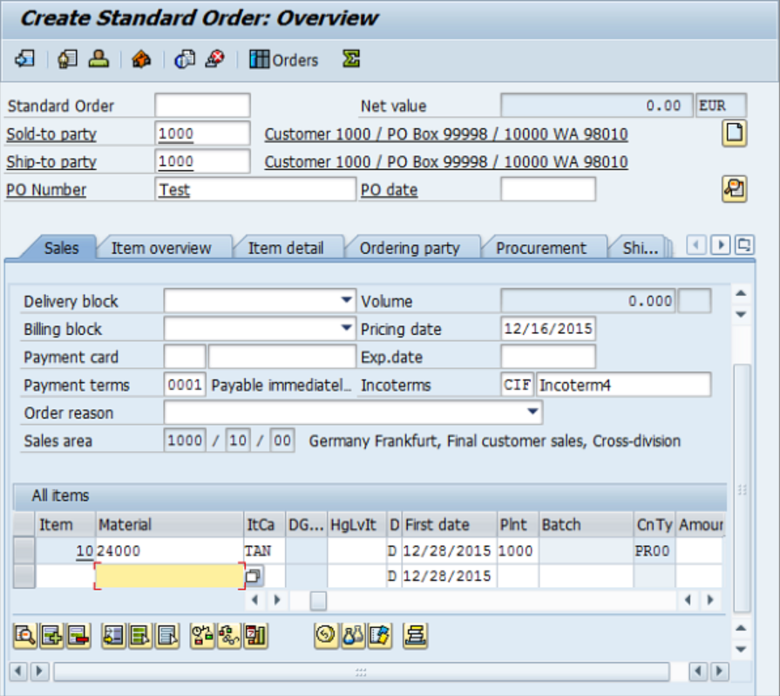
- VL01N — Delivery document creation screen
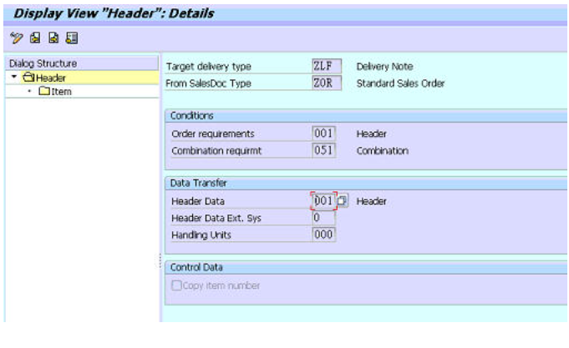
- VF01 — Billing document / invoice generation screen
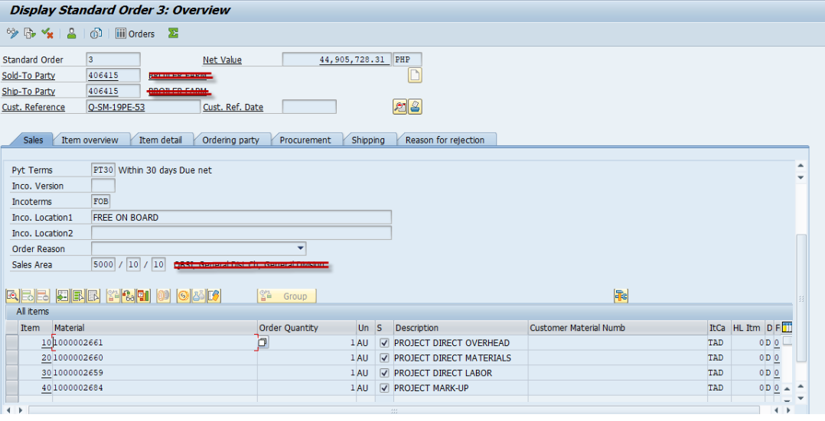
- F-28 — Payment posting screen in SAP FI
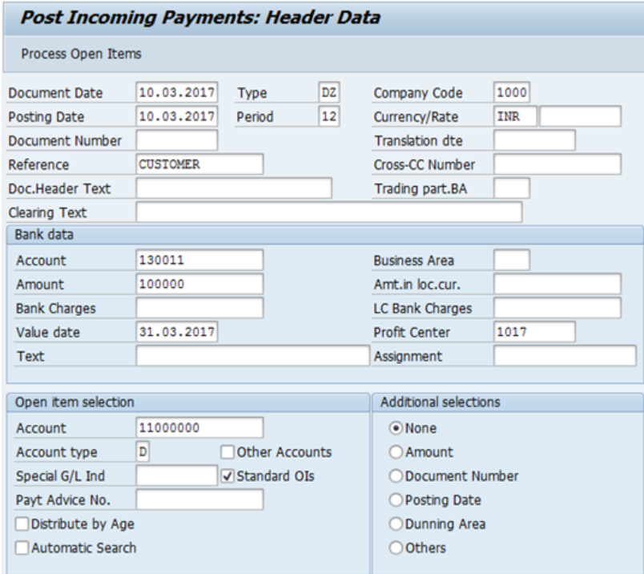
- VA03 or MD04 — Stock overview or order status tracking
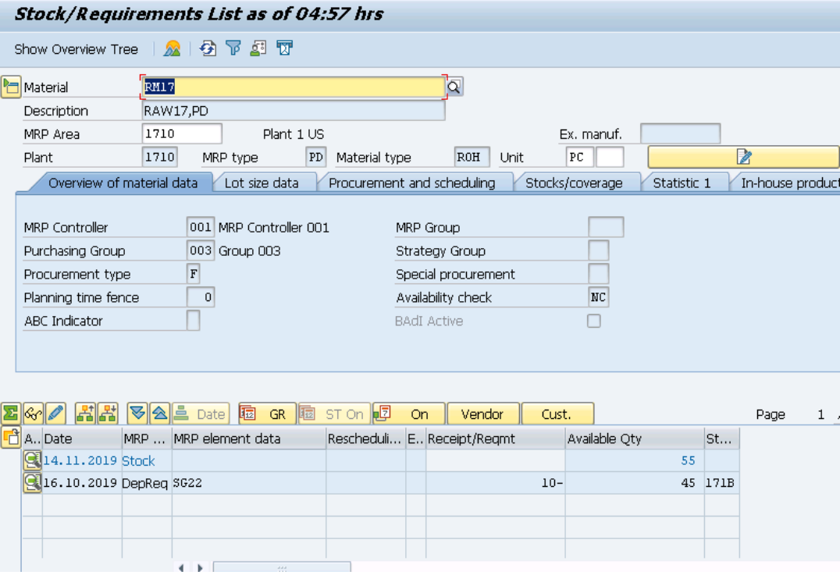

Technology / Modules Used
Module | Full Name | Role in O2C
SAP SD | Sales and Distribution | Core module — manages inquiry, quotation, sales order, delivery, and billing
SAP MM | Materials Management | Handles inventory and stock availability checks (ATP)
SAP WM | Warehouse Management | Manages picking, packing, and physical goods movement in the warehouse
SAP FI | Financial Accounting | Records billing entries, payment receipts, and accounts receivable updates
SAP CO | Controlling | Tracks cost centers and profitability linked to sales transactions
All five modules work in real time, sharing a common database. A single sales transaction in SD automatically updates MM, WM, and FI without any manual data transfer — this is the core value of SAP as an integrated ERP system.

Unique Points
- Retail-specific implementation: This project uses Croma — a real, well-known Indian electronics retailer — as the business scenario rather than a generic manufacturing example. This makes the O2C process more relatable and practically grounded.
- End-to-end customer lifecycle coverage: The process is traced from the very first customer inquiry all the way through to final payment and financial reconciliation, covering the complete revenue cycle.
- Three-module integration demonstrated: The project explicitly shows how SAP SD, MM/WM, and FI work together in one transaction chain — something many implementations demonstrate only partially.
- India-specific tax context: GST (CGST, SGST, IGST) is incorporated into the billing step, making the scenario directly applicable to Indian retail business operations.
- Omnichannel applicability: The scenario covers both in-store and online order channels, reflecting the real operating model of modern retailers like Croma.

Conclusion
The SAP Order-to-Cash process gives Croma a fully integrated, automated, and controlled system for managing its sales operations from end to end. By connecting the customer-facing sales process with warehouse operations and financial accounting in a single platform, SAP removes the inefficiencies, errors, and delays that result from working across disconnected systems.
Every transaction — from the first inquiry to the final payment — is recorded, traceable, and auditable. This level of integration improves operational speed, billing accuracy, inventory control, and customer satisfaction simultaneously. For a business like Croma that operates at scale across hundreds of locations and digital channels, SAP O2C is not just a software implementation — it is the operational foundation on which reliable, profitable retail is built.

Future Improvements
- E-commerce integration: Automatic creation of SAP sales orders directly from Croma's website and app, eliminating manual order entry and reducing processing time.
- AI-based demand forecasting: Using machine learning to predict product demand by location and season, enabling smarter inventory positioning and fewer stockouts.
- CRM and loyalty program integration: Linking SAP O2C with Croma's customer loyalty system so that reward points, membership discounts, and personalized offers are applied automatically at the point of order.
- Real-time delivery notifications: Automated customer alerts via SMS, WhatsApp, and email at key milestones — order confirmation, dispatch, and delivery — reducing inbound customer service calls.
- Returns and reverse logistics automation: Extending the O2C process to handle product returns, credit notes, and refunds within the same SAP framework, closing the full customer lifecycle loop.

