EXPERIMENT NO 1

**AIM**

To study various DDL commands – CREATE,INSERT.

**Question**

Create the following Tables

**Table 1: DEPOSIT**

ACTNO VARCHAR2(5) PRIMARY KEY, FIRST LETTER MUST START WITH ‘D’ CNAME VARCHAR2(15) FOREIGN KEY REFERENCES CUSTOMER

BNAME VARCHAR2(20) FOREIGN KEY REFERENCES BRANCH AMOUNT NUMBER (8,2) NOT NULL, CANNOT BE 0

ADATE DATE

CREATE DATABASE myaccout;

use myaccout;

create table deposit(Actno VARCHAR(5) PRIMARY KEY,Cname VARCHAR(15) REFERENCES Cname(Customer),Bname VARCHAR(20) REFERENCES Bname(Branch) ,Amount NUMERIC(8,2) NOT NULL, Adate DATE);

use deposit;

CREATE TABLE Branch(Bname VARCHAR(20) PRIMARY KEY,City VARCHAR(30) NOT NULL);

CREATE TABLE Customer(Cname VARCHAR(15) PRIMARY KEY,City VARCHAR(30) NOT NULL);

CREATE TABLE Borrow(Loan VARCHAR(8) PRIMARY KEY, Cname VARCHAR(15) REFERENCES Cname(Customer), Bname VARCHAR(20) REFERENCES Bname(Branch), Amount NUMERIC(8,2) NOT NULL);

DEPOSIT TABLE

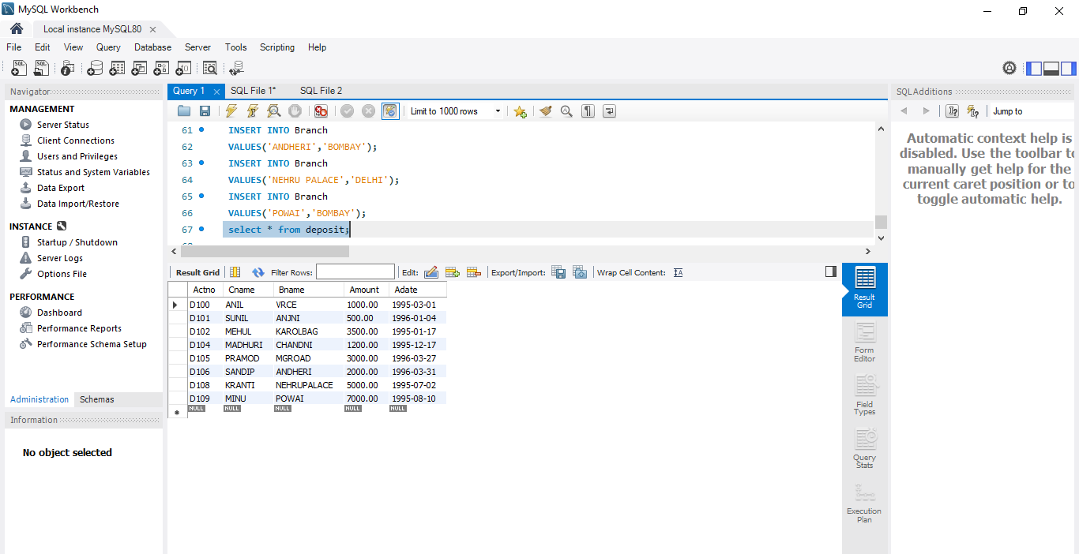

PROCEDURE

INSERT into deposit(Actno,Cname,Bname,Amount,Adate)VALUES('D100','ANIL','VRCE','1000.00','1995-3-1');

INSERT into deposit(Actno,Cname,Bname,Amount,Adate)VALUES('D101','SUNIL','ANJNI','500.00','1996-1-4');

INSERT into deposit(Actno,Cname,Bname,Amount,Adate)VALUES('D102','MEHUL','KAROLBAG','3500.00','1995-1-17');

INSERT into deposit(Actno,Cname,Bname,Amount,Adate)VALUES('D104','MADHURI','CHANDNI','1200.00','1995-12-17');

INSERT into deposit(Actno,Cname,Bname,Amount,Adate)VALUES('D105','PRAMOD','MGROAD','3000.00','1996-3-27');

INSERT into deposit(Actno,Cname,Bname,Amount,Adate)VALUES('D106','SANDIP','ANDHERI','2000.00','1996-3-31');

INSERT into deposit(Actno,Cname,Bname,Amount,Adate)VALUES('D107','SHIVANI','VIRAR','1000.00','1995-11-5');

INSERT into deposit(Actno,Cname,Bname,Amount,Adate)VALUES('D108','KRANTI','NEHRUPALACE','5000.00','1995-7-2');

INSERT into deposit(Actno,Cname,Bname,Amount,Adate)VALUES('D109','MINU','POWAI','7000.00','1995-8-10');

#### Table 2: BRANCH

BNAME VARCHAR2(20) PRIMARY KEY

CITY VARCHAR2(30) NOT NULL , any one of NAGPUR, DELHI, BANGALORE, BOMBAY

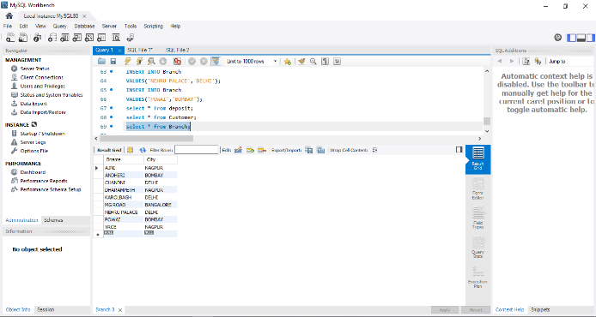

PROCEDURE:

INSERT INTO Branch

VALUES('VRCE','NAGPUR');

INSERT INTO Branch

VALUES('AJNI','NAGPUR');

INSERT INTO Branch

VALUES('KAROLBAGH','DELHI');

INSERT INTO Branch

VALUES('CHANDNI','DELHI');

INSERT INTO Branch

VALUES('DHARAMPETH','NAGPUR');

INSERT INTO Branch

VALUES('MG ROAD','BANGALORE');

INSERT INTO Branch

VALUES('ANDHERI','BOMBAY');

INSERT INTO Branch

VALUES('NEHRU PALACE','DELHI');

INSERT INTO Branch

VALUES('POWAI','BOMBAY');

#### Table 3: CUSTOMER

CNAME VARCHAR2(15) PRIMARY KEY CITY VARCHAR2(20) NOT NULL ,

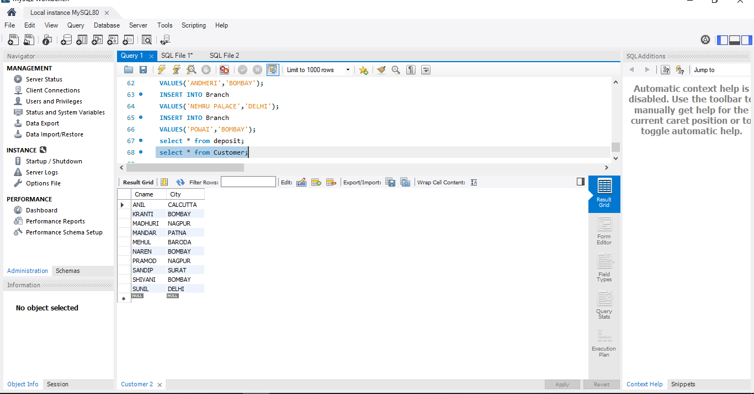

PROCEDURE:

INSERT INTO Customer

VALUES('ANIL','CALCUTTA');

INSERT INTO Customer

VALUES('SUNIL','DELHI');

INSERT INTO Customer

VALUES('MEHUL','BARODA');

INSERT INTO Customer

VALUES('MANDAR','PATNA');

INSERT INTO Customer

VALUES('MADHURI','NAGPUR');

INSERT INTO Customer

VALUES('PRAMOD', 'NAGPUR');

INSERT INTO Customer

VALUES('SANDIP','SURAT');

INSERT INTO Customer

VALUES('SHIVANI','BOMBAY');

INSERT INTO Customer

VALUES('KRANTI','BOMBAY');

INSERT INTO Customer

VALUES('NAREN','BOMBAY');

#### Table 4: BORROW

LOANNO VARCHAR2(8) PRIMARY KEY / FIRST LETTER MUST START WITH ‘L’ CNAME VARCHAR2(15) FOREIGN KEY REFERENCES CUSTOMER

BNAME VARCHAR2(20) FOREIGN KEY REFERENCES BRANCH AMOUNT NUMBER(8,2) NOT NULL, CANNOT BE 0

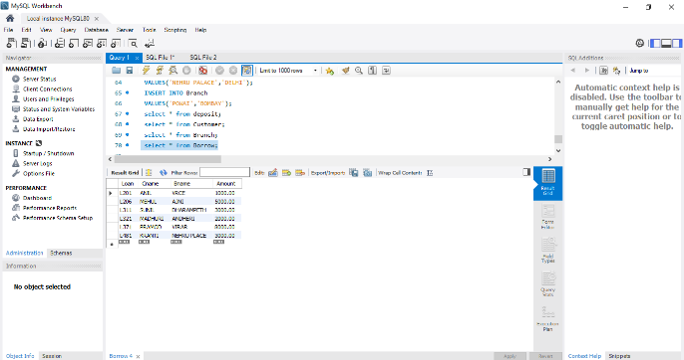

PROCEDURE:

INSERT INTO Borrow

VALUES('L201','ANIL','VRCE',1000.00);

INSERT INTO Borrow

VALUES('L206','MEHUL','AJNI',5000.00);

INSERT INTO Borrow

VALUES('L311','SUNIL','DHARAMPETH',3000.00);

INSERT INTO Borrow

VALUES('L321','MADHURI','ANDHERI',2000.00);

INSERT INTO Borrow

VALUES('L371','PRAMOD','VIRAR',8000.00);

INSERT INTO Borrow

VALUES('L481','KRANTI','NEHRU PLACE',3000.00);

