A STUDY OF DIFFERENT TYPES OF DATABASE MANAGEMENT SYSTEMS

**What is DBMS?**

**Database Management System (DBMS)** is a software for storing and retrieving users’ data while considering appropriate security measures. It consists of a group of programs which manipulate the database.

## What is a Database?

A database is a collection of related data which represents some aspect of the real world. A database system is designed to be built and populated with data for a certain task.

Types of Database Management Systems

There are several types of database management systems. Here is a list of seven common database management systems:

1. Hierarchical databases
2. Network databases
3. Relational databases
4. Object-oriented databases
5. Graph databases
6. ER model databases
7. Document databases
8. NoSQL databases

## Hierarchical Databases

## ->Data is stored in a parent-children relationship node.

## ->Records also contain information about their groups of parent/child relationships.

->Data is organized into a tree-like structure.

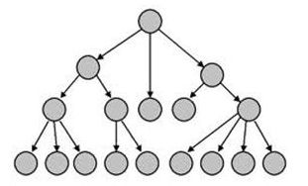

ADVANTAGES

->A hierarchical database can be accessed and updated rapidly.

DISADVANTAGES

->This type of database structure is that each child in the tree may have only one parent.

->Relationships or linkages between children are not permitted, even if they make sense from a logical standpoint.

->Hierarchical databases are like this in their design. Adding a new field or record requires that the entire database be redefined.

Network databases

->Use a network structure to create a relationship between entities.

-> Network node can have a relationship with multiple entities.

->In network databases, children are called members and parents are called occupiers. The difference between each child or member is that it can have more than one parent.

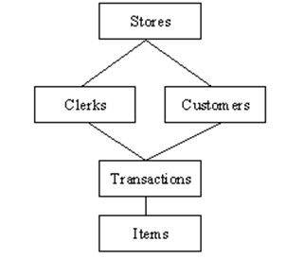

-> The approval of the network data model is similar to a hierarchical data model. Data in a network database is organized in many-to-many relationships.

RELATIONAL DATABASES

->The relationship between data is relational and data is stored in tabular form of columns and rows.

-> Each column of a table represents an attribute and each row in a table represents a record.

->Each field in a table represents a data value.

-> Structured Query Language (SQL) is the language used to query RDBMS, including inserting, updating, deleting, and searching records.

-> Relational databases are the most popular and widely used databases. Some of the popular DDBMS are Oracle, SQL Server, MySQL, SQLite, and IBM DB2.

**The relational database has two major advantages:**

1. Relational databases can be used with little or no training.
2. Database entries can be modified without specifying the entire body.

**Properties of Relational Tables**

In a relational database, we have to follow the properties given below:

* Values are Atomic
* Each Row is alone.
* Column Values are the same thing.
* Columns are undistinguished.
* Sequence of Rows is Insignificant.
* Each Column has a common name.

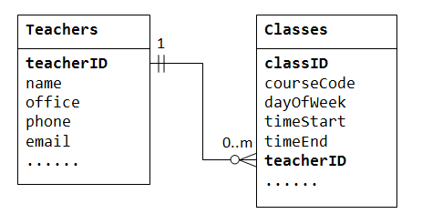

Object-oriented databases

-> It takes more than the storage of programming language objects. Object DBMS's increase in the semantics of C++ and Java.

-> It adds the database functionality to object programming languages.

-> Each object contains two elements:

1. A piece of data (e.g., sound, video, text, or graphics).
2. Instructions, or software programs called methods, for what to do with the data.

**Disadvantages of Object-oriented databases**

1. Object-oriented databases are more expensive to develop.
2. Most organizations are unwilling to abandon and convert from those databases.

**Benefits of Object-oriented databases**

The benefits of object-oriented databases are compelling. The ability to mix and match reusable objects provides the incredible multimedia capability.

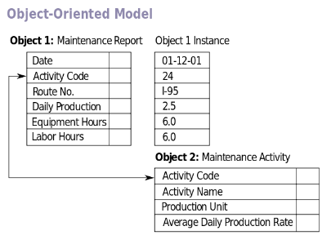

GRAPH DATABASES

-> The data is stored in the form of nodes, edges, and properties.

-> A node is equivalent to a record in a relational database system.

-> An Edge in a graph database represents a relationship that connects nodes.

->Properties are additional information added to the nodes.

->The Neo4j, Azure Cosmos DB, SAP HANA, Sparksee, Oracle Spatial and Graph, OrientDB, ArrangoDB, and MarkLogic are some of the popular graph databases.

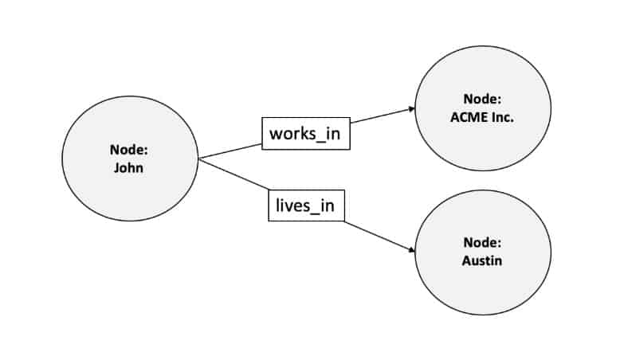

ERMODEL DATABASES

-> In a simple relational database implementation, each row of a table represents one instance of an entity type, and each field in a table represents an attribute type.

->  A relationship between entities is implemented by storing the primary key of one entity as a pointer or "foreign key" in the table of another entity.

->The entity-relationship model was developed by Peter Chen in 1976.

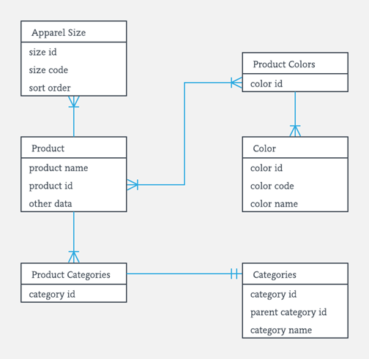

## Document Databases

-> Document databases (Document DB) are also NoSQL databases that store data in the form of documents.

-> Document database store data in a key-value form.

-> Document DB has become popular recently due to their document storage and NoSQL properties. NoSQL data storage provides a faster mechanism to store and search documents.

->Popular NoSQL databases are Hadoop/Hbase, Cassandra, Hypertable, MapR, Hortonworks, Cloudera, Amazon SimpleDB, Apache Flink, IBM Informix, Elastic, MongoDB, and Azure DocumentDB.

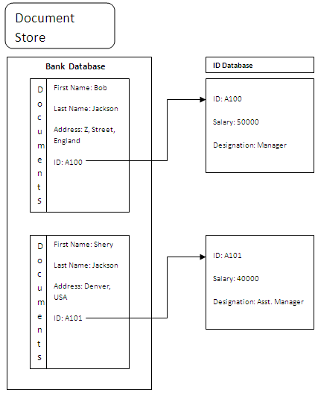

NoSQL Databases

NoSQL databases are databases that do not use SQL as their primary data access language. Graph database, network database, object database, and document databases are common NoSQL databases.

NoSQL database does not have predefined schemas, which makes NoSQL databases a perfect candidate for rapidly changing development environments.

NoSQL allows developers to make changes on the fly without affecting applications.

NoSQL databases can be categorized into the following five major categories, Column, Document, Graph, Key-value, and Object databases.

Popular NoSQL databases:

1. Cosmos DB
2. ArangoDB
3. Couchbase Server
4. CouchDB
5. Amazon DocumentDB
6. MongoDB, CouchBase
7. Elasticsearch
8. Informix
9. SAP HANA
10. Neo4j
11. 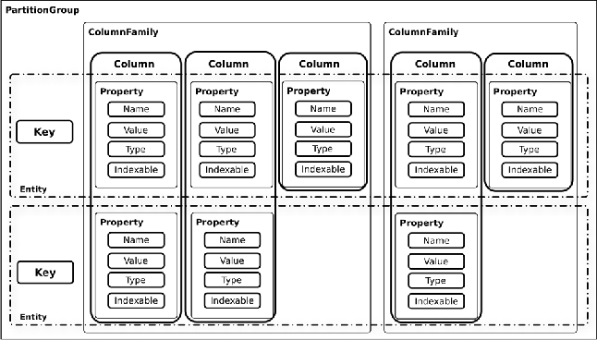

POPULAR DBMS SOFTWARE

1.MYSQL

2.MICROSOFT ACCESS

3.ORACLE

4.POSTGRESQL

5.DBASE

6.FOXPRO

7.SQLITE

8.IBM DB2

9.LIBREOFFICE BASE

10.MARIA DB

11.MICROSOFT SQL SERVER

1.MYSQL

## What is SQL?

Structured Query Language (SQL) is the standard language for data manipulation in a DBMS. In in simple words its used to talk to the data in a DBMS. Following are types of SQL Statements

1. Data Definition Language (DDL) allows you to create objects like Schemas, Tables in the database
2. Data Control Language (DCL) allows you to manipulate and manage access rights on database objects
3. Data Manipulation Language (DML) is used for searching, inserting, updating, and deleting data, which will be partially covered in this SQL tutorial.

## What is Query?

A Query is a set of instruction given to the database management system. It tells any database what information you would like to get from the database. For example, to fetch the student name from the database table STUDENT, you can write the SQL Query like this:

SELECT Student_name from STUDENT;

2.MICROSOFT ACCESS

**Microsoft Access** is a [database management system](https://en.wikipedia.org/wiki/Database_management_system) (DBMS) from [Microsoft](https://en.wikipedia.org/wiki/Microsoft) that combines the [relational](https://en.wikipedia.org/wiki/Relational_database) [Access Database Engine](https://en.wikipedia.org/wiki/Access_Database_Engine) (ACE) with a [graphical user interface](https://en.wikipedia.org/wiki/Graphical_user_interface) and software-development tools. It is a member of the [Microsoft 365](https://en.wikipedia.org/wiki/Microsoft_365) suite of applications, included in the Professional and higher editions or sold separately.

Microsoft Access stores data in its own format based on the Access Database Engine (formerly Jet Database Engine). It can also import or link directly to [data](https://en.wikipedia.org/wiki/Data) stored in other applications and databases.[[2]](https://en.wikipedia.org/wiki/Microsoft_Access#cite_note-ms-import-2)

3.ORACLE

An Oracle **database** is a collection of data treated as a unit. The purpose of a database is to store and retrieve related information. A database server is the key to solving the problems of information management. In general, a [**server**](https://docs.oracle.com/cd/B19306_01/server.102/b14220/glossary.htm#i432724) reliably manages a large amount of data in a multiuser environment so that many users can concurrently access the same data. All this is accomplished while delivering high performance. A database server also prevents unauthorized access and provides efficient solutions for failure recovery.

4.POSTGRESQL

## What is PostgreSQL?

**PostgreSQL** is an open-source database management system for enterprise-class database applications. It supports both SQL and JSON for relational and non-relational queries for extensibility and SQL compliance. It also offers advanced data types and performance optimization features to store and scale complicated database workloads. It is also known as Postgres.

5.DBASE

Is dBASE an example of an database?

**DBase is a microcomputer database management system** (DBMS) that runs on a Windows platform.

dBASE does not support SQL

Why is dBASE popular?

Very quickly dBASE grew in popularity **because of its simplicity and ease of use**. It featured a database engine, query system, forms engine and a programming language—the dBASE language

10.MARIA DB

## What is MariaDB?

MariaDB is a fork of the MySQL database management system. It is created by its original developers. This DBMS tool offers data processing capabilities for both small and enterprise tasks.

MariaDB is an improved version of MySQL. It comes with numerous inbuilt powerful features and many usabilities, security and performance improvements that you cannot find in MySQL.

 features of MariaDB:

* It operates under GPL, BSD or LGPL licenses.
* MariaDB supports a popular and standard querying language.
* It comes with many storage engines, including the high-performance ones that can be integrated with other relational database management systems.
* It provides the Galera cluster technology.
* MariaDB supports PHP, a popular language for web development.
* MariaDB can run on different operating systems, and it supports numerous programming languages.
* MariaDB comes with additional commands that are not available in MySQL. MySQL has features which have a negative impact on the performance of the DBMS. Such features have been replaced in MariaDB.