Program-1 salini k.b
roll no-33
mca-b
date-12-5-2022

Aim:Write a program to print sum of all digits of a number.

program

echo "Enter Size(N)"
read N
i=1
sum=0
echo "Enter Numbers"
while [ $i -le $N ]
do
read num
sum=$((sum + num))
i=$((i + 1))
done

echo "the sum of $N numbers is $sum"

output

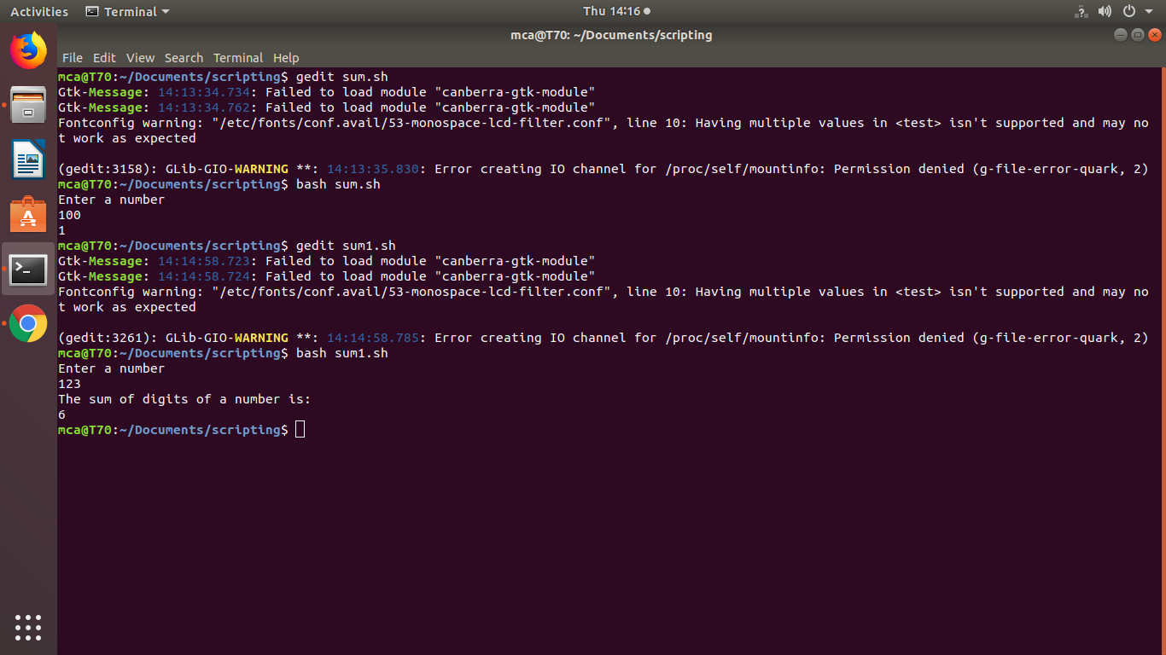
program-2

Aim:
write a shell script program to find the average of a number entered in a command line.

program
echo "Enter Limit"
read N
sum=0
echo "Enter Numbers"
for((i=0;i<N;i++))
{
read num
sum=$((sum + num))
}
avg=$(echo "scale=2; $sum / $N "| bc -l)
echo "the avereage of enetered numbers is $avg"

output

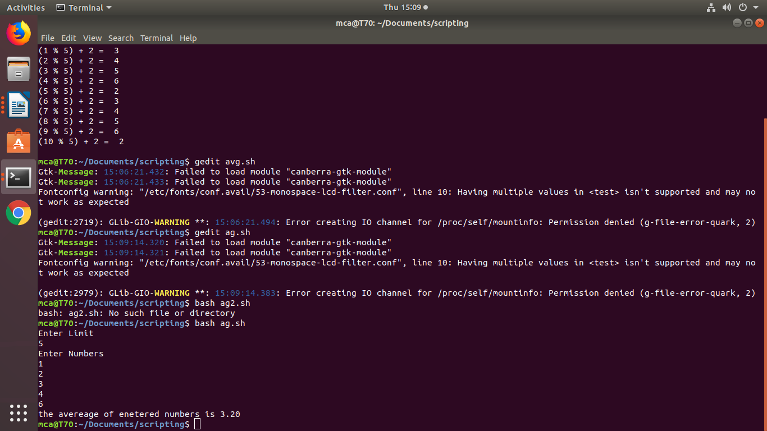

program-3

Aim:
Addition substract and multiplication using switch case.

Program

echo "Enter the first number"
read a

echo "Enter the second number"
read b

echo "Enter the operator:"
echo -e "Addition: +\nSubtraction: -\nMultiplication: x\nDivision: /"
read op

case $op in
+) c=`expr $a + $b`
echo "Sum of $a and $b is $c";;

-) c=`expr $a - $b`
echo "Difference of $a and $b is $c";;

x) c=`expr $a \* $b`
echo "Product of $a and $b is $c";;

/) c=`expr $a / $b`
echo "Division of $a and $b is $c";;

*) echo "Invalid Operator"
exit;;
esac

