Program no1

Aim] write a shell script to display current date and calender.

Program

echo "Today is $(date)"
echo ""

echo "Calendar :"
cal

output

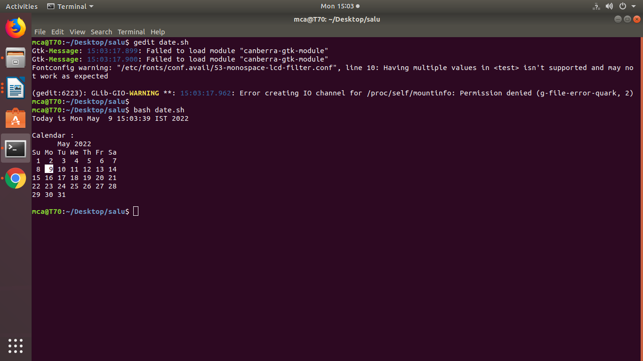

program no-2
Aim:

write a shell script to check a number is >,<,= another number.

echo "enter two numbers"
read var1
read var2
if [ $var2 -gt $var1 ]
then
echo "$var2 is greater than $var1"
elif [ $var1 -gt $var2]
then
echo "$var1 is greater than $var2"
else
echo "$var1 and $var2 are equal"
fi
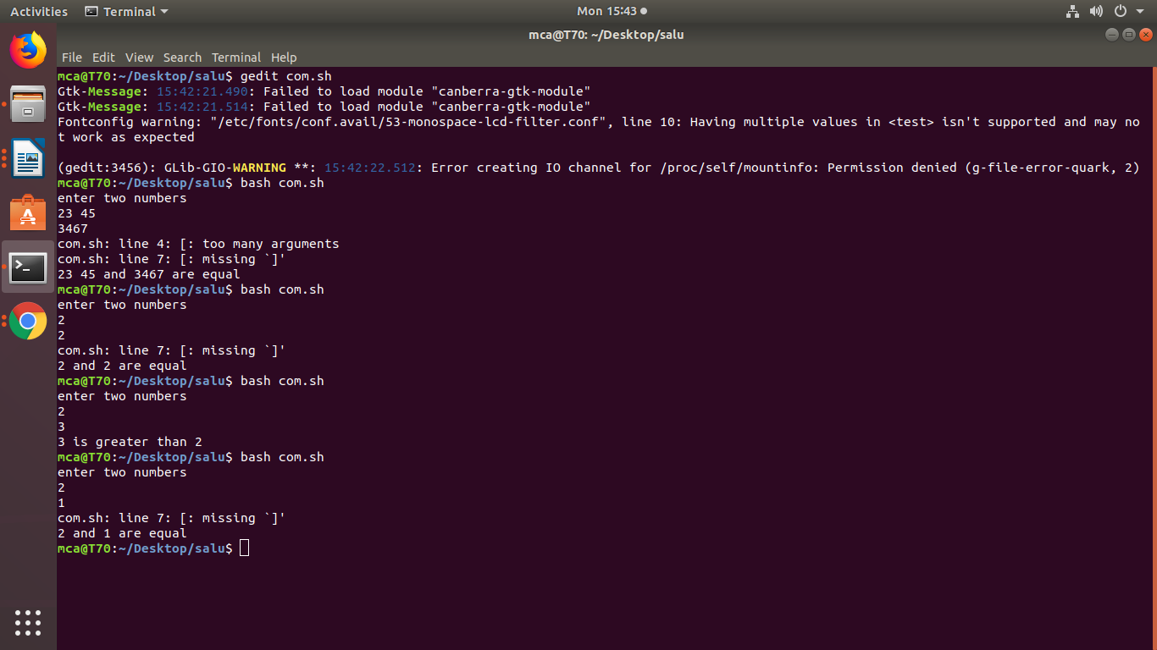

Program no-3
Aim:
write a shell script to find the sum of first 10 numbers.

echo "Enter Size(N)"
read N
i=1
sum=0
echo "Enter Numbers"
while [ $i -le $N ]
do
read num
sum=$((sum + num))
i=$((i + 1))
done

echo "the sum of $N numbers is $sum"

output

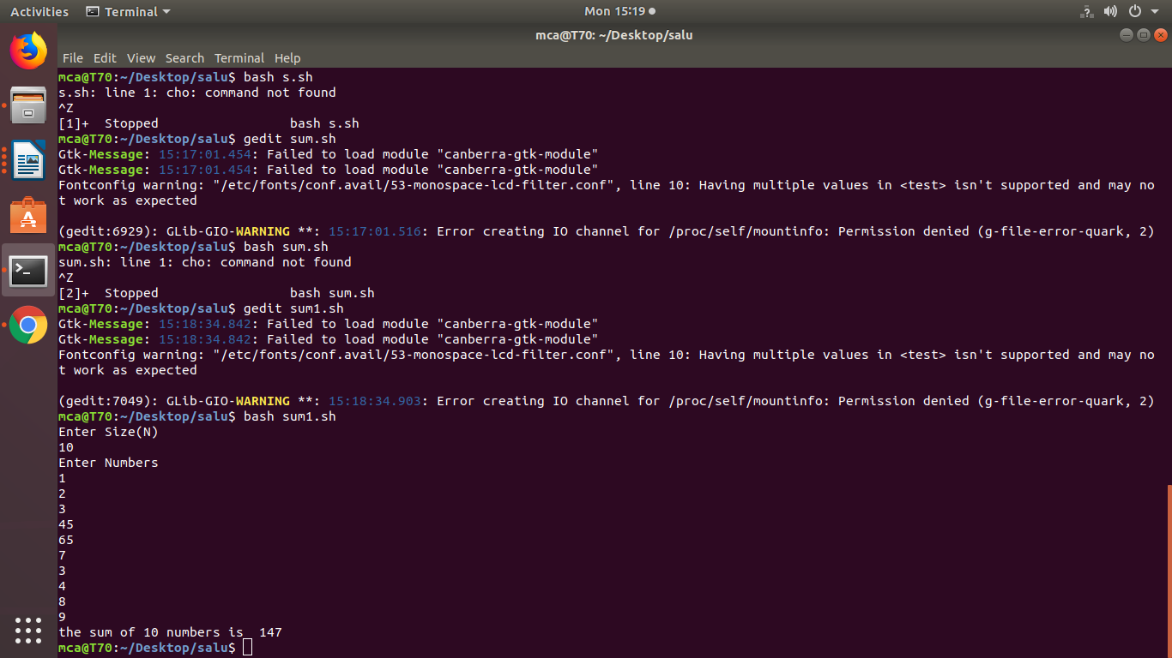

Program no-4
Aim:
write a shell script to find the sum average and the product of the 4 numbers.
#!/bin/bash
echo "enter four integers"
read a b c d
sum=$(echo "$a + $b + $c + $d" | bc -l)
average=$(echo "$sum / 4" | bc -l)
product=$(echo "$a * $b * $c * $d" | bc -l)
echo "sum = $sum"
echo "Average = $average"
echo "Product = $product"

output
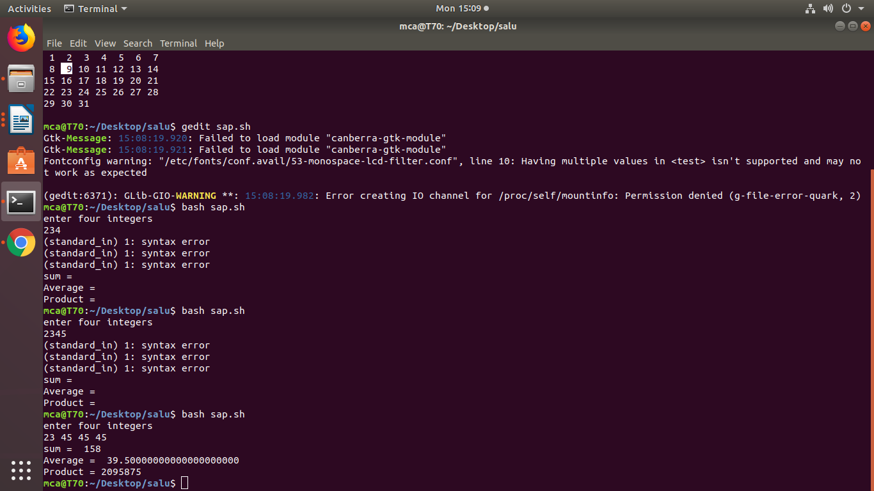

program no-5
Aim:write the shell script program to find factorial of a given number.

echo "Enter a number"
read num
fact=1
for((i=2;i<=num;i++))
{
fact=$((fact * i))
}

echo "factorial of $num number is $fact"

output
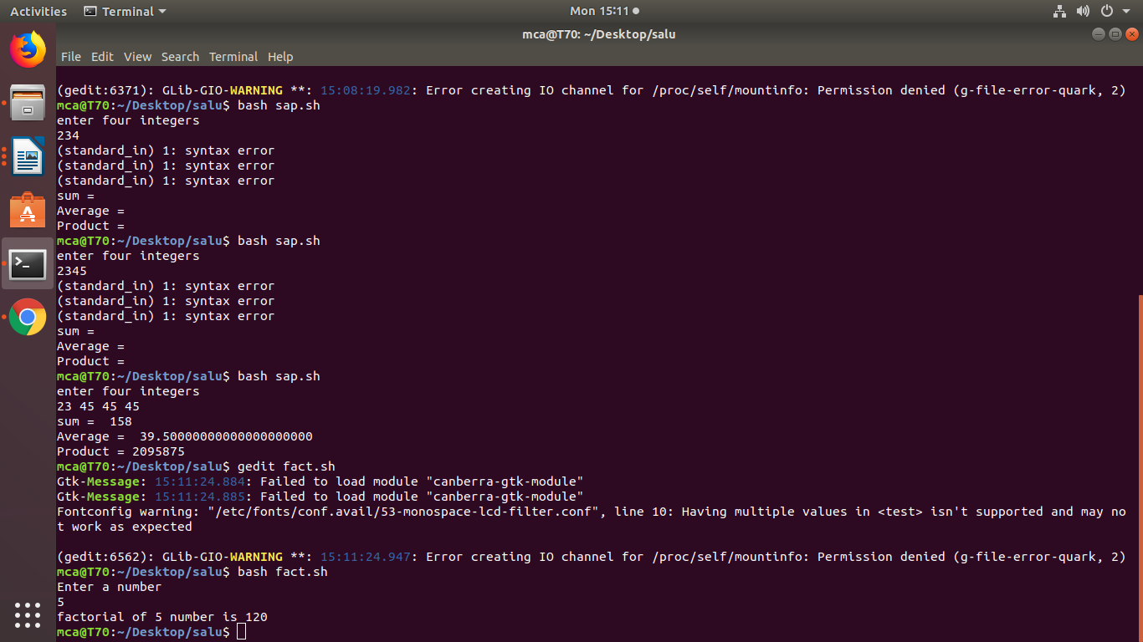

program no:6
Aim:display the palidrome of a given number.

echo "Enter the number"
read n
function pal
{
number=$n
reverse=0
while [ $n -gt 0 ]
do
a=`expr $n % 10 `
n=`expr $n / 10 `
reverse=`expr $reverse \* 10 + $a`
done
echo $reverse
if [ $number -eq $reverse ]
then
echo "Number is palindrome"
else
echo "Number is not palindrome"
fi
}
r=`pal $n`
echo "$r"

output
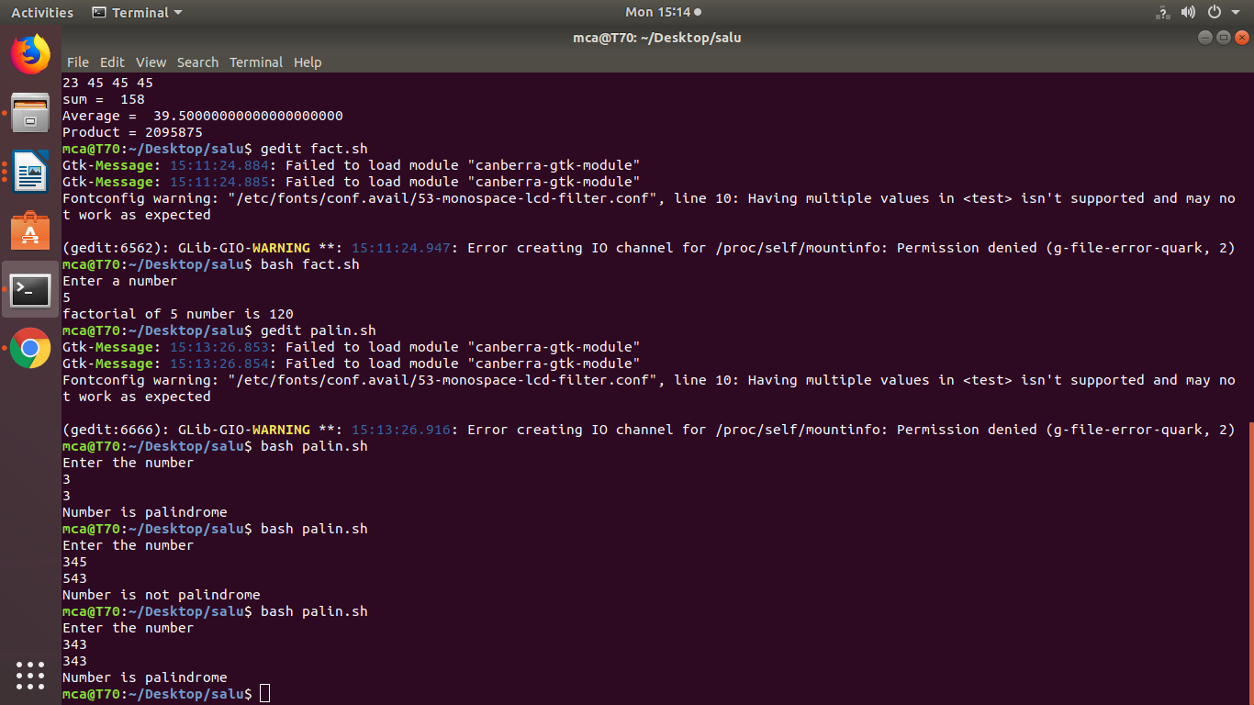

program no 7:

Aim:program to display leap year or not.

leap=$(date +"%Y")
echo taking year as $leap
if [ `expr $leap % 400` -eq 0 ]
then
echo leap year
elif [ `expr $leap % 100` -eq 0 ]
then
echo not a leap year
elif [ `expr $leap % 4` -eq 0 ]
then
echo leap year
else
echo not a leap year
fi

