Name: salini kb
Roll No:33
Batch:mca-b
Date:23-5-2022

NETWORKING & SYSTEM ADMINISTRATION LAB

Experiment No.: 1

Aim
Docker installation
Procedure

1. Open the terminal on Ubuntu.
2. Remove any Docter files that are running in the system, using the following command
sudo apt-get remove docker docker-engine docker.io
After entering the above command, you will need to enter the password of the root and press enter.

3]Check if the system is up-to-date using the following command:

$ sudo apt-get update
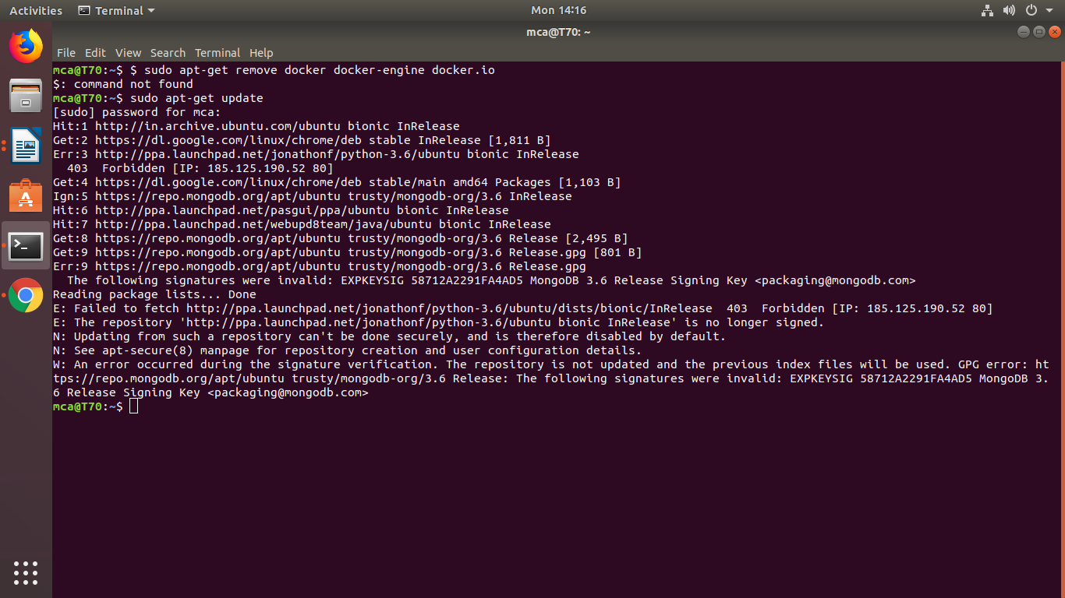

4. Install Docker using the following command:

$ sudo apt install docker.io

You’ll then get a prompt asking you to choose between y/n - choose y
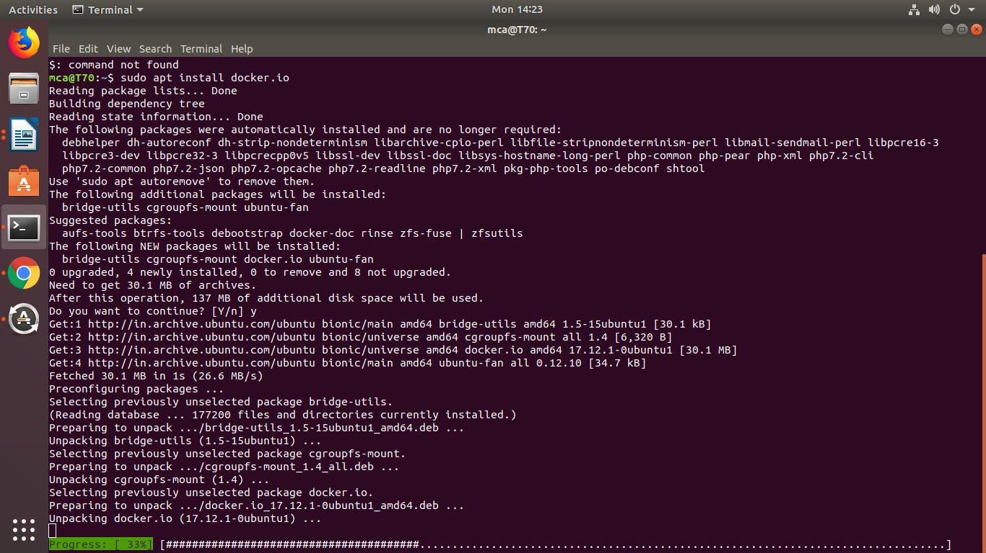

5. Install all the dependency packages using the following command:

$ sudo snap install docker

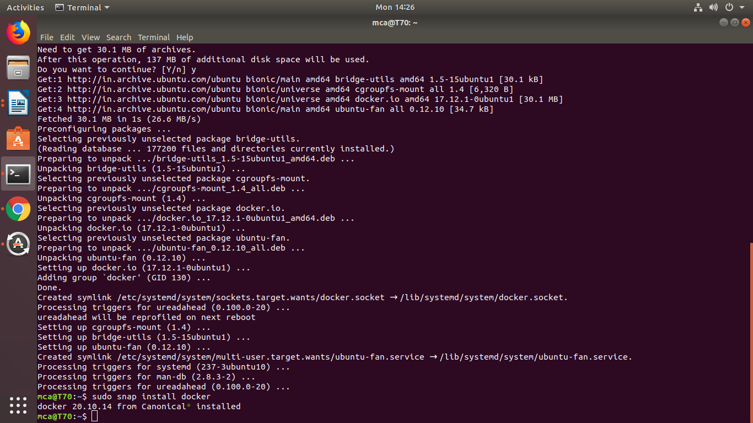

6. Before testing Docker, check the version installed using the following command:

$ docker –version

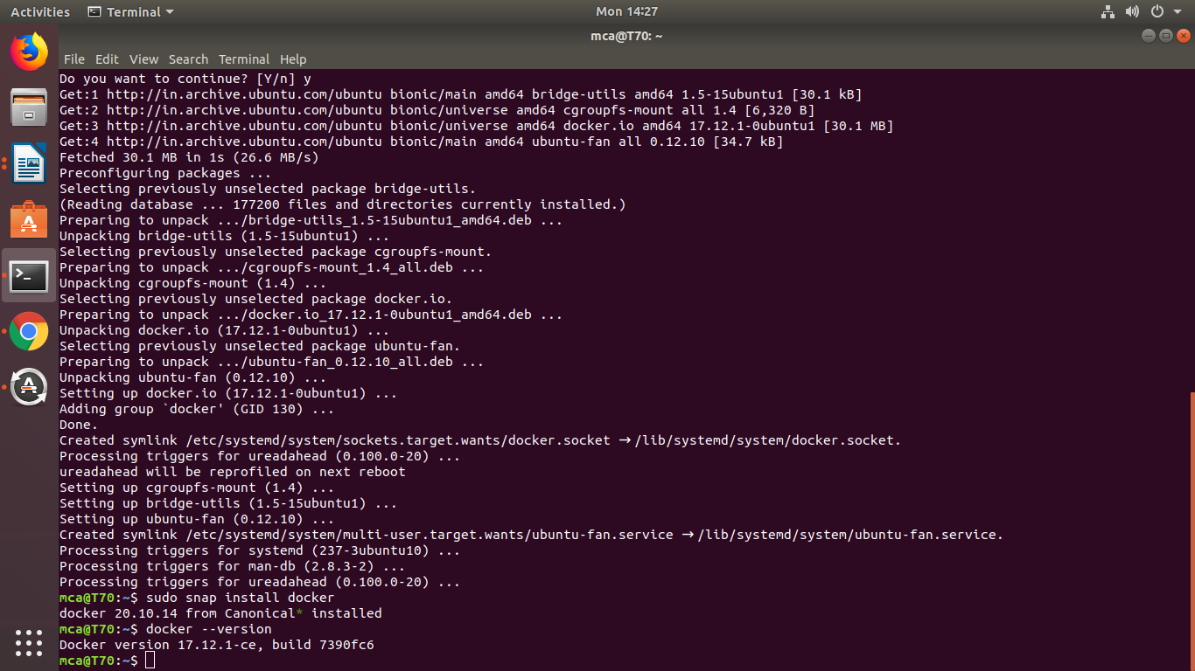

7. Pull an image from the Docker hub using the following command:

$ sudo docker run hello-world

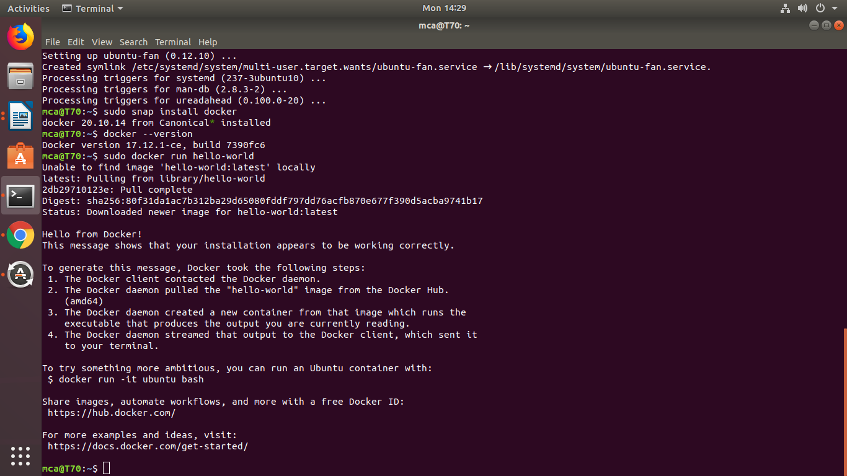

Here, hello-world is the docker image present on the Docker hub.

8. Check if the docker image has been pulled and is present in your system using the following command:
$ sudo docker images

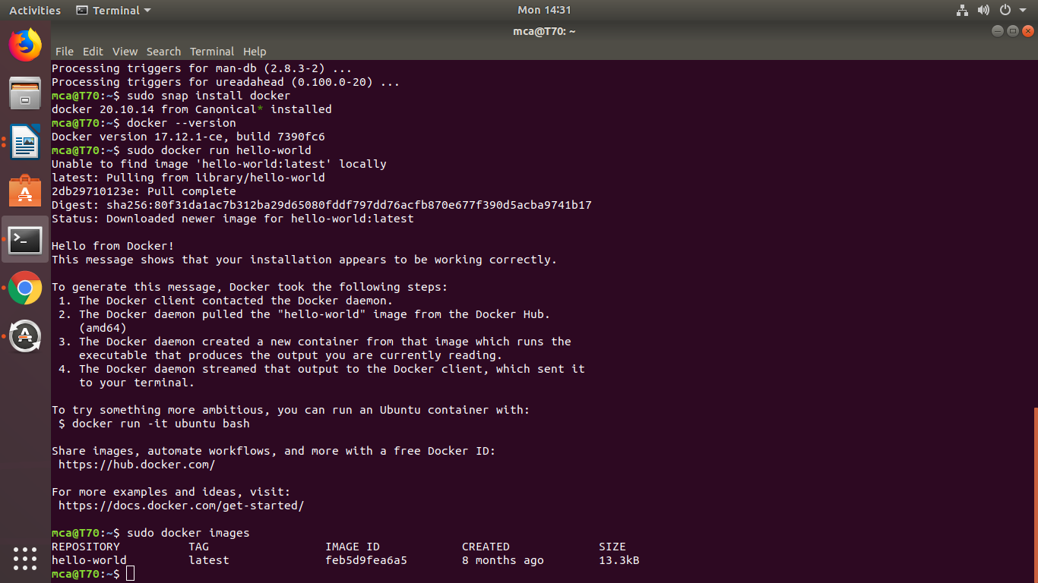

9. To display all the containers pulled, use the following command:

$ sudo docker ps -a
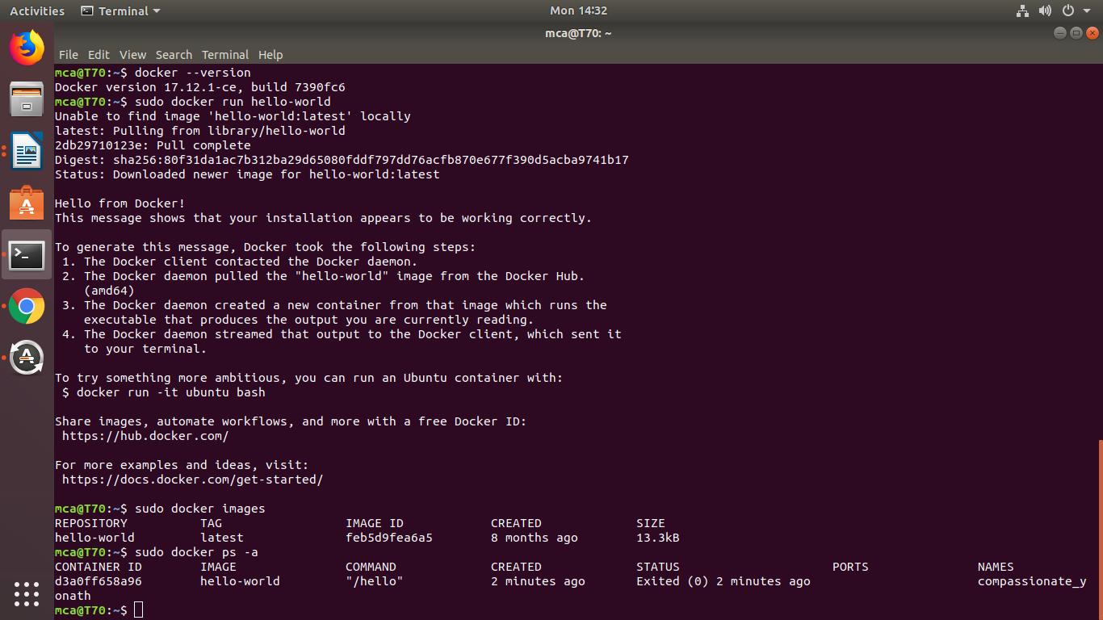

10. To check for containers in a running state, use the following command:
$ sudo docker ps

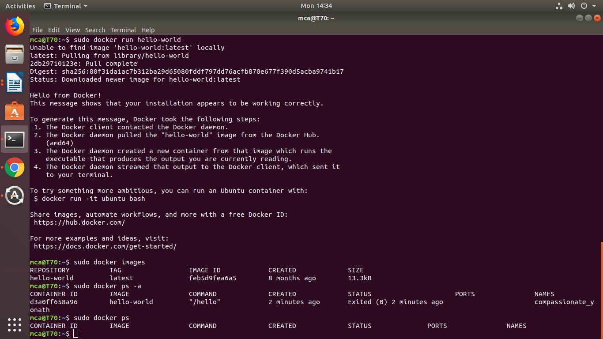
You’ve just successfully installed Docker on Ubuntu!

