**Name: salini K.b**

**Roll No:33**

**Batch:mca-b**

**Date:8-6-2022**

**NETWORKING & SYSTEM ADMINISTRATION LAB**

**Experiment No.: 1**

**Aim**

Working with netcat

**1]Procedure**

**Install netcat**

**$sudo apt –get install netcat**

**Output Screenshot**

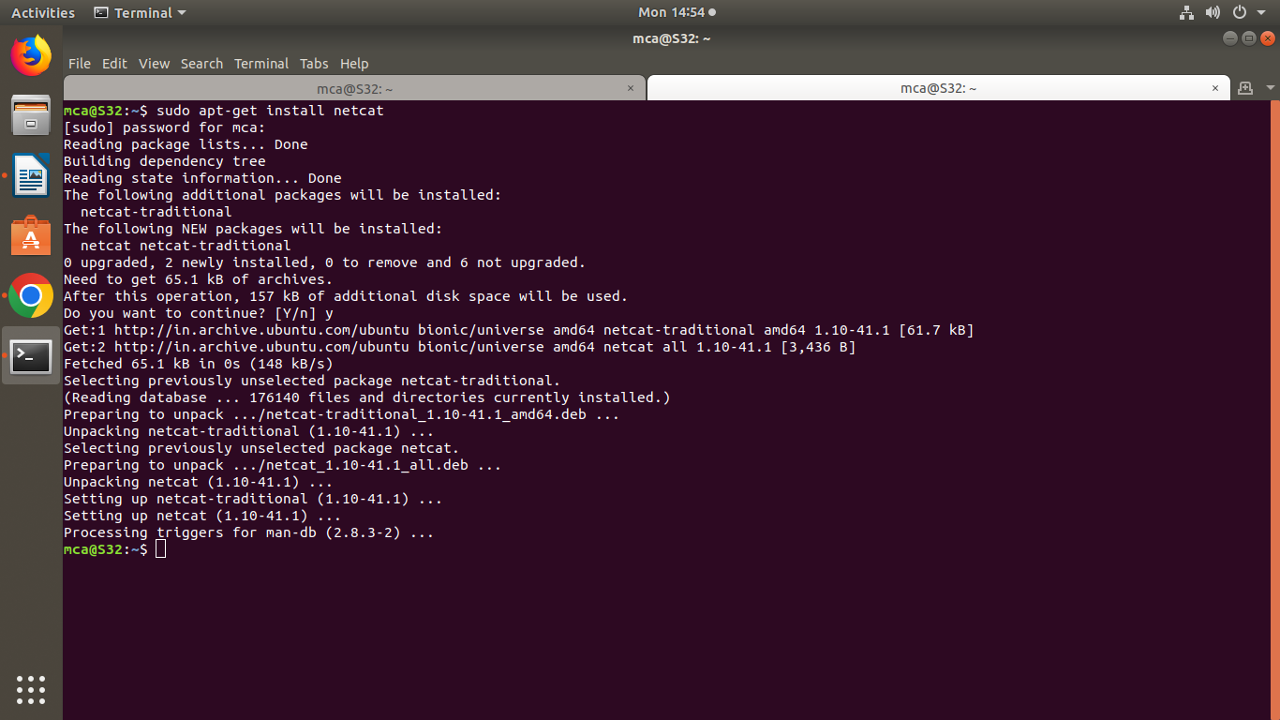

**2]Procedure**

**TERMINAL 1 FOR LISTENING**

**$nc -l –p 1234**

**Output Screenshot**

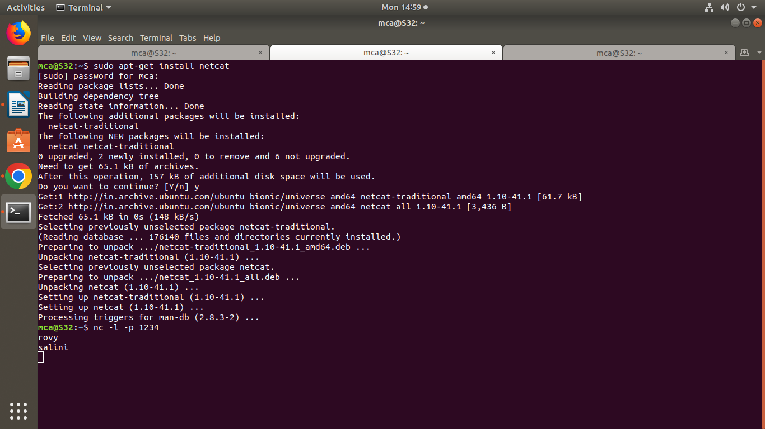

**3]Procedure**

**Terminal 2 sending request**

**$nc 127.0.0.1 1234**

**Output Screenshot**

