**Name: salini k.b**

**Roll No:33**

**Batch:mca-b**

**Date:8-6-2022**

**NETWORKING & SYSTEM ADMINISTRATION LAB**

**Experiment No.: 1**

**Aim**

Install the the wireshark on ubuntu

**Procedure**

**Step 1**

**Sudo update**

**Sudo apt update**

**Output Screenshot**

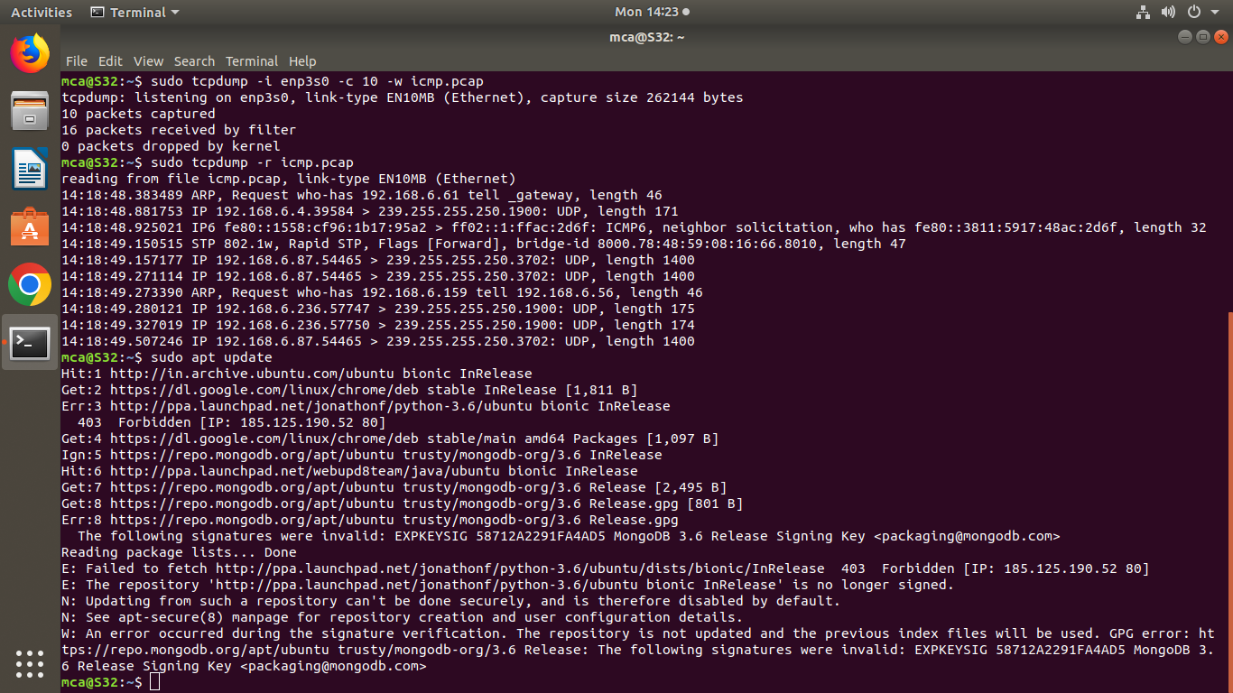

**Procedure**

**Step 2**

**Sudo latest version can be added to the apt.**

**Sudo apt install wireshark**

**Output Screenshot**

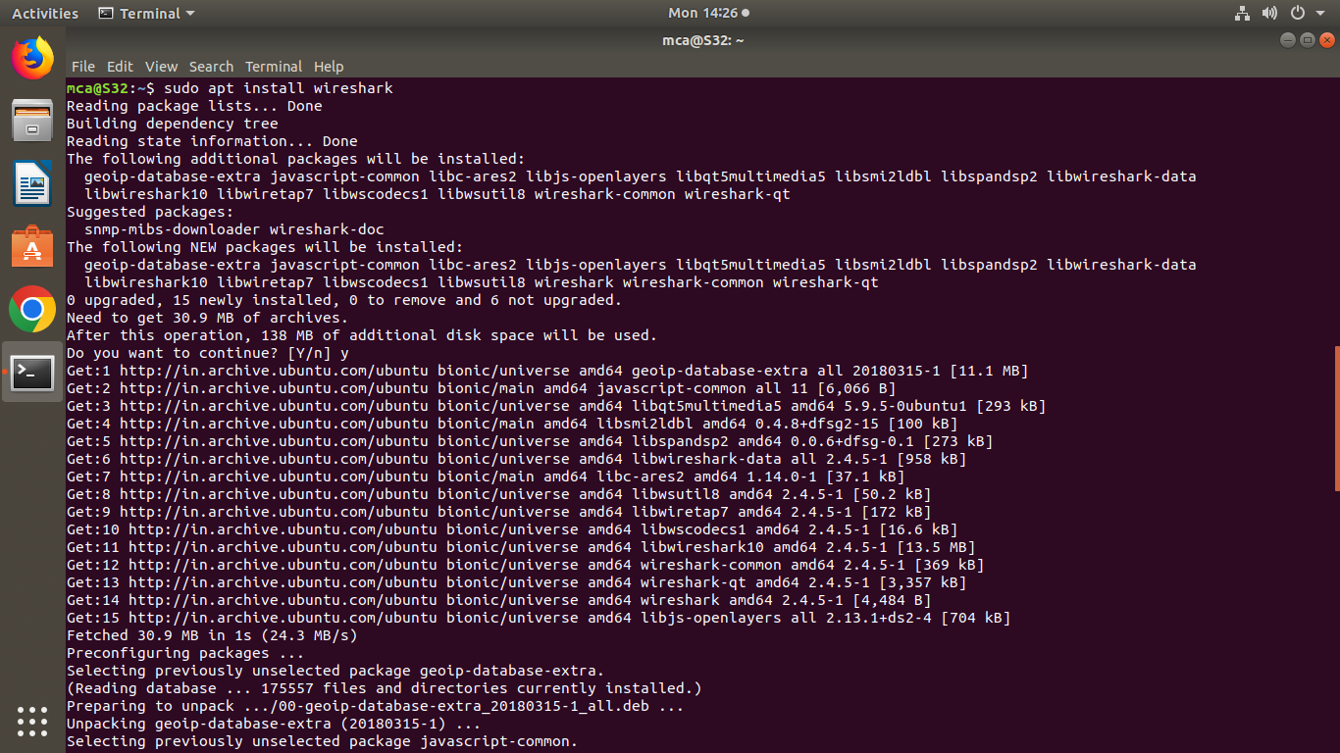

**Procedure**

**Step 3**

**Add user**

**Sudo adduser $user wireshark**

**Sudo adduser $mca wireshark**

**Procedure**

**Step 4**

**Sudo wireshark**

**Open wireshark window**

