**Experiment No.: 1**

**Name: Salini K B**

**Roll No: 33**

**Batch: RMCA-B**

**Date:**

**Aim**

**Questions**

1. Design a Login Form with username and password using LinearLayout and toast valid credentials.

**Program**

activity_main.xml

*<?***xml version="1.0" encoding="utf-8"***?>*

<**RelativeLayout xmlns:android="http://schemas.android.com/apk/res/android"**

**xmlns:app="http://schemas.android.com/apk/res-auto"**

**xmlns:tools="http://schemas.android.com/tools"**

**android:layout_width="match_parent"**

**android:layout_height="match_parent"**

**android:layout_centerInParent="@color/colorPrimaryDark"**

**android:background="@drawable/radius"**

**android:gravity="center"**

**android:orientation="vertical"**

**tools:context=".MainActivity"**

**android:layout_margin="@dimen/cardview_compat_inset_shadow"**>

<**TextView**

**android:id="@+id/t1"**

**android:layout_width="wrap_content"**

**android:layout_height="wrap_content"**>

</**TextView**>

<**Button**

**android:id="@+id/t2"**

**android:layout_width="159dp"**

**android:layout_height="81dp"**

**android:layout_alignParentEnd="true"**

**android:layout_alignParentBottom="true"**

**android:layout_marginStart="@dimen/cardview_compat_inset_shadow"**

**android:layout_marginTop="@dimen/cardview_compat_inset_shadow"**

**android:layout_marginEnd="121dp"**

**android:layout_marginBottom="14dp"**

**android:background="@drawable/radius"**

**android:backgroundTint="#EF6C00"**

**android:backgroundTintMode="src_over"**

**android:text="Login"**

**android:textAlignment="gravity"**

**android:textSize="30dp"**

**android:visibility="visible"**>

</**Button**>

<**EditText**

**android:id="@+id/editText2"**

**android:layout_width="match_parent"**

**android:layout_height="135dp"**

**android:layout_alignParentStart="true"**

**android:layout_alignParentTop="true"**

**android:layout_alignParentEnd="true"**

**android:layout_alignParentBottom="true"**

**android:layout_marginStart="0dp"**

**android:layout_marginTop="-4dp"**

**android:layout_marginEnd="0dp"**

**android:layout_marginBottom="599dp"**

**android:ems="10"**

**android:inputType="textPersonName"**

**android:text="Name"**

**android:textAlignment="center"**

**android:textAppearance="@style/TextAppearance.AppCompat.Medium"**

**android:textSize="20dp"**

**tools:text="Welcome To Home"**

**tools:visibility="visible"**>

</**EditText**>

<**TextView**

**android:id="@+id/textView2"**

**android:layout_width="182dp"**

**android:layout_height="51dp"**

**android:layout_alignParentBottom="true"**

**android:layout_marginBottom="244dp"**

**android:text="TextView"**

**android:textSize="20dp"**

**tools:text="Enter your Name"** />

<**TextView**

**android:id="@+id/textView4"**

**android:layout_width="180dp"**

**android:layout_height="53dp"**

**android:layout_alignParentBottom="true"**

**android:layout_marginBottom="169dp"**

**android:text="TextView"**

**android:textSize="20dp"**

**tools:text="Password"** />

<**TextView**

**android:id="@+id/textView5"**

**android:layout_width="188dp"**

**android:layout_height="68dp"**

**android:layout_alignParentBottom="true"**

**android:layout_marginBottom="84dp"**

**android:text="TextView"**

**android:textSize="20dp"**

**tools:text="Confirm Password"** />

<**com.google.android.material.textfield.TextInputLayout**

**android:layout_width="match_parent"**

**android:layout_height="wrap_content"**>

</**com.google.android.material.textfield.TextInputLayout**>

<**ImageView**

**android:id="@+id/imageView6"**

**android:layout_width="match_parent"**

**android:layout_height="440dp"**

**android:layout_alignParentBottom="true"**

**android:layout_marginBottom="281dp"**

**tools:srcCompat="@tools:sample/backgrounds/scenic[17]"** />

<**EditText**

**android:id="@+id/editText"**

**android:layout_width="wrap_content"**

**android:layout_height="wrap_content"**

**android:layout_alignParentTop="true"**

**android:layout_alignParentEnd="true"**

**android:layout_alignParentBottom="true"**

**android:layout_marginTop="419dp"**

**android:layout_marginEnd="-1dp"**

**android:layout_marginBottom="265dp"**

**android:ems="10"**

**android:inputType="textPersonName"** />

<**EditText**

**android:layout_width="wrap_content"**

**android:layout_height="wrap_content"**

**android:layout_alignParentEnd="true"**

**android:layout_alignParentBottom="true"**

**android:layout_marginEnd="-2dp"**

**android:layout_marginBottom="188dp"**

**android:ems="10"**

**android:inputType="numberPassword"** />

<**EditText**

**android:id="@+id/editText4"**

**android:layout_width="wrap_content"**

**android:layout_height="wrap_content"**

**android:layout_alignParentEnd="true"**

**android:layout_alignParentBottom="true"**

**android:layout_marginEnd="0dp"**

**android:layout_marginBottom="114dp"**

**android:ems="10"**

**android:inputType="numberPassword"** />

</**RelativeLayout**>

radius.xml

*<?***xml version="1.0" encoding="utf-8"***?>*

<**shape**

**xmlns:android="http://schemas.android.com/apk/res/android"**

**android:shape="rectangle"**>

<**corners android:radius="20dp"** />

<**solid android:color="@android:color/white"** />

<**stroke**

**android:width="1dip"**

**android:color="@color/white"** />

</**shape**>

mainactivity.java

**package** com.example.myapplication;

**import** androidx.appcompat.app.AppCompatActivity;

**import** android.os.Bundle;

**public class** MainActivity **extends** AppCompatActivity {

@Override

**protected void** onCreate(Bundle savedInstanceState) {

**super**.onCreate(savedInstanceState);

setContentView(R.layout.***activity_main***);

}

}

**Output**

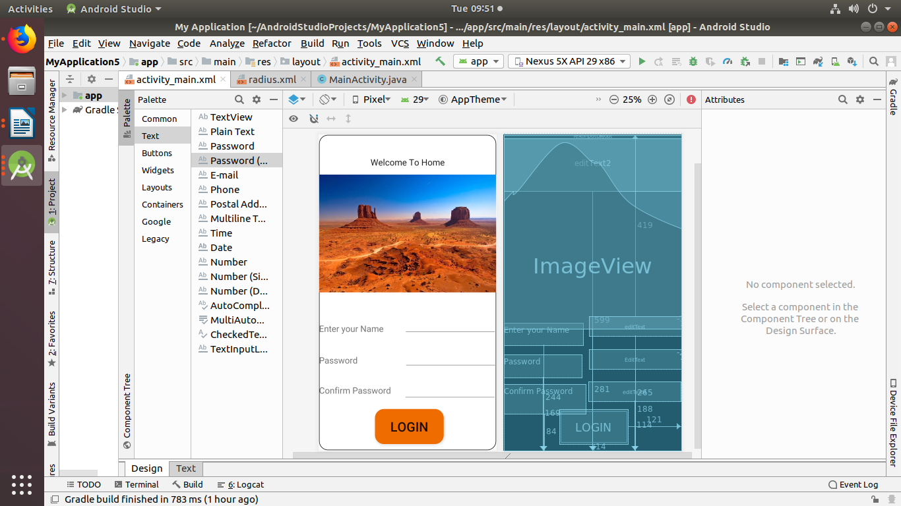

**Experiment No.: 2**

**Name: Salini K B**

**Roll No: 33**

**Batch: RMCA-B**

**Date: 29-08-2022**

**Aim**

. 2. Create an application to design a Visiting Card. The Visiting card should have a company logo at the top right corner. The company name should be displayed in Capital letters, aligned to the centre. Information like the name of the employee, job title, phone number, address, email, fax and the website address is to be displayed. Insert a horizontal line between the job title and the phone number.

**Program and Output**

**Experiment No.: 3**

**Name: Salini K B**

**Roll No: 33**

**Batch: RMCA-B**

**Date: 01-09-2022**

**Aim**

. Develop an Android application using controls like Button, TextView, EditText for designing a calculator having basic functionality like Addition, Subtraction, Multiplication, and Division.

**Program and Output**

mainactivity.xml

*<?***xml version="1.0" encoding="utf-8"***?>*

<**RelativeLayout xmlns:android="http://schemas.android.com/apk/res/android"**

**xmlns:app="http://schemas.android.com/apk/res-auto"**

**xmlns:tools="http://schemas.android.com/tools"**

**android:layout_width="match_parent"**

**android:layout_height="match_parent"**

**android:layout_margin="@dimen/cardview_default_elevation"**

**android:background="#C91162"**

**android:visibility="visible"**

**tools:context=".MainActivity"**

**tools:visibility="visible"**>

<**Button**

**android:id="@+id/button8"**

**android:layout_width="42dp"**

**android:layout_height="36dp"**

**android:layout_alignParentEnd="true"**

**android:layout_alignParentBottom="true"**

**android:layout_marginEnd="12dp"**

**android:layout_marginBottom="172dp"**

**android:background="#00838F"**

**android:text="5"** />

<**Button**

**android:id="@+id/button7"**

**android:layout_width="42dp"**

**android:layout_height="36dp"**

**android:layout_alignParentEnd="true"**

**android:layout_alignParentBottom="true"**

**android:layout_marginEnd="68dp"**

**android:layout_marginBottom="168dp"**

**android:background="#00838F"**

**android:text="4"** />

<**Button**

**android:id="@+id/button6"**

**android:layout_width="42dp"**

**android:layout_height="36dp"**

**android:layout_alignParentEnd="true"**

**android:layout_alignParentBottom="true"**

**android:layout_marginEnd="122dp"**

**android:layout_marginBottom="122dp"**

**android:background="#00838F"**

**android:text="6"** />

<**Button**

**android:id="@+id/button11"**

**android:layout_width="42dp"**

**android:layout_height="36dp"**

**android:layout_alignParentEnd="true"**

**android:layout_alignParentBottom="true"**

**android:layout_marginEnd="123dp"**

**android:layout_marginBottom="67dp"**

**android:background="#00838F"**

**android:text="9"** />

<**Button**

**android:id="@+id/button14"**

**android:layout_width="42dp"**

**android:layout_height="36dp"**

**android:layout_alignParentEnd="true"**

**android:layout_alignParentBottom="true"**

**android:layout_marginEnd="123dp"**

**android:layout_marginBottom="16dp"**

**android:background="#00838F"**

**android:text="+"** />

<**Button**

**android:id="@+id/button15"**

**android:layout_width="42dp"**

**android:layout_height="36dp"**

**android:layout_alignParentEnd="true"**

**android:layout_alignParentBottom="true"**

**android:layout_marginEnd="68dp"**

**android:layout_marginBottom="17dp"**

**android:background="#00838F"**

**android:text="-"** />

<**Button**

**android:id="@+id/button16"**

**android:layout_width="42dp"**

**android:layout_height="36dp"**

**android:layout_alignParentEnd="true"**

**android:layout_alignParentBottom="true"**

**android:layout_marginEnd="12dp"**

**android:layout_marginBottom="17dp"**

**android:background="#00838F"**

**android:text="/"** />

<**Button**

**android:id="@+id/button9"**

**android:layout_width="42dp"**

**android:layout_height="36dp"**

**android:layout_alignParentEnd="true"**

**android:layout_alignParentBottom="true"**

**android:layout_marginEnd="68dp"**

**android:layout_marginBottom="122dp"**

**android:background="#00838F"**

**android:text="7"** />

<**Button**

**android:id="@+id/button12"**

**android:layout_width="42dp"**

**android:layout_height="36dp"**

**android:layout_alignParentEnd="true"**

**android:layout_alignParentBottom="true"**

**android:layout_marginEnd="68dp"**

**android:layout_marginBottom="69dp"**

**android:background="#00838F"**

**android:text="10"** />

<**Button**

**android:id="@+id/button13"**

**android:layout_width="42dp"**

**android:layout_height="36dp"**

**android:layout_alignParentEnd="true"**

**android:layout_alignParentBottom="true"**

**android:layout_marginEnd="11dp"**

**android:layout_marginBottom="67dp"**

**android:background="#00838F"**

**android:text="="** />

<**Button**

**android:id="@+id/button10"**

**android:layout_width="42dp"**

**android:layout_height="36dp"**

**android:layout_alignParentEnd="true"**

**android:layout_alignParentBottom="true"**

**android:layout_marginEnd="10dp"**

**android:layout_marginBottom="122dp"**

**android:background="#00838F"**

**android:text="8"** />

<**Button**

**android:id="@+id/button5"**

**android:layout_width="42dp"**

**android:layout_height="36dp"**

**android:layout_alignParentEnd="true"**

**android:layout_alignParentBottom="true"**

**android:layout_marginEnd="123dp"**

**android:layout_marginBottom="171dp"**

**android:background="#00838F"**

**android:text="3"** />

<**Button**

**android:id="@+id/button4"**

**android:layout_width="42dp"**

**android:layout_height="36dp"**

**android:layout_alignParentEnd="true"**

**android:layout_alignParentBottom="true"**

**android:layout_marginEnd="12dp"**

**android:layout_marginBottom="217dp"**

**android:background="#00838F"**

**android:text="2"** />

<**Button**

**android:id="@+id/button3"**

**android:layout_width="42dp"**

**android:layout_height="36dp"**

**android:layout_alignParentEnd="true"**

**android:layout_alignParentBottom="true"**

**android:layout_marginEnd="68dp"**

**android:layout_marginBottom="217dp"**

**android:background="#00838F"**

**android:text="1"** />

<**Button**

**android:id="@+id/button"**

**android:layout_width="42dp"**

**android:layout_height="36dp"**

**android:layout_alignParentEnd="true"**

**android:layout_alignParentBottom="true"**

**android:layout_marginEnd="123dp"**

**android:layout_marginBottom="216dp"**

**android:background="#00838F"**

**android:text="0"** />

<**TextView**

**android:id="@+id/textView10"**

**android:layout_width="wrap_content"**

**android:layout_height="51dp"**

**android:layout_alignParentStart="true"**

**android:layout_alignParentEnd="true"**

**android:layout_alignParentBottom="true"**

**android:layout_marginStart="0dp"**

**android:layout_marginEnd="2dp"**

**android:layout_marginBottom="264dp"**

**android:background="#AD1457"**

**android:foreground="#00838F"** />

</**RelativeLayout**>

radius.xml

*<?***xml version="1.0" encoding="utf-8"***?>*

<**shape**

**xmlns:android="http://schemas.android.com/apk/res/android"**

**android:shape="rectangle"**>

<**corners android:radius="20dp"** />

<**solid android:color="@android:color/white"** />

<**stroke**

**android:width="1dip"**

**android:color="@color/white"** />

</**shape**>

mainactivity.java

**package** com.example.myapplication56;

**import** androidx.appcompat.app.AppCompatActivity;

**import** android.os.Bundle;

**public class** MainActivity **extends** AppCompatActivity {

@Override

**protected void** onCreate(Bundle savedInstanceState) {

**super**.onCreate(savedInstanceState);

setContentView(R.layout.***activity_main***);

}

}

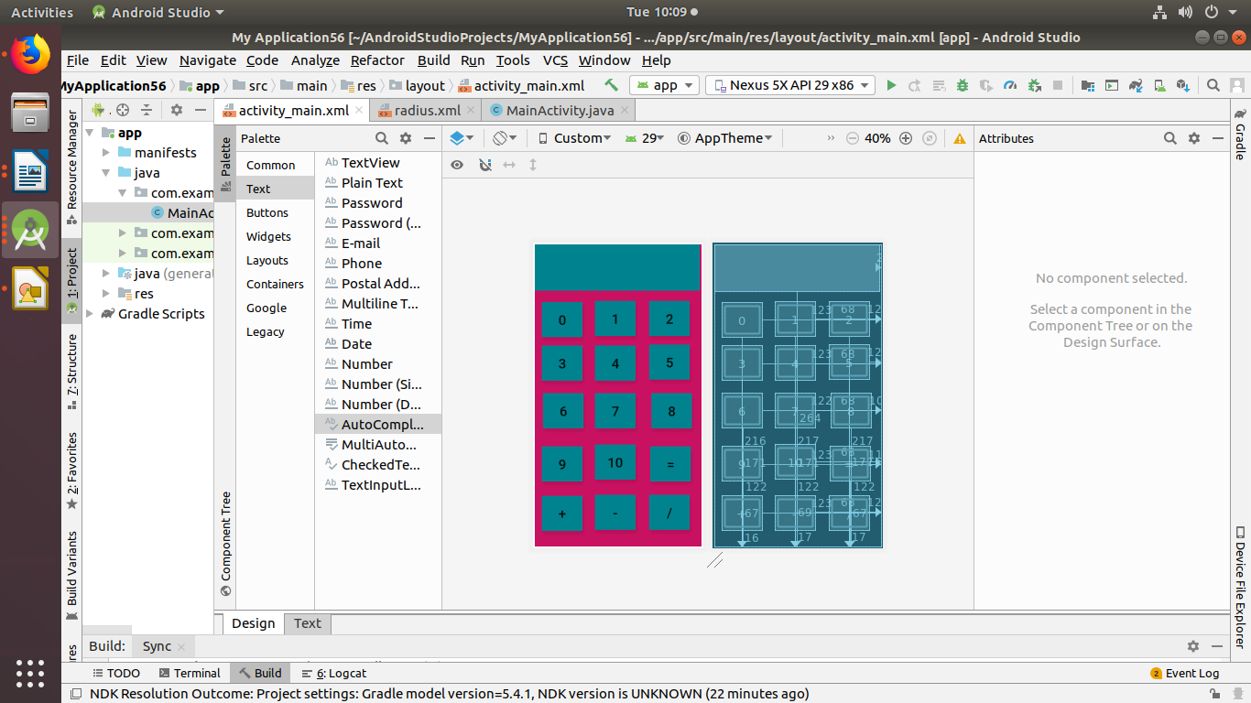

**Experiment No.: 4**

**Name: Salini K B**

**Roll No: 33**

**Batch: RMCA-B**

**Date: 12-09-2022**

**Aim**

Write a program to display following output using Relative layout.

**Output**

**&lt;?xml version=&quot;1.0&quot; encoding=&quot;utf-8&quot;?&gt;**

**&lt;androidx.constraintlayout.widget.ConstraintLayout**

**xmlns:android=&quot;http://schemas.android.com/apk/res/android&quot;**

**xmlns:app=&quot;http://schemas.android.com/apk/res-auto&quot;**

**xmlns:tools=&quot;http://schemas.android.com/tools&quot;**

**android:layout_width=&quot;match_parent&quot;**

**android:layout_height=&quot;match_parent&quot;**

**tools:context=&quot;.MainActivity&quot;&gt;**

**&lt;RelativeLayout**

**android:layout_width=&quot;409dp&quot;**

**android:layout_height=&quot;729dp&quot;**

**tools:layout_editor_absoluteX=&quot;-14dp&quot;**

**tools:layout_editor_absoluteY=&quot;1dp&quot;&gt;**

**&lt;Button**

**android:id=&quot;@+id/button&quot;**

**android:layout_width=&quot;wrap_content&quot;**

**android:layout_height=&quot;wrap_content&quot;**

**android:layout_alignParentEnd=&quot;true&quot;**

**android:layout_alignParentBottom=&quot;true&quot;**

**android:layout_marginEnd=&quot;312dp&quot;**

**android:layout_marginBottom=&quot;662dp&quot;**

**android:text=&quot;Button&quot; /&gt;**

**&lt;Button**

**android:id=&quot;@+id/button2&quot;**

**android:layout_width=&quot;195dp&quot;**

**android:layout_height=&quot;wrap_content&quot;**

**android:layout_alignParentStart=&quot;true&quot;**

**android:layout_alignParentTop=&quot;true&quot;**

**android:layout_alignParentEnd=&quot;true&quot;**

**android:layout_alignParentBottom=&quot;true&quot;**

**android:layout_marginStart=&quot;177dp&quot;**

**android:layout_marginTop=&quot;14dp&quot;**

**android:layout_marginEnd=&quot;37dp&quot;**

**android:layout_marginBottom=&quot;664dp&quot;**

**android:text=&quot;Button&quot; /&gt;**

**&lt;Button**

**android:id=&quot;@+id/button3&quot;**

**android:layout_width=&quot;wrap_content&quot;**

**android:layout_height=&quot;wrap_content&quot;**

**android:layout_alignParentEnd=&quot;true&quot;**

**android:layout_alignParentBottom=&quot;true&quot;**

**android:layout_marginEnd=&quot;312dp&quot;**

**android:layout_marginBottom=&quot;415dp&quot;**

**android:text=&quot;Button&quot; /&gt;**

**&lt;Button**

**android:id=&quot;@+id/button4&quot;**

**android:layout_width=&quot;wrap_content&quot;**

**android:layout_height=&quot;wrap_content&quot;**

**android:layout_alignParentStart=&quot;true&quot;**

**android:layout_alignParentTop=&quot;true&quot;**

**android:layout_alignParentEnd=&quot;true&quot;**

**android:layout_alignParentBottom=&quot;true&quot;**

**android:layout_marginStart=&quot;159dp&quot;**

**android:layout_marginTop=&quot;269dp&quot;**

**android:layout_marginEnd=&quot;155dp&quot;**

**android:layout_marginBottom=&quot;412dp&quot;**

**android:text=&quot;Button&quot; /&gt;**

**&lt;Button**

**android:id=&quot;@+id/button5&quot;**

**android:layout_width=&quot;110dp&quot;**

**android:layout_height=&quot;51dp&quot;**

**android:layout_alignParentTop=&quot;true&quot;**

**android:layout_alignParentEnd=&quot;true&quot;**

**android:layout_alignParentBottom=&quot;true&quot;**

**android:layout_marginTop=&quot;267dp&quot;**

**android:layout_marginEnd=&quot;4dp&quot;**

**android:layout_marginBottom=&quot;411dp&quot;**

**android:text=&quot;Button&quot; /&gt;**

**&lt;Button**

**android:id=&quot;@+id/button6&quot;**

**android:layout_width=&quot;wrap_content&quot;**

**android:layout_height=&quot;wrap_content&quot;**

**android:layout_alignParentStart=&quot;true&quot;**

**android:layout_alignParentTop=&quot;true&quot;**

**android:layout_alignParentEnd=&quot;true&quot;**

**android:layout_alignParentBottom=&quot;true&quot;**

**android:layout_marginStart=&quot;157dp&quot;**

**android:layout_marginTop=&quot;584dp&quot;**

**android:layout_marginEnd=&quot;157dp&quot;**

**android:layout_marginBottom=&quot;97dp&quot;**

**android:text=&quot;Button&quot; /&gt;**

**&lt;Button**

**android:id=&quot;@+id/button7&quot;**

**android:layout_width=&quot;354dp&quot;**

**android:layout_height=&quot;wrap_content&quot;**

**android:layout_alignParentStart=&quot;true&quot;**

**android:layout_alignParentTop=&quot;true&quot;**

**android:layout_alignParentEnd=&quot;true&quot;**

**android:layout_alignParentBottom=&quot;true&quot;**

**android:layout_marginStart=&quot;41dp&quot;**

**android:layout_marginTop=&quot;663dp&quot;**

**android:layout_marginEnd=&quot;14dp&quot;**

**android:layout_marginBottom=&quot;13dp&quot;**

**android:text=&quot;Button&quot; /&gt;**

**&lt;/RelativeLayout&gt;**

**&lt;/androidx.constraintlayout.widget.ConstraintLayout&gt;**

**Output**

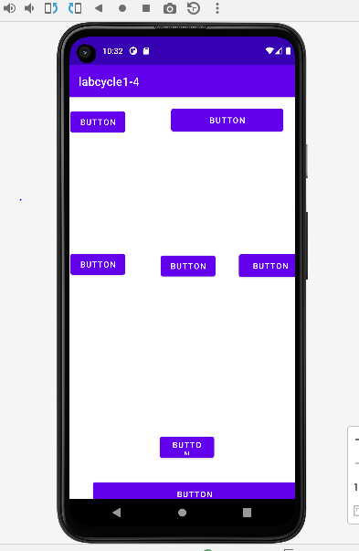

**Experiment No.: 5**

**Name: Salini K B**

**Roll No: 33**

**Batch: RMCA-B**

**Date: 12-09-2022**

**Aim**

5. Write a program to display following output using Table layout.

**Procedure**

**Output:**

*<?***xml version="1.0" encoding="utf-8"***?>*

<**RelativeLayout xmlns:android="http://schemas.android.com/apk/res/android"**

**xmlns:app="http://schemas.android.com/apk/res-auto"**

**xmlns:tools="http://schemas.android.com/tools"**

**android:layout_width="match_parent"**

**android:layout_height="match_parent"**

**android:layout_margin="@dimen/cardview_default_elevation"**

**android:background="#FCFAFB"**

**android:visibility="visible"**

**tools:context=".MainActivity"**

**tools:visibility="visible"**>

<**EditText**

**android:id="@+id/editText2"**

**android:layout_width="302dp"**

**android:layout_height="81dp"**

**android:layout_alignParentEnd="true"**

**android:layout_alignParentBottom="true"**

**android:layout_marginEnd="51dp"**

**android:layout_marginBottom="559dp"**

**android:ems="10"**

**android:inputType="textPersonName"**

**android:text="4"** />

<**EditText**

**android:id="@+id/editText3"**

**android:layout_width="302dp"**

**android:layout_height="81dp"**

**android:layout_alignParentEnd="true"**

**android:layout_alignParentBottom="true"**

**android:layout_marginEnd="51dp"**

**android:layout_marginBottom="396dp"**

**android:ems="10"**

**android:inputType="textPersonName"**

**android:text="5"** />

<**TextView**

**android:id="@+id/textView4"**

**android:layout_width="292dp"**

**android:layout_height="73dp"**

**android:layout_alignParentEnd="true"**

**android:layout_alignParentBottom="true"**

**android:layout_marginEnd="55dp"**

**android:layout_marginBottom="252dp"**

**android:text="9"** />

<**Button**

**android:id="@+id/button6"**

**android:layout_width="134dp"**

**android:layout_height="80dp"**

**android:layout_alignParentTop="true"**

**android:layout_alignParentEnd="true"**

**android:layout_alignParentBottom="true"**

**android:layout_marginTop="556dp"**

**android:layout_marginEnd="124dp"**

**android:layout_marginBottom="95dp"**

**android:text="BUTTON"** />

</**RelativeLayout**>

mainactivity.java

**package** com.example.myapplication;

**import** androidx.appcompat.app.AppCompatActivity;

**import** android.os.Bundle;

**import** android.widget.Button;

**import** android.widget.EditText;

**import** android.widget.TextView;

**public class** MainActivity **extends** AppCompatActivity {

EditText **editText2**;

EditText **editText3**;

TextView **textView4**;

Button **button6**;

@Override

**protected void** onCreate(Bundle savedInstanceState) {

**super**.onCreate(savedInstanceState);

setContentView(R.layout.***activity_main***);

**editText2**=(EditText)findViewById(R.id.***editText2***);

**editText3**=(EditText)findViewById(R.id.***editText3***);

**textView4**=(TextView)findViewById(R.id.***textView4***);

**button6**=(Button)findViewById(R.id.***button6***);

}9

}

profile

activity_main.xml

*<?***xml version="1.0" encoding="utf-8"***?>*

<**RelativeLayout xmlns:android="http://schemas.android.com/apk/res/android"**

**xmlns:app="http://schemas.android.com/apk/res-auto"**

**xmlns:tools="http://schemas.android.com/tools"**

**android:layout_width="match_parent"**

**android:layout_height="match_parent"**

**android:layout_margin="@dimen/cardview_default_elevation"**

**android:background="@color/colorPrimary"**

**android:visibility="visible"**

**tools:context=".MainActivity"**

**tools:visibility="visible"**>

<**EditText**

**android:id="@+id/editText2"**

**android:layout_width="281dp"**

**android:layout_height="83dp"**

**android:layout_alignParentEnd="true"**

**android:layout_alignParentBottom="true"**

**android:layout_marginEnd="0dp"**

**android:layout_marginBottom="648dp"**

**android:ems="10"**

**android:inputType="textPersonName"**

**android:text="welcom e to your profile"** />

<**EditText**

**android:id="@+id/editText3"**

**android:layout_width="302dp"**

**android:layout_height="81dp"**

**android:layout_alignParentEnd="true"**

**android:layout_alignParentBottom="true"**

**android:layout_marginEnd="52dp"**

**android:layout_marginBottom="446dp"**

**android:ems="10"**

**android:inputType="textPersonName"**

**android:text="salu"** />

<**TextView**

**android:id="@+id/textView4"**

**android:layout_width="307dp"**

**android:layout_height="78dp"**

**android:layout_alignParentEnd="true"**

**android:layout_alignParentBottom="true"**

**android:layout_marginEnd="50dp"**

**android:layout_marginBottom="341dp"**

**android:text="abcd"** />

<**TextView**

**android:id="@+id/textView"**

**android:layout_width="302dp"**

**android:layout_height="74dp"**

**android:layout_alignParentEnd="true"**

**android:layout_alignParentBottom="true"**

**android:layout_marginEnd="50dp"**

**android:layout_marginBottom="243dp"**

**android:text="4563234567"** />

<**Button**

**android:id="@+id/button6"**

**android:layout_width="134dp"**

**android:layout_height="80dp"**

**android:layout_alignParentTop="true"**

**android:layout_alignParentEnd="true"**

**android:layout_alignParentBottom="true"**

**android:layout_marginTop="592dp"**

**android:layout_marginEnd="108dp"**

**android:layout_marginBottom="59dp"**

**android:text="save"** />

<**ImageView**

**android:id="@+id/imageView"**

**android:layout_width="wrap_content"**

**android:layout_height="wrap_content"**

**tools:srcCompat="@tools:sample/avatars[12]"** />

</**RelativeLayout**>

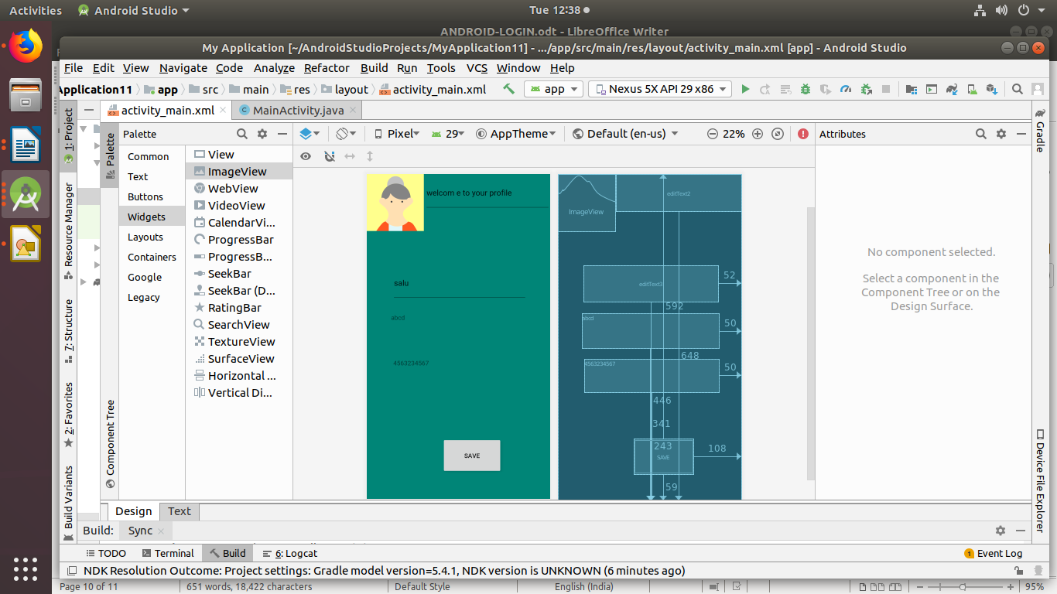s

**Experiment No.: 6**

**Name: Salini K B**

**Roll No: 33**

**Batch: RMCA-B**

**Date: 19-09-2022**

**Aim**

Write a program to create a Hello World activity using all lifecycles methods to display messages using Log.d.

**Procedure**

**Output**

**package** com.example.lifecycle;

**import** androidx.appcompat.app.AppCompatActivity;

**import** android.os.Bundle;

**import** android.util.Log;

**public class** MainActivity **extends** AppCompatActivity {

@Override

**protected void** onCreate(Bundle savedInstanceState) {

**super**.onCreate(savedInstanceState);

setContentView(R.layout.***activity_main***);

Log.*d*(**"lifecycle"**,**"onCreate invoked"**);

}

@Override

**protected void** onStart() {

**super**.onStart();

Log.*d*(**"lifecycle"**,**"onStart invoked"**);

}

@Override

**protected void** onResume() {

**super**.onResume();

Log.*d*(**"lifecycle"**,**"onResume invoked"**);

}

@Override

**protected void** onPause() {

**super**.onPause();

Log.*d*(**"lifecycle"**,**"onPause invoked"**);

}

@Override

**protected void** onStop() {

**super**.onStop();

Log.*d*(**"lifecycle"**,**"onStop invoked"**);

}

@Override

**protected void** onRestart() {

**super**.onRestart();

Log.*d*(**"lifecycle"**,**"onRestart invoked"**);

}

@Override

**protected void** onDestroy() {

**super**.onDestroy();

Log.*d*(**"lifecycle"**,**"onDestroy invoked"**);

}

}

**Output:**

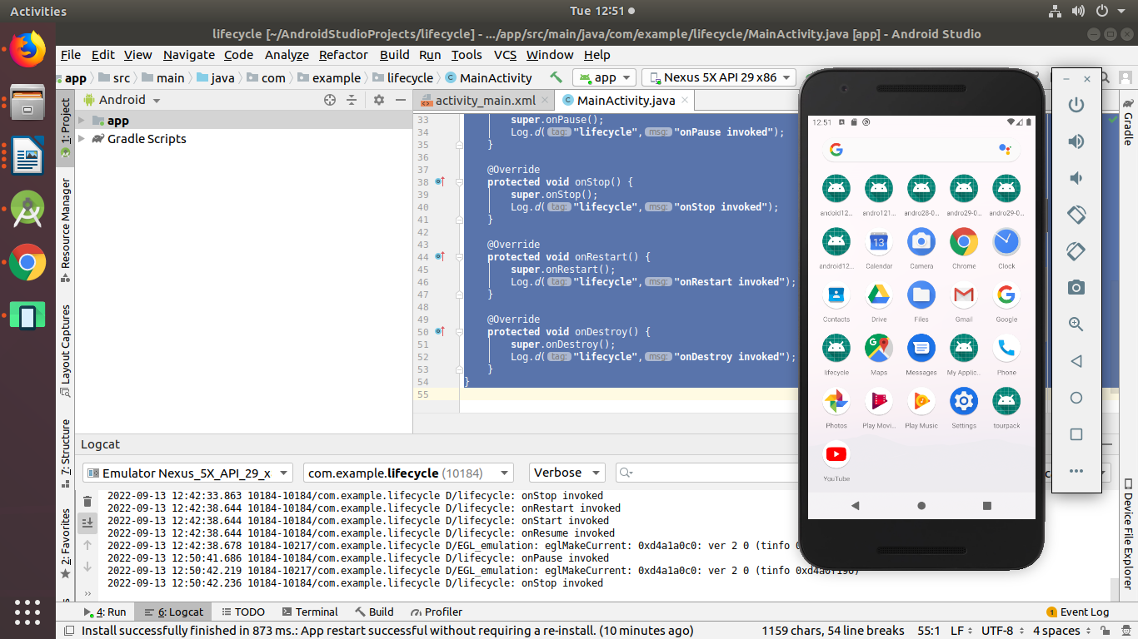

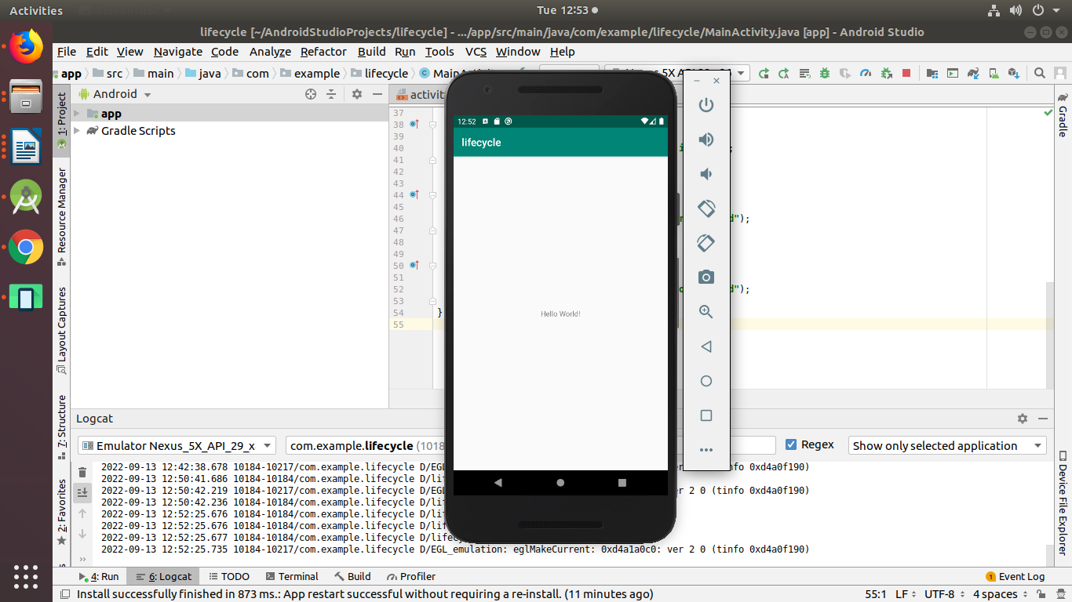

**Name: Salini K B**

**Roll No: 33**

**Batch: RMCA-B**

**Date: 13-10-2022**

**Experiment No.: 7**

**Aim**

Design a simple Calculator using GridLayout and Cascaded LinearLayout.

**Procedure**

**Xml file**

<?xml version="1.0" encoding="utf-8"?>

<LinearLayout xmlns:android="http://schemas.android.com/apk/res/android"

xmlns:tools="http://schemas.android.com/tools"

android:id="@+id/activity_main"

android:layout_width="match_parent"

android:layout_height="match_parent"

android:orientation="vertical"

android:textAlignment="center"

android:weightSum="1">

<TextView

android:text="calculator"

android:layout_width="match_parent"

android:id="@+id/textView"

android:layout_height="30dp"

android:gravity="center_horizontal"

android:textColorLink="?android:attr/editTextColor"

android:textSize="40sp"

android:layout_weight="0.07" />

<EditText

android:layout_width="match_parent"

android:layout_height="wrap_content"

android:inputType="number"

android:ems="10"

android:id="@+id/editOp1"

android:textSize="18sp"

android:gravity="center_horizontal"

android:layout_marginBottom="5dp"

android:visibility="visible"

android:hint="first number"

android:layout_marginLeft="30dp"

android:layout_marginRight="30dp"/>

<EditText

android:layout_width="match_parent"

android:layout_height="wrap_content"

android:inputType="number"

android:ems="10"

android:id="@+id/editOp2"

android:textSize="18sp"

android:gravity="center_horizontal"

android:elevation="1dp"

android:hint="second number"

android:layout_marginLeft="30dp"

android:layout_marginRight="30dp"/>

<LinearLayout

android:orientation="horizontal"

android:layout_width="match_parent"

android:layout_height="wrap_content">

<Button

android:text="+"

android:layout_width="78dp"

android:layout_height="wrap_content"

android:id="@+id/btnadd"

android:layout_weight="0.01"

android:layout_marginLeft="30dp"

android:layout_marginRight="30dp"/>

<Button

android:text="-"

android:layout_width="78dp"

android:layout_height="wrap_content"

android:id="@+id/btnsub"

android:layout_weight="0.01"

android:layout_marginLeft="30dp"

android:layout_marginRight="30dp"/>

</LinearLayout>

<LinearLayout

android:orientation="horizontal"

android:layout_width="match_parent"

android:layout_height="wrap_content">

<Button

android:text="*"

android:layout_width="78dp"

android:layout_height="wrap_content"

android:id="@+id/btnmul"

android:layout_weight="0.01"

android:layout_marginLeft="30dp"

android:layout_marginRight="30dp"/>

<Button

android:text="/"

android:layout_height="wrap_content"

android:id="@+id/btndiv"

android:layout_width="78dp"

android:layout_weight="0.01"

android:layout_marginLeft="30dp"

android:layout_marginRight="30dp"/>

</LinearLayout>

<LinearLayout

android:orientation="horizontal"

android:layout_width="match_parent"

android:layout_height="wrap_content">

<Button

android:text="Clear"

android:layout_width="80dp"

android:layout_height="wrap_content"

android:id="@+id/btnclr"

android:layout_weight="0.03"

android:layout_marginLeft="30dp"

android:layout_marginRight="30dp" />

</LinearLayout>

<EditText

android:layout_width="match_parent"

android:layout_height="wrap_content"

android:inputType="number"

android:ems="10"

android:id="@+id/result"

android:textSize="18sp"

android:text="answer"

android:gravity="center_horizontal"

android:layout_marginLeft="30dp"

android:layout_marginRight="30dp"/>

</LinearLayout>

**Java file**

package com.example.program1;

import androidx.appcompat.app.AppCompatActivity;

import android.os.Bundle;

import android.view.View;

import android.widget.Button;

import android.widget.EditText;

import android.widget.TextView;

import android.widget.Toast;

public class MainActivity extends AppCompatActivity {

private EditText opr1;

private EditText opr2;

private Button btnadd;

private Button btnsub;

private Button btnmul;

private Button btndiv;

private Button btnclr;

private TextView txtresult;

@Override

protected void onCreate(Bundle savedInstanceState) {

super.onCreate(savedInstanceState);

setContentView(R.layout.activity_main);

opr1 = (EditText) findViewById(R.id.editOp1);

opr2 = (EditText) findViewById(R.id.editOp2);

btnadd = (Button) findViewById(R.id.btnadd);

btnsub = (Button) findViewById(R.id.btnsub);

btnmul = (Button) findViewById(R.id.btnmul);

btndiv = (Button) findViewById(R.id.btndiv);

btnclr = (Button) findViewById(R.id.btnclr);

txtresult= (TextView) findViewById(R.id.result);

btnadd.setOnClickListener(new View.OnClickListener() {

@Override

public void onClick(View v) {

if((opr1.getText().length()>0) && (opr2.getText().length()>0)) {

double oper1 = Double.parseDouble(opr1.getText().toString());

double oper2 = Double.parseDouble(opr2.getText().toString());

double result = oper1 + oper2;

txtresult.setText(Double.toString(result));

}

else{

Toast toast= Toast.makeText(MainActivity.this,"Enter The Required Numbers",Toast.LENGTH_LONG);

toast.show();

}

}

});

btnsub.setOnClickListener(new View.OnClickListener() {

@Override

public void onClick(View v) {

if((opr1.getText().length()>0) && (opr2.getText().length()>0)) {

double oper1 = Double.parseDouble(opr1.getText().toString());

double oper2 = Double.parseDouble(opr2.getText().toString());

double result = oper1 - oper2;

txtresult.setText(Double.toString(result));

}

else{

Toast toast= Toast.makeText(MainActivity.this,"Enter The Required Numbers",Toast.LENGTH_LONG);

toast.show();

}

}

});

btnmul.setOnClickListener(new View.OnClickListener() {

@Override

public void onClick(View v) {

if((opr1.getText().length()>0) && (opr2.getText().length()>0)) {

double oper1 = Double.parseDouble(opr1.getText().toString());

double oper2 = Double.parseDouble(opr2.getText().toString());

double result = oper1 * oper2;

txtresult.setText(Double.toString(result));

}

else{

Toast toast= Toast.makeText(MainActivity.this,"Enter The Required Numbers",Toast.LENGTH_LONG);

toast.show();

}

}

});

btndiv.setOnClickListener(new View.OnClickListener() {

@Override

public void onClick(View v) {

if((opr1.getText().length()>0) && (opr2.getText().length()>0)) {

double oper1 = Double.parseDouble(opr1.getText().toString());

double oper2 = Double.parseDouble(opr2.getText().toString());

double result = oper1 / oper2;

txtresult.setText(Double.toString(result));

}

else{

Toast toast= Toast.makeText(MainActivity.this,"Enter The Required Numbers",Toast.LENGTH_LONG);

toast.show();

}

}

});

btnclr.setOnClickListener(new View.OnClickListener() {

@Override

public void onClick(View v) {

opr1.setText("");

opr2.setText("");

txtresult.setText("0.00");

opr1.requestFocus();

}

});

}

}

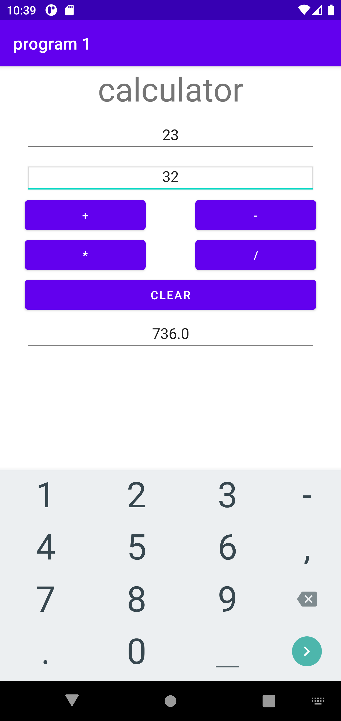

**Name: Salini K B**

**Roll No: 33**

**Batch: RMCA-B**

**Date: 27-10-2022**

**Experiment No.: 8**

**Aim**

Create a Facebook page using RelativeLayout; set properties using .xml file

**Procedure**

**Xml file**

<?xml version="1.0" encoding="utf-8"?>

<RelativeLayout xmlns:android="http://schemas.android.com/apk/res/android"

xmlns:tools="http://schemas.android.com/tools"

android:layout_width="match_parent"

android:layout_height="match_parent"

tools:context=".MainActivity">

<TextView

android:layout_width="wrap_content"

android:layout_height="wrap_content"

android:text="FACEBOOK"

android:textColor="#4267B2"

android:textSize="30dp"

android:textStyle="bold"

android:layout_marginLeft="125dp"

android:layout_marginTop="60dp"/>

<TextView

android:text="Log in to Facebook"

android:layout_width="match_parent"

android:layout_height="wrap_content"

android:layout_marginTop="140dp"

android:textSize="30dp"

android:textStyle="bold"

android:gravity="center_horizontal"

/>

<EditText

android:layout_width="match_parent"

android:layout_height="wrap_content"

android:inputType="number"

android:ems="10"

android:textSize="18sp"

android:gravity="center_horizontal"

android:elevation="1dp"

android:hint="Email address or phone number"

android:layout_marginLeft="30dp"

android:layout_marginRight="30dp"

android:layout_marginTop="200dp"

/>

<EditText

android:layout_width="match_parent"

android:layout_height="wrap_content"

android:inputType="number"

android:textSize="18sp"

android:gravity="center_horizontal"

android:hint="password"

android:layout_marginLeft="30dp"

android:layout_marginRight="30dp"

android:layout_marginTop="260dp"/>

<Button

android:text="Log In"

android:layout_width="wrap_content"

android:layout_height="wrap_content"

android:layout_marginLeft="150dp"

android:layout_marginRight="150dp"

android:layout_marginTop="330dp"

android:backgroundTint="#4267B2"

/>

<TextView

android:text="Forgotten account? · Sign up for Facebook"

android:layout_width="match_parent"

android:layout_height="wrap_content"

android:textSize="17dp"

android:textStyle="italic"

android:gravity="center_horizontal"

android:layout_marginTop="400dp"

android:textColor="#4267B2"

/>

</RelativeLayout>

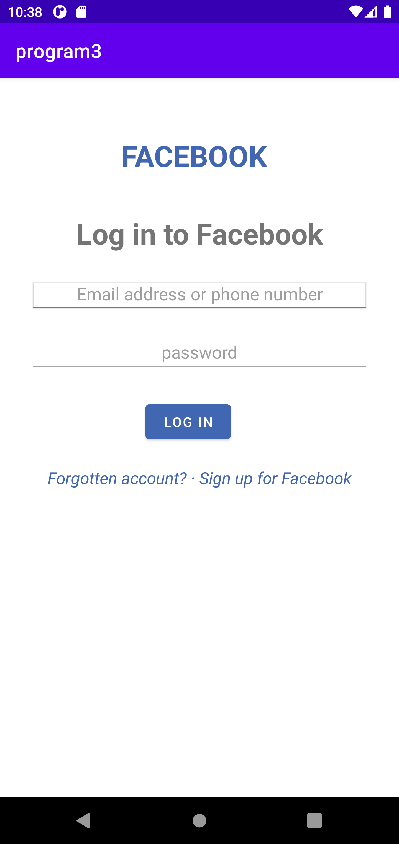

**Experiment No.: 9**

**Name: Salini K B**

**Roll No: 33**

**Batch: RMCA-B**

**Date: 31-10-2022**

**Aim:**

9. Develop an application that toggles image using FrameLayout.

**Procedure**

**Output**

**Name: Salini K B**

**Roll No: 33**

**Batch: RMCA-B**

**Date: -10-2022**

**Experiment No.: 10**

**Aim**

. Write a program to create a first display screen of any search engine using auto Complete Text View

**Procedure**

**Output**

**Name: Salini K B**

**Roll No: 33**

**Batch: RMCA-B**

**Date: -10-2022**

**Experiment No.: 11**

**Aim**

Write a program to create a toggle button to display on/off functionality on the display screen.

**Procedure**

**Output**

**Name: Salini K B**

**Roll No: 33**

**Batch: RMCA-B**

**Date: -10-2022**

**Experiment No.: 12**

**Aim**

2. Write a program to show five checkboxes and toast selected checkboxes

**Procedure**

**Output**

**Name: Salini K B**

**Roll No: 33**

**Batch: RMCA-B**

**Date: -10-2022**

**Experiment No.: 13**

**Aim**

Write a program to show functionality of radio group and radio buttons to toast selected gender.

**Procedure**

**Output**

**Name: Salini K B**

**Roll No: 33**

**Batch: RMCA-B**

**Date: -10-2022**

**Experiment No.: 14**

**Aim**

Write a program to display following output. Use Time Picker with Spinner mode.

**Procedure**

**Output**

**Name: Salini K B**

**Roll No: 33**

**Batch: RMCA-B**

**Date: -10-2022**

**Experiment No.: 15**

**Aim**

Write a program to display and image using image view and a button named as “Change Image”. Once you click on button another image should get displayed

**Procedure**

**Output**

**Name: Salini K B**

**Roll No: 33**

**Batch: RMCA-B**

**Date: -10-2022**

**Experiment No.: 16**

**Aim**

Write a program to display 15 buttons using grid view

**Procedure**

*<?***xml version="1.0" encoding="utf-8"***?>*

<**androidx.constraintlayout.widget.ConstraintLayout xmlns:android="http://schemas.android.com/apk/res/android"**

**xmlns:app="http://schemas.android.com/apk/res-auto"**

**xmlns:tools="http://schemas.android.com/tools"**

**android:layout_width="match_parent"**

**android:layout_height="match_parent"**

**tools:context=".MainActivity"**>

<**RelativeLayout**

**android:layout_width="409dp"**

**android:layout_height="729dp"**

**tools:layout_editor_absoluteX="-14dp"**

**tools:layout_editor_absoluteY="1dp"**>

<**Button**

**android:id="@+id/button"**

**android:layout_width="wrap_content"**

**android:layout_height="wrap_content"**

**android:layout_alignParentEnd="true"**

**android:layout_alignParentBottom="true"**

**android:layout_marginEnd="312dp"**

**android:layout_marginBottom="662dp"**

**android:text="Button"** />

<**Button**

**android:id="@+id/button2"**

**android:layout_width="195dp"**

**android:layout_height="wrap_content"**

**android:layout_alignParentStart="true"**

**android:layout_alignParentTop="true"**

**android:layout_alignParentEnd="true"**

**android:layout_alignParentBottom="true"**

**android:layout_marginStart="177dp"**

**android:layout_marginTop="14dp"**

**android:layout_marginEnd="37dp"**

**android:layout_marginBottom="664dp"**

**android:text="Button"** />

<**Button**

**android:id="@+id/button3"**

**android:layout_width="wrap_content"**

**android:layout_height="wrap_content"**

**android:layout_alignParentEnd="true"**

**android:layout_alignParentBottom="true"**

**android:layout_marginEnd="312dp"**

**android:layout_marginBottom="415dp"**

**android:text="Button"** />

<**Button**

**android:id="@+id/button4"**

**android:layout_width="wrap_content"**

**android:layout_height="wrap_content"**

**android:layout_alignParentStart="true"**

**android:layout_alignParentTop="true"**

**android:layout_alignParentEnd="true"**

**android:layout_alignParentBottom="true"**

**android:layout_marginStart="159dp"**

**android:layout_marginTop="269dp"**

**android:layout_marginEnd="155dp"**

**android:layout_marginBottom="412dp"**

**android:text="Button"** />

<**Button**

**android:id="@+id/button5"**

**android:layout_width="110dp"**

**android:layout_height="51dp"**

**android:layout_alignParentTop="true"**

**android:layout_alignParentEnd="true"**

**android:layout_alignParentBottom="true"**

**android:layout_marginTop="267dp"**

**android:layout_marginEnd="4dp"**

**android:layout_marginBottom="411dp"**

**android:text="Button"** />

<**Button**

**android:id="@+id/button6"**

**android:layout_width="wrap_content"**

**android:layout_height="wrap_content"**

**android:layout_alignParentStart="true"**

**android:layout_alignParentTop="true"**

**android:layout_alignParentEnd="true"**

**android:layout_alignParentBottom="true"**

**android:layout_marginStart="157dp"**

**android:layout_marginTop="584dp"**

**android:layout_marginEnd="157dp"**

**android:layout_marginBottom="97dp"**

**android:text="Button"** />

<**Button**

**android:id="@+id/button7"**

**android:layout_width="354dp"**

**android:layout_height="wrap_content"**

**android:layout_alignParentStart="true"**

**android:layout_alignParentTop="true"**

**android:layout_alignParentEnd="true"**

**android:layout_alignParentBottom="true"**

**android:layout_marginStart="41dp"**

**android:layout_marginTop="663dp"**

**android:layout_marginEnd="14dp"**

**android:layout_marginBottom="13dp"**

**android:text="Button"** />

</**RelativeLayout**>

</**androidx.constraintlayout.widget.ConstraintLayout**>

Output



**Output**

**Name: Salini K B**

**Roll No: 33**

**Batch: RMCA-B**

**Date: -10-2022**

**Experiment No.: 17**

**Aim**

Write a program to display three checkboxes and one button named” Order” as shown below. Once you click on button it should toast different selected checkboxes along with items individual and total price.

**Procedure**

**Output**

**Name: Salini K B**

**Roll No: 33**

**Batch: RMCA-B**

**Date: -10-2022**

**Experiment No.: 18**

**Aim**

8. Create a SIGN Up activity with Username and Password. Validation of password should happen based on the following rules: a. Password should contain uppercase and lowercase letters. b. Password should contain letters and numbers. c. Password should contain special characters. d. Minimum length of the password (the default value is 8).

**Procedure**

**Output**

**Name: Salini K B**

**Roll No: 33**

**Batch: RMCA-B**

**Date: -10-2022**

**Experiment No.: 19**

**Aim**

19. Design a registration activity and store registration details in local memory of phone using Intents and SharedPreferences.

**Procedure**

**Xml :**

<?xml version="1.0" encoding="utf-8"?>

<LinearLayout xmlns:android="http://schemas.android.com/apk/res/android"

xmlns:app="http://schemas.android.com/apk/res-auto"

xmlns:tools="http://schemas.android.com/tools"

android:orientation="vertical"

android:layout_width="match_parent"

android:layout_height="match_parent"

tools:context=".MainActivity">

<TextView

android:layout_width="wrap_content"

android:layout_height="wrap_content"

android:text="prgm4 shared preference "

android:id="@+id/textView"

android:layout_alignParentTop="true"

android:layout_centerHorizontal="true"

android:textSize="29dp" />

<EditText

android:layout_width="wrap_content"

android:layout_height="wrap_content"

android:id="@+id/editText"

android:layout_below="@+id/textView2"

android:layout_marginTop="67dp"

android:hint="Name"

android:layout_alignParentLeft="true"

android:layout_alignParentStart="true"

android:layout_alignParentRight="true"

android:layout_alignParentEnd="true" />

<EditText

android:layout_width="wrap_content"

android:layout_height="wrap_content"

android:id="@+id/editText3"

android:layout_below="@+id/editText2"

android:layout_alignParentLeft="true"

android:layout_alignParentStart="true"

android:layout_alignParentRight="true"

android:layout_alignParentEnd="true"

android:hint="Email" />

<EditText

android:layout_width="wrap_content"

android:layout_height="wrap_content"

android:id="@+id/editText2"

android:layout_below="@+id/editText"

android:layout_alignParentLeft="true"

android:layout_alignParentStart="true"

android:layout_alignParentRight="true"

android:layout_alignParentEnd="true"

android:hint="Pass" />

<Button

android:layout_width="wrap_content"

android:layout_height="wrap_content"

android:text="Save"

android:id="@+id/button"

android:layout_below="@+id/editText3"

android:layout_centerHorizontal="true"

android:layout_marginTop="50dp" />

</LinearLayout>

**Java :**

package com.example.program8;

import androidx.appcompat.app.AppCompatActivity;

import android.content.Context;

import android.content.SharedPreferences;

import android.os.Bundle;

import android.view.View;

import android.widget.Button;

import android.widget.EditText;

import android.widget.Toast;

public class MainActivity extends AppCompatActivity {

EditText ed1,ed2,ed3;

Button b1;

public static final String MyPREFERENCES = "MyPrefs" ;

public static final String Name = "nameKey";

public static final String Phone = "phoneKey";

public static final String Email = "emailKey";

SharedPreferences sharedpreferences;

@Override

protected void onCreate(Bundle savedInstanceState) {

super.onCreate(savedInstanceState);

setContentView(R.layout.activity_main);

ed1=(EditText)findViewById(R.id.editText);

ed2=(EditText)findViewById(R.id.editText2);

ed3=(EditText)findViewById(R.id.editText3);

b1=(Button)findViewById(R.id.button);

sharedpreferences = getSharedPreferences(MyPREFERENCES, Context.MODE_PRIVATE);

b1.setOnClickListener(new View.OnClickListener() {

@Override

public void onClick(View v) {

String n = ed1.getText().toString();

String ph = ed2.getText().toString();

String e = ed3.getText().toString();

SharedPreferences.Editor editor = sharedpreferences.edit();

editor.putString(Name, n);

editor.putString(Phone, ph);

editor.putString(Email, e);

editor.commit();

Toast.makeText(MainActivity.this,"Thanks",Toast.LENGTH_LONG).show();

}

});

}

}

**Output**

**Name: Salini K B**

**Roll No: 33**

**Batch: RMCA-B**

**Date: -10-2022**

**Experiment No.: 20**

**Aim**

Create sample application with login module. (check username and password) on successful login, Change text view “login successful” and on login fail, alert user using Toast” Login Fail”.

**Procedure**

**Output**

**Experiment No.: 21**

**Name: Salini K B**

**Roll No: 33**

**Batch: RMCA-B**

**Date: -10-2022**

**Aim**

Write a program to create the login form with necessary validations like length of username and password, empty text fields, count of unsuccessful login attempts. Display the login successful/unsuccessful toast message**Procedure**

**Output**

**Experiment No.: 22**

**Name: Salini K B**

**Roll No: 33**

**Batch: RMCA-B**

**Date: -10-2022**

**Aim**

2. Write a program to Implement Options Menu.

**Output**

**Experiment No.: 23**

**Name: Salini K B**

**Roll No: 33**

**Batch: RMCA-B**

**Date: -10-2022**

**Aim**

Write a program to Implement Context Menu

**Output**

**Experiment No.: 24**

**Name: Salini K B**

**Roll No: 33**

**Batch: RMCA-B**

**Date: -10-2022**

**Aim**

. Write a program to Implement Popup Menu.

**Output**