Login page

activity_main.xml

<?xml version="1.0" encoding="utf-8"?>
<RelativeLayout xmlns:android="http://schemas.android.com/apk/res/android"
xmlns:app="http://schemas.android.com/apk/res-auto"
xmlns:tools="http://schemas.android.com/tools"
android:layout_width="match_parent"
android:layout_height="match_parent"
android:layout_centerInParent="@color/colorPrimaryDark"
android:background="@drawable/radius"
android:gravity="center"
android:orientation="vertical"
tools:context=".MainActivity"
android:layout_margin="@dimen/cardview_compat_inset_shadow">
<TextView
android:id="@+id/t1"
android:layout_width="wrap_content"
android:layout_height="wrap_content">
</TextView>
<Button
android:id="@+id/t2"
android:layout_width="159dp"
android:layout_height="81dp"
android:layout_alignParentEnd="true"
android:layout_alignParentBottom="true"
android:layout_marginStart="@dimen/cardview_compat_inset_shadow"
android:layout_marginTop="@dimen/cardview_compat_inset_shadow"
android:layout_marginEnd="121dp"
android:layout_marginBottom="14dp"
android:background="@drawable/radius"
android:backgroundTint="#EF6C00"
android:backgroundTintMode="src_over"
android:text="Login"
android:textAlignment="gravity"
android:textSize="30dp"
android:visibility="visible">
</Button>
<EditText
android:id="@+id/editText2"
android:layout_width="match_parent"
android:layout_height="135dp"
android:layout_alignParentStart="true"
android:layout_alignParentTop="true"
android:layout_alignParentEnd="true"
android:layout_alignParentBottom="true"
android:layout_marginStart="0dp"
android:layout_marginTop="-4dp"
android:layout_marginEnd="0dp"
android:layout_marginBottom="599dp"
android:ems="10"
android:inputType="textPersonName"
android:text="Name"
android:textAlignment="center"
android:textAppearance="@style/TextAppearance.AppCompat.Medium"
android:textSize="20dp"
tools:text="Welcome To Home"
tools:visibility="visible">
</EditText>
<TextView
android:id="@+id/textView2"
android:layout_width="182dp"
android:layout_height="51dp"
android:layout_alignParentBottom="true"
android:layout_marginBottom="244dp"
android:text="TextView"
android:textSize="20dp"
tools:text="Enter your Name" />
<TextView
android:id="@+id/textView4"
android:layout_width="180dp"
android:layout_height="53dp"
android:layout_alignParentBottom="true"
android:layout_marginBottom="169dp"
android:text="TextView"
android:textSize="20dp"
tools:text="Password" />
<TextView
android:id="@+id/textView5"
android:layout_width="188dp"
android:layout_height="68dp"
android:layout_alignParentBottom="true"
android:layout_marginBottom="84dp"
android:text="TextView"
android:textSize="20dp"
tools:text="Confirm Password" />
<com.google.android.material.textfield.TextInputLayout
android:layout_width="match_parent"
android:layout_height="wrap_content">
</com.google.android.material.textfield.TextInputLayout>
<ImageView
android:id="@+id/imageView6"
android:layout_width="match_parent"
android:layout_height="440dp"
android:layout_alignParentBottom="true"
android:layout_marginBottom="281dp"
tools:srcCompat="@tools:sample/backgrounds/scenic[17]" />
<EditText
android:id="@+id/editText"
android:layout_width="wrap_content"
android:layout_height="wrap_content"
android:layout_alignParentTop="true"
android:layout_alignParentEnd="true"
android:layout_alignParentBottom="true"
android:layout_marginTop="419dp"
android:layout_marginEnd="-1dp"
android:layout_marginBottom="265dp"
android:ems="10"
android:inputType="textPersonName" />
<EditText
android:layout_width="wrap_content"
android:layout_height="wrap_content"
android:layout_alignParentEnd="true"
android:layout_alignParentBottom="true"
android:layout_marginEnd="-2dp"
android:layout_marginBottom="188dp"
android:ems="10"
android:inputType="numberPassword" />
<EditText
android:id="@+id/editText4"
android:layout_width="wrap_content"
android:layout_height="wrap_content"
android:layout_alignParentEnd="true"
android:layout_alignParentBottom="true"
android:layout_marginEnd="0dp"
android:layout_marginBottom="114dp"
android:ems="10"
android:inputType="numberPassword" />
</RelativeLayout>

radius.xml

<?xml version="1.0" encoding="utf-8"?>
<shape
xmlns:android="http://schemas.android.com/apk/res/android"
android:shape="rectangle">
<corners android:radius="20dp" />
<solid android:color="@android:color/white" />
<stroke
android:width="1dip"
android:color="@color/white" />
</shape>

mainactivity.java
package com.example.myapplication;
import androidx.appcompat.app.AppCompatActivity;
import android.os.Bundle;
public class MainActivity extends AppCompatActivity {
@Override
protected void onCreate(Bundle savedInstanceState) {
super.onCreate(savedInstanceState);
setContentView(R.layout.activity_main);
}
}

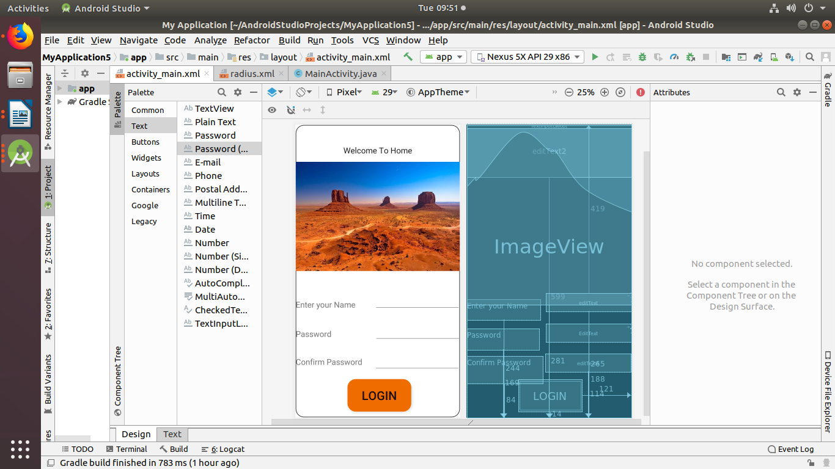

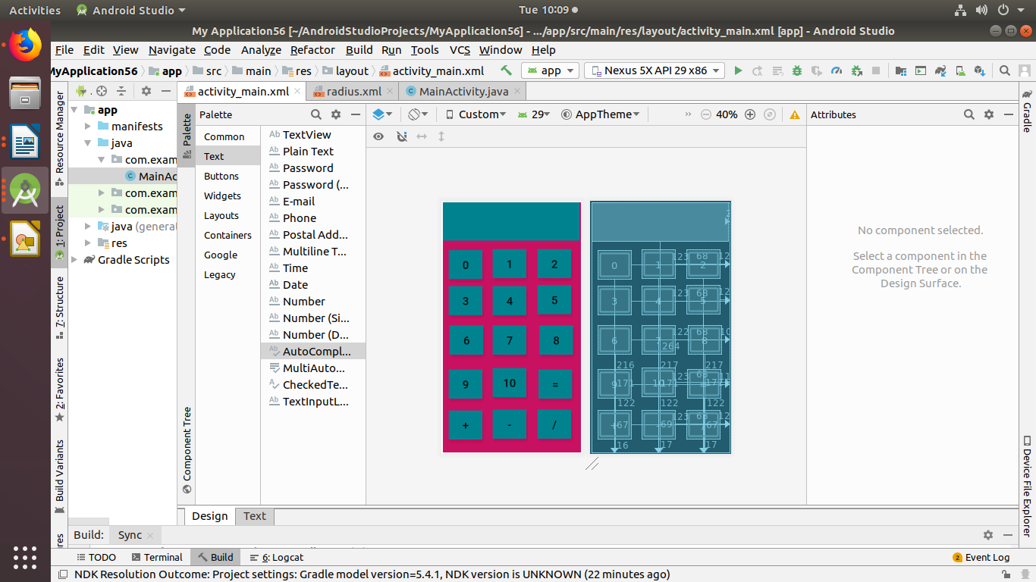

Calculator page

mainactivity.xml

<?xml version="1.0" encoding="utf-8"?>
<RelativeLayout xmlns:android="http://schemas.android.com/apk/res/android"
xmlns:app="http://schemas.android.com/apk/res-auto"
xmlns:tools="http://schemas.android.com/tools"
android:layout_width="match_parent"
android:layout_height="match_parent"
android:layout_margin="@dimen/cardview_default_elevation"
android:background="#C91162"
android:visibility="visible"
tools:context=".MainActivity"
tools:visibility="visible">
<Button
android:id="@+id/button8"
android:layout_width="42dp"
android:layout_height="36dp"
android:layout_alignParentEnd="true"
android:layout_alignParentBottom="true"
android:layout_marginEnd="12dp"
android:layout_marginBottom="172dp"
android:background="#00838F"
android:text="5" />
<Button
android:id="@+id/button7"
android:layout_width="42dp"
android:layout_height="36dp"
android:layout_alignParentEnd="true"
android:layout_alignParentBottom="true"
android:layout_marginEnd="68dp"
android:layout_marginBottom="168dp"
android:background="#00838F"
android:text="4" />
<Button
android:id="@+id/button6"
android:layout_width="42dp"
android:layout_height="36dp"
android:layout_alignParentEnd="true"
android:layout_alignParentBottom="true"
android:layout_marginEnd="122dp"
android:layout_marginBottom="122dp"
android:background="#00838F"
android:text="6" />
<Button
android:id="@+id/button11"
android:layout_width="42dp"
android:layout_height="36dp"
android:layout_alignParentEnd="true"
android:layout_alignParentBottom="true"
android:layout_marginEnd="123dp"
android:layout_marginBottom="67dp"
android:background="#00838F"
android:text="9" />
<Button
android:id="@+id/button14"
android:layout_width="42dp"
android:layout_height="36dp"
android:layout_alignParentEnd="true"
android:layout_alignParentBottom="true"
android:layout_marginEnd="123dp"
android:layout_marginBottom="16dp"
android:background="#00838F"
android:text="+" />
<Button
android:id="@+id/button15"
android:layout_width="42dp"
android:layout_height="36dp"
android:layout_alignParentEnd="true"
android:layout_alignParentBottom="true"
android:layout_marginEnd="68dp"
android:layout_marginBottom="17dp"
android:background="#00838F"
android:text="-" />
<Button
android:id="@+id/button16"
android:layout_width="42dp"
android:layout_height="36dp"
android:layout_alignParentEnd="true"
android:layout_alignParentBottom="true"
android:layout_marginEnd="12dp"
android:layout_marginBottom="17dp"
android:background="#00838F"
android:text="/" />
<Button
android:id="@+id/button9"
android:layout_width="42dp"
android:layout_height="36dp"
android:layout_alignParentEnd="true"
android:layout_alignParentBottom="true"
android:layout_marginEnd="68dp"
android:layout_marginBottom="122dp"
android:background="#00838F"
android:text="7" />
<Button
android:id="@+id/button12"
android:layout_width="42dp"
android:layout_height="36dp"
android:layout_alignParentEnd="true"
android:layout_alignParentBottom="true"
android:layout_marginEnd="68dp"
android:layout_marginBottom="69dp"
android:background="#00838F"
android:text="10" />
<Button
android:id="@+id/button13"
android:layout_width="42dp"
android:layout_height="36dp"
android:layout_alignParentEnd="true"
android:layout_alignParentBottom="true"
android:layout_marginEnd="11dp"
android:layout_marginBottom="67dp"
android:background="#00838F"
android:text="=" />
<Button
android:id="@+id/button10"
android:layout_width="42dp"
android:layout_height="36dp"
android:layout_alignParentEnd="true"
android:layout_alignParentBottom="true"
android:layout_marginEnd="10dp"
android:layout_marginBottom="122dp"
android:background="#00838F"
android:text="8" />
<Button
android:id="@+id/button5"
android:layout_width="42dp"
android:layout_height="36dp"
android:layout_alignParentEnd="true"
android:layout_alignParentBottom="true"
android:layout_marginEnd="123dp"
android:layout_marginBottom="171dp"
android:background="#00838F"
android:text="3" />
<Button
android:id="@+id/button4"
android:layout_width="42dp"
android:layout_height="36dp"
android:layout_alignParentEnd="true"
android:layout_alignParentBottom="true"
android:layout_marginEnd="12dp"
android:layout_marginBottom="217dp"
android:background="#00838F"
android:text="2" />
<Button
android:id="@+id/button3"
android:layout_width="42dp"
android:layout_height="36dp"
android:layout_alignParentEnd="true"
android:layout_alignParentBottom="true"
android:layout_marginEnd="68dp"
android:layout_marginBottom="217dp"
android:background="#00838F"
android:text="1" />
<Button
android:id="@+id/button"
android:layout_width="42dp"
android:layout_height="36dp"
android:layout_alignParentEnd="true"
android:layout_alignParentBottom="true"
android:layout_marginEnd="123dp"
android:layout_marginBottom="216dp"
android:background="#00838F"
android:text="0" />
<TextView
android:id="@+id/textView10"
android:layout_width="wrap_content"
android:layout_height="51dp"
android:layout_alignParentStart="true"
android:layout_alignParentEnd="true"
android:layout_alignParentBottom="true"
android:layout_marginStart="0dp"
android:layout_marginEnd="2dp"
android:layout_marginBottom="264dp"
android:background="#AD1457"
android:foreground="#00838F" />
</RelativeLayout>
radius.xml
<?xml version="1.0" encoding="utf-8"?>
<shape
xmlns:android="http://schemas.android.com/apk/res/android"
android:shape="rectangle">
<corners android:radius="20dp" />
<solid android:color="@android:color/white" />
<stroke
android:width="1dip"
android:color="@color/white" />
</shape>
mainactivity.java
package com.example.myapplication56;
import androidx.appcompat.app.AppCompatActivity;
import android.os.Bundle;
public class MainActivity extends AppCompatActivity {
@Override
protected void onCreate(Bundle savedInstanceState) {
super.onCreate(savedInstanceState);
setContentView(R.layout.activity_main);
}
}
home page

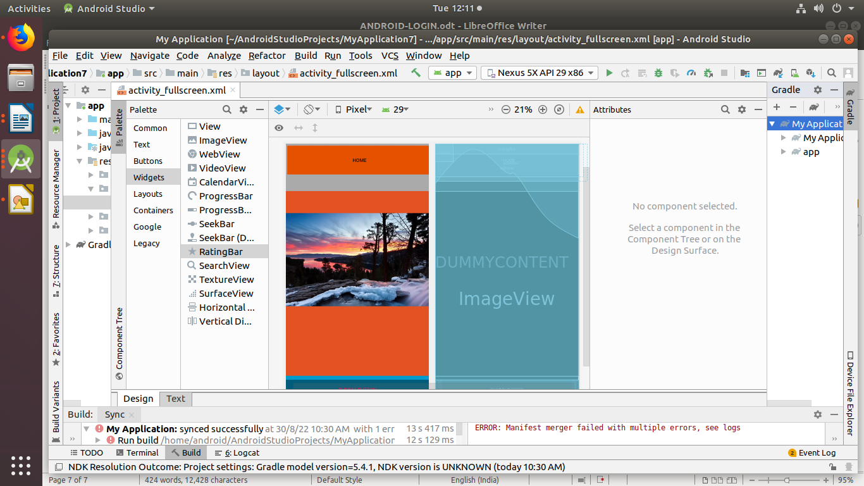
activityfullscreen,.xml

<?xml version="1.0" encoding="utf-8"?>
<FrameLayout xmlns:android="http://schemas.android.com/apk/res/android"
xmlns:app="http://schemas.android.com/apk/res-auto"
xmlns:tools="http://schemas.android.com/tools"
android:layout_width="match_parent"
android:layout_height="match_parent"
android:background="#0099cc"
tools:context=".FullscreenActivity">
<!-- The primary full-screen view. This can be replaced with whatever view
is needed to present your content, e.g. VideoView, SurfaceView,
TextureView, etc. -->
<TextView android:id="@+id/fullscreen_content"
android:layout_width="match_parent"
android:layout_height="match_parent"
android:keepScreenOn="true"
android:textColor="#33b5e5"
android:textStyle="bold"
android:textSize="50sp"
android:gravity="center"
android:text="@string/dummy_content" />
<!-- This FrameLayout insets its children based on system windows using
android:fitsSystemWindows. -->
<FrameLayout android:layout_width="match_parent"
android:layout_height="match_parent"
android:fitsSystemWindows="true">
<LinearLayout android:id="@+id/fullscreen_content_controls"
style="?metaButtonBarStyle"
android:layout_width="match_parent"
android:layout_height="wrap_content"
android:layout_gravity="bottom|center_horizontal"
android:background="@color/black_overlay"
android:orientation="horizontal"
tools:ignore="UselessParent">
<Button android:id="@+id/dummy_button"
style="?metaButtonBarButtonStyle"
android:layout_width="0dp"
android:layout_height="wrap_content"
android:layout_weight="1"
android:text="@string/dummy_button" />
</LinearLayout>
<ImageView
android:id="@+id/imageView2"
android:layout_width="wrap_content"
android:layout_height="wrap_content"
android:background="#E25223"
tools:srcCompat="@tools:sample/backgrounds/scenic[0]" />
<FrameLayout
android:layout_width="match_parent"
android:layout_height="match_parent">
<Button
android:id="@+id/button"
android:layout_width="424dp"
android:layout_height="94dp"
android:backgroundTint="#E65100"
android:text="home" />
<com.google.android.gms.ads.AdView
android:id="@+id/adView"
android:layout_width="match_parent"
android:layout_height="136dp" />
<com.google.android.gms.maps.MapView
android:id="@+id/mapView"
android:layout_width="wrap_content"
android:layout_height="wrap_content" />
<com.google.android.gms.ads.AdView
android:id="@+id/adView2"
android:layout_width="435dp"
android:layout_height="107dp" />
<RatingBar
android:id="@+id/ratingBar"
android:layout_width="match_parent"
android:layout_height="29dp" />
</FrameLayout>
</FrameLayout>
</FrameLayout>
sum

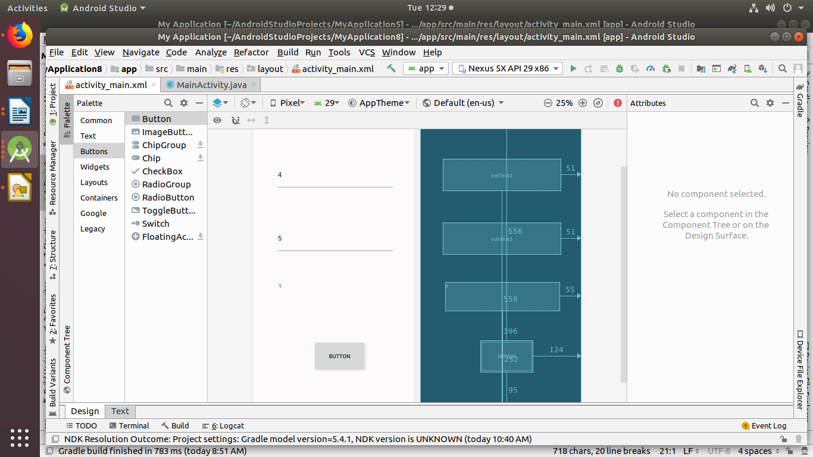

<?xml version="1.0" encoding="utf-8"?>
<RelativeLayout xmlns:android="http://schemas.android.com/apk/res/android"
xmlns:app="http://schemas.android.com/apk/res-auto"
xmlns:tools="http://schemas.android.com/tools"
android:layout_width="match_parent"
android:layout_height="match_parent"
android:layout_margin="@dimen/cardview_default_elevation"
android:background="#FCFAFB"
android:visibility="visible"
tools:context=".MainActivity"
tools:visibility="visible">
<EditText
android:id="@+id/editText2"
android:layout_width="302dp"
android:layout_height="81dp"
android:layout_alignParentEnd="true"
android:layout_alignParentBottom="true"
android:layout_marginEnd="51dp"
android:layout_marginBottom="559dp"
android:ems="10"
android:inputType="textPersonName"
android:text="4" />
<EditText
android:id="@+id/editText3"
android:layout_width="302dp"
android:layout_height="81dp"
android:layout_alignParentEnd="true"
android:layout_alignParentBottom="true"
android:layout_marginEnd="51dp"
android:layout_marginBottom="396dp"
android:ems="10"
android:inputType="textPersonName"
android:text="5" />
<TextView
android:id="@+id/textView4"
android:layout_width="292dp"
android:layout_height="73dp"
android:layout_alignParentEnd="true"
android:layout_alignParentBottom="true"
android:layout_marginEnd="55dp"
android:layout_marginBottom="252dp"
android:text="9" />
<Button
android:id="@+id/button6"
android:layout_width="134dp"
android:layout_height="80dp"
android:layout_alignParentTop="true"
android:layout_alignParentEnd="true"
android:layout_alignParentBottom="true"
android:layout_marginTop="556dp"
android:layout_marginEnd="124dp"
android:layout_marginBottom="95dp"
android:text="BUTTON" />
</RelativeLayout>
mainactivity.java

package com.example.myapplication;
import androidx.appcompat.app.AppCompatActivity;
import android.os.Bundle;
import android.widget.Button;
import android.widget.EditText;
import android.widget.TextView;
public class MainActivity extends AppCompatActivity {
EditText editText2;
EditText editText3;
TextView textView4;
Button button6;
@Override
protected void onCreate(Bundle savedInstanceState) {
super.onCreate(savedInstanceState);
setContentView(R.layout.activity_main);
editText2=(EditText)findViewById(R.id.editText2);
editText3=(EditText)findViewById(R.id.editText3);
textView4=(TextView)findViewById(R.id.textView4);
button6=(Button)findViewById(R.id.button6);
}9
}
profile

activity_main.xml

<?xml version="1.0" encoding="utf-8"?>
<RelativeLayout xmlns:android="http://schemas.android.com/apk/res/android"
xmlns:app="http://schemas.android.com/apk/res-auto"
xmlns:tools="http://schemas.android.com/tools"
android:layout_width="match_parent"
android:layout_height="match_parent"
android:layout_margin="@dimen/cardview_default_elevation"
android:background="@color/colorPrimary"
android:visibility="visible"
tools:context=".MainActivity"
tools:visibility="visible">
<EditText
android:id="@+id/editText2"
android:layout_width="281dp"
android:layout_height="83dp"
android:layout_alignParentEnd="true"
android:layout_alignParentBottom="true"
android:layout_marginEnd="0dp"
android:layout_marginBottom="648dp"
android:ems="10"
android:inputType="textPersonName"
android:text="welcom e to your profile" />
<EditText
android:id="@+id/editText3"
android:layout_width="302dp"
android:layout_height="81dp"
android:layout_alignParentEnd="true"
android:layout_alignParentBottom="true"
android:layout_marginEnd="52dp"
android:layout_marginBottom="446dp"
android:ems="10"
android:inputType="textPersonName"
android:text="salu" />
<TextView
android:id="@+id/textView4"
android:layout_width="307dp"
android:layout_height="78dp"
android:layout_alignParentEnd="true"
android:layout_alignParentBottom="true"
android:layout_marginEnd="50dp"
android:layout_marginBottom="341dp"
android:text="abcd" />
<TextView
android:id="@+id/textView"
android:layout_width="302dp"
android:layout_height="74dp"
android:layout_alignParentEnd="true"
android:layout_alignParentBottom="true"
android:layout_marginEnd="50dp"
android:layout_marginBottom="243dp"
android:text="4563234567" />
<Button
android:id="@+id/button6"
android:layout_width="134dp"
android:layout_height="80dp"
android:layout_alignParentTop="true"
android:layout_alignParentEnd="true"
android:layout_alignParentBottom="true"
android:layout_marginTop="592dp"
android:layout_marginEnd="108dp"
android:layout_marginBottom="59dp"
android:text="save" />
<ImageView
android:id="@+id/imageView"
android:layout_width="wrap_content"
android:layout_height="wrap_content"
tools:srcCompat="@tools:sample/avatars[12]" />
</RelativeLayout>

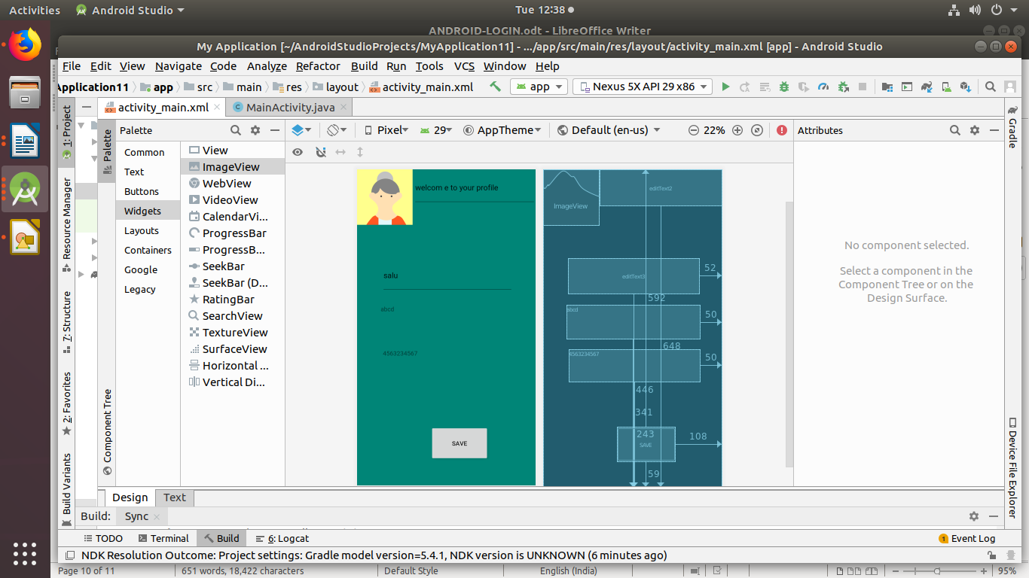
s

