**MS-DOS**

* MS-DOS (short for Microsoft Disk Operating System) is a command-line operating system that was popular in the 1980s and 1990s, primarily on IBM PC-compatible personal computers. It was developed by Microsoft Corporation and was the main operating system used on PCs before the advent of Windows. MS-DOS provided a basic interface for running applications and managing files, using a text-based command prompt. Users would type commands on the command line to perform tasks such as copying, deleting, and renaming files, as well as running programs. MS-DOS was eventually superseded by Windows, which provided a graphical user interface (GUI) and became the dominant operating system on personal computers.

**COMMAND PROMPT**

* The command prompt is a text-based interface in an operating system that allows users to execute commands by typing them in. It is commonly used for system administration tasks and can be accessed through a dedicated program or by using a keyboard shortcut. The command prompt provides access to a wide range of functions, including file management, networking, and system configuration, making it a powerful tool for advanced users and system administrators.
* The command prompt is a feature of MS-DOS and later versions of Windows that emulates the MS-DOS command-line interface, allowing users to execute commands and perform tasks in a similar way.

**SOME OF THE BASIC DOS COMMANDS**

**1) EXIT Command:** The "exit" command is a simple but useful command in DOS that allows you to close the command prompt, terminate a batch file, and return a status code to the system. For example, ***C:\>exit.***

**2) CLS Command:** This is an internal command. This command is used to clear the content on the screen of command prompt. For example, ***C:\>cls.***

**3) CD Command:** The command is used to navigate through different directories on your computer's file system. By using the "cd" command followed by the path of the directory you want to change to, you can quickly and easily move around your computer's file system from the command prompt. For example, After writing cd desktop we will go to Desktop.

,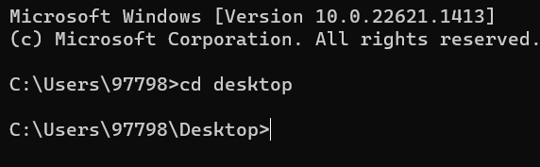

**4) MD or MKDIR Command:** The "md" (or "mkdir") command in DOS is used to create a new directory or folder in the current working directory or at a specified location in the file system. By using the "md" command followed by the name of the new directory, you can quickly and easily create a new folder for storing files and subfolders in your computer's file system.For example,

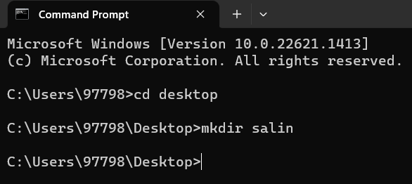

**Result:** New folder name “salin” has been created in desktop.

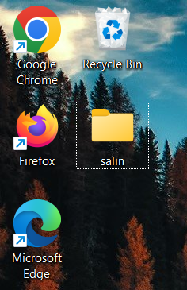

**5) TITLE Command:** This is an internal command. This command is used to set the window title for the command prompt window. Its general form is title[string]. For example, ***C:\Users\> title shrestha*** sets the title **shrestha** for the command prompt windows.

**6) SYSTEMINFO Command:** This is an external command. This command displays information about the computer and operating system of our computer. Its general form is **systeminfo**. For example, ***c:\user>systeminfo***

**Displays:**

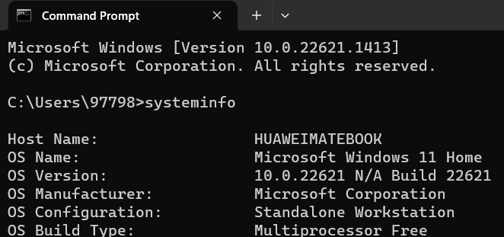

**7) COLOR Command:** To change the color of the text or background in the command prompt on Windows, you can use the "color" command followed by two hexadecimal digits representing the color you want to use. For example,***C:\Users\>color attr.***

* You can choose any color just by writing and entering any digits.

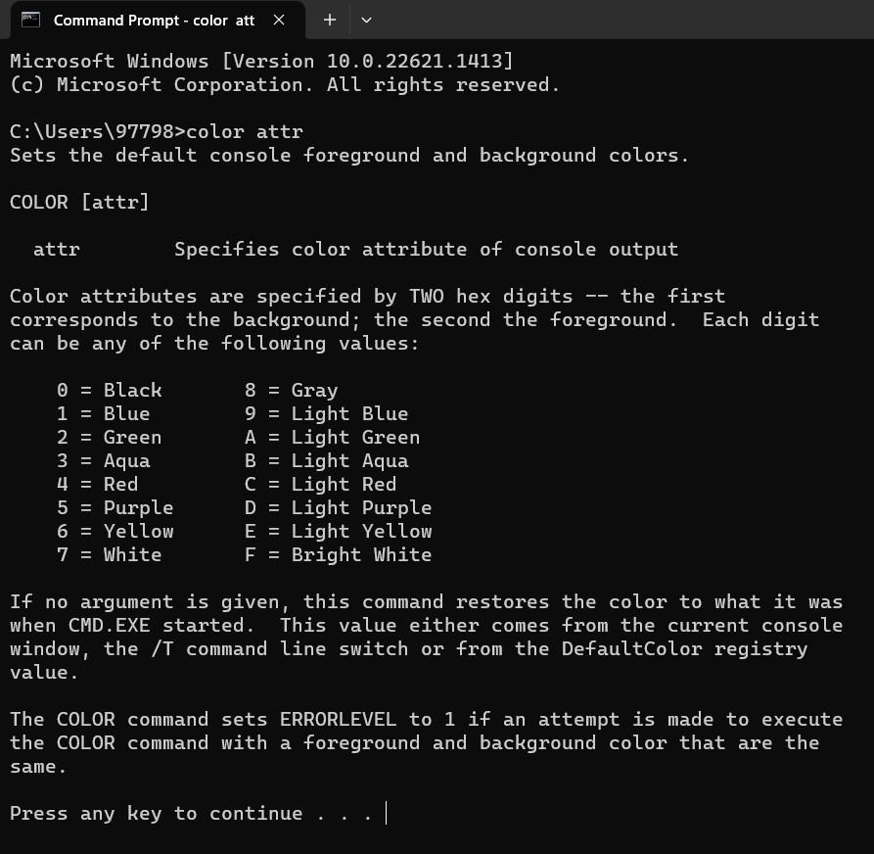

**8)TIME Command:** This is an internal command. This command is used to display or set the system time. For example, ***C:\Users\97798>Time.***

**Displays:**

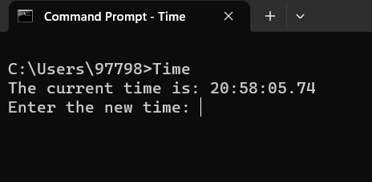

**9) REN or RENAME Command:** This is an internal command. This command is used to rename files and directories. For example, ***C:\Users\97798\Desktop>ren salin "hello".***

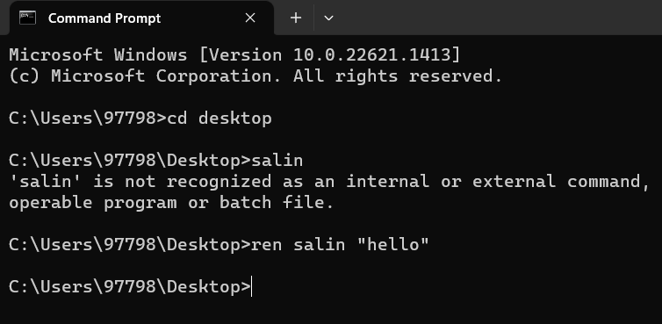

**Result:**

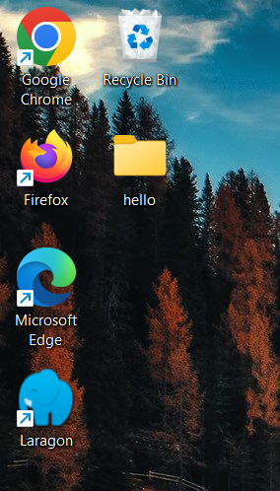

**10) ECHO Command:** Its primary purpose is to display text messages or variables on the screen or to redirect them to a file or device. For example, ***C:\Users\97798>echo how are you?***

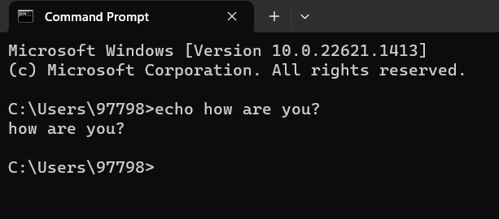

**11) DATE Command:** This is an internal command. This is used to display or set the system date. For example, ***C:\Users\97798>date.***

**Displays:**

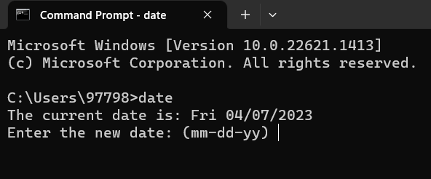

**12) RD** **or RDMIR Command:** This is an internal command. This command used to remove(delete) a directory. For example, ***C:\Users\97798\Desktop>rd hello***

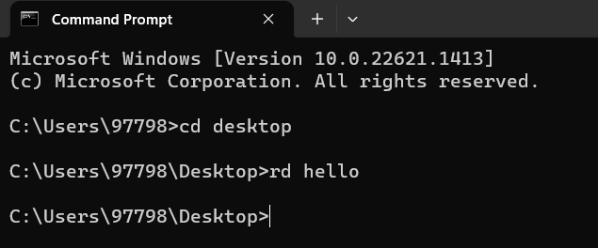

**Result:** Desktop hello folder has been removed

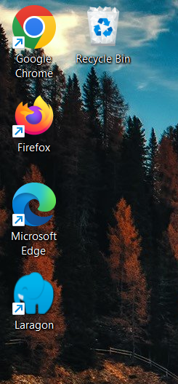

**13) IPCONFIGURATION Command:** The "ipconfig" command displays information such as the IP address, subnet mask, default gateway, DNS server, and other network settings for all active network adapters on the system. For example, ***C:\Users\97798>ipconfig***

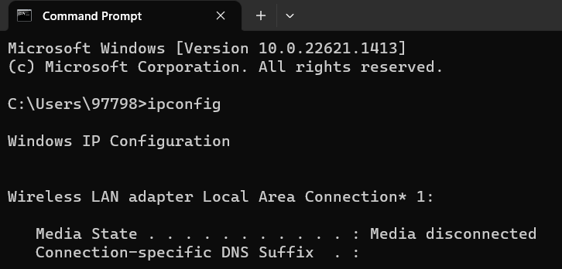

**14) VER Command:** This is an internal command. This command displays the windows version. For example, ***C:\Users\97798>ver.***

**Displays:**

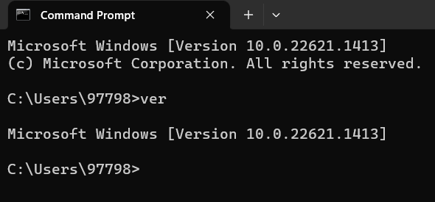

**15) COPY CON Command:** It is used to create new files. For example, ***C:\Users\97798\Desktop>copy con Hello.txt***

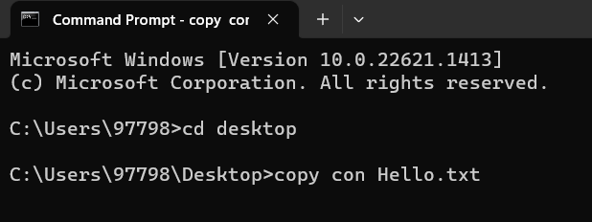

**Result:** New file has been created.



**Conclusion:**

DOS commands are still relevant today, especially for system administrators and advanced users who prefer to work with a command-line interface. These commands provide a powerful set of tools for managing and configuring the system, and can be used to perform a variety of tasks quickly and efficiently. By understanding the basic and advanced DOS commands, you can become more proficient in working with the command-line interface and achieve greater control over your system.