Jeremy Sklad
Sandheads wind data patching

Wind data is available for Sandheads CS (SH) (49°06'21.225" N, 123°18'12.123" W) in the Strait of Georgia all the way back to May, 1967. This file was available at '/ocean/sallen/allen/research/sog/sog-forcing/wind/SH_total.dat'. There are, however, large gaps and some interpolated sections of missing data in this file.

Table 1 lists all the gaps and interpolations in SH_total.dat that are longer than 12 hours. This table was generated using '/ocean/jsklad/Sandhead/SHwind_gapsxy.m' (most of the files used in this project are contained in this folder, '/ocean/jsklad/Sandhead/' unless otherwise stated). This file compares the difference between one value for both U and V components of wind with the next difference. If these differences are within 0.00001 of each other, with an ascending or descending trend for both U and V, then the section is marked as a gap. The end of the gap is marked when:

(~(abs(nextdiffu - prevdiffu) <= 0.00001) | ((uWind(i + 1) > uWind(i)) ~= (uWind(miStart + 1) > uWind(miStart)))) && (~(abs(nextdiffv - prevdiffv) <= 0.00001) | ((vWind(i + 1) > vWind(i)) ~= (vWind(miStart + 1) > vWind(miStart))))

Where uWind and vWind are the U and V wind values. prevdiff and nextdiff u and v are the difference between the current wind value at index i and the wind value at the previous/next index i, respectively. miStart is the index of the beginning of the gap or interpolation.

The list of the starting and ending days of these gaps is also contained in '/ocean/jsklad/Sandhead/mDatesTotalpm12.mat'. Most of the gaps are under two days, however some are as long as 70 or 80 days (December 1989 to February 1990 and January 2000 to April 2000).

In order to patch these gaps, wind data from nearby stations was acquired. Environment Canada data was available online for Entrance Island (EI) (49°13'00.000" N 123°48'00.000" W) from February 1994 until today. The rest of the data (from 1967 to 1994) was patched using winds from Vancouver International airport (YVR). The Environment Canada data was downloaded as monthly .cvs files and formatted. The formatting was done with '/ocean/jsklad/Sandhead/multiECconverter.m'.

For sections of data where all three data sets were available, the correlation between SH winds and the corresponding YVR and EI winds was determined. To adapt the YVR and EI data to match SH winds a linear correlation was chosen, combined with a square root function to bring the origins together; Y_fun = a.*x + b.*abs(x.^0.5). The coefficients a and b for this fit were chosen using '/ocean/jsklad/Sandhead/func.m', adapted from Susan Allen's code. See '/ocean/jsklad/Sandhead/SH_EI_correlation.m' and './SH_YV_correlation.m' for the fit. Figures 1-4 show this correlation.

Using this correlation the gaps in SH_total were patched with adjusted YVR and EI data. YVR data was used up to February 1994, EI data was used to patch the gaps from February 1994 and on. As Environment Canada data was imported, gaps in the imported data were interpolated linearly. North and East components of the wind were extracted, and the winds were rotated to produce Georgia Strait aligned U and V components of wind. These U and V components correspond to across- and along-Strait components of wind - V is along the Strait toward 305 degrees and U is across the Strait toward 35 degrees. Figures 5-8 are examples of this patching, done with './SHfilepatcher_total3.m'. For April 2006 to May 2010, Sandheads Environment Canada data was loaded directly into the new data set (after being formatted and rotated to be Strait-aligned). Two short sections of curvilinear interpolation in this new data were subsequently patched using './SHfilepatcher_end.m'.

A number of complicating issues arose throughout the project. The original patching was done with a simple linear correlation. This created an asymmetry in the patched data, since the patches were offset from the origin. This was corrected by adding the square root component to the fit. Another issue that arose was that patched sections were including one or two data points of original interpolated data (figure 9). This error was corrected by increasing the length of the gap sections, but some patches still included one data point of original interpolated data. At this point it was most efficient to manually correct for this error, replacing individual data points in the file, using './cind.m' to determine what the U and V values should have been for these points. Table 2 contains a list of the lines in the file that have been manually adjusted, and './SH_total_patchedJul22b.dat' is the original file before manual manipulation. Another issue was uncertainty over what to do with periods of zero wind that were being patched as though they were interpolated sections. In the end I left the data with some patching, as was returned by the algorithm. Since windspeed cubed is what matters, it makes little difference whether a section is low wind or zero wind, and all the patched zero wind sections still maintained low winds (figure 10).

The final patched file is available at '/ocean/jsklad/Sandhead/SH_patchedJul22c.dat'. The columns are formatted [ day, month, year, hour, wind U (m/s), wind V (m/s) ] to match the formatting of the original SH_total.dat file.

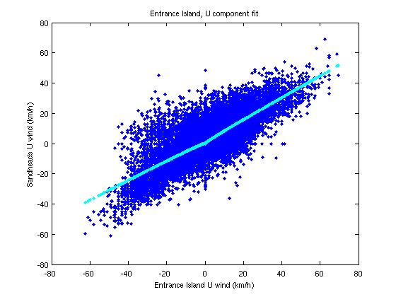
Figure 1 – Entrance Island, U component fit
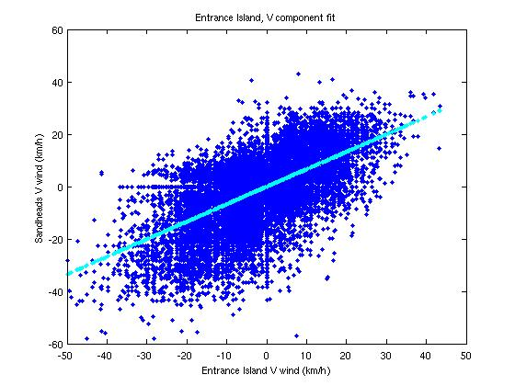
Figure 2 – Entrance Island, V component fit
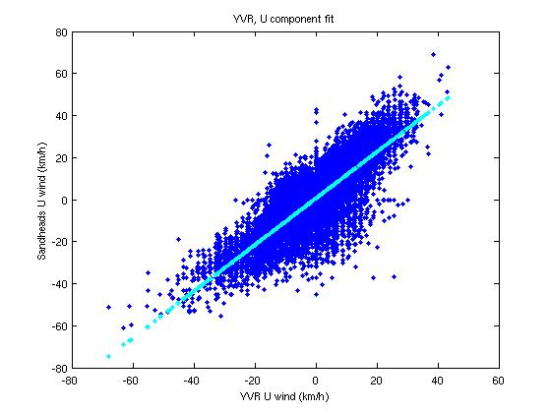
Figure 3 – YVR International, U component fit
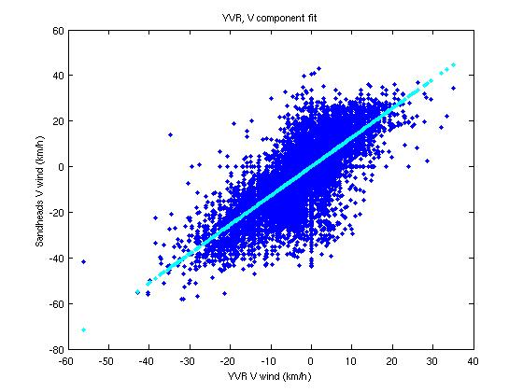
Figure 4 – YVR International, V component fit
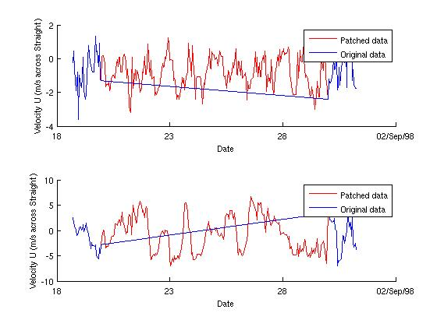
Figure 5 – An example of a patched section
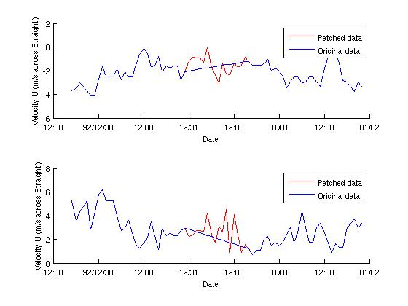
Figure 6 – An example of a patched section
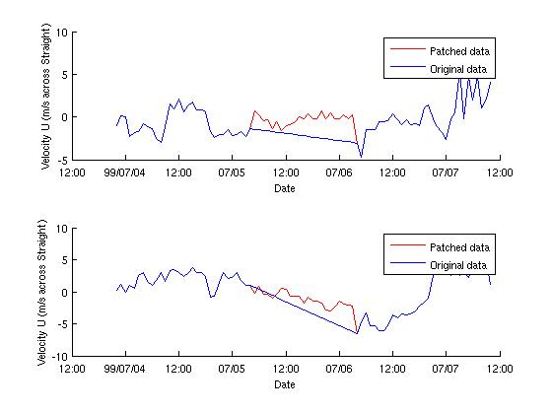
Figure 7 – An example of a patched section
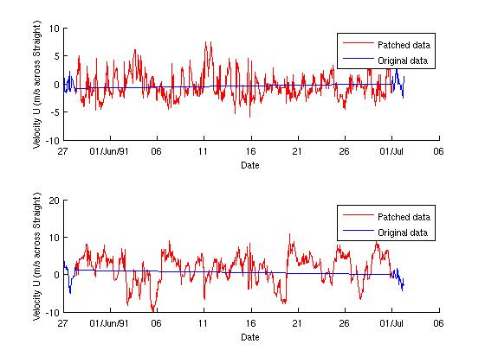
Figure 8 – An example of a patched section
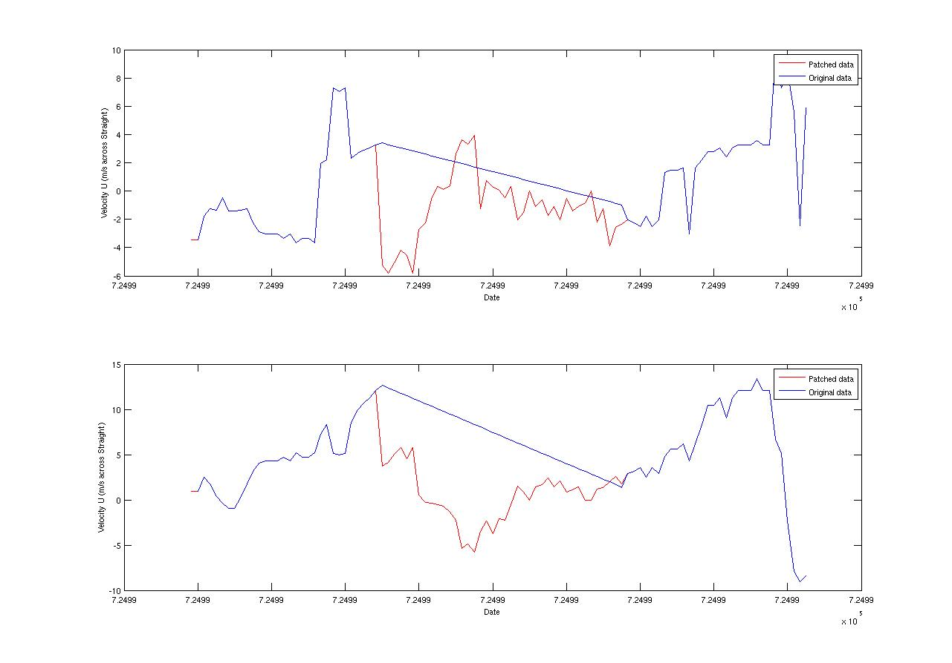
Figure 9 – Error in patching
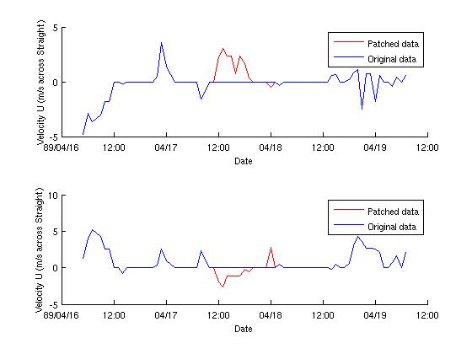
Figure 10 – Section of low or zero wind

Table 1 – Gaps in Sandhead data (SH_total.dat)
Start of gap | End of gap | Gap length (days)
06-Feb-1968 02:00:00 | 07-Feb-1968 00:00:00 | 0.92
03-Nov-1970 17:00:00 | 04-Nov-1970 08:00:00 | 0.62
26-Oct-1971 01:00:00 | 31-Oct-1971 08:00:00 | 5.29
08-Aug-1973 10:00:00 | 09-Aug-1973 08:00:00 | 0.92
11-Aug-1973 09:00:00 | 12-Aug-1973 09:00:00 | 1
13-Jul-1976 15:00:00 | 14-Jul-1976 07:00:00 | 0.67
14-Jul-1976 10:00:00 | 15-Jul-1976 08:00:00 | 0.92
02-Aug-1976 02:00:00 | 03-Aug-1976 00:00:00 | 0.92
30-Sep-1978 10:00:00 | 01-Oct-1978 08:00:00 | 0.92
30-Jul-1979 00:00:00 | 01-Aug-1979 08:00:00 | 2.33
01-Aug-1979 11:00:00 | 11-Aug-1979 04:00:00 | 9.71
11-Aug-1979 07:00:00 | 12-Aug-1979 11:00:00 | 1.17
12-Aug-1979 14:00:00 | 15-Aug-1979 11:00:00 | 2.88
15-Aug-1979 14:00:00 | 24-Aug-1979 08:00:00 | 8.75
20-Dec-1979 10:00:00 | 20-Dec-1979 22:00:00 | 0.5
30-Apr-1980 15:00:00 | 01-May-1980 15:00:00 | 1
04-May-1980 04:00:00 | 12-May-1980 11:00:00 | 8.29
01-Nov-1982 01:00:00 | 01-Dec-1982 00:00:00 | 29.96
29-Oct-1984 20:00:00 | 30-Oct-1984 08:00:00 | 0.5
11-Dec-1984 20:00:00 | 13-Dec-1984 08:00:00 | 1.5
16-Dec-1984 09:00:00 | 17-Dec-1984 15:00:00 | 1.25
17-Apr-1985 01:00:00 | 18-Apr-1985 00:00:00 | 0.96
25-Jun-1985 06:00:00 | 25-Jun-1985 18:00:00 | 0.5
07-Jul-1985 09:00:00 | 07-Jul-1985 23:00:00 | 0.58
09-Jan-1986 00:00:00 | 11-Jan-1986 21:00:00 | 2.88
12-Jan-1986 00:00:00 | 13-Jan-1986 05:00:00 | 1.21
13-Jan-1986 08:00:00 | 14-Jan-1986 14:00:00 | 1.25
14-Nov-1986 02:00:00 | 15-Nov-1986 00:00:00 | 0.92
07-Sep-1987 07:00:00 | 08-Sep-1987 07:00:00 | 1
27-Sep-1987 04:00:00 | 28-Sep-1987 05:00:00 | 1.04
01-Oct-1987 01:00:00 | 01-Nov-1987 00:00:00 | 30.96
01-Sep-1988 01:00:00 | 01-Oct-1988 08:00:00 | 30.29
21-Dec-1988 13:00:00 | 04-Jan-1989 15:00:00 | 14.08
17-Apr-1989 12:00:00 | 18-Apr-1989 00:00:00 | 0.5
10-Aug-1989 14:00:00 | 29-Aug-1989 11:00:00 | 18.88
12-Dec-1989 10:00:00 | 22-Feb-1990 10:00:00 | 72
03-May-1990 22:00:00 | 05-May-1990 05:00:00 | 1.29
28-May-1991 09:00:00 | 30-Jun-1991 23:00:00 | 33.58
31-Dec-1992 00:00:00 | 31-Dec-1992 15:00:00 | 0.62
10-Mar-1993 12:00:00 | 12-Mar-1993 10:00:00 | 1.92
28-Jul-1994 17:00:00 | 29-Jul-1994 13:00:00 | 0.83
14-Jul-1995 15:00:00 | 15-Jul-1995 08:00:00 | 0.71
10-Mar-1996 09:00:00 | 11-Mar-1996 02:00:00 | 0.71
06-Aug-1997 13:00:00 | 07-Aug-1997 06:00:00 | 0.71
29-Apr-1998 04:00:00 | 30-Apr-1998 02:00:00 | 0.92
20-Aug-1998 00:00:00 | 29-Aug-1998 23:00:00 | 9.96
05-Jul-1999 05:00:00 | 06-Jul-1999 03:00:00 | 0.92
21-Oct-1999 13:00:00 | 22-Oct-1999 12:00:00 | 0.96
22-Oct-1999 19:00:00 | 25-Oct-1999 03:00:00 | 2.33
25-Oct-1999 21:00:00 | 26-Oct-1999 12:00:00 | 0.62
27-Oct-1999 11:00:00 | 28-Oct-1999 01:00:00 | 0.58
28-Oct-1999 08:00:00 | 18-Nov-1999 13:00:00 | 21.21
09-Dec-1999 16:00:00 | 10-Dec-1999 05:00:00 | 0.54
16-Jan-2000 17:00:00 | 05-Apr-2000 10:00:00 | 79.71
17-May-2000 11:00:00 | 04-Jun-2000 18:00:00 | 18.29
04-Jun-2000 21:00:00 | 06-Jun-2000 11:00:00 | 1.58
06-Jun-2000 14:00:00 | 07-Jun-2000 10:00:00 | 0.83
15-Jun-2000 17:00:00 | 16-Jun-2000 05:00:00 | 0.5
31-Mar-2003 09:00:00 | 01-Apr-2003 14:00:00 | 1.21
06-Jul-2004 13:00:00 | 09-Jul-2004 11:00:00 | 2.92

Table 2 – Manual corrections
Line number
6745
100089
107410
107646
107677
107749
110793
195301
252992
284780
290173

