Name- Salita Dbritto

Roll no- A010

SAP ID- 86062300036

CLOUD COMPUTING PRACTICAL-1 [EC2]

**### WITHOUT PUTTY ###**

Go to AWS Management Console and sign in into your account.

Navigate to EC2 dashboard and go to instances.

Click on "Launch Instance"

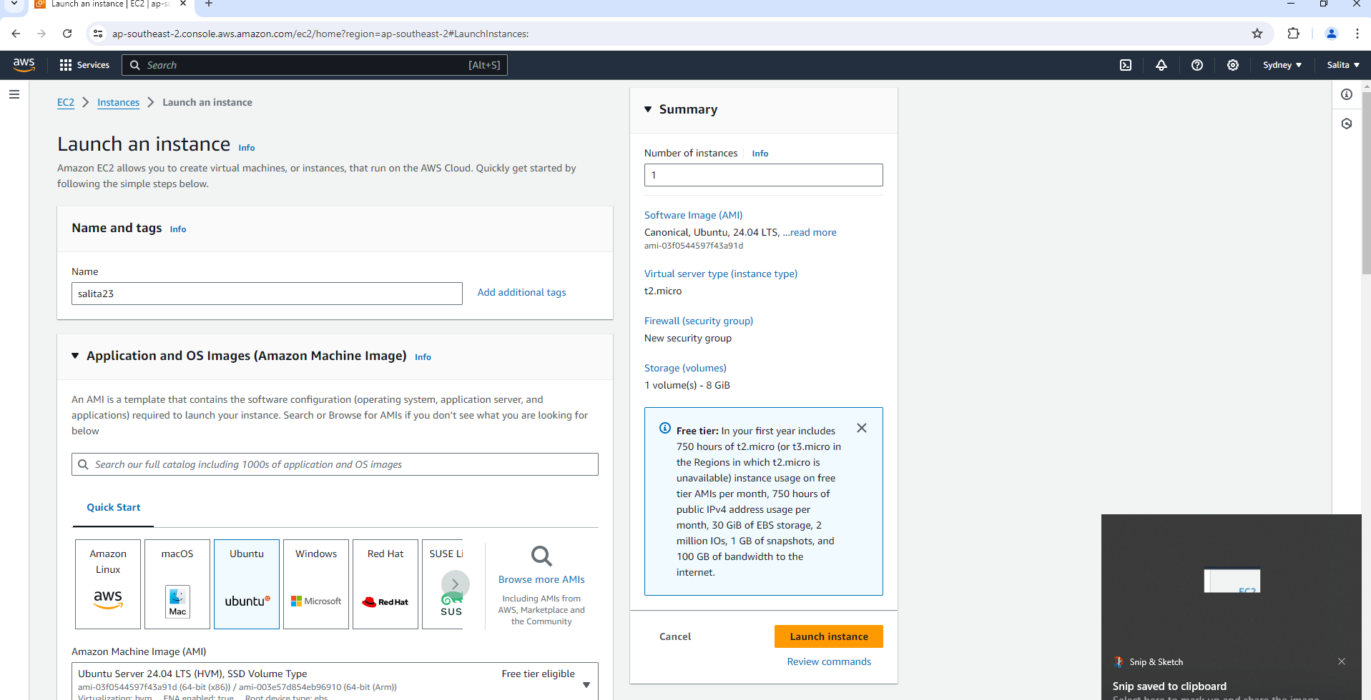

**Choose AMI-** Select "Amazon Machine Image (AMI)" -ubuntu

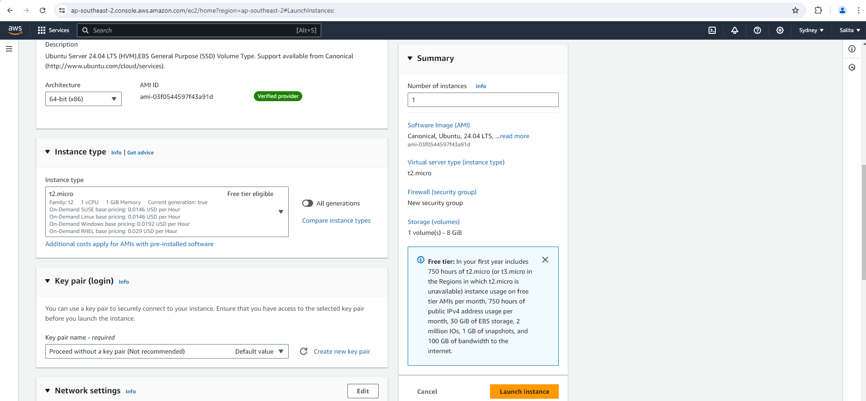

Select allow SSH traffic in network settings.

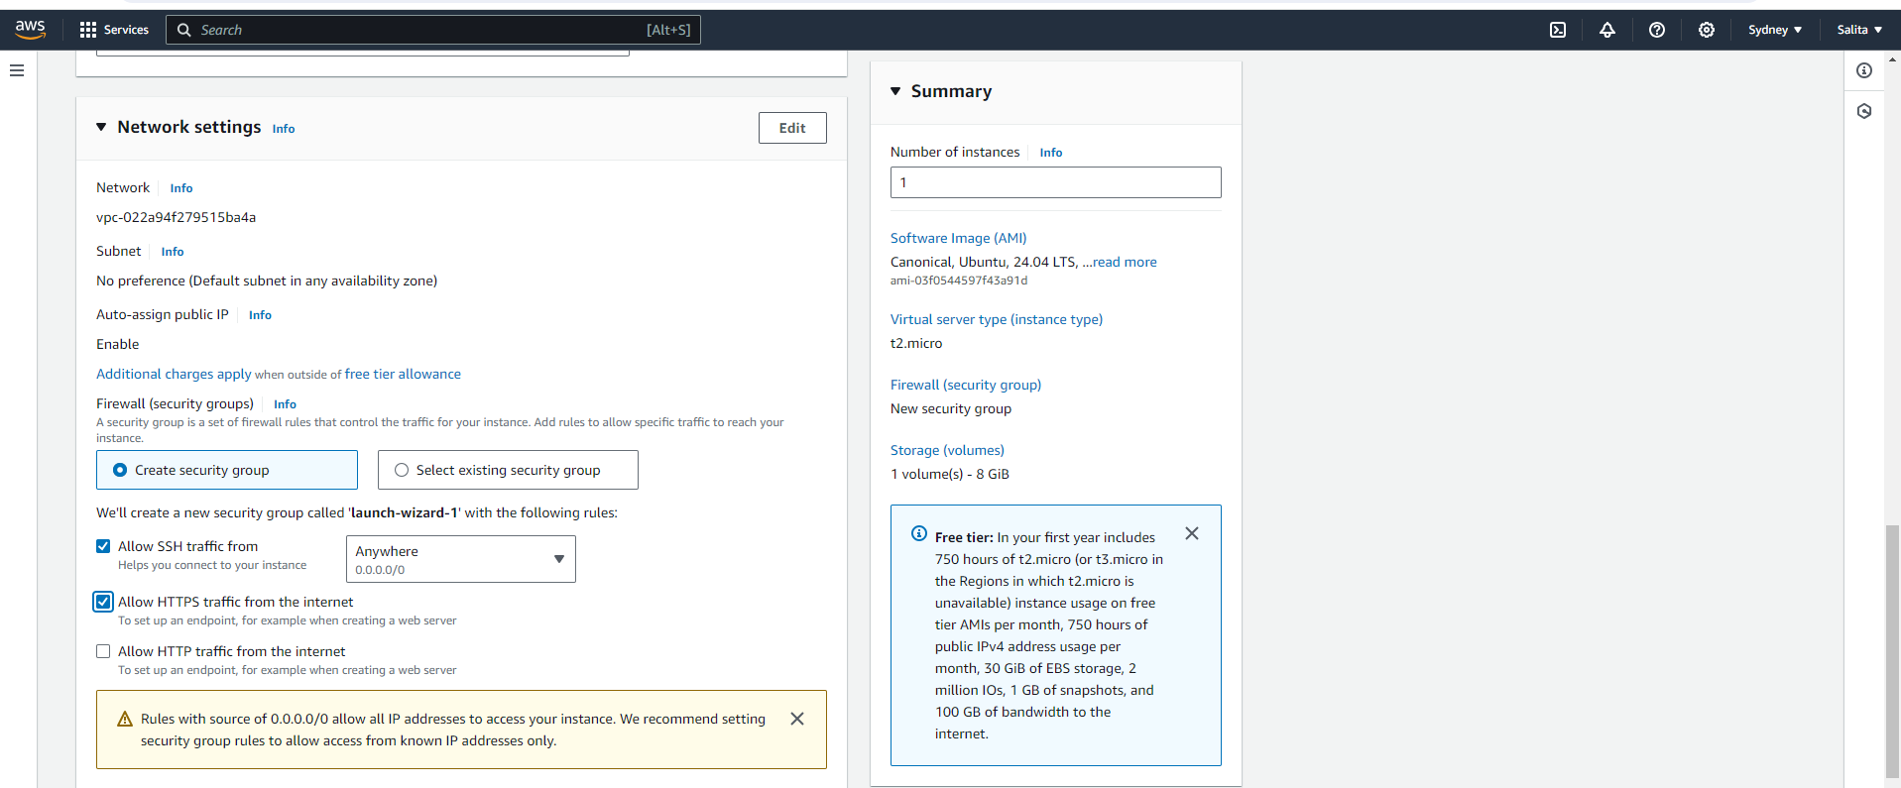

Click on "Launch" if everything looks good

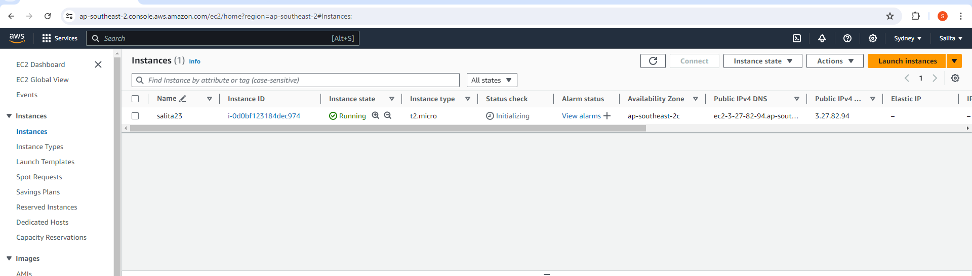

Click on "Launch" if everything looks good

 Once the instance is running, go to the EC2 dashboard and select "Instances" from the left-hand menu.

 Select the instance you just launched.

Click on the "Connect" button at the top of the screen. Use EC2 connect

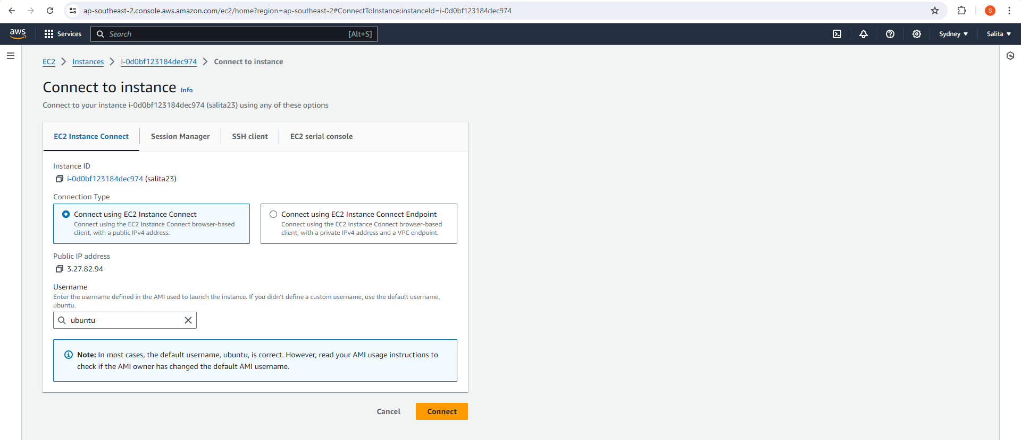

CONNECTED

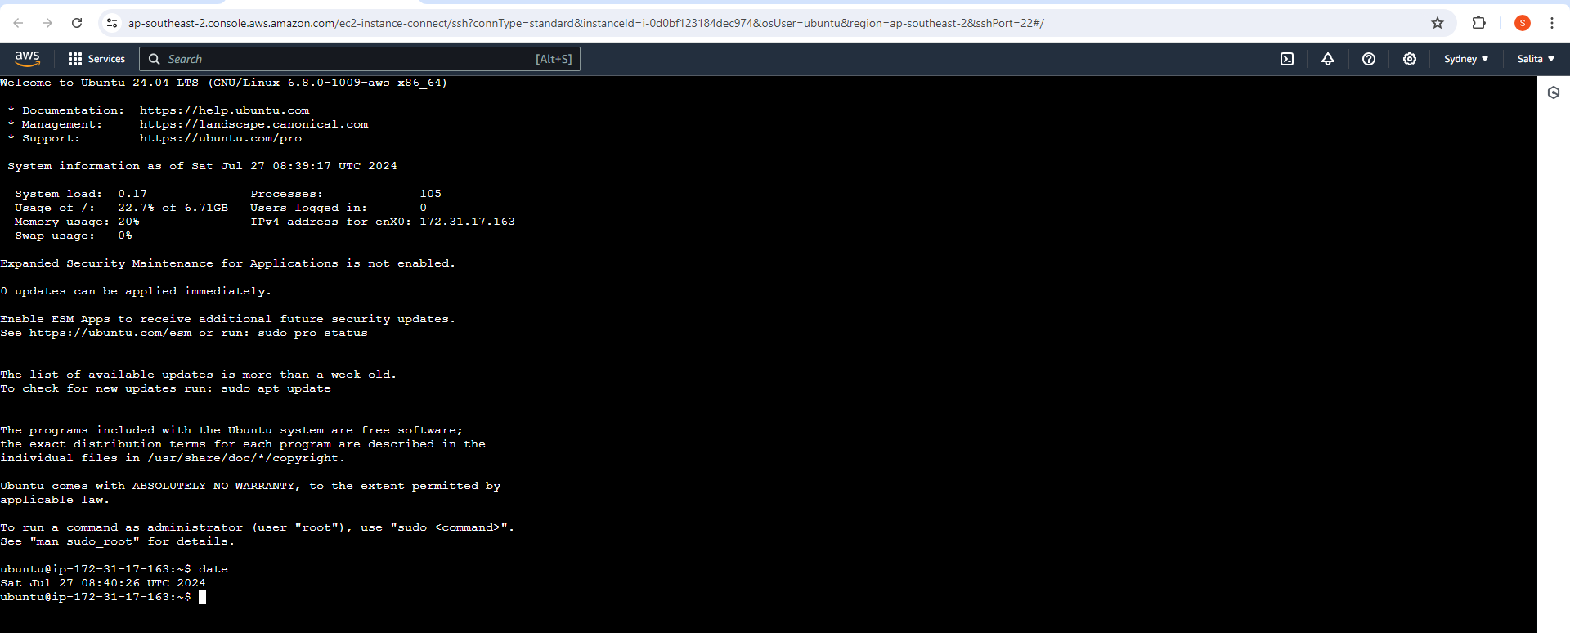

In the EC2 dashboard, click on "Instances" in the left-hand menu to see a list of your running instances.

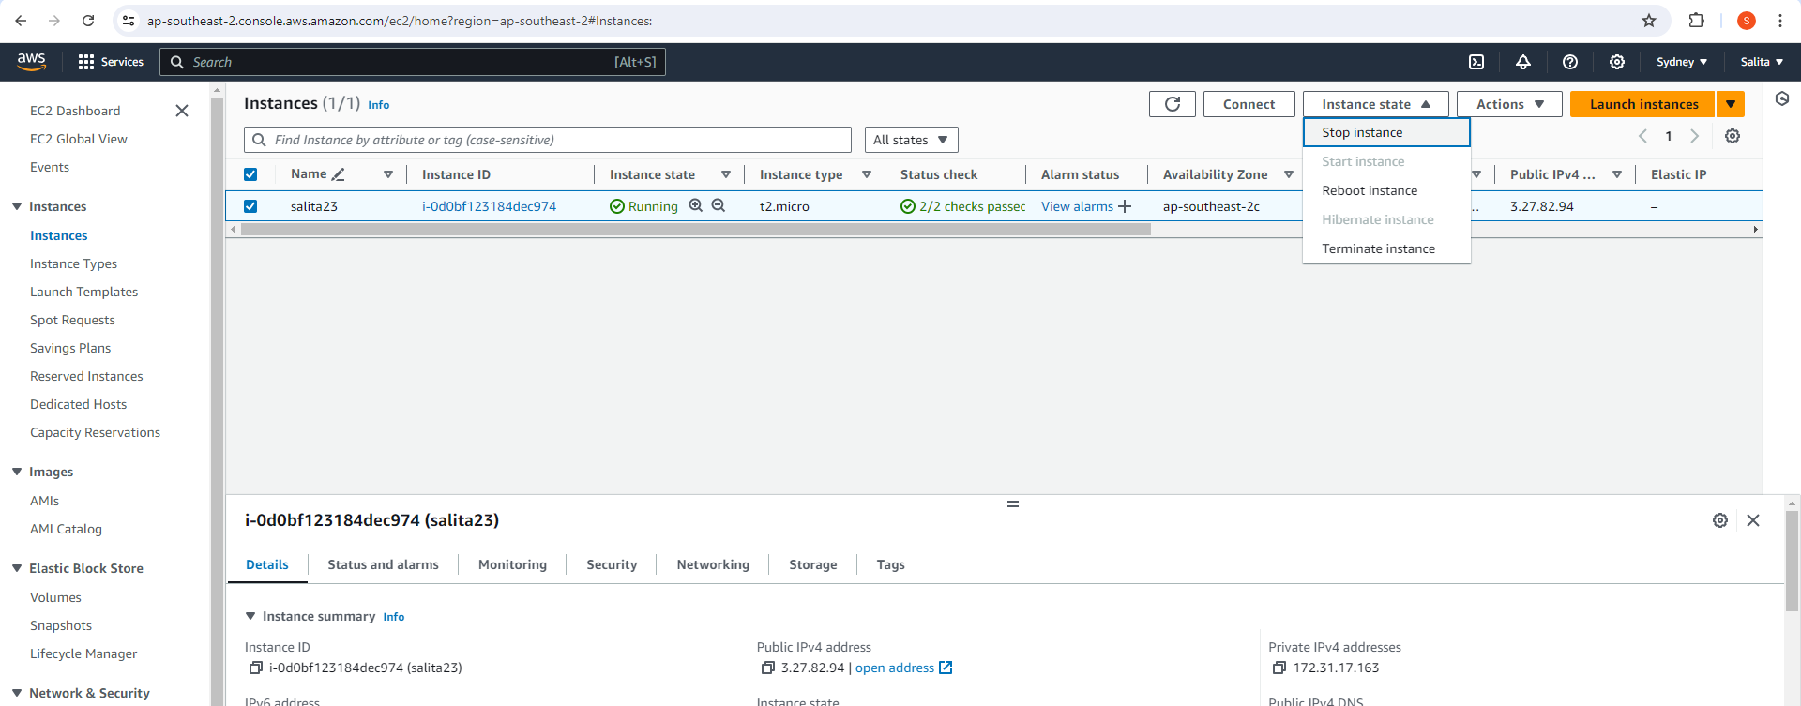

With the instance selected, click on the "Instance State" dropdown menu at the top of the screen.

Select "Stop Instance" from the dropdown options.

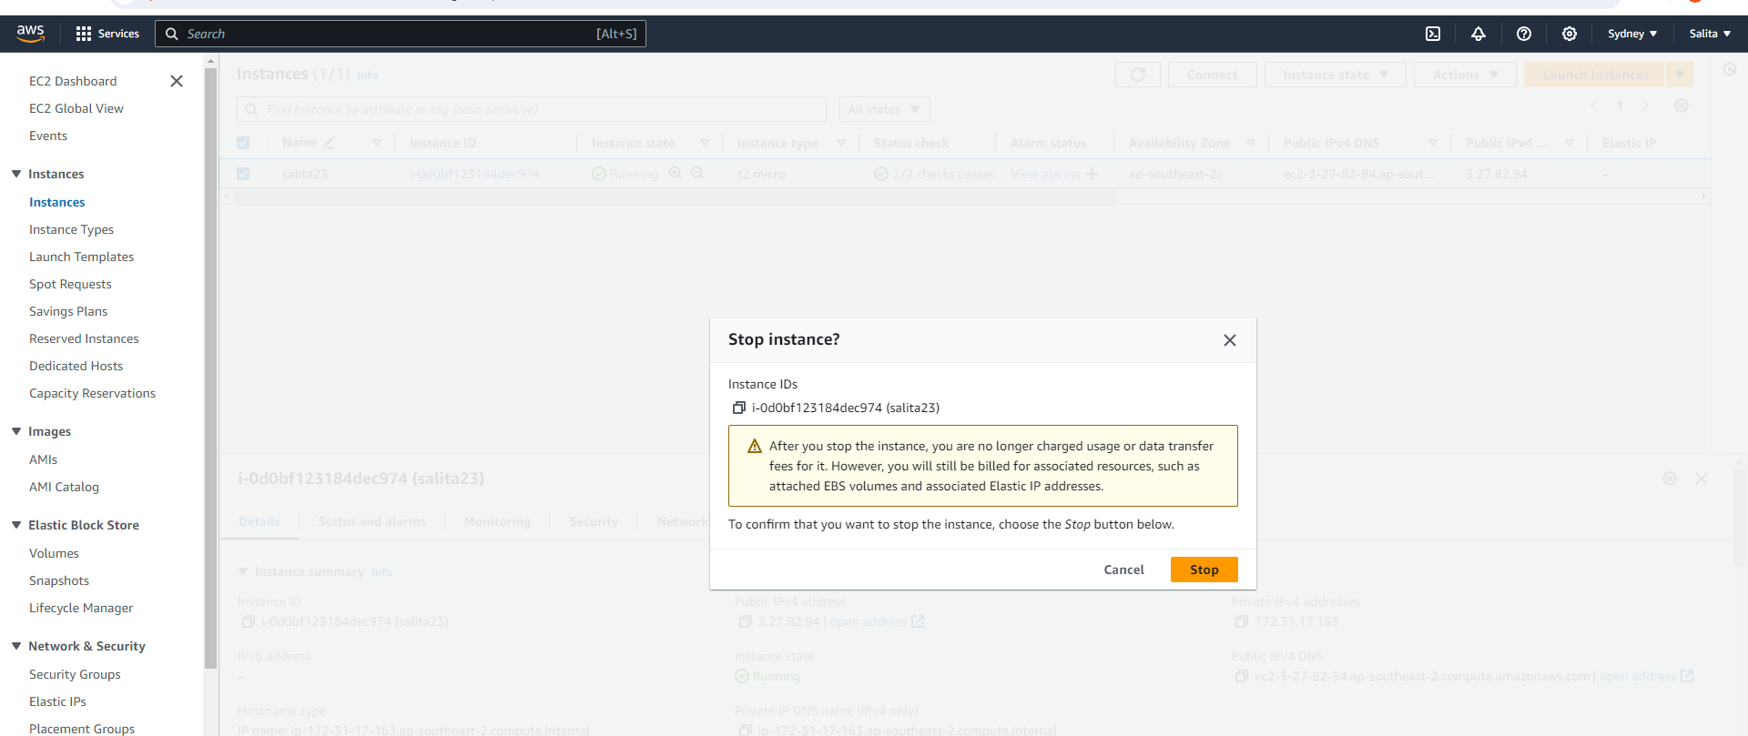

The instance is STOPPED.

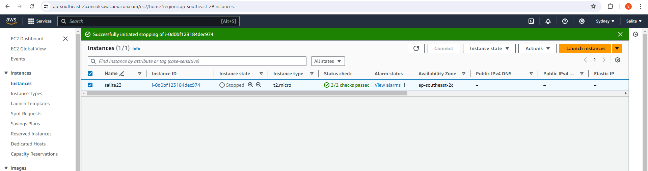

--------------------------------------------------------------------------------------------------------------------------------------

**### WITH PUTTY ###**

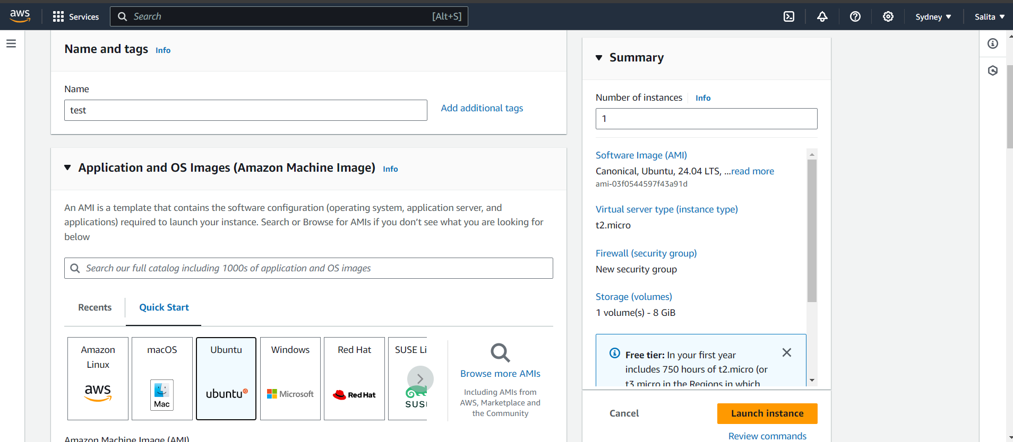

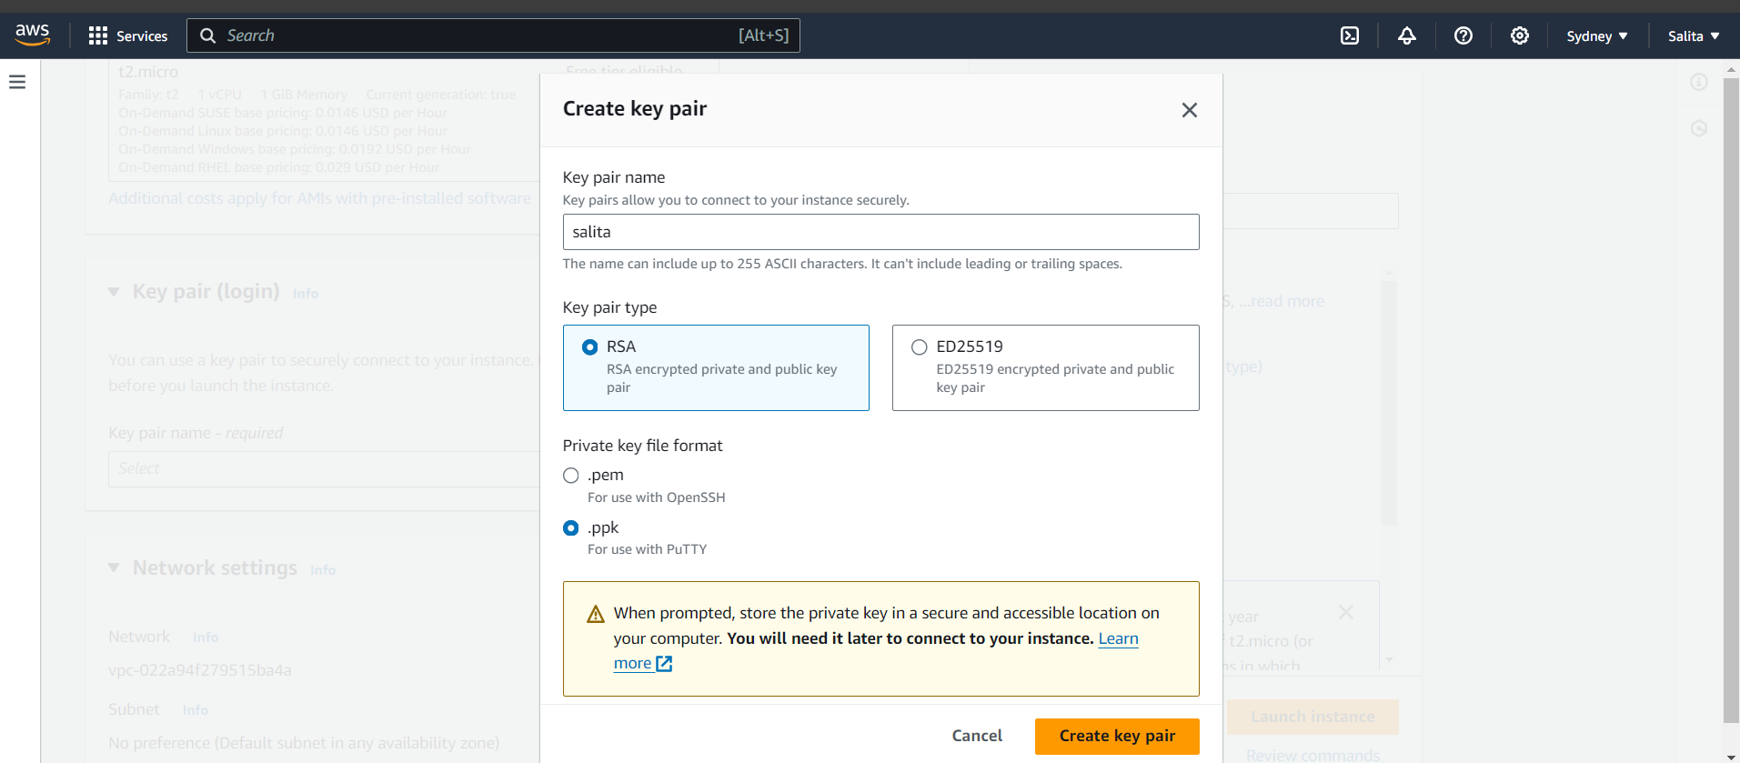

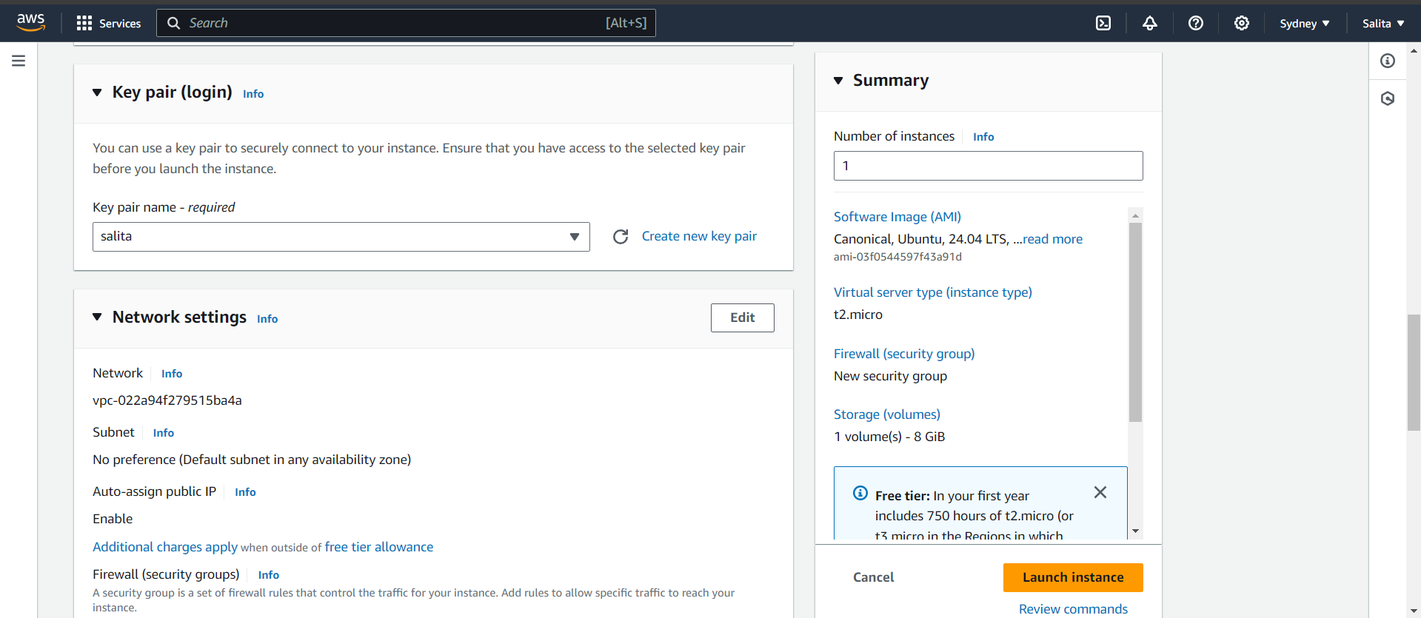

Create a new instance and download the key pair in .ppk format for putty.

Download putty (exe file)

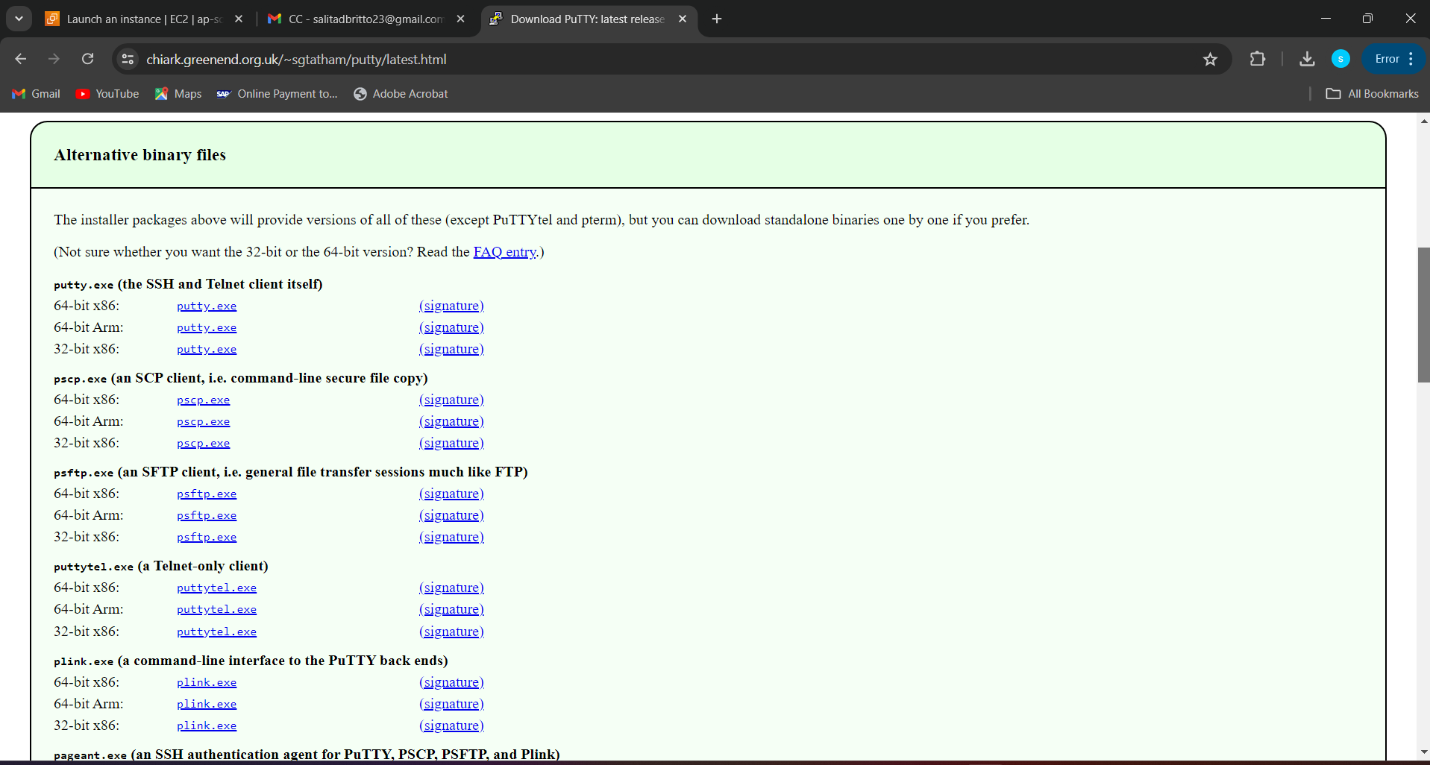

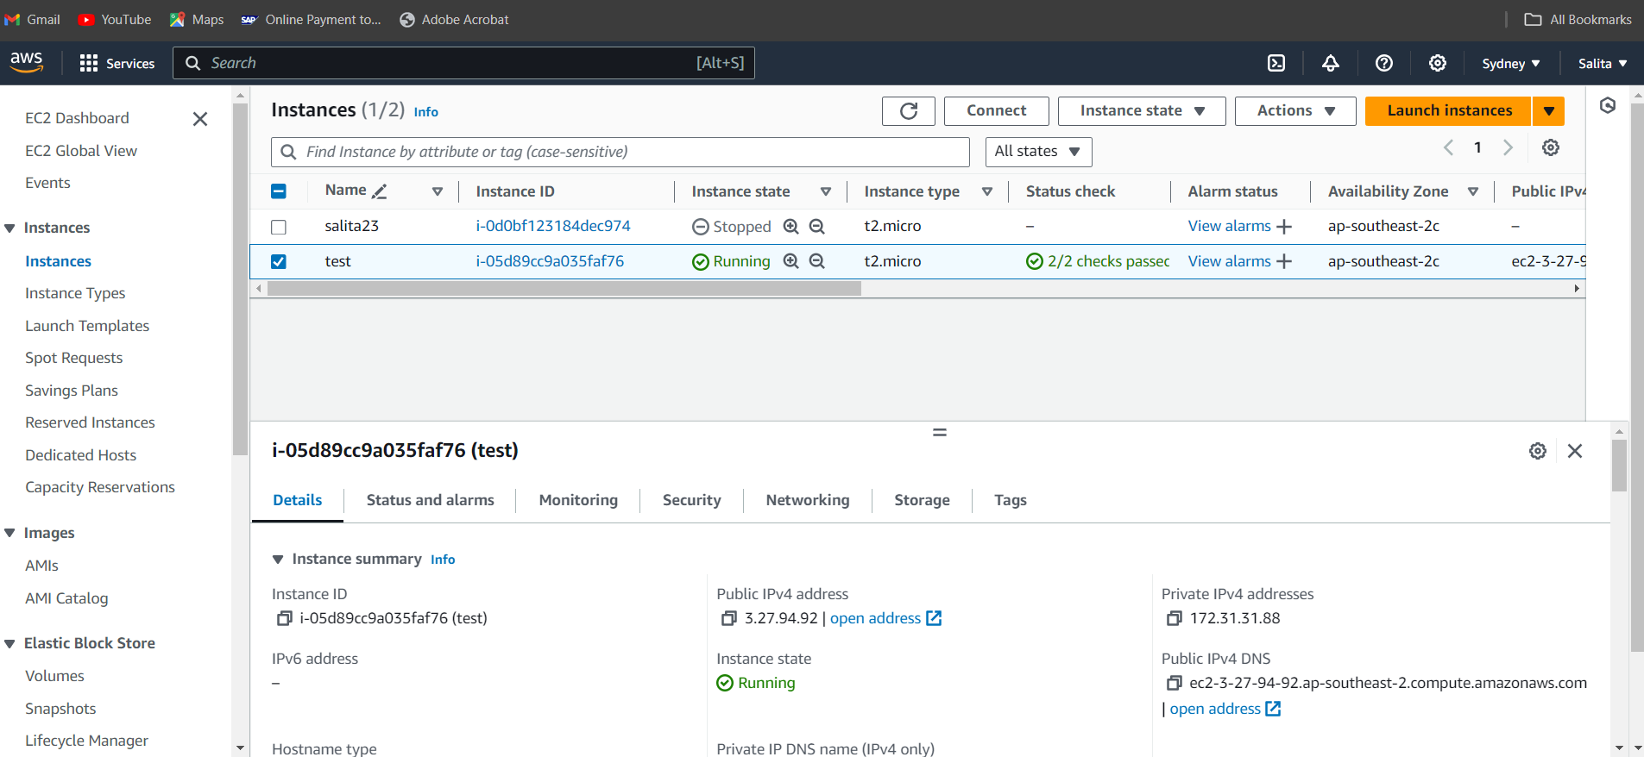

Create and connect to your instance. (Using ec2 connect)

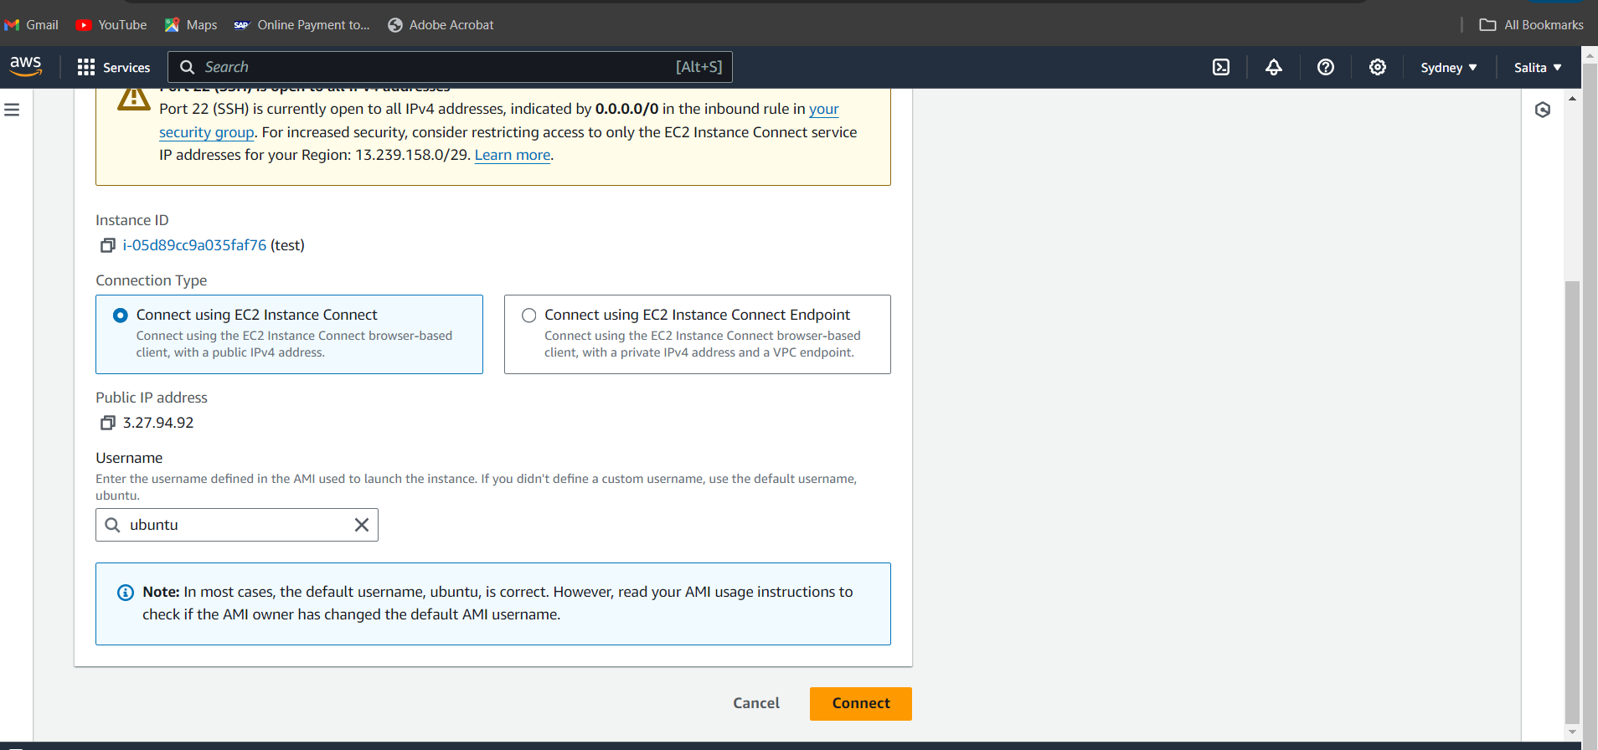

Executing the Linux commands.

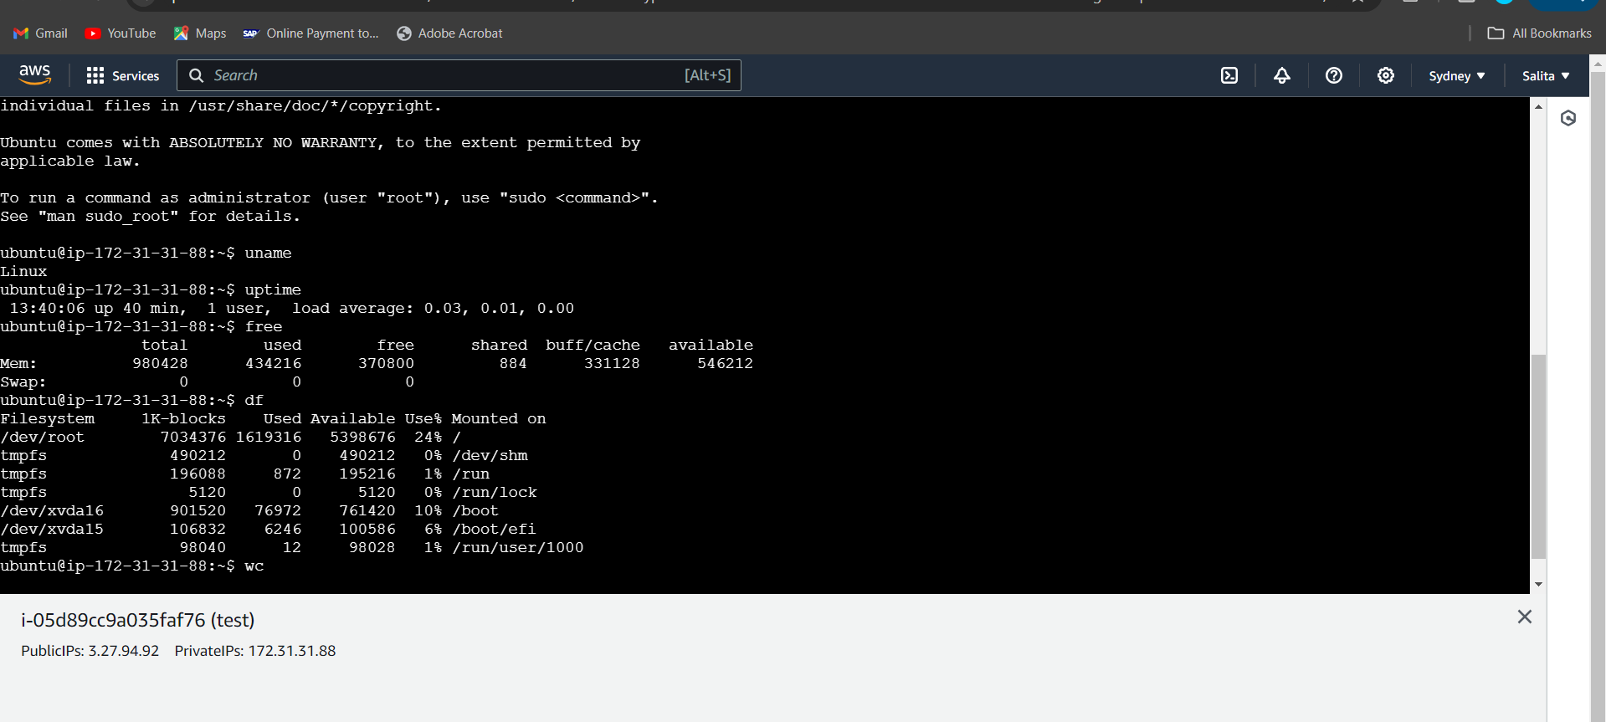

Go to instance id.

Copy the Public IPv4 address.

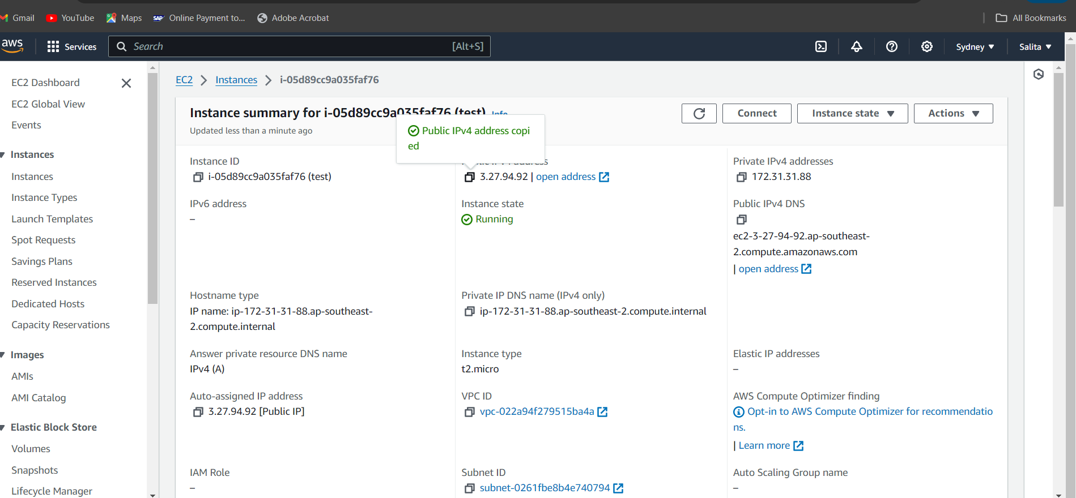

**Configure PuTTY Session:**

* In the "Host Name (or IP address)" field, enter the public DNS or IP address of your EC2 instance.
* In the "Category" section on the left, navigate to Connection > SSH > Auth > Credentials.
* Click on "Browse" and select the .ppk file you saved earlier.

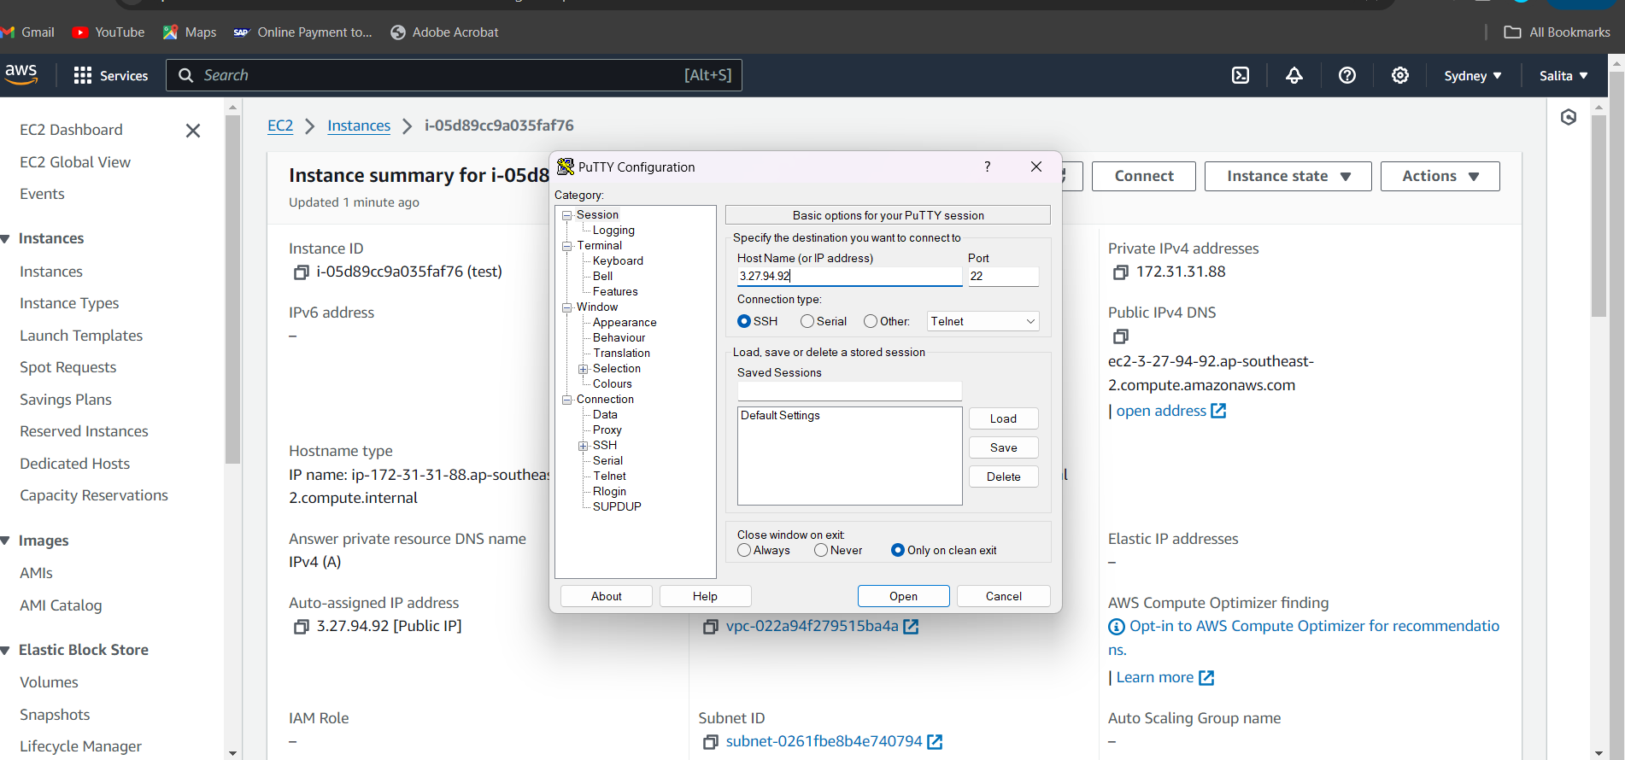

Upload private key and Open.

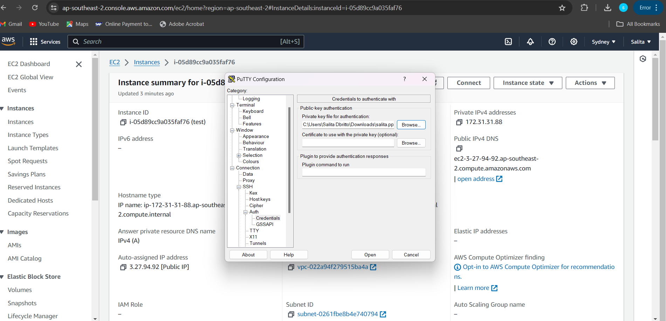

Select "Stop Instance" from the dropdown options.

The instance is STOPPED.

