Name- Salita Dbritto

Roll no- A010

SAP ID- 86062300036

CLOUD COMPUTING PRACTICAL-2 [S3]

In the AWS Management Console, type “S3” in the search bar and select “S3” from the dropdown.

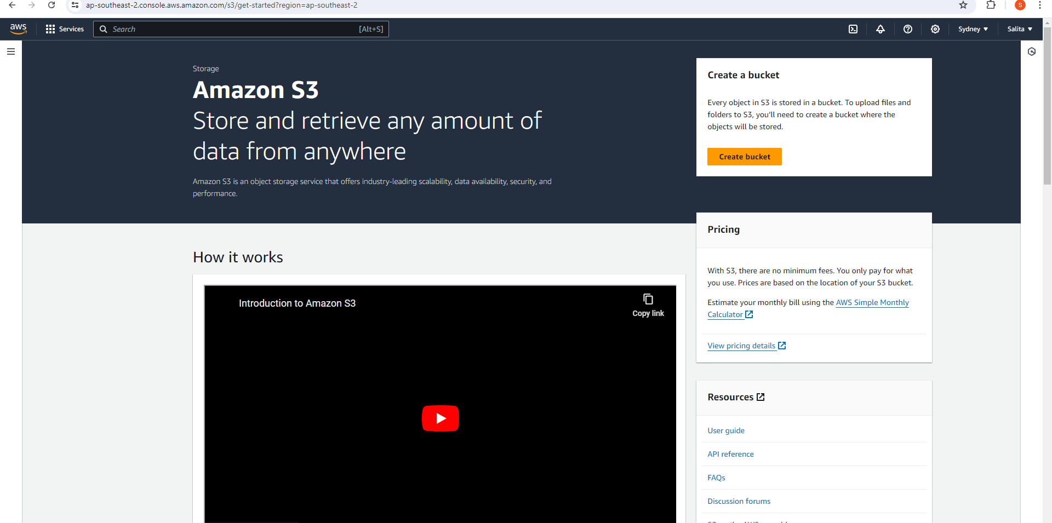

To create a new bucket, click on the “Create bucket” button.

* **Bucket Name**: Enter a globally unique name for your bucket.

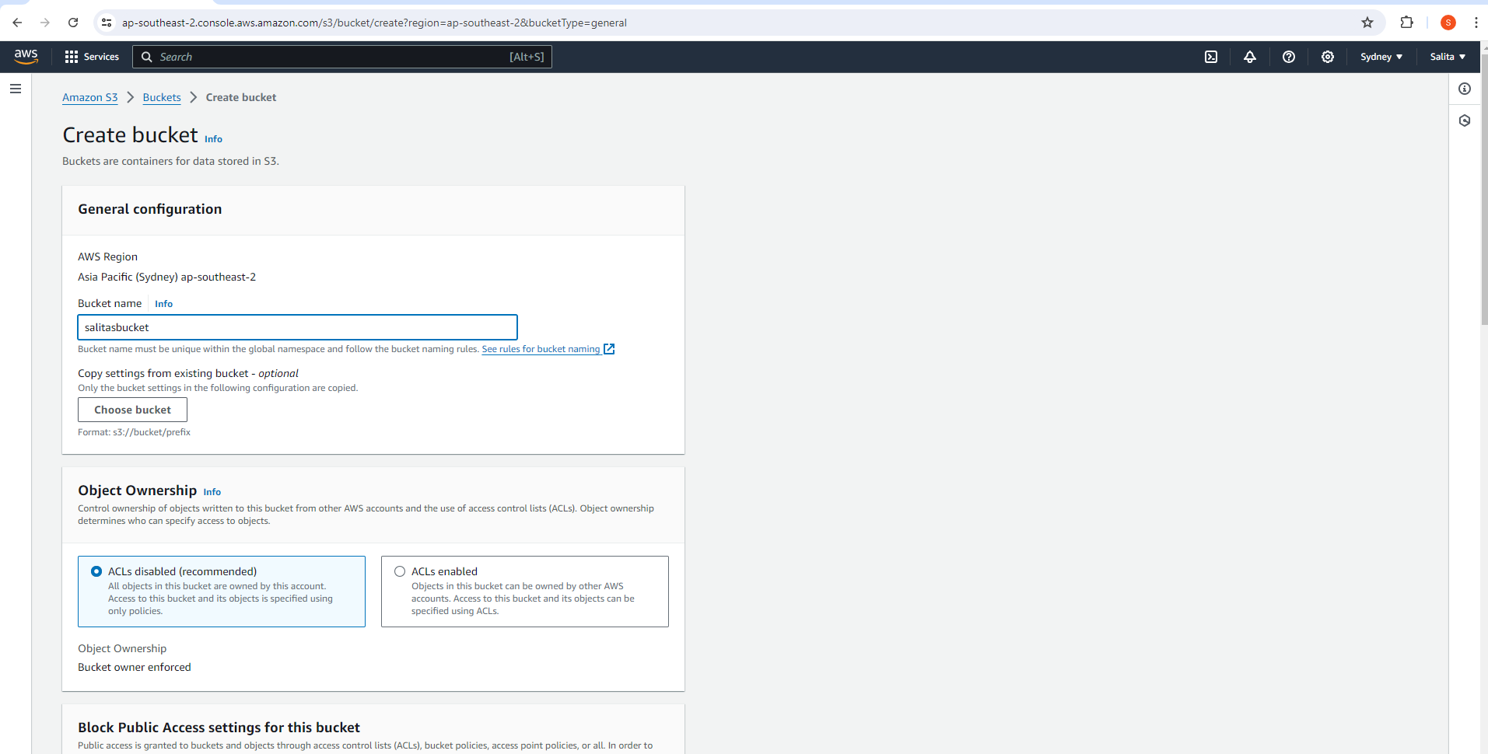

Block public access, disable versioning and bucket key.

Click on “Create bucket” at the bottom.

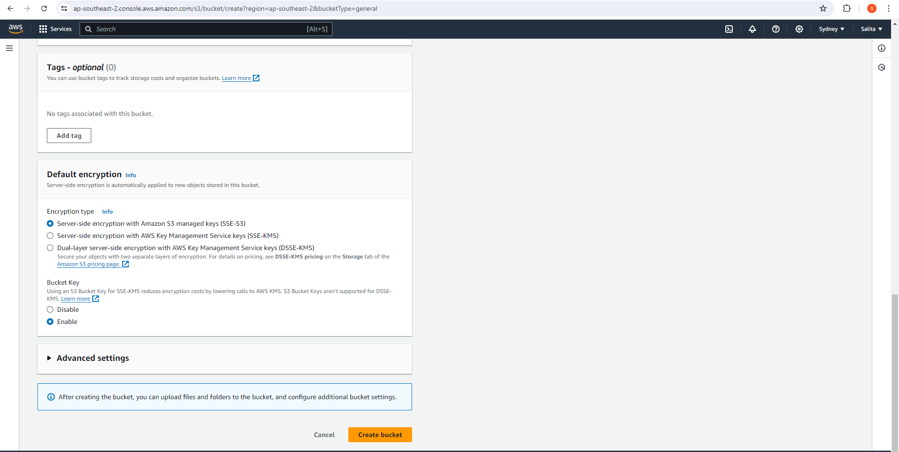

Bucket is created.

•  Go to the **Objects** tab in your bucket.

•  Click on the “Upload” button.

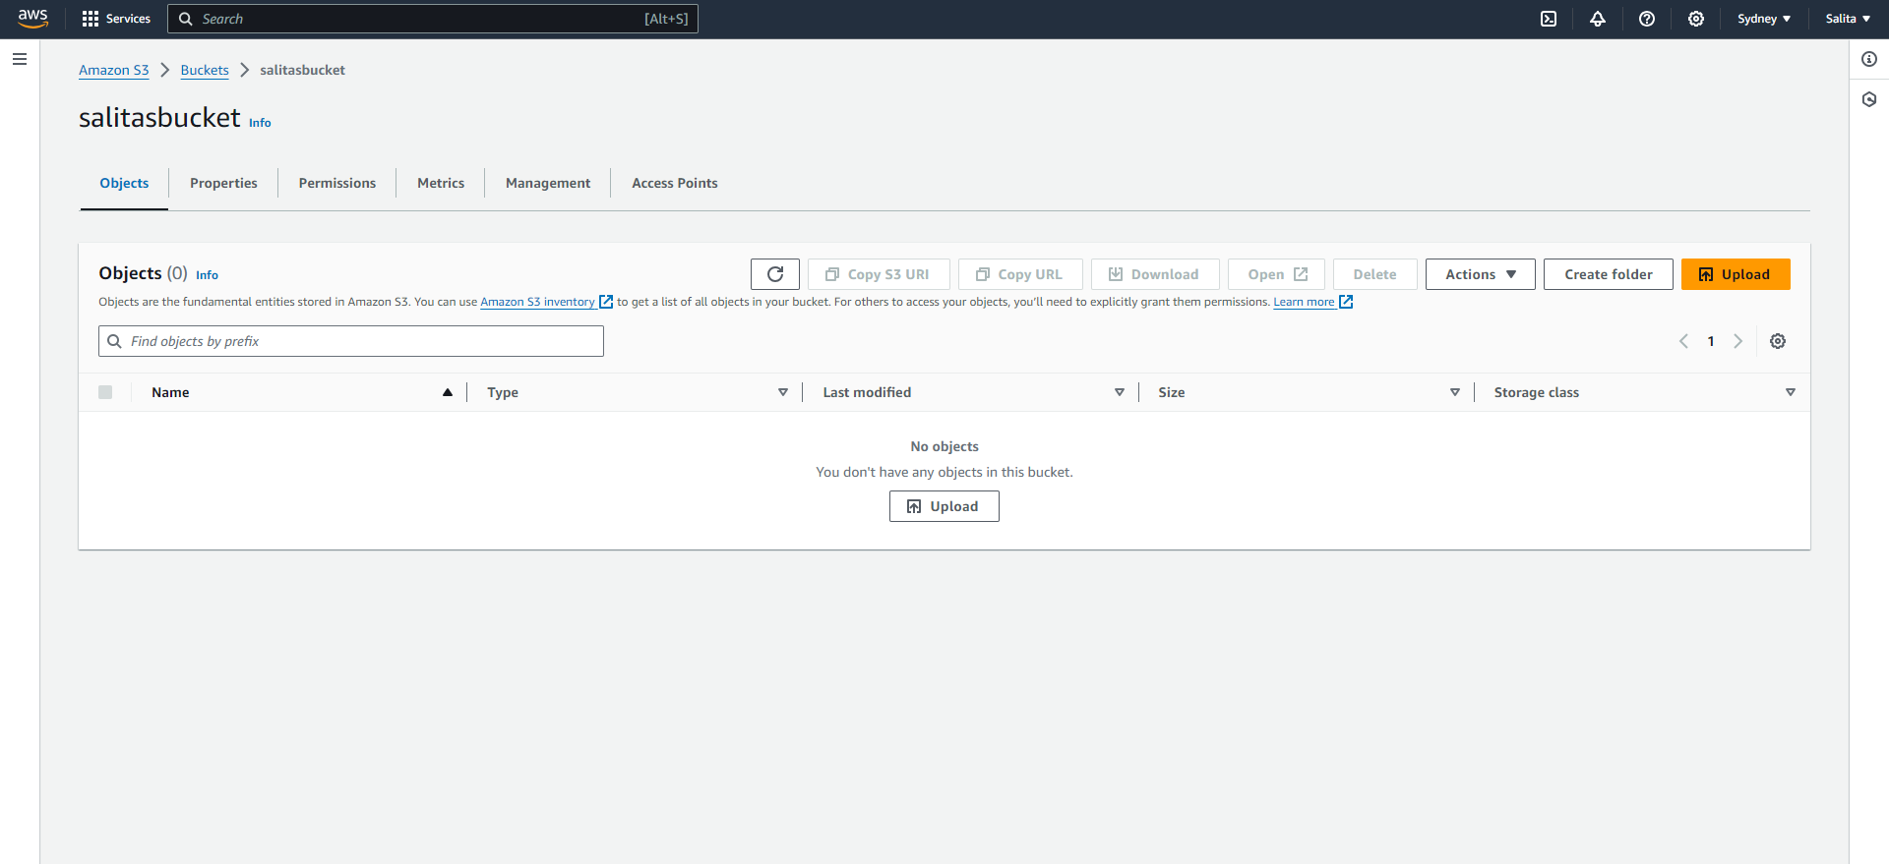

•  Drag and drop your file or use the “Add files” button to select it.

•  Click on “Upload” to start the upload process.

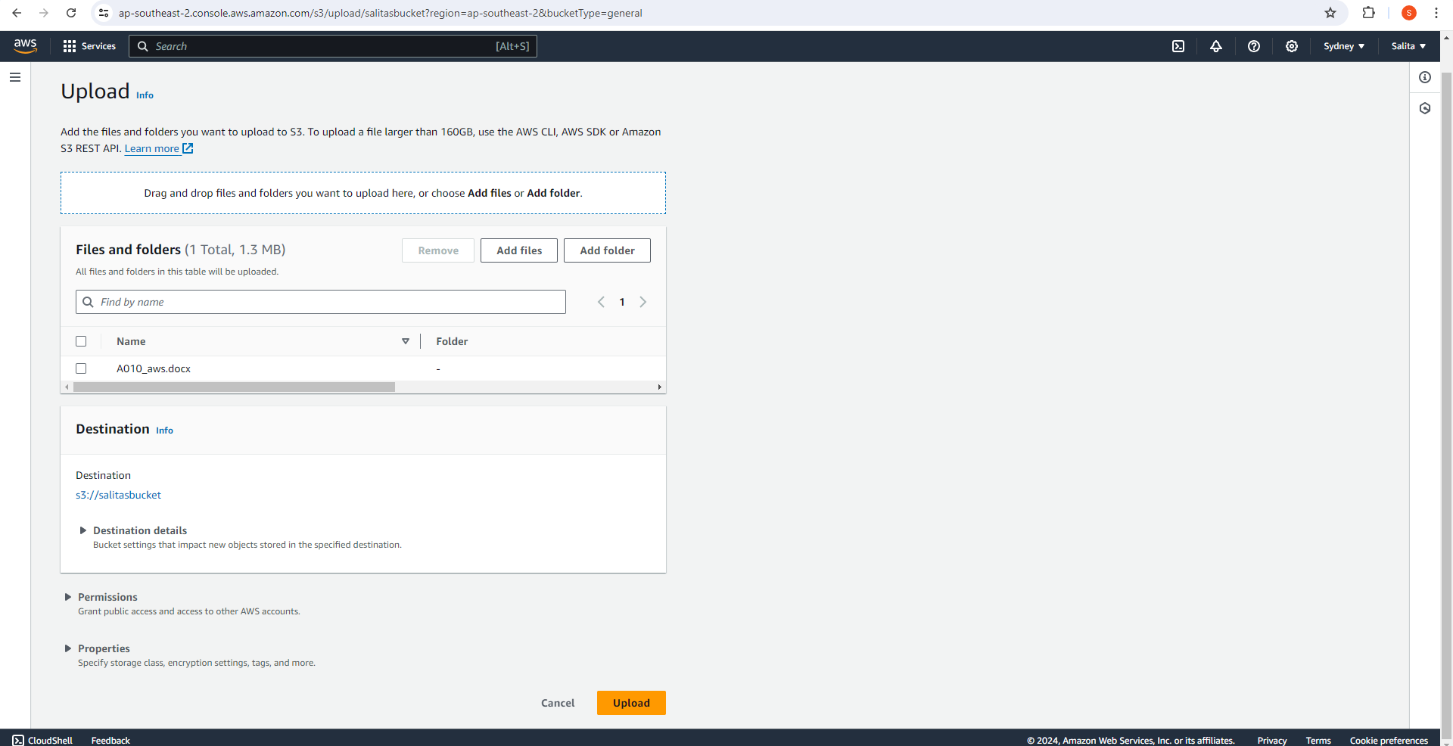

Upload successful.

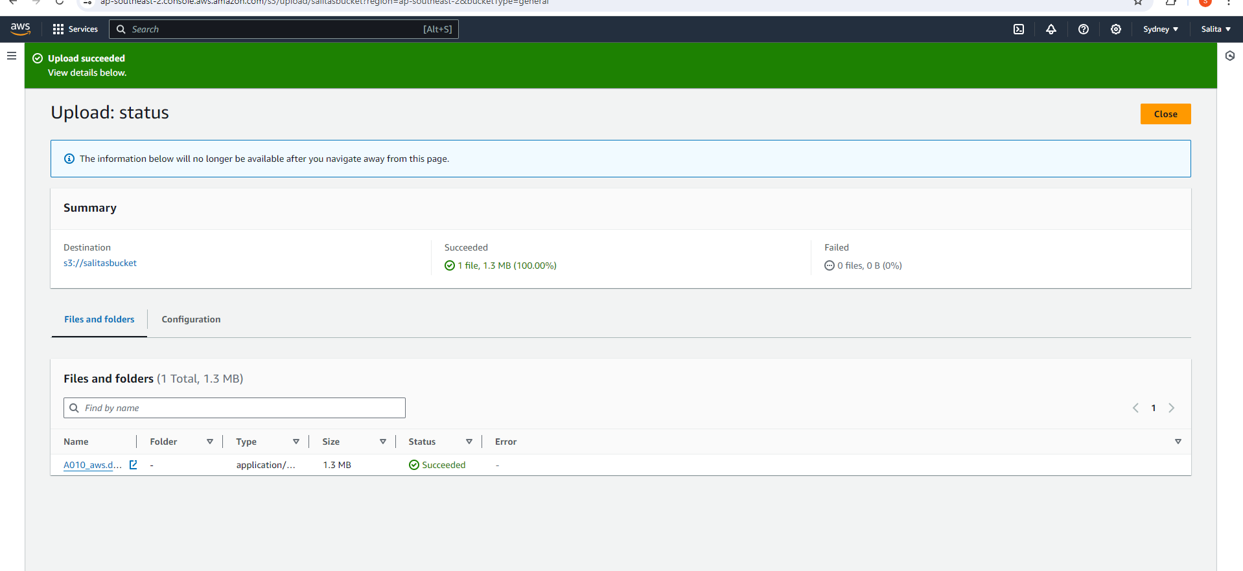

•  Once the file is uploaded, click on its name in the S3 console.

•  In the **Object details** section, you’ll see an **Object URL**.

•  Click on the URL or copy and paste it into your browser to access the file.

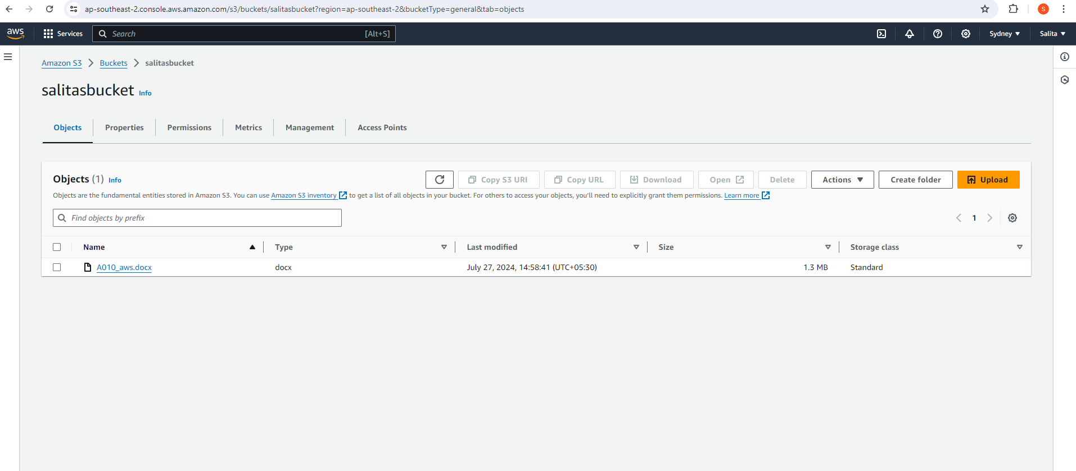

--------------------------------------------------------------------------------------------------------------------------------------

Go to javatpoint and copy the code and paste it into notepad and save as a html extension. Now upload that into s3.

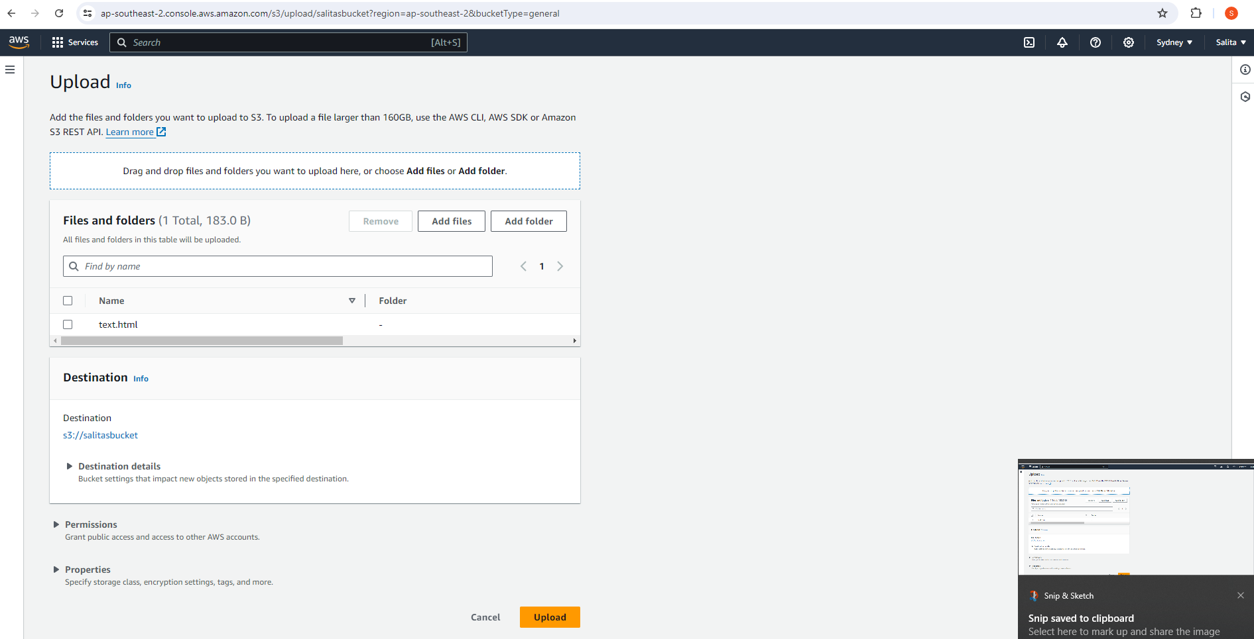

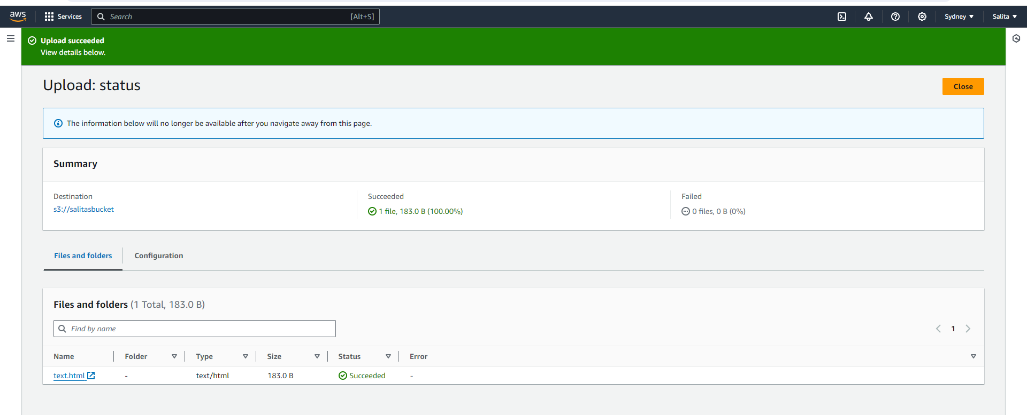

Now open the file by clicking on open.

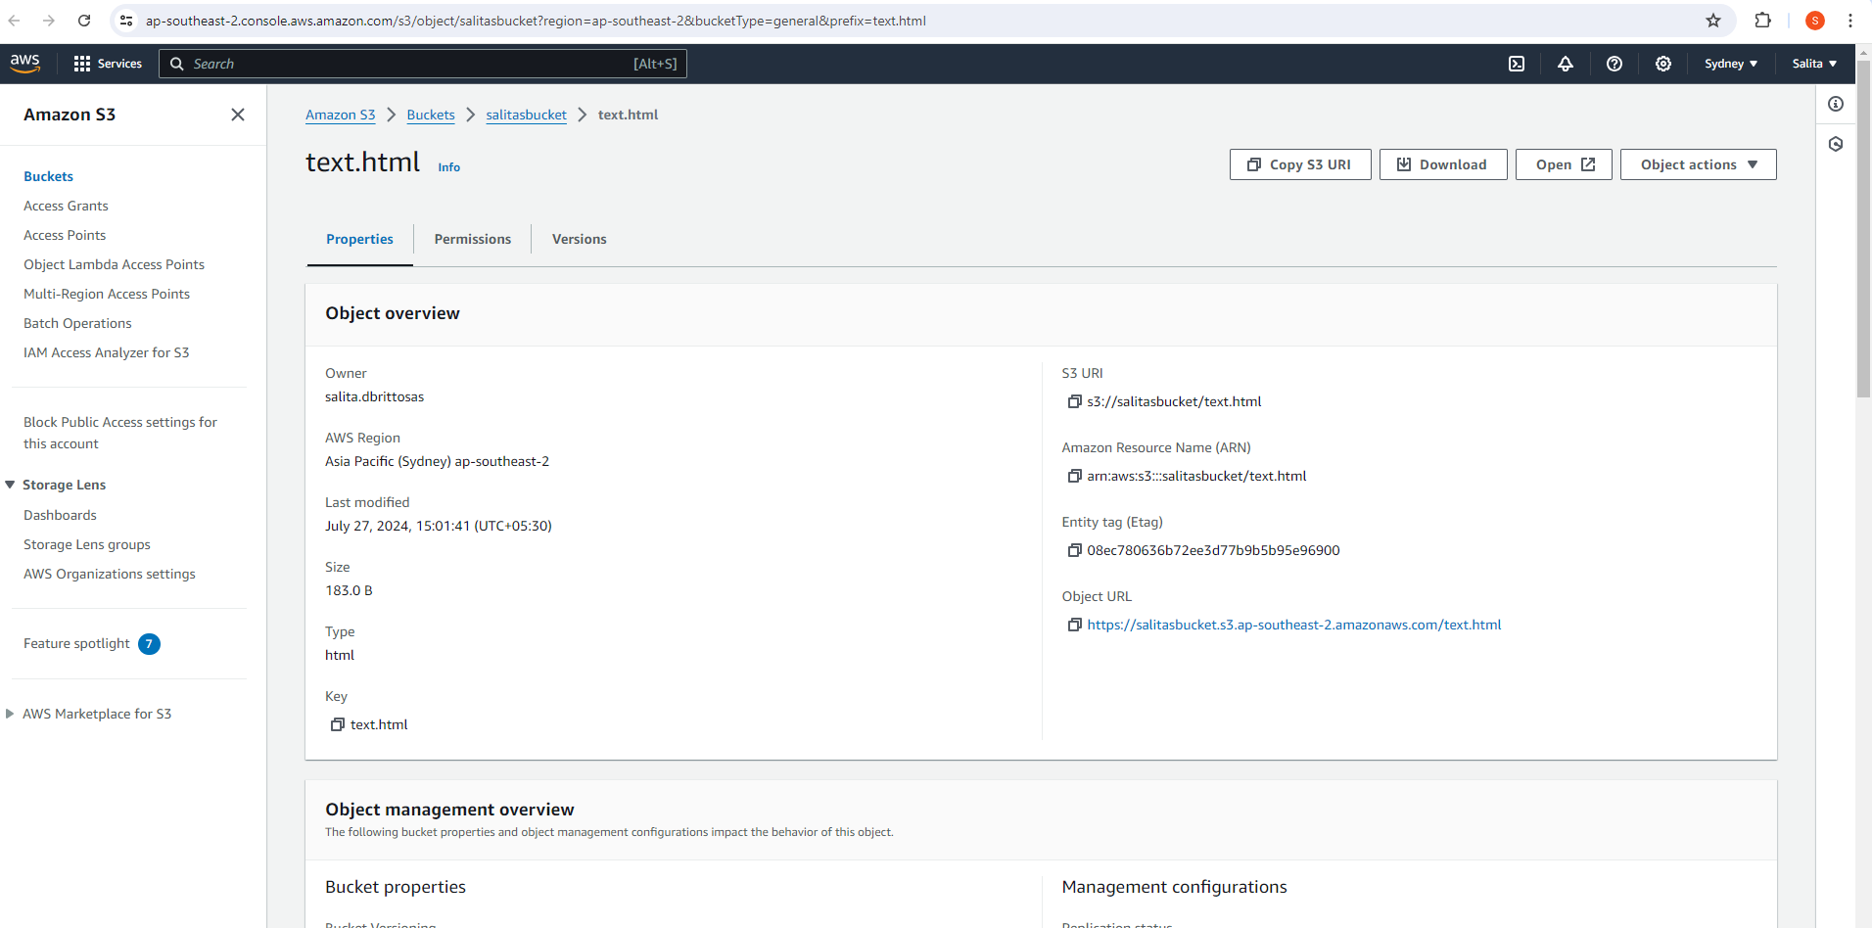

Webpage opens.

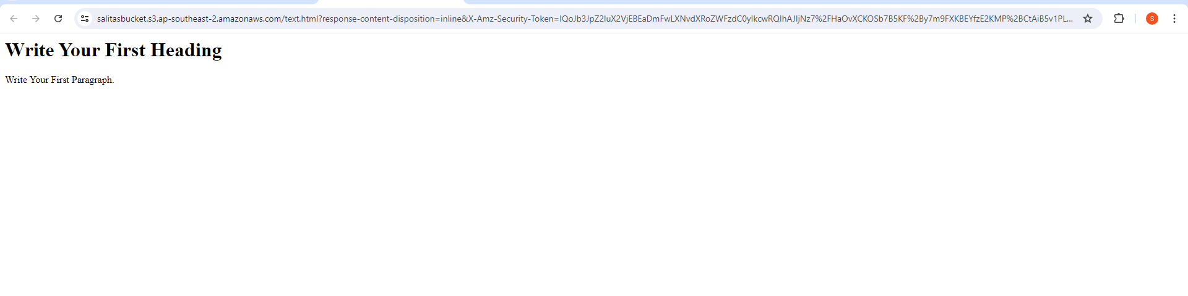

Delete the objects and buckets later.

