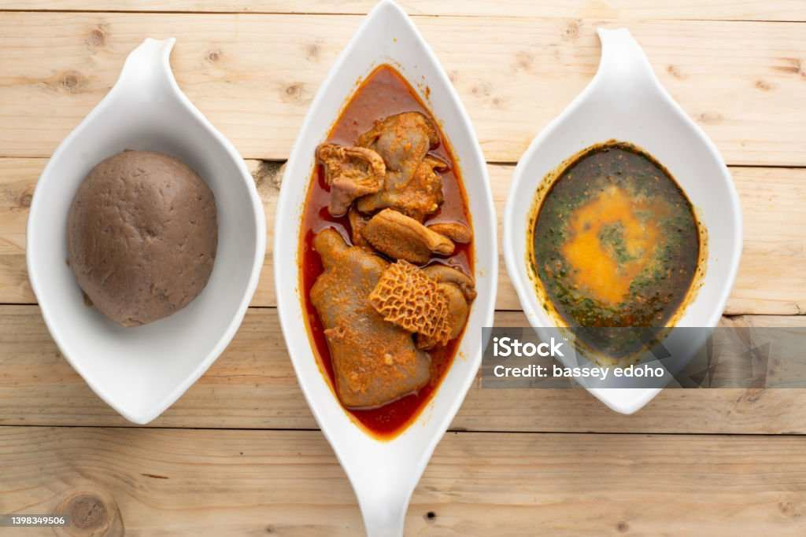AMALA TREND

DATA DRIVEN TEND DETECTION FOR AFRICAN RESTAURANTS: FOCUS ON AMALA IN THE UK

GROUP 1

**Table Of Contents**

1. Introduction 2
2. Libraries & Conﬁguration 4
   1. Libraries 4
   2. Conﬁguration 4
3. Data Collection 5
   1. Data Scraping 5
   2. Data Exploration 5
4. Trendiness Metrics 8
   1. Velocity 8
   2. Acceleration 9
   3. Volatility 10
   4. Trendiness score 11
5. Decision Model 15
   1. Feature Engineering 15
   2. Decision Model 15
6. Business Recommendation 17

# Introduction:

This project explores how **Nigerian food trends speciﬁcally** *Amala* are surfacing in the UK, using **Google Trends time-series analysis** to guide strategic decisions for small African food businesses. It supports a case study of *\*Amala Hut\**, a Nigerian restaurant planning to expand into the UK, and addresses how to detect trends and recommend business adoption strategies.

# Problem Statement:

In the multicultural and competitive UK restaurant scene, identifying which **West African dishes are gaining popularity** is critical for small businesses. However, unstructured or anecdotal evidence makes it dificult to justify strategic decisions. This project seeks to answer:

*Is Amala trending enough in the UK for a small African restaurant to adopt or expand its ofering?*

# Background

As African cuisine gains global popularity, small African-owned food businesses face key questions:

*Which traditional meals are trending abroad? Should we expand our oferings based on search and cultural demand data?*

This research draws inspiration from data-driven product strategies used in industries like tech and applies a similar method to **retail food trends**. Just like audio brands use reviews and consumer data to guide product launches, African restaurants can now do the same with **cuisine trends**.

# Objective:

* + - Scrape and analyse UK-based Google search interest for Amala and other Nigerian dishes.
    - Calculate **trend metrics**:
      * **Velocity** (growth rate)
      * **Acceleration** (momentum)
      * **Volatility** (stability)
    - Create a **trendiness score** for each dish to support business decisions.
    - Recommend whether *Amala Hut* should include Amala on their menu in the UK.

# Methodology:

* + - Time-series analysis of Google Trends data across ﬁve years
    - Compute trend signals using:
      * .dif() for velocity
      * .dif() of velocity for acceleration
      * rolling().std() for volatility
    - Normalize these scores and combine into a **composite trendiness score**
    - Simulate business-level decision-making using **cost**, **local relevance**, and **trend strength**

# Data Sources

* Google Trends via the pytrends Python API
* Keywords: "Amala", "Pounded yam", "Jollof rice" (comparisons)
* Focus: UK region, last 5 years

GitHub Project Repository **- https://github.com/SaliuA/Amala-trend-detection-uk**

# 1.7 Summary

Jollof Rice is the most trend-responsive dish and should be prioritized for adoption.

Amala is stable and suitable for culturally aligned markets, while Pounded Yam may be deferred unless niche demand justiﬁes it.

# Libraries & Conﬁgurations

# Libraries

List of libraries to be used in the Exploratory data analysis and Decision Model development: pandas for data manipulation

numpy as for data computation matplotlib for 2D data visualization seaborn for 2D data visualization scipy for statistics

import seaborn as sns for visualization StandardScaler for standardization train_test_split for splitting the data LinearRegression for base linear regression model

RandomForestRegressor for Esemble linear regression model xgboost for ensemble machine learning model

mean_squared_error, mean_absolute_error, r2_score for evaluation metrics GridSearchCV for hyperparameter selection

# Conﬁgurations

conﬁgurations used for the analysis. seed = 42

# Data Collection

This dataset was scraped from google trend with search terms Amala, Pounded yam and Jollof rice and location United Kingdom.

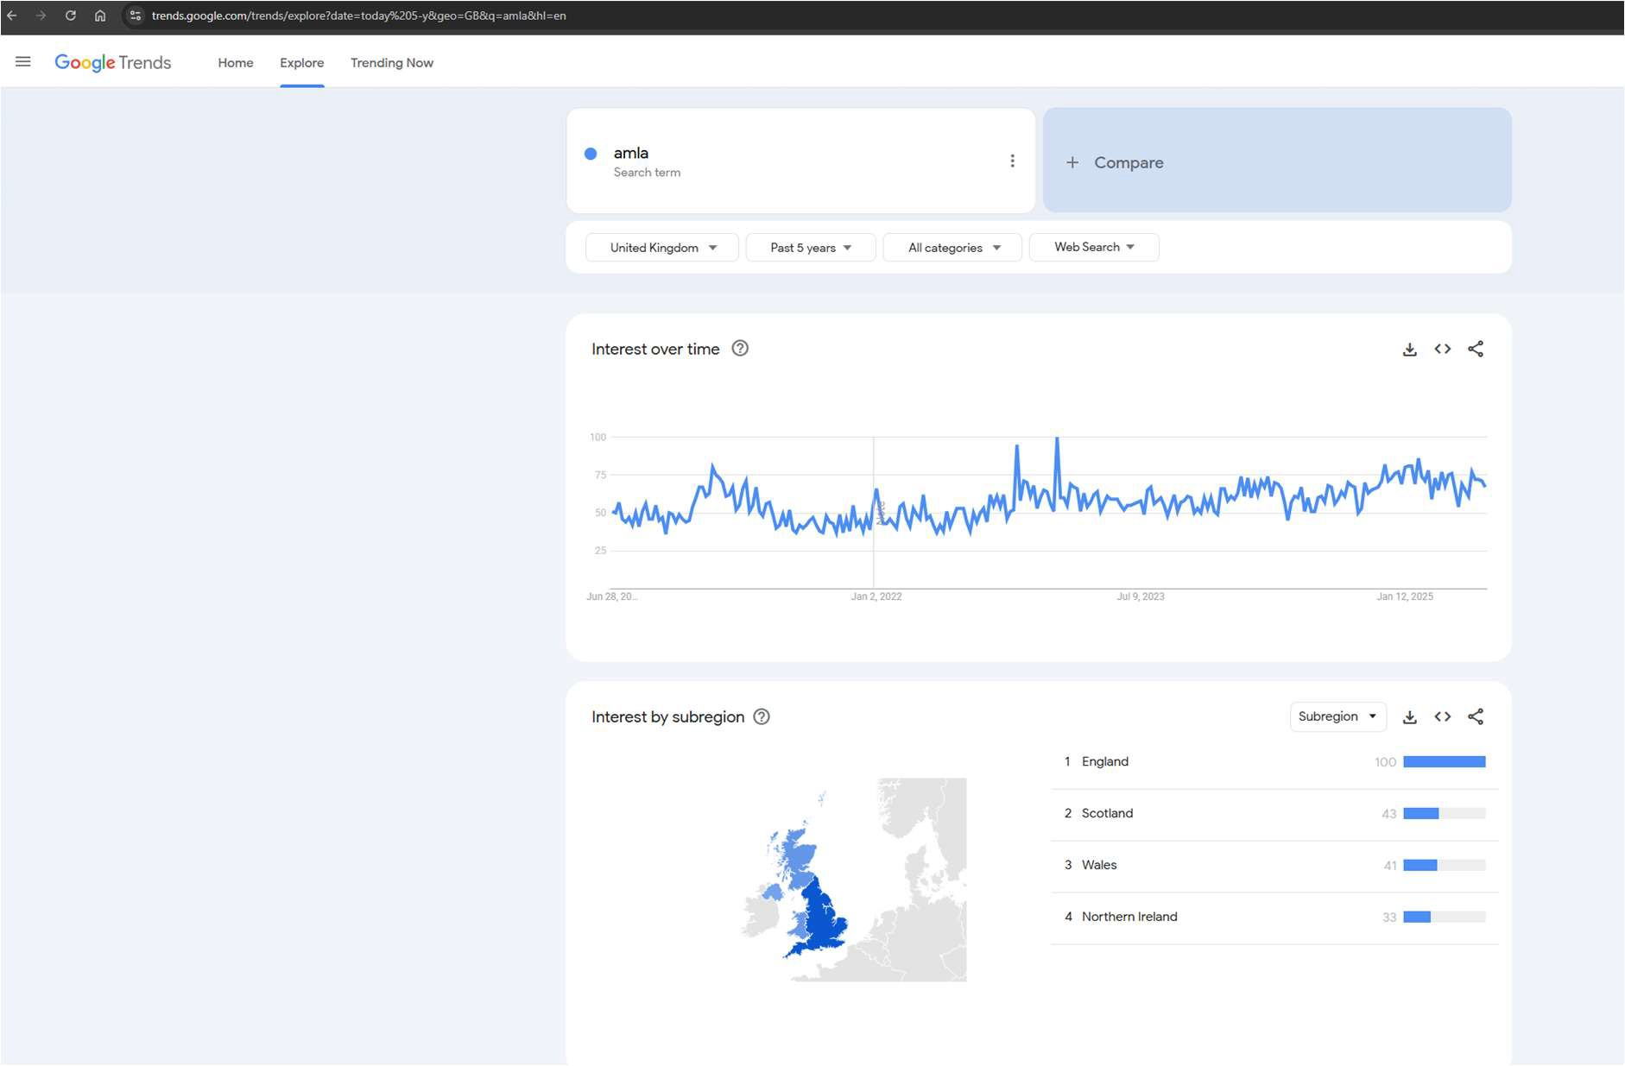

*Fig 1.0 google trend page*

# Data Scraping

The Google pytrend API was used for scripting purposes.

# Data Exploration

The data was explored to reveal relationships between the trends of diferent dishes

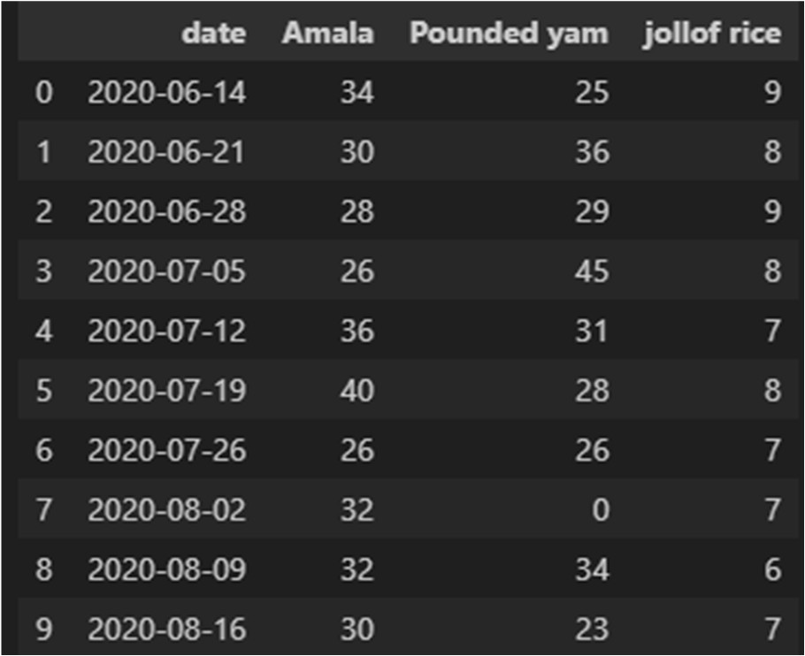

*Fig 1.2 google trend data*

# Line plot of search interest

Comparative Google Search Interest in the UK: Amala vs. Pounded Yam vs. Jollof Rice

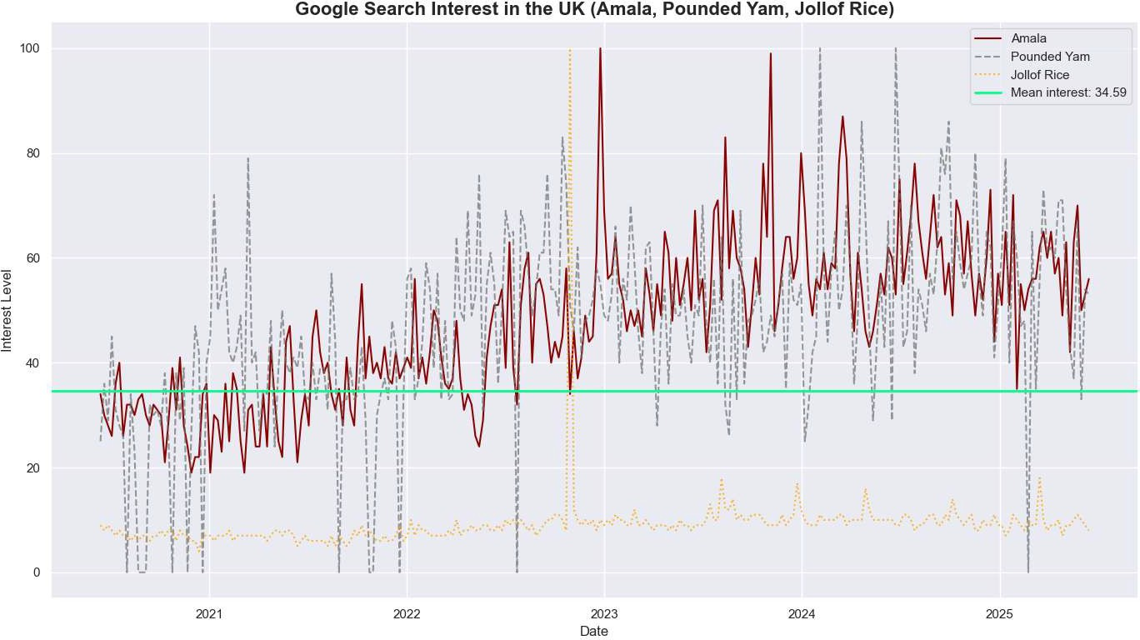

*Fig 1.3 google trend line plot*

This line chart compares the Google search interest trends for three popular West African dishes Amala, Pounded Yam, and Jollof Rice in the United Kingdom over the past ﬁve years.

* + - * Amala (red solid line) shows a steady upward trend with noticeable peaks, suggesting a growing and consistent interest, especially post-2022. Its search activity frequently rises above the group average.
      * Pounded Yam (grey dashed line) exhibits a highly volatile pattern, with interest ﬂuctuating signiﬁcantly. While it occasionally spikes above Amala, its inconsistency may indicate less sustained curiosity or fragmented audience engagement.
      * Jollof Rice (orange dotted line) has consistently low search interest compared to the other two dishes, despite its global popularity. This could imply that its trend status is stable but saturated.
      * The green horizontal line indicates the average interest level across the trends, estimated at 34.59. Amala consistently remains above this benchmark in recent years.

Among the three dishes, Amala demonstrates the most promising trend for sustained and increasing interest in the UK. This supports its strategic positioning for market entry or expansion by Nigerian food businesses like Amala Hut.

# KDE plot of search interest

KDE of Google Search Interest in the UK (Amala, Pounded Yam, Jollof Rice)

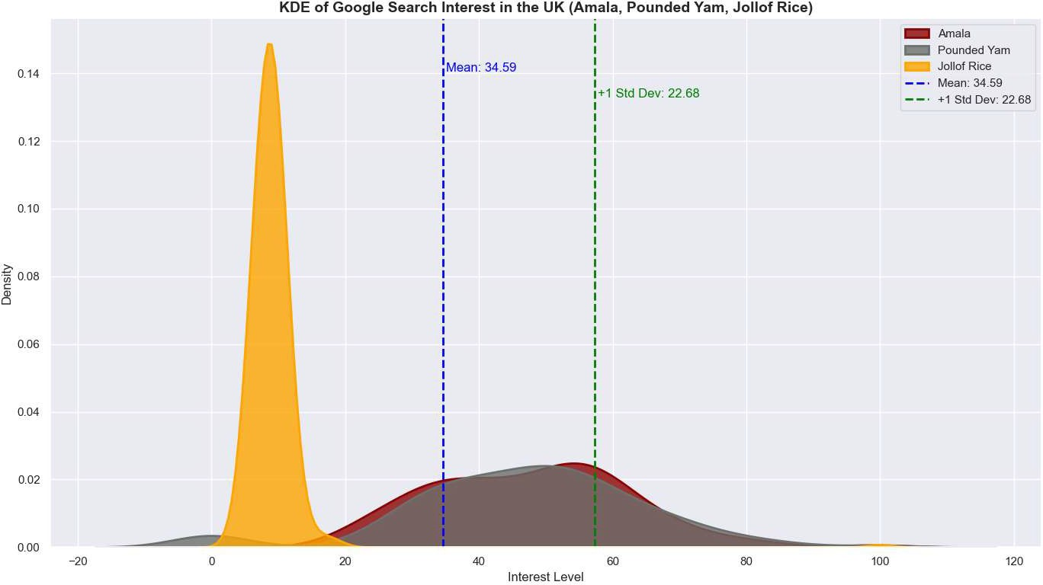

*Fig 1.4 Google trend data KDE plot*

This KDE plot visualizes the distribution of Google Search interest levels for three popular African dishes over the last ﬁve years in the UK:

* + - * Amala and Pounded Yam exhibit similar, broader distributions centered around moderate-to-high interest levels. Their curves are wide and slightly right-skewed, suggesting varying but sustained search volumes over time.
      * Jollof Rice, on the other hand, shows a sharp, narrow peak at a low interest level, indicating consistently low and stable search activity. This could reﬂect either saturation or lack of trend volatility.
      * The blue dashed line represents the overall mean interest level of approximately 34.59, which both Amala and Pounded Yam frequently exceed.
      * The green dashed line marks +1 standard deviation (22.68) from the mean, highlighting the range of higher-than-average interest.

Insights:

* + - * Amala and Pounded Yam are more dynamic in terms of interest, suggesting better trend potential for cultural food ventures.
      * Jollof Rice, despite being globally known, shows less ﬂuctuation, possibly indicating lower potential for novelty-driven growth in search interest.

This distribution supports the hypothesis that Amala, due to its consistent and upward-moving interest levels, is a strong candidate for cultural culinary expansion (e.g., by Amala Hut in the UK).

# Trendiness Metrics

The Velocity , Acceleration and volatility of the trend data was calculated for the three dishes.

# Velocity ( rate of change)

The velocity represents the ﬁrst derivative of the interest time series (week-to-week change)

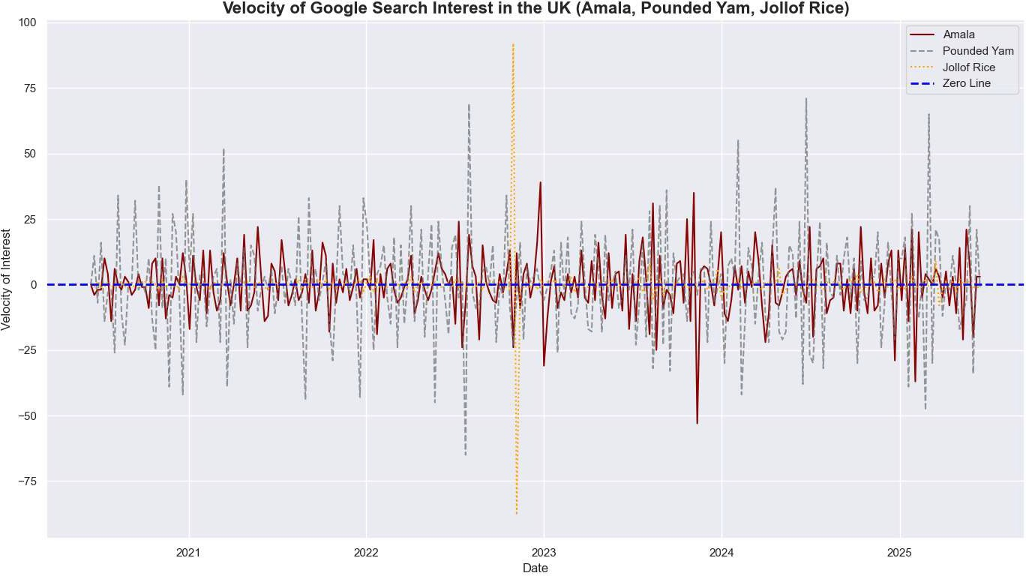

*Fig 1.5 Google trend velocity plot*

This plot represents the rate of change (velocity) of Google Search interest over time for three popular African dishes in the UK:

* + - Amala (maroon line) shows frequent and sharp ﬂuctuations in velocity, indicating volatile but dynamic interest, with both sudden spikes and dips over the years.
    - Pounded Yam (grey dashed line) also displays large swings, suggesting that search interest for this dish can be quite sporadic.
    - Jollof Rice (orange dotted line) has much lower and smoother velocity, reinforcing its stable and consistent search trend compared to the others.

The blue dashed horizontal line marks the zero velocity level, which helps distinguish between increasing and decreasing interest:

* + - Points above the line indicate rising interest in the respective period.
    - Points below the line indicate declining interest. Key Takeaways:
    - Amala shows bursts of upward and downward momentum, which could reﬂect campaign efects, seasonal trends, or cultural events.
    - Jollof Rice's stability suggests an established presence with little trend-driven behavior.
    - The volatility of Pounded Yam and Amala may signal trend adoption opportunities if harnessed with the right timing and marketing strategies.

This analysis helps identify how quickly public attention is shifting, which is critical for businesses like Amala Hut considering UK market timing and promotional strategies.

# Acceleration ( change of rate )

The Acceleration represents the second derivative of the interest time series (rate of change of velocity)

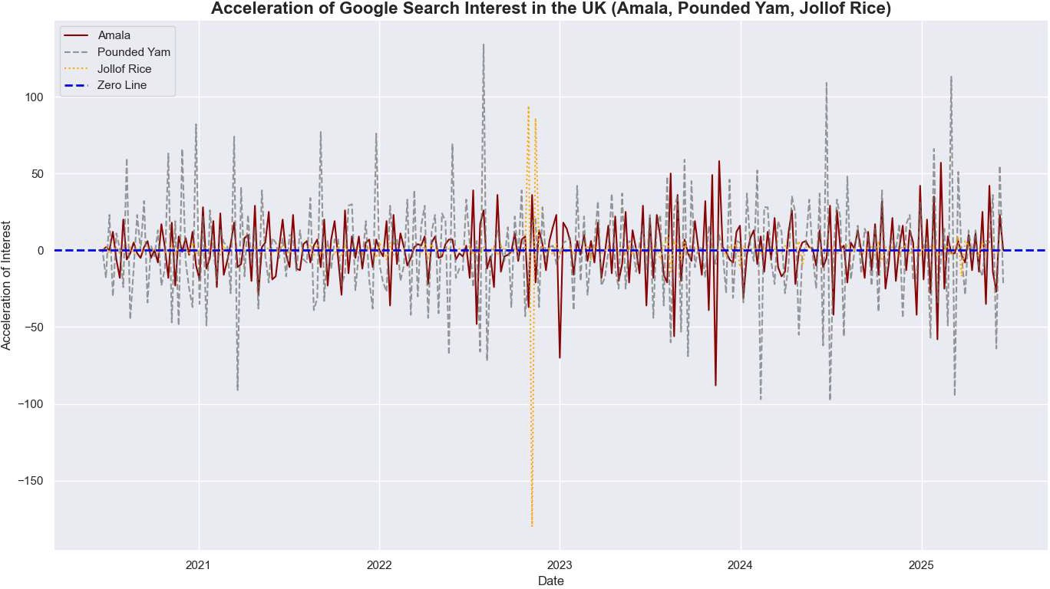

*Fig 1.6 Google trend data Acceleration plot*

This chart visualizes the acceleration (second derivative) of search interest for three African dishes in the UK: Amala, Pounded Yam, and Jollof Rice. Acceleration measures the rate of change of velocity, ofering deeper insight into how quickly public attention is shifting direction.

* + - Amala (maroon line) exhibits frequent bursts of both positive and negative acceleration, suggesting that spikes and dips in interest often occur rapidly and unpredictably.
    - Pounded Yam (grey dashed line) shows high variability in acceleration, especially early on, indicating sporadic surges or declines in trend momentum.
    - Jollof Rice (orange dotted line), in contrast, has mostly stable and low acceleration, conﬁrming its steady trend dynamics over time.

The blue dashed horizontal line at y = 0 acts as a baseline:

* + - Points above the line reﬂect periods where interest is increasing at a growing rate.
    - Points below the line show deceleration or declining momentum.

Key Takeaways:

* + - Amala continues to show trend-like behaviour, with clear momentum bursts that could be strategic marketing windows.
    - Jollof Rice remains stable, likely due to its established brand awareness.
    - Tracking acceleration helps identify early signals of viral moments or trend fatigue, which are critical for timing new campaigns or product launches.

# Volatility ( rolling std deviation ) Volatility:

Rolling standard deviation measures instability over time

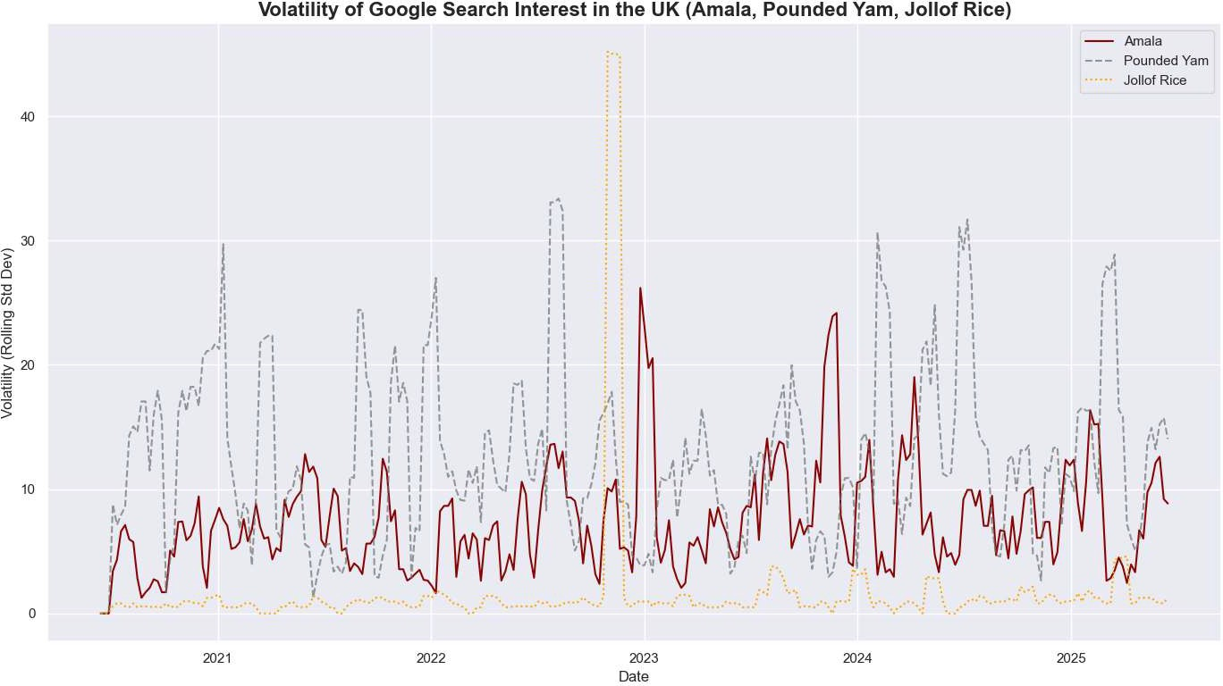

*Fig 1.7 Google trend volatility plot*

This plot tracks the volatility (measured as the rolling standard deviation) of Google search interest over time for three African dishes: Amala, Pounded Yam, and Jollof Rice. Volatility captures how unpredictable or ﬂuctuating the interest is on a regular basis.

Observations:

* + - Pounded Yam (grey dashed line) shows the highest volatility throughout the timeline, suggesting frequent and intense shifts in search interest. This could be due to irregular events or seasonal campaigns.
    - Amala (maroon line) has moderate volatility, with a few sharp peaks—particularly around 2023—indicating signiﬁcant ﬂuctuations in public attention.
    - Jollof Rice (orange dotted line) demonstrates very low and stable volatility, meaning its search interest is relatively steady and predictable across time.

Key Takeaways:

* + - Amala and Pounded Yam are more reactive to trends, holidays, or viral spikes.
    - Jollof Rice behaves more like a staple in public interest with minimal noise.
    - Spikes in volatility can be strategic entry points for marketing or cultural engagement.

Tracking volatility helps businesses and marketers understand when a product or topic is undergoing a period of instability or growth opportunity.

# Trendiness Score:

A composite score was calculated using normalized values of velocity, acceleration, and (inverted) volatility:

Trendiness Score = 0.4 * velocity_norm + 0.4 * acceleration_norm + 0.2 * (1 - volatility_norm) This score was used to track how “trendy” the product is across time.

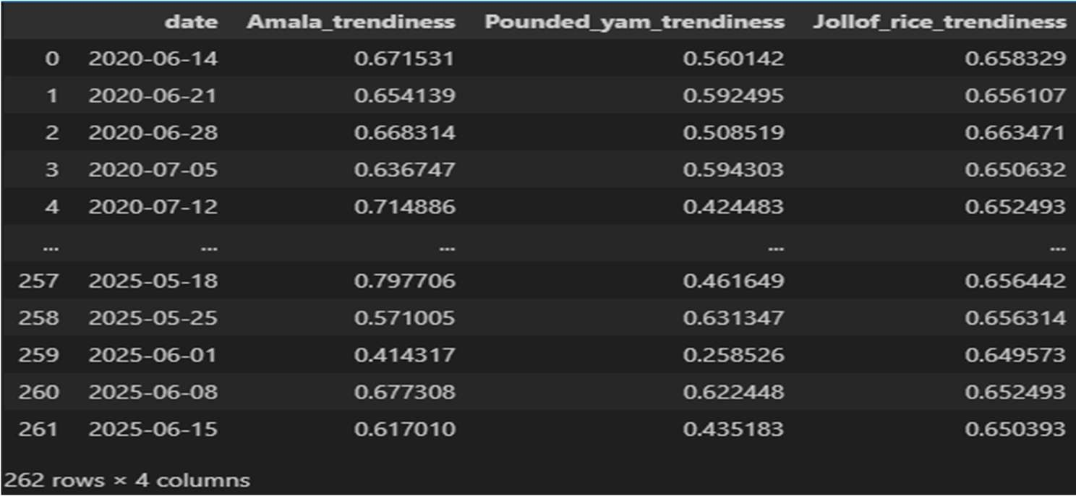

*Fig 1.8 The table shows the* ***trendiness scores*** *of selected Nigerian dishes.*

# Line Plot of Trendiness:

Line plot below shows the trendiness scores of amala, pounded yam and jollof rice

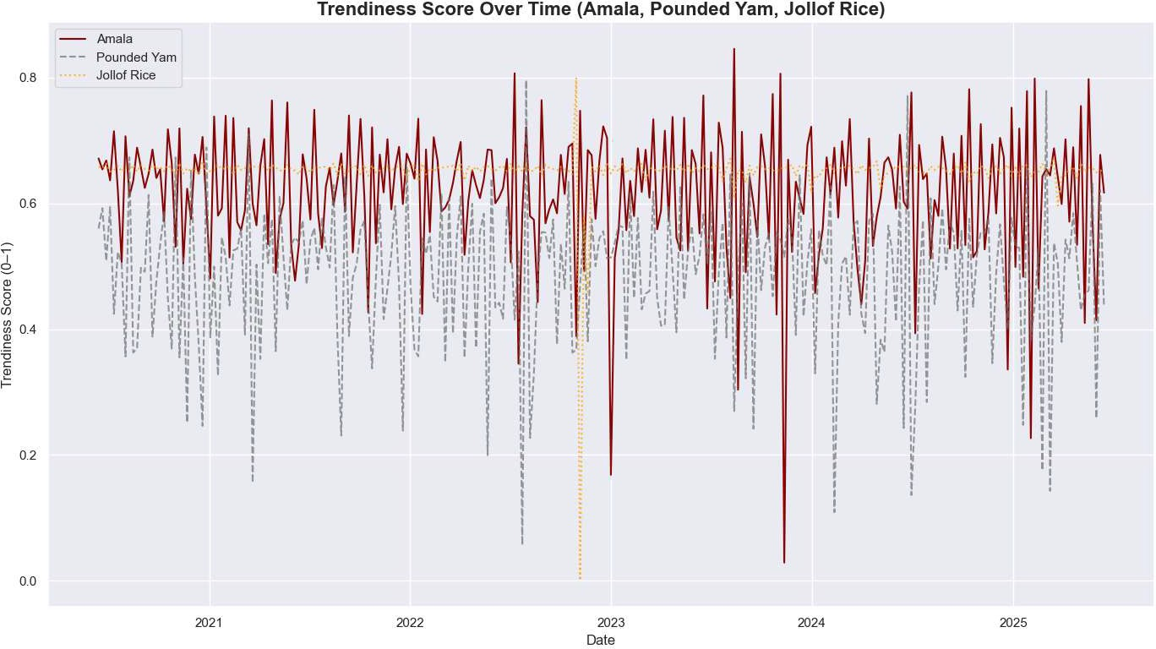

*Fig 1.9 Trendiness line plot*

This chart shows the normalized trendiness scores (scaled from 0 to 1) for the dishes Amala, Pounded Yam, and Jollof Rice based on Google search data in the UK over time.

Observations:

* + - * Amala (maroon line) consistently scores the highest in trendiness, frequently remaining above 0.65, indicating it is the most culturally resonant or top-of-mind dish among the three.
      * Jollof Rice (orange dotted line) maintains a stable trendiness score around 0.67, showing consistent interest with minimal volatility. It reﬂects steady cultural relevance.
      * Pounded Yam (grey dashed line) shows the lowest and most volatile trendiness, with frequent dips below 0.4, suggesting that its popularity is seasonal or event-driven rather than persistent.

Key Insights:

* + - * Amala's high trendiness indicates strong and growing visibility in digital conversations and search activity.
      * Jollof Rice, while not as volatile, maintains stable trend appeal—ideal for long-term cultural or culinary branding.
      * Pounded Yam requires targeted eforts (e.g. events, inﬂuencer campaigns) to raise and stabilize its trend relevance.

Monitoring trendiness helps determine which dish is currently culturally hot, which is ideal for product positioning, digital campaigns, or menu innovation.

# KDE Plot of Trendiness:

The KDE plot below shows the trendiness scores of amala, pounded yam and jollof rice

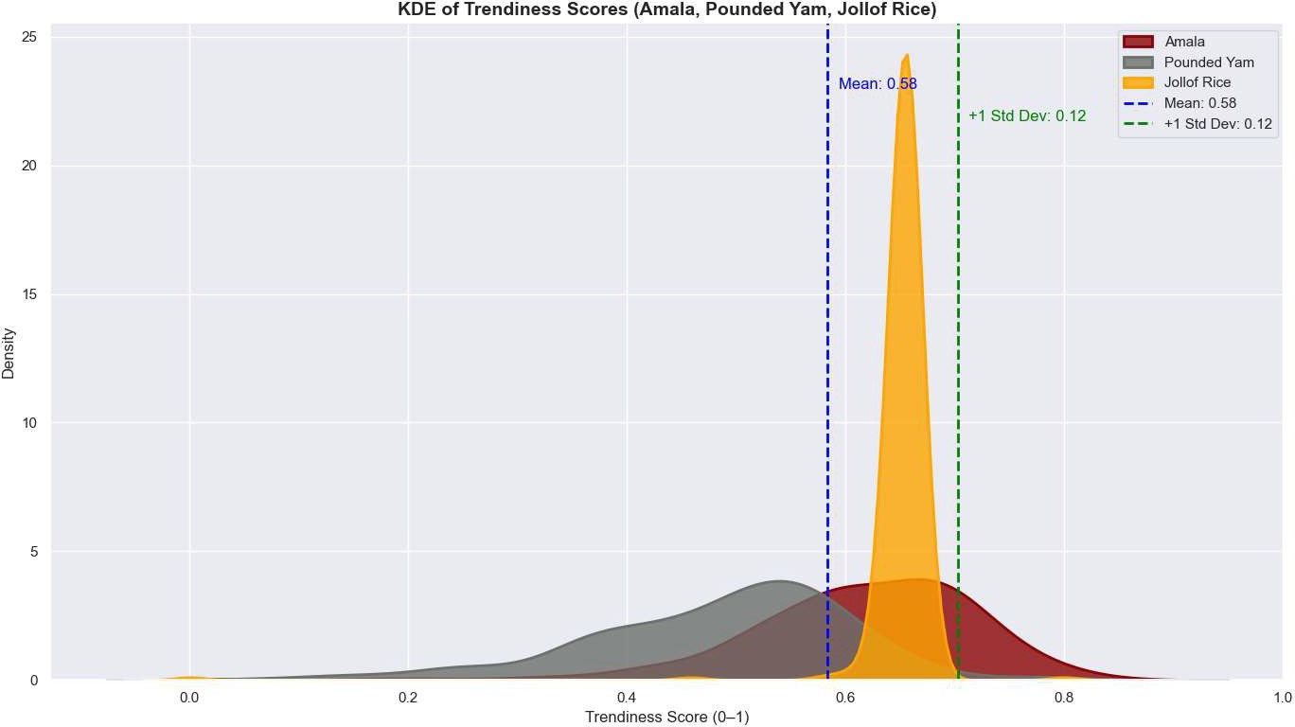

*Fig 2.0 Trendiness kde plot*

This plot visualizes the distribution of trendiness scores for Amala, Pounded Yam, and Jollof Rice, based on normalized momentum metrics (velocity, acceleration) and penalized volatility.

* + - * Mean Trendiness Score ≈ 0.58 (blue dashed line) Represents the average trendiness across all three dishes.

• +1 Standard Deviation ≈ 0.12 (green dashed line)

Dishes with scores beyond this threshold may be considered strongly trending.

Dish-Level Insights:

* + - * Jollof Rice (orange):
        + Displays a sharp, narrow peak near the mean.
        + Indicates high consistency and minimal volatility.
        + Suggests Jollof Rice is a reliable and stable trend, even if overall search volume is lower.
      * Amala (deep red):
        + Shows a wider distribution, mostly between 0.5 and 0.7.
        + Reﬂects moderate trend strength with some ﬂuctuation.
        + Suggests it remains culturally strong but less consistent than Jollof.
      * Pounded Yam (gray):
        + Exhibits a ﬂatter curve centered below 0.5.
        + Implies lower trendiness and greater variability.
        + Currently the weakest candidate for trend-driven adoption.

# Average Trendiness over time:

The average tardiness over time was calculated for a 5 years and 6 months period

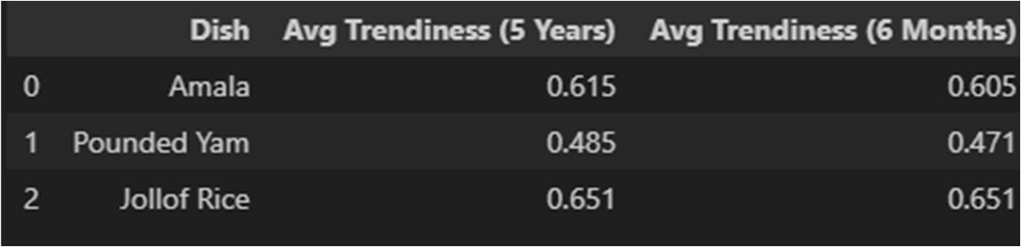

*Fig 2.1 Table of Average Trendiness over time ( 6 months, 5 years)*

Jollof Rice

* + - * Has the highest average trendiness in both long-term (5 years) and short-term (6 months).
      * Shows stability, with the exact same score in both periods.
      * This suggests Jollof Rice is a consistently popular dish, and likely to be a safe bet for inclusion in a menu.

Amala

* + - * Shows a slight decrease in trendiness in the last 6 months.
      * Despite this, it remains relatively strong and stable.
      * Could be a viable candidate for adoption, especially in areas with existing demand or cultural relevance.

Pounded Yam

* + - * Has the lowest trendiness score overall.
      * Also experienced a minor decline in the last 6 months.
      * May not be a strong trend at the moment; adoption should be supported by other factors such as:
        + Proﬁt margins
        + Ingredient availability
        + Culture

# Decision Model

A decision model was built to predict the adoption of the amala dish

# Feature Engineering

Mock features were generated for the restaurant business

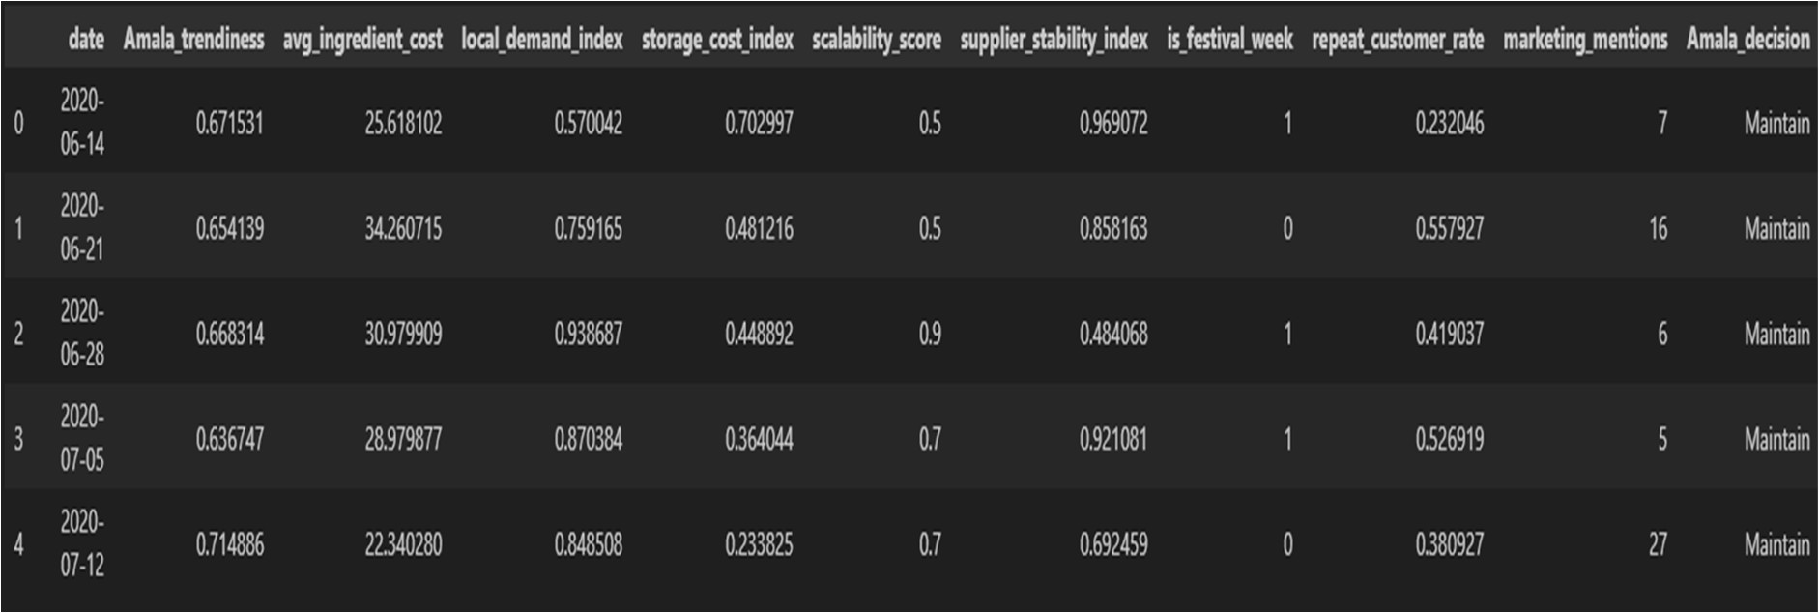

*Fig 2.2 The table shows the* ***decision adoption table***

# Decision Model

Decision model was developed for the restaurant amala adoption.

The Gradient Boosting Classiﬁer emerged as the best-performing model for predicting whether Amala Hut should maintain, scale up, or phase out the promotion of Amala based on trend indicators and business-speciﬁc features.

Best Model: GradientBoostingClassiﬁer

* + - Optimized via: RandomizedSearchCV
    - Selection Criterion: Aggregated Weighted F1 Score from Walk-Forward Validation Performance Metrics (Weighted):
    - Accuracy: 0.9767
    - Precision: 0.9761
    - Recall: 0.9767
    - F1 Score: 0.9755
    - ROC AUC: 0.0000 (Not applicable due to multiclass setup) Classiﬁcation Report Highlights:
    - Maintain: Precision = 0.98, Recall = 1.00, F1 Score = 0.99, Support = 201
    - Phase Out: Precision = 1.00, Recall = 0.75, F1 Score = 0.86, Support = 8
    - Scale Up: Precision = 0.80, Recall = 0.67, F1 Score = 0.73, Support = 6
    - The model performs exceptionally well in predicting the "Maintain" class, which dominates the dataset.
    - While it shows lower recall for "Scale Up," its high precision suggests scaling recommendations are accurate.
    - These insights support strategic marketing decisions for trend adoption and resource allocation.

Best Hyperparameters:

* + - classiﬁer learning_rate: 0.1979
    - classiﬁer max_depth: 6
    - classiﬁer n_estimators: 63
    - classiﬁer subsample: 0.8909

The Gradient Boosting model provides robust, accurate, and high-conﬁdence recommendations to guide Amala Hut’s decision on trend adoption. Its ability to capture nuanced signals from features like trendiness score, cost, and local relevance makes it a strong decision support tool for market expansion strategies in the UK.

# 6.0 Business Recommendations

Based on the analysis of trendiness scores across a 5-year historical period and the most recent 6-month window, the following recommendations were made regarding the adoption or prioritisation of each dish:

Jollof Rice – High-Priority Adoption

* Jollof Rice demonstrates strong and consistent trendiness in both the long term and short term.
* Despite having the lowest overall Google search interest, it shows the highest trendiness score.
* This indicates that Jollof Rice is gaining traction quickly and steadily.
* It is an excellent candidate for businesses looking to adopt or expand their menu with a dish that is on the rise, stable, and likely to perform well with appropriate promotion.

Recommendation: Adopt and prioritize marketing campaigns or pilot menus. Jollof Rice represents a strategic opportunity for early movers.

Amala – Viable for Targeted Adoption

* Amala shows a slight decline in trendiness over the last 6 months, yet remains relatively strong overall.
* It is likely a mature trend — popular in established communities but currently stable rather than growing.
* This makes Amala a safe, culturally relevant option, particularly in areas with a strong Nigerian or West African presence.

Recommendation: Adopt where cultural alignment exists. Consider positioning as a traditional or classic menu item.

Pounded Yam – Low-Priority Adoption

* Pounded Yam has the lowest trendiness score overall and has shown limited recent momentum.
* While it may ofer cultural or niche appeal, it does not currently signal enough market activity to justify widespread menu placement.

Recommendation: Defer adoption unless supported by ofline demand, high proﬁt margins, or low operational complexity.

Summary Table:

# Dish Avg Trendiness (5 Years) Avg Trendiness (6 Months) Recommended Action

|  |  |  |  |
| --- | --- | --- | --- |
| Jollof Rice | 0.651 | 0.651 | Adopt & Prioritize |
| Amala | 0.615 | 0.605 | Adopt (Targeted Strategy) |
| Pounded Yam | 0.485 | 0.471 | Defer / Niche Opportunity |

Amala Decision Model

This model provides a data-informed framework for supporting expansion and trend adoption decisions. With ongoing retraining using updated trend data, it can evolve into a real-time strategy assistant for Amala Hut in the UK food market.

Business Implication

Based on KDE analysis, Jollof Rice emerges as the most consistent and reliable trend performer. Amala shows moderate trend strength with some volatility, making it a viable option in culturally aligned markets. Pounded Yam, however, demonstrates limited trend movement and may be deprioritized unless supported by external business factors.