
Salix Live 13.0

Startup Guide

Main Index


Salix OS
Introduction
Software
System Management
Package Management
Support


Salix Live
Introduction
Boot procedure
Live Tools


Installing Salix OS
Partition Management
Salix Live Installer
LiloSetup


Customizing Salix Live
Advanced Boot Options
Linux Live Scripts
Personalizing Modules
Live USB Key

About this manual...
The latest version of this document can be found here.
The purpose of this manual is to enable you to take full advantage of Salix Live many functionalities.
Salix Live User's Guide is released under CC-BY-SA 3.0 license.

Salix OS

Introduction

Salix OS is a Linux Distribution based on Slackware that retains full backward compatibility with its illustrious parent.
However, while in the KISS principle Slackware adheres to, "Simple" refers to the viewpoint of system design, Salix OS attempts to make it refer to the viewpoint of the end user as well.
In order to do this, Salix OS has chosen the Xfce desktop, which offers a comprehensive full feature environment while managing to remain simple, unobstructive & highly responsive.
Salix OS also provides all the necessary GUI utilities to assist system management.
Of course, Salix OS package management through the proven slapt-get/gslapt tandem includes dependency resolution, transparently weaved indifferently both on Slackware's original and on Salix OS ever growing complementary software repository.
Finally Salix OS strives to provide a localized system which is usable around the globe and can easily be used by non-English speakers.

Software

Salix is usually installed with either one of the following set of software:

Core Mode
Here, only the minimum software, essential for a console system to start is included. A graphical environment is not provided. This is ideal if you are an experienced user and want to customize your installation for any specific purpose, such as a web server, file server etc.

Basic Mode
The Basic Mode is build on the Core Mode with the addition of Xfce desktop environment, Firefox web browser and Gslapt package manager. This is ideal for advanced users that would like to install a lightweight Xfce and add their own choice of applications.

Xfce and Firefox
Xfce is a lightweight desktop environment for various Unix/Linux systems. Designed for productivity, it loads and executes applications fast, while conserving system resources
Mozilla Firefox is a free and open source web browser with tabbed browsing, spell checking, incremental find, private browsing & numerous plugins.
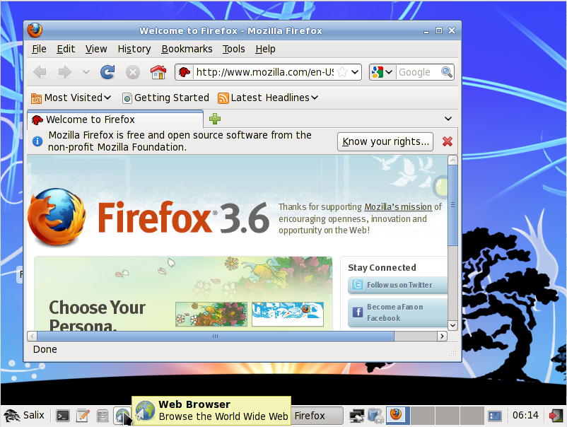

Full Mode
This last mode is build on the Basic Mode & offers a full range of useful software applications one could need on a daily basis while following the "one application per task" rationale.
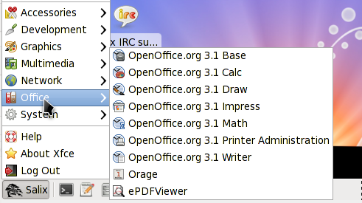

The Office applications are composed of the full OpenOffice productivity suite, ePDFView & Orage agenda.

Beside Firefox, Network applications include Claws-mail, Pidgin Transmission & gFTP.
Multimedia applications include Asunder, Brasero, Exaile, Iso master, Totem & Salix Codec Installer.
Graphical applications include the Gimp, Ristretto & Xsane
Geany is provided in the Development applications.
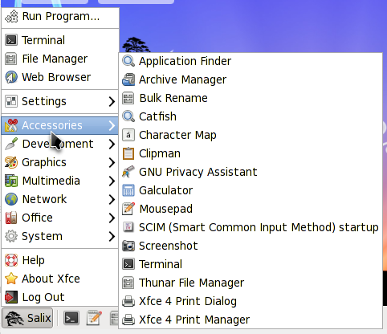

And finally Accessories applications include a variety of useful small utilities among which Galculator, Mousepad, Catfish, File Roller, SCIM, etc.

OpenOffice
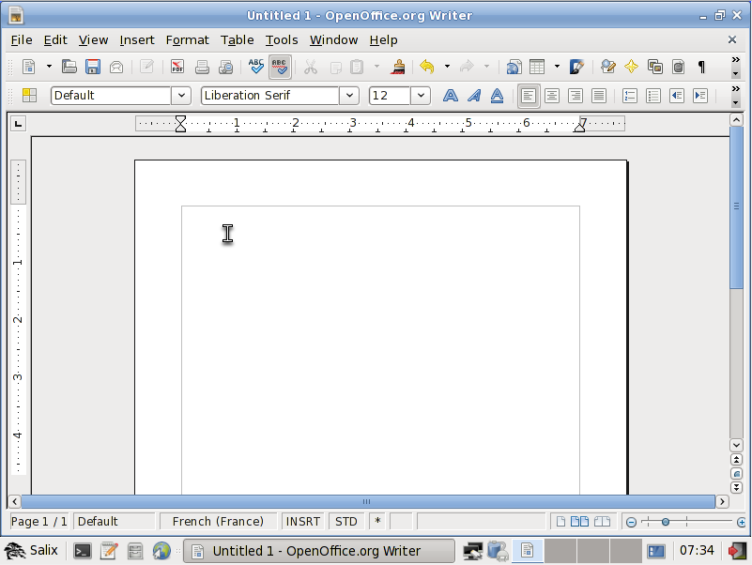

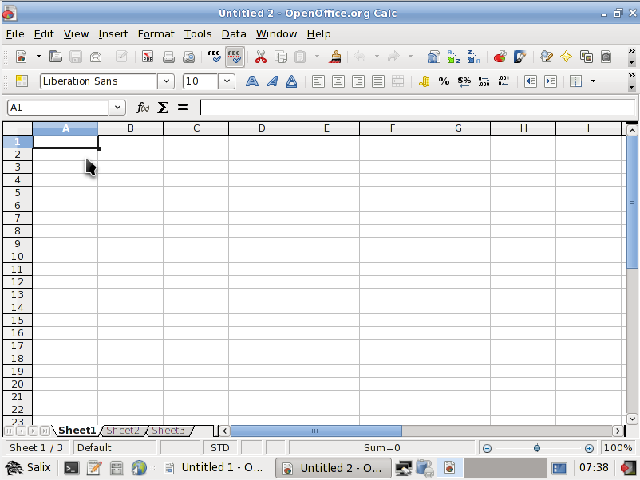

OpenOffice.org 3 is the leading open-source office software suite for word processing, spreadsheets, presentations, graphics, databases and more. It is available in many languages and works on all common computers. It stores all your data in an international open standard format and can also read and write files from other common office software packages.

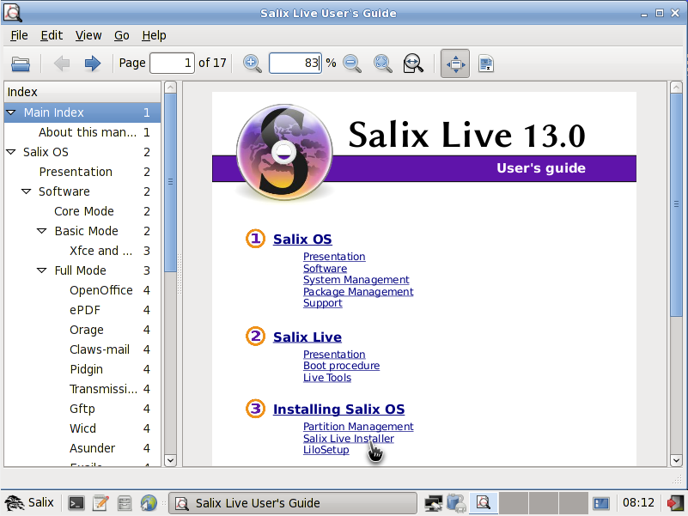
ePDFView

ePDFView is a very lightweight, simple PDF document viewer.

Orage
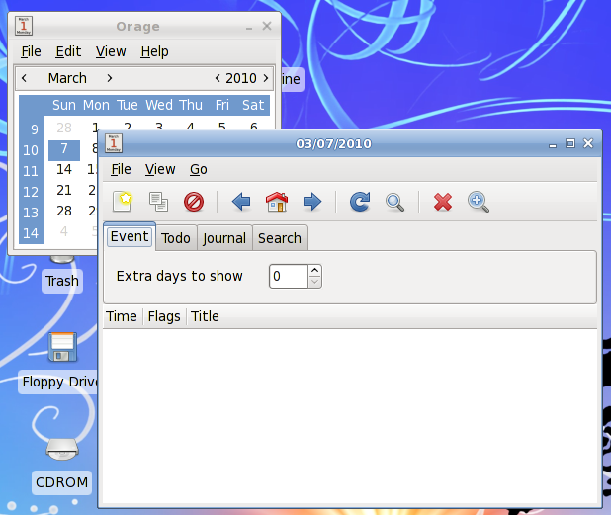
Orage provides a calendar which integrates nicely into the Xfce Desktop Environment. It is highly configurable and supports alerts based on dates. It warns you with popup or audio alarm.
As it is an application for every day use, it launches itself in the background and can be accessed using the Orage Clock plugin for the panel.
Simply click on a date to display or set the agenda for the day.

Claws-mail
Claws Mail is an open source email and news client. It offers easy configuration and an abundance of features. It stores mail in the MH mailbox format as well as the Mbox mailbox format via a plugin.
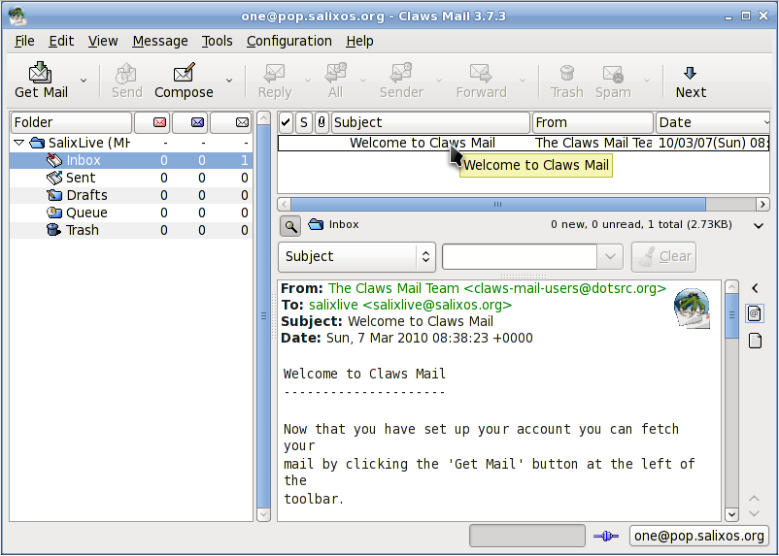

Pidgin
Pidgin is an easy to use and free chat client which lets you log in to accounts on multiple chat networks simultaneously. Pidgin is compatible with numerous chat networks out of the box: AIM, ICQ, Google Talk, Jabber/XMPP, MSN Messenger, Yahoo, etc..
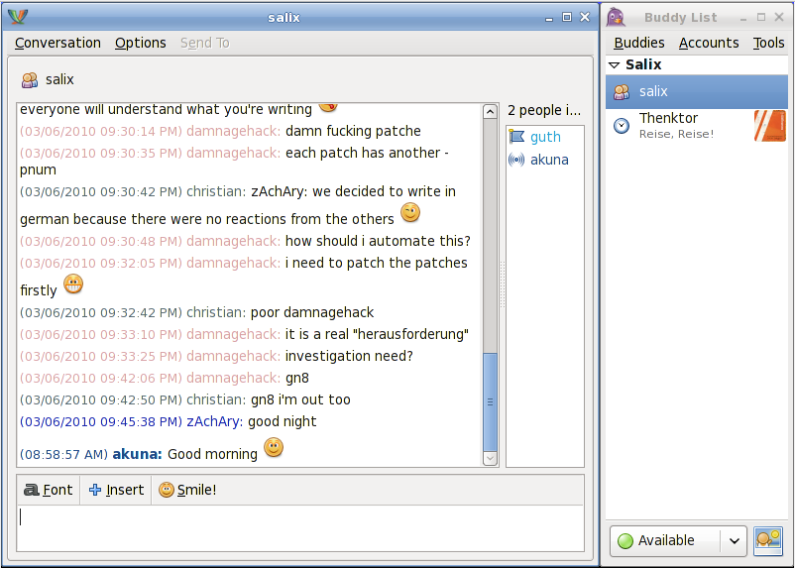

Transmission
Transmission is a BitTorrent client that is simple, lean, & powerful.
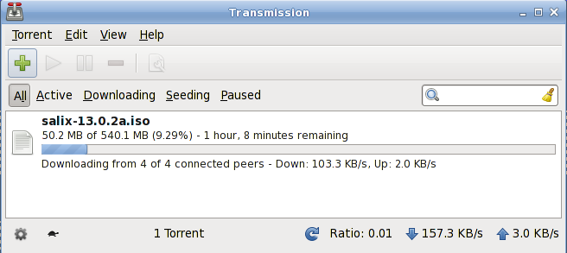

gFTP
gFTP is a FTP client with both a text & a GUI interface. gFTP aims to be simple to use yet powerful.
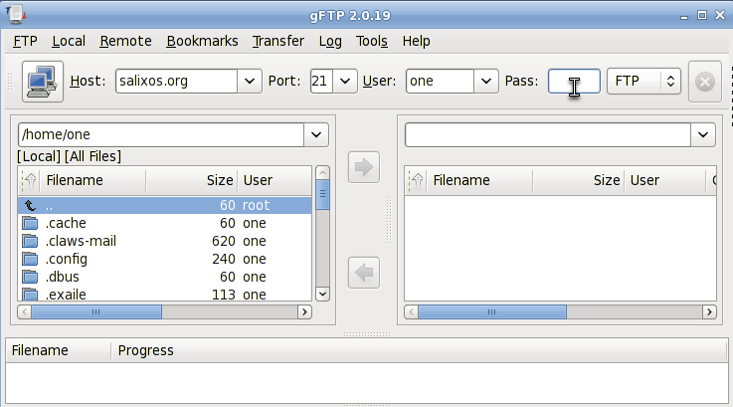

Salix Codec Installer
Before you can use any of the multimedia applications, you might have to first install some missing codecs.
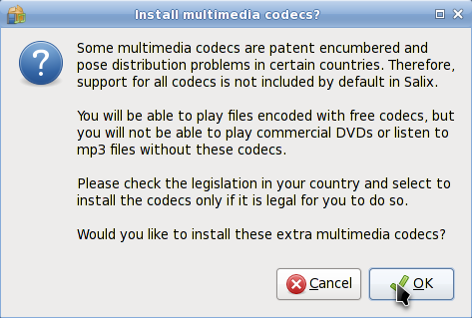
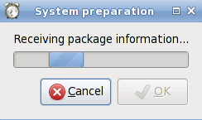

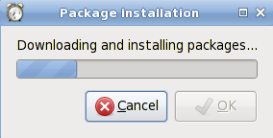

Asunder
Asunder is an Audio CD ripper and encoder for Linux.
You can use Asunder to save tracks from an Audio CD as any of WAV, MP3, OGG, FLAC, WavPack, Musepack, AAC, and Monkey's Audio files.
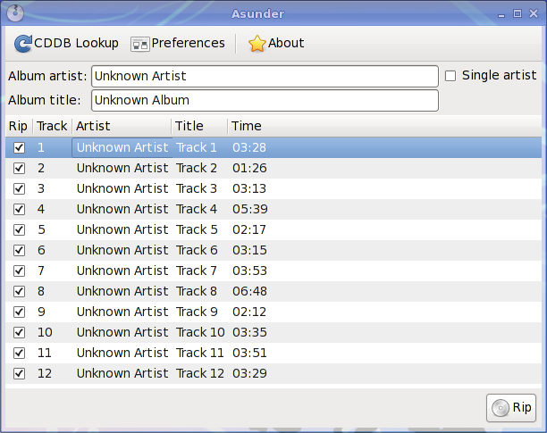

Brasero
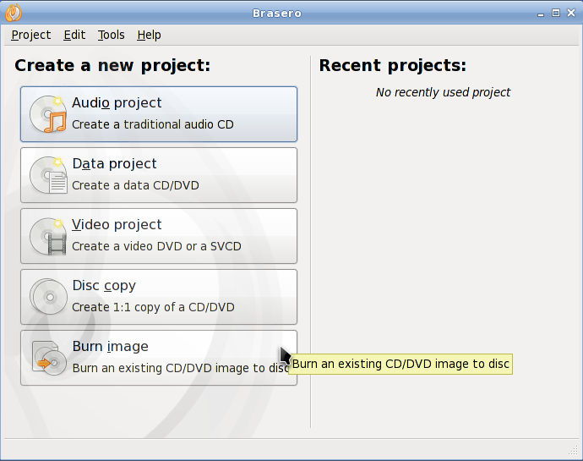
Brasero is an application to burn CD/DVD. It is designed to be as simple as possible and has some unique features to enable users to create their discs easily and quickly.

Exaile
Exaile is a music manager which incorporates automatic fetching of album art, lyrics fetching, Last.fm scrobbling, support for many portable media players, Internet radio such as Shoutcast, tabbed playlists, etc..
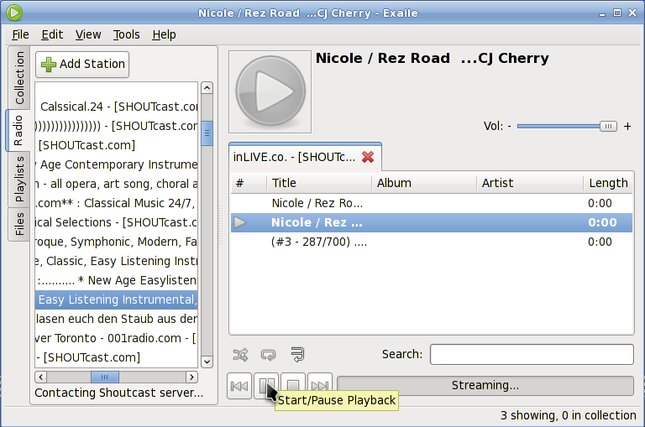

Totem
Totem is a media player (audio and video) which utilizes the GStreamer framework for playback.
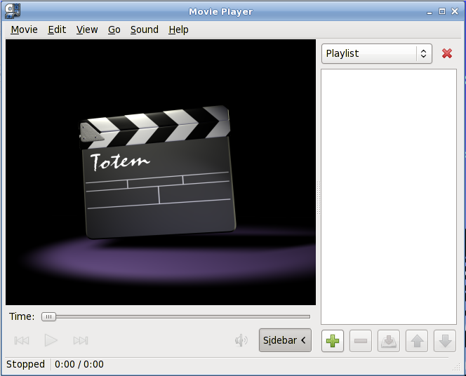

Gimp
GIMP (GNU Image Manipulation Program) is an image retouching and editing tool. In addition to offering free form drawing, it can accomplish essential image workflow steps such as resizing, editing, and cropping photos, combining multiple images, converting between different image formats as well as create basic animated images in GIF.
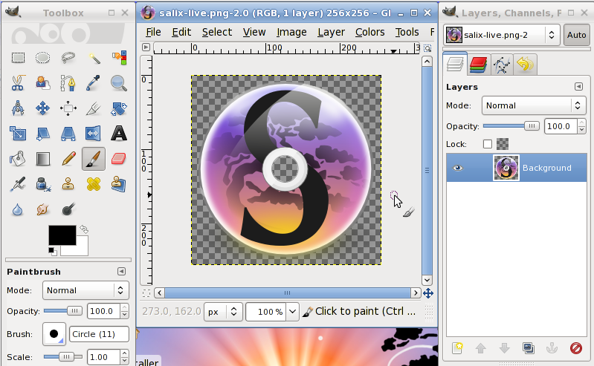

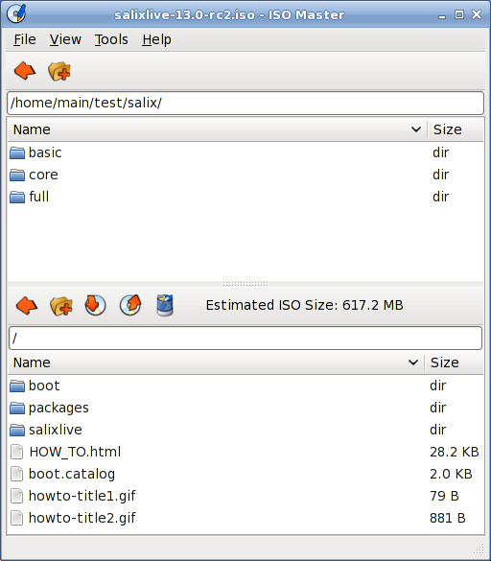
Iso Master
ISO Master is an application for creating and modifying ISO9660 files (ISO images).
Functionalities:
* Create an ISO image from scratch.
* Add or remove files and directories to/from a CD image.
* Create bootable CDs using various boot record types.

Ristretto
Ristretto is a fast and lightweight picture-viewer.
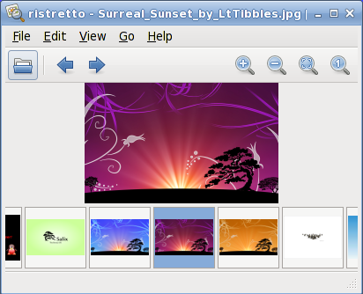

Xsane
XSane is a GUI scanning utility which uses the SANE-library to communicate with scanners.
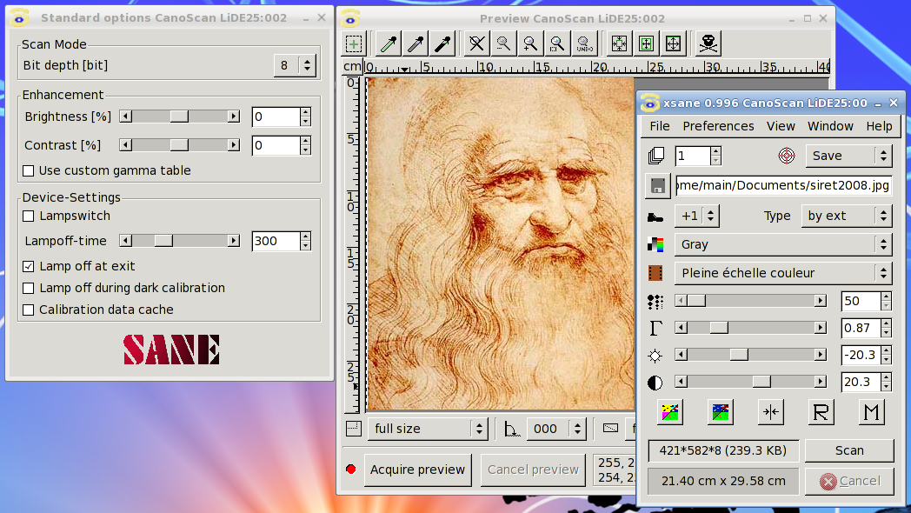

Geany
Geany is a small and lightweight Integrated Development Environment which only has a few dependencies & is independent from any particular Desktop Environment.
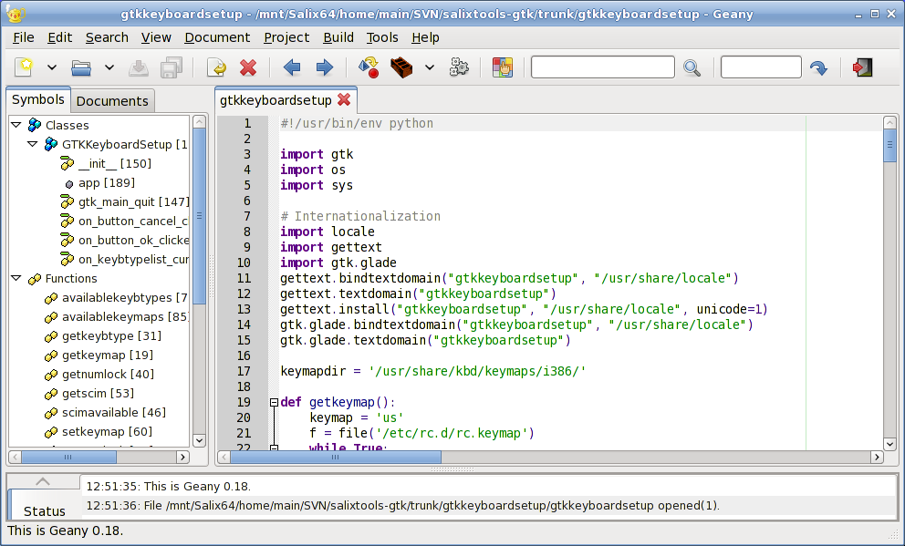

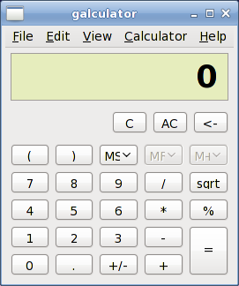
Galculator
Galculator is a calculator featuring two user modes: basic and scientific mode. Basic mode is intended for simple computations while Scientific Mode is Galculator's state-of-the-art.

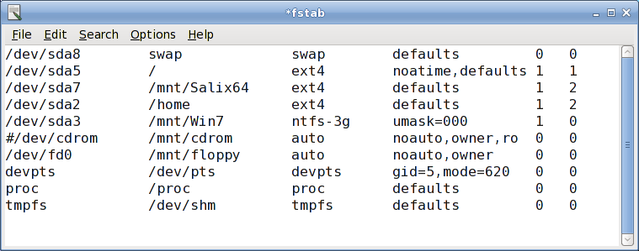
Mousepad

Mousepad is a simple text editor with printing support.

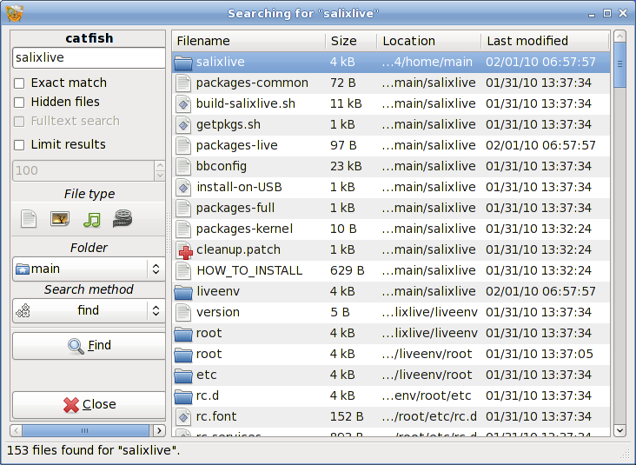
Catfish

Catfish is a handy file searching tool which provides a unified, lightweight and simple interface for different search engines such as find, (s)locate, doodle, tracker and beagle.

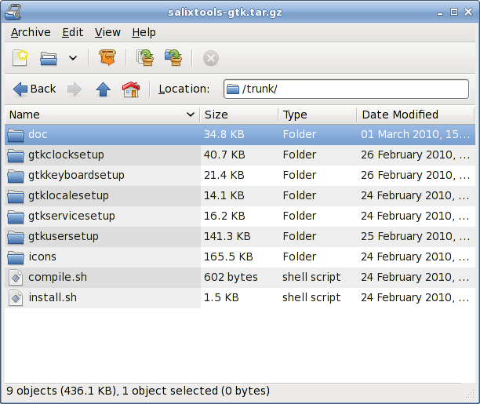
File Roller
File Roller is an archive manager. Supported archive types include gzip, bzip, bzip2, compress, lzop, zip, jar, lha, rar, zoo, arj, 7-zip, etc.

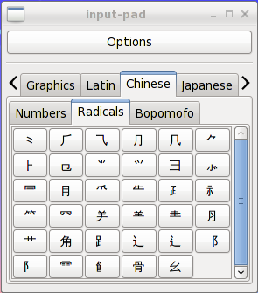
SCIM

The Smart Common Input Method platform (SCIM) is an X input method (XIM) platform containing support for more than thirty languages (Chinese, Japanese, Korean and many European languages).

System Management

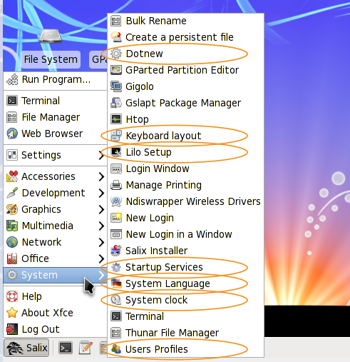
All system management in Salix OS can be done the usual (manual) Slackware way.
Alternatively, you can use any one of Salix System Tools which you will find under the System section of the Menu.
Most Salix tools (except LiloSetup) have a ncurse counterpart which can be used in a non-graphical environment (init 3).

Salix Tools

Dotnew
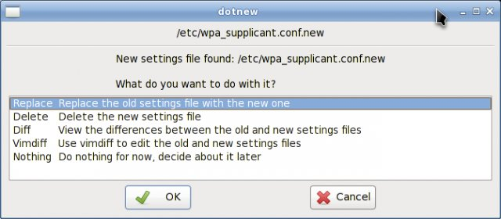
Dotnew manages the system configuration upgrades used by Slackware. It will display a possible course of action for each new configuration file found in the system
To execute this utility in init 3, simply type dotnew.

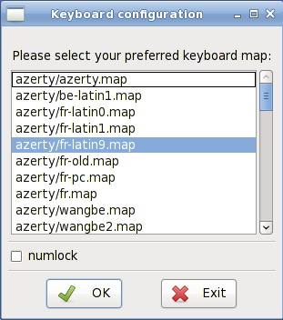
Keyboard Layout

This utility will configure the keyboard disposition being used both in the graphical & non-graphical environments. Modifications are applied instantly.
To execute this utility in init 3, simply type keyboardsetup.

Lilo Setup
LiloSetup will install a new LILO bootloader on your computer.
A bootloader is required to load the main operating system of a computer and will initially display a boot menu if several operating systems are available on the same computer.
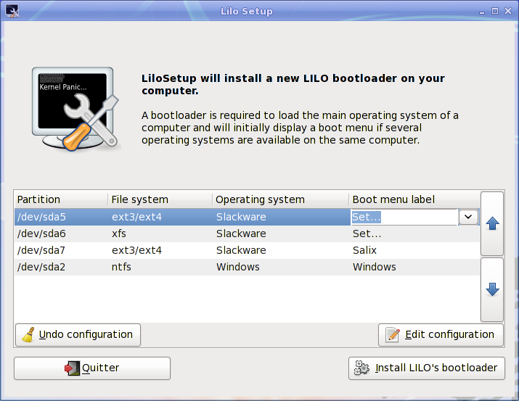
It is necessary to (re)configure the bootloader each time you install a new operating system on your computer.
LiloSetup can also be useful in the process of a disaster recovery in which case you may have to launch it from a Live CD if you have lost all other means to boot into your system.

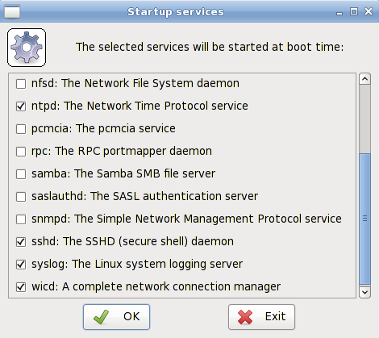
Startup Services
Here you will be able to select the services that should or shouldn't be activated in the background when your system starts.
All your modifications will be applied instantly if you press on the OK button & will not necessitate a reboot.
To execute this utility in init 3, simply type servicesetup.

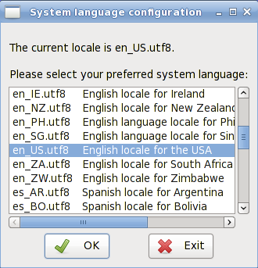
System Language

This utility will configure the language of your system.
To execute it in init 3, simply type localesetup.

System Clock
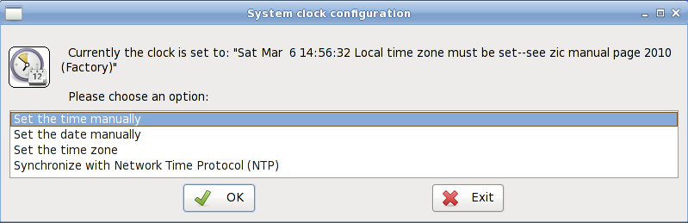
This utility will configure your computer clock.
To execute it in init 3, simply type clocksetup.

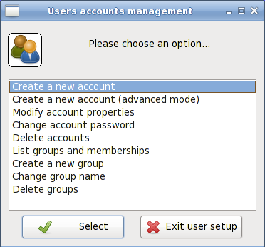
Users Profile
In Unix/Linux, all users and groups of users are given certain permissions & access rights to some part of the system in order to control their ability to access & temper with it.
This utility manages the creation, deletion & properties of all the system users & groups of users.
To execute it in init 3, simply type usersetup.

Other System Utilities

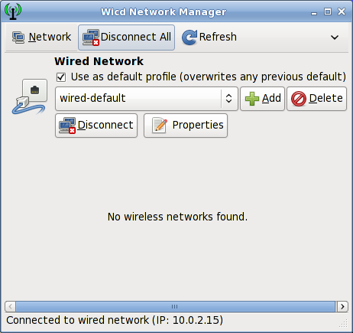
Wicd

Wicd is an open source wired and wireless network manager for Linux which aims to provide a simple interface to connect to networks with a wide variety of settings.
It will connect to wired (Ethernet only, no PPPoE/DSL support yet) and wireless networks.

Package Management

As previously stated Salix relies on the excellent slapt-get/Gslapt tandem for its software package management.

Slapt-get
Slapt-get is a CLI tool providing an APT like system for Slackware package management. It allows one to search Slackware/Salix mirrors and third party sources for packages, compare them with installed packages, install new packages, or upgrade all installed packages.

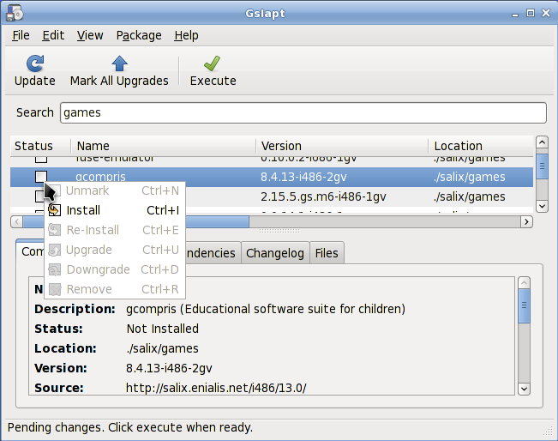
Gslapt
Gslapt is the GUI version of Slapt-get.
You should not forget to first press on the Update button to ensure that the latest updates from the software repositories are known to Gslapt.
Apart from this, everything is self-explanatory.

Support

Support is available straight from Salix desktop:
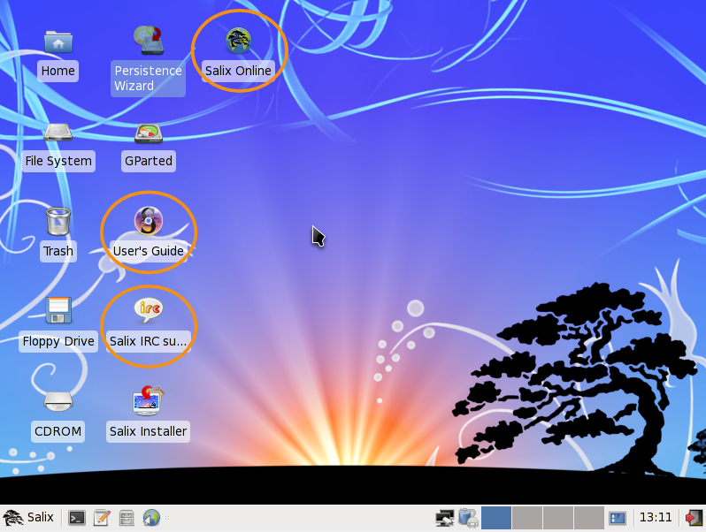
If you are still quite new to either Salix, Slackware or even Linux in general, then you should first of all take some time to study Salix User's Guide as it is specifically aimed to be accessible to newcomers.
The desktop link, Salix Online, will bring you to Salix Homepage. Our Wiki & Forum will be two other important sources of information. The search option of the forum will quickly show you if the question you have in mind has already been posted by a member of the community and if it has been answered.
You could also use the IRC link above to be in live communication with some member of the community & get instant help if necessary. If you do however, you might want to modify the default qwebircxxx login to something more personal & human readable.

Salix Live

Presentation

What is a Live CD?
A Live CD is a CD-ROM holding a self-contained bootable & fully functional operating system. It loads into memory using only data provided on the CD. It will not modify any operating system or data present on its host computer and will leave no trace after shutdown.
A Live USB flash drive is similar to a Live CD, but it can have the added functionality of automatically and transparently writing changes back to its bootable medium.
Salix Live is the Live CD version of Salix OS. You can therefore safely use it to 'test drive' Salix OS without having to install anything on your computer. You will thus be able to determine whether and to what extent Salix OS is compatible with your particular hardware configuration & if it suits your personal tastes.
If you are fully satisfied with your Live experience of Salix OS, you can then proceed to install it with the help of Salix Live Installer
Salix Live will also come in handy as a mobile solution if you wish to carry Salix OS everywhere you go or if you need to perform some basic rescue operation such as fixing an ailing LILO bootloader with LiloSetup, configuring some partitions with Gparted, etc.

What is an ISO image?
The latest Salix OS or Salix Live releases are freely & easily available as ISO image files from Salix OS download page.
An ISO image is an archive file of an optical disc. It can be easily rendered or burned to a DVD or CD by using media authoring or disc burning software. The resulting CD must not contain the .iso file, or you made a mistake in the process.
If necessary, you can verify the integrity of your downloaded file by comparing its md5sum file with the original one uploaded besides the corresponding ISO image file by Salix OS.
You can also explode Salix Live ISO image on an USB key.

Boot procedure

How to boot from Salix Live CD/DVD?
Your computer must be set to first try to boot on the optical drive before defaulting on the internal hard disk drive.
If that is the case, you simply need to feed Salix Live CD/DVD in the optical drive and start your computer.
If that is not the case, which is very rare, you will need to first enter the BIOS setup, usually by pressing the Del-key or the F2-key (or some other key combinations depending on your machine...). Once in the BIOS, find the "boot menu" and set the order of the boot devices properly, with your optical drive in first position. Save your changes & reboot your computer.

Boot menu
The first screen to greet you will enable you to select your language. Once you have selected your language, simply press on the Enter key to activate your choice.
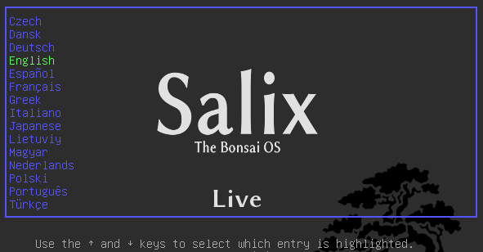

On the following menu, you will be given the possibility to change your keyboard map if the default one for your language does not suit you.

You also have the possibility to modify most default boot settings.
Simply press Enter on the default menu entry: Start Salix Live & a moment later you will enter Xfce desktop.
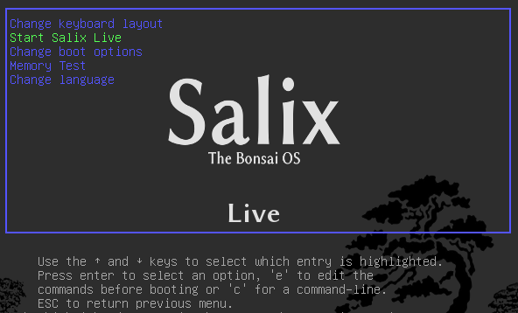

Live Tools

Administrator (root) password
All Live Tools require administrator's right & will ask you for the (root) password.
Salix Live root password is: live

What are the Live Tools?
Salix Live comes with all the default software included in Salix OS.
However due to its Live nature it also includes some extra utilities which are either needed or simply very useful in a Live session.
Some of the Live Tools are graphical utilities that can be accessed directly on the desktop while some Live Tools, reserved for advanced users can only be executed in a Terminal, from the command line (CLI).

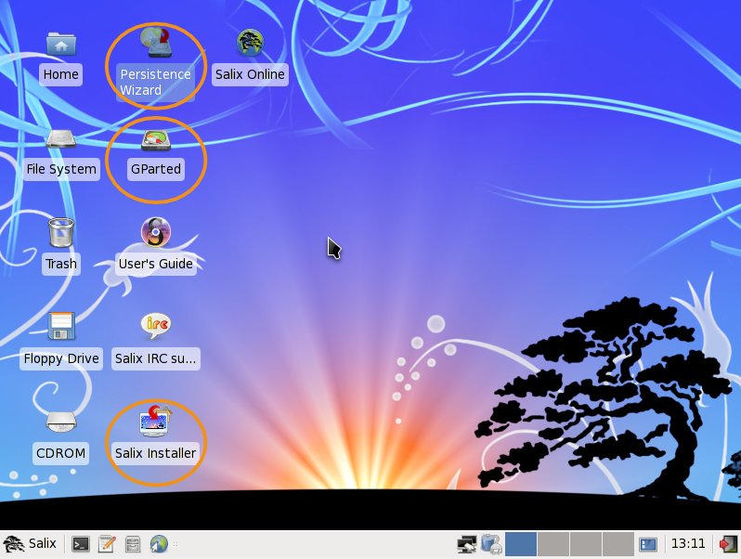

The Persistence Wizard
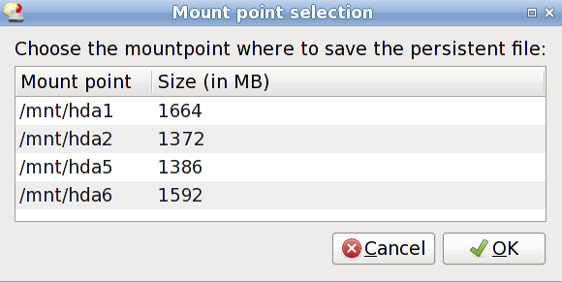
Even if run from a CD/DVD, Salix Live gives you the possibility to save any of your work or modification performed while in a Live session.
To do this however, you must first create a special "persistent file" which will have a pre-decided fixed-size and will be formatted as a Linux file system.
Important! Once this file has been created, it is necessary to reboot the Live CD. From then on, Salix Live will begin to monitor any change you perform & will record them in the new persistent file.
To remove any changes and come back to the default settings, simply delete the persistent file (slxsave.xfs) from the mount point it was initially created on.

Gparted
Gparted is included in Salix Live to assist you in managing your partitions if it is necessary for you to do so before performing the installation of Salix OS.

Salix Live Installer
Salix Live Installer will enable you to install Salix OS from the comfort of Salix Live graphical environment.

Linux Live Scripts:
Like most Live CDs based on Slackware, Salix Live is relying on the Linux Live Scripts technology. Some of the shell scripts it includes will enable an advanced user to fully customize & re-master Salix Live to better suit its own need.

Salix Live Scripts
In order to bypass certain limitations or to complement some of the third-party technology it uses, Salix developed its own set of patches & scripts which for the most part need no user interaction while some can be executed, for instance to facilitate the creation of a Salix Live USB Flash Disk.

Installing Salix OS

Partition Management

A disk device can be subdivided into one or more partitions. Before executing Salix Live Installer, you should already have the necessary partitions available on your system.
Salix needs, at the very minimum, one swap partition (which will be automatically used by the Live Installer without any user intervention) and one Linux partition to hold its main directory tree. If possible, it is recommended to also have at least another Linux partition to hold your /home directory.
If you do not already have these needed partitions ready, you may want to use Gparted to create them first. Gparted will enable you to change the partition organization on a disk device while preserving the contents of the partitions.
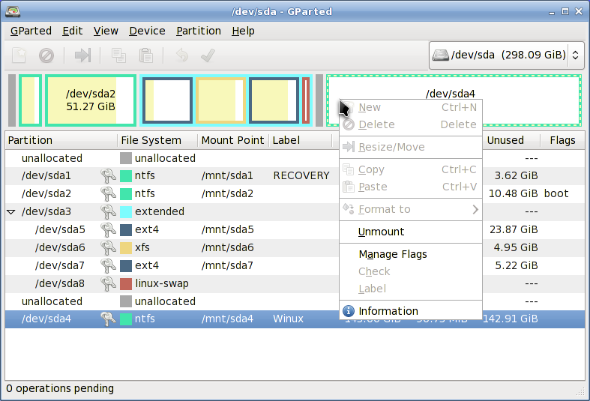

Salix Live Installer

Salix Live Installer is very easy to use. Contextual help triggered by the position of the mouse will be displayed above the application & will guide you every step of the way.
You will be greeted by a reminder that all the necessary partitions have to be created first. As we have seen, this can be done simply with the help of Gparted, which is included in SalixLive & is available directly on the desktop.
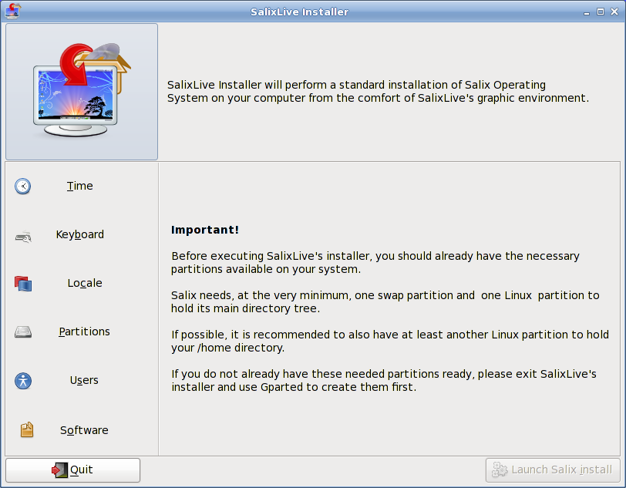

On the right side of the application, you will notice the different sections that must be configured before launching the installation process: Time, Keyboard, Locale, Partitions, Users & Software. Clicking on one of these sections will display the corresponding options that need to be set. As you progress through the configuration process, a check will be displayed beside each completed section. Once all sections have been completed, only then will the 'Launch Salix Install' button be activated.
So do take the time to familiarize yourself fully with Salix Live Installer. Undo options are available & none of the settings will be applied until you click on the 'Launch Salix Install' button.

Remember that the existing swap partition will be automatically used by the Live installer without any prompting on your part.
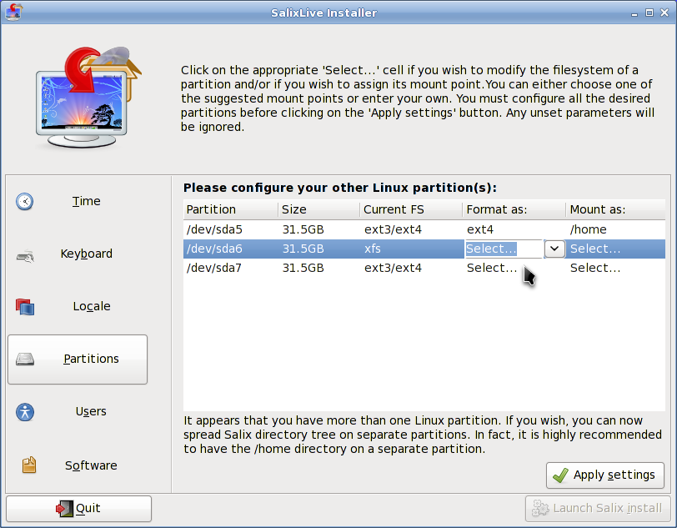

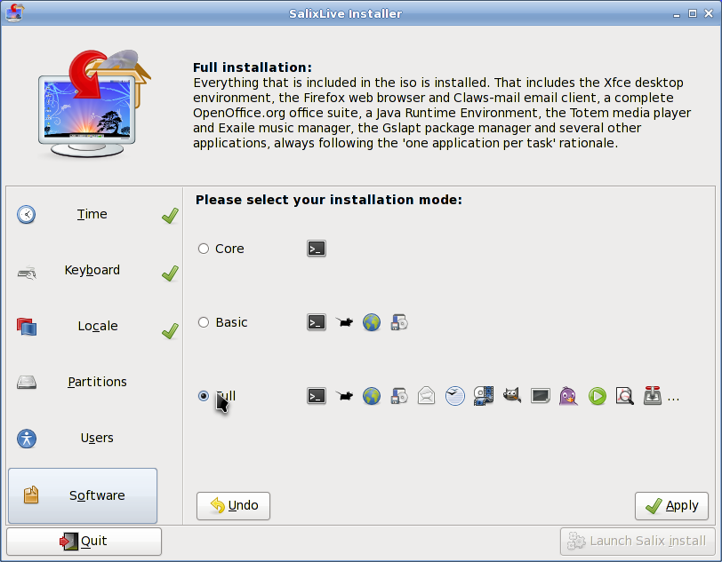

LiloSetup

Once the installation process is completed, You will be given the choice to launch LiloSetup to configure your LILO bootloader. Most of the time this is what you will want to do although on some occasion, it might be preferable not to, for example if you want to use Grub instead or if you want to simply incorporate Salix in an already existing bootloader configured from another distribution in a multiple boot setup.
LiloSetup is also very easy to use. Contextual help triggered by the position of the mouse will also be displayed above the application & will guide you every step of the way.

Customizing Salix Live

Advanced Boot Options

By selecting 'Change boot options' on Salix Live Boot menu, you will be offered a choice of supplementary boot options
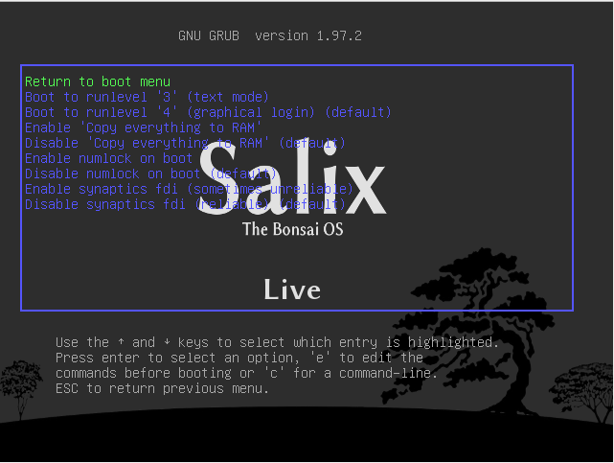
While instructions below Salix Live Boot menu will enable you to access to Salix Live 'manual' advanced Boot options.
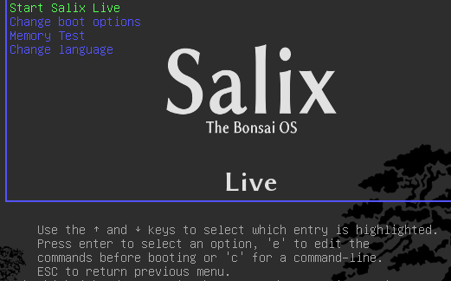

Pressing 'c' gives you access to the Grub shell. Type help to view all available commands.
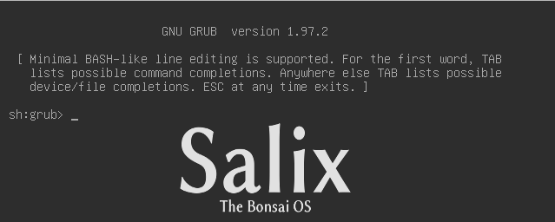
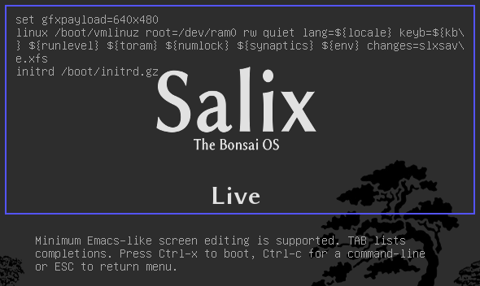
Pressing 'e' while 'Start Salix Live' is selected opens up the following display, enabling you to modify some of the booting options for example in order to enter a boot parameter.

Boot Parameters
Booting parameters or cheatcodes, are used to manipulate the booting process of Linux. Some of them are specific to Linux Live Scrips while some are common for all Linux versions. To enter a cheatcode, you simply have to add it to the 'linux' line above (after changes=slxsave.xfs), ensuring a blank space separates it from the previous boot parameter.

Useful boot parameters
To load in console only without executing Xorg (init 3)
3

To load Salix Live from a different location than the boot device:
from=/dev/device/salixlive-version.iso
from=path/to/salixlive-version.iso
from=path/to/exploded/salixlive-version.iso

To set root's password to "somepass", or ask for a new password:
passwd=somepass
passwd=ask

To load optional modules from /optional/ directory on the CD:
load=module
(You can use full module name (module.lzm) or you can skip the extension.)

To safeguard all changes made in a Salix Live session:
changes=file
changes=/dev/device
changes=/dev/device/file
changes=/path/
changes=/path/file
changes=/dev/device/path/
(This cheatcode is already included in Salix Live boot menu & the Persistence Wizard can assist you in creating a persistent file that will be automatically managed by SalixLive.)

To enable debug mode:
debug
(Starts bash several times during boot. Press Ctrl+D to resume booting)

Linux Live Scripts

The Linux Live Scripts come with the following useful commands:

Adding/Removing modules on the fly:
/usr/bin/activate
/usr/bin/deactivate

Make a module out of a directory:
/usr/bin/dir2lzm

Explode a module to a directory
/usr/bin/lzm2dir

Make a module out of a package:
/usr/bin/tgz2lzm
/usr/bin/txz2lzm

Personalizing Modules

Creating a module
1- Create a working directory
mkdir -p /mnt/hdxx/directory1

2- Install all software packages using this directory as root:
installpkg --root=/mnt/hdxx/directory1 packagea-x.x.x.txz
installpkg –-root=/mnt/hdxx/directory1 packageb-x.x.x.txz
installpkg –-root=/mnt/hdxx/directory1 packagec-x.x.x.txz
etc.

3- Remove all unneeded files:
rm -rf /mnt/hdxx/directory1/usr/doc/*

4- Make any modifications you want:
echo "whatever" > /mnt/hdxx/directory1/foo/bar

5- Build the module:
cd /mnt/hdxx/
dir2lzm directory1 module1.lzm

Customizing a module
You can fully customize the content of a module by removing or adding applications and by deleting, editing or adding new files inside of it.

1- Create a working directory.
mkdir -p /mnt/hdxx/directoryx

2- Explode the module you want to customize under the working directory.
lzm2dir /mnt/hdc/salixlive/base/modulex.lzm /mnt/hdxx/directoryx
(TIP: You can inspect that the module contains the unwanted packages by listing the /mnt/hdxx/directoryx/var/log/packages/ directory.)

3- Remove the packages from the working directory:
ROOT=/mnt/hdxx/directoryx removepkg packagex
ROOT=/mnt/hdxx/directoryx removepkg packagey
ROOT=/mnt/hdxx/directoryx removepkg packagez
etc.

4- Install new packages to the working directory
installpkg –-root=/mnt/hdxx/directoryx package1-x.x.x.txz
installpkg –-root=/mnt/hdxx/directoryx package2-x.x.x.txz
installpkg –-root=/mnt/hdxx/directoryx package3-x.x.x.txz
etc.

5- Rebuild the module.
cd /mnt/hdxx/
dir2lzm directoryx modulex.lzm

6- Replace the original module with your new module, rebuild the ISO image and reburn the CD.

Which module contains application XXX?

By browsing /mnt/live/memory/images/xxx.lzm/, you can view the contents of each modules, therefore you'll find which module holds a given package in /mnt/live/memory/images/xxx.lzm/var/log/packages/

Adding files to Salix Live
Sometimes all you want to do is add a couple files to Salix Live, for example specific configuration files. In that case it is not necessary to create or modify a module.
Salix Live CD holds a /salixlive/rootcopy/ directory. The content of this directory is copied to the root filesystem each time you boot, preserving all directories.
So, for example, if you wish to just use your own xorg.conf file, create etc/X11/ directories inside of /salixlive/rootcopy and store your xorg.conf in it. Note that you need to recreate the full directory hierarchy for the patches to work as desired.

Modify Salix Live ISO
To remaster Salix Live, you could simply use the program Isomaster. You must open an ISO file of Salix Live (for example the one you downloaded) and then add to and/or remove from the modules situated in /salixlive/base, /salixlive/modules or /salixlive/optional. Once you are done, save the modified ISO to your hard drive and use Brasero to burn it on a CD-ROM.

Or alternatively in CLI:
1- Create a work directory
mkdir /mnt/hdxx/custom_live

2- Copy Salix Live's CD content to your working directory.
cp -ra /mnt/live/mnt/hdc/* /mnt/hdxx/custom_live

3- Add or remove modules or files as needed.
rm /mnt/hdxx/custom_live/base/unwanted_module
cp new_module /mnt/hdxx/custom_live/base

4. Rebuild the CD image.
cd /mnt/hdxx/custom_live
./make_iso.sh /mnt/hdxx/live-x.x.x-custom.iso

A new bootable ISO image will be created with all your modifications. You simply need to burn it on a CD-ROM with brasero.

Live USB Flash Drive

How to install SalixLive on an USB key?
1- Open the .iso file using an archiver software (file-roller, xarchiver, 7-zip, iso-master ...).
2- Extract all files and folders (boot, packages and salixlive) to your USB root directory.
3- Go to the "boot" directory on the USB key.
4- Run "bootinst.sh" if you are on Linux or Unix, "bootinst.bat" if you're on Windows.
Alternatively, you can run "install-on-USB" if you're on Linux and have grub2 installed; this will prevent the first "reboot on first boot" operation.

How to boot from a SalixLive USB key?
In the same manner that you boot from the optical drive, you must assure you that the USB boot is set to boot before other devices in the BIOS setup.
On the first boot from a USB key, an advanced bootloader will be installed (grub2) and the system will reboot once, this process is normal and only happens one.

