
Universitat Jaume I
Degree in Design and Development of Video Games

Micorrizas
  - Design and Development of a Geolocated Cooperative Educational Video Game
for the Jardin de los Sentidos

Student | Saúl Pacheco Trilles
Supervisor | [Pending confirmation]
Course | VJ1241 - Final Degree Project
Version | Initial memory draft
Defense date | [Pending confirmation]
This draft follows the evaluation rubric provided for the UJI Final Degree Project and is intended as the starting point for the final dissertation.

Table of Contents

Note: the table of contents may require an automatic field update when the file is opened in Word or LibreOffice.

Keywords
Serious game; educational game design; cooperative multiplayer; geolocation; mobile learning; environmental education; Jardin de los Sentidos; Unity; botanical interpretation.

1. Introduction
Micorrizas is a Final Degree Project focused on the design and development of an educational mobile video game that must be played in the real setting of the Jardin de los Sentidos at Universitat Jaume I. The project transforms an existing didactic activity into a cooperative digital experience in which players observe, discuss and interpret the natural environment together [B1][B2][B4].
The project is not conceived as a conventional entertainment-only title. Its academic value lies in connecting three complementary domains: video game design, mobile software development and environmental didactics. The collaboration with the Early Childhood Education degree gives the game a clear pedagogical purpose: the environment is not only represented, but used as an educational resource that encourages attention, dialogue and shared interpretation.
A second defining feature is the cooperative structure. The game is designed for groups of two to six players. This decision is not cosmetic; it affects session management, information distribution, interface design, progression rules and the implementation of the multiplayer architecture. Several minigames deliberately distribute partial information across devices so that the group must coordinate before acting [B3].
A third milestone is geolocation. The physical location of the players is part of the interaction model, not just a contextual detail. The system must acquire device positioning, share that state across the cooperative session and represent the group over the campus map in a way that supports play and orientation. This makes geolocation one of the most technically demanding subsystems in the project [B3].
Finally, the project includes five distinct minigames related to different sensory and pedagogical dimensions of the garden. Their heterogeneity creates design breadth, while the shared cooperative framework provides architectural coherence. The project therefore combines variety at the gameplay level with reuse at the implementation level.

Main contributions of the project
- Transformation of a face-to-face educational activity into a playable cooperative mobile experience.
- Integration of multiplayer session flow and geolocation in the same learning-oriented system.
- Reusable minigame architecture supporting five mechanically distinct activities.
- Didactic focus grounded on biodiversity, observation and collaborative interpretation of the environment.

2. Motivations
The main motivation behind Micorrizas is to explore how game design can support meaningful learning without reducing the educational activity to a sequence of quizzes. The Jardin de los Sentidos already offers a rich pedagogical setting, but its educational potential depends heavily on guided facilitation. This project investigates whether a digital layer can preserve that pedagogical richness while increasing autonomy, repeatability and student engagement [B2][B4].
From a professional perspective, the project is an opportunity to integrate several areas that are especially relevant in game development: multiplayer interaction, responsive mobile interfaces, state synchronization, world-space mapping and the design of serious games. Rather than specializing in a single mechanic, the project embraces the complexity of a real product in which technical constraints and educational goals must coexist.
From an academic perspective, the project is also motivated by the interdisciplinary dialogue between video game development and teacher training. That collaboration gives the dissertation a clear rationale: the technical effort is justified by a concrete educational use case, and the design decisions can be defended not only as engineering choices but also as didactic ones.

3. Planning

3.1 Objectives
- Design a cooperative serious game that promotes active learning through observation and discussion.
- Develop a mobile experience that reacts to the player's position inside the Jardin de los Sentidos.
- Implement a multiplayer flow for groups of two to six users with shared progression.
- Create five minigames that address different sensory and didactic dimensions while sharing a common system architecture.
- Produce an understandable and extensible prototype that can support future educational validation.

3.2 Work breakdown and estimated effort
Task | Description | Estimated hours
Project analysis | Study of pedagogical context, garden activity and technical constraints | 10
Game design | Narrative, cooperative loop, minigame concepts and progression | 50
Technical design | Architecture, scene flow, session rules and content strategy | 30
Art and content preparation | Visual assets, spreadsheets, CSV content and supporting materials | 10
Core development | Gameplay systems, UI, reusable minigame framework and state management | 100
Multiplayer and geolocation | Relay session flow, GPS acquisition, synchronization and map markers | 40
Testing and iteration | Bug fixing, balancing, UX improvements and field validation | 30
Documentation | Technical proposal, GDD, memory and complementary writing | 20
Defense preparation | Slides, demo flow and oral presentation training | 10
Total |  | 300

3.3 Cost estimation model
The final dissertation should include an accredited market reference for hourly rates, hardware and software costs, as required by the evaluation rubric [B1]. To avoid introducing unsupported figures, this draft defines the structure of the estimate and leaves the numerical rates ready to be completed with cited sources in the next revision.
Cost item | Basis | Draft status
Labour cost | 300 hours distributed across design, programming, testing and documentation roles | Pending accredited rate source
Hardware cost | Personal computer and Android devices used for Unity development and on-site testing | Pending proportional valuation
Software cost | Unity ecosystem, IDE, design tools and complementary services | Pending licensing breakdown
Indirect costs | Energy consumption, connectivity and possible travel for on-site validation | Pending quantitative estimate

3.4 Planned vs. actual effort
The rubric requires a comparison between planned and real dedication. This table is intentionally included from the beginning so that the final memory can be updated with actual logs instead of retrofitting the chapter at the end.
Task | Planned hours | Current real hours | Deviation and justification
Project analysis | 10 | Pending consolidation | To be completed in the final revision
Game design | 50 | Pending consolidation | To be completed in the final revision
Technical design | 30 | Pending consolidation | To be completed in the final revision
Core development | 100 | Pending consolidation | To be completed in the final revision
Multiplayer and geolocation | 40 | Pending consolidation | To be completed in the final revision
Testing and iteration | 30 | Pending consolidation | To be completed in the final revision
Documentation and defense | 30 | Pending consolidation | To be completed in the final revision

4. Analysis

4.1 Functional requirements
Code | Requirement
FR1 | The system shall allow a host to create a cooperative lobby and share a join code.
FR2 | The system shall allow between two and six players to join the same session.
FR3 | The host shall synchronize transitions between lobby, world map and minigame scenes.
FR4 | Each device shall obtain local GPS readings and update them during play.
FR5 | The cooperative session shall share player location states across the network.
FR6 | The system shall display the local player and remote players on the campus map.
FR7 | The game shall include five cooperative minigames with differentiated mechanics.
FR8 | Minigames shall support tutorial, gameplay and result phases in a shared flow.
FR9 | Some minigames shall distribute partial information across devices so that communication is necessary.
FR10 | The game shall report results and allow the host to return the group to the main map.

4.2 Non-functional requirements
Code | Requirement
NFR1 | The interface must remain understandable on mobile screens with different aspect ratios.
NFR2 | The multiplayer flow must remain stable despite players joining from different devices.
NFR3 | GPS initialization must tolerate permission requests, disabled services and startup delays.
NFR4 | The architecture must separate cooperative session flow, geolocation logic, UI and minigame-specific rules.
NFR5 | Content for species, hints and attributes should be externalizable to CSV or config assets when possible.
NFR6 | The game should remain intelligible to non-technical readers and educators during demonstration.

4.3 System design
The design combines a shared session backbone with specialized gameplay modules. The cooperative loop starts in a lobby, moves to the world map once the player count is valid and then launches individual minigames from a synchronized coordinator. This structure makes the map the central hub and turns each minigame into a self-contained cooperative activity [B3].
At the minigame level, a common base class handles tutorial dismissal, stage changes and result publication. Concrete minigame sessions inherit that shared flow and only add their own data model, rule set and scoring logic. This approach allows the five activities to remain mechanically distinct without duplicating lifecycle code.

4.4 Architecture of the system
The implementation is organized around three clear layers. First, the session layer creates or joins the Relay lobby and controls synchronized scene transitions. Second, the spatial layer captures GPS data and publishes it to the network while projecting markers onto the map. Third, the gameplay layer encapsulates reusable minigame flow and the rules of each specific activity [B3].
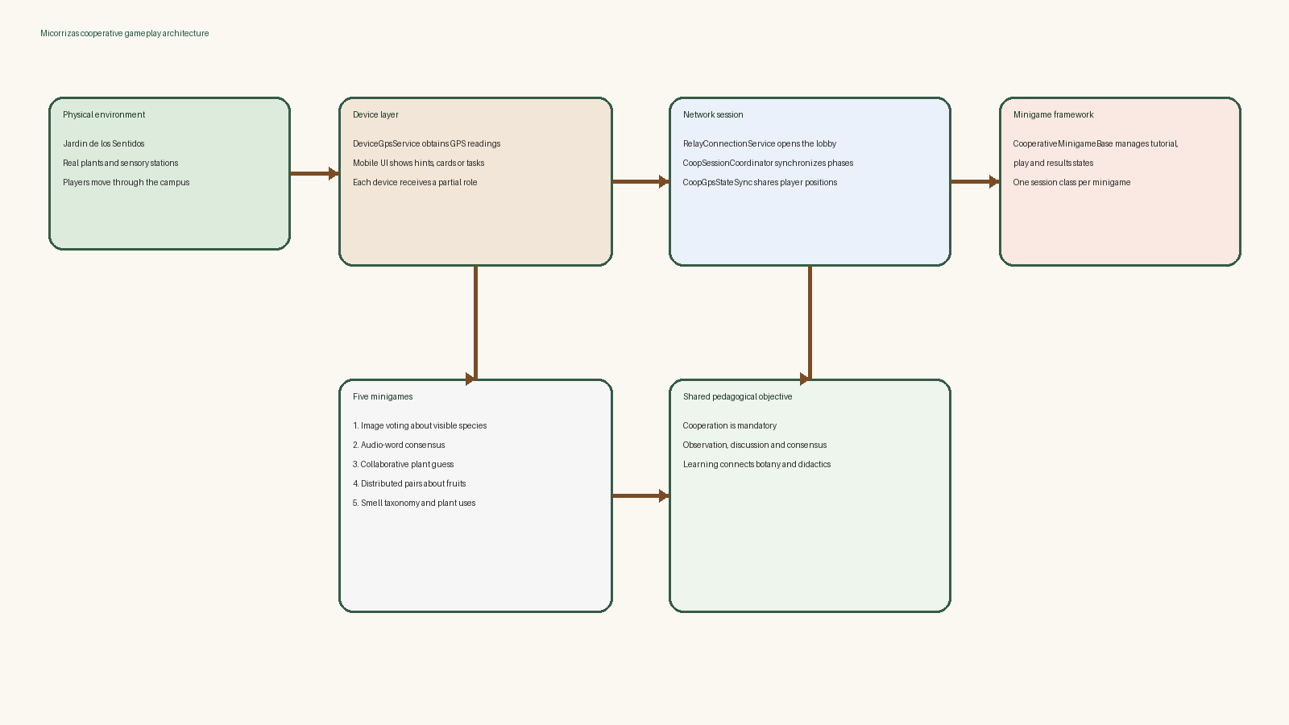
Figure 1. High-level architecture linking the physical garden, mobile devices, network session management and the reusable minigame layer.
Layer | Representative components | Responsibility
Session management | RelayConnectionService, CoopSessionCoordinator, CoopSessionRules | Lobby creation, join code flow, player limits and scene synchronization
Geolocation and map | DeviceGpsService, CoopGpsStateSync, CoopGpsMarkerController | GPS acquisition, network sharing and world-space representation of players
Reusable minigame framework | CooperativeMinigameBase, config assets, result models, responsive UI controllers | Common tutorial-gameplay-result lifecycle and shared UI patterns
Specific minigames | GardenImageVoting, AudioWordConsensus, CollaborativePlantGuess, DistributedPairs, GardenSmellTaxonomy | Rules, data interpretation and pedagogical tasks for each garden

4.5 Interface and gameplay structure
The project pays special attention to mobile usability. The source code already includes responsive layout controllers, safe area fitting and reusable view classes, which indicates that the interface is expected to adapt to different devices rather than rely on a single fixed composition [B3]. This is especially important because the project is intended for small groups using their own phones outdoors.

5. Development

5.1 Cooperative backbone
The cooperative backbone is implemented through Unity Netcode and a session coordinator that centralizes the current game phase, active minigame index and registered player slots. This enables the host to move the group from the lobby to the world map and from the map to individual minigame scenes while maintaining a shared state for all participants [B3].

5.2 Multiplayer through Relay
The relay service is responsible for creating or joining a lobby, generating the join code and starting the host or client role. The session rules clamp the valid range to two to six players, which matches the design intention stated by the project and the cooperative nature of the classroom activity. This decision is mirrored both in the high-level design and in the actual code, where player count is validated before the group can leave the lobby [B3].

5.3 Geolocation subsystem
Geolocation has been one of the most demanding milestones. The current implementation does more than call the device location API once: it requests permissions, verifies whether the operating system has location enabled, retries initialization after timeouts and publishes diagnostic states. This defensive design is necessary because outdoor mobile testing is much less predictable than a desktop-only prototype [B3].
Once readings are available, the system broadcasts them through a network list and uses a marker controller to place local and remote players on the map. This closes the loop between the real campus, the mobile device and the cooperative shared space.

5.4 Five minigames, one framework
Minigame | Didactic focus | Cooperative structure
Garden Image Voting | Visual recognition of plants and environmental observation | Players classify images together and validate what belongs to the garden
Audio Word Consensus | Interpretation of sounds and environmental meaning | One device provides audio while others contribute labels or contextual decisions
Collaborative Plant Guess | Deduction of plant identity from shared attributes | The group alternates turns and reads the common history to infer the target species
Distributed Pairs | Recognition of fruits and relations between items | Cards are split across devices, so communication is required to find the pairs
Garden Smell Taxonomy | Association between smell, function and botanical identity | Each device receives only part of the information needed to classify the plant

Although the five activities are distinct, they benefit from the same lifecycle: tutorial, waiting state until all players are ready, active gameplay and synchronized results. This is an important architectural achievement because it avoids implementing five isolated prototypes and instead builds a reusable cooperative platform [B3].

5.5 Problems found and solved
- Synchronizing the transition from tutorial to gameplay for all players without leaving late devices behind.
- Handling unreliable GPS initialization through retries, permission checks and diagnostic states.
- Representing multiple remote positions over the map while keeping local and remote markers visually distinguishable.
- Building minigames with different rules while preserving a shared architecture and avoiding duplicated multiplayer code.
- Keeping the project understandable for a didactic context instead of allowing the technical layer to dominate the design.

6. Results
At the current stage, the project already shows a coherent prototype structure aligned with the original goals. The source code and project assets demonstrate that the game is organized around a playable cooperative session, a geolocated map experience and five differentiated minigames that share a common technical framework [B3][B4].
Initial objective | Current outcome
Create a cooperative educational game | A multiplayer-first structure has been implemented, with explicit player limits and shared progression.
React to the players' physical position | GPS acquisition, state synchronization and map markers are integrated into the project.
Support collaboration instead of isolated play | Several minigames distribute information across devices and require discussion or turn alternation.
Cover multiple didactic dimensions | Five minigames address sight, sound, touch-like deduction, taste/pairs and smell taxonomy.
Produce an extensible prototype | The common minigame base and config-driven content point to a reusable architecture.

The most relevant practical application of the prototype is educational deployment in guided or semi-guided activities linked to the Jardin de los Sentidos. The project could also be adapted to other local natural environments if the content databases, world map references and didactic materials were replaced.
The final version of this chapter should add a completed comparison between planned and actual hours, together with screenshots and validation results from field sessions or supervised playtests.

7. Conclusions and Future Work
Micorrizas stands out because it does not treat the educational setting as a decorative theme. The natural environment, the cooperative structure and the geolocated interaction are all essential to the identity of the project. This makes the prototype more demanding than a conventional mobile minigame collection, but it also gives the dissertation a clearer academic justification.
The project demonstrates that a serious game can be designed around collaboration rather than individual performance. In this case, cooperation is reinforced by the session rules, the distribution of information across devices and the shared interpretation of the physical environment.
Future work should focus on three directions already suggested by the current prototype: first, completing the educational validation with target users; second, refining the content authoring pipeline so that new plants, clues and pedagogical activities can be added with less technical friction; and third, strengthening deployment readiness through broader device testing and robust outdoor validation sessions.

8. Bibliography
[B1] Universitat Jaume I. VJ1241 - Trabajo de Final de Grado. Rúbrica evaluación TFG. PDF supplied by the student.
[B2] Pacheco Trilles, Saúl. Micorrizas narrative notes stored in the project file 'Documentos/Micorrizas.txt'.
[B3] Micorrizas source code repository. Local inspection of Unity scripts, cooperative minigame framework, relay session flow and GPS synchronization. Accessed on April 29, 2026.
[B4] Pacheco Trilles, Saúl. Initial technical proposal for Micorrizas stored in 'Documentos/PropTec_Pacheco_Trilles_Saúl/PropuestaTecnica.tex'.

Appendix A. Repository-derived project overview
- Main session scripts: RelayConnectionService, CoopSessionCoordinator, CoopSessionRules.
- Geolocation scripts: DeviceGpsService, CoopGpsStateSync, CoopGpsMarkerController.
- Reusable minigame core: CooperativeMinigameBase, config assets, result models and responsive layout controllers.
- Specific minigame families: 01-GardenImageVoting, 02-AudioWordConsensus, 03-CollaborativePlantGuess, 04-DistributedPairs, 05-GardenSmellTaxonomy.

Appendix B. Next revision checklist
- Replace supervisor name and defense date on the cover.
- Complete the planning chapter with actual hours and justified deviations.
- Add accredited sources for labour, hardware and software costs.
- Expand the bibliography with the final scientific and technical references cited in the text.
- Insert screenshots from the latest stable build and field validation evidence.

