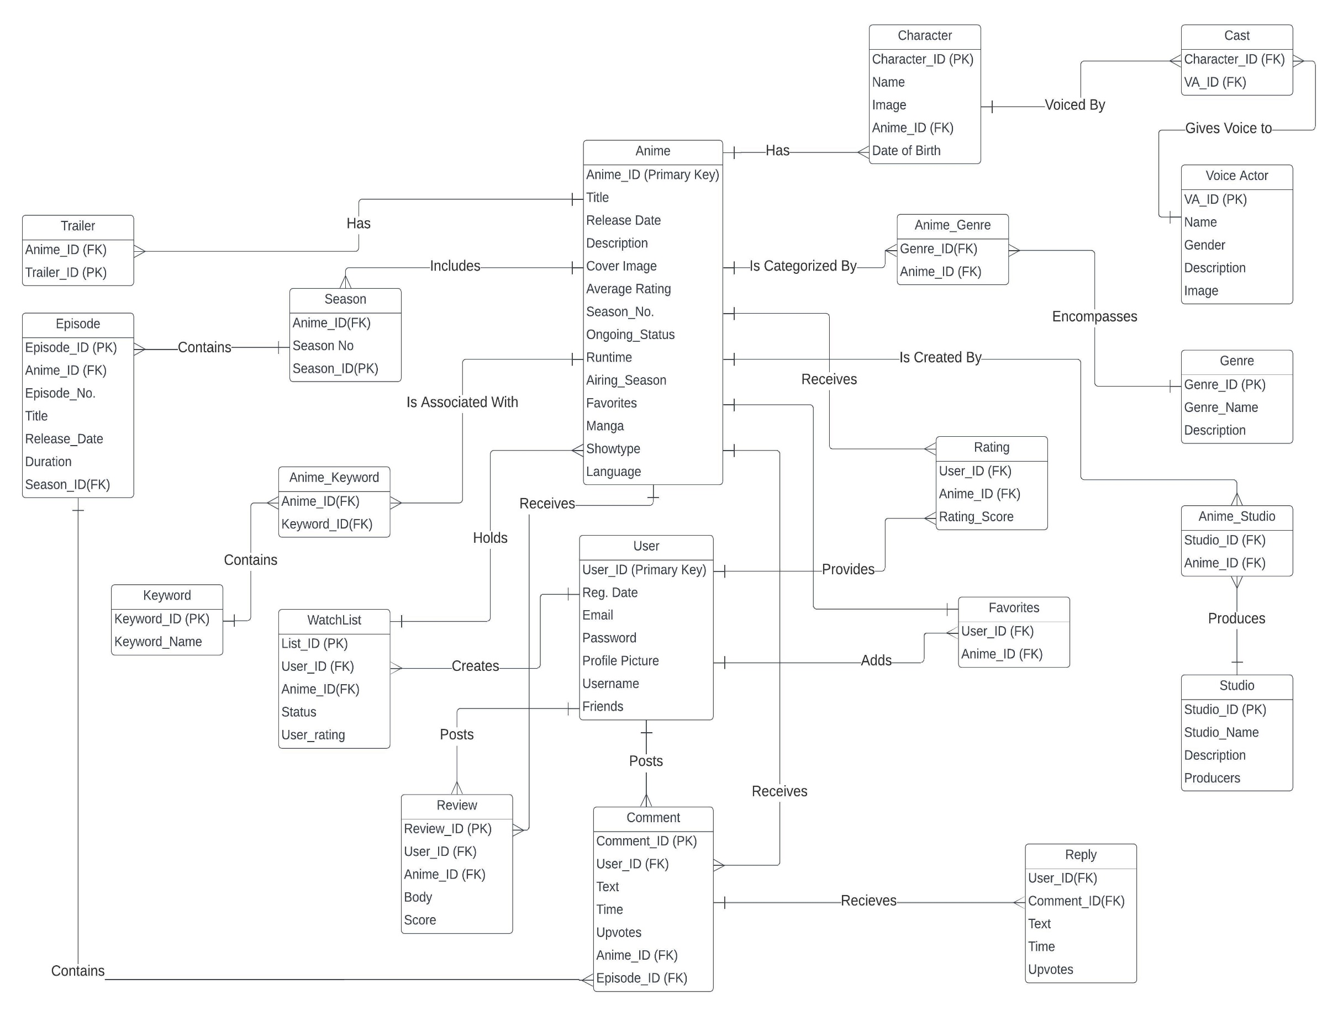

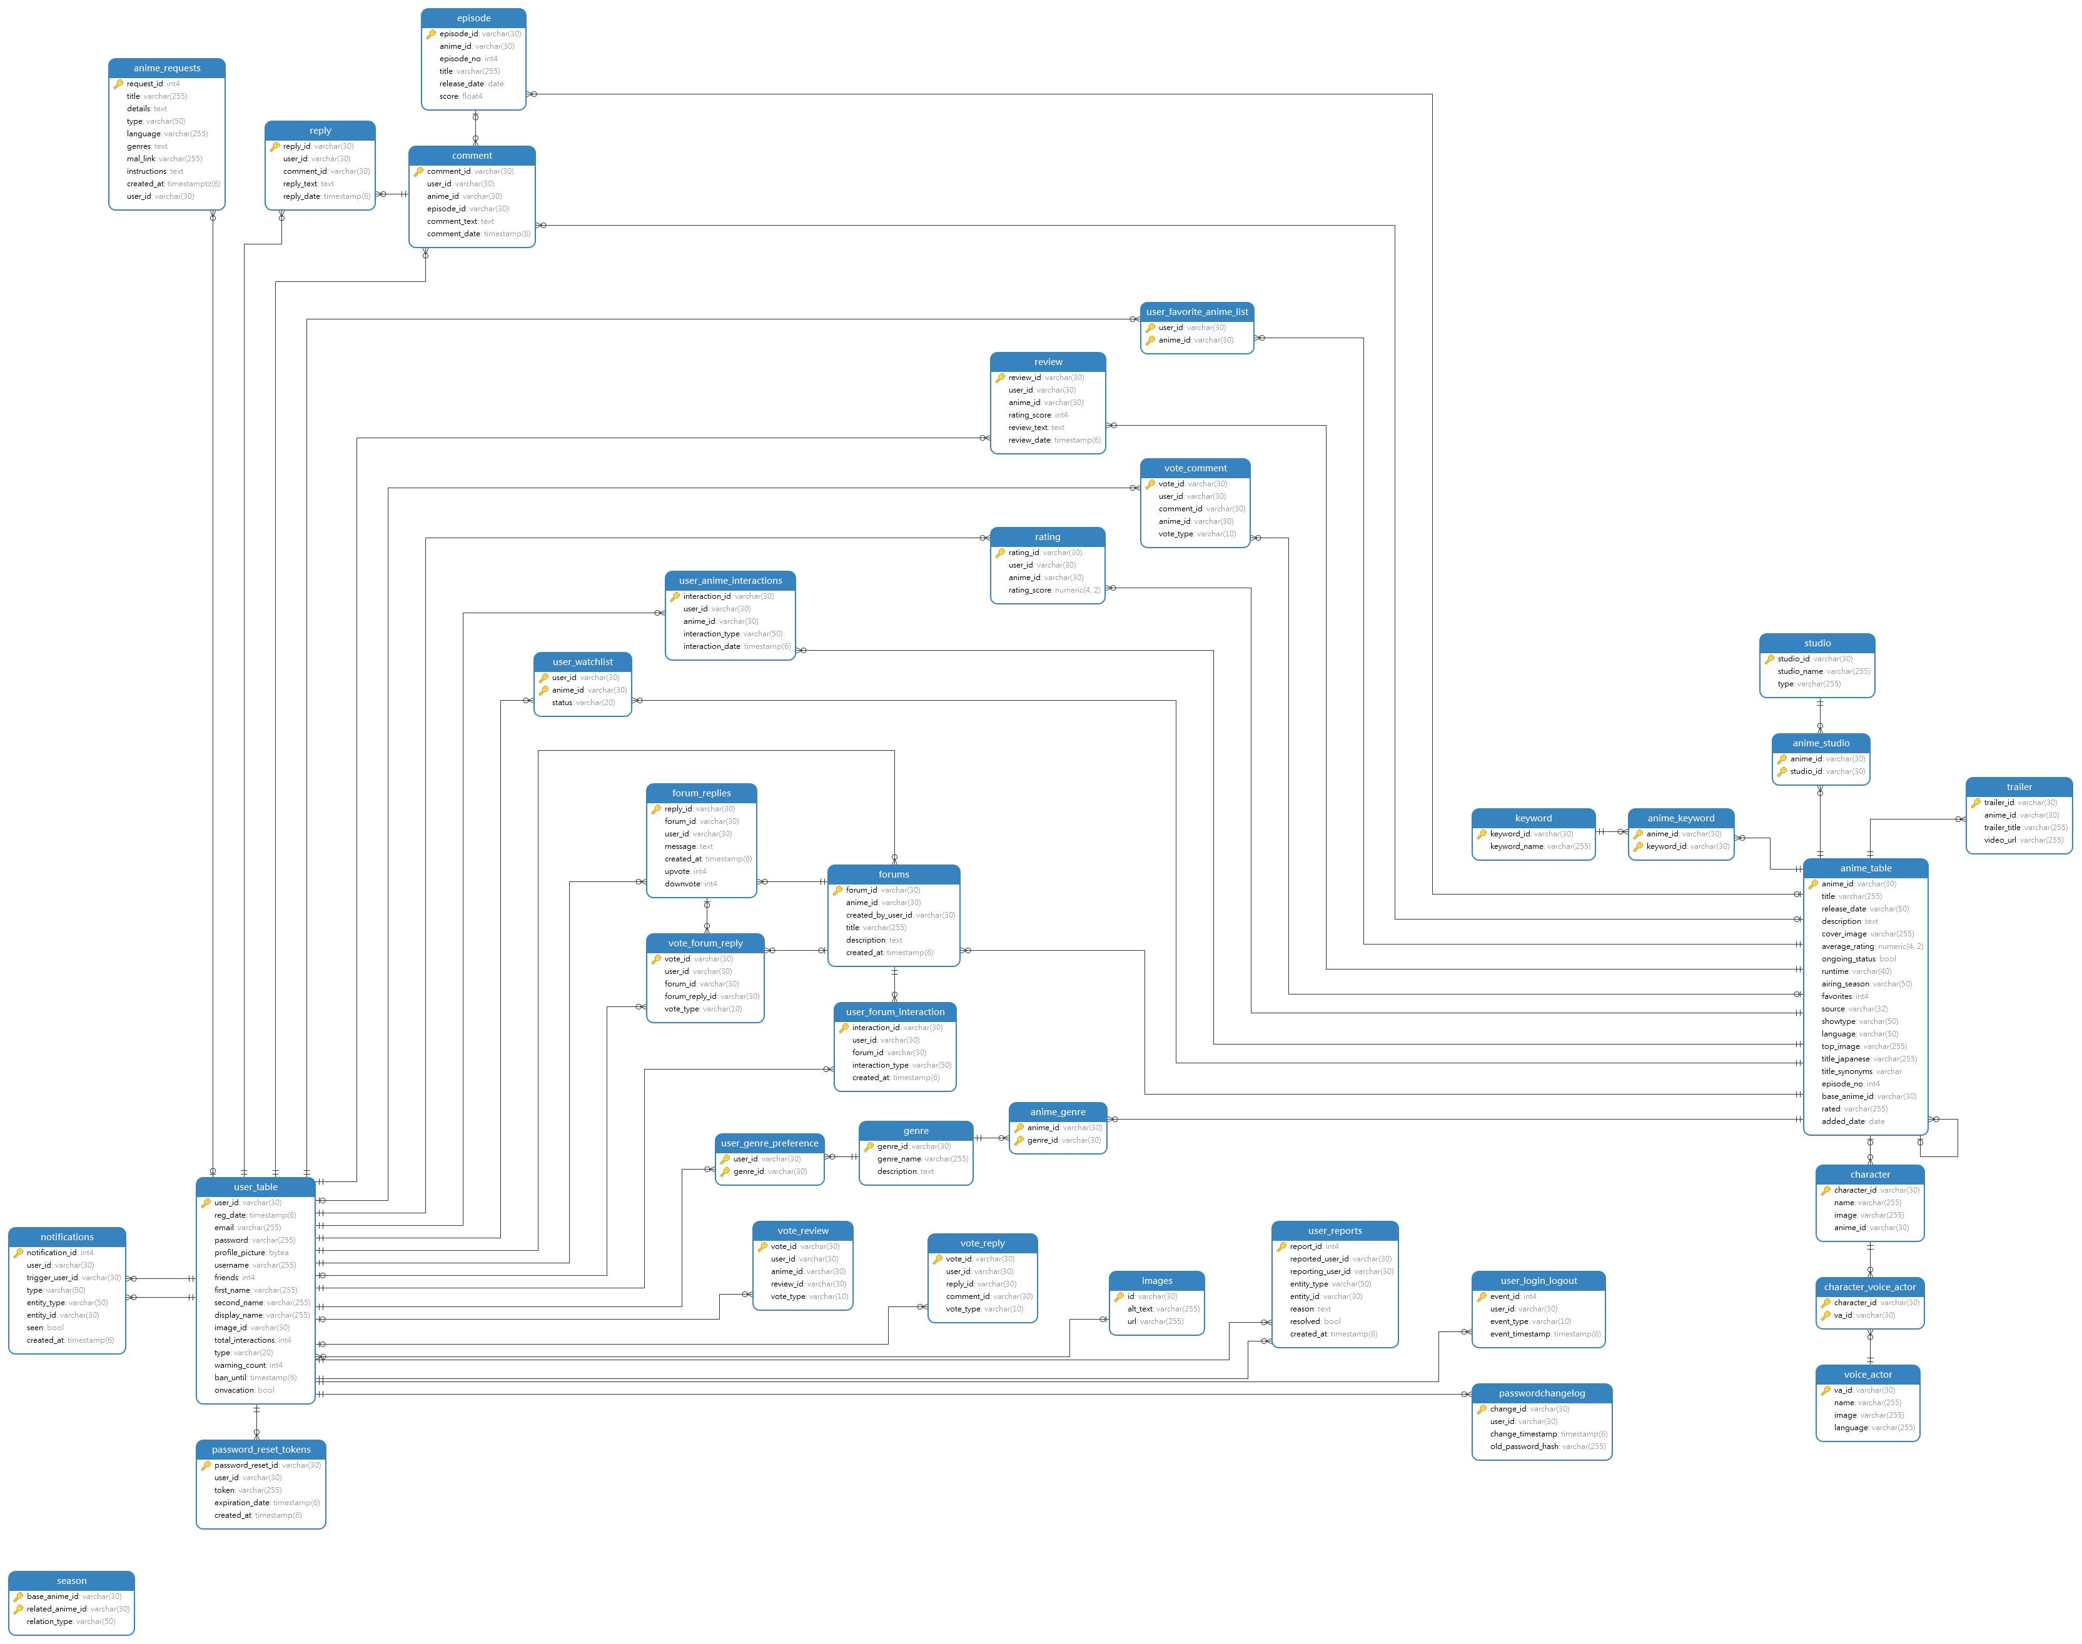

**Features :** As a Guest :

1. Home page
   1. Featured Anime
   2. New Added
   3. Recent Releases
   4. Upcoming
2. Browse page
   1. Trending now
   2. Popular This Season
   3. All Anime Top 30
3. Forum
   1. Recent Discussed Forum
   2. Recent Created Forum
   3. Forum info
4. Search page – finding based on many criteria
5. Anime page
   1. Every info about that anime
   2. Stats graph
6. Login
   1. Forgot Password
   2. Create Account – which leads to Sign Up page
7. Signup
8. Header
   1. A nav bar
   2. Login signup button
   3. A small search bar where user can search anime by their title
9. Footer
   1. A nav bar for contact faq and request
   2. A search system where user can search anime according to button from A to Z

As a Member :

1. Home – bored? Watch this
2. Header & footer – Request Option
3. Anime Page
   1. Add to watchlist
   2. Add Rating
   3. Add to favorites
   4. Add Forum
   5. Add Comment
      1. Edit
      2. Delete
      3. Flag other comments
      4. Upvote – downvote -> Can’t upvote or downvote own comment
   6. Add Reply
      1. Edit
      2. Delete
      3. Flag other replies
      4. Upvote- downvote -> Can’t upvote or downvote own reply
   7. Review – a user can add at most 1 review per anime
      1. Edit
      2. Delete
      3. Flag other reviews
      4. Upvote – downvote -> Can’t upvote or downvote own review
      5. Review rating score and Rating rating score are intra-connected
4. Forum
   1. Add Reply
   2. Upvote downvote reply
5. Other users profile
   1. Report user
6. Own Profile
   1. Profile picture selection
   2. Change password
   3. Update user info
   4. Delete Accout
      1. Permanently delete – Cascade Delete
      2. Take a break – Soft delete
   5. User Watchlist
   6. User favoritelist
   7. Notifications
      1. Interactions
      2. Warnings
   8. Stats
      1. Total interaction graph
      2. Watchlist line graph
      3. Rating graph
   9. Social
      1. Top Forums
      2. Top Reviews

As a moderator:

Same as member with below extra functionalities

* Anime Page
  + Comment
    - Delete other user’s comment except Admin
    - Edit other user’s comment except Admin
    - Flag other user’s comment except Admin
  + Reply
    - Delete other user’s reply except Admin
    - Edit other user’s reply except Admin
    - Flag other user’s reply except Admin
  + Review
    - Delete other user’s review except Admin
    - Edit other user’s review except Admin
    - Flag other user’s review except Admin
* Other user’s profile
  + Report user
  + Warn user
  + Ban user but can not ban another moderator
* Own Profile
  + Stats – 2 extra new stats
    - Genre preference pie chart according all user
    - User login logout rate per day
  + Reports
    - Can review a user
    - Can delete the report
  + Warning
    - Can set the warning as seen
* User Logs – Database area in front end – This shows what insert update or delete been done to database

As an admin :

Same as Member and Moderator with some modifications

* Anime Page
  + Delete, Reply, Review – Can delete, update every entity except other admin’s
* Other user’s profile
  + Can Delete the user Account
  + Can ban everyone except another admin
  + Can promote him to Moderator or can demote him to Member
* Own Profile
  + Can’t delete his own account
  + Notification
    - There is no warning field for an Admin
  + Request
    - Can add new anime according to user request
    - Can delete the user request

Total **Unique** Queries According to Rubrics

* Insert – 18
* Delete – 6
* Update – 17
* Join – 13
* Join (3 tables or more) – 18
* Subquery – 7
* Cascade Delete – 1
* Soft delete – 2
* Triggers – 5
* Procedures – 4
* Function – 3

Data in Anime Table - 24097

*Overall there are countless insertions deletions and function calls