EX 2: - Create a simple cloud software application for Property Buying & Rental process (In Chennai city) using any Cloud Service Provider to demonstrate SaaS include the necessary fields such as Buy, Rent, commercial, Rental Agreement, Rental Agreement, Area, place, Range, property value etc.

Step 1: - Go to ZOHO.com

Step 2: - Create an account and log into the account.

Step 3: - Create an application

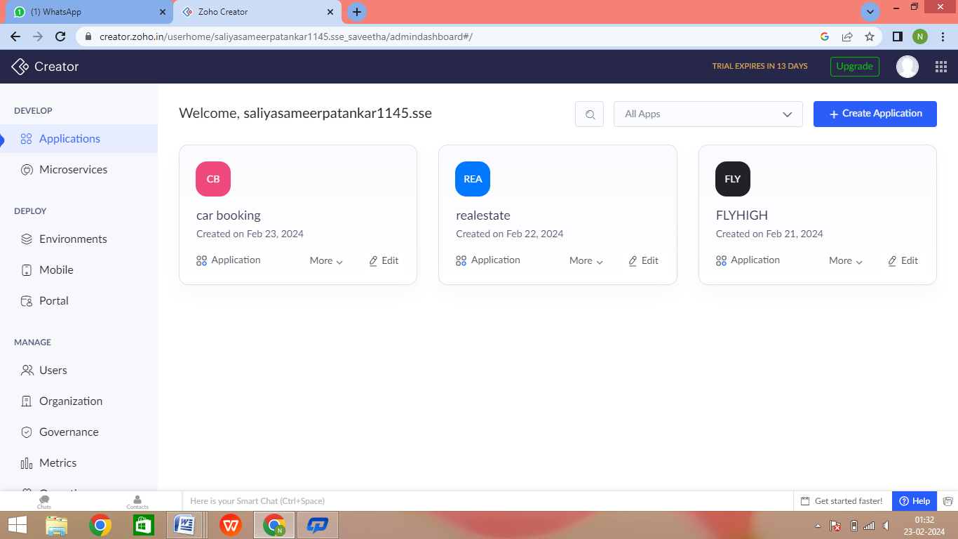

­­

Step 4: - Create login page(form)

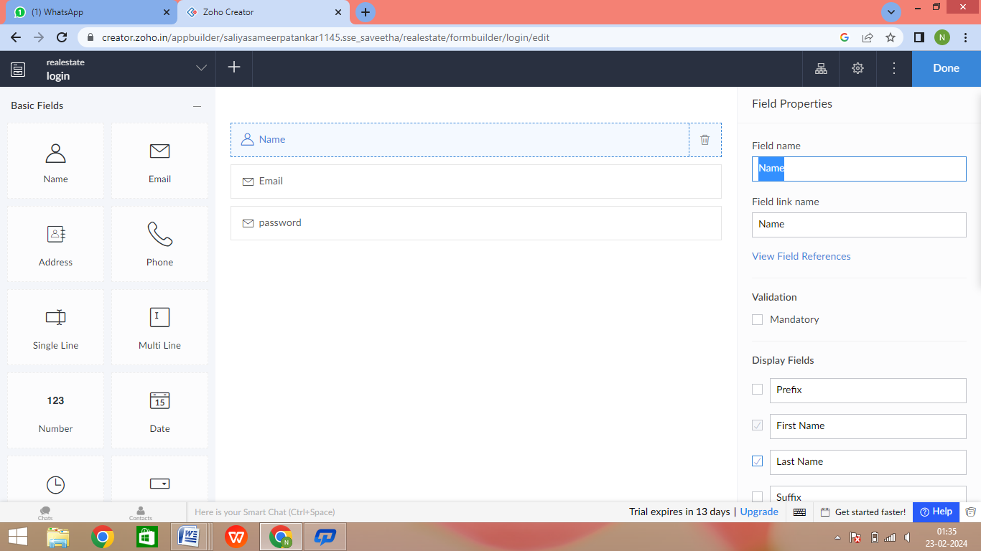

Step 5: - Second form creation (Property details)

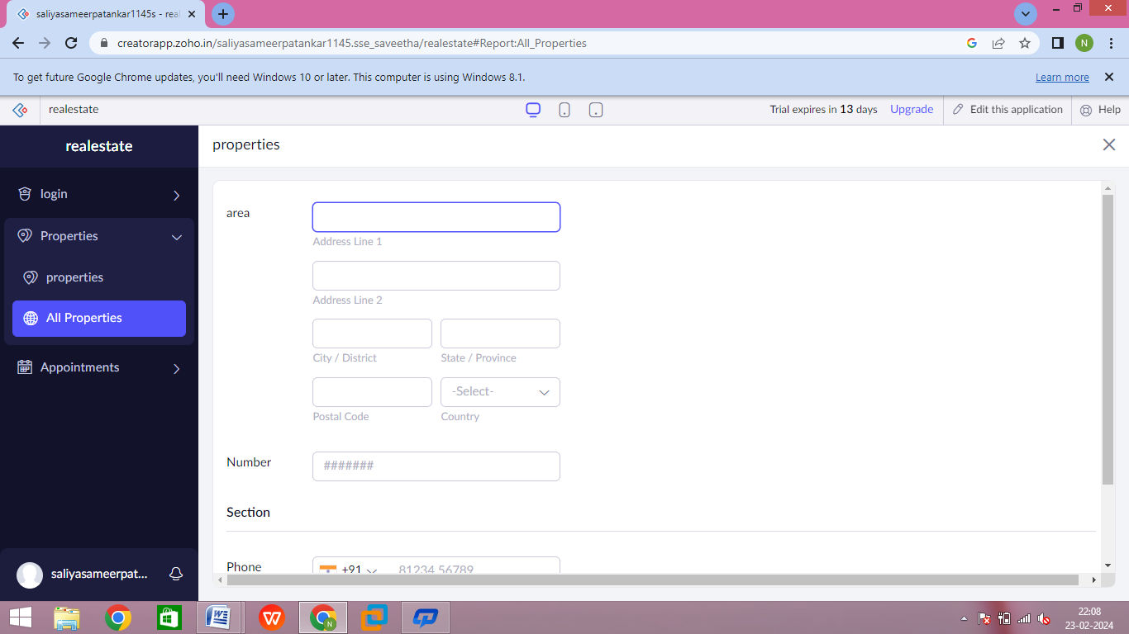

Step 6: - Create the next form for Appointment fixing

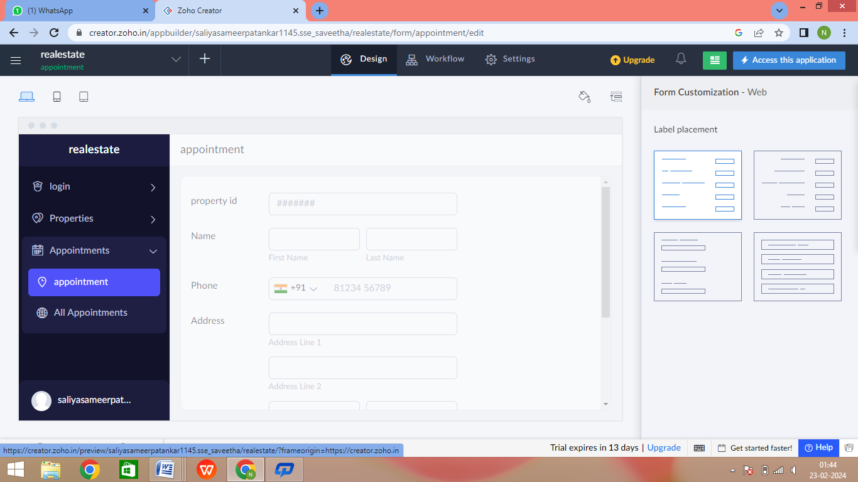

Step 7: - Click the report to see the stored data

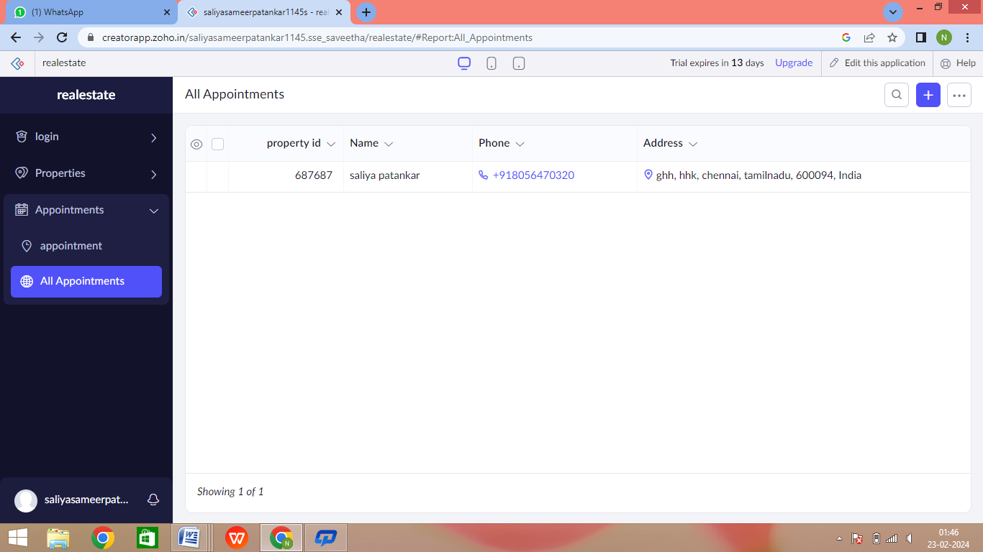

Step 8: - Click the mobile icon to see the output in mobile format

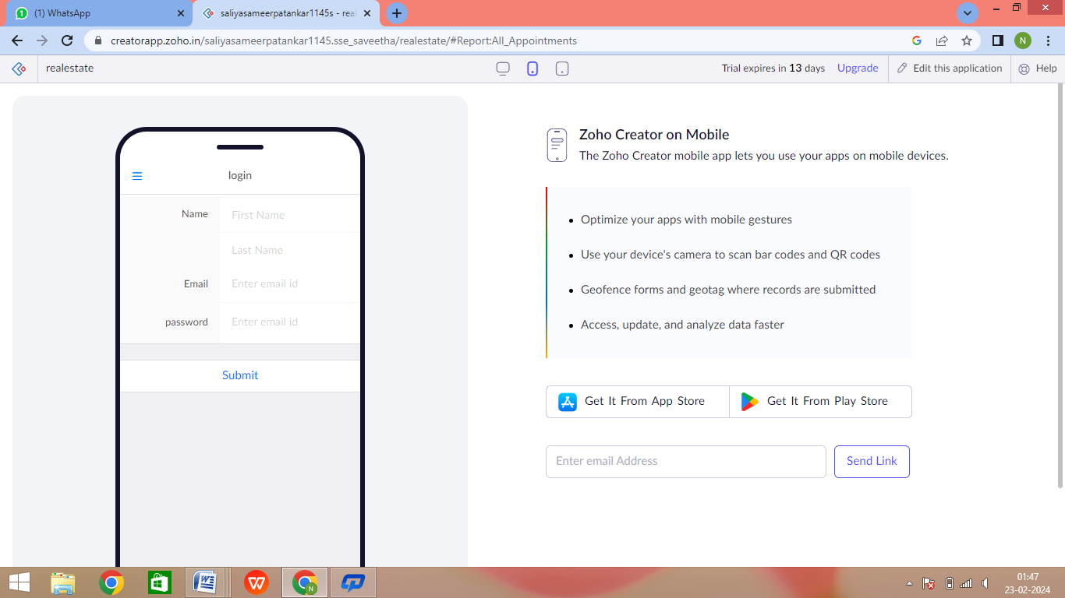

Step 9: - Click the tablet icon to see the output in tablet format

