**Ng-show**

1. The ng-Show directive shows or hides the given HTML element based on the expression provided to the ng-Show attribute

2.Syntax:-

<*element* ng-show="*expression*"></*element*>

3.parameters passed:- ngShow type:- expression if the expression is true/false element is shown/hidden respectively

4.Example :-

<body ng-app="">

<p><input type="checkbox" ng-model="check">Show Example</p>

<div ng-show="check">

<h1>this is ng show example</h1>

<h2>thankyou!!</h2>

</div>

</body>

5. ng-hide is another just opposite to ng show It shows the element when the expression is **false**, otherwise, it hides it.

6.ng-show/ng-hide does not remove the elements from DOM. It uses CSS styles to hide/show elements.This way your handlers that were attached to children will not be lost.

7.as shown in the picture the checkbox is uncheck so the Boolean value is false.

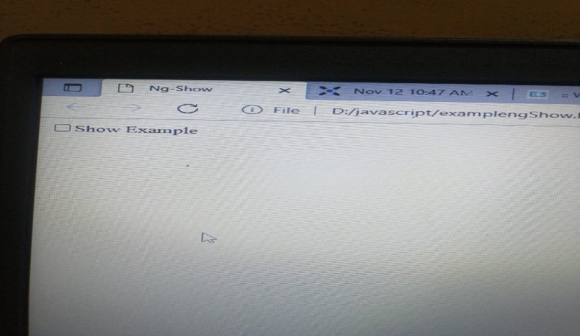

8.In this After checkbox is check we can see the Boolean value turns to be true and we see message inside div

