**Directives - Ng-style**

**Definition**

1.The ng-style directive specifies the style attribute for the HTML element.

**2.** The value of the ng-style attribute must be an object, or an expression returning an object.

3.The object consists of CSS properties and values, in key value pairs.

4. It is supported by all the HTML Elements.

**Syntax:**

5. <element ng-style="expression"></element>

**Parameter Values**

6.

**Value** – *expression*

**Description** - An expression which returns an object where the keys are CSS properties, and the values are CSS values.

## Directive Info

**7.** This directive executes at priority level 0.

## Usage

**8**. as attribute: <ANY

ng-style="expression"> …</ANY>

**9.** as CSS class: <ANY class="ng-style: expression;"> ... </ANY>

**10.Example**

**HTML**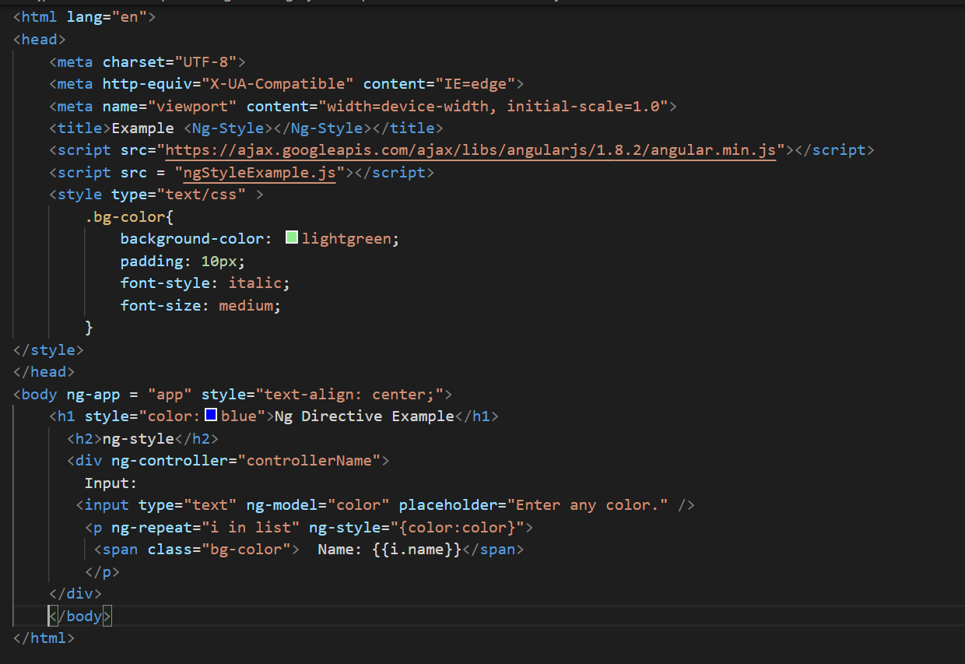

**JS**

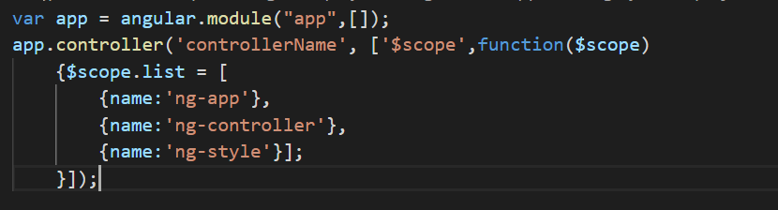

**Output:**

