Maze Graph

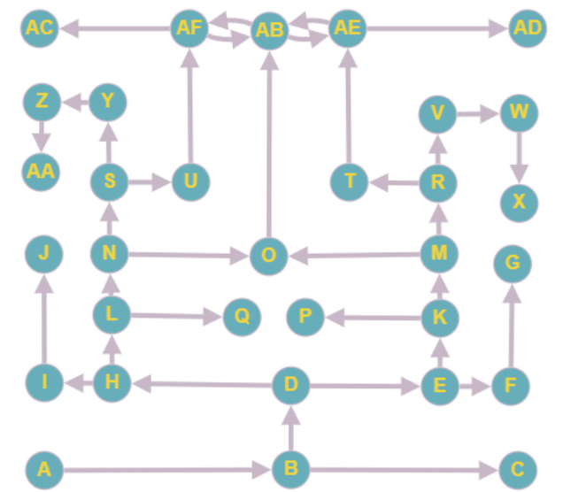

BFS

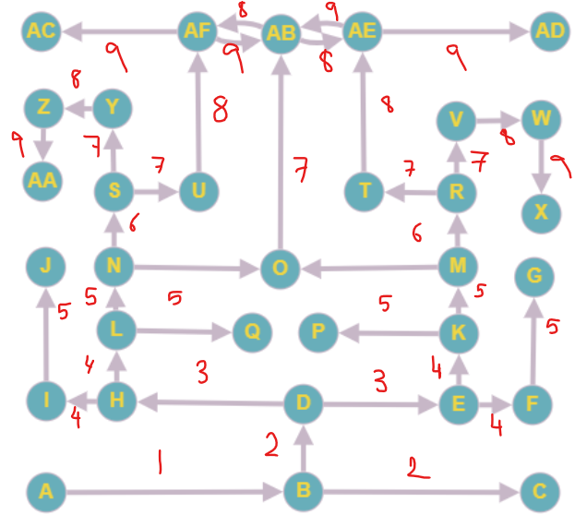

DFS

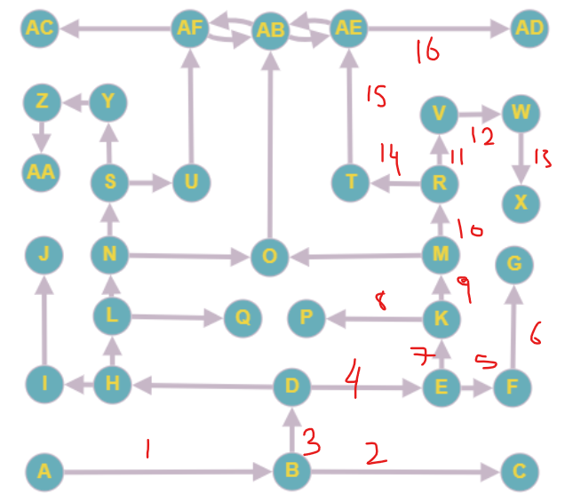

If I was stuck in a maze, I would use a DFS approach since it brute forces its way to a solution, unlike the BFS, It might not find the shortest path but it should find a path faster, it also doesn’t require moving through as many nodes as in BFS.