Machine Learning
Ahmed Sallam
2200588

Under supervision of
Dr .Batoul Haidar
&
Dr. Ghada Adel

GitHub Repo

Table of Contents:-
Introduction 4
Dataset Choice and Reasoning 5
2.1 Dataset 1 – Large but Fails the Minority Class 5
2.2 Dataset 2 – Smaller but Balanced 8
Exploratory Analysis and Pre-processing 9
Preprocessing: 9
Models and Methods 10
4.1 Logistic Regression 10
4.2 Random Forest 10
4.3 Unsupervised Feature Engineering with K-Means 11
5. Evaluation Protocol and Results (Dataset 2) 13
5.1 Test-set Results 13
5.2 Cross-Validation 14
6. Hyperparameter Tuning of Random Forest 15
7. Comparison with Existing Work 17
8. Role of Machine Learning and Impact on Society 17
9. Conclusion 18
Appendix B 19

Table of Figures:-
Figure 1. LR-Confusion Matrix dataset-1 Figure 2. RF- Confusion Matrix dataset-1 6
Table 1. K-Means clusters, sizes, and disease rates (training set). 11
Figure 3. K-Means clusters 11
Table 2. Test-set performance for all models (Dataset 2). 12
Figure 4. RF-Confusion Matrix dataset-2 Figure 5. LR-Confusion Matrix dataset-2 13
Table 3. 5-fold stratified cross-validation performance (Dataset 2, validation folds). 14

Introduction
Cardiovascular disease is a major cause of death worldwide. Being able to flag patients at high risk of heart disease can help clinicians prioritize further tests and interventions. This project attempts to tackle a binary classification problem: predicting whether a patient has heart disease based on clinical and demographic features.
The aim is to build an end-to-end machine learning pipeline that:
- Cleans and preprocesses real medical data.
- Trains and compares Logistic Regression and Random Forest models.
- Incorporates an unsupervised step (K-Means) for feature engineering.
- Uses cross-validation and hyperparameter tuning to assess stability.
- Critically evaluates results and discusses their implications.
I started on a large imbalanced survey dataset (Dataset 1), found that it led to misleading performance, and then moved (with lecturer approval) to a smaller, more balanced UCI-style dataset (Dataset 2), both from Kaggle, which is used for all final results.

Dataset Choice and Reasoning

2.1 Dataset 1 – Large but Fails the Minority Class
The first dataset I used was the “Heart Disease Dataset”. After preprocessing and splitting, I worked with:
- Total samples: 4,238
  - Train: 3,390
  - Test: 848
- Class distribution (overall):
  - No Disease (0): ~3,594 samples (~84.8%)
  - Disease (1): ~644 samples (~15.2%)
So roughly 85% vs 15% – a classic heavy imbalance.
On this dataset I tried several models and tricks:
- Logistic Regression
  - With class_weight='balanced'.
  - With SMOTE oversampling (standard SMOTE at 0.5).
  - With risk clustering (K-Means with k=3) + SMOTE.
  - With threshold tuning (targeting recall ≈ 0.8 for the disease class).
- Random Forest
  - Baseline: class_weight='balanced', n_estimators = 100.
  - With SMOTE (standard and gentle), and n_estimators = 200.
- ANN
  - Architecture: 17 inputs → Dense(32, ReLU, L2) → BatchNorm → Dropout(0.3) → Dense(16, ReLU, L2) → BatchNorm → Dropout(0.3) → Dense(1, Sigmoid).
  - Used class_weight='balanced'.
  - Early stopping with Val Precision-AUC as the monitored metric.
A typical bad case was the baseline Random Forest with class weights. On the test set (848 samples), it behaved roughly like this:
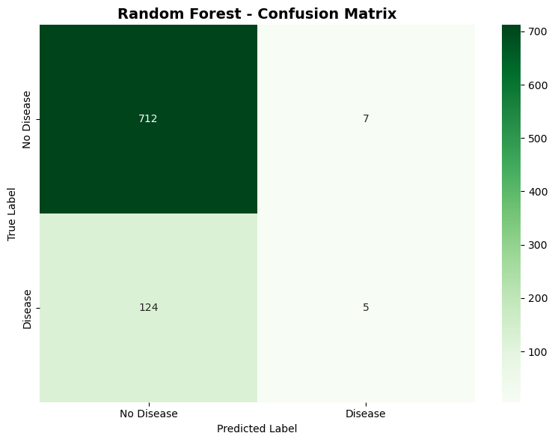
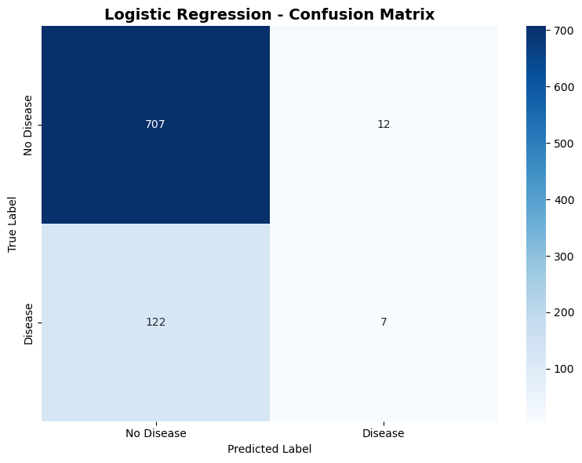

Figure 1. LR-Confusion Matrix dataset-1 Figure 2. RF- Confusion Matrix dataset-1
So out of ~129 diseased patients, it correctly caught only 7 and missed ~122.
- Approx metrics for the disease class (1):
  - Accuracy: ~0.85 (looks good at first glance).
  - Recall (1): ~0.02 → basically useless for detecting disease.
  - F1 (1): ~0.04.
  - ROC-AUC: around 0.70–0.75 (looks ok but hides the recall disaster).
Logistic Regression and the ANN did better for the minority class:
- ANN on Dataset 1:
  - Minority recall: ~0.55–0.60.
  - Precision: ~0.27.
  - So it actually learned something about the disease class, but at the cost of many false positives.
- Logistic Regression + SMOTE + clustering + threshold tuning:
  - Start: RF recall ≈ 0.02, LR baseline recall ≈ 0.60 for class 1.
  - After oversampling + cluster feature + threshold ≈ 0.22:
    - Minority recall pushed up to ≈ 0.80.
    - But precision dropped to ≈ 0.22.
    - Overall accuracy collapsed to ≈ 0.54.
So on Dataset 1, I could either:
- Have “nice” accuracy/ROC-AUC but awful recall for the patients that actually matter,
or
- Pump recall up by sacrificing accuracy and precision to the point where the model is just shouting “disease” on way too many healthy people.
That’s fine if the project was about dealing with extreme imbalance. After discussing this behaviour and these trade-offs with the lecturer, I was advised to try a different dataset.

2.2 Dataset 2 – Smaller but Balanced
I then switched to the “heart_disease_uci” . It is a cleaned UCI-style heart disease dataset with around 918 patient records and standard clinical features like:
- Age, sex
- Chest pain type
- Resting blood pressure, cholesterol
- Fasting blood sugar, resting ECG
- Maximum heart rate achieved, exercise-induced angina
- ST-segment related measures
The target is a binary label: values 0–4 (0 = no disease, 1–4 = increasing severity), which I binarized to a single label used in all models: 0 = no disease, 1 = any heart disease (num ≥ 1).
Compared to Dataset 1:
- It is much less skewed, so the models can be evaluated in a more meaningful way.

All results from here on use Dataset 2.
The ANN experiments on Dataset 1 are mentioned only to justify the dataset switch; the detailed evaluation focuses on Logistic Regression and Random Forest on Dataset

Exploratory Analysis and Pre-processing
On Dataset 2, basic EDA showed:
- Reasonable feature ranges, no obviously broken values.
- Moderate class imbalance, but both classes are well represented.
- Mix of numeric and categorical features.

Preprocessing:
- Train–test split
  - Stratified 80/20 split so class ratios are preserved in both train and test sets.
- Missing values
  - Numeric: imputed with the median.
  - Categorical: imputed with the most frequent category.
- Encoding
  - Categorical variables (e.g. chest pain type, slope) encoded as integers using label encoding.
- Scaling
  - Numeric features scaled with StandardScaler (zero mean, unit variance).
  - Needed for Logistic Regression, and used for K-Means and PCA.
- Class imbalance
  - Both Logistic Regression and Random Forest trained with class_weight='balanced'.
Data has been cleaned, numeric, scaled and ready for modelling.

Models and Methods

4.1 Logistic Regression
- Logistic Regression with class_weight='balanced'.
- Trained on the scaled features.
- Provides interpretable coefficients and probabilistic outputs.

4.2 Random Forest
- Baseline Random Forest:
  - n_estimators = 100
  - class_weight = 'balanced'
  - Default depth/split parameters.
- Later, a tuned Random Forest (Section 6) using GridSearchCV.

4.3 Unsupervised Feature Engineering with K-Means
To satisfy the unsupervised requirement in a useful way, I used K-Means on the scaled numeric features of the training set.
- Elbow method
  - Trained K-Means for $k∈\{2,3,4,5,6,7\}$.
  - Inertia plot shows an elbow around k = 3.
That means it was found that after k = 3, the curve of improvement starts to flatten, so 3 is the best option.
- Cluster stats
Table 1. K-Means clusters, sizes, and disease rates (training set).
Cluster ID | Risk Level | Count | Disease Rate | Disease percentage
0 | Low Risk | 342 | 0.3099 | 30.99%
2 | Medium Risk | 324 | 0.7562 | 75.62%
1 | High Risk | 70 | 0.8000 | 80.00%

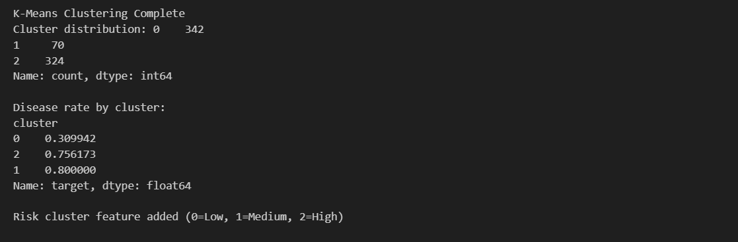
Figure 3. K-Means clusters

Disease prevalence increases monotonically from Cluster 0 to Cluster 1.
- Risk feature
I mapped these clusters to an ordinal risk_cluster feature:
- Cluster 0 → 0 (Low risk)
  - Cluster 2 → 1 (Medium risk)
  - Cluster 1 → 2 (High risk)
risk_cluster was added to the scaled training and test sets and used as an extra feature for Random Forest.
- PCA sanity check
Using PCA on the numeric features, plots of the first two components coloured by cluster and disease status showed that higher risk_cluster values aligned with regions having more positive (disease) cases, which supports the interpretation of this as a sensible risk stratification.

5. Evaluation Protocol and Results (Dataset 2)

5.1 Test-set Results
On the 20% test split (184 samples), metrics were:
Model | Accuracy | Precision | Recall | F1-Score | ROC-AUC
Logistic Regression | 0.8152 | 0.8333 | 0.8333 | 0.8333 | 0.8945
Random Forest (baseline) | 0.8370 | 0.8333 | 0.8824 | 0.8571 | 0.9216
Random Forest (tuned) | 0.8261 | — | 0.8627 | — | 0.9167
Table 2. Test-set performance for all models (Dataset 2).
Confusion matrices (for the two main models):
- Logistic Regression
Both classes have recall ≈ 0.83.
- Baseline Random Forest
Disease-class recall improves to ≈ 0.88.
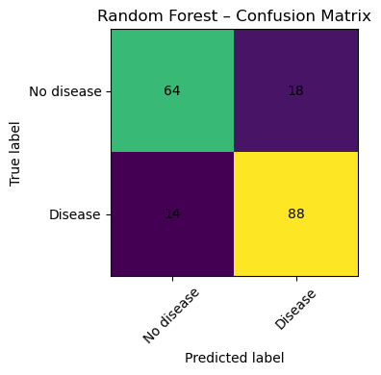
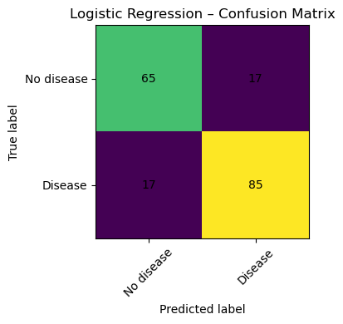

Figure 4. RF-Confusion Matrix dataset-2 Figure 5. LR-Confusion Matrix dataset-2
So on Dataset 2:
- Random Forest improves recall and F1 over Logistic Regression, and gives a higher ROC-AUC on the test set.
- Logistic Regression still performs strongly and is more interpretable.

5.2 Cross-Validation
To avoid overfitting to one split, I ran 5-fold StratifiedKFold CV on the training data:
Model | Accuracy  (mean ± std) | Precision | Recall | F1-Score | ROC-AUC
Logistic Regression |  |  | 0.7786 ±  0.0430 | 0.8041 ±  0.0126 | 0.8709 ±  0.0123
  0.7908 ± 0.0076
  0.8344 ±
  0.0268
Random Forest | 0.8030 ±  0.0143 | 0.8085 ±  0.0306 | 0.8475 ±  0.0367 | 0.8263 ±  0.0100 | 0.8659 ±  0.0216

Table 3. 5-fold stratified cross-validation performance (Dataset 2, validation folds).

Pattern:
- Logistic Regression: slightly higher mean ROC-AUC.
- Random Forest: higher recall and F1-score.
- Both: low standard deviations → stable across folds.

6. Hyperparameter Tuning of Random Forest
I tuned Random Forest using GridSearchCV (scoring = ROC-AUC) over:
- max_depth: [10, 20, 30, None]
- min_samples_split: [2, 5, 10]
- min_samples_leaf: [1, 2, 4]
- n_estimators: [100, 200]
Total: 72 combinations → 360 fits with 5-fold CV.
Best parameters:
- max_depth = 10
- min_samples_leaf = 2
- min_samples_split = 10
- n_estimators = 200
Performance:
Table 4. Baseline vs tuned Random Forest (Dataset 2).
Model | CV ROC-AUC (mean) | Test Accuracy | Test Recall | Test ROC-AUC
Random Forest (baseline) | 0.8659 | — | — | 0.9216
Random Forest (tuned) | 0.8793 | 0.8261 | 0.8627 | 0.9167

So:
- CV ROC-AUC improves from 0.8659 → 0.8793 with tuning.
- On the test set, baseline RF actually has slightly better accuracy, recall, and ROC-AUC.
- Differences are small; both are strong models.
This is expected on a relatively small dataset: CV performance improves, but on one fixed test split the “baseline vs tuned” difference is mostly noise-level.

7. Comparison with Existing Work
Published work and Kaggle notebooks on UCI-style heart disease datasets typically report:
- Accuracy and ROC-AUC in the 0.80–0.90 range.
- Tree-based models (Random Forest, Gradient Boosting) often slightly outperform linear models but are less interpretable.
My results match that pattern:
- Logistic Regression: ROC-AUC ≈ 0.89, balanced metrics, interpretable.
- Random Forest (baseline and tuned): ROC-AUC ≈ 0.92 on this test split, higher recall and F1-score.
The extra K-Means risk_cluster feature is a small step beyond “just train a classifier” and shows how unsupervised learning can contribute to clinically interpretable risk stratification.

8. Role of Machine Learning and Impact on Society
ML models for heart disease risk prediction can:
- Help flag high-risk patients earlier.
- Support clinicians with quantitative risk estimates.
- Improve prioritisation when resources are limited.
But:
- False negatives can delay care.
- False positives can cause anxiety and unnecessary tests.
- Bias in training data can harm under-represented groups.
- Privacy and security of health data is critical.
So models like these should be used as decision support, not replacements for clinicians, with external validation, monitoring and strong data governance.

9. Conclusion
This coursework built a complete ML pipeline for heart disease prediction:
- Started with a large, heavily imbalanced survey dataset (Dataset 1) and showed, with numbers, how models (including ANN) either failed the minority class badly or required extreme trade-offs.
- Switched, with lecturer approval, to a smaller but more balanced UCI-style dataset (Dataset 2) that better fits the coursework objectives.
- Applied a solid preprocessing pipeline (imputation, encoding, scaling, class weights).
- Trained and compared Logistic Regression and Random Forest on Dataset 2.
- Incorporated K-Means as an unsupervised step to engineer a risk_cluster feature.
- Used cross-validation and GridSearchCV to evaluate stability and tune Random Forest.
Final models achieved ROC-AUC around 0.89–0.92 with good recall, in line with the literature. The work shows both how data quality and class balance can make or break model behaviour (Dataset 1 vs Dataset 2), and how standard ML techniques can be combined to build and justify a practical heart-disease risk model.

Appendix B
{~ 1100 words}
import os
import pandas as pd
import numpy as np
from pathlib import Path
import warnings
warnings.filterwarnings('ignore')
Plotting
import matplotlib.pyplot as plt
import seaborn as sns
Machine Learning
from sklearn.model_selection import train_test_split, cross_val_score, GridSearchCV, StratifiedKFold
from sklearn.preprocessing import StandardScaler, LabelEncoder
from sklearn.compose import ColumnTransformer
from sklearn.pipeline import Pipeline
from sklearn.impute import SimpleImputer
from sklearn.linear_model import LogisticRegression
from sklearn.ensemble import RandomForestClassifier, GradientBoostingClassifier
from sklearn.metrics import (
accuracy_score, precision_score, recall_score, f1_score,
confusion_matrix, classification_report, roc_auc_score,
roc_curve, precision_recall_curve
)
Model persistence
import joblib
Set style for plots
plt.style.use('default')
sns.set_palette("husl")
Configuration
DATA_PATH = Path(r'....\dataset\heart_disease_uci.csv')
OUTPUT_DIR = Path('outputs')
OUTPUT_DIR.mkdir(exist_ok=True, parents=True)
(OUTPUT_DIR / 'figures').mkdir(exist_ok=True, parents=True)
(OUTPUT_DIR / 'models').mkdir(exist_ok=True, parents=True)
print("Setup complete!")
Load dataset
if not DATA_PATH.exists():
raise FileNotFoundError(f"Dataset not found at {DATA_PATH}")
Read CSV - handle missing values represented as empty strings or '?'
df = pd.read_csv(DATA_PATH, na_values=['NA', 'na', 'N/A', 'n/a', '', '?'])
print(f"Dataset shape: {df.shape}")
print(f"\nColumns: {df.columns.tolist()}")
print("\n" + "="*50)
print("First 5 rows:")
print("="*50)
df.head()
Data types and basic info
print("Dataset Info:")
print("="*50)
df.info()
print("\n" + "="*50)
print("Missing Values:")
print("="*50)
missing = df.isnull().sum()
missing_pct = (missing / len(df)) * 100
missing_df = pd.DataFrame({
'Missing Count': missing,
'Percentage': missing_pct
})
missing_df = missing_df[missing_df['Missing Count'] > 0].sort_values('Missing Count', ascending=False)
if len(missing_df) > 0:
print(missing_df)
else:
print("No missing values found!")
print("\n" + "="*50)
print("Basic Statistics:")
print("="*50)
df.describe()
Check target variable distribution
target_col = 'num'
print("Target variable distribution:")
print("="*50)
print(df[target_col].value_counts().sort_index())
print(f"\nUnique values: {sorted(df[target_col].unique())}")
Convert to binary classification: 0 = no disease, 1 = disease present (1-4)
df['target'] = (df[target_col] > 0).astype(int)
print(f"\nBinary target distribution:")
print(df['target'].value_counts().sort_index())
print(f"\nClass balance: {df['target'].value_counts(normalize=True)}")
Visualize target distribution
fig, axes = plt.subplots(1, 2, figsize=(12, 4))
Original multi-class target
df[target_col].value_counts().sort_index().plot(kind='bar', ax=axes[0], color='skyblue')
axes[0].set_title('Original Target Distribution (0-4)')
axes[0].set_xlabel('Disease Severity')
axes[0].set_ylabel('Count')
Binary target
df['target'].value_counts().sort_index().plot(kind='bar', ax=axes[1], color=['skyblue', 'salmon'])
axes[1].set_title('Binary Target Distribution')
axes[1].set_xlabel('target (0=No Disease, 1=Disease)')
axes[1].set_ylabel('Count')
axes[1].set_xticks([0, 1])
plt.tight_layout()
plt.savefig(OUTPUT_DIR / 'figures' / 'target_distribution.png', dpi=300, bbox_inches='tight')
plt.show()
Identify numeric and categorical features
Exclude id, dataset, and target columns
exclude_cols = ['id', 'dataset', 'num', 'target']
feature_cols = [col for col in df.columns if col not in exclude_cols]
Separate numeric and categorical features
numeric_features = df[feature_cols].select_dtypes(include=['int64', 'float64']).columns.tolist()
categorical_features = df[feature_cols].select_dtypes(include=['object']).columns.tolist()
print(f"Numeric features: {numeric_features}")
print(f"\nCategorical features: {categorical_features}")
For categorical features, we'll use LabelEncoder manually
Note: Numeric features will be imputed after splitting to avoid leakage
df_processed = df.copy()
for col in categorical_features:
le = LabelEncoder()
# Fill categorical missing values with mode
df_processed[col] = df_processed[col].fillna(
df_processed[col].mode()[0] if not df_processed[col].mode().empty else 'Unknown'
)
df_processed[col] = le.fit_transform(df_processed[col].astype(str))
print("\nCategorical encoding complete! Numeric imputation will be done after split.")
Prepare features and target
X = df_processed[feature_cols]
y = df_processed['target']
Split the data
X_train, X_test, y_train, y_test = train_test_split(
X, y, test_size=0.2, random_state=42, stratify=y
)
print(f"Training set size: {X_train.shape}")
print(f"Test set size: {X_test.shape}")
print(f"\nTraining set class distribution:")
print(y_train.value_counts(normalize=True))
print(f"\nTest set class distribution:")
print(y_test.value_counts(normalize=True))
1. Impute missing values in numeric features
imputer = SimpleImputer(strategy='median')
X_train_imputed = X_train.copy()
X_test_imputed = X_test.copy()
if numeric_features:
X_train_imputed[numeric_features] = imputer.fit_transform(X_train[numeric_features])
X_test_imputed[numeric_features] = imputer.transform(X_test[numeric_features])
2. Scale features
scaler = StandardScaler()
X_train_scaled = X_train_imputed.copy()
X_test_scaled = X_test_imputed.copy()
if numeric_features:
X_train_scaled[numeric_features] = scaler.fit_transform(X_train_imputed[numeric_features])
X_test_scaled[numeric_features] = scaler.transform(X_test_imputed[numeric_features])
print("\nData split, imputation, and scaling complete!")
Train Logistic Regression with balanced class weights
lr_model = LogisticRegression(class_weight='balanced', random_state=42, max_iter=1000)
lr_model.fit(X_train_scaled, y_train)
Make predictions
y_pred_lr = lr_model.predict(X_test_scaled)
y_pred_proba_lr = lr_model.predict_proba(X_test_scaled)[:, 1]
Evaluate
print("="*60)
print("LOGISTIC REGRESSION RESULTS")
print("="*60)
print(f"\nAccuracy: {accuracy_score(y_test, y_pred_lr):.4f}")
print(f"Precision: {precision_score(y_test, y_pred_lr):.4f}")
print(f"Recall: {recall_score(y_test, y_pred_lr):.4f}")
print(f"F1-Score: {f1_score(y_test, y_pred_lr):.4f}")
print(f"ROC-AUC: {roc_auc_score(y_test, y_pred_proba_lr):.4f}")
print("\nConfusion Matrix:")
print(confusion_matrix(y_test, y_pred_lr))
print("\nClassification Report:")
print(classification_report(y_test, y_pred_lr))
Train Random Forest with balanced class weights
rf_model = RandomForestClassifier(class_weight='balanced', random_state=42, n_estimators=100)
rf_model.fit(X_train_scaled, y_train)
Make predictions
y_pred_rf = rf_model.predict(X_test_scaled)
y_pred_proba_rf = rf_model.predict_proba(X_test_scaled)[:, 1]
Evaluate
print("="*60)
print("RANDOM FOREST RESULTS")
print("="*60)
print(f"\nAccuracy: {accuracy_score(y_test, y_pred_rf):.4f}")
print(f"Precision: {precision_score(y_test, y_pred_rf):.4f}")
print(f"Recall: {recall_score(y_test, y_pred_rf):.4f}")
print(f"F1-Score: {f1_score(y_test, y_pred_rf):.4f}")
print(f"ROC-AUC: {roc_auc_score(y_test, y_pred_proba_rf):.4f}")
print("\nConfusion Matrix:")
print(confusion_matrix(y_test, y_pred_rf))
print("\nClassification Report:")
print(classification_report(y_test, y_pred_rf))
from sklearn.metrics import confusion_matrix
import matplotlib.pyplot as plt
import numpy as np
Confusion matrix visualization – Random Forest
cm_rf = confusion_matrix(y_test, y_pred_rf)
classes = ["No disease", "Disease"]
plt.figure(figsize=(4, 4))
plt.imshow(cm_rf)
plt.title("Random Forest – Confusion Matrix")
plt.xlabel("Predicted label")
plt.ylabel("True label")
plt.xticks(np.arange(len(classes)), classes, rotation=45)
plt.yticks(np.arange(len(classes)), classes)
for i in range(cm_rf.shape[0]):
for j in range(cm_rf.shape[1]):
plt.text(j, i, str(cm_rf[i, j]), ha="center", va="center")
plt.tight_layout()
plt.show()
Create comparison dataframe
comparison_df = pd.DataFrame({
'Model': ['Logistic Regression', 'Random Forest'],
'Accuracy': [
accuracy_score(y_test, y_pred_lr),
accuracy_score(y_test, y_pred_rf)
],
'Precision': [
precision_score(y_test, y_pred_lr),
precision_score(y_test, y_pred_rf)
],
'Recall': [
recall_score(y_test, y_pred_lr),
recall_score(y_test, y_pred_rf)
],
'F1-Score': [
f1_score(y_test, y_pred_lr),
f1_score(y_test, y_pred_rf)
],
'ROC-AUC': [
roc_auc_score(y_test, y_pred_proba_lr),
roc_auc_score(y_test, y_pred_proba_rf)
]
})
print("\n" + "="*80)
print("MODEL COMPARISON")
print("="*80)
print(comparison_df.round(4))
Save comparison results
comparison_df.to_csv(OUTPUT_DIR / 'model_comparison.csv', index=False)
print("\nComparison results saved to 'outputs/model_comparison.csv'")
Get feature importance
feature_importance = pd.DataFrame({
'Feature': feature_cols,
'Importance': rf_model.feature_importances_
}).sort_values('Importance', ascending=False)
print("Feature Importance (Random Forest):")
print(feature_importance)
Plot feature importance
plt.figure(figsize=(10, 6))
plt.barh(feature_importance['Feature'], feature_importance['Importance'])
plt.xlabel('Importance')
plt.title('Feature Importance - Random Forest')
plt.gca().invert_yaxis()
plt.tight_layout()
plt.savefig(OUTPUT_DIR / 'figures' / 'feature_importance.png', dpi=300, bbox_inches='tight')
plt.show()
from sklearn.cluster import KMeans
Apply K-Means clustering (k=3)
kmeans = KMeans(n_clusters=3, random_state=42, n_init=10)
train_clusters = kmeans.fit_predict(X_train_scaled[numeric_features])
test_clusters = kmeans.predict(X_test_scaled[numeric_features])
print("K-Means Clustering Complete")
print(f"Cluster distribution: {pd.Series(train_clusters).value_counts().sort_index()}")
Analyze clusters
X_train_analysis = X_train_scaled.copy()
X_train_analysis['cluster'] = train_clusters
X_train_analysis['target'] = y_train.values
cluster_disease_rate = X_train_analysis.groupby('cluster')['target'].mean().sort_values()
print(f"\nDisease rate by cluster:\n{cluster_disease_rate}")
Map to risk levels
cluster_risk_mapping = {
cluster_disease_rate.index[0]: 0,
cluster_disease_rate.index[1]: 1,
cluster_disease_rate.index[2]: 2
}
Add as feature
train_risk = np.array([cluster_risk_mapping[c] for c in train_clusters])
test_risk = np.array([cluster_risk_mapping[c] for c in test_clusters])
X_train_scaled['risk_cluster'] = train_risk
X_test_scaled['risk_cluster'] = test_risk
print(f"\nRisk cluster feature added (0=Low, 1=Medium, 2=High)")
from sklearn.model_selection import cross_validate, StratifiedKFold
cv_strategy = StratifiedKFold(n_splits=5, shuffle=True, random_state=42)
scoring = ['accuracy', 'precision', 'recall', 'f1', 'roc_auc']
Logistic Regression CV
lr_cv = cross_validate(
LogisticRegression(class_weight='balanced', random_state=42, max_iter=1000),
X_train_scaled, y_train, cv=cv_strategy, scoring=scoring, n_jobs=-1
)
Random Forest CV
rf_cv = cross_validate(
RandomForestClassifier(class_weight='balanced', random_state=42, n_estimators=100),
X_train_scaled, y_train, cv=cv_strategy, scoring=scoring, n_jobs=-1
)
print("Cross-Validation Results (Mean ± Std):")
print(f"\nLogistic Regression:")
for metric in scoring:
scores = lr_cv[f'test_{metric}']
print(f" {metric}: {scores.mean():.4f} ± {scores.std():.4f}")
print(f"\nRandom Forest:")
for metric in scoring:
scores = rf_cv[f'test_{metric}']
print(f" {metric}: {scores.mean():.4f} ± {scores.std():.4f}")
from sklearn.model_selection import GridSearchCV
param_grid = {
'max_depth': [10, 20, 30, None],
'min_samples_split': [2, 5, 10],
'min_samples_leaf': [1, 2, 4],
'n_estimators': [100, 200]
}
grid_search = GridSearchCV(
RandomForestClassifier(class_weight='balanced', random_state=42),
param_grid, cv=5, scoring='roc_auc', n_jobs=-1, verbose=1
)
grid_search.fit(X_train_scaled, y_train)
print(f"Best parameters: {grid_search.best_params_}")
print(f"Best CV ROC-AUC: {grid_search.best_score_:.4f}")
Evaluate on test set
rf_tuned = grid_search.best_estimator_
y_pred_tuned = rf_tuned.predict(X_test_scaled)
y_pred_proba_tuned = rf_tuned.predict_proba(X_test_scaled)[:, 1]
print(f"\nTuned Model Test Performance:")
print(f" Accuracy: {accuracy_score(y_test, y_pred_tuned):.4f}")
print(f" ROC-AUC: {roc_auc_score(y_test, y_pred_proba_tuned):.4f}")
print(f" Recall: {recall_score(y_test, y_pred_tuned):.4f}")
print(f"\nBaseline vs Tuned:")
print(f" Baseline ROC-AUC: {roc_auc_score(y_test, y_pred_proba_rf):.4f}")
print(f" Tuned ROC-AUC: {roc_auc_score(y_test, y_pred_proba_tuned):.4f}")

