Project : ITI Educational Academy
Team : Sallam Rady – Magdy Adel.
A brief overview of the project
The project is a site for an educational academy that provides free and paid courses for students in various departments and classes.
Roles and powers
Admins.
Managers.
Professors.
Students.
DB Diagram
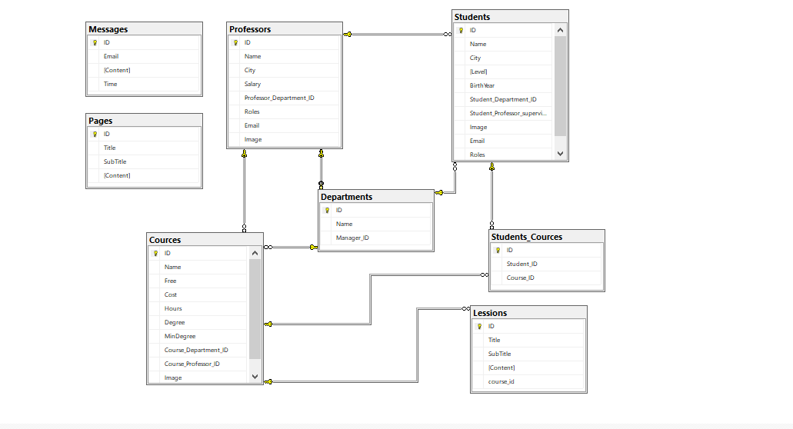

Video Link
https://www.loom.com/share/ea7ec96d01f24dbeb56cc6c6adcfa1c2
Github Link
https://github.com/SallamRady/ITI-Project
You will find script file in the same folder close to this file.
Thanks for reading Sallam Rady.

