
Slam-bot Mobile Robot Simulation

By: Salma Farid 197607

Module Leader: Dr. Anwar Magdy
Teaching Assistant: Eng. Mohamed Red

Table of Contents
1 Introduction 4
2 Project Description 4
2.1 Software Architecture 5
3 Hardware and Robot Platform Specifications 5
3.1 Actuators and Drive System 6
3.2 Sensing Suite 6
4 Robot Kinematics 7
4.1 Kinematic Equations 7
5 Localization and Mapping 7
5.1 SLAM-EKF (Simultaneous Localization and Mapping) along with Extended Kalman Filter 8
5.2 Cartography 9
6 Navigation Stack Configuration 9
7 Analysis And Results 10
7.1 SLAM-EKF Analysis 10
7.2 Cartography Analysis 10
7.3 Navigation Performance 10
8 Conclusion 11
9 Appendices 11
9.1 Appendix A Map Metadata (indoor_map_cartographer.yaml) 11
9.2 Appendix B: Simulation Environment 11
9.3 Appendix C: Robot Configuration and Description Files 12
9.3.1 C.1 SLAM Map Metadata (indoor_map_slam.yaml) 12
9.3.2 C.2 Main Robot Description (slambot.urdf.xacro) 12

Table of figures
Figure 1 - Indoor World 4
Figure 2 - Slambot stl file 5
Figure 3 - ROS2 node architecture for SLAM 5
Figure 4 - Indoor World SLAM-EKF in RVIZ Figure 5 - Generated SLAM-EKF map 8
Figure 6 – Slambot with TF and cartography vector showing 9
Figure 7 - Generated cartography map 9

Table of equations
Equation 1 - Velocity equations 7
Equation 2 - Position uncertainty prediction 8
Equation 3 - Position update 8

Table of Tables
Table 1 - Simulated Actuator Specs 6
Table 2 - Simulated Sensors 7

Introduction
The project explores the development and simulation of a mobile robot capable of Simultaneous Localization and Mapping (SLAM) within a ROS2 environment. Mobile robotics studies systems that can move unbounded throughout an environment, thus requiring sophisticated navigation stacks to achieve autonomy. The primary objective is to implement a robust navigation and mapping system. The simulation was implemented utilizing ROS2 Jazzy on Ubuntu 24.04, Nav2 and SLAM-Toolbox package. A cartographer code was also integrated to be able to test the resulting SLAM results. The software architecture follows the standard control scheme for mobile robots, integrating perception, localization and motion control to achieve autonomous behavior.

Project Description
The Slambot implements a differential-drive configuration with the following specifications
- Wheel radius: 0.1 m
- Wheel separation: 0.5 m
- Maximum linear velocity: 1.0 m/s
- Sensors:
  - 2D LiDAR (180° field of view, 1° resolution, 10m range)
  - Wheel encoders (simulated with Gaussian noise: μ=0, σ=0.01 rad/s)
  - IMU (simulated with drift characteristic of MEMS sensors)
Note: a camera was installed, however it was not needed in the model as it was for a different purpose.
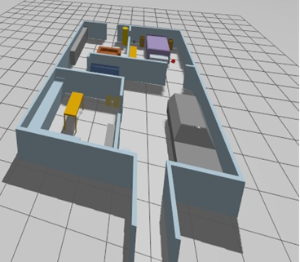
Figure 1 - Indoor World
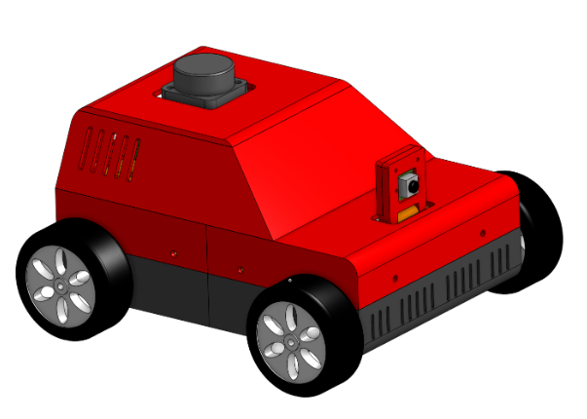
Figure 2 - Slambot stl file

Software Architecture
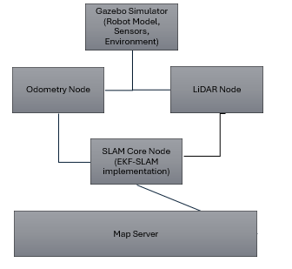
Figure 3 - ROS2 node architecture for SLAM

Hardware and Robot Platform Specifications
The simulated hardware is based on specific hardware constraints to ensure realistic behavior from the robot.

Actuators and Drive System
The robot utilizes a differential drive; the motion is driven by JGA25-371 DC gearmotors.
 | Hardware specs/constraints | Where the specs are utilized in simulation
Motor (JGA25-371) | 12V nominal Voltage  1:21 gear ratio  stall torque of 2.65 kg-cm | Gazebo_ros_diff_drive plugin takes values from the URDF and SDF files where max_wheel_torque and max_wheel_acceleration are defined respectively
Encoder | Integrated encoders provide 12 counts per revolution (CPR), used to calculate wheel odometry | The gazebo_ros_diff_drive plugin calculates the 12 CPR using the wheel radius
Driver (MDD10A) | Dual-channel 10A motor driver sends PWM speed and direction logic | In nav2_sim_params.yaml, a velocity limit was implemented as well as max yaw value based on the wheel radius and speed  nav2_amcl is also defined inside the .yaml file, defining the robot_model_type as a differential motion model.
Table 1 - Simulated Actuator Specs

Sensing Suite
Perception is necessary to be able to realize the location of the robot and the surrounding environment. There are two types implemented in the project; exteroceptive and proprioceptive, this is to avoid limited knowledge about the robot and the environment, as sensors are likely to have noise in the real world and thus can predict or assume certain incorrect outputs, this is avoided by using sensor fusion, where multiple types of sensors are used for the same objective – Localization and perception, to be able to accurately predict the environment and current position of the robot as it navigates. This is done using an extended Kalman filter, in the simulation environment it assumes a normal, gaussian noise distribution for all sensors.
 | Name | Function | Specs
Extroceptive | Okdo LiDAR | 2-d Laser scan used for obstacle detection and map building | Inside nav2_sim_params.yaml  Laser_max_range and max_dist are defined to be 100 and 2.0 respectively.
Proprioceptive | Motor Encoders | Tracks number of revolutions of each wheel, which is used to calculate approximate position based on wheel ratio. | Mentioned in table 1
Proprioceptive | IMU | Tracks the position and orientation of the robot | Sensor position described in imu.xacro, the position is used to correctly identify the robot’s current frame
Table 2 - Simulated Sensors
The odometry model functions by converting the encoder readings to odometry messages using the differential drive kinematics.
The LiDAR scan data is processed to extract line features using a random sample consensus, the lines are then parameterized in polar form and serve as landmarks in the EKF-SLAM state vector, they are extracted by first clustering adjacent points then line fitting is applied to each cluster, then detected lines are matched to existing landmarks using mahalanobis distance.

Robot Kinematics

Kinematic Equations
The differential drive configuration used for this robot is mechanically simple, in the 2d plane it’s represented by equation 2. For the slambot the wheel radius and distance between the wheels are defined and as such the linear and angular velocity were calculated using the following formulas
$$v = \frac{r\left(\dot{φ_{1}} + \dot{φ_{2}}\right)}{2}, ω = \frac{r\left(\dot{φ_{1}} - \dot{φ_{2}}\right)}{l}$$
Equation 1 - Velocity equations
To be able to represent the orientation to the global reference frame the standard rotation matrix with the x-axis theta is found

Localization and Mapping
Odometry uses encoders to track the robot’s position through the wheel’s radius and angular velocity, however since it is subject to systematic and non-systematic errors such as floor slippage, errors tend to propagate and pose uncertainty as the robot moves, there are two methods used in this project to map the environment.

SLAM-EKF (Simultaneous Localization and Mapping) along with Extended Kalman Filter

Ekf_sim.yaml takes all the sensor readings and applies a gaussian noise to each of the sensors on the diagonal to represent uncertainty, and calculates the estimated position based on the following equation
$x={\left[ξ_{I},m_{1},m_{2},…,m_{n}\right]}^{T}$
where:
$$ξ_{i}= \begin{matrix}x \\ y \\ θ\end{matrix}$$
Prediction Step:
$$p ( x_{t+1}) , m | z_{1:t+1} , u_{1:t +1}$$
Equation 2 - Position uncertainty prediction
Update Step (for each landmark observation $z_{i}$):
$$\iint{K}\int{p ( x_{t+1}) , m | z_{1:t+1} , u_{1:t +1}}dx_{1}dx_{2}Kdx_{t}$$
Equation 3 - Position update
where $m_{i}$ represents landmarks. The covariance matrix P represents uncertainty in both robot and landmark estimates, z is the estimated position of the robot from the landmarks, K is current position.
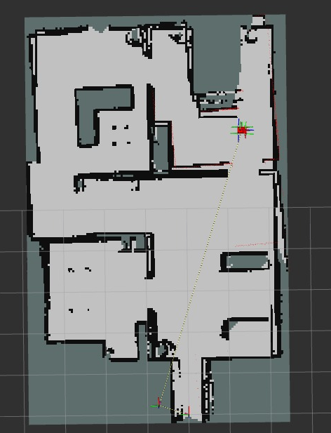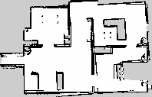
Figure 4 - Indoor World SLAM-EKF in RVIZ Figure 5 - Generated SLAM-EKF map

Cartography
To confirm the results of the SLAM map generated utilizing the above-mentioned process, a cartography map is generated by extracting features from Lidar data and detecting loops that have been closed when the robot visits a location twice to correct the accumulated drift in the map and trajectory.
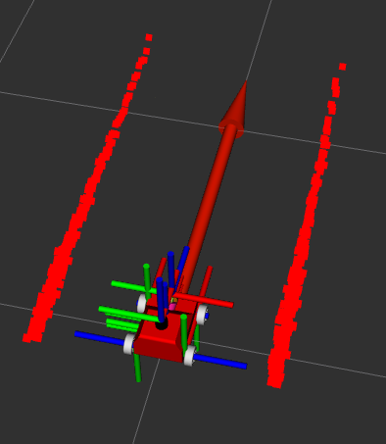
Figure 6 – Slambot with TF and cartography vector showing
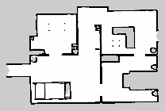
Figure 7 - Generated cartography map

Navigation Stack Configuration
Autonomous movement is achieved following the generated map using several methods, namely the AMCL particle filter, configured in this project with a maximum of 2000 particles to track the robot’s pose against the generated map, then a collision monitor is implemented using a “footprint approach” to prevent collisions with obstacles by monitoring the laser scans, then a planner and controller servers calculate global path and local motor commands to follow the programmed path.

Analysis And Results
By contrasting the two mapping techniques—EKF-SLAM and Google Cartographer—the Slambot's performance was assessed. Map consistency, structural accuracy, and the robot's capacity to manage sensor noise were taken into consideration when analyzing the outcomes.

SLAM-EKF Analysis

The SLAM-EKF implementation showed excellent landmark tracking efficiency. Throughout the initial exploration, the robot was able to maintain a consistent pose estimate by fusing wheel odometry and LiDAR data using the Extended Kalman Filter.
Precision: Gaussian noise from the encoders and IMU was successfully reduced by the EKF.
Observations: The generated map correctly depicts the main boundaries of the indoor world, as shown in Figure 5. However, a small accumulation of drift was seen in the covariance matrix ($P$) as movement persisted over longer times, which is common for EKF-based systems when landmark density is low.

Cartography Analysis
The Cartographer map (Figure 7) served as a benchmark for the EKF results. Unlike the EKF, which focuses on landmark state vectors, Cartographer utilizes scan-to-scan matching and global submap optimization.
Loop Closure: Cartographer outperformed the EKF in "closing the loop." When the Slambot revisited the starting location, the backend optimization corrected the accumulated odometry drift, resulting in sharper wall definitions and more accurate corridor lengths.
Visual Fidelity: The occupancy grid generated via Cartography showed fewer "ghosting" effects (double walls) compared to the raw EKF output, confirming that the scan-matching constraints provided a more rigid map structure.

Navigation Performance
The robot was successfully localized in both maps by the AMCL particle filter after the navigation stack was set up. The collision monitor successfully interpreted the LiDAR data using the footprint approach, making sure that the robot was slowed down before it reached obstacles specified in the.yaml parameters thanks to the Okdo LiDAR's 10m range.

Conclusion
This project effectively used ROS2 Jazzy and Gazebo to demonstrate the implementation of an autonomous mobile robot simulation. The Slambot successfully navigated a simulated indoor environment by fusing sophisticated perception and localization algorithms with differential drive kinematics.
The advantages of contemporary SLAM backends were demonstrated by the comparison study between SLAM-EKF and Cartography. The Cartographer incorporated superior loop-closure capabilities that were crucial for preserving map integrity over long trajectories, while the EKF-SLAM offered a computationally effective approach for real-time localization and landmark tracking.
Overcoming simulated sensor noise and slippage required the use of sensor fusion (LiDAR, IMU, and encoders) processed through the EKF. In the end, the project demonstrates that high-level autonomy in mobile robotics can be achieved with a well-tuned navigation stack, bolstered by reliable mapping data and collision monitoring. In order to improve environmental understanding, future work may incorporate the onboard camera for semantic mapping or visual SLAM.

Appendices

Appendix A Map Metadata (indoor_map_cartographer.yaml)
The generated occupancy grid utilizes the following spatial constraints:
- Resolution: 0.050 m/pixel
- Origin: [-0.653, -2.558, 0.0]
- Occupied Threshold: 0.65
- Free Threshold: 0.196

Appendix B: Simulation Environment
The testing environment was constructed using the indoor_world_with_qr_codes.sdf file, which includes:
- Physics Engine: Gazebo Sim (1ms step size)
- Surface Properties: Friction coefficients set to mimic polished concrete to test odometry slippage.
- Lidar Profile: 60 beams with a 180 degrees field of view

Appendix C: Robot Configuration and Description Files

C.1 SLAM Map Metadata (indoor_map_slam.yaml)
image: indoor_map_slam.pgm
mode: trinary
resolution: 0.050
origin: [-0.207, -2.458, 0]
negate: 0
occupied_thresh: 0.65
free_thresh: 0.196

C.2 Main Robot Description (slambot.urdf.xacro)
The master XACRO file handles modular inclusion of chassis, sensors, and simulation-specific plugins (e.g., imu_sim.xacro and ros2_control_sim.xacro).

