INFS3103 Systems Analysis and Design
Phase 2: Analysis
Smart Diabetes Prevention & Management System

Course | INFS3103 Systems Analysis and Design
Team Members | Sally Jumah, Lamis Alkahlout
Submission | Phase 2 Analysis
Document | Use Case Models, Wireframes & Requirements Alignment
Date | 2026\3\29

1. Use Case Models
This section presents the use case models for the Smart Diabetes Prevention & Management System (SDPMS). It includes the use case diagram covering all system interactions and four fully developed use case descriptions for the most complex use cases.

1.1 Use Case Diagram
The following use case diagram identifies all actors and their interactions with the SDPMS system boundary.

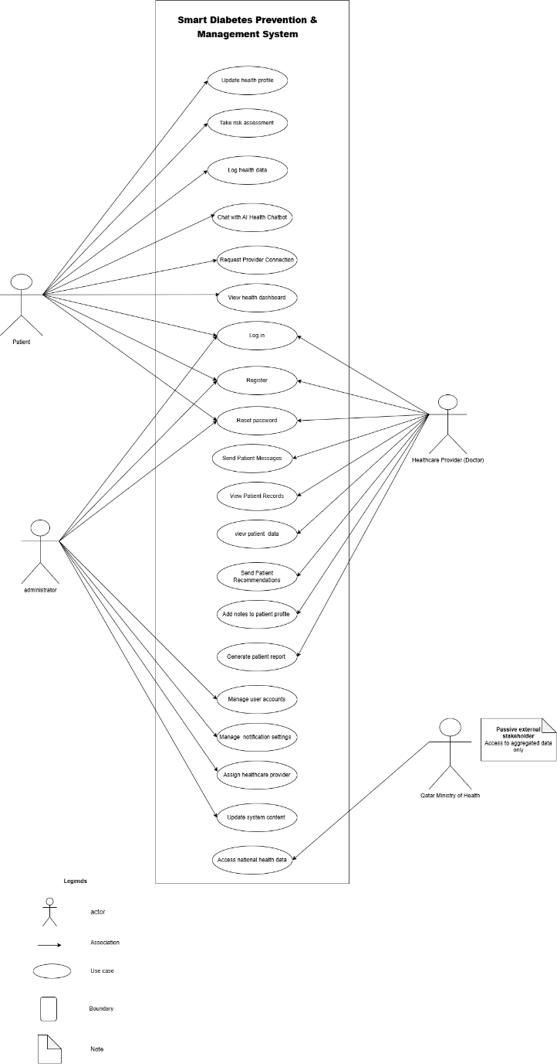

1.2 Fully Developed Use Case Descriptions

Use Case 1: Submit Risk Assessment
Use Case Name | Submit Risk Assessment
Use Case ID | UC-01
Actor | Patient
Description | The patient inputs their health data into the AI risk assessment form and submits it to receive a diabetes risk level and personalized recommendations.
Preconditions | - User must be registered and logged in  - User profile exists in the system  - System is available
Postconditions | - Risk assessment results are stored in the patient's profile.  - Recommendations are shown to the patient.  - The result remains accessible through the dashboard until a new assessment is completed.
Main Flow | - The patient logs into the system.  - The patient navigates to the Risk Assessment feature.  - The system displays the diabetes risk assessment form.  - The patient enters the required data, including:  - age  - sex  - BMI (obesity status)  - physical activity level  - smoking status  - The patient submits the form.  - The system validates the entered data.  - The system sends the data to the AI risk assessment engine.  - The AI engine analyzes the patient’s inputs.  - The system determines the patient’s diabetes risk level (Low / Medium / High).  - The system displays risk assessment results.  - The system provides an explanation of the main contributing factors.  - The system provides personalized prevention recommendations based on the user’s risk level and input data.  - The system stores the assessment result in the patient's profile.
Alternative Flow | A1. Missing or invalid input  At step 6, if required data is missing or invalid:  - The system highlights the missing/incorrect fields.  - The patient corrects the information.  - The process continues from step 5.  A2. High-risk case  At step 10, if the result is High Risk:  - The system displays an alert indicating a high risk condition.  - The system strongly recommends consulting a healthcare provider.  - The system may suggest seeking medical advice or visiting a clinic.
Exception Flow | E1. AI service unavailable  - The system displays an error message.  - The patient is asked to try again later.  - The system does not save incomplete results.

Use Case 2: Log Health Data

Use Case Name | Log Health Data
Use Case ID | UC-02
Actor | Patient
Description | This use case allows a patient to log daily health-related data, such as blood glucose readings, meal information, physical activity, and medication intake. The system stores the data, updates the patient's dashboard, and generates alerts if abnormal or critical readings are detected.
Preconditions | - The user must be registered and logged in.  - The user must have a patient account.  - The user profile must exist in the system.  - The health logging module must be available.
Postconditions | - The health data entry is stored in the patient’s records.  - The patient dashboard is updated with the latest logged information.  - Alerts may be generated if abnormal or critical readings are detected.
Main Flow | - The patient logs into the system.  - The patient navigates to the Health Logging feature.  - The system displays the health data entry form.  - The patient enters the required health data, including:  - blood glucose reading  - meal information  - physical activity  - medication intake  - The patient submits the entry.  - The system validates the entered data.  - The system stores the data in the patient’s health record.  - The system updates the patient dashboard with the latest logged data.  - The system checks whether the submitted reading is within the normal range.  - If the reading is within normal range, the system confirms the entry with a success message  - The system confirms that the health data has been logged successfully.
Alternative Flow | A3. Abnormal Glucose Reading Detected  At step 9, if the glucose reading is outside the normal range:  - The system flags the reading as abnormal.  - The system sends an alert notification to the patient warning them of the abnormal reading.  - The system sends an alert to the patient's assigned healthcare provider.  - The system recommends the patient to contact their healthcare provider.  - The process continues from step 10
Exception Flow | A1. Missing or Invalid Input  At step 6, if one or more fields contain invalid data:  - The system highlights the incorrect fields.  - The patient corrects the information.  - The process continues from step 5.  A2. Incomplete Health Data Entry  At step 6, if one or more required fields are missing:  - The system displays a validation message indicating that all required fields must be completed.  - The system prevents the patient from submitting entry.  - The patient completes the missing fields.  - The process continues from step 5.

Use Case 3: Chat with AI Health Chatbot

Use Case Name | Chat with AI Health Chatbot
Use Case ID | UC-03
Actor | Patient
Description | This use case allows a patient or at-risk user to interact with the AI Health Chatbot to receive personalized support related to diabetes prevention and management. The chatbot answers health-related questions, provides dietary suggestions, explains medication usage, and reminds users of relevant health related activities based on the user’s profile and input.
Preconditions | - The user must be registered and logged in.  - The user profile must exist in the system.  - The chatbot service must be available.  - The system must be connected to the AI service.
Postconditions | - The patient receives a chatbot response.  - The conversation is stored in the patient’s chat history.  - Personalized health guidance, dietary suggestions, or support may be provided.
Main Flow | - The patient logs into the system.  - The patient navigates to the AI Health Chatbot feature.  - The system displays the chatbot interface.  - The patient enters a health related question or request.  - The system receives the patient’s message.  - The system retrieves relevant user profile information to personalize the response.  - The system sends message and contextual profile data to the AI chatbot service.  - The AI chatbot analyzes the patient’s request.  - The AI chatbot generates an appropriate personalized response.  - The system displays the chatbot response to the patient.  - The patient may continue the conversation by asking follow up questions.  - The system stores the conversation in the patient’s chat history.
Alternative Flow | A1. Critical Health Concern Detected  At step 9, if the chatbot detects a potentially serious health concern:  - The chatbot advises the patient to consult a healthcare provider.  - The process continues from step 10.
Exception Flow | E1. Invalid or Empty Input  At step 5, if the patient submits an empty or invalid message:  - The system displays a validation message.  - The patient reenters the message.  - The process continues from step 4.  E2. AI Service Unavailable  At step 7, if the AI chatbot service is unavailable:  - The system displays an error message.  - The patient is asked to try again later.  - The system does not store the incomplete interaction.

Use Case 4: Generate Patient Report

Use Case Name | Generate Patient Report
Use Case ID | UC-04
Actor | Healthcare Provider
Description | This use case allows a healthcare provider to generate a patient report based on the patient’s logged health data, risk assessment results, and monitoring history. The report supports professional review, follow-up, and clinical decision-making.
Preconditions | - The healthcare provider must be registered and logged in.  - The patient must be assigned to the healthcare provider.  - The patient profile must exist in the system.  - At least some patient health data must be available in the system.  - The reporting module must be available.
Postconditions | - A patient report is generated successfully.  - The healthcare provider can review, save, or download the report.
Main Flow | - The healthcare provider logs into the system.  - The healthcare provider navigates to the Healthcare Provider Portal.  - The healthcare provider selects one of their assigned patients.  - The system displays the selected patient’s health profile and monitoring history.  - The healthcare provider selects “Generate Patient Report.”  - The system displays the available report options.  - The healthcare provider selects the desired report criteria, such as:  - date range  - blood glucose readings  - medication records  - physical activity logs  - meal logs  - risk assessment results  - The healthcare provider confirms the selected report options.  - The system retrieves the relevant patient's data.  - The system compiles the selected data into a report.  - The system generates patient reports.  - The system displays the generated report to the healthcare provider.  - The healthcare provider may review, download, or save the report.
Alternative Flow | A1. Insufficient Data for Full Report  At step 9, if the patient has limited health data available:  - The system generates a partial report using the available data.  - The system informs the healthcare provider that some report sections are incomplete.  - The process continues from step 12.
Exception Flow | E1. Report Generation Failure  At step 11, if the report cannot be generated because of a system or processing error:  - The system displays an error message.  - The healthcare provider is asked to try again later.  - The use case ends.

2. Wireframes
The following wireframes illustrate the proposed system interface for core user journeys including login, feature access, and data entry. Each wireframe focuses on the key screens a user interacts with when performing the main use cases.

2.1 Register and Login
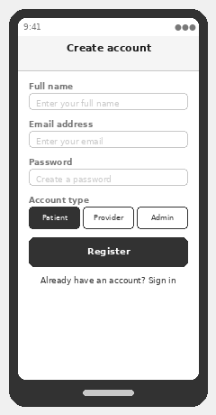
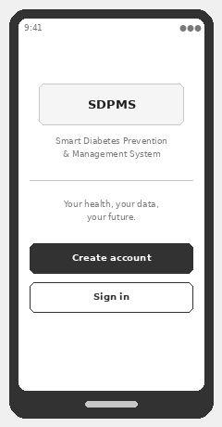
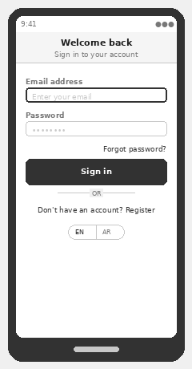

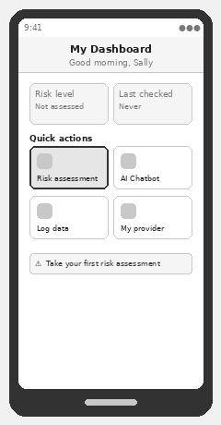
2.2 Submit Risk Assessment
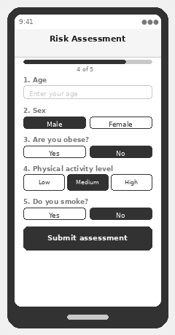
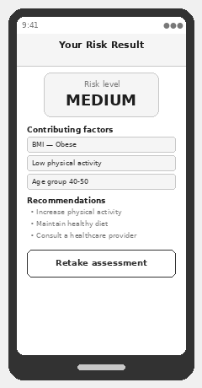

2.3 Log Health Data

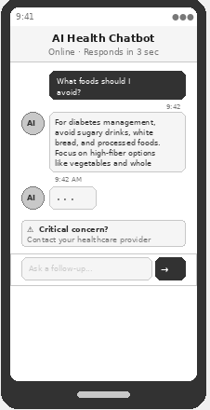
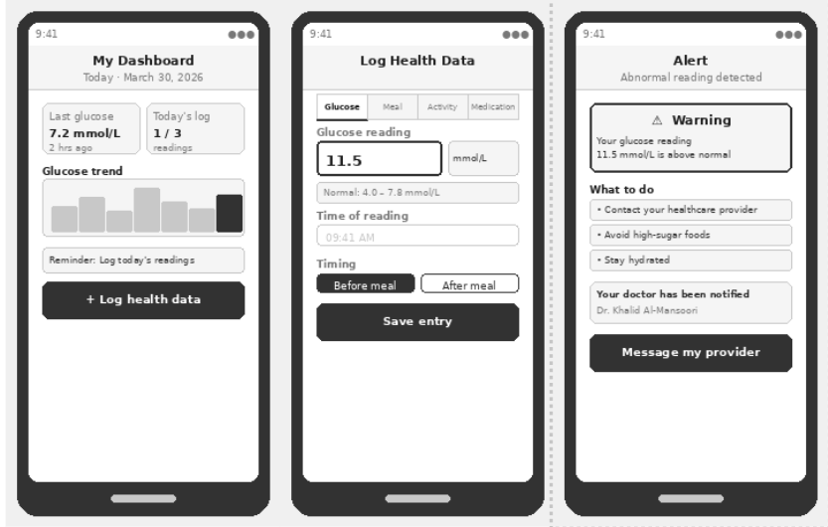
2.4 Chat with AI Health Chatbot
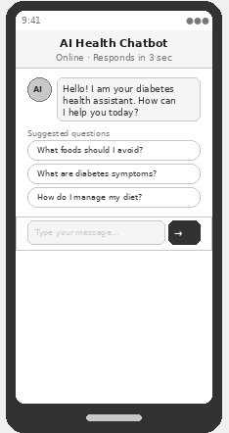
2.4 Generate Patient Report
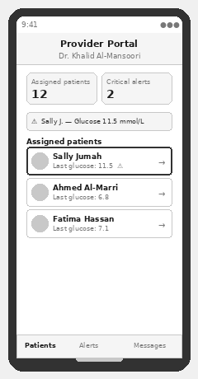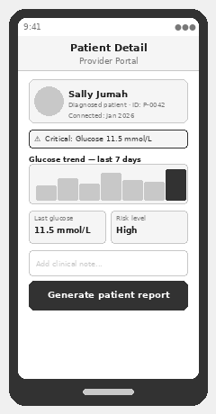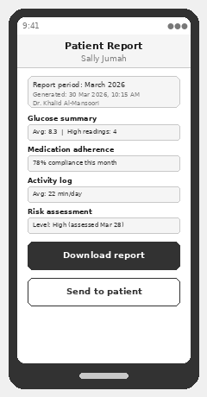
Question 1: According to the functional and non-functional requirements identified earlier, explain to what extent these requirements align with user needs?
Every user need stated in the stakeholder analysis has at least one corresponding functional requirement that directly addresses it:
User Need | Addressed By
Know diabetes risk level | FR-05, FR-06, FR-07, FR-08, FR-09
Manage diabetes daily | FR-10, FR-12,
Get health advice anytime | FR-16, FR-17, FR-18, FR-19, FR-20
Coordinate with doctor | FR-15, FR-27, FR-29, FR-16, FR-34
Stay reminded and informed | FR-35, FR-36, FR-37
Manage user accounts securely | FR-30, FR-31

No user need was left without a corresponding requirement, which means the requirements cover user needs fully with no gaps

Question 2: How effectively does the designed system meet the identified user needs in terms of performance, security, usability, and maintainability?
Performance
In a diabetes management system, delayed access to health data is not just an inconvenience it can directly affect patient safety. A patient waiting too long for their risk assessment result or chatbot response may abandon the system entirely, undermining its core public health purpose. The system addresses this effectively through four specific requirements. NFR-01 ensures pages load within 3 seconds directly addressing the need for fast access to health data. NFR-02 ensures the AI risk assessment returns results within 5 seconds so patients are not left waiting after submitting their health data. NFR-04 ensures the chatbot responds within 3 seconds meeting the need for immediate health guidance. NFR-03 supports up to 1,000 concurrent users ensuring the system does not degrade during peak usage periods such as national health awareness campaigns.
Security
In a diabetes management system where patients share highly sensitive data including glucose levels, medication history, and lifestyle information, security is not optional, a breach could expose personal medical information and permanently damage patient trust in the platform. The system meets security needs effectively through five specific requirements. NFR-05 encrypts all health data using AES-256 and TLS 1.3 directly addressing the patient need for private and protected health records. NFR-06 ensures compliance with Qatar's Personal Data Privacy Protection Law giving users legal assurance over their data rights. NFR-07 implements role-based access control (RBAC) meaning a patient cannot see another patient's data, and a doctor can only see their assigned patients. NFR-08 logs out inactive users after 15 minutes protecting accounts from unauthorized access on shared devices. NFR-09 secures all API endpoints with JWT tokens ensuring that data exchanged between the system and the AI features is protected end to end.
Usability
A diabetes management system is only effective if patients use it consistently. In Qatar, the target population includes elderly patients, individuals with limited digital literacy, Arabic speakers, and users with disabilities making usability a critical factor in whether the system achieves its health outcomes. The system addresses this effectively through four requirements. NFR-10 ensures registration is completed within 5 minutes removing barriers to onboarding for first-time users. NFR-11 ensures the system works on both web and mobile addressing the need for access anywhere and anytime, which is essential for patients logging daily readings or accessing the chatbot on the go. NFR-12 complies with WCAG 2.1 accessibility standards making the system usable for patients with visual or motor disabilities. NFR-13 supports both Arabic and English layouts directly addressing the bilingual needs of Qatar's diverse population and ensuring no user is excluded due to language barriers.
Maintainability

A diabetes management system must evolve over time as medical knowledge advances, user needs change, and new AI capabilities emerge. A system that cannot be maintained and updated becomes obsolete and eventually a liability rather than an asset to public health. The system addresses this effectively through three requirements. NFR-14 requires a layered architecture meaning each module such as the dashboard, chatbot, or risk assessment can be updated independently without disrupting the rest of the system. This is especially important as the AI models powering the risk predictor and chatbot will need to be updated as new diabetes research emerges. NFR-15 requires documentation for all API endpoints making it easier for future developers to maintain and extend the system without relying on institutional knowledge. NFR-16 requires version control and modular deployment ensuring the system can grow and adapt to future NHS-3 health priorities without rebuilding from scratch.

