INFS3103 Systems Analysis and Design Phase 3: Design Smart Diabetes Prevention & Management System

1. System Architecture
1.1 Adopted Software Architecture
For the Smart Diabetes Prevention & Management System (SDPMS), we adopted a Layered Architecture pattern organized into five layers: Presentation, Business Logic, Persistence, Domain Entities, and External AI Services. This architecture was selected because SDPMS is a web and mobile health platform that supports multiple user roles, handles sensitive health data, and integrates AI-powered services through the OpenAI API.
The layered pattern provides a clear separation of concerns, where each layer has a specific responsibility and communicates only with adjacent layers. This improves the system’s security, modularity, and maintainability, while also supporting easier updates and better control of patient data.
This architecture also aligns well with NFR-14, which specifies that the system should follow a layered architecture to support independent module updates, and NFR-15, as the clear separation of system components makes documentation easier to organize and maintain.

1.2 Architecture Diagram
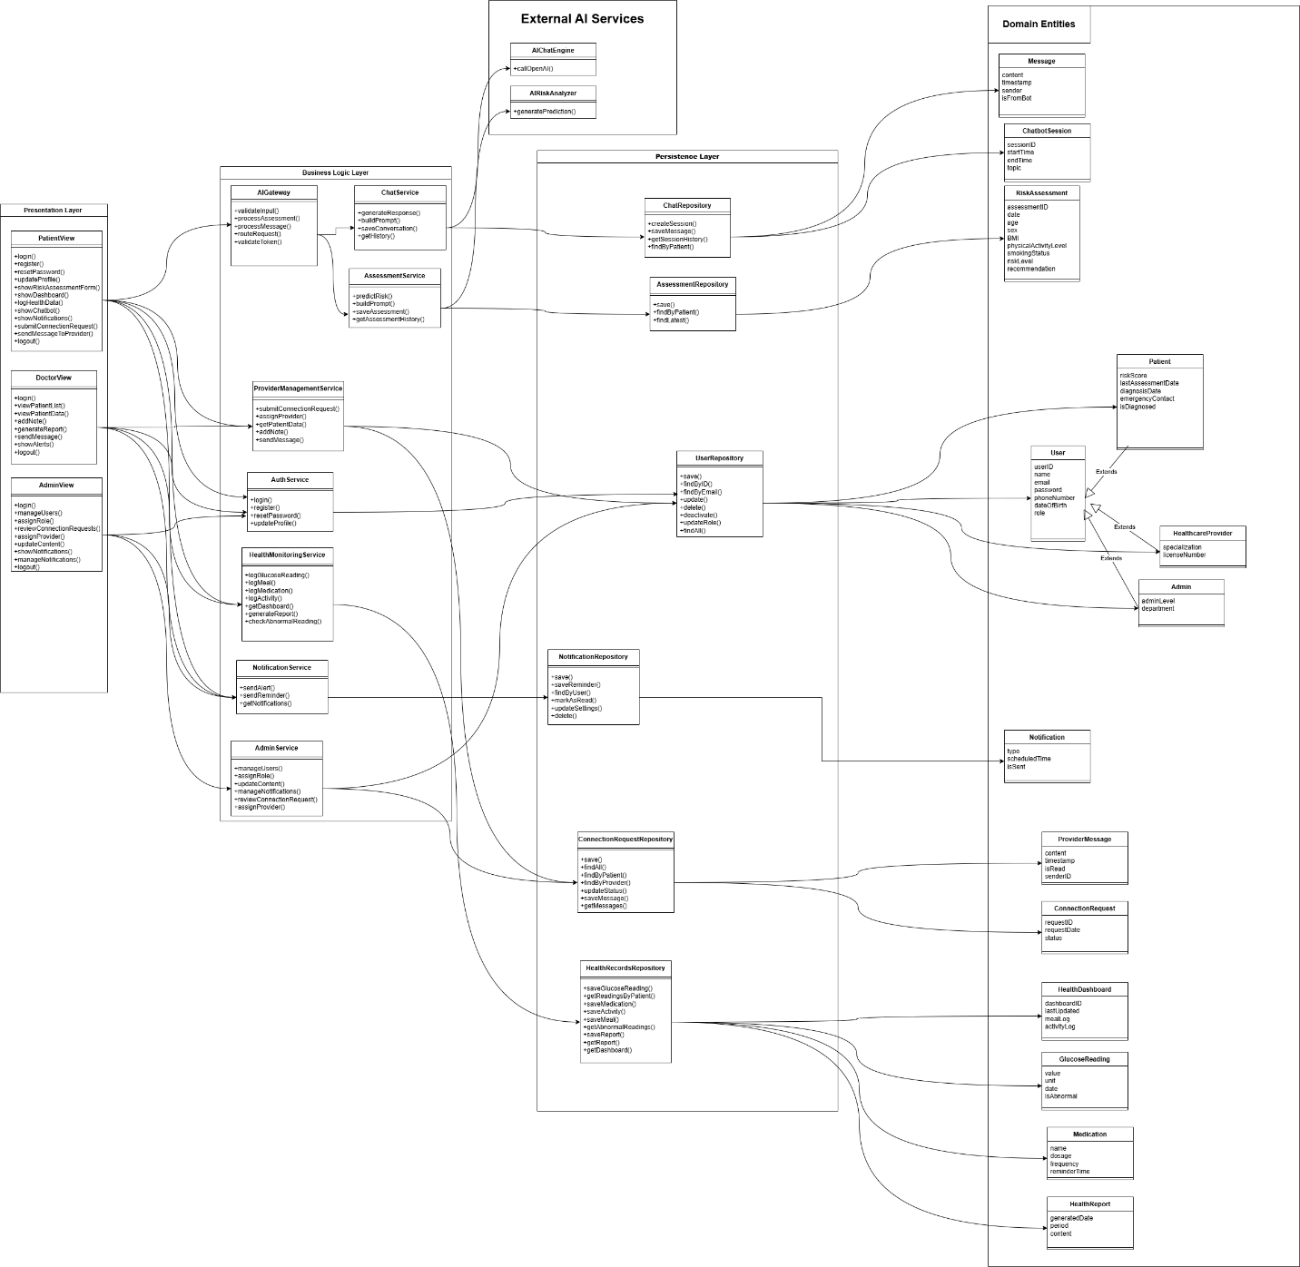

1.3 How the Architecture Satisfies Requirements
Performance:
The layered architecture satisfies the performance requirements of SDPMS in the following ways. NFR-01 requires that the system loads any page within 3 seconds, which is supported because the Presentation Layer is separated from the Business Logic Layer, allowing the UI to load independently without waiting for heavy backend processing. NFR-02 requires that the AI risk assessment returns results within 5 seconds, which is supported because the AssessmentService communicates directly with the OpenAI API through the AIGateway, minimizing processing overhead. NFR-03 requires that the system supports up to 1,000 concurrent users, which is supported because each layer can be scaled independently without affecting the others. NFR-04 requires that the chatbot responds within 3 seconds, which is supported because the ChatService is a dedicated service that handles only chatbot logic, avoiding interference from other services.
Security:
The layered architecture satisfies the security requirements of SDPMS as follows. NFR-05 requires that all user health data be encrypted at rest and in transit using AES-256 and TLS 1.3, which is enforced at the Persistence Layer for data at rest and through the AIGateway for data in transit. NFR-06 requires compliance with Qatar's Personal Data Privacy Protection Law, which is supported because all health data is stored in a controlled Persistence Layer with restricted access through repositories only. NFR-07 requires role-based access control, which is implemented through the AIGateway that validates JWT tokens and enforces role-based permissions before any request reaches the Business Logic Layer. NFR-08 requires automatic logout after 15 minutes of inactivity, which is handled by the AuthService in the Business Logic Layer that manages session tokens and expiry times. NFR-09 requires that all API endpoints require authentication via JWT, which is enforced by the AIGateway that intercepts all AI-related requests and validates tokens before routing them to the appropriate service.
Usability:
The layered architecture supports the usability requirements of SDPMS as follows. NFR-10 requires that new users can complete registration within 5 minutes, which is supported because the Presentation Layer provides a dedicated registration screen that communicates only with the AuthService, keeping the flow simple and fast. NFR-11 requires that the system be accessible on both web browsers and mobile devices, which is supported because the Presentation Layer is completely separate from the backend, allowing the same Business Logic Layer to serve both web and mobile interfaces without duplication. NFR-12 requires compliance with WCAG 2.1 accessibility standards, which is supported because all accessibility features are implemented in the Presentation Layer independently without affecting any other layer. NFR-13 requires that the system support both Arabic and English, which is handled entirely in the Presentation Layer, meaning language changes do not affect the Business Logic or Persistence layers at all.
Maintainability:
The layered architecture supports maintainability in the following ways. The separation of concerns principle means that fixing a bug or updating functionality in one layer does not affect other layers, for example updating the chatbot UI in the Presentation Layer does not require touching the ChatService or ChatRepository. Independent updates are possible for each layer, as the OpenAI API integration in the External AI Services layer can be swapped to a different AI provider without changing the Business Logic Layer. Code reusability is achieved because the same Business Logic Layer services are reused across both web and mobile presentation interfaces without duplication. Finally, easier testing is supported because each layer and service can be tested independently, for example the AssessmentService can be tested without the Presentation Layer being complete.

2. UML Design Class Diagram
2.1 Introduction
The UML Design Class Diagram for the Smart Diabetes Prevention & Management System (SDPMS) presents the system's structure at the design level. It extends the domain class diagram developed in Phase 2 by incorporating implementation details such as visibility markers, data types, method signatures, and design specific classes.
The diagram is organized across four layers: the Presentation Layer containing the view classes, the Business Logic Layer containing the service classes, the Persistence Layer containing the repository classes, and the Domain Entities layer containing the core data classes. Additionally, the External AI Services layer represents the OpenAI API integration used by the two AI powered features.
The relationships between classes are shown using standard UML notation, including inheritance, composition, aggregation, and association with navigability and multiplicity where applicable.

2.2 Design Class Diagram (PlantUML diagram)
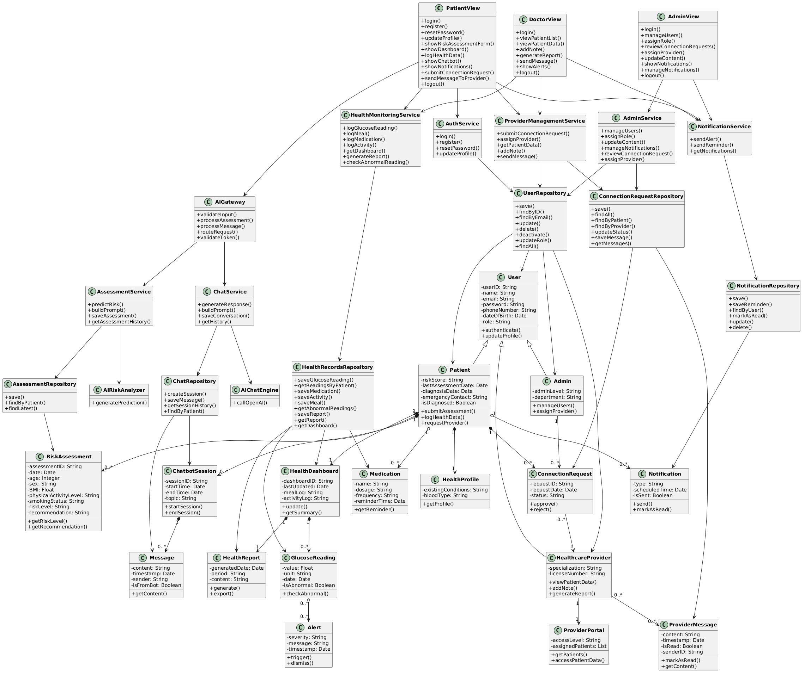

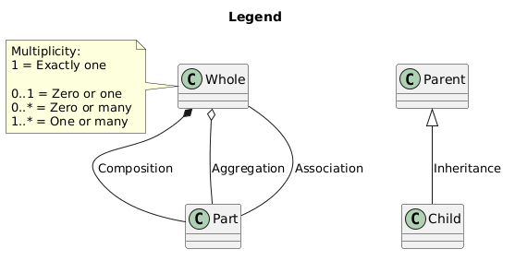
3. REST API Design
3.1 Introduction
The REST API for the Smart Diabetes Prevention & Management System (SDPMS) defines how external systems and users interact with the system through a standardized set of endpoints. The API follows REST architectural principles, using HTTP methods to perform operations on resources and returning responses in JSON format.
All API endpoints require authentication via JSON Web Tokens (JWT) as specified in NFR-09. The API is organized around the main features of the system: authentication, risk assessment, health monitoring, chatbot, notifications, provider management, and system administration.
The following HTTP methods are used throughout the API:
- GET — retrieve data
- POST — create new data or send data
- PUT — update existing data
- DELETE — remove data

3.2 API Endpoints Tables
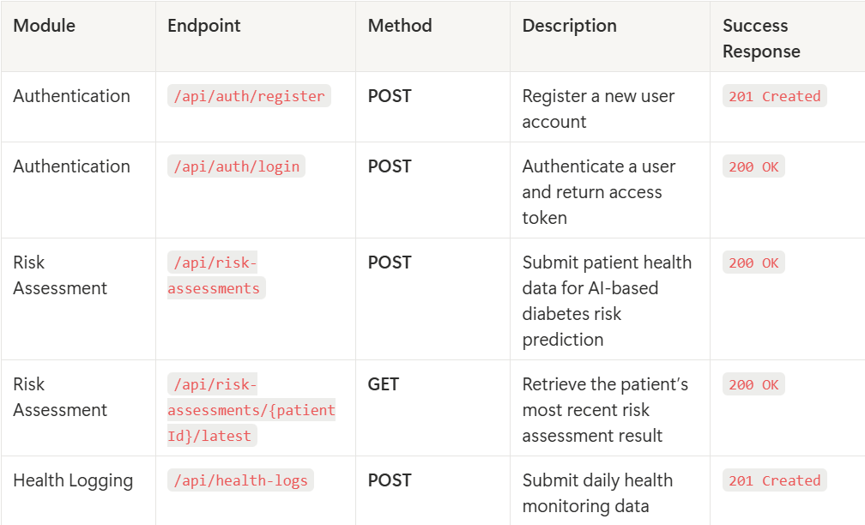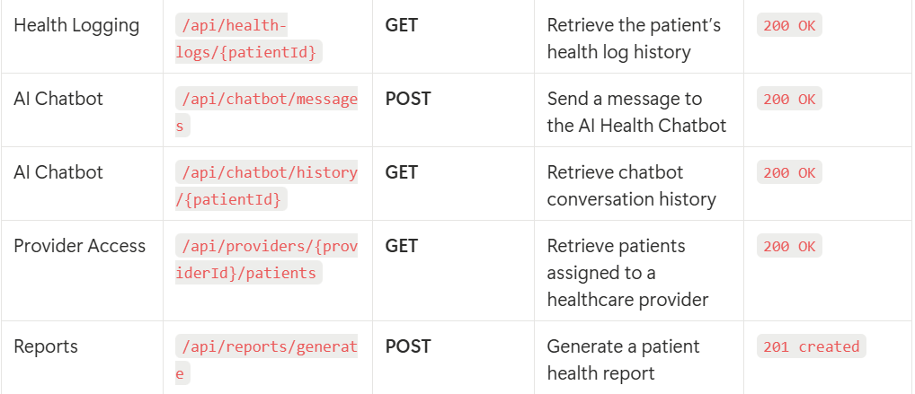

4. Sequence Diagrams
4.1 Sequence Diagram 1 — AI Risk Assessment
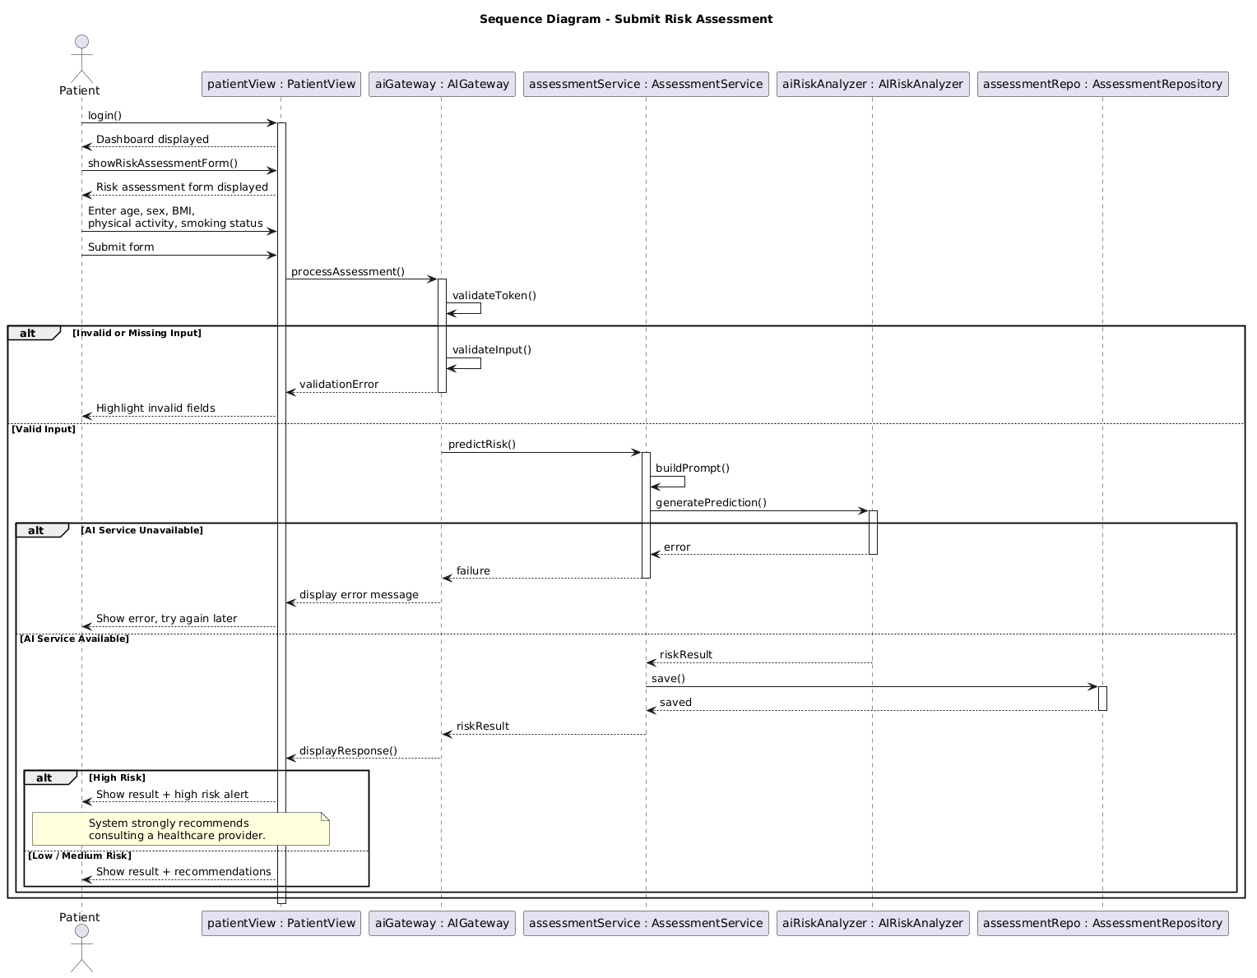

4.2 Sequence Diagram 2 — AI Health Chatbot
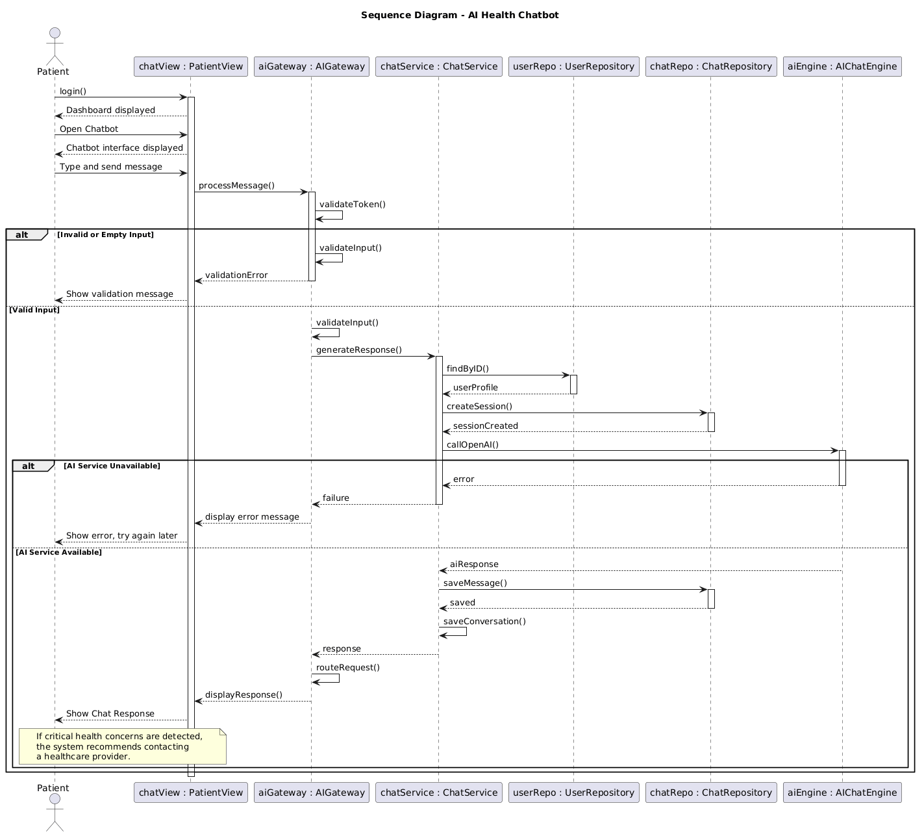
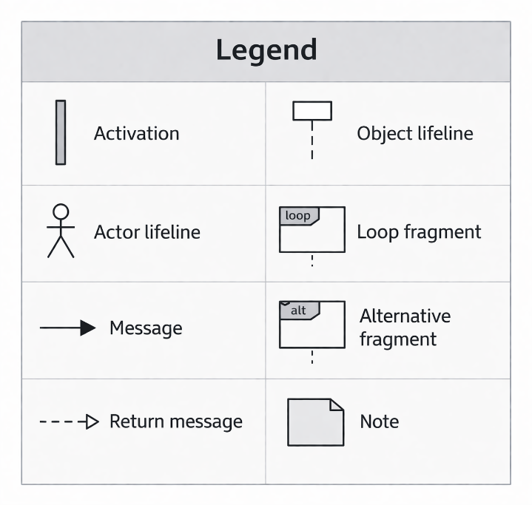

5. User Needs / Delivery & Administration
5.1 Delivery of the System
The delivery of the Smart Diabetes Prevention & Management System (SDPMS) should be designed based on the needs of its main users: at risk individuals, diagnosed patients, healthcare providers, and system administrators. Since users need quick, easy, and continuous access to the system, SDPMS should be delivered as a web based and mobile responsive platform that is available anytime and supports both Arabic and English. This is especially important because patients may need to log health data, access reminders, or use the AI chatbot at any time during the day, while healthcare providers need timely access to patient information and reports. These delivery decisions directly support the identified user needs for accessibility, usability, convenience, security, and continuity of care.
In addition, the system should be delivered in a way that prioritizes the most important user-facing services, such as user registration, AI risk assessment, health logging, alerts, and chatbot support, since these features directly address the core needs identified in earlier phases. Because the system handles sensitive health information, it should also be delivered with secure login, encrypted data handling, and role based access control. Delivering the system through a modular and layered design also supports future improvements and allows new features to be added without disrupting existing services. This is important in a healthcare environment where the system must remain secure, reliable, and easy to update.

5.2 Administration of the System
From an administration perspective, the system must be managed in a way that protects user data and ensures reliable operation. Because the platform handles sensitive health information, administrators must manage user accounts, access permissions, and security controls carefully. Role based access should ensure that patients can only view their own records, while healthcare providers can only access data for their assigned patients. In addition, the system should be monitored regularly to ensure that important services such as the AI risk assessment, chatbot, alerts, and provider portal remain available and function correctly. This supports user needs for privacy, trust, safety, and system reliability.
The administration of the system should also support the ongoing needs of healthcare delivery. For example, administrators should be able to manage patient provider connections, maintain notification settings, and ensure that healthcare providers receive alerts and can generate reports when needed. This is important because users do not only need a working technical system, but also a system that supports real coordination between patients and doctors. Therefore, the administration of SDPMS should focus on security, availability, role management, operational support, and maintainability. Overall, this ensures that the system remains effective, secure, and sustainable in supporting diabetes prevention and management over time.

