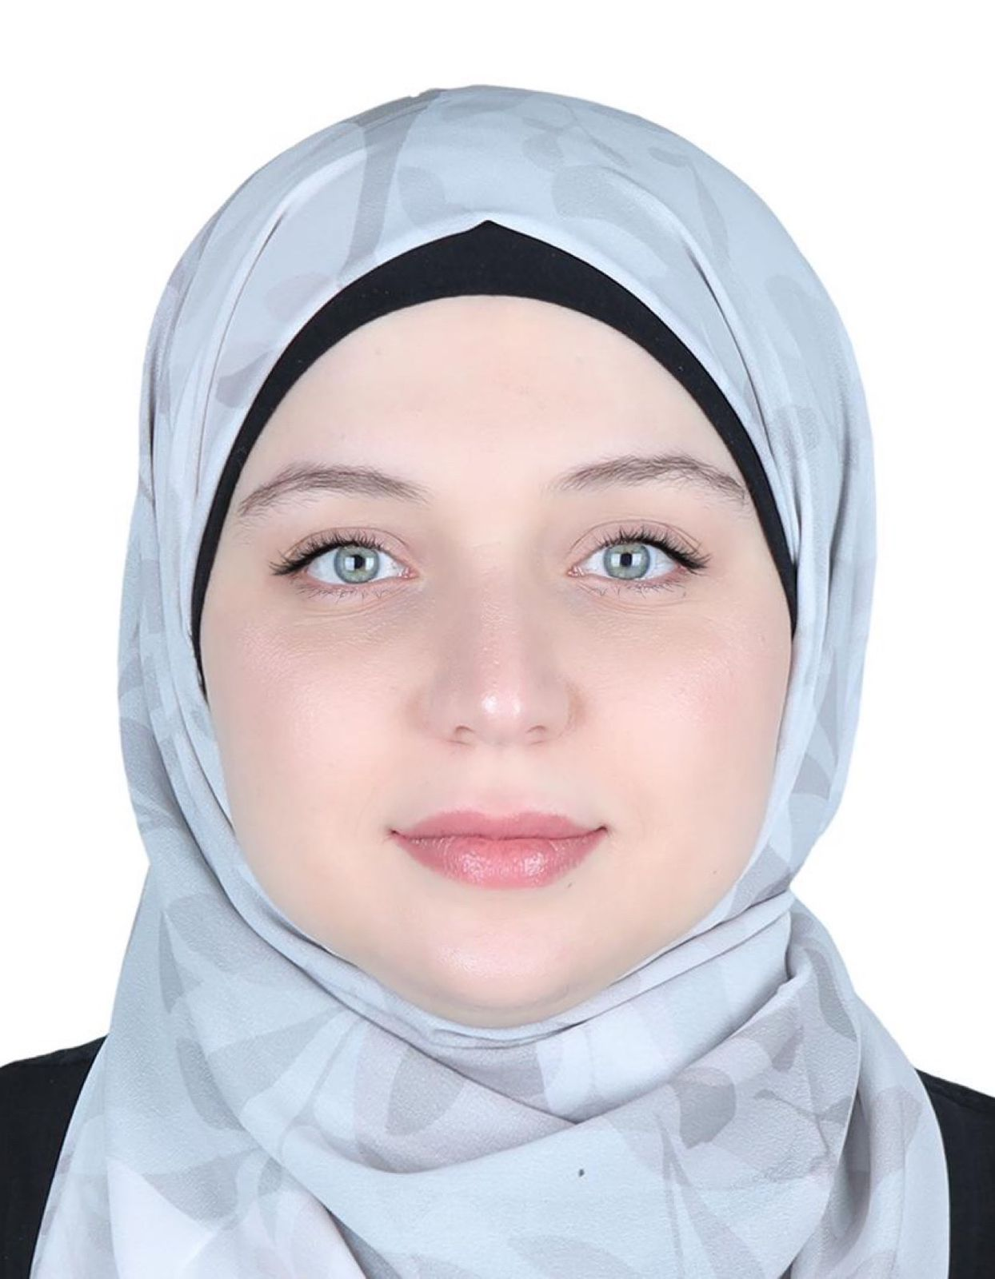 | SALSABEEL HAMDY  Social Media Coordinator · Content Creator · AI Video Creator  Sharjah, UAE | salsabeel.h.mohamed60@gmail.com | +971 50 229 5504  Portfolio: sally-hamdy.github.io/SallyHamdy.github.io
PROFILE
Social Media Coordinator and Content Creator with 5+ years of experience growing brands across very different industries — bridal fashion, e-commerce, industrial packaging, and technology. I build creative strategies, produce engaging multimedia content, and create modern AI-generated videos that give brands a cutting-edge presence. Managed the channels of 7 brands, from strategy and content calendars to community engagement and analytics.
EXPERIENCE
Social Media Manager — LinSync Technologies 2025 – Present
Managing all media channels for a technology company — content strategy, publishing, brand voice, and AI-powered video content.
Social Media Manager — Dupack & Empack (Packaging Factories, UAE) 2024 – 2025
Managed the social channels of two packaging factories, building their B2B presence and producing AI-generated promotional videos of their products and facilities.
Social Media Coordinator (Freelance) — Bookbee 2024 – Present
Brand identity — logos, color schemes, typography — plus graphics for web, social media, and digital ads.
Content Creator (Freelance) — DropShippingScout 2023 – 2024
Developed visual concepts aligned with project goals; supervised the design process and managed timelines and budgets.
Social Media Coordinator — Tatweer Company 2022 – 2023
Responsible for all social media channels, including LinkedIn and Facebook.
Social Media Coordinator — TiaraBridal 2021 – 2023
Ran all social channels for a bridal fashion brand, growing engagement with on-trend content.
SKILLS
- Social media strategy & management (Instagram, Facebook, LinkedIn, TikTok)
- Content creation — graphics, copywriting, multimedia campaigns
- AI video production & editing with the latest AI tools
- Brand identity design — logos, color schemes, typography
- Web design — clean, modern, responsive
- Analytics, trends & community engagement
EDUCATION
Bachelor of Science — Cairo University 2018 – 2022
Foundation in digital communication, media production, and data analysis, with focus on content strategy, visual storytelling, and audience engagement.
CERTIFICATIONS
Meta Social Media Marketing Professional Certificate — Coursera (in progress)
- Social Media Management — Completed
- Fundamentals of Social Media Advertising · Advertising with Meta · Measure & Optimize Social Media Marketing Campaigns — In progress

