Test Plan

1. Check that name input works in modal when send button is pressed.

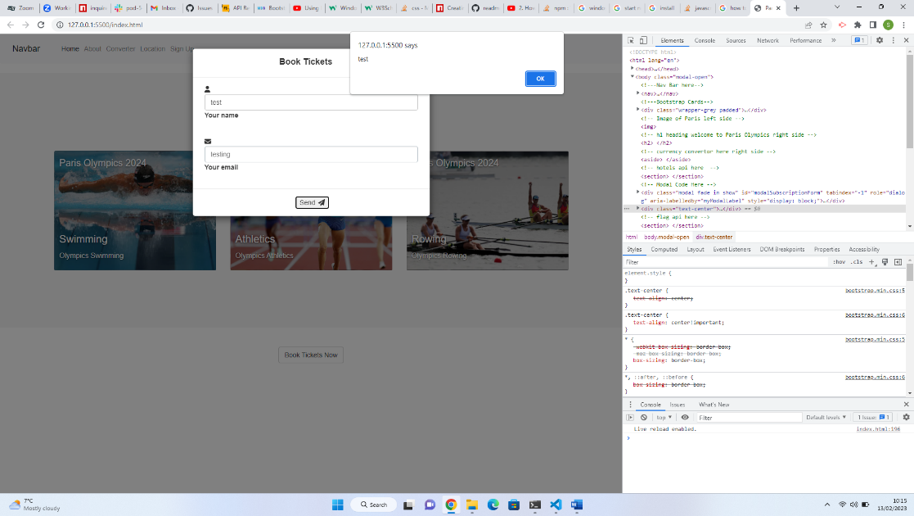

1. Check that e-mail input works when send button is pressed.

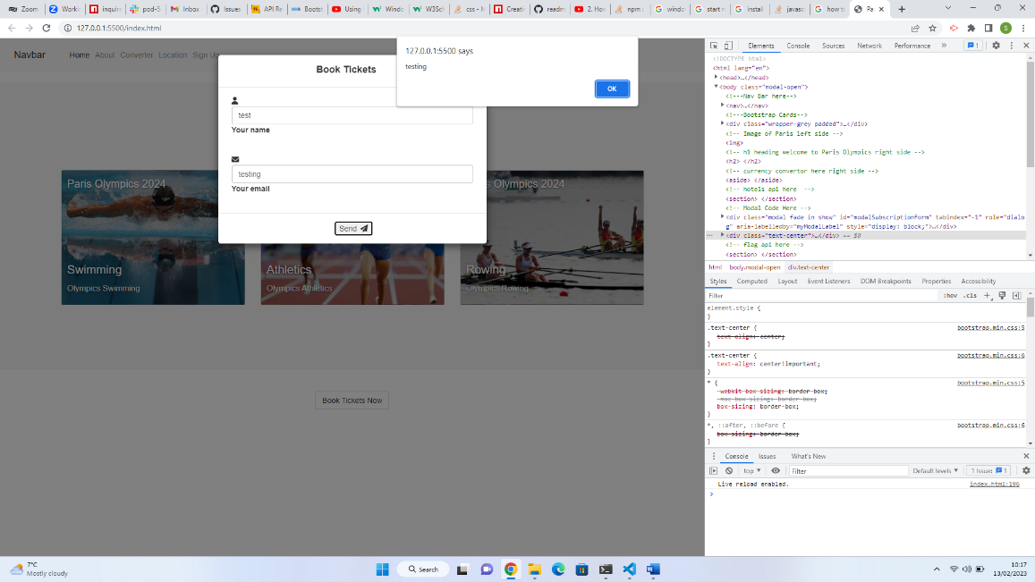

1. Check modal data is saved to local storage

Local storage did not work issue with user undefined.

Amended variable names and changed in the code on lines 8 + 9

As you can see data is now saved to local storage

